26-04-2022

TO INSERT MULTIPLE RECORDS
db.surya.insertMany([{"name":"abd","dept":"ise","marks":"90"},{"name":"kohli","dept":"ece","marks":"70"},])

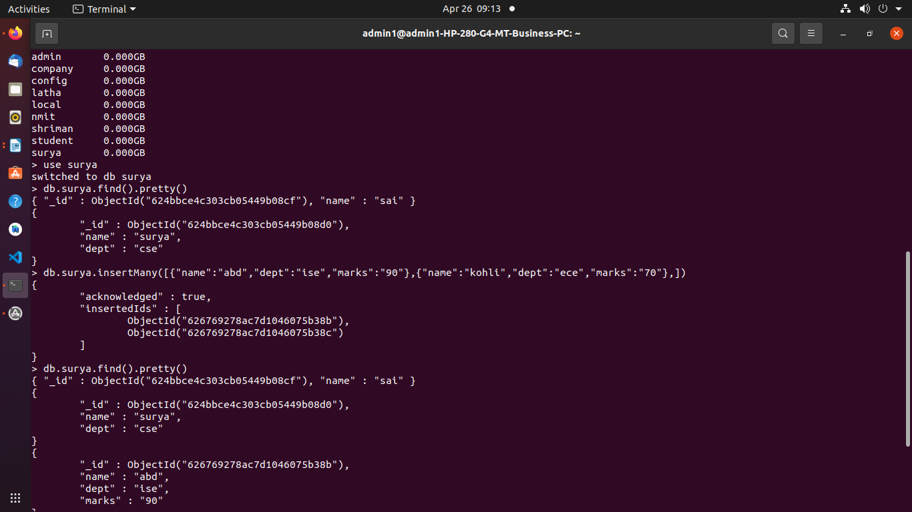
AGGREGATE FUNCTIONS:

TO DISPLAY STUDENTS OF ISE BRANCH:
CMD:
db.surya.aggregate([{$match:{"dept":"ise"}},{$count:"TOTAL STUDENTS IN ISE DEPT"}])

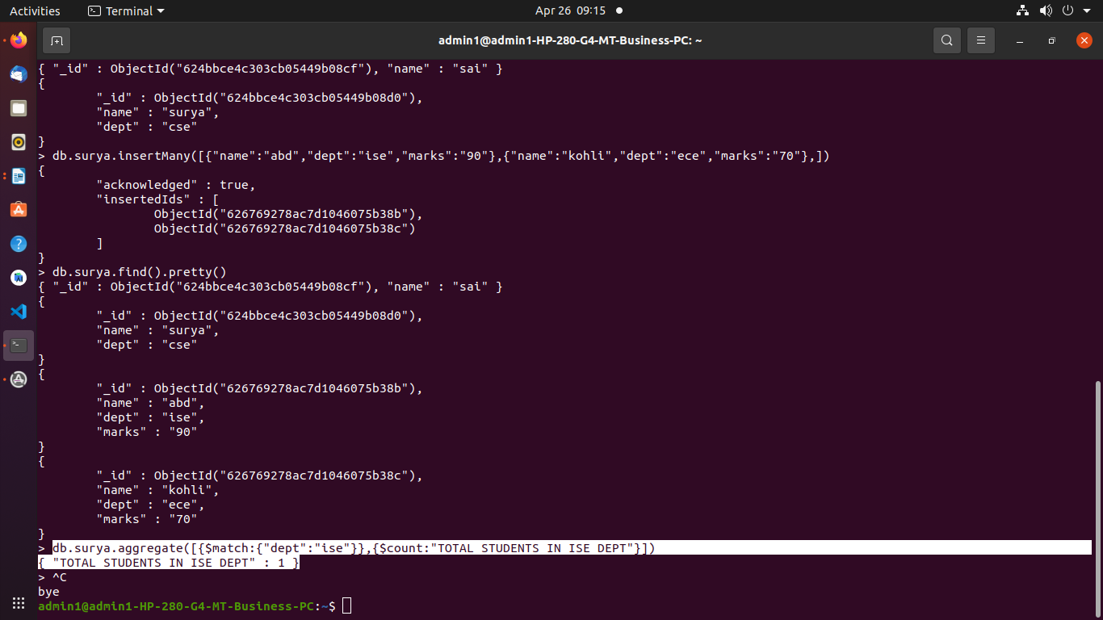
TO DISPLAY MARKS GREATER THAN 80 USING AGGREGATE FUNCTIONS.

CMD:
db.surya.aggregate([{$match:{"marks":{$gt:"80"}}}])

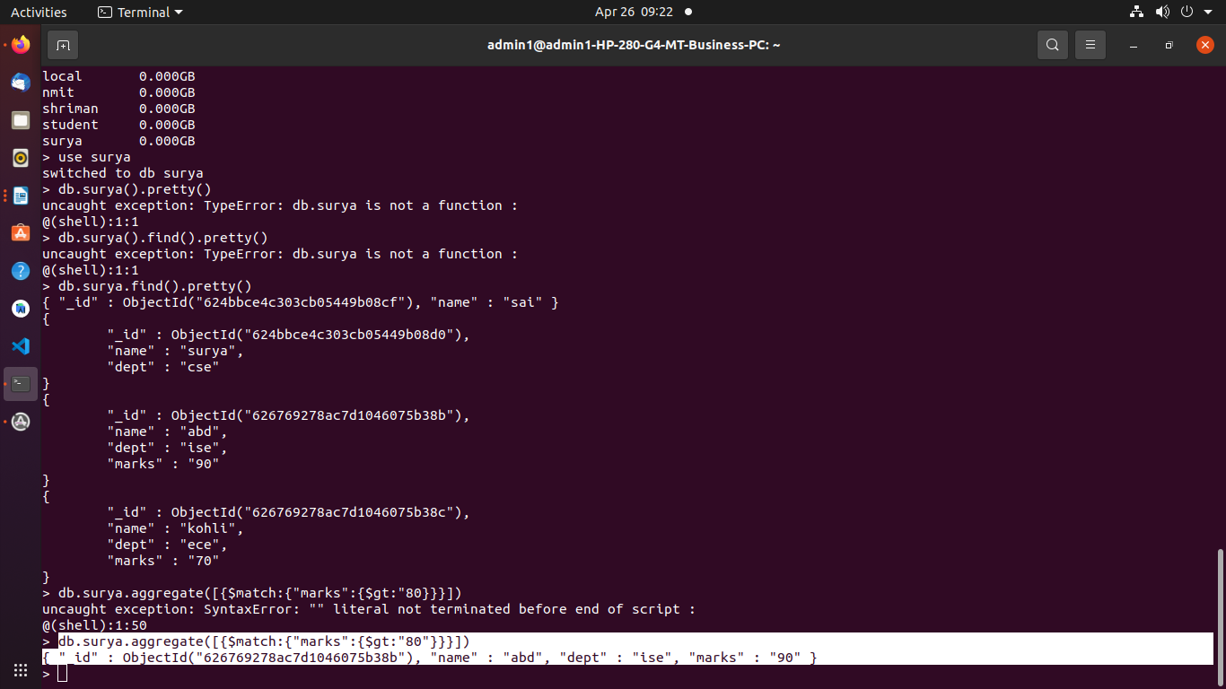
TO SORT THE RECORDS BASED ON MARKS FROM LOW TO HIGH USING AGGREGATE AND SORT
CMD:db.surya.aggregate([{'$sort':{"marks":1}}])
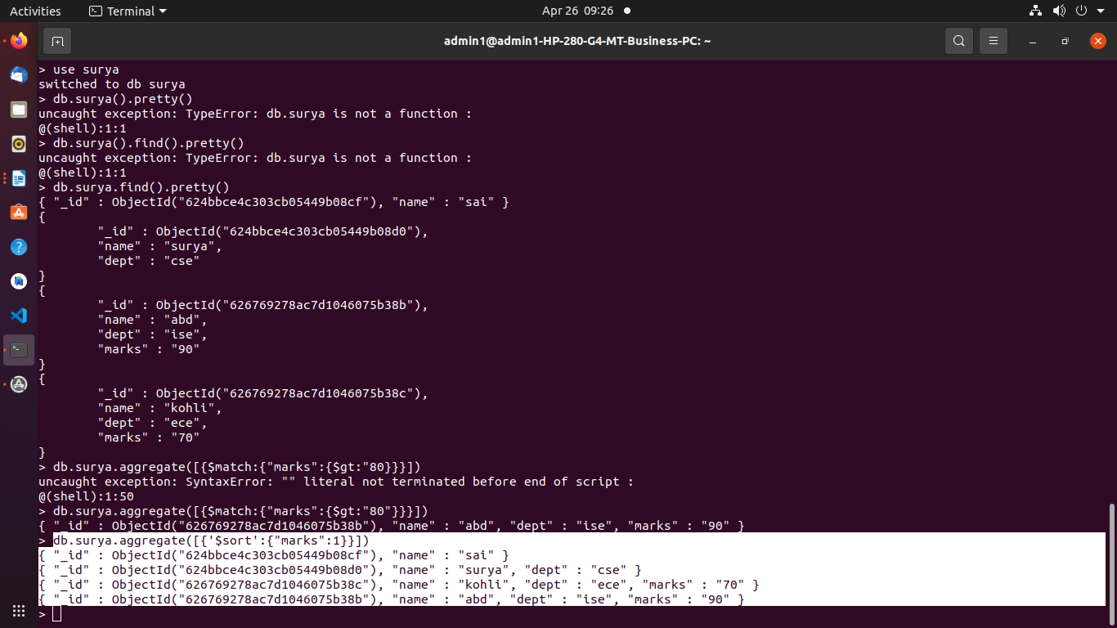
TO SORT THE RECORDS BASED ON MARKS FROM HIGH TO LOW USING AGGREGATE AND SORT
CMD:db.surya.aggregate([{'$sort':{"marks":-1}}])

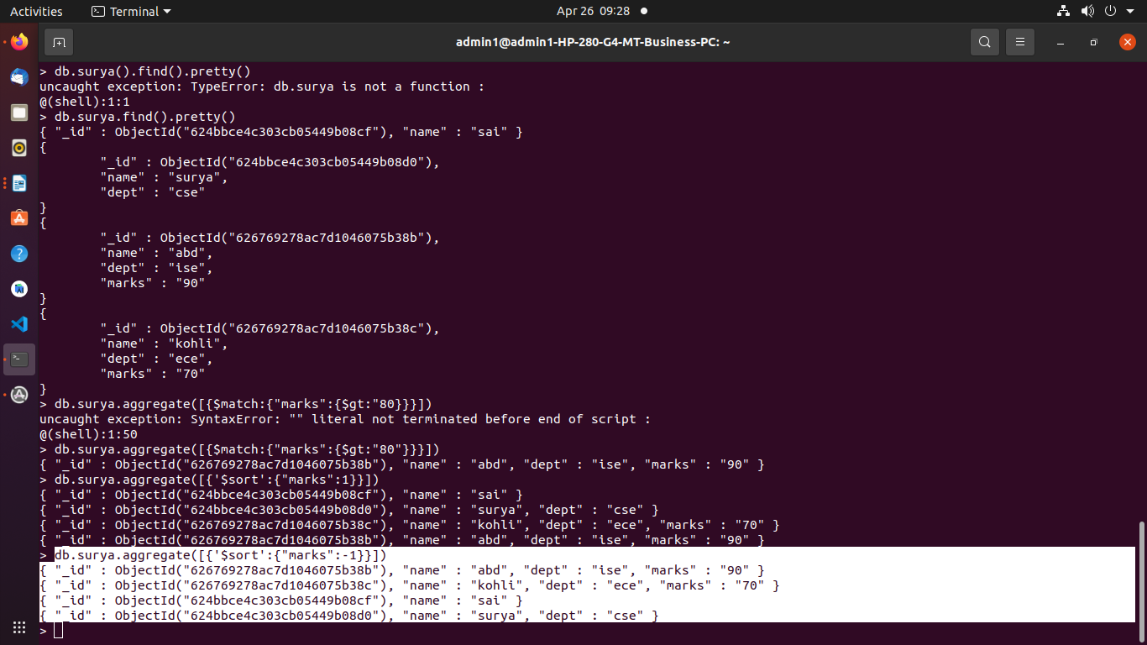
TO DISPLAY THE RECORD OF STUDENT WHO HAS HIGHEST MARKS IN ISE DEPT USING AGGREGATE FUNCTIONS
CMD:db.surya.aggregate([{$match:{"dept":"ise"}},{'$sort':{"marks":-1}},{$limit:1}])

db.surya.aggregate([{$match:{"dept":"ise"}},{'$sort':{"marks":-1}},{$limit:1}])
{ "_id" : ObjectId("62676e99ce719d84d2ac7b6a"), "name" : "dk", "dept" : "ise", "marks" : "95" }

