Experiment 4: Map Reduce Program
1nt19is137

package program;

import java.io.IOException;
import java.util.*;
import org.apache.hadoop.fs.Path;
import org.apache.hadoop.io.*;
import org.apache.hadoop.mapred.*;
public class mapreduce {
//MAPPER CODE
public static class Map extends MapReduceBase implements
Mapper<LongWritable, Text, Text, IntWritable> {
private final static IntWritable one = new IntWritable(1);
//private Text word = new Text();
public void map(LongWritable key, Text value, OutputCollector<Text,
IntWritable> output, Reporter reporter) throws IOException {
String myString = value.toString();
String[] userCount = myString.split(",");
output.collect(new Text(userCount[3]), one);
}
}
//REDUCER CODE
public static class Reduce extends MapReduceBase implements
Reducer<Text, IntWritable, Text, IntWritable> {
public void reduce(Text key, Iterator<IntWritable> values,
OutputCollector<Text, IntWritable> output, Reporter reporter) throws
IOException { //{little: {1,1}}
int finaluserCount = 0 ;
Text mykey = key ;
while(values.hasNext()) {
IntWritable value = values.next();
finaluserCount += value.get();
}
output.collect(mykey, new IntWritable(finaluserCount));
}
}
//DRIVER CODE
public static void main(String[] args) throws Exception {
JobConf conf = new JobConf(WordCount.class);
conf.setJobName("wordcount");
conf.setOutputKeyClass(Text.class);
conf.setOutputValueClass(IntWritable.class);
conf.setMapperClass(Map.class);
conf.setCombinerClass(Reduce.class);
conf.setReducerClass(Reduce.class);
conf.setInputFormat(TextInputFormat.class);
conf.setOutputFormat(TextOutputFormat.class);
FileInputFormat.setInputPaths(conf, new Path(args[0]));
FileOutputFormat.setOutputPath(conf, new Path(args[1]));
JobClient.runJob(conf);
}
}

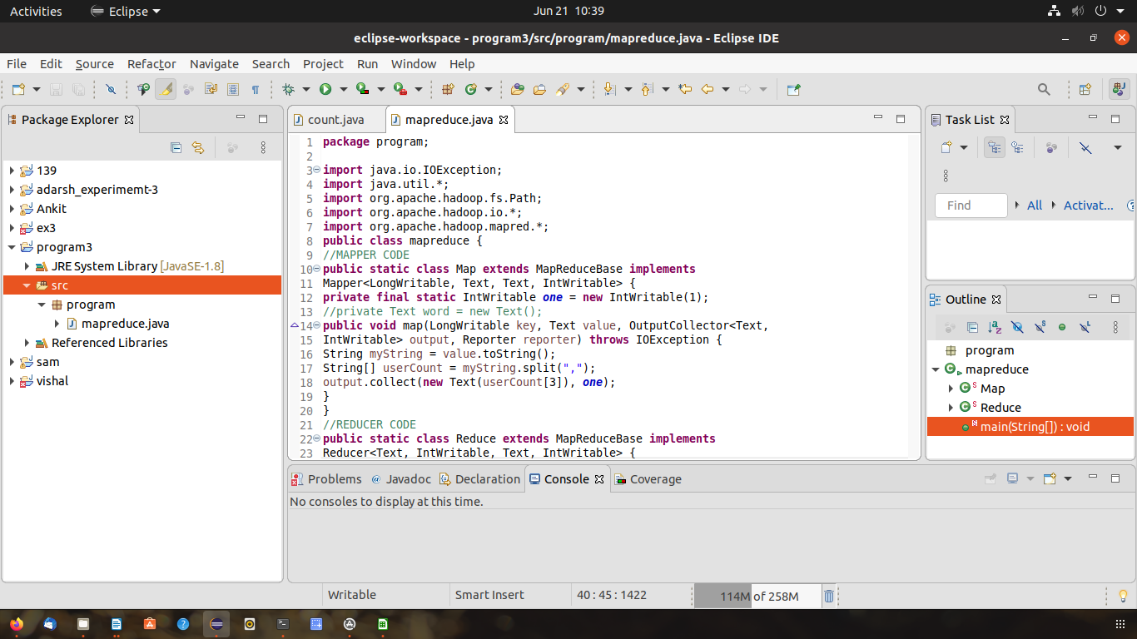
OUTPUT:
cd $HADOOP_HOME/sbin
hdoop@admin1-HP-280-G4-MT-Business-PC:~/hadoop-3.2.1/sbin$ ./start-all.sh
WARNING: Attempting to start all Apache Hadoop daemons as hdoop in 10 seconds.
WARNING: This is not a recommended production deployment configuration.
WARNING: Use CTRL-C to abort.
Starting namenodes on [localhost]
localhost: namenode is running as process 11176. Stop it first.
Starting datanodes
localhost: datanode is running as process 11352. Stop it first.
Starting secondary namenodes [admin1-HP-280-G4-MT-Business-PC]
admin1-HP-280-G4-MT-Business-PC: secondarynamenode is running as process 11559. Stop it first.
Starting resourcemanager
resourcemanager is running as process 11747. Stop it first.
Starting nodemanagers
localhost: nodemanager is running as process 12032. Stop it first.
hdoop@admin1-HP-280-G4-MT-Business-PC:~/hadoop-3.2.1/sbin$ hdfs dfs -mkdir -p /sai123
hdoop@admin1-HP-280-G4-MT-Business-PC:~/hadoop-3.2.1/sbin$ hdfs dfs -

hdoop@admin1-HP-280-G4-MT-Business-PC:~/hadoop-3.2.1/sbin$ hdfs dfs -copyFromLocal /home/hdoop/Documents/surya.csv /sai123
2022-06-21 10:35:44,427 INFO sasl.SaslDataTransferClient: SASL encryption trust check: localHostTrusted = false, remoteHostTrusted = false
hdoop@admin1-HP-280-G4-MT-Business-PC:~/hadoop-3.2.1/sbin$ hadoop jar /home/hdoop/Desktop/sai.jar /sai123 /output
2022-06-21 10:37:30,141 INFO client.RMProxy: Connecting to ResourceManager at /127.0.0.1:8032
2022-06-21 10:37:30,408 INFO mapreduce.JobResourceUploader: Disabling Erasure Coding for path: /tmp/hadoop-yarn/staging/hdoop/.staging/job_1655786534327_0001
2022-06-21 10:37:30,527 INFO sasl.SaslDataTransferClient: SASL encryption trust check: localHostTrusted = false, remoteHostTrusted = false
2022-06-21 10:37:31,075 INFO input.FileInputFormat: Total input files to process : 1
2022-06-21 10:37:31,125 INFO sasl.SaslDataTransferClient: SASL encryption trust check: localHostTrusted = false, remoteHostTrusted = false
2022-06-21 10:37:31,184 INFO sasl.SaslDataTransferClient: SASL encryption trust check: localHostTrusted = false, remoteHostTrusted = false
2022-06-21 10:37:31,209 INFO mapreduce.JobSubmitter: number of splits:1
2022-06-21 10:37:31,316 INFO sasl.SaslDataTransferClient: SASL encryption trust check: localHostTrusted = false, remoteHostTrusted = false
2022-06-21 10:37:31,341 INFO mapreduce.JobSubmitter: Submitting tokens for job: job_1655786534327_0001
2022-06-21 10:37:31,341 INFO mapreduce.JobSubmitter: Executing with tokens: []
2022-06-21 10:37:31,459 INFO conf.Configuration: resource-types.xml not found
2022-06-21 10:37:31,459 INFO resource.ResourceUtils: Unable to find 'resource-types.xml'.
2022-06-21 10:37:31,636 INFO impl.YarnClientImpl: Submitted application application_1655786534327_0001
2022-06-21 10:37:31,663 INFO mapreduce.Job: The url to track the job: http://admin1-HP-280-G4-MT-Business-PC:8088/proxy/application_1655786534327_0001/
2022-06-21 10:37:31,663 INFO mapreduce.Job: Running job: job_1655786534327_0001
2022-06-21 10:37:37,745 INFO mapreduce.Job: Job job_1655786534327_0001 running in uber mode : false
2022-06-21 10:37:37,747 INFO mapreduce.Job: map 0% reduce 0%
2022-06-21 10:37:40,805 INFO mapreduce.Job: map 100% reduce 0%
2022-06-21 10:37:44,836 INFO mapreduce.Job: map 100% reduce 100%
2022-06-21 10:37:45,861 INFO mapreduce.Job: Job job_1655786534327_0001 completed successfully
2022-06-21 10:37:45,942 INFO mapreduce.Job: Counters: 54
File System Counters
FILE: Number of bytes read=129
FILE: Number of bytes written=451101
FILE: Number of read operations=0
FILE: Number of large read operations=0
FILE: Number of write operations=0
HDFS: Number of bytes read=155
HDFS: Number of bytes written=70
HDFS: Number of read operations=8
HDFS: Number of large read operations=0
HDFS: Number of write operations=2
HDFS: Number of bytes read erasure-coded=0
Job Counters
Launched map tasks=1
Launched reduce tasks=1
Data-local map tasks=1
Total time spent by all maps in occupied slots (ms)=1401
Total time spent by all reduces in occupied slots (ms)=1583
Total time spent by all map tasks (ms)=1401
Total time spent by all reduce tasks (ms)=1583
Total vcore-milliseconds taken by all map tasks=1401
Total vcore-milliseconds taken by all reduce tasks=1583
Total megabyte-milliseconds taken by all map tasks=1434624
Total megabyte-milliseconds taken by all reduce tasks=1620992
Map-Reduce Framework
Map input records=4
Map output records=12
Map output bytes=99
Map output materialized bytes=129
Input split bytes=103
Combine input records=0
Combine output records=0
Reduce input groups=11
Reduce shuffle bytes=129
Reduce input records=12
Reduce output records=11
Spilled Records=24
Shuffled Maps =1
Failed Shuffles=0
Merged Map outputs=1
GC time elapsed (ms)=72
CPU time spent (ms)=770
Physical memory (bytes) snapshot=489230336
Virtual memory (bytes) snapshot=5082435584
Total committed heap usage (bytes)=517996544
Peak Map Physical memory (bytes)=298614784
Peak Map Virtual memory (bytes)=2538127360
Peak Reduce Physical memory (bytes)=190615552
Peak Reduce Virtual memory (bytes)=2544308224
Shuffle Errors
BAD_ID=0
CONNECTION=0
IO_ERROR=0
WRONG_LENGTH=0
WRONG_MAP=0
WRONG_REDUCE=0
File Input Format Counters
Bytes Read=52
File Output Format Counters
Bytes Written=70
hdoop@admin1-HP-280-G4-MT-Business-PC:~/hadoop-3.2.1/sbin$ hdfs dfs -cat /output123/part*

