BIG DATA LAB 5/04/2022

mongo version

MongoDB server version: 5.0.1

mongo

create the database

>use surya

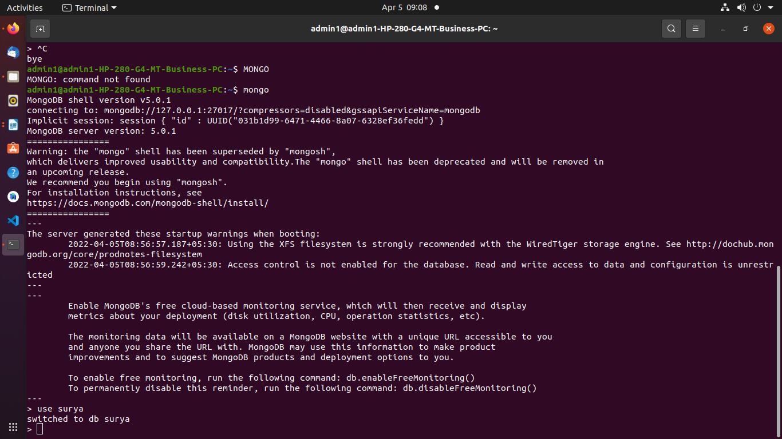

to check the current database

>show dbs

to insert one record

> db.surya.insertOne({name:"surya",dept:"ise"})
{
"acknowledged" : true,
"insertedId" : ObjectId("624bb8352d68e02286f8f369")
}

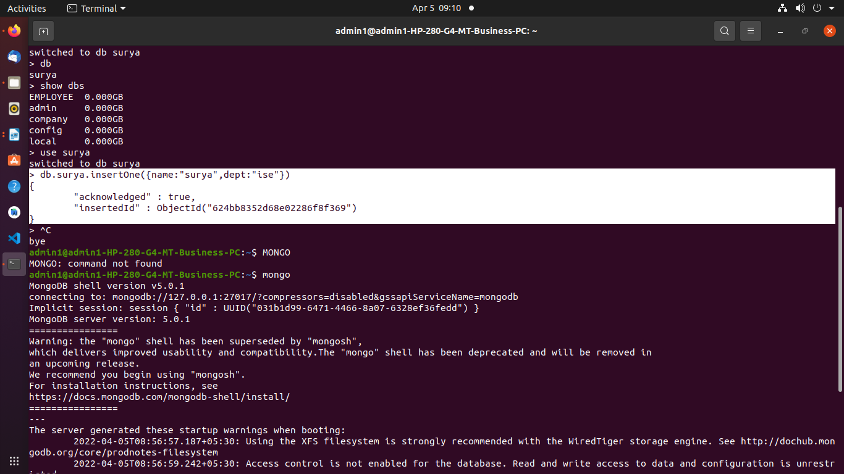

insert many records

> db.surya.insertMany([{name:"sai",dept:"ise"}, {name:"surya",dept:"cse"}]);

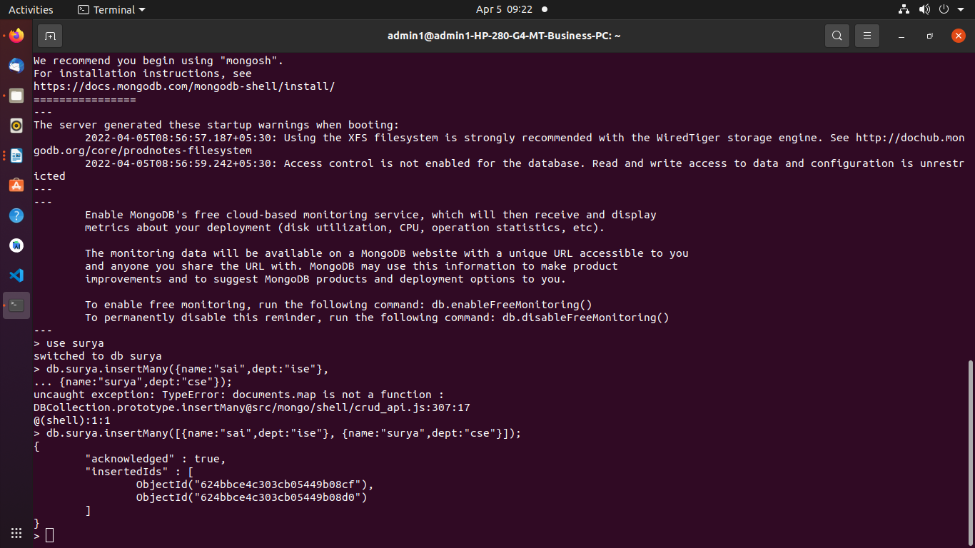

> db.surya.find();
{ "_id" : ObjectId("624bb8352d68e02286f8f369"), "name" : "surya", "dept" : "ise" }
{ "_id" : ObjectId("624bbce4c303cb05449b08cf"), "name" : "sai", "dept" : "ise" }
{ "_id" : ObjectId("624bbce4c303cb05449b08d0"), "name" : "surya", "dept" : "cse" }

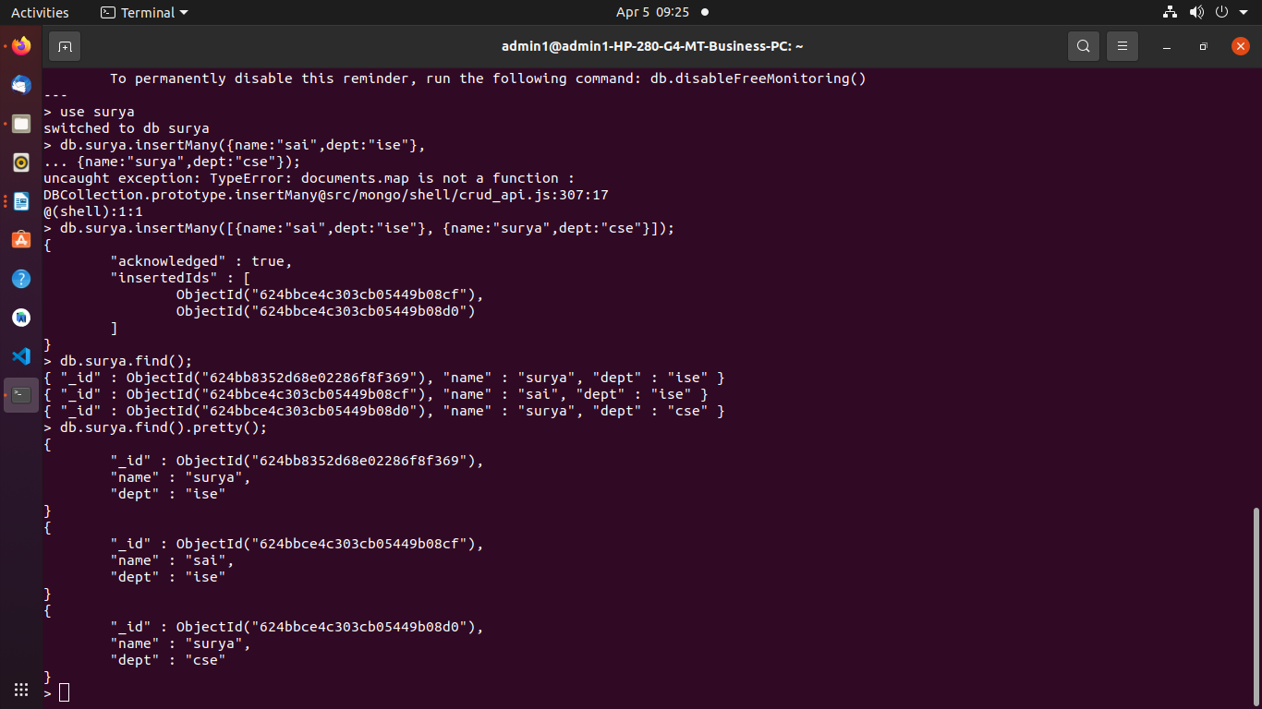
> db.surya.find().pretty();
{
"_id" : ObjectId("624bb8352d68e02286f8f369"),
"name" : "surya",
"dept" : "ise"
}
{
"_id" : ObjectId("624bbce4c303cb05449b08cf"),
"name" : "sai",
"dept" : "ise"
}
{
"_id" : ObjectId("624bbce4c303cb05449b08d0"),
"name" : "surya",
"dept" : "cse"
}

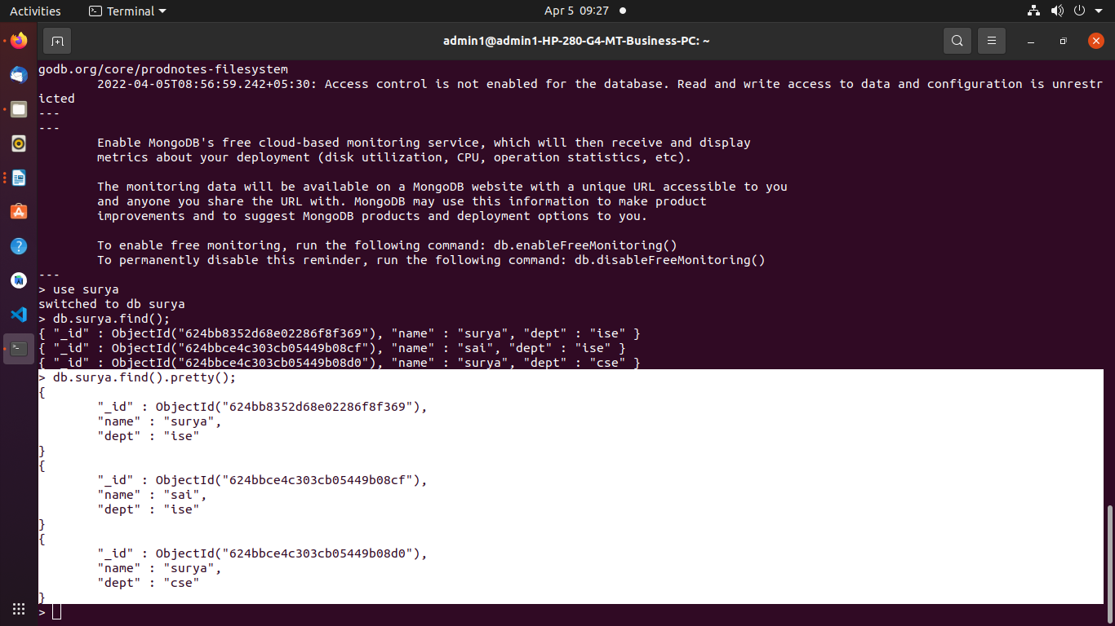

to update one record using $set

> db.surya.updateOne({"name":"surya"},{$set:{"dept":"eee"}})
{ "acknowledged" : true, "matchedCount" : 1, "modifiedCount" : 1 }

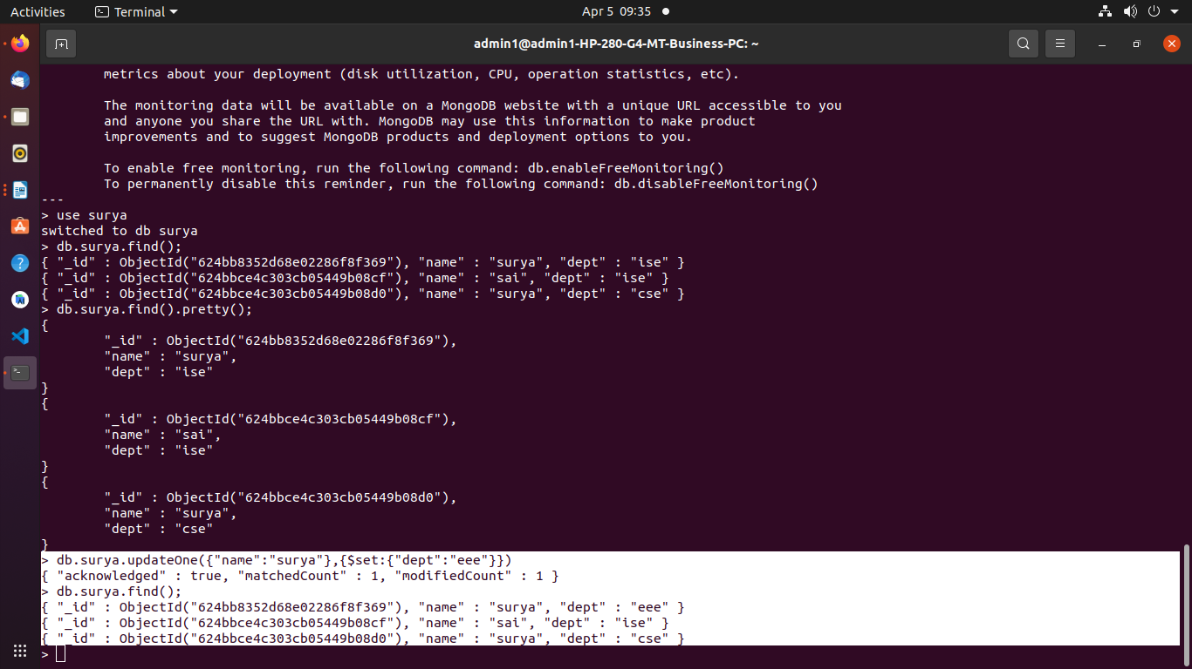

to update using $unset

> db.surya.updateOne({"name":"sai"},{$unset:{"dept":""}})
{ "acknowledged" : true, "matchedCount" : 1, "modifiedCount" : 1 }

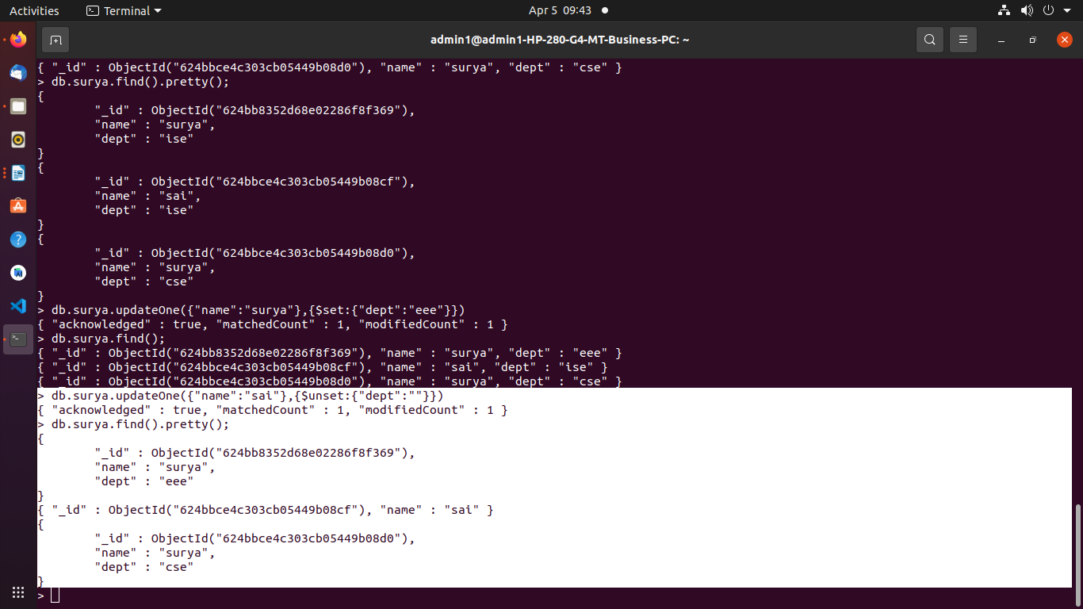

To delete One record

> db.surya.deleteOne({name:"surya"})
{ "acknowledged" : true, "deletedCount" : 1 }

