Project 1: CSE-5330



Railway Reservation System

GORREPATI SAI SURYA - 1002028664

BONTHA MANOHAR – 1002091309

HONOR CODE



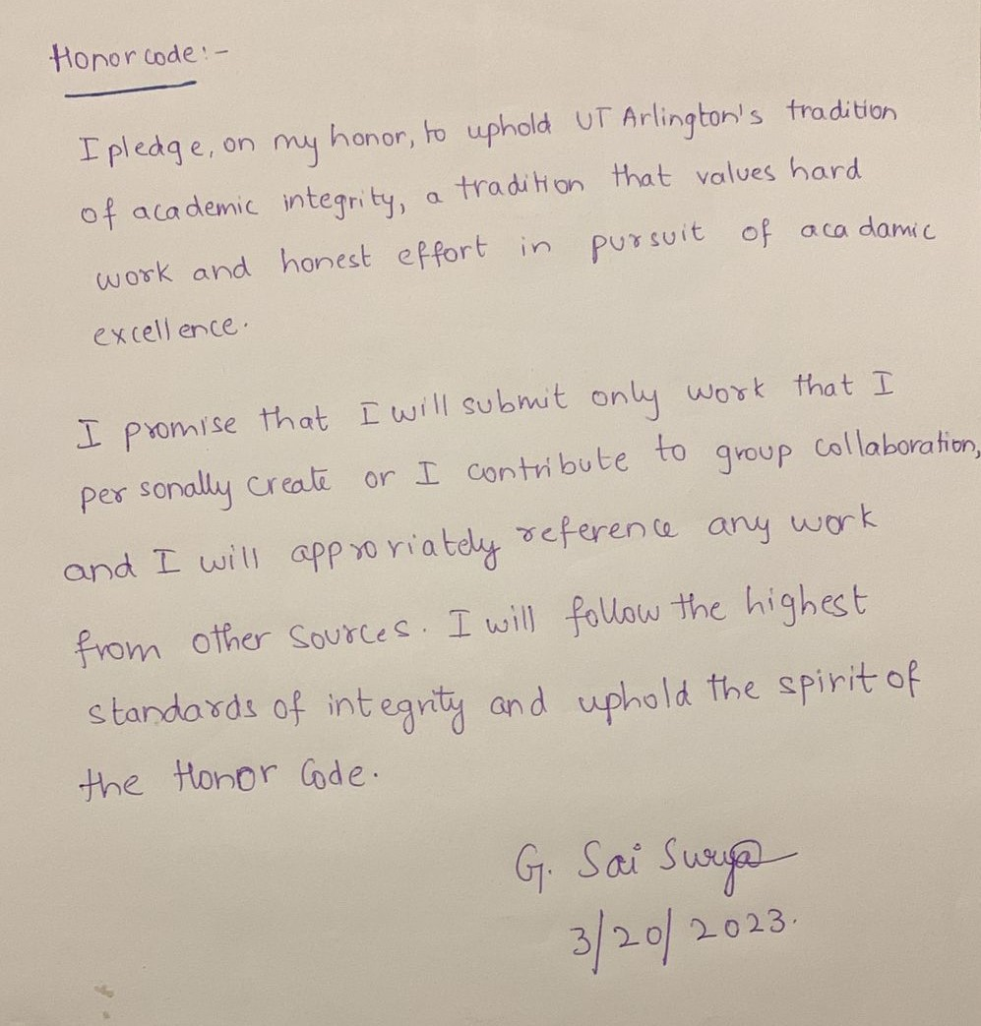

ER DIAGRAM

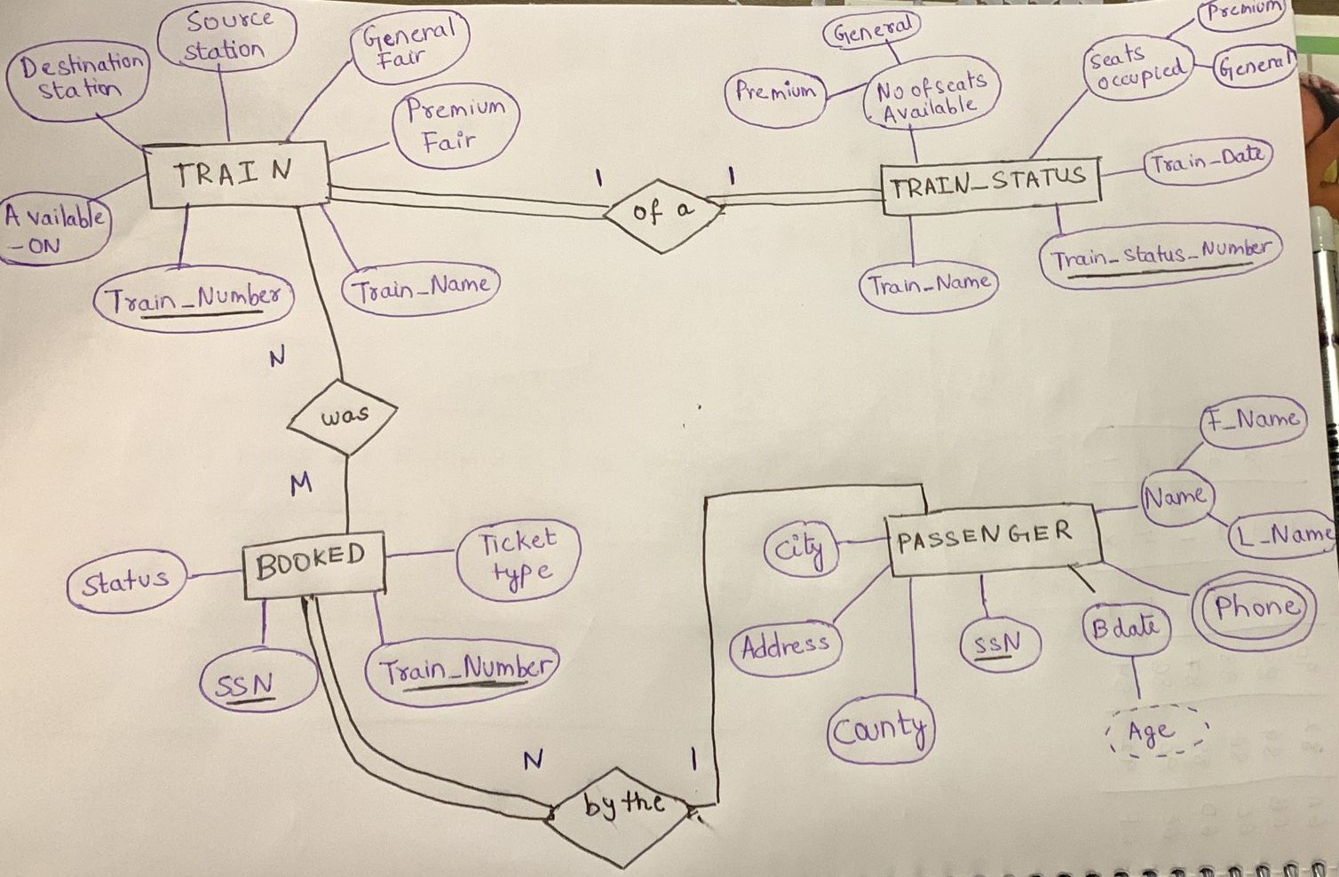

Assumptions:
- Only two categories of tickets are available: Premium and General Ticket.
- The total number of tickets that can be booked in each category (Premium and General) is 10.
- Number of tickets in waiting list is 2.
- Total Number of trains are 5.
- Any stops made by a train before its destination and their bookings are not considered.

Cardinality Mappings:
- Each Train has many (1 to many) bookings.
- Each Booking is associated with one and only one Train.
- Each Train has one and only one source and destination.
- Each Train can have one or more (1 to many) weekdays on which it is available.
- Each Booking can have one and only one Passenger.
- Each Passenger can have many (1 to many) Bookings.
- Each Booking can have one and only one Ticket.
- Each Ticket is associated with one and only one Booking.
- Each Ticket has one and only one category (Premium or General).
- Each Train can have many (1 to many) seats.
- Each Seat is associated with one and only one Train.
- Each Seat can be associated with many (1 to many) Bookings

Task 1. User input the passenger’s last name and first name and retrieve all trains they are booked on.

Output data for all passenger info(TABLE 1)

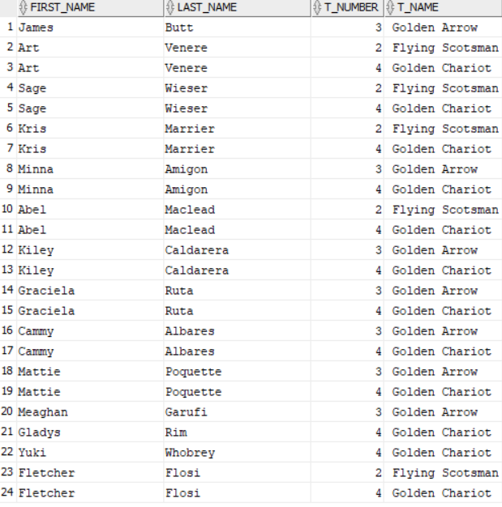

To retrieve all trains that a passenger is booked on, the system needs to have access to a database containing information on the passenger and their bookings on train . The user would input the passenger's last name and first name, and the system would query the database to retrieve all bookings associated with that passenger. The system would then display the train information (Train Number, Train Name, Source, and Destination) for each booking.

On UI : We enter first name and last name of passenger
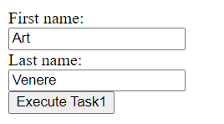
Output for Task 1 on UI: with train name and train number
This output can be validated and then verified by the table1 output obtained on oracle sql which is shown above

Task 2. User input the Day and list of passengers travelling on entered day with confirmed tickets displays on UI.

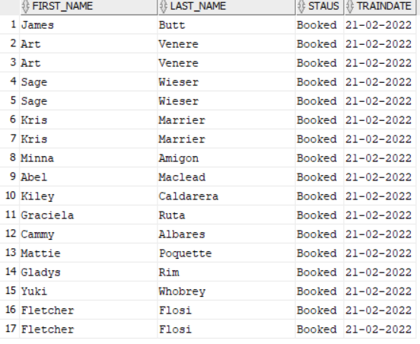

To display a list of passengers traveling on a specific day with confirmed tickets, the system would need access to a database containing information on bookings. The user would input the day they are interested in, and the system would query the database to retrieve all bookings with confirmed tickets for that day. The system would then display the list of passengers along with their booking details, including the train number, train name, source, and destination.

On Ui : we enter the date on ui
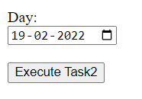
Output for Task 2 on UI: with passenger full name and their type of ticket

Task 3. User input the age of the passenger (50 to 60) and UI display the train information (Train Number, Train Name, Source and Destination) and passenger information (Name, Address, Category, ticket status) of passengers who are between the ages of 50 to 60.

To display train and passenger information for passengers between the ages of 50 to 60, the system would need access to a database containing passenger information and bookings. The user would input the age range they are interested in, and the system would query the database to retrieve all passengers within that age range with confirmed bookings. The system would then display the train information (Train Number, Train Name, Source, and Destination) and passenger information (Name, Address, Category, ticket status) for each booking.

On Ui : 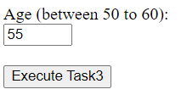
We enter a number in age between 50 to 60 let’s say we enter 55
Output on UI:

For any other age input which is in between 50 to 60 it return an empty list.
For any age input which is not in between 50 to 60 it returns in correct input.

Task 4. List all the train name along with count of passengers it is carrying.

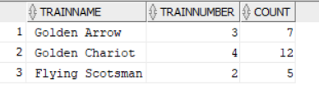

To list all the train names along with the count of passengers they are carrying, the system would need access to a database containing booking information. The system would query the database to retrieve all train names and their associated bookings. The system would then count the number of passengers for each train and display the result along with the train name.

On UI: we simply click on execute task 4

The output would be
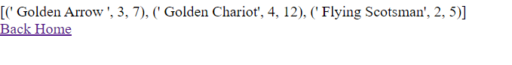
This is the same as above tabular data which is a output of a query.

Task 5. Enter a train name and retrieve all the passengers with confirmed status travelling in that train.

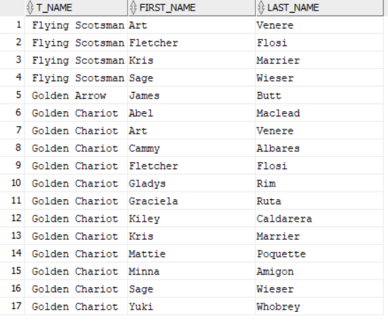

To retrieve all passengers with confirmed status traveling on a specific train, the system would need access to a database containing booking information. The user would input the train name they are interested in, and the system would query the database to retrieve all bookings with confirmed tickets for that train. The system would then display the list of passengers along with their booking details, including the train number, train name, source, and destination.

On UI: we input train name
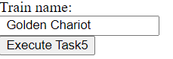

The following would be the output with all names of passengers who travelled on train name golden chariot

Task 6. User Cancel a ticket (delete a record) and show that passenger in waiting list get ticket confirmed.

To cancel a ticket and show the passenger in the waiting list getting a confirmed ticket, the system would need access to a database containing booking information. The user would input the booking reference number for the ticket they want to cancel, and the system would mark that booking as canceled in the database. The system would then query the database to retrieve all bookings on the waiting list for that train and allocate a confirmed ticket to the first passenger on the list. The system would then display the new

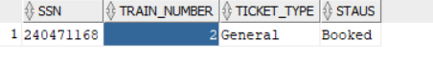
Here we are deleting this particular ssn from booked table. Based on this ticket type =’general’ and train number =2 . we update the first waitlist person who has same type of ticket and train number.

In UI: we need to enter ssn number of the person who want to cancel the ticket.

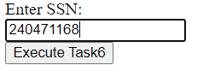

The following is displayed as the output: The passenger whose ssn is 302548590 a nd ticket type was in waitlist has been updated to confirmed.

TEAM CONTRIBUTION

SURYA – CREATED UI , PERFORMED 4,5,6 TASKS IN GUI AND ALSO README FILE
MANOHAR – CREATED ER DIAGRAM , COMPLETED THE 1,2,3 TASKS AND REPORT FILE

