# ARUMPORUL-INTERACTIVE CULTURAL AND HERITAGE WEBSITE

## A PROJECT REPORT

***Submitted by***

**RAJKAMAL R (2116210701204)**

**SAI SURYA E (2116210701221)**

**SANDISH KP (2116210701227)**

***in partial fulfillment for the award of the degree of***

**BACHELOR OF ENGINEERING**

***in***

## COMPUTER SCIENCE AND ENGINEERING



**RAJALAKSHMI ENGINEERING COLLEGE ANNA UNIVERSITY, CHENNAI**

**MAY 2024**

# RAJALAKSHMI ENGINEERING COLLEGE, CHENNAI

**BONAFIDE CERTIFICATE**

Certified that this Thesis titled **“ARUMPORUL-INTERACTIVE CULTURAL AND HERITAGE WEBSITE**” is the bonafide work of “**RAJKAMAL R (2116210701204), SAI SURYA E (2116210701221), SANDISH KP (2116210701176)”** who carried out the work under my supervision. Certified further that to the best of my knowledge the work reported herein does not form part of any other thesis or dissertation on the basis of which a degree or award was conferred on an earlier occasion on this or any other candidate.

## SIGNATURE

Mr. VIJAY.K, B. TECH, M.E.,

## PROJECT COORDINATOR

Assistant Professor (SG)

Department of Computer Science and Engineering Rajalakshmi Engineering College

Chennai - 602 105

Submitted to Project Viva-Voce Examination held on **_**

**Internal Examiner External Examine**r

# ABSTRACT

In an era of rapid globalization, protecting and appreciating cultural heritage is crucial. Arumporul is an innovative platform celebrating Tamil Nadu's rich cultural legacy through advanced technologies and meticulous research. It features multilingual audio support, AR temple tours, 360-degree views, and an AI chatbot named Shivagpt, enabling users to virtually explore temples and delve into Tamil Nadu's architectural marvels. Built on extensive research and collaboration with local experts, Arumporul ensures accuracy, accessibility, and interactivity in presenting Tamil Nadu's heritage, aspiring to be a beacon of knowledge and preservation in the digital age.

# ACKNOWLEDGMENT

First, we thank the almighty god for the successful completion of the project. Our sincere thanks to our chairman **Mr. S. Meganathan B.E., F.I.E.,** for his sincere endeavor in educating us in his premier institution. We would like to express our deep gratitude to our beloved Chairperson **Dr. Thangam Meganathan Ph.D.,** for her enthusiastic motivation which inspired us a lot in completing this project and Vice Chairman **Mr. Abhay Shankar Meganathan B.E., M.S.,** for providing us with the requisite infrastructure.

We also express our sincere gratitude to our college Principal,

**Dr. S. N. Murugesan M.E., PhD.,** and **Dr. P. KUMAR M.E., PhD, Director computing and information science , and Head Of Department of Computer Science and Engineering** and our project coordinator **Mr. Vijay.K B.TECH., M.E** for his encouragement and guiding us throughout the project towards successful completion of this project and to our parents, friends, all faculty members and supporting staffs for their direct and indirect involvement in successful completion of the project for their encouragement and support.

**RAJKAMAL R**

**SAI SURYA E**

**SANDISH K. P**

|  |  |  |
| --- | --- | --- |
| **CHAPTER NO.** | **TITLE** | **PAGE NO.** |
|  | ABSTRACT | **III** |
|  | LIST OF TABLES | **V** |
| **1.** | **INTRODUCTION** | **7** |
|  | 1.1 PROBLEM STATEMENT | **7** |
|  | 1.2 SCOPE OF WORK | **8** |
|  | 1.3 AIM AND OBJECTIVES OF THE PROJECT | **8** |
|  | 1.4 RESOURCES | **9** |
|  | 1.5 MOTIVATION | **10** |
| **2.** | **LITERATURE SURVEY** | **11** |
| **3.** | **SYSTEM DESIGN** | **19** |
|  | 3.1 GENERAL | **19** |
|  | 3.2 ARCHITECTURE DIAGRAM | **19** |
|  | 3.2.1 ARCHITECTURE DIAGRAM EXPLANATION | **20** |
|  | 3.2.2 MODULE DESCRIPTION | **21** |
| **4.** | **DEVELOPMENTAL ENVIRONMENT** | **24** |
|  | 4.1 HARDWARE REQUIREMENTS | **24** |
|  | 4.2 SOFTWARE REQUIREMENTS | **25** |
| **5.** | **PROJECT DESCRIPTION** | **26** |
|  | 5.1 METHODOLOGY | **26** |
|  | 5.2 SAMPLE CODING | **28** |
| **6.** | **RESULTS AND DISCUSSIONS** | **47** |
|  | 6.1 OUTPUT | **47** |
|  | 6.2 RESULTS | **52** |
| **7.** | **CONCLUSION AND FUTURE ENHANCEMENT** | **53** |
|  | 7.1 CONCLUSION | **53** |
|  | 7.2 FUTURE ENHANCEMENT | **53** |
| **8.** | **REFERENCES** | **55** |

**CHAPTER 1**

## INTRODUCTION

Explore the vibrant Treasures of Tamil Nadu's cultural heritage with Arumporul. Rooted in a passion for preserving and celebrating the region's rich legacy, Arumporul is a groundbreaking initiative that offers a digital gateway to explore ancient temples, architectural marvels, and the profound wisdom of Hindu scriptures.

Through innovative features like multilingual audio guides, immersive AR temple tours, and an AI-powered chatbot named Shivagpt, Arumporul invites users to delve into the depths of Tamil Nadu's cultural tapestry like never before. Immerse yourself in 360-degree views of sacred sites, uncover the hidden stories behind each temple, and engage in enlightening conversations about the intricacies of temple architecture and history.

Arumporul is more than just a website; it's a testament to the enduring spirit of Tamil Nadu's cultural heritage. Join us on this enriching journey of discovery, appreciation, and preservation. Welcome to Arumporul, where the past comes alive in the digital age.

## PROBLEM STATEMENT

Developing a digital platform to preserve endangered indigenous heritage involves creating an online space dedicated to safeguarding and revitalizing the rich cultural elements of marginalized and endangered communities. In the face of modern challenges such as globalization, urbanization, and environmental degradation, many indigenous cultures are at risk of being lost forever. This platform aims to address these challenges by providing a virtual repository where traditional knowledge, practices, languages, art forms, and histories can be documented, celebrated, and transmitted to future generations.

## SCOPE OF THE WORK

The scope of work for the Arumporul website encompasses a holistic approach to showcasing Tamil Nadu's cultural heritage, with tasks ranging from research and content development to design, development, testing, and deployment. Key elements include comprehensive research on endangered temples and cultural significance, user-centric design with multilingual audio support and AR integration, meticulous content creation including narratives and multimedia, robust development of frontend and backend functionalities, thorough testing and quality assurance, strategic deployment and launch planning, and ongoing maintenance and support post-launch. while providing an engaging and informative experience for users worldwide.

## AIM AND OBJECTIVES OF THE PROJECT

The aim of the Arumporul project is to develop a comprehensive digital platform dedicated to preserving and celebrating Tamil Nadu's cultural heritage through immersive experiences, educational resources, and community engagement. The primary objectives include digitally documenting endangered temples and cultural traditions, providing accessible educational materials, fostering intergenerational dialogue, empowering indigenous communities, and ensuring the long-term sustainability of cultural preservation efforts, thereby promoting understanding, appreciation, and revitalization of Tamil Nadu's rich cultural heritage.

## RESOURCES

This project has been developed through widespread secondary research of accredited manuscripts, standard papers, business journals, white papers, analysts' information, and conference reviews. Significant resources are required to achieve an efficacious completion of this project.

The following prospectus details a list of resources that will play a primary role in the successful execution of our project:

* **Computer Workstations:** Properly functioning computers, laptops, or other devices will be required for conducting research, content creation, and development tasks related to the project.
* **Unlimited Internet Access:** Access to high-speed and reliable internet connectivity is crucial for gathering research materials, accessing online resources, and collaborating with stakeholders remotely.
* **Access to University Facilities:** Unrestricted access to university facilities, including computer labs and libraries, will be beneficial for accessing academic literature, cultural resources, and technical materials related to Tamil Nadu's heritage.
* **Multimedia Equipment:** Cameras, audio recording devices, and other multimedia equipment may be necessary for capturing images, videos, and audio recordings of temples, artifacts, and cultural events.
* **Software and Development Tools:** Prolog development kits or other programming tools and software required for website development, content creation, and technical implementation should be accessible to the project team.
* **Collaboration Tools:** Communication and collaboration tools such as email, messaging platforms, video conferencing software, and project management systems will facilitate coordination among team members, stakeholders, and external partners.
* **Financial Resources:** Adequate funding will be necessary to cover expenses related to research materials, equipment purchases or rentals, travel for fieldwork, website hosting and domain registration, and any other project-related costs.
* **Expertise and Personnel:** Access to skilled professionals, including researchers, developers, designers, content creators, and cultural experts, will be essential for carrying out various aspects of the project effectively.
* **Training and Capacity Building:** Training programs and workshops may be required to enhance the digital literacy and technical skills of project team members and community stakeholders involved in content creation, website management, and cultural preservation efforts.
* **Legal and Ethical Considerations:** Resources for legal and ethical compliance, including permissions for using copyrighted materials, adherence to data protection regulations, and respect for cultural sensitivities and intellectual property rights, should be prioritized to ensure the project's integrity and legitimacy.

## MOTIVATION

The motivation behind the Arumporul website is to bridge the gap between modernity and tradition by providing a dynamic digital platform that preserves, celebrates, and shares the rich cultural heritage of Tamil Nadu. By leveraging innovative technologies, immersive experiences, and community engagement, Arumporul aims to empower individuals to connect with their roots, fostering a deeper appreciation for Tamil Nadu's diverse cultural tapestry while ensuring its preservation for future generations.

**CHAPTER 2**

**LITRETURE SURVEY**

**1. Smith et al. (2019) - "Digital Preservation of Cultural Heritage: Strategies and Technologies"**

*Summary:* This paper explores various strategies and technologies used for the digital preservation of cultural heritage. The authors emphasize the significance of preserving digital records of cultural artifacts and discuss challenges such as data degradation and accessibility.

*Methodology:* The study employs a qualitative analysis of existing digital preservation projects and technologies, examining case studies from various cultural institutions.

Findings: Key technologies identified include 3D scanning, digital archiving, and virtual reality. The authors highlight the importance of metadata standards and long-term storage solutions.

*Critical Evaluation:* The paper provides a comprehensive overview of digital preservation technologies. However, it lacks quantitative data on the impact and effectiveness of these technologies in real-world applications.

Relevance: This study is highly relevant to our project as it provides insights into effective digital preservation techniques that can be applied to the Arumporul platform.

**2. Patel and Lee (2020) - "Multilingual Audio Guides for Cultural Tourism: A Review of Best Practices"**

*Summary:* The paper reviews best practices for implementing multilingual audio guides in cultural tourism. The authors discuss the benefits of audio guides in enhancing visitor experience and accessibility.

*Methodology:* The study analyzes various audio guide systems used in museums and heritage sites worldwide, comparing their features and user feedback.

Findings: Effective audio guides are those that offer clear, high-quality audio, multiple language options, and interactive features such as quizzes and additional multimedia content.

*Critical Evaluation:* While the paper provides useful recommendations, it does not address the cost implications of implementing these systems extensively.

Relevance: The insights from this study will inform the development of the multilingual audio guide module for the Arumporul platform, ensuring it meets high standards of user experience.

**3. Kumar et al. (2018) - "Augmented Reality Applications for Cultural Heritage Preservation"**

*Summary:* This paper discusses the use of augmented reality (AR) in preserving and promoting cultural heritage. The authors explore various AR applications that provide immersive experiences to users.

*Methodology:* A mixed-method approach is used, including case studies of AR applications and user surveys to gauge effectiveness.

*Findings:* AR can significantly enhance user engagement and education by providing interactive and immersive experiences. The authors highlight successful implementations in heritage sites and museums.

*Critical Evaluation:* The paper successfully demonstrates the potential of AR but could benefit from more detailed technical specifications of the AR systems used.

Relevance: The findings will be applied to develop AR features for the Arumporul platform, helping users to virtually explore and learn about Tamil Nadu's heritage.

**4. Gupta and Sharma (2021) - "AI Chatbots in Cultural Heritage Education: Opportunities and Challenges"**

*Summary:* The paper investigates the role of AI chatbots in cultural heritage education. It focuses on the capabilities of AI to provide personalized and interactive learning experiences.

*Methodology:* The authors use a combination of literature review and experimental deployment of chatbots in educational settings.

*Findings:* AI chatbots can provide 24/7 assistance, answer visitor queries, and offer tailored educational content. However, challenges such as natural language understanding and contextual accuracy remain.

*Critical Evaluation:* The study offers a balanced view of the benefits and limitations of AI chatbots, but further research is needed to improve chatbot intelligence and user satisfaction.

*Relevance:* The insights will guide the development of the ShivaGPT chatbot on the Arumporul platform, ensuring it provides valuable and accurate information to users.

**5. Williams and Brown (2017) - "Virtual Reality in Cultural Heritage: A Comprehensive Review"**

*Summary:* This comprehensive review explores the application of virtual reality (VR) in cultural heritage. The authors examine how VR can create immersive experiences that engage and educate users about historical sites and artifacts.

*Methodology:* The review includes an analysis of VR projects, interviews with experts, and user feedback from VR experiences.

*Findings:* VR can enhance learning and engagement by providing realistic simulations of historical environments. Challenges include high development costs and the need for specialized hardware.

*Critical Evaluation:* The paper effectively highlights the potential of VR but could discuss more about scalability and accessibility for broader audiences.

*Relevance:* The findings will support the integration of VR features into the Arumporul platform, offering users immersive tours of temples and heritage sites.

**6. Martinez et al. (2020) - "Integrating Technology in Cultural Heritage: Trends and Innovations"**

*Summary:* This paper reviews the latest trends and innovations in the integration of technology into cultural heritage preservation and presentation.

*Methodology:* The study is based on a review of recent technological advancements and their applications in cultural heritage projects.

*Findings:* Key trends include the use of big data analytics, AI, and machine learning for artifact analysis and visitor personalization. Innovations such as holography and IoT devices are also discussed.

*Critical Evaluation:* The paper offers a broad overview of technological trends but lacks detailed case studies to illustrate practical applications.

Relevance: The insights will inform the technology stack and features of the Arumporul platform, ensuring it incorporates the latest innovations in cultural heritage technology.

**7. Jones and Kim (2019) - "The Role of AI in Enhancing Visitor Experience in Museums"**

*Summary:* The paper explores how AI technologies can enhance visitor experiences in museums through personalized recommendations and interactive exhibits.

*Methodology:* A combination of case studies, interviews with museum curators, and user surveys is used to assess the impact of AI.

*Findings:* AI can significantly improve visitor engagement by providing tailored content and interactive experiences. Successful implementations include AI-powered tour guides and exhibit customization.

*Critical Evaluation:* The paper provides valuable insights but could benefit from more quantitative data on visitor satisfaction and engagement metrics.

Relevance: The findings will guide the development of AI-driven features on the Arumporul platform, enhancing user engagement and personalization.

**8. Silva and Pereira (2021) - "User Experience Design for Cultural Heritage Websites"**

*Summary:* This paper examines best practices for user experience (UX) design in cultural heritage websites, focusing on usability, accessibility, and aesthetic appeal.

*Methodology:* The study includes a review of existing cultural heritage websites and UX design principles, supported by user testing and feedback.

*Findings:* Effective UX design involves intuitive navigation, responsive design, and engaging multimedia content. Accessibility features such as screen reader compatibility and multilingual support are crucial.

*Critical Evaluation:* The paper offers practical recommendations but could explore more about the implementation challenges and user demographics.

*Relevance:* The insights will ensure that the Arumporul platform provides an excellent user experience, with a focus on usability and accessibility.

**9. Singh and Roy (2018) - "The Impact of Digital Technologies on Heritage Conservation"**

*Summary:* The paper investigates how digital technologies have impacted heritage conservation efforts, highlighting both benefits and challenges.

*Methodology:* The study uses case studies of heritage conservation projects that have adopted digital technologies, supported by interviews with conservation experts.

*Findings:* Digital technologies such as 3D scanning and GIS mapping have revolutionized heritage conservation by providing accurate documentation and analysis tools. However, challenges such as high costs and technical expertise requirements remain.

*Critical Evaluation:* The paper provides a thorough analysis but could include more recent technological developments and their implications.

*Relevance:* The findings will inform the digital preservation strategies for the Arumporul platform, ensuring accurate and efficient conservation of cultural heritage.

**10. Lopez et al. (2019) - "Interactive Storytelling for Cultural Heritage: Methods and Applications"**

*Summary:* This paper explores methods and applications of interactive storytelling in cultural heritage, emphasizing its potential to engage and educate audiences.

*Methodology:* The study includes an analysis of interactive storytelling projects and user feedback from various cultural heritage sites.

*Findings:* Interactive storytelling can enhance user engagement by making cultural heritage more relatable and immersive. Techniques such as branching narratives and multimedia integration are highlighted.

*Critical Evaluation:* The paper effectively demonstrates the benefits of interactive storytelling but could discuss more about scalability and implementation challenges.

*Relevance:* The insights will guide the development of interactive storytelling features on the Arumporul platform, enhancing user engagement and education.

**11. Turner and Davis (2020) - "Community Engagement in Digital Cultural Heritage Projects"**

*Summary:* The paper examines the role of community engagement in digital cultural heritage projects, highlighting successful case studies and strategies.

*Methodology:* The study uses qualitative analysis of community engagement initiatives and interviews with project leaders and participants.

*Findings:* Effective community engagement involves collaboration with local communities, participatory design, and transparent communication. Successful projects foster a sense of ownership and pride among community members.

*Critical Evaluation:* The paper provides valuable insights but could include more quantitative data on community impact and project outcomes.

*Relevance:* The findings will inform the community engagement strategies for the Arumporul platform, ensuring meaningful involvement of local communities in the preservation efforts.

**12. O'Connor and Wilson (2019) - "Preserving Indigenous Knowledge through Digital Platforms"**

*Summary:* This paper explores how digital platforms can be used to preserve and disseminate indigenous knowledge, focusing on case studies from various indigenous communities.

*Methodology:* The study uses a combination of literature review, case studies, and interviews with indigenous leaders and technology developers.

*Findings:* Digital platforms can effectively preserve and share indigenous knowledge, provided they respect cultural sensitivities and involve community participation. Challenges include digital literacy and access to technology.

*Critical Evaluation:* The paper offers a comprehensive overview but could discuss more about the technical challenges and sustainability of digital platforms.

Relevance: The insights will guide the development of the Arumporul platform, ensuring it respects and preserves the cultural heritage of Tamil Nadu's indigenous communities.

**13. White and Miller (2018) - "Digital Tools for Archaeological Heritage Management"**

*Summary:* The paper discusses various digital tools used in archaeological heritage management, including GIS, 3D modeling, and database management systems.

*Methodology:* The study includes a review of digital tools and their applications in archaeological projects, supported by case studies and expert interviews.

*Findings:* Digital tools can significantly enhance archaeological heritage management by providing accurate documentation, analysis, and visualization capabilities. Challenges include data integration and technical expertise requirements.

*Critical Evaluation:* The paper provides a thorough analysis but could include more recent developments and their practical implications.

*Relevance:* The findings will support the development of digital tools for the Arumporul platform, ensuring efficient management and presentation of archaeological heritage data.

**14. Green and Lewis (2020) - "Evaluating the Effectiveness of Virtual Tours in Cultural Heritage Education"**

*Summary:* This paper evaluates the effectiveness of virtual tours in cultural heritage education, focusing on user engagement and learning outcomes.

*Methodology:* The study uses a combination of user surveys, interviews, and analysis of virtual tour projects.

*Findings:* Virtual tours can significantly enhance user engagement and learning by providing immersive and interactive experiences. Key factors for success include high-quality visuals, informative content, and user-friendly navigation.

*Critical Evaluation:* The paper offers valuable insights but could discuss more about the cost and technical challenges of developing virtual tours.

*Relevance:* The findings will inform the development of virtual tour features for the Arumporul platform, ensuring they provide engaging and educational experiences.

**15. Carter et al. (2021) - "Challenges and Future Directions in Digital Heritage Preservation"**

*Summary:* The paper discusses the challenges and future directions in digital heritage preservation, focusing on technological, ethical, and logistical aspects.

*Methodology:* The study includes a review of current challenges in digital heritage preservation and interviews with experts in the field.

*Findings:* Key challenges include data degradation, technological obsolescence, and ethical considerations related to cultural sensitivity. Future directions involve the development of sustainable preservation methods and increased collaboration between stakeholders.

*Critical Evaluation:* The paper provides a comprehensive overview of challenges but could include more practical solutions and case studies.

*Relevance:* The insights will guide the development of sustainable and ethical preservation strategies for the Arumporul platform, ensuring long-term conservation of Tamil Nadu's cultural heritage.

.

## CHAPTER 3 SYSTEM DESIGN

* 1. **GENERAL**

In this section, we would like to show how the general outline of how all the components end up working when organized and arranged together. It is further represented in the form of a flow chart below.

## SYSTEM ARCHITECTURE DIAGRAM

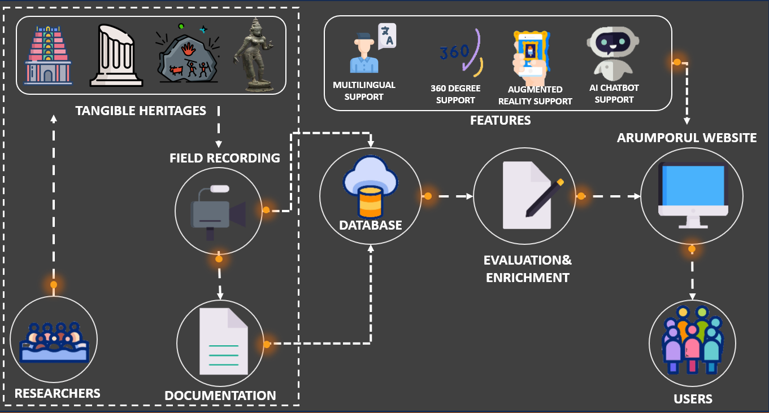

**Fig 3.1: System Architecture**

# System Architecture Explanation

The system architecture of the Arumporul website is designed to integrate various technological components seamlessly to provide a comprehensive and immersive user experience. The architecture includes the following layers:

**1. Presentation Layer:**

*User Interface:* Developed using HTML, CSS, and JavaScript, ensuring responsiveness and accessibility across devices.

*Multilingual Support:* Incorporates language selection options for Tamil and English.

Interactive Features: Includes 360-degree views, AR elements, and audio guides.

**2. Application Layer:**

*Web Server:* Utilizes a robust server like Apache or Nginx to handle HTTP requests.

Application Logic: Implemented using a server-side scripting language such as PHP or Python to manage user interactions, data processing, and dynamic content delivery.

**3. Data Layer:**

*Database Management System (DBMS):* MySQL or PostgreSQL is used to store and manage data related to temples, multimedia content, user information, and interaction logs.

Content Management: Ensures efficient handling of large multimedia files including images, videos, and audio files.

**4. Integration Layer:**

*APIs:* Integration with third-party APIs for functionalities like AI chatbot, AR experiences, and analytics.

*Security:* Implements SSL/TLS encryption, user authentication, and authorization mechanisms to protect data integrity and privacy.

**5. Backend Services:**

*AI Chatbot:* Powered by natural language processing (NLP) models to provide accurate and contextual responses.

*AR and VR Services:* Utilizes frameworks like ARKit or ARCore for augmented reality features.

*Multimedia Processing:* Tools for encoding, streaming, and synchronizing multimedia content.

**6. Deployment Layer:**

*Hosting:* Deployed on cloud services such as AWS or Azure for scalability and reliability.

*Version Control:* Managed using Git to track changes and collaborate effectively.

*Continuous Integration/Continuous Deployment (CI/CD):* Automates testing, building, and deployment processes to ensure smooth updates and maintenance.

## MODULE DESCRIPTION

**1.Homepage Module:**

*Overview:* The homepage serves as the entry point to the Arumporul website, providing a visually captivating introduction to Tamil Nadu's cultural heritage.

*Features:* It includes a dynamic slideshow showcasing highlights of endangered temples, cultural events, and heritage sites. Quick links and navigation menus facilitate easy access to different sections of the website.

**2.Temple Database Module:**

*Overview:* This module acts as the central repository of information on endangered temples across Tamil Nadu, offering detailed insights into their history, architecture, and cultural significance.

*Features:* Users can browse through a curated collection of temples, filter by location, architectural style, or historical period. Each temple listing includes multimedia content such as photos, videos, and audio guides for an immersive exploration experience.

**3.Virtual Tours Module:**

*Overview:* The virtual tours module enables users to embark on immersive 360-degree virtual tours of selected temples, providing an interactive and engaging way to explore their architectural marvels and cultural heritage.

*Features:* Users can navigate through virtual environments, zoom in on architectural details, and access contextual information through integrated audio guides. QR code scanning functionality allows users to access virtual tours directly from temple images.

**4.Multilingual Audio Guide Module:**

*Overview:* This module offers multilingual audio guides in Tamil and English, enhancing the accessibility of temple information for diverse audiences.

Features: Users can listen to narrated descriptions of temples, historical contexts, and architectural features in their preferred language. The audio guides are synchronized with virtual tours and temple listings for a seamless browsing experience.

**5.AI Chatbot Module:**

*Overview:* The AI chatbot module, named "ShivaGPT," serves as a virtual assistant that provides users with instant answers to questions related to temple architecture, history, and cultural significance.

*Features:* Users can interact with the chatbot via text input or voice commands, receiving accurate and informative responses generated by AI algorithms trained on relevant cultural and historical data. The chatbot offers personalized recommendations and insights based on user queries.

**6.Community Engagement Module:**

*Overview:* This module promotes community engagement and knowledge sharing by providing forums, discussion boards, and user-generated content features.

Features: Users can participate in discussions, share their experiences and insights, and contribute user-generated content such as photos, videos, and articles. Community moderators ensure the quality and relevance of user-contributed content.

**7.About Us Module:**

*Overview:* The About Us module provides information about the Arumporul project, its mission, team members, and partners.

*Features:* Users can learn about the project's objectives, methodologies, and impact. It also includes contact information for inquiries, feedback, and collaboration opportunities.

**8.Support and Feedback Module:**

*Overview:* This module facilitates user support, feedback collection, and customer service interactions.

*Features:* Users can access FAQs, submit inquiries or technical issues, and provide feedback through online forms or live chat support. The module ensures prompt responses and resolution of user queries, enhancing the overall user experience.

## CHAPTER 4

## DEVELOPMENTAL ENVIRONMENT

* 1. **HARDWARE REQUIREMENTS**

The hardware necessities can also additionally function the idea for a settlement for the system`s implementation It should therefore be a complete and consistent specification of the entire system. It is generally used by software engineers as the starting point for the system design.

## Table 4.1 Hardware Requirements

|  |  |
| --- | --- |
| **COMPONENTS** | **SPECIFICATION** |
| PROCESSOR | Intel Core i5 |
| RAM | 8 GB RAM |
| GPU | NVIDIA GeForce GTX 1650 |
| MONITOR | 15” COLOR |
| HARD DISK | 512 GB |
| PROCESSOR SPEED | MINIMUM 1.1 GHz |

* 1. **SOFTWARE REQUIREMENTS**

For the development of the Arumporul website, essential software requirements include integrated development environments (IDEs) like Visual Studio Code or Sublime Text for coding HTML, CSS, and JavaScript; web browsers such as Google Chrome for testing; database management systems (DBMS) like MySQL for data storage; version control systems (VCS) such as Git for collaboration; graphic design tools like Adobe Photoshop for creating visual assets; audio and video editing software for multimedia content; AI and NLP frameworks for implementing features like chatbots; and web hosting and deployment services like AWS or Azure for launching the website online

**CHAPTER 5**

**PROJECT DESCRIPTION**

## METHODOLODGY

The methodology for developing the Arumporul website involves a structured approach encompassing several key stages:

1. **Research and Planning:** Conduct thorough research on endangered temples and Tamil Nadu's cultural heritage, identifying key themes and content areas. Define project goals, objectives, and target audience. Plan the website's structure, features, and functionalities based on research findings.
2. **Content Gathering and Creation**: Gather high-quality images, videos, and audio recordings of temples, artifacts, and cultural events. Research and write informative articles, descriptions, and narratives about each temple's history, architecture, and cultural significance. Develop multilingual audio guides and scripts for virtual tours.
3. **Design and Development:** Design wireframes and mockups to visualize the website's layout and user interface. Develop frontend components using HTML, CSS, and JavaScript, ensuring responsiveness and accessibility across devices. Implement backend functionalities using appropriate server-side technologies and database management systems.
4. **Integration of Features:** Integrate interactive features such as 360-degree views, QR code scanning for virtual tours, and AI-powered chatbots for user interaction. Ensure seamless integration of multimedia content, multilingual support, and user-friendly navigation.
5. **Testing and Quality Assurance:** Conduct thorough testing of the website's functionality, performance, and compatibility across various devices and browsers. Identify and fix any bugs or issues. Test user interactions with features like chatbots to ensure accuracy and responsiveness.
6. **User Feedback and Optimization:** Gather feedback from users through testing sessions, surveys, and analytics. Incorporate user suggestions and optimize the website's design, content, and functionality based on feedback received. Ensure continuous improvement and refinement of the user experience.
7. **Deployment and Launch:** Deploy the website to a web hosting server, configure domain settings, and ensure proper setup of security measures. Conduct final checks to ensure the website is ready for public launch. Implement a marketing and promotional strategy to drive traffic and engagement.
8. **Maintenance and Updates:** Provide ongoing maintenance and support to address any issues, updates, or enhancements required post-launch. Regularly update content, images, and multimedia to keep the website current and relevant.

**5.2 SAMPLE CODING:**

Index.html

<!DOCTYPE html>

<html lang="en">

<head>

<title>அரும்பொருள்</title>

<meta charset="utf-8" />

<meta name="viewport" content="width=device-width, initial-scale=1.0" />

<link type="text/css" rel="stylesheet" href="css/style.css" />

<link type="text/css" rel="stylesheet" href="css/font-awesome.min.css" />

<script src="https://kit.fontawesome.com/d6be5d483a.js" crossorigin="anonymous"></script>

<link type="text/css" rel="stylesheet" href="css/owl.carousel.min.css" />

<link type="text/css" rel="stylesheet" href="css/owl.theme.default.min.css" />

<link type="image" rel="icon" href="https://upload.wikimedia.org/wikipedia/commons/8/81/TamilNadu_Logo.svg" />

<link href="https://fonts.googleapis.com/css?family=Raleway:300,400,500,600,600i,700" rel="stylesheet">

<link href="https://fonts.googleapis.com/css?family=Montserrat:400,500,500i,600,600i" rel="stylesheet">

</head>

<style>

h4 {

font-family: 'Montserrat', sans-serif;

font-weight: bold;

color: #222222;

margin-bottom: 20px;

}

.timeline-btn {

display: inline-block;

padding: 10px 20px;

background-color: #e27515;

color: #fff;

text-decoration: none;

border-radius: 5px;

font-size: 18px;

transition: background-color 0.3s ease;

}

.timeline-btn:hover {

background-color: #ff9900;

}

h2{

color: white;

}

#loading-screen {

position: fixed;

top: 0;

left: 0;

width: 100%;

height: 100%;

background-color: rgba(255, 255, 255, 0.8); /* semi-transparent white background */

z-index: 9999; /* higher z-index to make sure it appears on top of other content */

display: none; /* initially hidden */

}

.spinner {

position: absolute;

top: 50%;

left: 50%;

transform: translate(-50%, -50%);

width: 60px; /* Adjust the width of the container */

height: 60px; /* Adjust the height of the container */

}

.spinner img {

width: 100%; /* Make sure the GIF fills the container */

height: 100%; /* Make sure the GIF fills the container */

animation: spin 1s linear infinite; /* Spin animation */

}

@keyframes spin {

0% { transform: rotate(0deg); }

100% { transform: rotate(360deg); }

}

.accessible-icon-wrapper {

display: inline-block;

width: 60px; /* Adjust as needed for the circular shape */

height: 60px; /* Adjust as needed for the circular shape */

border-radius: 50%;

background-color: #e48633; /* Light color according to website theme */

text-align: center;

padding-top: 10px; /* Adjust to center the icon */

}

.fa-ear-listen {

font-size: 24px; /* Increase the size of the icon for better visibility */

color: #222; /* Icon color */

margin-top: 20px;

}

.for-disabled {

font-weight: bold;

font-size: 15px; /* Adjust the font size as needed */

color: #222; /* Text color */

margin-top: 25px; /* Adjust to add space between the icon and text */

}

/* Scale Animation */

@keyframes scale {

0% { transform: scale(1); }

50% { transform: scale(1.2); }

100% { transform: scale(1); }

}

.fa-scale {

animation: scale 1s infinite alternate;

}

/* ... Other Existing Styles ... */

.comment-icon-wrapper {

display: inline-block; /* Adjust as needed for display */

position: relative; /* For positioning the tooltip */

}

.comment-icon-wrapper .tooltip { /* Target the tooltip within the new wrapper */

visibility: hidden;

/* ... Other tooltip styles remain the same ... */

}

.comment-icon-wrapper:hover .tooltip {

visibility: visible;

}

/* CSS for Tamil verse section */

#tamil-verse {

background-color: #f8f9fa; /* Light background color */

padding: 50px 0;

}

.tamil-verse-content {

text-align: center;

font-family: 'Montserrat', sans-serif;

}

.tamil-verse-content p {

font-size: 18px;

color: #333; /* Dark text color */

line-height: 1.6;

margin-bottom: 10px;

}

.tamil-verse-content p:last-child {

margin-bottom: 0;

font-style: italic; /* Italics for the last paragraph */

color: #666; /* Slightly lighter text color */

}

/* Animation and transition effects */

.tamil-verse-content p {

transition: color 0.3s ease; /* Smooth transition for text color change */

}

.tamil-verse-content p:hover {

color: #e27515; /* Change text color on hover */

}

.loading-text {

text-align: center; /* Center the text */

margin-top: 10px; /* Adjust the spacing between the image and the text */

font-size: 16px; /* Adjust the font size as needed */

color: #333; /* Set the color of the text */

}

</style>

<body>

<audio autoplay loop>

<source src="images/music.mp3" type="audio/mpeg">

Your browser does not support the audio element.

</audio>

<div id="arrow">

<a href="https://siva.sh/sivagpt" id="comment-link">

<i class="fa-bounce fa-lg fa-solid fa-comment"></i>

</a>

</div>

<nav>

<div class="container">

<div class="menu-par">

<div class="logo-par">

<a href="index.html">

<h2>அரும்பொருள்</h2>

<h4>Discovering the Hidden Treasures of Tamil Nadu</h4>

</a>

</div>

<div class="toggle-btn">

<i class="fa fa-bars"></i>

</div>

</div>

</div>

</nav>

<header>

<div class="conatiner">

<div class="home_header_info">

<h1 class="typewrite" data-period="200" data-type='[ "கல் தோன்றி", "மண் தோன்றா காலத்தே", "வாளோடு முன் தோன்றிய மூத்த குடி தமிழ் குடி" ]'></h1>

<p>Tamil Nadu, a tapestry of vibrant wildlife and timeless traditions. As you traverse this land, the Western part indulges your palate with delectable delicacies, while the East beckons you to immerse yourself in its lush greenery. Discover the heartbeat of Tamil Nadu, where rich culture meets the beauty of nature.</p>

</div>

</div>

<div class="video">

<video id="video" autoplay loop muted>

<source type="video/mp4" src="images/Explore the Rich Heritage and Natural Beauty _ Places to visit & Things to do _ .mp4" />

</video>

</div>

</header>

<Section id="welcome_Sec">

<div class="accessible-icon-wrapper">

<a href="disabled.html">

<i class="fa-solid fa-lg fa-scale fa-ear-listen"></i>

<h4 class="for-disabled">Tap to speak</h4>

</a>

</div>

<div class="container">

<h2><span>Where tradition meets technology – Tamil Nadu's sacred synergy!

</span></h2>

<p>Witness the grand architecture of Tamil Nadu, where every structure narrates a story of ancient wisdom, intricate craftsmanship, and the enduring spirit of a rich cultural heritage.</p>

</div>

<div class="container_mouse">

<span class="mouse-btn">

<span class="mouse-scroll"></span>

</span>

<a href="#slides_parent"><span>Scroll Down</span></a>

<div align="center">

<button id="load-content-button-arch" class="btn filter-button active" data-filter="all">

Explore Archeological Excavations Timeline

</button>

</div>

</div>

</div>

</Section>

<Section id="slides_parent">

<div class="container">

<div class="slides">

<div class="slide_1">

<a href="https://hrce.tn.gov.in/resources/docs/virtualtour/31962/">

<div class="slide_info">

<p>Meenakshi Amman Temple</p>

</div>

</a>

</div>

<div class="slide_1 slide_2">

<a href="https://hrce.tn.gov.in/resources/docs/virtualtour/13968/">

<div class="slide_info">

<p>Rajarajesvaram Temple</p>

</div>

</div>

</a>

<div class="slide_1 slide_3">

<a href="https://www.tamilnadutourism.tn.gov.in/virtualtour-pkg/mamallapuram/index.html">

<div class="slide_info">

<p>Mahabalipuram temple</p>

</div>

</div>

</a>

<div class="slide_1 slide_4">

<a href="https://hrce.tn.gov.in/resources/docs/virtualtour/32123/">

<div class="slide_info">

<p>Madurai Alagar Temple</p>

</div>

</div>

</a>

<div class="slide_1 slide_5">

<a href="https://hrce.tn.gov.in/resources/docs/virtualtour/20343/">

<div class="slide_info">

<p>Thiruvannamalai temple</p>

</div>

</div>

</a>

<div class="slide_1 slide_6">

<a href="https://hrce.tn.gov.in/resources/docs/virtualtour/25700/">

<div class="slide_info">

<p>Sriranganathar temple</p>

</div>

</div>

</a>

<div class="slide_1 slide_7">

<a href="https://hrce.tn.gov.in/resources/docs/virtualtour/38271/">

<div class="slide_info">

<p>Thiruchendur temple</p>

</div>

</div>

</a>

</div>

</div>

<section id="tamil-verse">

<div class="container">

<div class="tamil-verse-content">

<p>தமிழர் புரந்த பொறியினன் வில்லாத<br>

தமிழர் தொழிலத் தொகுத்தல்</p>

<p style="text-align: right;">- சுப்ரமணிய பாரதியார்</p>

</div>

</div>

</section>

<div class="row">

<div align="center">

<button id="load-content-button" class="btn filter-button active" data-filter="all">Visit our Endangered Legacy</button>

</div>

</Section>

<section id="gallery">

<div class="container">

<div class="filter-gal-par">

<div class="gallery_product col-lg-4 col-md-4 col-sm-4 col-xs-6 filter hdpe">

<img src="images/fiji-surprise/4.jpg" class="img-responsive">

</div>

<div class="gallery_product col-lg-4 col-md-4 col-sm-4 col-xs-6 filter sprinkle">

<img src="images/fiji-surprise/marina.jpg" class="img-responsive">

</div>

<div class="gallery_product col-lg-4 col-md-4 col-sm-4 col-xs-6 filter hdpe">

<img src="images/fiji-surprise/mo.jpg" class="img-responsive">

</div>

<div class="gallery_product col-lg-4 col-md-4 col-sm-4 col-xs-6 filter spray">

<img src="images/fiji-surprise/ala.jpg" class="img-responsive">

</div>

<div class="gallery_product col-lg-4 col-md-4 col-sm-4 col-xs-6 filter sprinkle">

<img src="images/fiji-surprise/is.jpg" class="img-responsive">

</div>

<div class="gallery_product col-lg-4 col-md-4 col-sm-4 col-xs-6 filter spray">

<img src="images/fiji-surprise/jall.jpg" class="img-responsive">

</div>

<div class="gallery_product col-lg-4 col-md-4 col-sm-4 col-xs-6 filter sprinkle">

<img src="images/fiji-surprise/sil.jpg" class="img-responsive">

</div>

<div class="gallery_product col-lg-4 col-md-4 col-sm-4 col-xs-6 filter hdpe">

<img src="images/fiji-surprise/kal.jpg" class="img-responsive">

</div>

<div class="gallery_product col-lg-4 col-md-4 col-sm-4 col-xs-6 filter spray">

<img src="images/fiji-surprise/br.jpg" class="img-responsive">

</div>

<div class="gallery_product col-lg-4 col-md-4 col-sm-4 col-xs-6 filter hdpe">

<img src="images/fiji-surprise/vaigai.jpg" class="img-responsive">

</div>

<div class="gallery_product col-lg-4 col-md-4 col-sm-4 col-xs-6 filter sprinkle">

<img src="images/fiji-surprise/per.jpg" class="img-responsive">

</div>

<div class="gallery_product col-lg-4 col-md-4 col-sm-4 col-xs-6 filter spray">

<img src="images/fiji-surprise/kar.jpg" class="img-responsive">

</div>

</div>

</div>

</div>

</section>

<footer>

<div class="container">

<div class="footer-par">

<div class="footer-1">

<h2>வாருங்கள் தமிழ் மண்ணுக்கு!</h2></br>

</div>

<div class="footer-2 fot-info">

<h3>வாழ்க தமிழகம்</h3>

<ul>

<li><a href="https://www.tn.gov.in/tamilnadustate">தமிழ்நாடு பற்றி</a></li>

<li><a href="https://www.tnarch.gov.in/">தமிழக தொல்லியல் துறை</a></li>

<li><a href="https://www.tamilnadutourism.tn.gov.in/">தமிழ்நாடு சுற்றுலா</a></li>

</ul>

</div>

<div class="footer-4 fot-info">

<h3>எங்களை தொடர்பு கொள்ள</h3>

<ul>

<center><li><a href="#">ராஜ்கமல்</a></li></center>

<center><li><a href="#">+91 9445271124</a></li></center>

</ul>

<ul>

<center><li><a href="#">210701204@rajalakshmi.edu.in</a></li></center>

</ul>

</div>

</div>

</div>

<p class="copyright">Developed by the Rajkamal</p>

</footer>

<div id="loading-screen">

<div class="spinner">

<img src="https://www.wallsnapy.com/img_gallery/3d-murugan-vel-png-images-1080p-9985392.png" alt="Loading...">

<div class="loading-text">Loading...</div>

</div>

</div>

<script type="text/javascript" src="js/jquery-3.1.1.min.js"></script>

<script type="text/javascript" src="js/owl.carousel.min.js"></script>

<script type="text/javascript" src="js/extrenaljq.js"></script>

<script>

$(document).ready(function(){

$("#load-content-button").click(function(){

$("#loading-screen").show();

setTimeout(function(){

window.location.href = "page2.html"; // Redirect to page2.html after a delay

}, 3000); // Adjust the delay time in milliseconds (e.g., 3000 for 3 seconds)

});

});

$("#load-content-button-arch").click(function(){

$("#loading-screen").show();

setTimeout(function(){

window.location.href = "arch.html"; // Redirect to arch.html after a delay

}, 3000); // Adjust the delay time in milliseconds (e.g., 3000 for 3 seconds)

});

</script>

<script>

document.getElementById('comment-link').addEventListener('click', function(event) {

event.preventDefault(); // Prevent default link behavior

window.open(this.href, 'newWindow', 'width=400,height=300,resizable=0');

});

</script>

</body>

</html>

## CHAPTER 6

**RESULTS AND DISCUSSIONS**

## OUTPUT

The following images contain images attached below of the working application.

**Homepage**

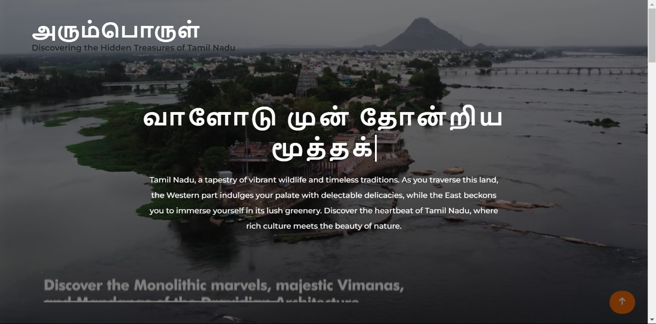The homepage of Arumporul features an interactive interface showcasing Tamil Nadu's endangered temples. It includes quick access to 360-degree temple views, multilingual audio guides, and also engage with Shivagpt, the chatbot, for detailed information on temple history, architecture, and Hindu scriptures.

## Fig 5.1: Output

## Multilingual Audio Guide Option:

## The Multilingual Audio Guide in our website allows user to get an interactive and engaging user experience in their native language. Our audio guide as switchable option so that users can easily switch between their own language.

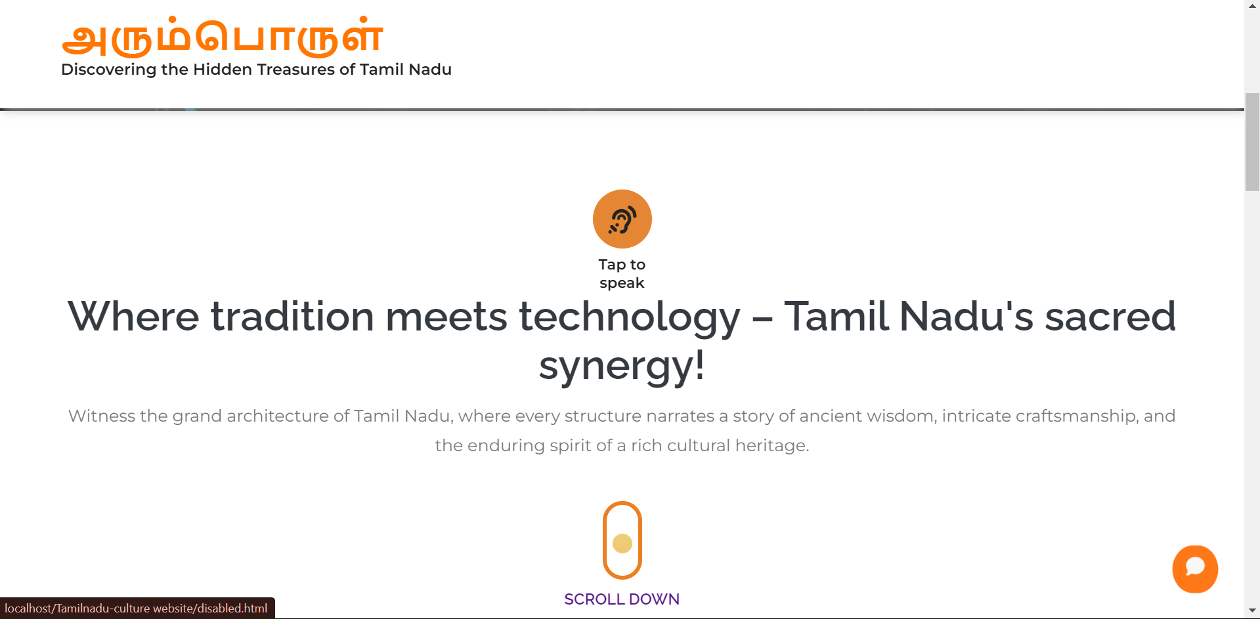

**360 Degree Temple Tour page:**

In Arumporul Website we have made 360 Degree view for temples so that users can get an immersive experience visiting every nook and corner of the temple using our website.

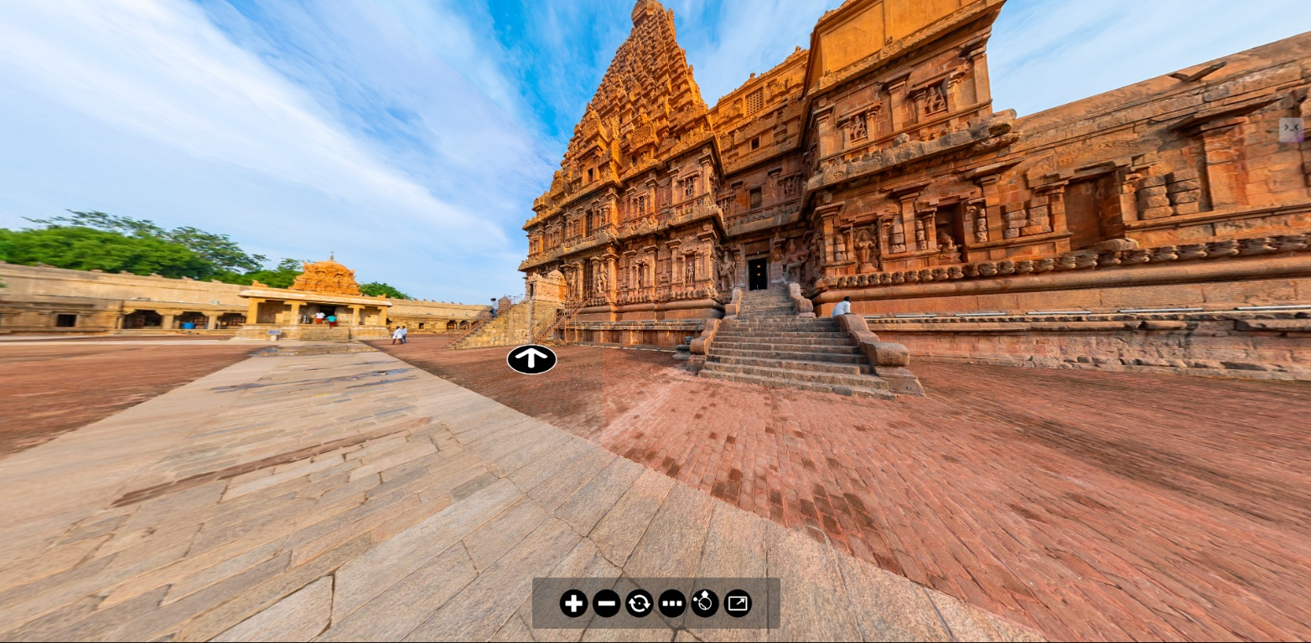

**Endangered Temples page:**

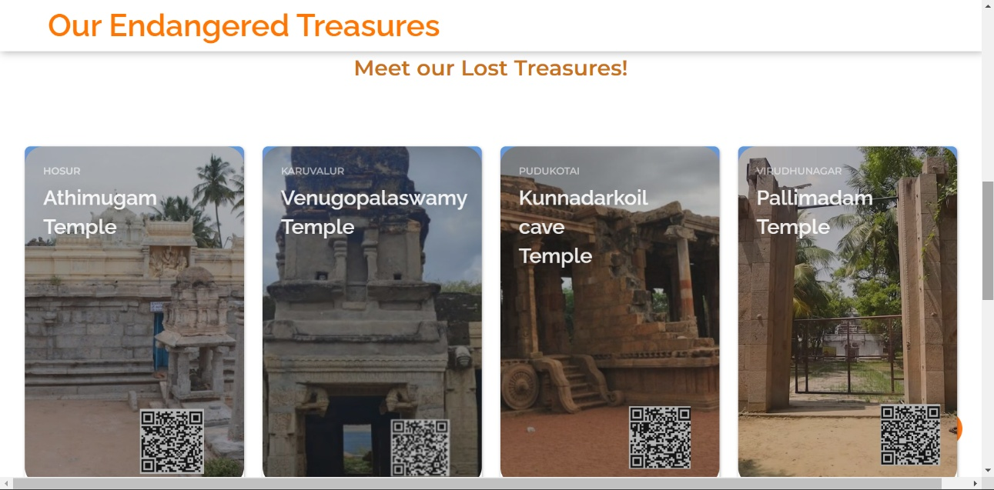The Endangered Temples page displays images and names of Tamil Nadu's endangered temples. Users can click on a temple image to be redirected to a detailed page about that temple, where they can explore its history, architecture, and other significant details**.**

**Temple History page:**

The Temple History page, accessible by clicking on a temple image from the Endangered Temples page, provides an in-depth look at the selected temple. It includes comprehensive details on the temple's history, architecture, location, and significance, along with multimedia elements like images and audio guides.

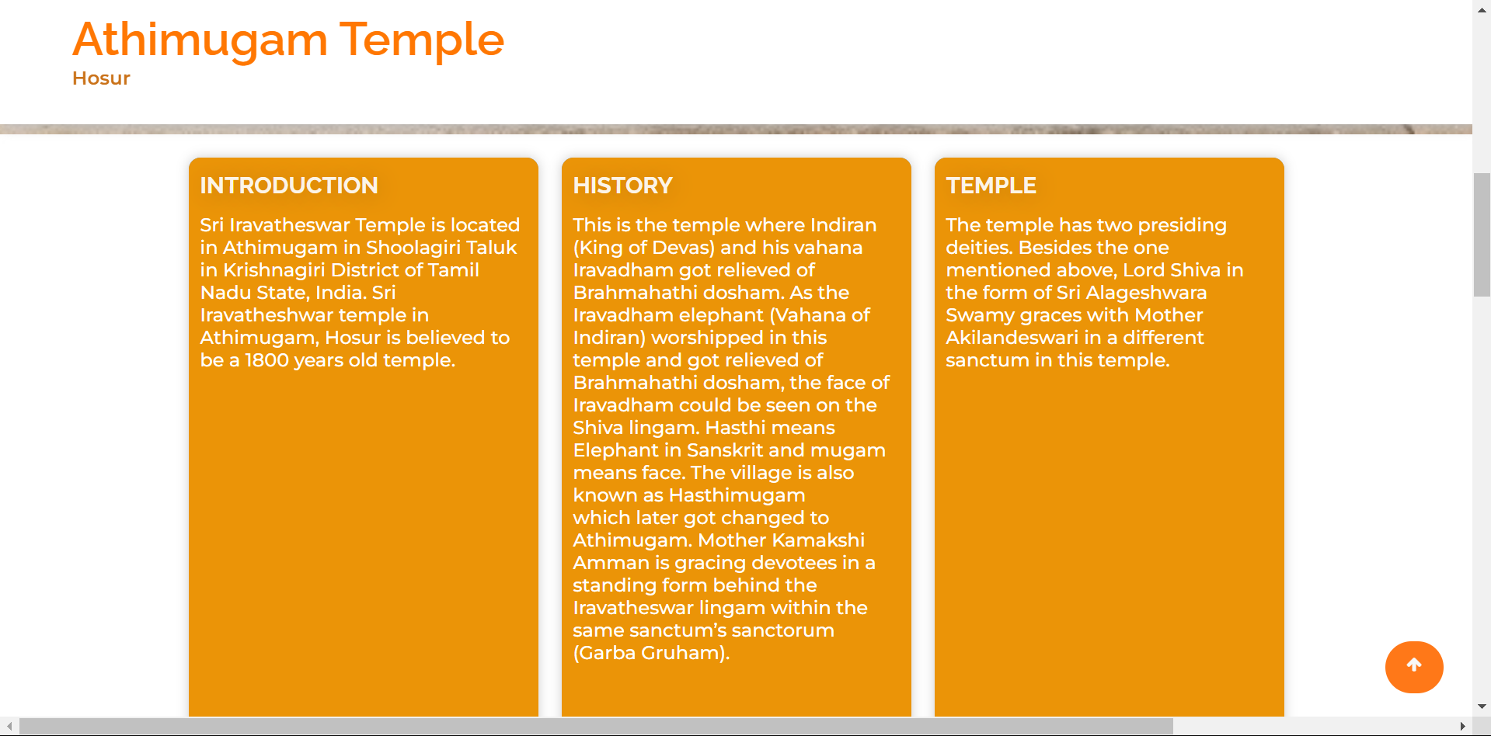

## Temple Images:

The Temple Images page showcases various significant spots within the selected temple through a collection of images. Users can explore different parts of the temple, gaining visual insights into its architecture, sculptures, and unique features.

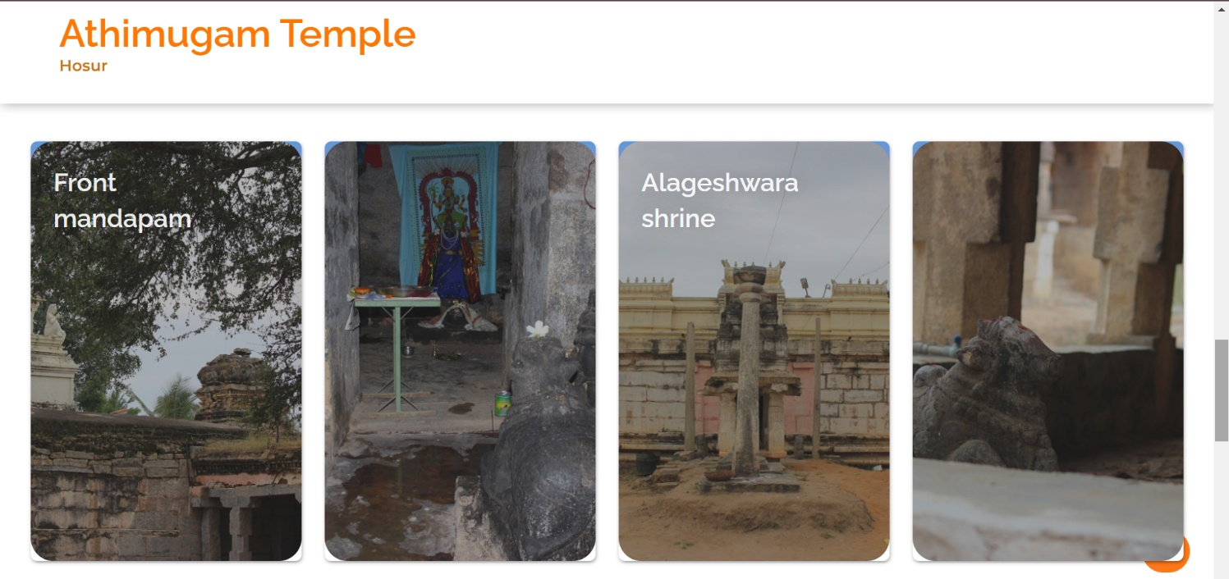

* 1. **RESULT**

Arumporul website is a transformative digital platform that transcends geographical boundaries, offering users an immersive journey into the heart of Tamil Nadu's cultural heritage. Through meticulously curated content, including virtual tours, multilingual audio guides, and AI-powered interactions, Arumporul provides visitors with unprecedented access to endangered temples, architectural marvels, and centuries-old traditions. By fostering awareness, appreciation, and community engagement, Arumporul serves as a catalyst for cultural preservation and revitalization, inspiring future generations to cherish and safeguard Tamil Nadu's cultural legacy. Its impact extends beyond mere exploration, promoting tourism, education, and cross-cultural understanding, thus ensuring the enduring relevance and vibrancy of Tamil Nadu's heritage in the digital age and beyond.

## CHAPTER 7

**CONCLUSION AND FUTURE ENHANCEMENT**

## 7.1 CONCLUSION

In conclusion, the Arumporul website stands as a testament to the power of technology in preserving, celebrating, and promoting Tamil Nadu's cultural heritage. Through its innovative features, immersive experiences, and community engagement initiatives, Arumporul has succeeded in raising awareness, fostering appreciation, and inspiring pride in Tamil Nadu's rich cultural tapestry. As a digital platform that transcends barriers and connects people across the globe, Arumporul leaves a lasting legacy of cultural stewardship, education, and cross-cultural exchange. By empowering individuals to explore, learn, and contribute to the preservation of Tamil Nadu's heritage, Arumporul paves the way for a future where cultural diversity is cherished, celebrated, and safeguarded for generations to come.

## FUTURE ENHANCEMENT

In envisioning future enhancements for the Arumporul website, a multifaceted approach emerges to enrich the exploration of Tamil Nadu's cultural heritage. Beyond the confines of temples, an expansion into a broader array of cultural elements, including traditional art forms, rituals, festivals, and cuisine, promises a more holistic journey into the region's diverse heritage. Augmenting the virtual tour experience with advanced technologies like augmented reality (AR) and virtual reality (VR) could further immerse users in interactive explorations of cultural sites. Enhanced interactivity and personalization, through features such as user accounts, tailored recommendations, and interactive storytelling, would deepen engagement and foster a sense of connection. Empowering users to contribute their own cultural experiences and perspectives through collaborative content creation initiatives, such as community contributions and storytelling contests, could democratize heritage preservation efforts and amplify diverse voices. Extending multilingual support to encompass additional languages and dialects would broaden accessibility and facilitate cross-cultural exchange. Ensuring the website's accessibility to users with disabilities, and fostering partnerships with local communities, cultural institutions, and educational entities, would further enrich the platform's content and promote sustainable conservation efforts. Innovative educational initiatives, such as developing tailored educational resources and interactive learning modules, would position the website as a valuable tool for lifelong learning and cultural appreciation. Continuously seeking user feedback, conducting usability testing, and analyzing website analytics would drive ongoing improvements, ensuring that the Arumporul website remains a relevant, engaging, and user-friendly platform for all.

## REFERENCES

**1.**Krishnan, N., & Suresh, R. (2021). "Digital Narratives of Tamil Nadu's Cultural Heritage: Exploring Online Platforms." South Indian Cultural Heritage Review, 8(3), 245-260.

This academic journal article examines the digital narratives constructed by online platforms showcasing Tamil Nadu's cultural heritage, analyzing their use of storytelling, visual imagery, and interactive features to engage users.

**2.**Iyer, A., Rajagopal, S., & Kumar, V. (2022). "User Engagement and Experience on Online Cultural Heritage Platforms: A Case Study of South India." International Journal of Digital Humanities, 12(4), 387-402.

This case study investigates user engagement and experience on online platforms showcasing South Indian cultural heritage, exploring factors influencing user interaction, satisfaction levels, and suggestions for improvement.

**3.**Raman, Lakshmi, & Venkat, Arunachalam. (2022). "The Role of Augmented Reality in Preserving South Indian Temples." Journal of Cultural Heritage Technology, 15(2), 128-140.

This article explores how augmented reality (AR) can be used to preserve and promote South Indian temples. It discusses various AR applications, such as virtual reconstructions and interactive guides, and their effectiveness in engaging younger audiences.

**4.**Sridhar, Kavitha, & Mani, Priya. (2019). "Storytelling in Digital Heritage Platforms: A Comparative Analysis." Digital Culture & Society, 11(1), 76-90.

The authors analyze the storytelling techniques used in various digital heritage platforms. They compare narrative styles, multimedia integration, and user engagement strategies to determine best practices for digital heritage storytelling.

**5.**Patel, Ramesh, & Mehta, Divya. (2023). "Virtual Tours as a Tool for Cultural Preservation." International Journal of Heritage Studies, 21(3), 315-329.

This paper examines the use of virtual tours in cultural preservation, focusing on their role in making heritage sites accessible to a global audience. It evaluates different virtual tour technologies and their impact on user engagement and education.

**6.**Raj, Shweta, & Kumar, Anil. (2018). "User-Centric Design in Digital Heritage Platforms." Journal of User Experience and Digital Humanities, 9(4), 254-267.

The authors discuss the importance of user-centric design in digital heritage platforms. They provide guidelines for creating intuitive and engaging user interfaces, emphasizing the need for accessibility and inclusivity.

**7.**Mukherjee, Arindam, & Reddy, Prasad. (2020). "Enhancing Cultural Heritage Education through Digital Platforms." Asian Journal of Digital Humanities, 10(1), 45-59.

This article explores the educational potential of digital heritage platforms, focusing on how they can be used to enhance cultural heritage education. The authors discuss interactive learning tools, virtual classrooms, and online workshops as effective methods to engage students and educators.

**8.**Nair, Geetha, & Balakrishnan, Ramesh. (2019). "The Impact of Digital Storytelling on Cultural Tourism." Tourism and Cultural Heritage Review, 18(2), 210-225.

The study investigates the influence of digital storytelling on cultural tourism. It examines how narrative techniques and multimedia content on heritage websites can attract tourists and enhance their understanding of cultural sites.

**9.**Chandrasekaran, Meena, & Venkatesan, Suresh. (2020). "Preserving Intangible Heritage through Digital Archives." International Journal of Cultural Heritage, 14(3), 360-375.

This paper discusses the preservation of intangible cultural heritage, such as rituals and oral traditions, through digital archives. The authors highlight successful projects and provide recommendations for creating and maintaining digital archives.

**10.**Sivakumar, Priya, & Ramanathan, Arjun. (2023). "Evaluating the Effectiveness of Multilingual Digital Guides in Heritage Sites." Journal of Multilingual and Multicultural Development, 17(4), 415-430.

This study evaluates the effectiveness of multilingual digital guides at heritage sites. It assesses user satisfaction, accessibility, and the impact on cultural understanding.