**Simple Bank Management System**

This project aims to address the needs of efficient banking transactions and secure account management. Here’s a concise overview:

**Abstract:**

The **Bank Management System** project is designed to keep track of clients’ bank accounts. It serves as a robust banking software, covering essential functionalities. Here are the key points:

1. **Account Creation**: Users can open new accounts by providing necessary details such as account number, account type, name, and initial balance.
2. **Account Details**: The system displays account information, including the account holder’s name, account number, account type, and current balance.
3. **Deposits and Withdrawals**: Users can deposit or withdraw money from their accounts.
4. **Search Functionality**: The system allows users to search for account details based on the account number.
5. **Account Transfer:** The system allows users to transfer amount from one account to another account.

**Implementation Details:**

* **Languages Used**: The project can be implemented using various programming languages, including **Spring Boot, MySQL,** **Java 8, Maven, Tomcat Server**.
* **Source Codes**: Complete source codes are available for free, enabling developers to explore and enhance the system.
* **Modules**:
  + - **Manage Bank Transactions**: Handles deposits and withdrawals.
    - **Client Management**: Manages client details.
    - **Log In and Log Out**: Provides secure access.
    - **Client Registration**: Allows new clients to register.
    - **Contact Information**: Stores client contact details.
    - **Bank Information**: Stores bank-specific data.

**Conclusion:**

The Bank Management System project bridges the gap between traditional banking and modern digital solutions. By offering multiple ways to perform banking tasks, it caters to the needs of end users. [Whether you’re a developer or a curious learner, exploring this project can provide valuable insights into banking software development1](https://itsourcecode.com/fyp/bank-management-system-project-report-abstract-pdf-documentation/).

Remember, this abstract is just the tip of the iceberg! If you’re interested, you can dive deeper into the full project report and documentation to understand the intricacies of building a robust bank management system.

# System Configuration:-

# H/W System Configuration:-

# Processor - Intel(R) Core(TM) i5-6300U CPU @ 2.40GHz 2.50 GHz

Speed - 1.1 Ghz

RAM - 16 GB

Hard Disk - 20 GB

Key Board - Standard Windows Keyboard

Mouse - Two or Three Button Mouse

Monitor - SVGA

CreateAccount: 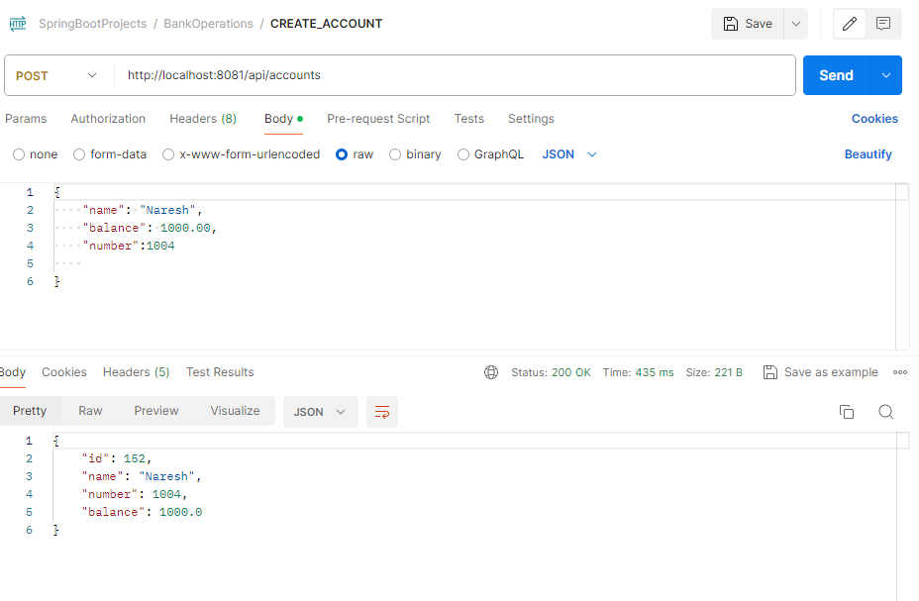

Account Deposit:

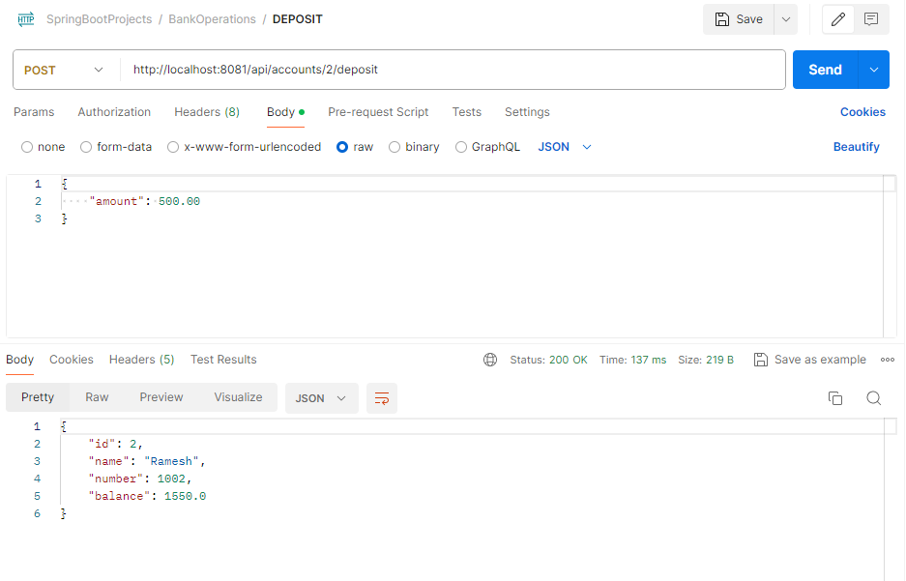

FetchAccountDetails: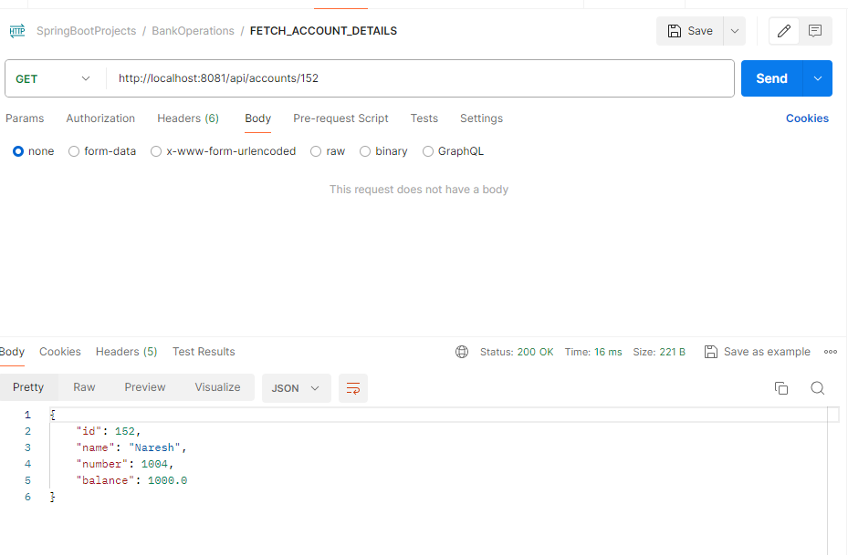

WithDraw: 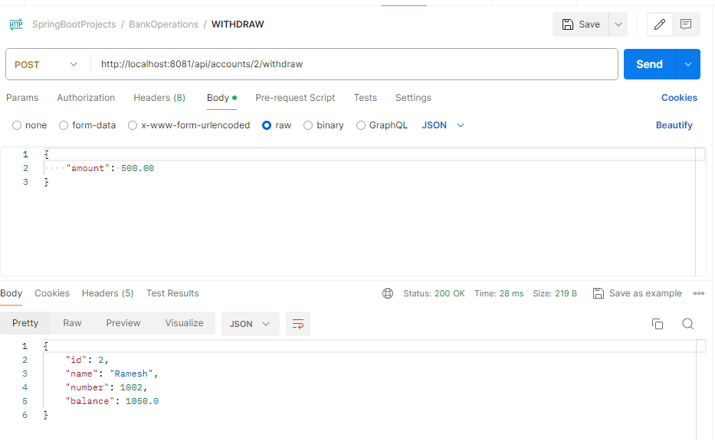

BalanceEnquiry: 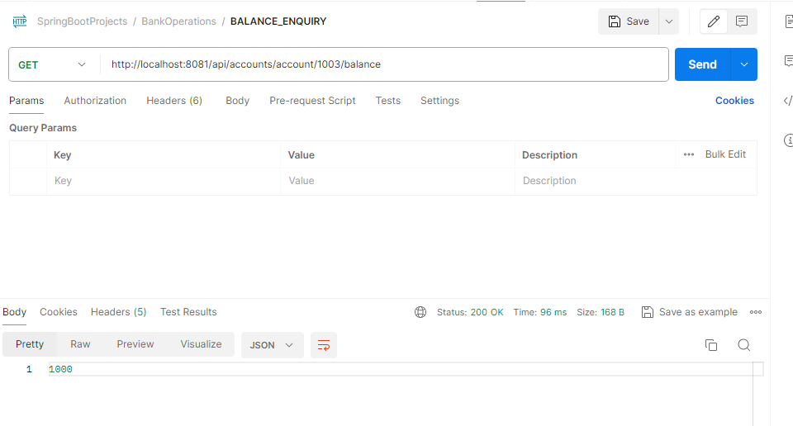

Balance Transfer: 