**CRYPTOGRAPHY**

1. **Substitution2**

It seems that another encrypted message has been intercepted. The encryptor seems to have learned their lesson though and now there isn't any punctuation! Can you still crack the cipher?

I did frequency analysis for substitution first, following were the results:

|  |  |  |  |  |  |  |  |  |  |  |  |  |  |  |  |  |  |  |  |  |  |  |  |  |  |  |  |  |  |  |  |  |  |  |  |  |  |  |  |  |  |  |  |  |  |  |  |  |  |  |  |  |  |  |  |  |  |  |  |  |  |  |
| --- | --- | --- | --- | --- | --- | --- | --- | --- | --- | --- | --- | --- | --- | --- | --- | --- | --- | --- | --- | --- | --- | --- | --- | --- | --- | --- | --- | --- | --- | --- | --- | --- | --- | --- | --- | --- | --- | --- | --- | --- | --- | --- | --- | --- | --- | --- | --- | --- | --- | --- | --- | --- | --- | --- | --- | --- | --- | --- | --- | --- | --- | --- |
| |  |  |  |  | | --- | --- | --- | --- | | F | 175× | 13.87% |  | | N | 125× | 9.9% |  | | X | 103× | 8.16% |  | | Q | 102× | 8.08% |  | | L | 98× | 7.77% |  | | E | 83× | 6.58% |  | | T | 68× | 5.39% |  | | Z | 63× | 4.99% |  | | |  |  |  |  | | --- | --- | --- | --- | | Y | 61× | 4.83% |  | | A | 56× | 4.44% |  | | P | 46× | 3.65% |  | | W | 42× | 3.33% |  | | V | 39× | 3.09% |  | | G | 35× | 2.77% |  | | B | 34× | 2.69% |  | |  |

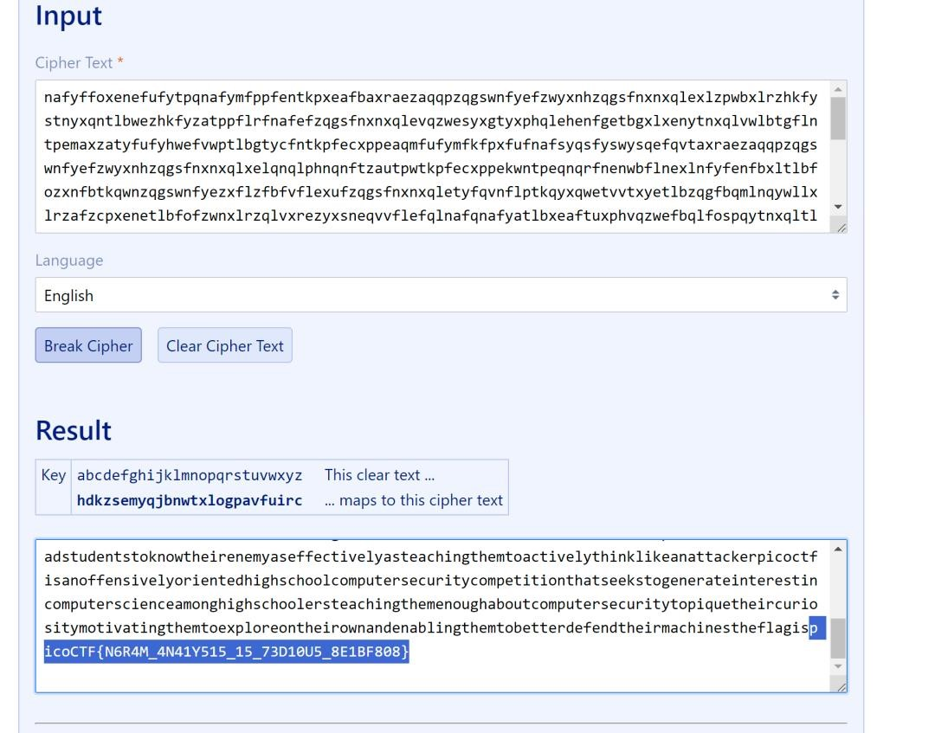

I used this <https://www.guballa.de/substitution-solver>

1. **Transposition-trial**

Our data got corrupted on the way here. Luckily, nothing got replaced, but every block of 3 got scrambled around! The first word seems to be three letters long, maybe you can use that to recover the rest of the message.

Message - heTfl g as iicpCTo{7F4NRP051N5_16_35P3X51N3_V9AAB1F8}7

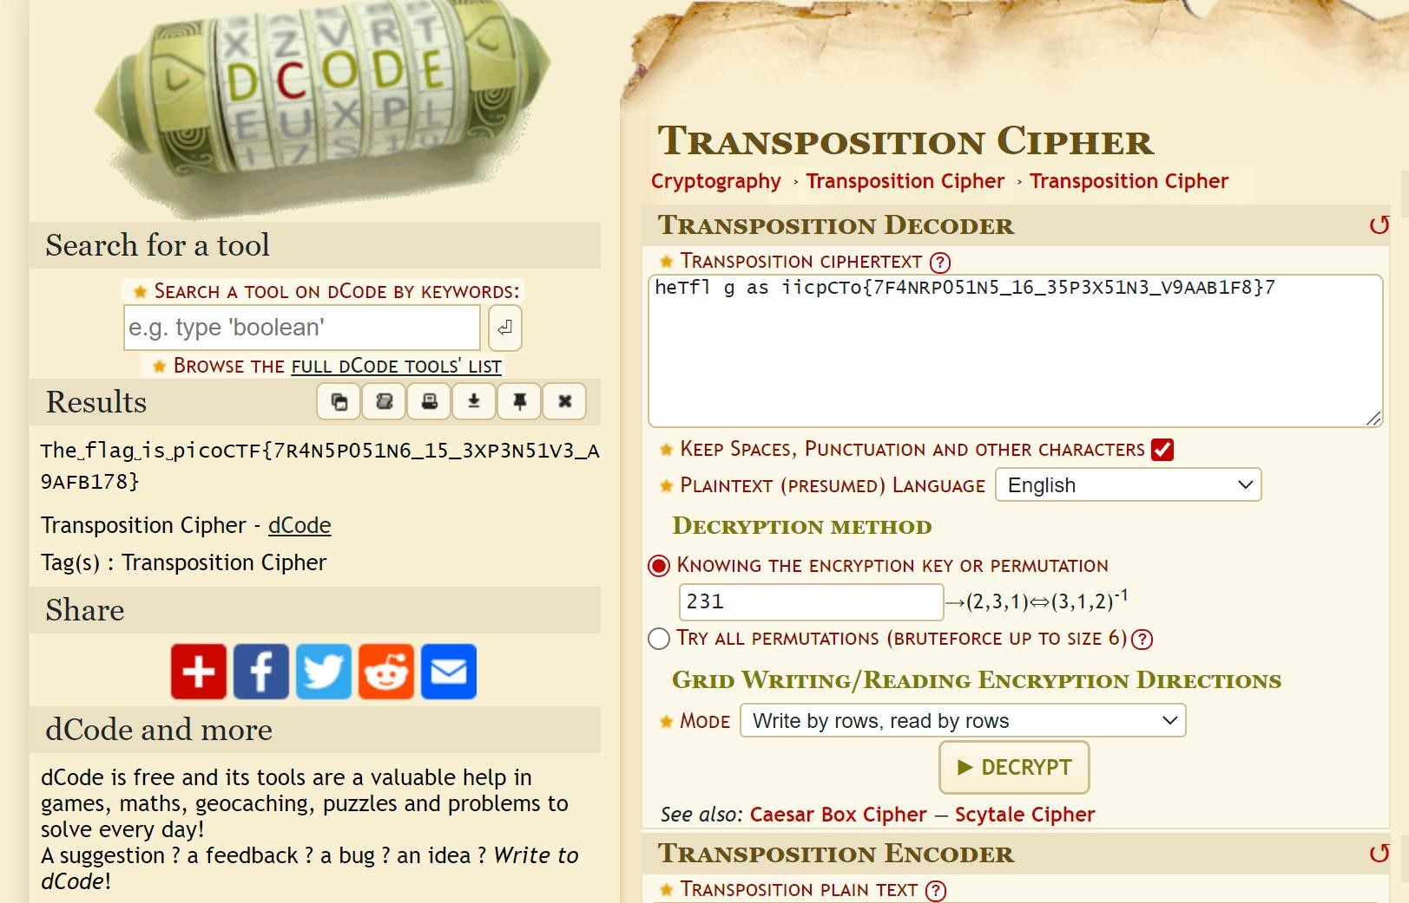

Hints

Split the message up into blocks of 3 and see how the first block is scrambled.

I used this website https://www.dcode.fr/transposition-cipher

1. **Waves over lambda**

We made a lot of substitutions to encrypt this. Can you decrypt it? Connect with nc jupiter.challenges.picoctf.org 43522.

saisuthirth-picoctf@webshell:~$ nc jupiter.challenges.picoctf.org 43522

-------------------------------------------------------------------------------

gekyjlrw vmjm xw ieaj szly - sjmnamkgi_xw_g_etmj_zlfdhl_eysflakjls

-------------------------------------------------------------------------------

lzmumi siehejetxrgv pljlflqet olw rvm rvxjh wek es siehej cltzetxrgv pljlflqet, l zlkh eokmj omzz pkeok xk eaj hxwrjxgr xk vxw eok hli, lkh wrxzz jmfmfdmjmh lfeky aw eoxky re vxw yzeefi lkh rjlyxg hmlrv, ovxgv vlccmkmh rvxjrmmk imljw lye, lkh ovxgv x wvlzz hmwgjxdm xk xrw cjecmj czlgm. sej rvm cjmwmkr x oxzz ekzi wli rvlr rvxw zlkheokmjsej we om awmh re glzz vxf, lzrveayv vm vljhzi wcmkr l hli es vxw zxsm ek vxw eok mwrlrmolw l wrjlkym ricm, imr ekm cjmrri sjmnamkrzi re dm fmr oxrv, l ricm ldbmgr lkh txgxeaw lkh lr rvm wlfm rxfm wmkwmzmww. dar vm olw ekm es rvewm wmkwmzmww cmjwekw ove ljm tmji omzz glcldzm es zeepxky lsrmj rvmxj oejzhzi lsslxjw, lkh, lccljmkrzi, lsrmj kervxky mzwm. siehej cltzetxrgv, sej xkwrlkgm, dmylk oxrv kmur re kervxky; vxw mwrlrm olw es rvm wflzzmwr; vm jlk re hxkm lr ervmj fmk'w rldzmw, lkh slwrmkmh ek rvmf lw l relhi, imr lr vxw hmlrv xr lccmljmh rvlr vm vlh l vakhjmh rveawlkh jeadzmw xk vljh glwv. lr rvm wlfm rxfm, vm olw lzz vxw zxsm ekm es rvm fewr wmkwmzmww, slkrlwrxglz smzzeow xk rvm ovezm hxwrjxgr. x jmcmlr, xr olw ker wracxhxrirvm flbejxri es rvmwm slkrlwrxglz smzzeow ljm wvjmoh lkh xkrmzzxymkr mkeayvdar bawr wmkwmzmwwkmww, lkh l cmgazxlj klrxeklz sejf es xr.

I used this website https://quipqiup.com/