**General Skills**

1. PW Crack 5

Description

Can you crack the password to get the flag? Download the password checker [here](https://artifacts.picoctf.net/c/33/level5.py) and you'll need the encrypted [flag](https://artifacts.picoctf.net/c/33/level5.flag.txt.enc) and the [hash](https://artifacts.picoctf.net/c/33/level5.hash.bin) in the same directory too. Here's a [dictionary](https://artifacts.picoctf.net/c/33/dictionary.txt) with all possible passwords based on the password conventions we've seen so far.

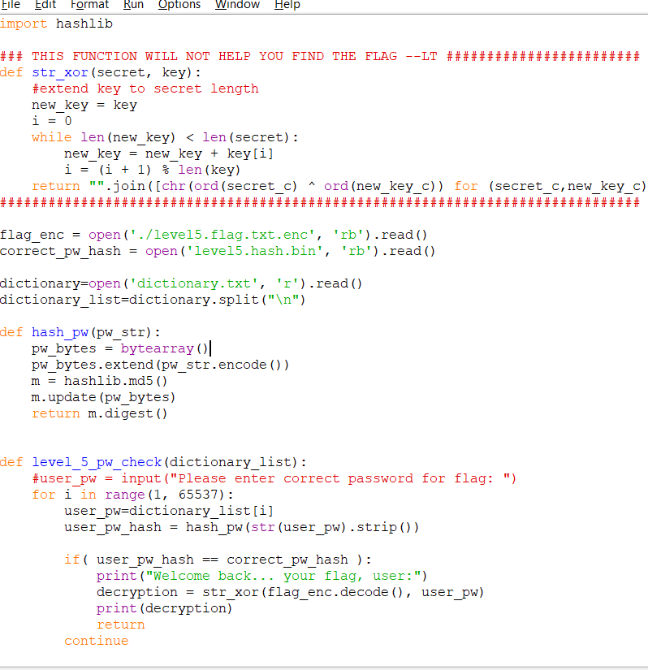

Welcome back... your flag, user:

picoCTF{h45h_sl1ng1ng_fffcda23}

1. Repetitions(base 64 multiple decoding)

picoCTF{base64_n3st3d_dic0d!n8_d0wnl04d3d_73494190}

1. Useless

Description

There's an interesting script in the user's home directoryAdditional details will be available after launching your challenge instance.

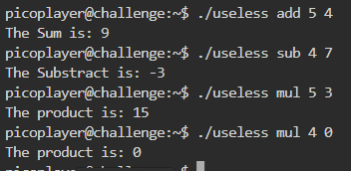

Use man useless :

picoCTF{us3l3ss_ch4ll3ng3_3xpl0it3d_5657}