Deep Learning-Based Prediction of Alzheimer's Disease Progression in Patients with Mild Cognitive Impairment Using Structural MRI: An Investigation of Sex-Based Performance Differences
Student Name | Department / Institution | B.Tech Project Report
Abstract—This project proposes a multimodal deep-learning pipeline to estimate whether a participant with mild cognitive impairment (MCI) will receive an Alzheimer’s disease (AD) diagnosis within 36 months. A 3D convolutional neural network (CNN) is planned for baseline T1-weighted MRI, while a multilayer perceptron (MLP) processes baseline clinical variables; the learned embeddings are fused for binary classification. The study will compare discrimination and error rates by recorded sex and use Grad-CAM and SHAP for model interpretation. A clinical cohort-building workflow and MRI metadata-matching tools have been started, but a sufficiently matched, quality-controlled MRI cohort is not yet available. Therefore, this report presents the design and a synthetic software demonstration only; it reports no ADNI-trained model performance.
Index Terms—Alzheimer’s disease, mild cognitive impairment, structural MRI, 3D CNN, multimodal learning, sex-stratified evaluation, explainable AI.

I. Introduction
Alzheimer’s disease is a progressive neurodegenerative condition. Mild cognitive impairment is a clinical state in which cognition is impaired but everyday independence is relatively preserved; some people progress to AD while others remain stable or later receive another diagnosis. Predicting progression from baseline data could support research follow-up and risk stratification, but a model’s output would not replace clinical diagnosis.
This project focuses on baseline T1-weighted structural MRI and clinical information from the Alzheimer’s Disease Neuroimaging Initiative (ADNI). The intended prediction target is conversion from MCI to AD within 36 months. The current work is at the data-preparation and prototype stage, so the report distinguishes proposed methods from results already demonstrated with generated data.

II. Motivation
MRI contains spatial information about brain structure that can be difficult to summarize with a few measurements. Deep CNNs can learn local and global image features, while cognitive scores and demographics provide complementary context. Prior work suggests that combining MRI and clinical measurements can help MCI conversion prediction [1], [2]. However, performance can vary with cohort definitions, follow-up, class balance, and data leakage. Reporting results separately for female and male participants can reveal whether aggregate metrics conceal different error rates.

III. Literature Review
Moradi et al. combined an MRI-derived biomarker with age and cognitive tests for MCI-to-AD prediction, demonstrating the value of multimodal information in ADNI [1]. Spasov et al. proposed a parameter-efficient deep-learning method using structural MRI and additional imaging-derived information for conversion within three years [2]. These studies motivate multimodal modeling, but their reported results do not transfer to this project.
CNN-based approaches have also used MRI patches and 3D volumes for conversion prediction [3], [4]. Qiao et al. evaluated multiview slices with a 3D convolutional network on ADNI tasks [5]. More recent multimodal work continues to examine interactions among imaging, clinical, and biological variables [6]. These papers show feasibility, while also highlighting that cohort selection and validation design materially affect reported performance.
For interpretation, Grad-CAM uses gradients to highlight image regions contributing to a CNN output [7]. SHAP assigns feature contributions to individual predictions [8]. Such maps are explanatory aids, not evidence that a model has discovered causal biomarkers. Sex-related progression differences have been studied in clinical and imaging cohorts, supporting explicit subgroup analysis while underscoring the need for adequate subgroup sample sizes [9].

IV. Issues in the Existing System
Many research pipelines report only overall accuracy or AUC, even when class imbalance or subgroup error rates matter. Single-modality systems can omit useful information. Small matched imaging cohorts can make deep models unstable, and repeated scans from one participant can leak across training and test sets unless splitting is performed by participant. Follow-up diagnoses can also be accidentally used as model inputs, creating target leakage.
The present project has an additional practical constraint: MRI metadata has not yet yielded a sufficiently large and verified baseline-T1 cohort linked to the clinical labels. DICOM metadata alone does not prove that a scan is T1-weighted or aligned to the correct baseline visit. No ADNI-trained performance claim can be made until scan identity, sequence, date, preprocessing, and outcome labels are reviewed.

V. Problem Statement
Given a participant with baseline MCI, a quality-controlled baseline T1-weighted MRI volume, and baseline clinical features, estimate whether the participant receives an AD diagnosis within 36 months (pMCI) or remains MCI through the required follow-up window (sMCI). Evaluate the model on held-out participants and report overall and sex-stratified AUC, sensitivity, specificity, F1-score, and false-negative rate.
A participant should be labeled only when the follow-up record supports the stated outcome. Insufficient follow-up and intervening non-AD diagnoses should be handled by prespecified exclusion rules rather than silently treated as stable MCI. The exact rules must be frozen before model training.

VI. Proposed System
The proposed system has two input branches. A 3D CNN receives preprocessed baseline T1 MRI. An MLP receives baseline age, recorded sex, education, MMSE, and ADAS scores. The resulting embeddings are concatenated and passed to a classifier that estimates pMCI versus sMCI. Only baseline values enter the predictor; follow-up diagnoses supply labels for training and evaluation.
Initial preprocessing will verify scan series and visit dates, convert selected DICOM series to NIfTI, standardize orientation and voxel spacing, normalize intensities, and apply brain extraction and registration. A medial-temporal or hippocampal crop can reduce memory use, but the crop and registration procedure must be fixed before evaluation. Missing clinical values will be imputed using training-fold statistics only.

VII. System Architecture / System Model
Fig. 1 shows the intended data flow. Clinical labels are constructed independently from baseline predictors to avoid leakage. After fusion, probabilities are evaluated overall and by recorded sex. Group-specific results will be accompanied by subgroup sample counts and uncertainty intervals; if a subgroup is too small, its estimate will be described as unstable rather than overinterpreted.
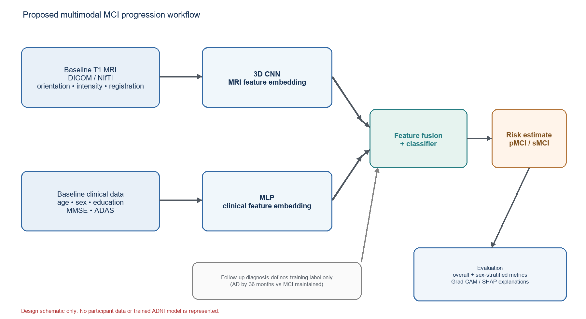
Fig. 1. Proposed multimodal workflow. This is a design diagram, not evidence of a trained ADNI model.

VIII. Modules / Phases and Algorithm
Phase 1: build a participant-level clinical cohort from ADNI diagnostic and cognitive tables; select baseline MCI and define 36-month labels. Phase 2: match MRI metadata by participant and date, then verify the T1 sequence and image series in IDA. Phase 3: preprocess images and assemble one baseline row per participant. Phase 4: split participants into training, validation, and test sets before fitting transforms. Phase 5: train the CNN–MLP fusion model and tune using training/validation data only. Phase 6: evaluate the untouched test set overall and by sex, then generate Grad-CAM and SHAP explanations.
Algorithm (high level): (1) select eligible baseline MCI participants; (2) assign pMCI/sMCI labels from longitudinal diagnosis under the frozen rule; (3) join one verified baseline T1 scan and baseline clinical variables; (4) split by participant with stratification where feasible; (5) fit preprocessing on the training fold; (6) train the two-branch network with binary cross-entropy and early stopping; (7) choose a threshold on validation data; (8) calculate test metrics and confidence intervals; (9) repeat evaluation by sex and inspect explanations. For a small cohort, a simpler clinical-only baseline should be compared before interpreting a 3D CNN.

IX. Implementation Details and Results Analysis
A Python project workspace contains scripts for converting R data exports, building clinical cohorts, matching scan metadata, converting DICOM series, and defining/training a multimodal model. A synthetic-demo script is available to illustrate the software flow without reading ADNI participant data. The real-data pipeline remains blocked at verified MRI-to-cohort matching and scan-quality review.
Component | Current state | What remains
Clinical cohort workflow | Scripts prepared; prior local cohort output exists | Rebuild from current ADNI exports and audit label rules
MRI matching | Metadata matching workflow started | Verify T1 sequence, baseline dates, and one scan per participant
Preprocessing | Conversion/preprocessing code scaffolded | Run on authorized scans; inspect orientation, masks, and registration
CNN + clinical fusion | Model/training script present | Train only after a sufficiently sized verified cohort is ready
Sex analysis / explainability | Planned evaluation and explanation methods | Report only after held-out real-data evaluation

The graphic in Fig. 2 is a software demonstration using generated toy values. Its decreasing loss curve and perfect toy confusion matrix are constructed to show that plotting and reporting components execute; the synthetic examples are deliberately simple. They are not measurements from ADNI, do not estimate generalization, and must not be described as model accuracy or scientific results.
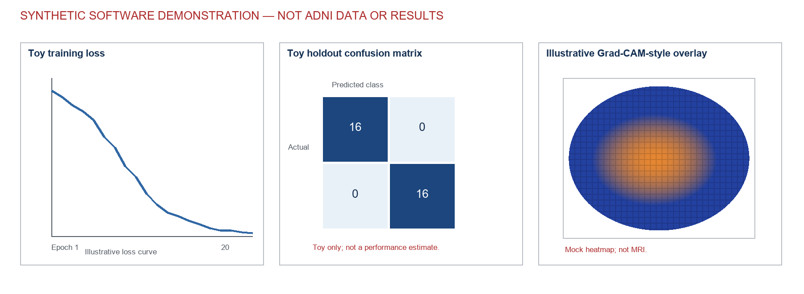
Fig. 2. Synthetic interface/demo graphic. The toy values and mock heatmap are not ADNI observations, model performance, or a real MRI explanation.
Once real data are available, the results table should include test-set size, pMCI/sMCI counts, subgroup counts, ROC-AUC with confidence intervals, sensitivity, specificity, F1-score, and false-negative rate. A confusion matrix should use a threshold chosen on validation data, not the test set. Performance claims should be withheld until participant-level splitting and leakage checks are complete.

X. Result Screenshots
Fig. 2 serves as the current prototype screenshot. It demonstrates the intended presentation of a training curve, confusion matrix, and saliency-style panel. The heatmap is a generated visual, not an MRI slice and not Grad-CAM computed from brain data. The eventual real-data screenshots should show preprocessing quality checks, training/validation curves, held-out metrics, and example explanations only after access controls and ADNI data-use conditions are satisfied.

XI. Novelty
The project’s contribution is a planned, reproducible pipeline that combines baseline structural MRI with cognitive and demographic variables and makes sex-stratified error analysis part of evaluation. It also pairs image-level Grad-CAM with clinical-feature SHAP explanations. These are project aims and an implementation focus, not a claim that the methods are new to the field or that a clinical discovery has been made.

XII. Conclusion
A multimodal CNN–MLP is a suitable implementation target for studying 36-month MCI-to-AD progression, provided the cohort and scans are carefully verified. The codebase and synthetic demonstration can show the intended workflow, but real ADNI model results are not yet available because scan matching and quality control remain incomplete. The next priority is to obtain and verify enough baseline T1 scans, freeze outcome and exclusion rules, and then run participant-level validation before reporting performance or sex differences.

References
[1] E. Moradi, A. Pepe, C. Gaser, H. Huttunen, and J. Tohka, “Machine learning framework for early MRI-based Alzheimer’s conversion prediction in MCI subjects,” NeuroImage, vol. 104, pp. 398–412, 2015, doi: 10.1016/j.neuroimage.2014.10.002.
[2] A. Spasov, L. Passamonti, A. Duggento, P. Lió, and N. Toschi, “A parameter-efficient deep learning approach to predict conversion from mild cognitive impairment to Alzheimer’s disease,” NeuroImage, vol. 189, pp. 276–287, 2019, doi: 10.1016/j.neuroimage.2019.01.031.
[3] S. Liu et al., “Convolutional neural networks-based MRI image analysis for the Alzheimer’s disease prediction from mild cognitive impairment,” Frontiers in Neuroscience, vol. 12, 2018, doi: 10.3389/fnins.2018.00777.
[4] J. Zhang et al., “A 3D densely connected convolution neural network with connection-wise attention mechanism for Alzheimer’s disease classification,” Magnetic Resonance Imaging, vol. 78, pp. 119–126, 2021, doi: 10.1016/j.mri.2021.02.001.
[5] Y. Qiao et al., “Alzheimer’s disease diagnosis with brain structural MRI using multiview-slice attention and 3D convolution neural network,” Frontiers in Neuroscience, vol. 16, 2022, doi: 10.3389/fnins.2022.843386.
[6] Y. Wang et al., “Predicting long-term progression of Alzheimer’s disease using a multimodal deep learning model incorporating interaction effects,” Journal of Translational Medicine, vol. 22, art. 265, 2024, doi: 10.1186/s12967-024-05025-w.
[7] R. R. Selvaraju et al., “Grad-CAM: Visual explanations from deep networks via gradient-based localization,” in Proc. IEEE ICCV, 2017, pp. 618–626.
[8] S. M. Lundberg and S.-I. Lee, “A unified approach to interpreting model predictions,” in Proc. Advances in Neural Information Processing Systems, vol. 30, 2017.
[9] A. Fernández et al., “Sex differences in the progression to Alzheimer’s disease: a combination of functional and structural markers,” GeroScience, vol. 46, no. 2, pp. 2619–2640, 2024, doi: 10.1007/s11357-023-01020-z.

