Servlet, JSP and Spring Core Skill Based Assessment

1. Write a JSP that takes the user’s name and age from a form. -Echo backs the name and age along with a message stating the price of movie tickets. -The price is determined by the age passed to the JSP. -If the age is greater than 62, the movie ticket price is $7.00. -If the user is less than 10 years old, the price is $5.00. -For everyone else, the price is $9.50.

**Index.html:-**

<!DOCTYPE html>

<html>

<head>

<meta charset=*"ISO-8859-1"*>

<title>Insert title here</title>

</head>

<body>

<form action=*"Validate.jsp"*>

Enter your name:<input type=*"text"* name=*"Name"*/><br>

Enter your age:<input type=*"text"* name=*"Age"*/><br>

<input type=*"button"* value=*"Submit"*>

</form>

</body>

</html>

**Validate.jsp:-**

<%@ page language=*"java"* contentType=*"text/html; charset=ISO-8859-1"* pageEncoding=*"ISO-8859-1"*%>

<!DOCTYPE html PUBLIC "-//W3C//DTD HTML 4.01 Transitional//EN" "http://www.w3.org/TR/html4/loose.dtd">

<html>

<head>

<meta http-equiv=*"Content-Type"* content=*"text/html; charset=ISO-8859-1"*>

<title>Insert title here</title>

</head>

<body>

<%

String name=request.getParameter("Name");

**int** age=Integer.parseInt((request.getParameter("Age")));

**if**(age>=62)

{ %>

<h1>The ticket price is:$7.00</h1>

<% }

**else** **if**(age<=10)

{ %>

<h2>The ticket price is:$5.00</h2>

<%

}

**else** { %>

<h2>The ticket price is:$9.50</h2>

<%}%>

</body>

</html>

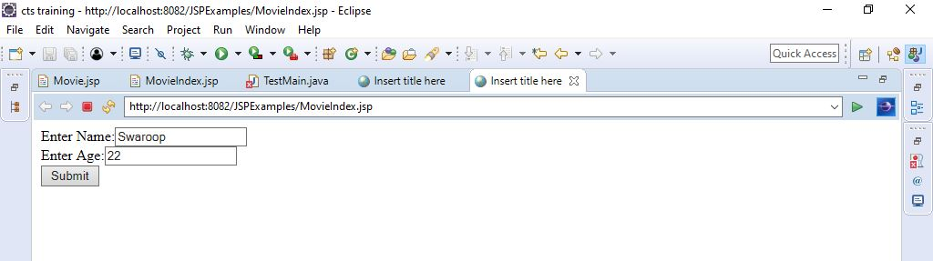

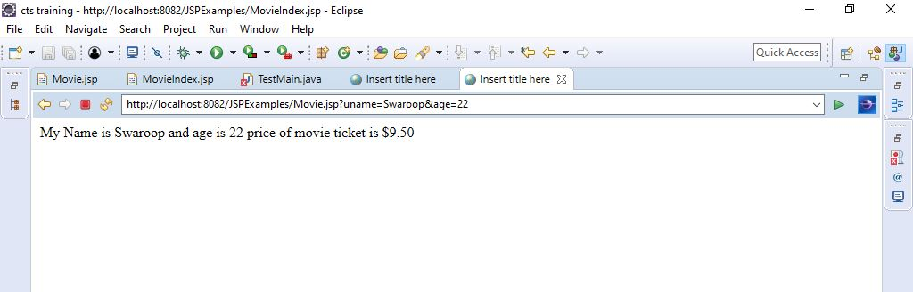

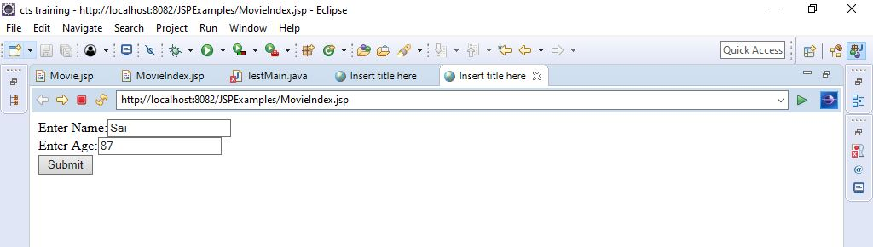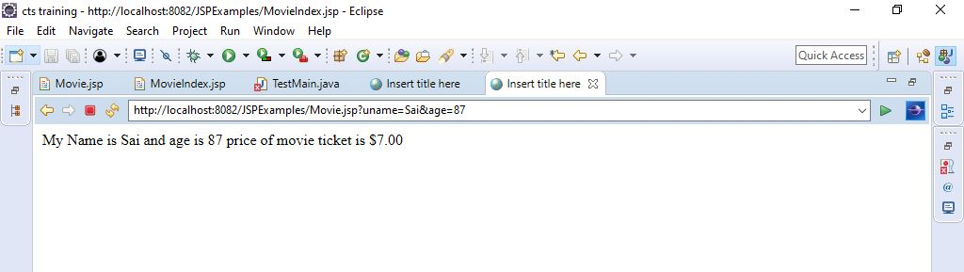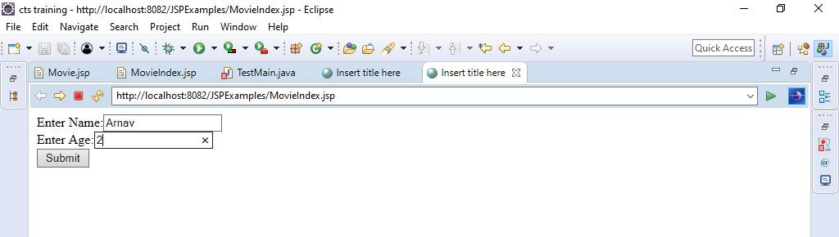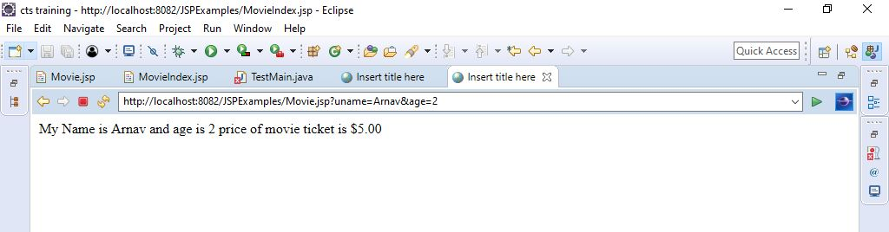

3. Write a spring program which will demonstrate the spring life cycle bean post processor methods.

Employee.java:-

**package** beanpostprocessor;

**public** **class** Employee

{

**private** String name,dept;

**public** String getName() {

**return** name;

}

**public** **void** setName(String name) {

**this**.name = name;

}

**public** String getDept() {

**return** dept;

}

**public** **void** setDept(String dept) {

**this**.dept = dept;

}

**public** **void** init()

{

System.***out***.println("init in emp");

}

**public** **void** display()

{

System.***out***.println("Employee name:" +name + "Department name:"+dept);

}

}

Initialization.java:-

package beanpostprocessor;

import org.springframework.beans.BeansException;

import org.springframework.beans.factory.config.BeanPostProcessor;

public class Initialization implements BeanPostProcessor

{

public Object postProcessBeforeInitialization(Object bean,String beanName)

throws BeansException{

System.out.println("before init");

return bean;

}

public Object postProcessAfterInitialization(Object bean,String beanName)

throws BeansException{

System.out.println("After init");

return bean;

}

}

TestEmployee.java:-

package beanpostprocessor;

import org.springframework.context.ApplicationContext;

import org.springframework.context.support.ClassPathXmlApplicationContext;

public class TestEmployee {

public static void main(String[] args)

{

// TODO Auto-generated method stub

ApplicationContext ap=new ClassPathXmlApplicationContext("bean.xml");

Employee e=(Employee) ap.getBean("emp");

System.out.println("Employee Name is:"+e.getName());

System.out.println("Employee Department is:"+e.getDept());

}

}

Output:-

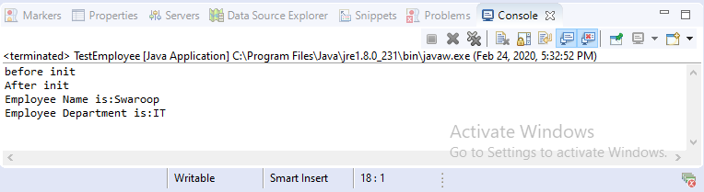

4. Write a simple spring program to implement Dependency injection using constructor method for dependent objects and Map objects

Maptest.java:-

package map;

import java.util.Iterator;

import java.util.Map;

import java.util.Set;

public class Maptest {

int id;

String Question;

Map<String,String> answers;

public int getId() {

return id;

}

public void setId(int id) {

this.id = id;

}

public String getQuestion() {

return Question;

}

public void setQuestion(String question) {

Question = question;

}

public Map<String, String> getAnswers() {

return answers;

}

public void setAnswers(Map<String, String> answers) {

this.answers = answers;

}

public Maptest(int id, String question, Map<String, String> answers) {

super();

this.id = id;

Question = question;

this.answers = answers;

}

public void displayAnswers()

{

System.out.println("id is:" + id + "Question is:" +Question);

Set keys=answers.entrySet();

Iterator itr=keys.iterator();

while(itr.hasNext())

{

Map.Entry e=(Map.Entry)itr.next();

System.out.println(e.getKey()+" "+e.getValue());

}

}

}

TestMap.java:-

package map;

import org.springframework.context.ApplicationContext;

import org.springframework.context.support.ClassPathXmlApplicationContext;

public class TestMap {

public static void main(String[] args)

{

ApplicationContext context=new ClassPathXmlApplicationContext("map.xml");

Maptest m=(Maptest) context.getBean("map");

m.displayAnswers();

}

}

Map.xml:-

<?xml version=*"1.0"* encoding=*"UTF-8"*?>

<beans xmlns = *"http://www.springframework.org/schema/beans"*

xmlns:xsi = *"http://www.w3.org/2001/XMLSchema-instance"*

xsi:schemaLocation = *"http://www.springframework.org/schema/beans*

*http://www.springframework.org/schema/beans/spring-beans-3.0.xsd"*>

<bean id=*"map"* class=*"map.Maptest"*>

<constructor-arg value=*"77563"*/>

<constructor-arg value=*"who when why?"*/>

<constructor-arg>

<map>

<entry key=*"who....?"* value=*"Swaroop"*/>

<entry key=*"when....?"* value=*"then"*/>

<entry key=*"why.....?"* value=*"for money"*/>

</map>

</constructor-arg>

</bean>

</beans>

Output:-

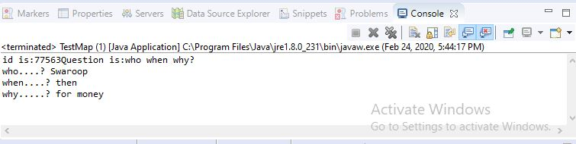

5. Write a spring jdbc program to display all the records from any table from the mysql database.

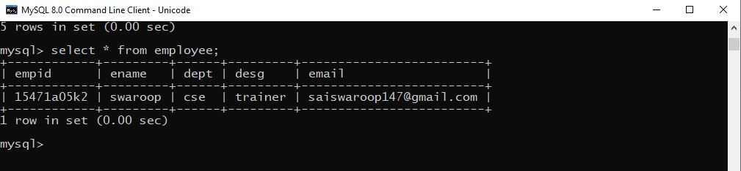

Employee.java:-

**package** Employee;

**public** **class** Employee

{

String empid;

String ename;

String dept;

String desg;

String email;

**public** Employee()

{

}

**public** Employee(String string, String string2, String string3, String string4) {

}

**public** String getEmpid() {

**return** empid;

}

**public** **void** setEmpid(String empid) {

**this**.empid = empid;

}

**public** String getEname() {

**return** ename;

}

**public** **void** setEname(String ename) {

**this**.ename = ename;

}

**public** String getDept() {

**return** dept;

}

**public** **void** setDept(String dept) {

**this**.dept = dept;

}

**public** String getDesg() {

**return** desg;

}

**public** **void** setDesg(String desg) {

**this**.desg = desg;

}

**public** String getEmail() {

**return** email;

}

**public** **void** setEmail(String email) {

**this**.email = email;

}

}

EmployeeDao.java:-

package Employee;

import java.sql.ResultSet;

import java.sql.SQLException;

import java.util.List;

import org.springframework.jdbc.core.JdbcTemplate;

import org.springframework.jdbc.core.RowMapper;

public class EmployeeDao

{

private JdbcTemplate jdbcTemplate;

public void setJdbcTemplate(JdbcTemplate jdbcTemplate)

{

this.jdbcTemplate=jdbcTemplate;

}

public List<Employee> getEmployee()

{

String sql="select * from employee";

List<Employee> list=jdbcTemplate.query(sql, new RowMapper<Employee>()

{

public Employee mapRow(ResultSet rs, int rowNum) throws SQLException

{

Employee e=new Employee();

e.setEmpid(rs.getString("empid"));

e.setEname(rs.getString("ename"));

e.setDept(rs.getString("dept"));

e.setDesg(rs.getString("desg"));

e.setEmail(rs.getString("email"));

return e;

}

});

return list;

}

}

Employee.xml:-

<?xml version=*"1.0"* encoding=*"UTF-8"*?>

<beans xmlns = *"http://www.springframework.org/schema/beans"*

xmlns:xsi = *"http://www.w3.org/2001/XMLSchema-instance"*

xsi:schemaLocation = *"http://www.springframework.org/schema/beans*

*http://www.springframework.org/schema/beans/spring-beans-3.0.xsd"*>

<bean id=*"ds"* class=*"org.springframework.jdbc.datasource.DriverManagerDataSource"*>

<property name=*"driverClassName"* value=*"com.mysql.cj.jdbc.Driver"* />

<property name=*"url"* value=*"jdbc:mysql://localhost:3306/banking"* />

<property name=*"username"* value=*"root"* />

<property name=*"password"* value=*"root"* />

</bean>

<bean id=*"jdbcTemplate"* class=*"org.springframework.jdbc.core.JdbcTemplate"*>

<property name=*"dataSource"* ref=*"ds"* />

</bean>

<bean id=*"edao"* class=*"Employee.EmployeeDao"* >

<property name=*"jdbcTemplate"* ref=*"jdbcTemplate"* />

</bean>

</beans>

Main.java:-

package Employee;

import java.util.Iterator;

import java.util.List;

import org.springframework.context.ApplicationContext;

import org.springframework.context.support.ClassPathXmlApplicationContext;

public class Main

{

public static void main(String[] args)

{

// TODO Auto-generated method stub

ApplicationContext ctx=new ClassPathXmlApplicationContext("Employee.xml");

EmployeeDao dao=(EmployeeDao)ctx.getBean("edao");

List<Employee> employee =dao.getEmployee();

Iterator<Employee> itr=employee.iterator();

for(Employee e:employee)

{

System.out.println(e.getEmpid()+" " +e.getEname()+" "+e.getDept()+" "+e.getDesg()+" "+e.getEmail());

}

dao.getEmployee();

}

}

Output:-

