**PAN main code:-**

**-------------**

**package** xam08022020;

**import** java.util.Scanner;

**public** **class** Pan

{

**public** **static** **void** main(String args[])

{

Scanner sc=**new** Scanner(System.***in***);

System.***out***.println("Enter ur PAN number");

String s=sc.nextLine();

PanValidation.*PANNumber*(s);

}

}

**Panvalidation class:-(subclass to pan main code)**

**-------------------**

**package** xam08022020;

**public** **class** PanValidation

{

**public** **static** **void** PANNumber(String s1)

{

**if**(s1.matches("[A-Z]{3}[0-9]{4}[A-Z]{1}"))

{

System.***out***.println("VALID");

}

**else**

{

System.***out***.println("NOT VALID");

}

}

}

**Output:-**

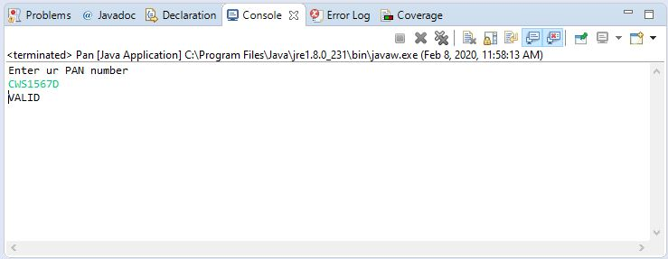

VOTING main class:-

package xam08022020;

import java.util.Scanner;

import xam08022020.InsufficientAgeException;

import xam08022020.InvalidAgeException;

public class VotingTest {

public static void main(String[] args) {

// TODO Auto-generated method stub

Scanner sc=new Scanner(System.in);

System.out.println("Enter ur age");

int age=sc.nextInt();

VotingValidation vote=new VotingValidation();

try {

vote.testAge(age);

}

catch(InvalidAgeException e)

{

System.out.println(e);

}

catch(InsufficientAgeException e)

{

System.out.println(e);

}

}

}

Votingvalidation class:-(subclass of the voting class)

package xam08022020;

import xam08022020.InsufficientAgeException;

import xam08022020.InvalidAgeException;

public class VotingValidation

{

public void testAge(int age)throws InsufficientAgeException,InvalidAgeException

{

if(age>=0&&age<18)

throw new InsufficientAgeException();

else if(age<0||age>=100)

throw new InvalidAgeException();

else

System.out.println("you are eligible for voting...");

}

}

**User defined exceptions:-**

**InvalidAgeException class:-**

**package** xam08022020;

**public** **class** InvalidAgeException **extends** Exception

{

**public** InvalidAgeException()

{

System.***out***.println("Invalid age");

}

}

**InsufficientAgeException class:-**

**package** xam08022020;

**public** **class** InsufficientAgeException **extends** Exception {

**public** InsufficientAgeException()

{

System.***out***.println("Insufficient age");

}

}

**Output:-**

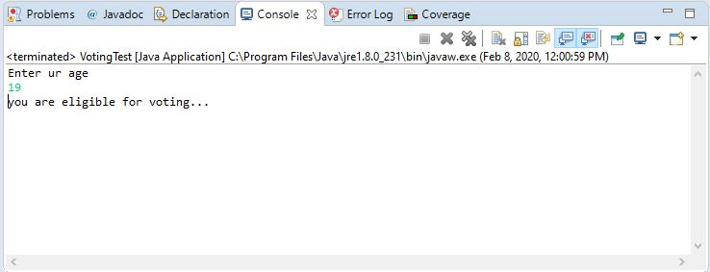

**Students main class:-**

package xam08022020;

import java.util.ArrayList;

import java.util.Scanner;

import java.util.function.Consumer;

import java.util.function.Function;

import java.util.function.Predicate;

import xam08022020.Student;

public class Students {

public static void main(String[] args)

{

ArrayList<Student> ar=new ArrayList<Student>();

Student s1=new Student("swaroop",44);

Student s2=new Student("siva",88);

Student s3=new Student("chaithanya",66);

Student s4=new Student("Vinay", 99);

ar.add(s1);

ar.add(s2);

ar.add(s3);

ar.add(s4);

Predicate<Student> p=s->s.marks>=50;

Function<Student,String> f=s->

{

int marks=s.marks;

if(marks>=80)

{

return "Distinction";

}

else if(marks>=60&&marks<=79)

{

return "First Class";

}

else if(marks>=50&&marks<=59)

{

return "Second Class";

}

else

{

return "Failed";

}

};

Consumer<Student> c=s->

{

System.out.println("Student name" +s.name);

System.out.println("Student marks" +s.marks);

System.out.println("Student grade" +f.apply(s));

};

for(Student s:ar)

{

if(p.test(s))

c.accept(s);

}

}

}

Student class:-(Students sub class)

**package** xam08022020;

**public** **class** Student

{

String name;

**int** marks;

**public** Student(String name, **int** marks) {

**super**();

**this**.name = name;

**this**.marks = marks;

}

@Override

**public** String toString() {

**return** "Student [name=" + name + ", marks=" + marks + "]";

}

}

**Output:-**

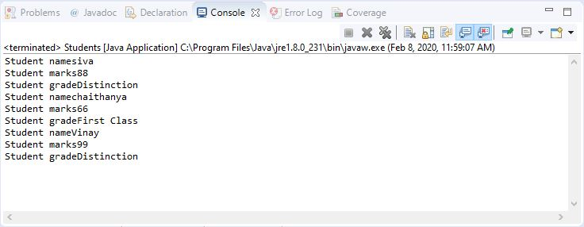

**Maincode:-**

**----------**

**package** xam08022020;

**import** java.util.ArrayList;

**import** java.util.Scanner;

**public** **class** MainCode {

**public** **static** **void** main(String[] args)

{

Scanner sc = **new** Scanner(System.***in***);

System.***out***.println("enter the size of arraylist");

**int** n = Integer.*parseInt*(sc.nextLine());

ArrayList<Integer> ar1 = **new** ArrayList<Integer>();

ArrayList<Integer> ar2 = **new** ArrayList<Integer>();

System.***out***.println("enter elements in arraylist1");

**for** (**int** i = 0; i < n; i++)

ar1.add(Integer.*parseInt*(sc.nextLine()));

System.***out***.println("enter elements in ararylist2");

**for** (**int** i = 0; i < n; i++)

ar2.add(Integer.*parseInt*(sc.nextLine()));

**char** ch = sc.nextLine().charAt(0);

System.***out***.println(UserMainCode.*performSetOperations*(ar1,ar2,ch));

}

}

**UserMainCode:-**

**------------**

**package** xam08022020;

**import** java.util.ArrayList;

**public** **class** UserMainCode

{

**public** **static** ArrayList<Integer> performSetOperations(ArrayList<Integer> ar1,ArrayList<Integer> ar2, **char** ch)

{

ArrayList<Integer> ar = **new** ArrayList<Integer>();

**int** i = 0;

**switch** (ch)

{

**case** '+':

ar1.removeAll(ar2);

ar1.addAll(ar2);

ar = ar1;

**break**;

**case** '*':

ar1.retainAll(ar2);

ar = ar1;

**break**;

**case** '-':

**for** (**int** j = 0; j < ar1.size(); j++)

{

i = 0;

**for** (**int** k = 0; k < ar2.size(); k++)

{

**if** (ar1.get(j) == ar2.get(k))

i = 1;

}

**if** (i == 0)

ar.add(ar1.get(j));

}

**break**;

}

**return** ar;

}

}

**Output:-**

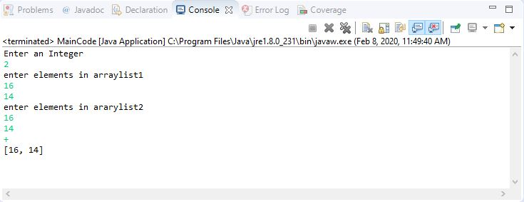

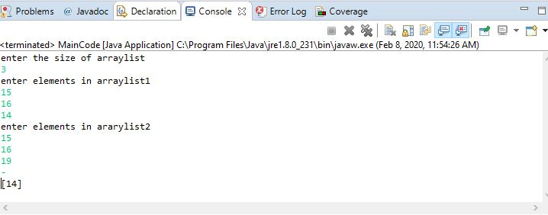

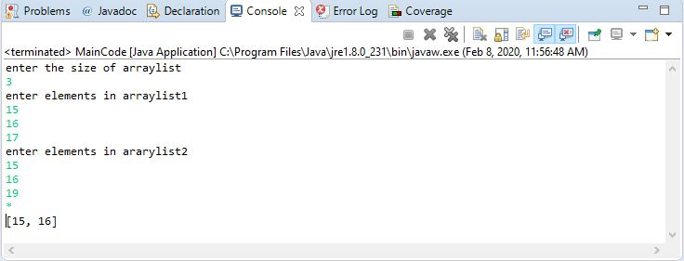

**EmployeeJDBC connection:-**

package xam08022020;

import java.sql.Connection;

import java.sql.DriverManager;

import java.sql.PreparedStatement;

import java.util.Scanner;

public class Employee {

public static void main(String[] args) {

try {

Class.forName("com.mysql.jdbc.Driver");

Connection connection=DriverManager.getConnection

("jdbc:mysql://localhost:3306/cts","root","root");

Scanner sc=new Scanner(System.in);

System.out.println("enter employee name");

String name=sc.next();

System.out.println("enter employee id");

String id=sc.next();

System.out.println("enter employee department:");

String dept=sc.next();

System.out.println("enter employee designation:");

String desg=sc.next();

System.out.println("enter employee company:");

String company=sc.next();

System.out.println("enter employee emailid:");

String emailid=sc.next();

PreparedStatement pst=connection.prepareStatement

("insert into employee values(?,?,?,?,?,?)");

pst.setString(1, name);

pst.setString(2, id);

pst.setString(3, dept);

pst.setString(4, desg);

pst.setString(5, company);

pst.setString(6, emailid);

pst.executeUpdate();

System.out.println("Record inserted...");

}

catch(Exception e) {

}

}

**Output:-**



