
ASSIGNMENT OF CSE310(CA3)
(THEATER MANAGEMENT SYSTEM)

Submitted by

SUNNAM SAI JYOTHI SWAROOP
Registration No: 11802400
Section: K18KP (B55)

Submitted to

Harjeet Kaur

In partial fulfilment of the award of the degree of
BACHELOR OF TECHNOLOGY (CSE)
School of Computer Science
LOVELY PROFESSIONAL UNIVERSITY

GITHUB link:
https://github.com/saiswaroop5225/Theater-management-system.git

CODE SNIPPET:-
QUESTION 1:
THEATER MANAGMENT SYSTEM
import java.util.*;
import java.io.*;
import java.util.Random;
interface Movie
{
void price();
}

abstract class Viewer
{
abstract void getDetails();
abstract void printDetails();
}

class silver implements Movie
{
public void price()
{
int Bill;
Bill = 130;
System.out.println("Total Bill: "+Bill);
}
}
class Golden implements Movie
{
public void price()
{
int Bill;
Bill =190;
System.out.println("Total Bill: "+Bill);
}
}
class Platinum implements Movie
{
public void price()
{
int Bill;
Bill = 250;
System.out.println("Total Bill: "+Bill);

}
}
class Customer extends Viewer
{
String Name,Mail,MyMobile,MyMovie,option;
String MyTheater,MovieName,myseat;
String regex1 = "(0/91)?[7-9][0-9]{9}";
String regex2 = "^[\\w-_\\.+]*[\\w-_\\.]\\@([\\w]+\\.)+[\\w]+[\\w]$";
long Mobile;

void getDetails() {
Scanner Sc = new Scanner(System.in);
System.out.println("Enter Your Name: ");
Name = Sc.nextLine();
System.out.println("Enter Your Mobile Number:");
Mobile = Sc.nextLong();
MyMobile = Long.toString(Mobile);
Sc.nextLine();
System.out.println("Enter Your Email Id:");
Mail = Sc.nextLine();
System.out.println("\t\t\t\t\tEnter Your Movie Theater");
MyTheater = Sc.nextLine();
System.out.println("\t\t\t\t\tEnter Your myseat");
System.out.println("Enter 1 For Avengers\tEnter 2 For baahubali\tEnter 3 For Godzilla \t\tEnter 4 For war\tEnter 5 Forjoker");
MovieName = Sc.nextLine();
System.out.println("\t\t\t\t\tEnter Type Of Your MyMovie:");
System.out.println("Enter 1 For Platinum\tEnter 2 For silver\tEnter 3 For Golden");
option = Sc.nextLine();
}

void printDetails() {
try{
FileWriter fw = new FileWriter("Booking.txt");
PrintWriter pw = new PrintWriter(fw);
silver S = new silver();
Golden Gn = new Golden();
Platinum PL = new Platinum();
Random rand = new Random();
System.out.println("\t\t\tYour MyMovie Details");
int rand_int1 = rand.nextInt(10000);
// System.out.println("Booking Id: "+rand_int1);
pw.println("Booking Id: "+rand_int1);
// System.out.println("Name: " + Name);
pw.println("Name: " + Name);
if(MyMobile.matches(regex1) && Mail.matches(regex2))
{
// System.out.println("Mobile: " + MyMobile);
pw.println("Mobile: " + MyMobile);
// System.out.println("MailID:"+ Mail);
pw.println("MailID:"+ Mail);
pw.println("MyTheater:"+MyTheater);
if (MovieName.equals("1"))
{
myseat = "Avengers";
pw.write("mymoviename:"+myseat+"\n");

}
else if (MovieName.equals("2"))
{
myseat = "Baahubali";
pw.write("mymoviename:"+myseat+"\n");

}

else if (MovieName.equals("3"))
{
myseat = "Godzilla";
pw.write("mymoviename:"+myseat+"\n");

}
else if (MovieName.equals("4"))
{
myseat = "war";
pw.write("mymoviename:"+myseat+"\n");

}
else if (MovieName.equals("5"))
{
myseat = "joker";
pw.write("mymoviename:"+myseat+"\n");

}

else
{
System.out.println("Only These five movies are Available");
}
if (option.equals("1")) {
MyMovie = "Platinum";
int upperbound = 60;
int int_random = rand.nextInt(upperbound);
// System.out.println("Myseat_section: " + MyMovie );
pw.println("Myseat_section" + MyMovie);
pw.println("and your seat number is"+int_random)
pw.println("Your Bill is 250");
PL.price();
} else if (option.equals("2")) {
MyMovie = "silver";
int upperbound = 60;
int int_random = rand.nextInt(upperbound);
// System.out.println("Myseat_section: " + MyMovie );
pw.println("Myseat_section" + MyMovie);
pw.println("and your seat number is"+int_random)
pw.println("Your Bill is 130");
S.price();
} else if (option.equals("3")) {
MyMovie = "Golden";
int upperbound = 60;
int int_random = rand.nextInt(upperbound);
// System.out.println("Myseat_section: " + MyMovie );
pw.println("Myseat_section" + MyMovie);
pw.println("and your seat number is"+int_random)
pw.println("Your Bill is 190");
Gn.price();

} else {
System.out.println("Only Enter Available MyMovies");
}
pw.close();

FileReader fr = new FileReader("Booking.txt");
BufferedReader br = new BufferedReader(fr);

String str;
while ((str = br.readLine()) != null)
{
System.out.println(str);
}
br.close();
System.out.println("\t\t\t\t\tBooking Successful");
}
else
{
System.out.println("Invalid Mobile no or EmailId ");
getDetails();
printDetails();
}
}

catch(IOException e)
{
System.out.println("Please Book Your Movie");
}

}

}
class AddandDelticket
{
void showMyMovie()
{
try
{
FileReader fr = new FileReader("Booking.txt");
BufferedReader br = new BufferedReader(fr);

String str;
while ((str = br.readLine()) != null)
{
System.out.println(str);
}
br.close();
}
catch(IOException e)
{
System.out.println("Please Book Your Movie");
}
}
void cancelMyMovie()
{
File file = new File("Booking.txt");

if(file.delete())
{
System.out.println("MyMovie Cancelled successfully");
}
else
{
System.out.println("Failed to Cancel the MyMovie");
}
}
}
class TheatermanagementSystem
{
public static void main(String[] args)
{
Scanner In = new Scanner(System.in);
Viewer P = new Customer();
AddandDelticket AD = new AddandDelticket();
System.out.println("\t\t\t\t\tTheater Management System by SUNNAM SAI JYOTHI SWAROOP");
System.out.println("Enter 1 To Book Tickets\tEnter 2 To Cancel ticket\tEnter 3 To View ticket");
String choice = In.nextLine();
if(choice.equals("1"))
{
P.getDetails();
P.printDetails();
}
else if (choice.equals("2"))
{
AD.cancelMyMovie();
}
else if(choice.equals("3"))
{
System.out.println("\t\t\t\t\tThis Will Only Show Last Booked ticket.");
AD.showMyMovie();
}
else
{
System.out.println("Please Enter Available Option");
}

}

}

Runtime results:
After sucessfull completion of program the program runs fine.

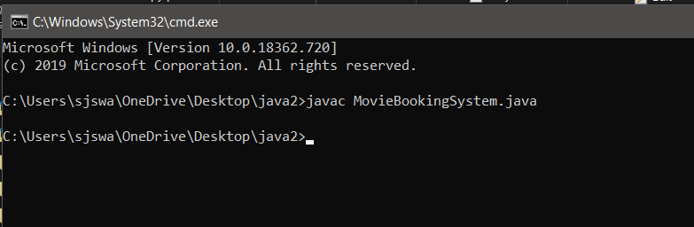

After running of the program the classes are created as following.

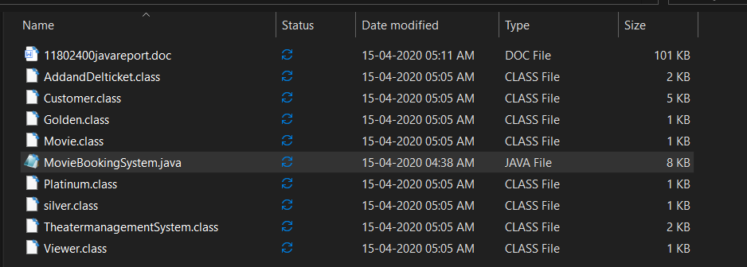

Now we need to run the main class which is TheatermanagementSystem which is main class where all above functions would full fill.

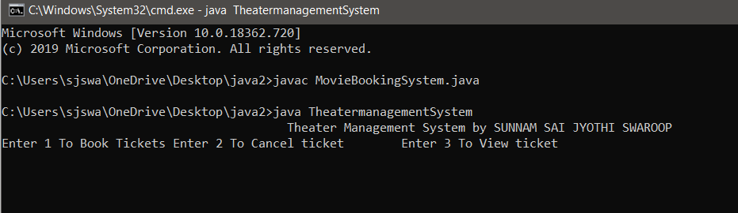

There are three funtions which books tickets and cancel tickets and view ticket.

If we enter one we would like to fill name,mobilenumber,
Email,movie theater,movie,seat.

And in cancel the stored data will be deleted and data would come to zero from Booking.txt

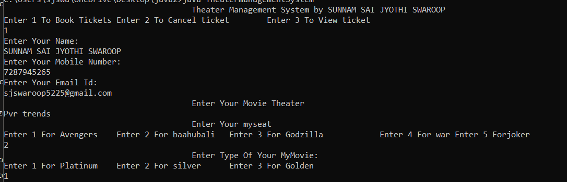

The portal opens here and we need to give input as shown above.
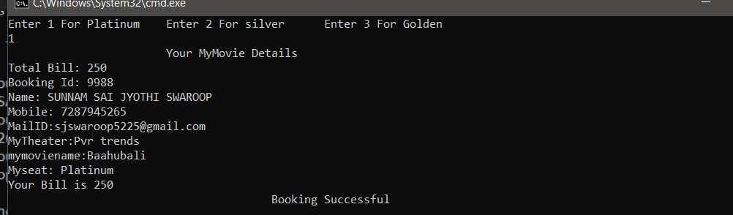

After completion of process it shows the total details of booking.

By entering 2 we could cancel ticket as shown.

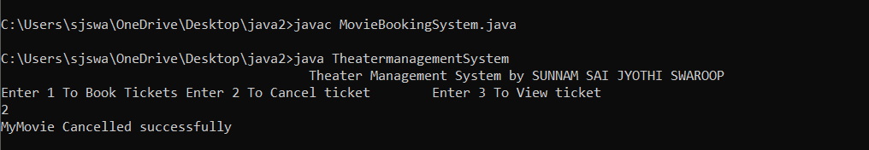

Now if we enter 3 we could see the details filled by us.

Due to deletion the data shows empty as follows.
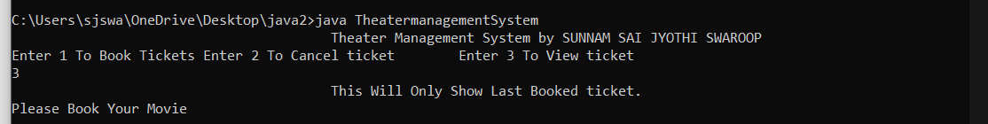

Now after refilling the details again if we enter 3 then the
Total details would be seen as follows.

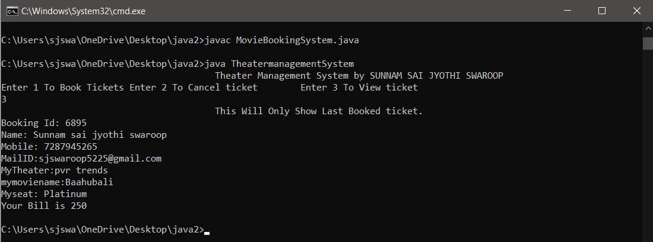

The project is all about booking tickets and showing the details by using inheritance, polymorphism, abstract classes, interfaces, exception handling with user defined exceptions and IO fundamentals.

Question 2:
- Differentiate throw and throws
- Differentiate abstract classes and interfaces
- What are assertions?
- Short note on try with resource statement

- Differentiate throw and throws.
Ans.
THROW | THROWS
1.java throw keyword is used to explicitly thrown an exception. | 1.It is used to declare an exception.
2.checked exception cannot be propagated using throw only. | 2.checked exception can be propagated with throws.
3.it is followed by an instance | 3.it is followed by class.
4.it is used within method | 4.it is used with the method
5.cannot throw multiple exceptions. | 5.can declare multiple exceptions.

B.
Abstract class | Interface
For abstract class a methd must be declared as abstract.abstract methods doesn’t have any implemention. | for interface all methods by default are abstract methods only.so one cannot declare variables methods in interfaces.
The Abstract methods casn declare with access modifires like public,internal,protected.When implementing in subclass these methods must be defined with same visibility. | All methods in an interface must be public.
Abstract class can be contain variabbles. | Interface cannot contain variables
A class can be inherit only one abstract class and multiple inheritance is not possible for adstarct class. | A class can be implemented many interface and multiple interface inheritance is possibble
A child class may or may not override defined in the parent class. | A class tha implements an inerface must override all interface metdhods.

C.
Assertion allow to put in checks during test and to have them automatically removed in production code.
- Throws and AssertionError if ot is false.
- Expression value is passed intp the error.
Syntax:-
assert condition;

D.
Piece of code that you want to monitor for exceptions are contained within an try block.if an exception occurs within try block,it is thrown.
Try with resources statement means try statement that declares one or more resoures.

