**A Web Based Strategy on Enhancement of Student Fee**

**Management System Using Web Development**

**Technologies**

***A Mini Project report submitted to***

**JAWAHARLAL NEHRU TECHNOLOGICAL UNIVERSITY-KAKINADA, KAKINADA**

***Submitted in partial fulfillment of the requirements***

***for the award of degree***

**BACHELOR OF TECHNOLOGY**

**In**

**INFORMATION TECHNOLOGY**

**II B. Tech**

**–**

**II Semester**

**Submitted by**

**U. Sai Syam (19KN1A1254)**

**V.Sirisha (19KN1A1257)**

**V.Rohith (19KN1A1256)**

***Under the esteemed Guidance of***

**Mr. E. KARUNAKAR,**

**Associate Professor**

**Department of Information Technology**

**NRI**

**INSTITUTE OF TECHNOLOGY**

**(**

**AUTONOMOUS**

**)**

**Approved by AICTE, New Delhi: :Permanent Affiliation to JNTUK, Kakinada**

**Accredited by NBA (CSE, ECE & EEE), Accredited by NAAC with A-Grade**

**An ISO 9001:2015 Certified Institution**

**Pothavarappadu (V), Via Nunna, Agiripalli (M), PIN-521 212.**

**Ph: 0866**

**–**

**2469666 | e-mail: nrihitech@rediffmail.com**

**Website: www. nriit.edu.in**

**(2018**

**–**

**2022)**



**A Web Based Strategy on Enhancement of Student Fee**

# Management System Using Web Development Technologies

***A Mini Project report submitted to***

**JAWAHARLAL NEHRU TECHNOLOGICAL UNIVERSITY-KAKINADA, KAKINADA**

***Submitted in partial fulfillment of the requirements***

***for the award of degree***

**BACHELOR OF TECHNOLOGY**

**In**

## INFORMATION TECHNOLOGY

**II B. Tech – II Semester**

**Submitted by**

1. **Bhandhavya (18KN1A1226)**
2. **Prathyusha (18KN1A1230)**

**S. Vasanthi (18KN1A1246)**

***Under the esteemed Guidance of***

**Mr. E. Karunakar,**

**Associate Professor**



# Department of Information Technology

**NRI INSTITUTE OF TECHNOLOGY**

**(AUTONOMOUS)**

**Approved by AICTE, New Delhi: :Permanent Affiliation to JNTUK, Kakinada**

**Accredited by NBA (CSE, ECE & EEE), Accredited by NAAC with A-Grade**

**An ISO 9001:2015 Certified Institution**

**Pothavarappadu (V), Via Nunna, Agiripalli (M), PIN-521 212.**

**Ph: 0866 – 2469666 | e-mail: nrihitech@rediffmail.com Website: www. nriit.edu.in**

**(2018 – 2022)**

# NRI INSTITUTE OF TECHNOLOGYB



**(AUTONOMOUS)**

**Approved by AICTE, New Delhi: Permanent Affiliation to JNTUK, Kakinada**

**Accredited by NBA (CSE, ECE & EEE), Accredited by NAAC with A-Grade**

**An ISO 9001:2015 Certified Institution**

**Pothavarappadu (V), Via Nunna, Agiripalli (M), PIN-521 212.**

**Ph: 0866 – 2469666 | e-mail: nrihitech@rediffmail.com**

**Website: www.nriit.edu.in**

## Department of Information Technology Certificate

**This is to certify that the project work entitled**

**A Web Based Strategy on Enhancement of Student**

**Fee Management System Using Web Development**

### Technologies

#### is a bonafide record work done by

**K.Bhandhavya (18KN1A1226)**

**L.Prathyusha (18KN1A1230)**

**S.Vasanthi (18KN1A1246)**

**In the Department of Information Technology, NRI Institute of Technology, is affiliated to JNTU-Kakinada in partial fulfillment of the requirements for the award of Bachelor of Technology in Information Technology during 20182022. This work has been carried out under my guidance and supervision.**

**The results embodied in this Project report have not been submitted in any University or Organization for the award of any degree or diploma.**

**INTERNAL GUIDE: HEAD OF DEPARTMENT:**

**Mr. E. Karunakar, Mr. B.B.K. Prasad,**

**ASSOCIATE PROFESSOR ASSOCIATE PROFESSOR**

## ACKNOWLEDGEMENT

Before getting into the thickest of things, we would like to thank the personalities who were part of my project in numerous ways, those who gave me outstanding support from birth of the project.

We are extremely thankful to our beloved chairman **Dr. R. Venkat Rao** for providing necessary infrastructure and resources for the accomplishment of our project at **NRI Institute of Technology,**

**Agiripalli**.

We are highly indebted to **Dr. C. Naga Bhaskar,** Principal of **NRI Institute of Technology,** for his support during the tenure of the project.

We hereby wish to express our deep sense of gratitude to

**Dr. M. Chaitanya Kishore Reddy, Prof & Dean**, **Mr. B. B. K. Prasad, Head of the Department,** Department of Information Technology, NRI Institute of Technology for the esteemed guidance, moral support and invaluable advice provided by them for the success of the project.

With grateful thanks, I express my deep sense of gratitude and respect towards my internal guide **Mr. E. Karunakar*,*** Associate Professor for his valuable suggestions, guidance and encouragement throughout the project.

We are also thankful to all the staff members of Information Technology department who have cooperated in making our project a success. We would like to thank all our parents and friends who extended their help, encouragement and moral support either directly or indirectly in our project work.

Thanks for Your Valuable Guidance and kind support.

## DECLARATION

We hereby declare that project report entitled **“A Web Based Strategy on Enhancement of Student Fee Management System Using Web Development**

**Technologies”** is a genuine project work carried out by us, in **B. Tech (Information Technology)** degree course of

**JAWAHARLAL NEHRU TECHNOLOGICAL UNIVERSITY,**

**KAKINADA** and has not been submitted to any other courses or University for award of any other courses or University for award of any degree by us.

**Signature of the Students**

K.Bhandhavya 18KN1A1226

L.Prathyusha 18KN1A1230

S.Vasanthi 18KN1A1246

### ABSTRACT

The Fee Management System is a desktop system based on

maintaining student records and their details. It is an integrated system that manages the gathering of student fees, issuing fee receipts, maintaining and generating due fee reports leading to untroubled, convenient and paperless management. It provides a comprehensive manner of managing the finance department of institutes with none work. It is time-saving and additional economical. It conjointly prevents frauds in transactions. This management system needs less force. The main advantage of this management system is secured information of accounts. It provides a simple interface to support of student fee knowledge. it would be utilized by instructive universities or faculties to stay up the fee records of scholars effectively. College Fee Management could be a sample fee management system. In this project for login authentication OTP or SMS is employed and navigate. To run this project, we want to put in virtual server i.e. XAMPP on your laptop (for Windows). To outline a supportive framework with a specific end goal to make simplicity to the client, the framework is created by utilizing XAMPP Server interfacing with database that is using 'PHP' language as the dialect or guideline of the framework. Fees sought by educational institutes from persons responsible for costs associated with the attendance of a student come in many forms and often are reduced by grants, by financial aid awards, and by other discounts.

#### TABLE OF CONTENTS

|  |  |  |
| --- | --- | --- |
| **S.No** | **CHAPTERS** | **PAGE NO** |
|  | **TITLE PAGE** | **i** |
| **CERTIFICATE** | **ii** |
| **ACKNOWLEDGEMENT** | **iii** |
| **DECLARATION** | **iv** |
| **ABSTRACT** | **v** |
| **LIST OF FIGURES** | **viii** |
| **LIST OF ABBREVIATIONS** | **ix** |
| **LIST OF SCREENS** | **x** |
| **1** | **INTRODUCTION** | **1-3** |
|  | 1.1 Problem Statement | 2 |
|  | 1.2System Architecture | 3 |
| **2** | **LITERATURE SURVEY** | **4** |
|  | 2.1 Existing System | 4 |
| **3** | **SOFTWARE REQUIREMENT ANALYSIS** | **5** |
|  | 3.1 Functional Requirements | 5 |
|  | 3.2 Non-functional Requirements | 5 |
| **4** | **SOFTWARE DESIGN** | **6-12** |
| **5** | **PROPOSED SYSTEM** | **13** |
| **6** | **CODING** | **14-26** |
| **7** | **TESTING** | **27-29** |
|  | 7.1 Software Testing | 27 |
|  | 7.2 Testing Techniques | 27-28 |
|  | 7.3 Testing Strategies | 28-29 |
| **8** | **OUTPUT SCREENS** | **30-34** |
|  | 8.1 Main Page | 30 |
|  | 8.2 Login page | 30 |
|  | 8.3 Sign Up Page | 31 |
|  | 8.4 Contact Us | 31 |
|  | 8.5 Pay Fee | 32 |
|  | 8.6 Check Dues | 32 |
|  | 8.7 Add Student | 33 |
|  | 8.8 View Student | 33 |
|  | 8.9 Settings | 34 |
| **9** | **CONCLUSION AND FURTHER WORKS** | **35** |
| **10** | **REFERENCES** | **36-37** |

**LIST OF FIGURES**

|  |  |  |
| --- | --- | --- |
| **FIG.NO.** | **NAME OF THE FIGURE** | **PAGE NO.** |
| 1.1 | Fee Management System | 2 |
| 1.2 | System Architecture | 3 |
| 2.1 | Existing System | 4 |
| 4.1 | Software Design | 6 |
| 5.1 | Proposed Fee Management System | 13 |

**LIST OF ABBREVIATIONS**

|  |  |  |
| --- | --- | --- |
| **S.NO.** | **MNEMONICS** | **ABBREVIATION NAME** |
| 1 | PHP | Hypertext Preprocessor |
| 2 | SQL | Structured Query Language |
| 3 | HTML | Hyper Text Mark-Up language |
| 4 | CSS | Cascading Style Sheets |
| 5 | JS | JavaScript |
| 6 | XAMPP | Cross-platform, Apache, Maria DB (MySQL), PHP and Perl |

**LIST OF SCREENS**

|  |  |  |
| --- | --- | --- |
| **SCREEN NO.** | **NAME OF SCREEN** | **PAGE NO.** |
| 8.1 | Main page | 30 |
| 8.2 | Login Page | 30 |
| 8.3 | Signup page | 31 |
| 8.4 | Contact us page | 31 |
| 8.5 | Pay page | 32 |
| 8.6 | Check Dues | 32 |
| 8.7 | Add student | 33 |
| 8.8 | View Student | 33 |
| 8.9 | Settings | 34 |

CHAPTER

-

1

##### INTRODUCTION

Fee Management System suggests that Managing the dues or fee reports in a very system manner. Fee management is that the vital feature of an academic establishment because it maintains a whole track of fee paid by the scholars. Earlier, fee assortment and management was essential and error prone because it needed manual power and was conjointly it's terribly time intense. The system can establish the scholar, his current standing, his fees history and on the idea of the Fee History records it'll calculate the collectible quantity mechanically. Thus the choice creating at clerical finish is eliminated. Organization needn't to fret concerning recent records too. Any reasonably recent record that is inserted within the system may be generated through reports at any time in future. Establishment will get the fees quantity on-line via Payment entryway. Through the out there reports Administration will get an even bigger image of the organization and decide the financial gain. during this approach, the choice creating ought to reform can become additional quicker. All the vital options that are needed is ready for this project. style of this project is pretty and responsive so user won’t realize it tough to grasp, use and navigate. The invention relates generally to information System transactions over a communication network and, more particularly, to Systems and methods for transacting fees associated with intellectual property filings and/or events. To run this project, we want to put in virtual server i.e. XAMPP on your laptop (for Windows). The full type of XAMPP stands for Cross-platform, Apache, Maria DB(MYSQL), PHP and Perl. it's one in all the best and lightweight native servers that's accustomed check your web site domestically. it's Associate in Nursing open supply platform. This includes X-OS as a result of it works all told major in operation systems like Windows, Linux, Mac etc.Fees Management may be a terribly tedious job until date and any organization ought to take tons of care whereas taking fees, as maintaining monetary records is extremely vital task in any institute. a correct accounting is additionally required at the tip of each year. Fee management is that the vital feature of an academic establishment because it maintains a whole track of fee paid by the scholars. Earlier, fee assortment and management were essential and error prone because it needed manual power and was conjointly it's terribly time intense.



**Fig. 1.1 Fee Management System**

##### 1.1 Problem Statement

1. The aim of problem statement was to design a model.
2. The model must be user-friendly.
3. It should not allow viewing others data.
4. The data privileges should be easily viewed.

##### 1.2. System Architecture

NO

YES

Start

Home Page

Login

Register

Fee Module

Admin Module

Course Module

Report module

Stop

###### Fig. 1.2 System Architecture

CHAPTER

-

2

##### LITERATURE SURVEY / EXISTING SYSTEM

In the existing system most of the records are maintained by paper work. It becomes terribly inconvenient to switch the info. In the existing system, here could be a risk that a similar data completely different in several in numerous registers could have different values which means the entries of the same information don't match. This inconsistent state doesn't offer the concrete data that poses a retardant within the case information associated with explicit search record. It is not properly capable to manage the scholar records with their fee details at one place.

Drawbacks of the Existing System

1. Colleges have restricted time per every day.
2. Time overwhelming method.
3. Less security as it is maintained on paper.
4. We cannot produce manually for all file inside the time.
5. More Man Power.
6. Needs Manual Calculations.



###### Fig. 2.1 Existing System

4

CHAPTER

-

3

**SOFTWARE REQUIREMENT ANALYSIS**

##### 3.1 Functional Requirements

* Creation of new record this function creates a record for a new student.
* Deletion of record this function is used to delete the existing record of any student.
* Updating in record this function updates the information in a record of any student.
* Display of data in record This Function displays the record of the students.
* The system asks for student’s information such as student id, name.
* The system stores student’s record.
* The system stores college day to day financial status.

##### 3.2. Non Functional Requirements

* **System performance** All system must perform all the mentioned operations at a reasonable speed so that the user experience is not affected.
* **Security** The personal information of the students along with other sensitive information must be hidden from administrative staff and should only be visible to the system admin. Hence this data must remain in an encrypted from to increase system security.
* **Usability** as the system is implemented through a universal app the user can log into the system both from his mobile and desktop, anywhere.
* **Capacity** The system must have the capacity to handle large amount of student data and should not slow down as the amount of data increases.
* **Maintainability** The system must be able to modify the stored records so that any change in the student information that occur can be accommodated easily in the student database.

5

CHAPTER

-

4

##### SOFTWARE DESIGN



**Create Class/ Course**

**Details**



**Enter price list**



**Enter student information**

**& payment details**



**Enter paid amount ,unpaid**

**amount&discount**



**Calculate tax**



**Update payment status**

Student Fee

Management

System

###### Fig. 4.1 Software Design

Fees management software is a tool, platform, or application that helps educational institutions like schools and colleges plan and manage all of their fee payment-related processes. A good fee management software manages the end to end fee payment cycle – from the calculation of fees, accounting for additions and deductions, fee due notice, fee payment portals, and fee receipt generation.

Fee management software ensures that the process of fee payment for parents and fee collection for management remains a safe, secure, and hassle-free experience. It also ensures that an ongoing record is remain maintained for the administration of all these sensitive financial transactions.

Fee generation and payment is an essential process for any educational institution since it concerns itself with the bottom line. Fees management software automates and digitizes this entire process, making it less prone to human error and also ensuring that it occurs seamlessly for parents and management. Parents [benefit from the implementation of a fees management software](https://fedena.com/blog/2018/06/what-are-the-benefits-of-fees-management-system-in-educational-institutions.html#inbox/_blank) because they are sent timely reminders to complete the fee payment and can make the payment from anywhere at any time and from any device. For management, automating the process reduces the error rate and ensures that fee payment becomes a hassle-free process in terms of collection and generation of receipt, while also reducing labour costs, thanks to lowered dependency on the accounts team at their educational institution.

Robust [fees management software l](https://fedena.com/feature-tour/school-fees-management-system#inbox/_blank)ike Federal automates the entire fee process for parents and school management. They virtually automate and digitize existing processes to reduce time and labour burden on the educational institution. But there are also many hidden features that might not be as intuitive as the pen and paper process, but enhance the fee process to be more useful to stakeholders.

Below we have discussed some of these features

##### Multiple Accounts

Online fees management system gives users the ability to group fees into different account heads. This is done to ease the process of accounting. For instance, let us say that a specific department [collects multiple types of fee](https://fedena.com/blog/2017/07/types-of-fees-collection-in-fedena.html#inbox/_blank) – like the recreation department collects both arts and crafts related fees as well as sports fees.

The fees management software will enable users to see these fees individually but also group, if necessary. It does not just stop with the maintenance and delineation of records in this way. Fee reports also give users the option to filter accounts under this, making it an end to end experience for users wishing to study financial reports.

##### Fee Receipt Sets

Fee receipts are an essential final step of any fee payment process that indicates the closing of the fee payment process. These receipts are necessary as a signifier, but also vital for parents paying the fees for their financial records. In many instances, since students are on differing fee bands, participating in different activities that accrue additional charges, or perhaps responsible for paying fines, the receipts have to be individually designed and generated.

However, with robust fees management software, users can group different fees based on the accounts they fall under, to different receipt sequences and header designs. This ultimately results in dedicated fee receipts, fee receipt generation processes, and customized designs for specific needs. This kind of customization would initially be very time and labour-intensive using a traditional pen and paper process, but thanks to fees management software, it becomes much more comfortable and less time consuming to generate such receipts.

##### Financial Year

Fees generation and payment are not a standalone feature of educational institutions. They are part of a much larger entity that reflects the financial health of the school. This is why many schools and colleges nowadays rely on the efficiency and error-free character of a fees management software to organize and maintain fee-related records. When approaching the fees process holistically, it has noticed that they are part and parcel of how the financial year pans out for an educational institution like a school or a college.

For instance, a newly debuting financial year provides a logical division for each year’s reports. When maintaining the fee records following the same timeline and logic, then fees become an integral part of the financial reports that are generated by the fees management system. So next time you set up a fee process, create a financial year before configuring the fees to dovetail with the same.

##### Master Particulars

Avoid confusion and complexity while dealing with different fee categories. This feature allows creating distinctive Master Particulars to use them under different fee categories. Link the existing fee categories to the Master Particulars created, to use them in the further transaction processes.

##### Master Discounts

Fee generation and payment is a highly rules-driven process, making it an ideal process that needs to be automated and digitized. Fees management software is particularly adept at this. However, despite this process being so rules-driven, there are always multiple customized exceptions – an example of this is deductions or discounts in the fee-based on every individual student’s requirements.

Such discounts can range from awarded scholarships to waivers need-based exceptions or adjustments against other payments. All these discounts can be highly individualistic and vary from time to time and student to student. It is thus necessary the schools must have an exhaustive list of all the discounts.

In fees management software, such a list would be called Master Discounts. Master Discounts is a distinctive category that lists all the discounts that apply under different fee categories. When generating a fee, implement existing discounts by linking them to the Master Discounts to avoid the complexity and confusion involved in doing granular transactions. Having such a Master Discounts list reduces errors and missteps when generating the fees due for any students.

##### Multiple Receipt Number

Fee receipt generation is an essential step of the fee process and as any finance team member will tell you – the most cumbersome one since it requires a high level of precision. Sometimes it is prone to human error, or things slip through the cracks, resulting in time and labour overload for both managements in an educational institution as well as parents. At the same time, fee receipts are highly sensitive documents that require a high level of accuracy also.

Fee and bill payment is one of the most crucial tasks in any organization. In school and colleges, it starts with admissions and ends with graduation or course completion. If your institute also provides hostel facility, transport facility, and other services as well, then managing fee and bill payment can take you to a higher level of stress.

What more is fee and bill payment system require 100% error-free result, you are not allowed to make even a tiny mistake as that can change the complete balance sheet and can ruin the reputation of your school or college.

If you are using the best student management system, you will get an integrated fee management system. It gives you the facility to set up a complete fee structure according to student category, course or service requirement. The system also gives you the power to collect a late payment, fines and provide required function as well.

##### Easy online transaction

It is important that your student management system has a preferred payment gateway. With payment integration, students submit their fees online without any hassle. This way you would be able to collect fees online and it is easier to make records of it. The reports generated via online payment includes all the important details of the transaction which you can access any time you need.

##### Generate Invoice /Bill Reports

Whatever is the type of payment, nowadays people want to have an invoice or bill for the record. An education ERP system to help you to generate invoice/bill of all the transactions. Some education ERP solution also provides customized invoice/ bill generation with various categories. You can also download record in pdf or excel format inbulk. Education ERP also comes with accounting software like tally or sage integration to manage ledger account as well.

It saves you from tedious manual tasks which in turn save your time.

##### Handle Multiple Finance

In school/ college you deal with various of payment. You collect fees for form, admission, exams, registration fee, maintaining caution money, scholarship & sponsorship, etc. An education ERP can handle all these tasks in one platform. It makes fee management operation simplified, smooth and fast.

##### Calculate Tax and GST

You can use this system to calculate all type tax including GST whenever it is applicable. It also lets you do important transaction such as refunding fees. The best thing is it is all user-controlled and the privilege to control this function can be given to specific employees as per the requirement.

##### Calculate Necessary Discount

There are different types of discount an educational institute provides such as fixed, percentage, ad-hoc or standalone. A student management system enables you to set up all such discount type. It also generates separate reports on the basis of the category of discount.

##### Control Finances of Your Institute

With a fee management system, you have the power to control finance of your institute. As we discussed before you can also give access to other departments if you need specifically from them. You can view and generate a report from the financial database.

Some student management system also comes up with a feature of finance hold in which you can hold documents of a student if he or she has outstanding fees in his account. Moreover, it also provides to look at the fee and bill payment records of students, course wise, category wise and with other filters.

##### An easy and safe fee payment system for parents

You can have all kinds of parents who prefer different types of payment methods, such as cash, challan , cheque, online payment, credit card, debit card, demand draft, etc. A fee management system is suitable for all types of payment. This provides a safe and easy service for payments.

This customized fee management system enables parents and students both to submit their fees, settle their bills easily and with a short interval of time.

##### Final Note

Fee management is one of the complex and tedious tasks to handle among multiple academic operations which actually requires automation. An education technology designed to hit the pain areas of the institutions, resolve them and strengthen institution to reach new heights. Fee management solution in a student management system is one essence of one such realistic technology.

CHAPTER

-

5

##### PROPOSED SYSTEM

In this new fee management system, the distinction between previous fee system and new fee system is shown. The new system will overcome the previous fee system by adding some further options love it is completely computerized and information may be simply maintained in database for a protracted time. The present invention consists of an improved system and method for creating a fee agreement with a client in an improved, efficient manner by providing the client or customer with an online account, a variety of fee arrangement templates. The system needs bit of your time to come up with reports required to manage the fees of the scholars. It conjointly generates records like i.e. Fees paid, dues, and Decrease time required to access and deliver student records. To make the system more secure.

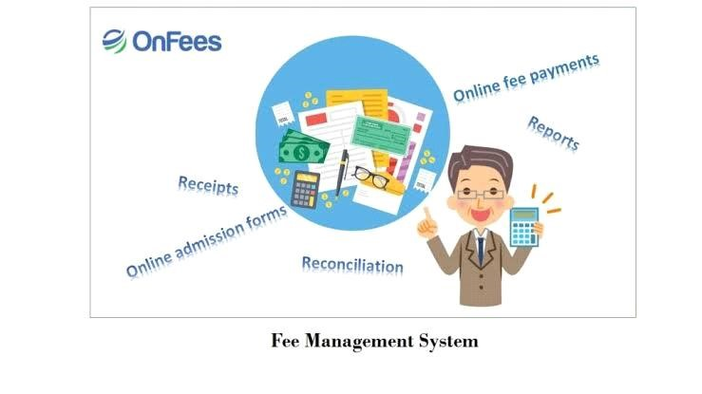

**Fig. 5.1 Proposed Fee Management System**

13

CHAPTER

-

6

##### CODING Main

<html>

<head>

<link rel="stylesheet" href="[**https//maxcdn.bootstrapcdn.com/bootstrap/3.3.7/css/bootstrap.min.css**"](https://maxcdn.bootstrapcdn.com/bootstrap/3.3.7/css/bootstrap.min.css)>

<!--jQuery library-->

<script src="[**https//ajax.googleapis.com/ajax/libs/jquery/1.12.4/jquery.min.js**"](https://ajax.googleapis.com/ajax/libs/jquery/1.12.4/jquery.min.js)></script>

<!--Latest compiled and minified JavaScript-->

<script src="[**https//maxcdn.bootstrapcdn.com/bootstrap/3.3.7/js/bootstrap.min.js**"](https://maxcdn.bootstrapcdn.com/bootstrap/3.3.7/js/bootstrap.min.js)></script>

<meta name="viewport" content="width=device-width, initial-scale=1">

<title>Navbar in Bootstrap</title>

<style>

.v { background-image url("search.jpg"); background-repeat no-repeat; background-size cover;

}

.caption { text-align center;

}

.navbar-custom{ background-color#286090;

}

</style>

</head>

<body>

<nav class="navbar navbar-custom navbar-fixed-top">

<div class="container">

<div class="navbar-header">

<a class="navbar-brand" href="#" style="colorwhite;font-size24px;">Fee Management

System</a>

</div>

<ul class="nav navbar-nav navbar-right">

<li><a style="colorwhite;font-size18px;" href="login.html"><span class="glyphicon glyphicon-user"></span> login</a></li>

<li><a style="colorwhite;font-size18px;" href="signup.html"><span class="glyphicon glyphicon-log-in"></span> Sign Up </a></li>

</ul>

</div>

</nav>

<div class="v">

<div class="container" style="padding-top100px;">

<div class="jumbotron" style="text-align center;background-color rgba(23,67,88,0.7);colorwhite;height150px; width 700px;margin-left100px;margintop100px;margin-bottom 100px;">

<h1 class="display-4"></h1>

<p class="lead" style="font-size22px;font-family Cambria, Cochin, Georgia, Times, 'Times

New Roman', serif;"><b>The Effective Fee Management System</b></p>

</div>

</div>

</div>

<hr>

<div class="container-fluid">

<div class="alert alert-light" role="alert">

<b style="color cadetblue;font-size30px">Welcome to the fee management system</b> <p align="justify" style="font-family Cambria, Cochin, Georgia, Times, 'Times New Roman', serif; font-size20px;">In Fee Collection System, you can effortlessly manage student Fee Collection and maintain fees related data.

Fees Management is a very tedious job till date and any organization need to take a lot of care while taking fees, as maintaining financial records is very important task in any institute. A proper accounting is also needed at the end of every financial year.</p>

<p align="justify"style="font-family Cambria, Cochin, Georgia, Times, 'Times New Roman', serif; font-size20px;">

<b align="justify" style="color brown">The Fee Management System is a desktop system aimed at maintaining student records and their fee details. It also generate records like i.e. Fees paid, dues, and etc. The system requires small amount of time to generate reports needed to manage the fees of the students.</b></p>

<p align="justify" style="font-family Cambria, Cochin, Georgia, Times, 'Times New Roman', serif; font-size20px;">

This system mainly reduces the work task and it is easy to maintain the records for a long time than normal hand written records. The user can check his record details by just entering his name no need to search all the record. With the help of this system fee calculations can be done very easily.

</p>

</div>

</div>

<nav class="nav navbar-custom navbar-fixed-bottom">

<div class="container">

<div class="nav navbar-nav ">

<p style=" colorwhitesmoke;margin-left 200px;">Copyright ©Fee Management System. All

Rights Reserved and Contact Us +91 9676047502</p>

</div>

</div>

</nav>

</body>

</html>

##### login page

<html>

<head>

<link rel="stylesheet"

href="[https//maxcdn.bootstrapcdn.com/bootstrap/3.3.7/css/bootstrap.min.css"](https://maxcdn.bootstrapcdn.com/bootstrap/3.3.7/css/bootstrap.min.css)>

<!--jQuery library-->

<script src="[https//ajax.googleapis.com/ajax/libs/jquery/1.12.4/jquery.min.js"](https://ajax.googleapis.com/ajax/libs/jquery/1.12.4/jquery.min.js)></script>

<!--Latest compiled and minified JavaScript-->

<script src="[https//maxcdn.bootstrapcdn.com/bootstrap/3.3.7/js/bootstrap.min.js"](https://maxcdn.bootstrapcdn.com/bootstrap/3.3.7/js/bootstrap.min.js)></script>

<meta name="viewport" content="width=device-width, initial-scale=1">

<title>Navbar in Bootstrap</title>

<style>

.navbar-custom{ background-color#286090;

}

</style>

</head>

<body>

<nav class="navbar navbar-custom navbar-fixed-top">

<div class="container">

<div class="navbar-header">

<a class="navbar-brand" href="#" style="colorwhite;font-size24px;">Fee Management

System</a>

</div>

<ul class="nav navbar-nav navbar-right">

<li><a style="colorwhite;font-size18px;" href="login.html"><span class="glyphicon glyphicon-user"></span> login</a></li>

<li><a style="colorwhite;font-size18px;" href="signup.html"><span class="glyphicon glyphicon-log-in"></span> Sign Up </a></li>

</ul>

</div>

</nav>

<div class="container" style="margin-top 150px;">

<div class="row">

<div class="col-xs-4">

<div class="panel panel-primary">

<div class="panel-heading " style="text-aligncenter;">

<b style="font-size20px;">Sign In</b>

</div>

<div class="panel-body">

<form action="ulogin.php" method="get">

<div class="form-group">

<label for="Email">Email</label>

<input id="my-input" class="form-control" placeholder="Email" type="email" name="email" required>

</div>

<div class="form-group">

<label for="Password">Password</label>

<input id="my-input" class="form-control" placeholder="Password" type="password" name="pass" required>

</div>

<button class="btn btn-primary btn-block" type="submit">Sign In</button>

</form>

</div>

<div class="panel-footer">

<b><a href="uforget.html">forget password?</a></b>

</div>

</div>

</div>

<nav class="nav navbar-custom navbar-fixed-bottom">

<div class="container">

<div class="nav navbar-nav ">

<p style=" colorwhitesmoke;margin-left 200px;">Copyright ©Fee Management System. All

Rights Reserved and Contact Us +91 9676047502</p>

</div>

</div>

</nav>

</body>

</html>

##### sign up

<html>

<head>

<link rel="stylesheet" href="[https//maxcdn.bootstrapcdn.com/bootstrap/3.3.7/css/bootstrap.min.css"](https://maxcdn.bootstrapcdn.com/bootstrap/3.3.7/css/bootstrap.min.css)>

<!--jQuery library-->

<script src="[https//ajax.googleapis.com/ajax/libs/jquery/1.12.4/jquery.min.js"](https://ajax.googleapis.com/ajax/libs/jquery/1.12.4/jquery.min.js)></script>

<!--Latest compiled and minified JavaScript-->

<script src="[https//maxcdn.bootstrapcdn.com/bootstrap/3.3.7/js/bootstrap.min.js"](https://maxcdn.bootstrapcdn.com/bootstrap/3.3.7/js/bootstrap.min.js)></script>

<meta name="viewport" content="width=device-width, initial-scale=1">

<title>Navbar in Bootstrap</title>

<style> .navbar-custom{ background-color#286090;

}

</style>

</head>

<body>

<nav class="navbar navbar-custom navbar-fixed-top">

<div class="container">

<div class="navbar-header">

<a class="navbar-brand" href="#" style="colorwhite;font-size24px;">Fee Management

System</a>

</div>

<ul class="nav navbar-nav navbar-right">

<li><a style="colorwhite;font-size18px;" href="login.html"><span class="glyphicon glyphicon-user"></span> login</a></li>

<li><a style="colorwhite;font-size18px;" href="signup.html"><spanclass="glyphicon glyphicon-log-in"></span> Sign Up </a></li>

</ul>

</div>

</nav>

<div class="container" style="margin-top 150px;">

<div class="row">

<div class="col-xs-4">

<div class="panel panel-primary">

<div class="panel-heading " style="text-aligncenter;">

<b style="font-size20px;">Sign Up</b>

</div>

<div class="panel-body">

<form action="usignup.php" method="get">

<div class="form-group">

<div class="form-group">

<label for="Name">Name</label>

<input id="my-input" class="form-control" placeholder="Name" type="text" name="name" required>

</div>

<label for="Email">Email</label>

<input id="my-input" class="form-control" placeholder="Email" type="email" name="email" required>

</div>

<div class="form-group">

<label for="Password">Password</label>

<input id="my-input" class="form-control" placeholder="Password" type="password" name="pass" required>

</div>

<button class="btn btn-primary btn-block" type="submit">Submit</button>

</form>

</div>

<div class="panel-footer">

</div>

</div>

</div>

<nav class="nav navbar-custom navbar-fixed-bottom">

<div class="container">

<div class="nav navbar-nav ">

<p style=" colorwhitesmoke;margin-left 200px;">Copyright ©Fee Management System. All Rights Reserved and Contact Us +91 9676047502</p>

</div>

</div>

</nav>

</body>

</html>

##### pay fee

<html>

<head>

<link rel="stylesheet" href="[https//maxcdn.bootstrapcdn.com/bootstrap/3.3.7/css/bootstrap.min.css"](https://maxcdn.bootstrapcdn.com/bootstrap/3.3.7/css/bootstrap.min.css)>

<!--jQuery library-->

<script src="[https//ajax.googleapis.com/ajax/libs/jquery/1.12.4/jquery.min.js"](https://ajax.googleapis.com/ajax/libs/jquery/1.12.4/jquery.min.js)></script>

<!--Latest compiled and minified JavaScript-->

<script src="[https//maxcdn.bootstrapcdn.com/bootstrap/3.3.7/js/bootstrap.min.js"](https://maxcdn.bootstrapcdn.com/bootstrap/3.3.7/js/bootstrap.min.js)></script>

<meta name="viewport" content="width=device-width, initial-scale=1">

<title>Navbar in Bootstrap</title>

<style> .navbar-custom{ background-color#286090;

}

</style>

</head>

<body>

<nav class="navbar navbar-custom navbar-fixed-top">

<div class="container">

<div class="navbar-header">

<a class="navbar-brand" href="#" style="colorwhite;font-size24px;">Fee Management

System</a>

</div>

<ul class="nav navbar-nav navbar-right">

<li><a style="colorwhite;font-size18px;" href="due.html"> Check Due</a></li>

<li><a style="colorwhite;font-size18px;" href="view.php"> View Student</a></li>

<li><a style="colorwhite;font-size18px;" href="add.html"> Add Student</a></li>

<li><a style="colorwhite;font-size18px;" href="contact.html"></span>Contact Us </a></li>

<li><a style="colorwhite;font-size18px;" href="setting.html"></span>Settings </a></li>

<li><a style="colorwhite;font-size18px;padding-right20px;" href="login.html"></span>Logout </a></li>

</ul>

</div>

</nav>

<div class="container" style="margin-top 150px;">

<div class="row">

<div class="col-xs-4">

<div class="panel panel-primary">

<div class="panel-heading " style="text-aligncenter;">

<b style="font-size20px;">Sign In</b>

</div>

<div class="panel-body">

<form action="payu.php" method="get">

<div class="form-group">

<label for="Email">Email</label>

<input id="my-input" class="form-control" placeholder="Email" type="email" name="email" required>

</div>

<div class="form-group">

<label for="Amount"></label>

<input id="my-input" class="form-control" placeholder="Amount" type="text" name="amt" required>

</div>

<button class="btn btn-primary btn-block" type="submit">Sign In</button>

</form>

</div>

<div class="panel-footer">

</div>

</div>

</div>

<nav class="nav navbar-custom navbar-fixed-bottom">

<div class="container">

<div class="nav navbar-nav ">

<p style=" colorwhitesmoke;margin-left 200px;">Copyright ©Fee Management System. All

Rights Reserved and Contact Us +91 9676047502</p>

</div>

</div>

</nav>

</body>

</html>

##### check due

<html>

<head>

<link rel="stylesheet" href="[https//maxcdn.bootstrapcdn.com/bootstrap/3.3.7/css/bootstrap.min.css"](https://maxcdn.bootstrapcdn.com/bootstrap/3.3.7/css/bootstrap.min.css)>

<!--jQuery library-->

<script src="[https//ajax.googleapis.com/ajax/libs/jquery/1.12.4/jquery.min.js"](https://ajax.googleapis.com/ajax/libs/jquery/1.12.4/jquery.min.js)></script>

<!--Latest compiled and minified JavaScript-->

<script src="[https//maxcdn.bootstrapcdn.com/bootstrap/3.3.7/js/bootstrap.min.js"](https://maxcdn.bootstrapcdn.com/bootstrap/3.3.7/js/bootstrap.min.js)></script>

<meta name="viewport" content="width=device-width, initial-scale=1">

<title>Navbar in Bootstrap</title>

<style>

.navbar-custom{ background-color#286090;

}

</style>

</head>

<body>

<nav class="navbar navbar-custom navbar-fixed-top">

<div class="container">

<div class="navbar-header">

<a class="navbar-brand" href="#" style="colorwhite;font-size24px;">Fee Management

System</a>

</div>

<ul class="nav navbar-nav navbar-right">

<li><a style="colorwhite;font-size18px;" href="pay.html"> Pay Fee</a></li>

<li><a style="colorwhite;font-size18px;" href="view.php"> View Student</a></li>

<li><a style="colorwhite;font-size18px;" href="add.html"> Add Student</a></li>

<li><a style="colorwhite;font-size18px;" href="contact.html"></span>Contact Us </a></li>

<li><a style="colorwhite;font-size18px;" href="setting.html"></span>Settings </a></li>

<li><a style="colorwhite;font-size18px;padding-right20px;" href="login.html"></span>Logout </a></li></ul>

</div>

</nav>

<div class="container" style="margin-top 150px;">

<div class="row">

<div class="col-xs-4">

<div class="panel panel-primary">

<div class="panel-heading " style="text-aligncenter;">

<b style="font-size20px;">Check Due's</b>

</div>

<div class="panel-body">

<form action="dueu.php" method="get">

<div class="form-group">

<label for="Email">Email</label>

<input id="my-input" class="form-control" placeholder="Email" type="email" name="email" required>

</div>

<button class="btn btn-primary btn-block" type="submit">Sign In</button>

</form>

</div>

<div class="panel-footer">

</div>

</div>

</div>

<nav class="nav navbar-custom navbar-fixed-bottom">

<div class="container">

<div class="nav navbar-nav ">

<p style=" colorwhitesmoke;margin-left 200px;">Copyright ©Fee Management System. All

Rights Reserved and Contact Us +91 9676047502</p>

</div>

</div> </nav>

</body>

</html>

CHAPTER

-

7

##### TESTING

Testing is a process of executing a program with the aim of finding error. To make our software perform well it should be error free. If testing is done successfully it will remove all the errors from the software. Software testing is defined as an activity to check whether the actual results match the expected results and to ensure that the software system is defect free. It involves execution of a software component or system component to evaluate one or more properties of interest. Software testing also helps to identify errors, gaps or missing requirements in contrary to the actual requirements. It can be either done manually by using automated tools.

##### Principles of Testing-

1. All the test should meet the customer requirements.
2. To make our software testing should be performed by third party.
3. Exhaustive testing is not possible.
4. Start testing with small parts and extend it to large parts.
5. All the test to be conducted should be planned before implementing it(v) It follows pare to rule(80/20 rule) which states that 80% of errors comes from 20% of

##### 7.1 SOFTWARE TESTING

Software testing is a critical element of software quality assurance and represents the ultimate reuse of specification. Design and Code testing represents interesting anomaly for the software during earlier definition and development phase, it was attempted to build software from an abstract concept to tangible implementation. The testing phase involves, testing of the development of the system using various techniques.

##### 7.2 TESTING TECHNIQUES

###### 7.2.1 White Box Testing

White box testing is a test case design method that uses the control structure of the procedural design to derive test cases. The software tester has knowledge of their inner workings, structure and language of the software, or at least its purpose. After performing white box testing it was identified that The Leave Recording System (LRS) software guarantees that all independent paths within the modules have been exercised at least once. It has been exercised

all logical decisions on their true and false sides. It was tested to execute all loops at their boundaries and within their Operational bounds. It was tested for the internal data structures to ensure their validity.

###### 7.2.2 Black Box Testing

Black box Testing is testing the software without any knowledge of the inner workings, structure or language of the module being tested. Black box tests, as most other kinds of tests, must be written from a definitive source document, such as specification or requirements document, such as specification or requirements document. It is a testing in which the software under test is treated, as a black box. This tests provides inputs and responds to outputs without considering how the software works.

##### 7.3 TESTING STRATAGIES

###### 7.3.1 Unit Testing

Unit testing is a software testing technique by means of which individual units of software i.e. group of computer program modules, usage procedures and operating procedures are tested to determine whether they are suitable for use or not. It is a testing method using which every independent moduleis tested to determine if there are any issue by the developer himself. It is correlated with functional correctness of the independent modules.

###### 7.3.2 Integration Testing

Integration Testing is a level of software testing where individual units are combined and tested to verify if they are working as they intend to when integrated. The main aim here is to test the interface between the modules. Just unit testing is not enough for multiple reasons like A module/unit is usually designed by an individual software developer whose techniques and programming logic differs from that of other programmers Often at the time of module development, user requirements change and these new requirements may not be unit tested. This instigates Issues like data formatting, error trapping, hardware interfaces, and third-party service interfaces are sometimes missed during unit testing So, no matter how efficiently each module/unit is running, if they aren’t properly integrated, it will affect the functionality of the software program. As a solution integration testing is implemented. This article ‘What is Integration Testing?’ further lists out the advantages of integration testing.

###### 7.3.3 System Testing

Testing the entire system as a whole end checking for its correctness is system testing. The system is listed for dispensaries between the system and its original objectives. The project was effective and efficient.

CHAPTER

-

8

##### SCREENS

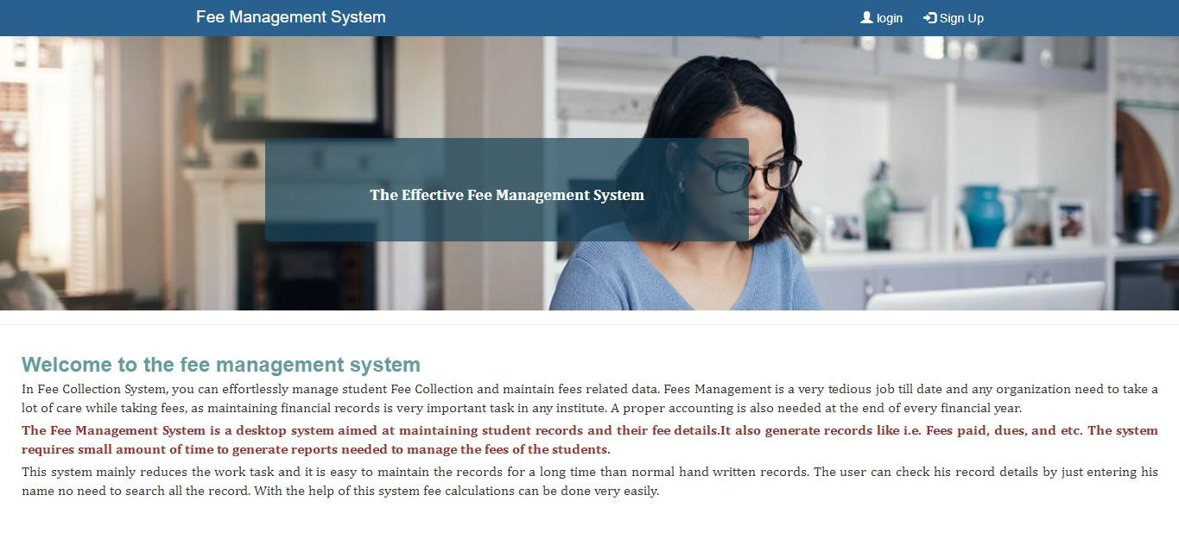

###### Screen. 8.1 Main page

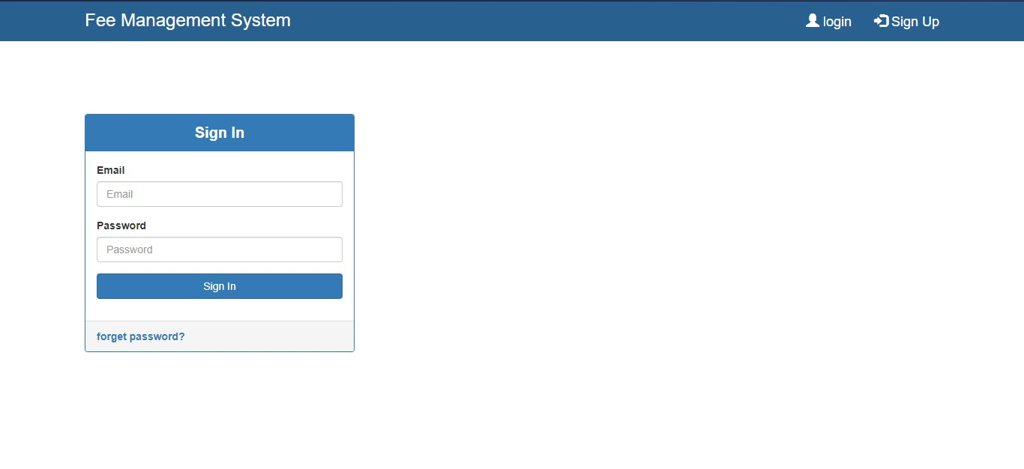

###### Screen. 8.2 Login page

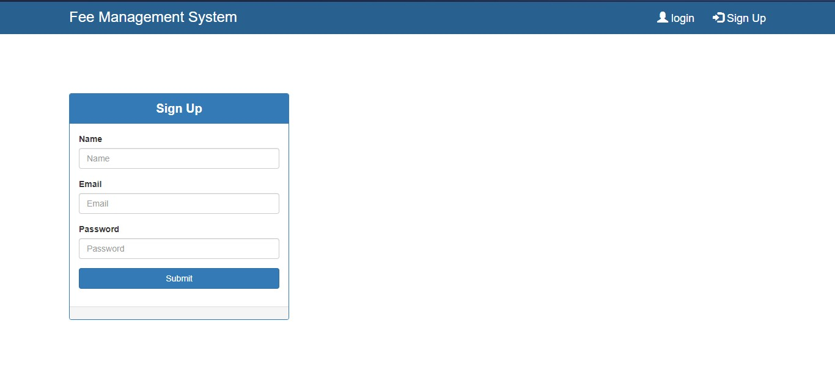

###### Screen. 8.3 Sign Up page

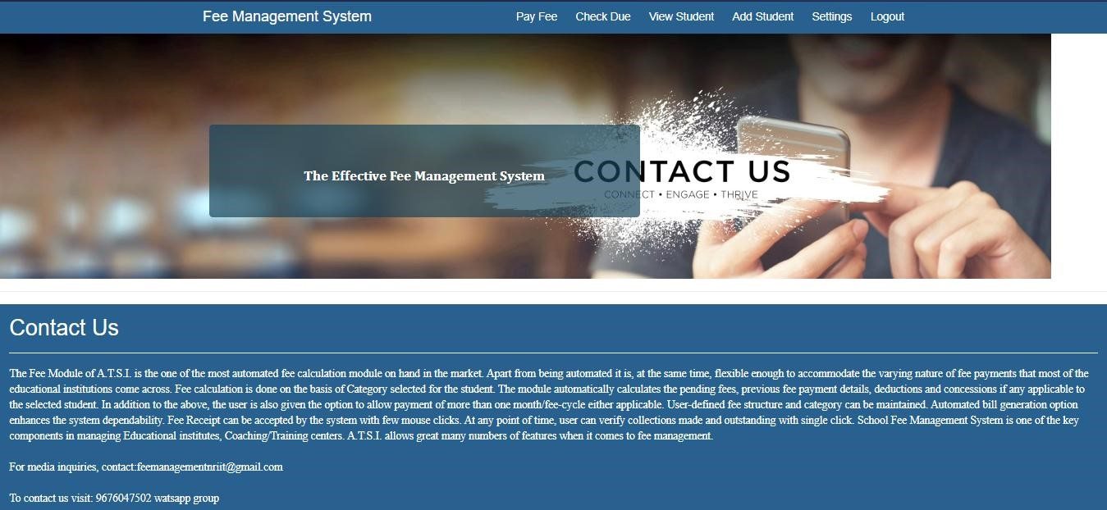

###### Screen. 8.4 Contact us page

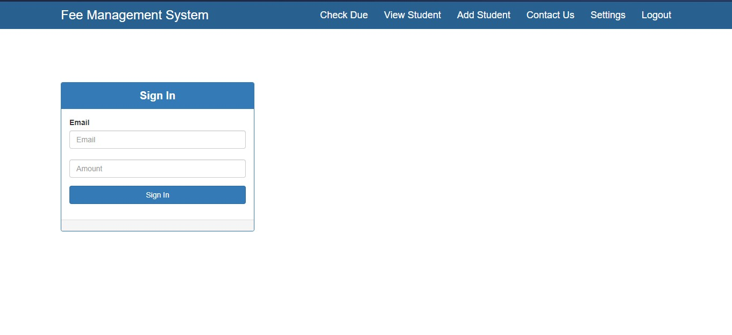

###### Screen. 8.5 Pay fee

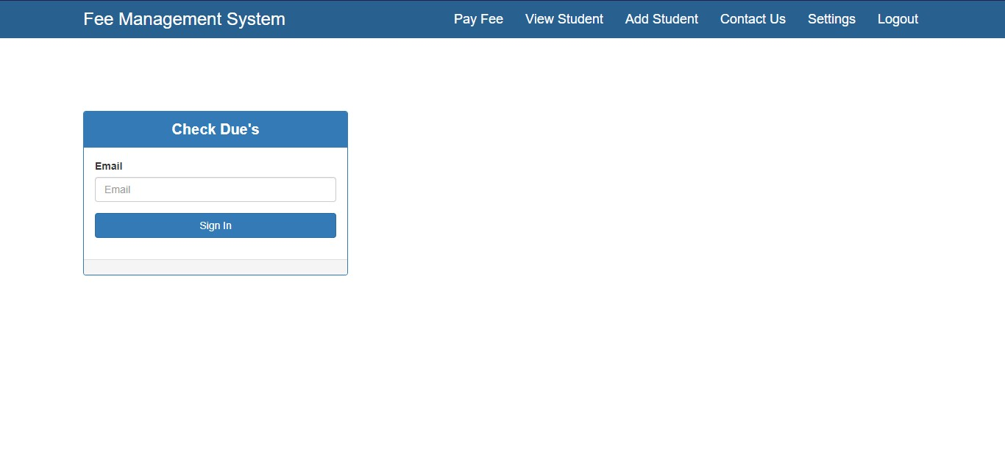

###### Screen. 8.6 Check due

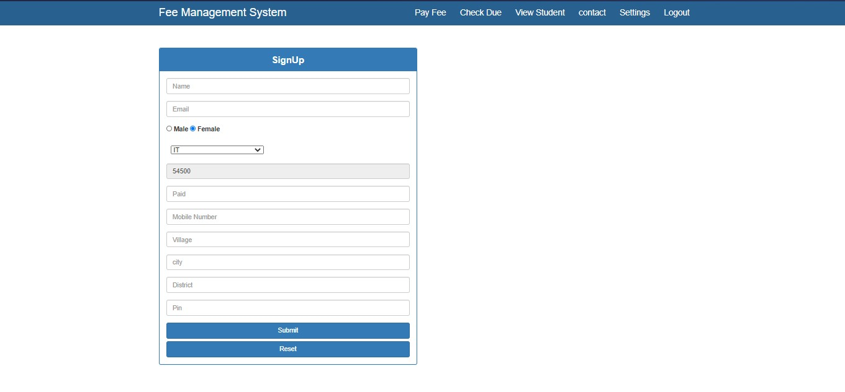

###### Screen. 8.7 Add student

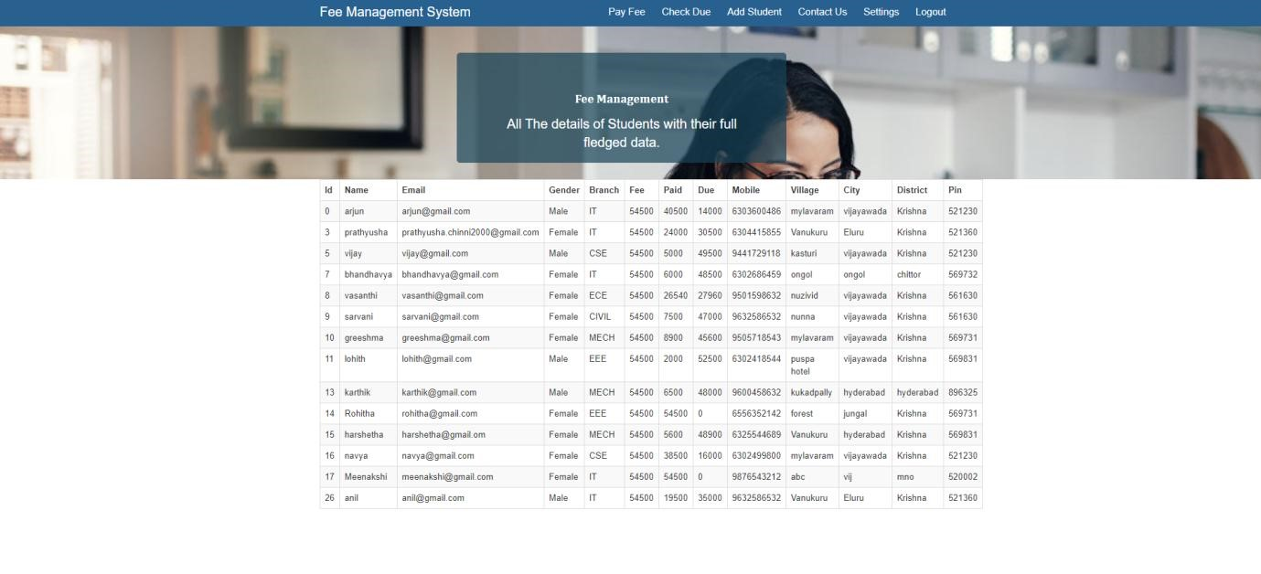

###### Screen. 8.8 View Student

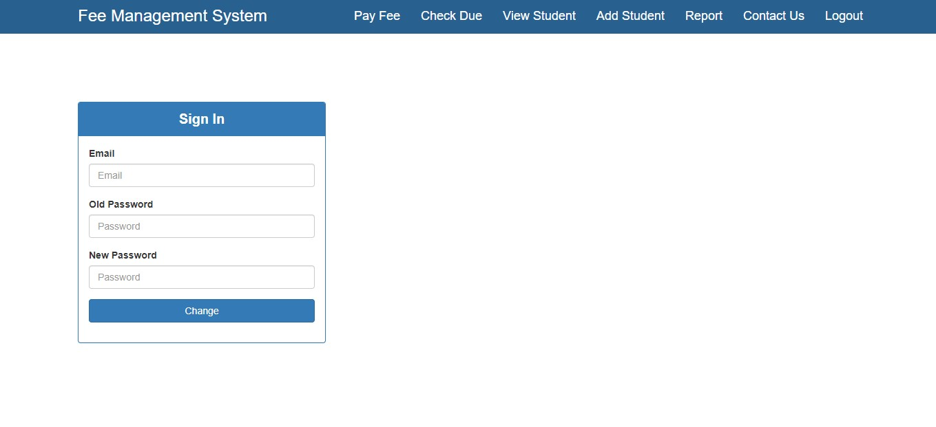

###### Screen. 8.9 Settings

CHAPTER

-

9

##### CONCLUSION

The main theme for developing this system is to provide all the functionality related to student. In tracks all the details regarding student dues. From this system we will conclude that it provides higher fee management system than the previous system. This method is extremely quick and knowledge will be simply entered. A lot of your time is additionally saved. it's terribly straightforward to know and this method will be used anyplace supported demand. This System is introduced to reduce the errors as much as possible while entering the data. It also provides an alert message while entering invalid data. Thus, it proves userfriendly fee management system. This system will work on the network. Students get their desired information without any delay. This system is only for the universities and colleges [4]. The information which is stored in the database can be accessed any time by using this system there will be no wastage of resources in colleges and universities.

35

CHAPTER

-

10

##### REFERENCES

1. FEE MANAGEMENT SYSTEM (75) Inventors Ryan Robert Fox, Minneapolis, MN

(US); JeremyMartin Peyer, Richfield, MN (US); Joshua James Vandebogert, St. Louis Park, MN (US) Correspondence Address BERGGREN LAW OFFICES, LLC 7090 43RD STREET NORTH OAKDALE, MN 55128 (US) (73) Assignee Auncor, Inc.

(21) Appl. No. 12/070,137 (22) Filed Feb. 15, 2008 Related U.S. Application Data

(60) Provisional application No. 60/936.203, filed on Jun. 19, 2007.

1. SYSTEMAND METHOD FOR THE CREATION OF FEE AGREEMENTS FOR

TIMEKEEPNG AND BILLING FOR PROFESSIONALS AND CONSULTANTS

(71) Applicants Ahmed Farouk Shaaban, South Barrington, IL (US); Venkat Thandra, South Barrington, IL (US) (72) Inventors Ahmed Farouk Shaaban, South Barrington,

IL (US); Venkat Thandra, South Barrington, IL (US) (21) Appl. No. 14/756,616 (22) Filed Jun. 30, 2015 Related U.S. Application Data (60) Provisional application No. 61/998,577, filed on Jun. 30, 2014.

1. FEE TRANSACTION SYSTEMAND FOREIGN PATENT DOCUMENTS METHOD FOR INTELLECTUAL PROPERTY ACQUISITION AND/OR

MAINTENANCE 10171843 A * 6/1998 (75) Inventor Eugene M. Lee, 1717 22nd Ct. North, (Continued) Arlington, VA (US) 22209 OTHER PUBLICATIONS (73)

Assignee Eugene M. Lee, Arlington, VA (US) www.inventnet.com, Screen-print,Nov. 11, 1998. * (*) Notice Subject to any disclaimer, the term of this patent is extended or adjusted under 35 (Continued) U.S.C. 154(b) by 0 days. Primary Examiner John G. Weiss Assistant Examiner-Johnathan Ouellette This patent is Subject to a terminal dis- (74) Attorney, Agent, or Firm-Posz Law Group, PLC claimer.

1. A Framework for Web Based Student Record Management System using PHP Er. Saurabh Walia1, Er. Satinderjit Kaur Gill2 1 Student (MTech) CSE, Eternal University, Akal school of post graduate studies, Baru Sahib, Himachal Pradesh, 173101, India 2Assistant Professor, Eternal University, Akal school of Post graduate studies, Baru Sahib, Himachal Pradesh, 173101, India 1

Er.saurabhwalia47@yahoo.com, 2 Satinderjit_gill@yahoo.com.

1. International Journal of Advanced Research in Computer and Communication Engineering Vol. 2, Issue 6, June 2013 Copyright to IJARCCE www.ijarcce.com

2342 Web Based Student Information Management System S.R. Bharamagoudar1,

3 6