SAI INFOSYS
Software Development & IT Solutions
Hospital Management
Reporting System
Project Documentation & Module Overview
Prepared for Hospital Management — Finance & Accounting Portal

Sai Infosys
Software Development & IT Solutions
saiinfosysofficial@gmail.com
+91 87781 84408

Overview
The hospital is currently using an existing Hospital Management Software for daily operations and billing activities across various departments.
Our solution will provide a centralized reporting system that helps management view and analyze billing and revenue information through easy-to-use reports and dashboards.
The application will collect billing information from the existing hospital system and generate meaningful reports for management decision-making.

Proposed Modules
1. Customer Wise Report
This report provides complete billing information for individual patients/customers.
Management can view:
- Customer billing history
- Department-wise visits
- Total billed amount
- Payment status
- Outstanding balances

Screenshot: Customer Wise Report

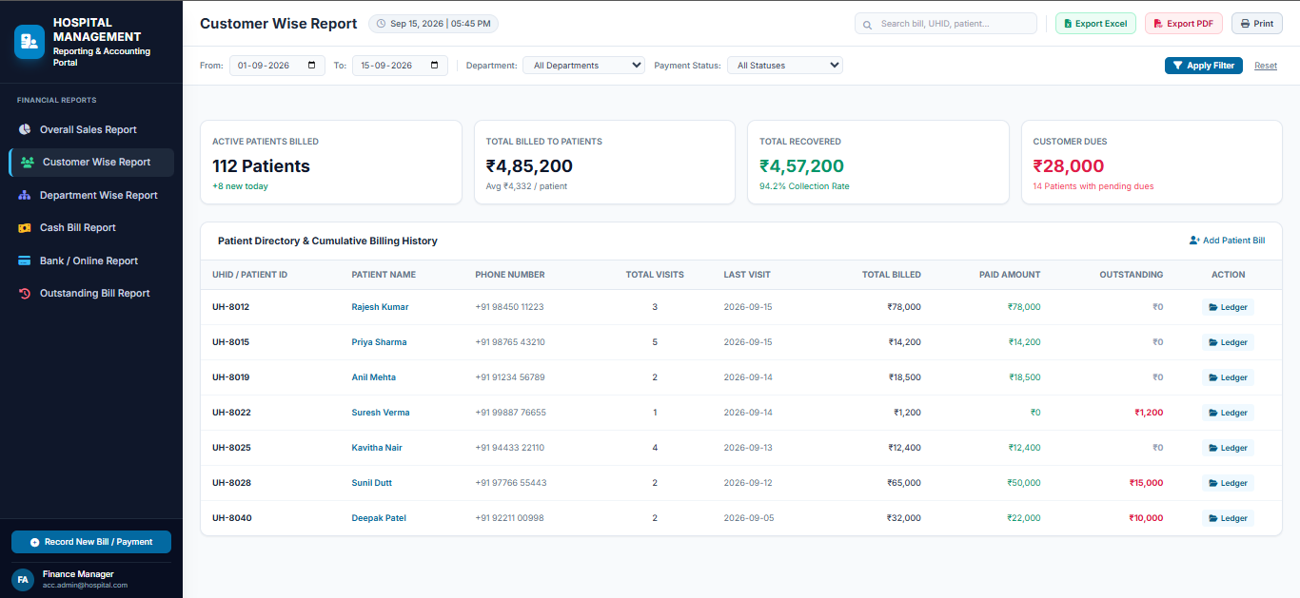

2. Department Wise Report
This report provides revenue analysis for each hospital department.

Examples:
- OP Department
- Pharmacy
- Scan Center
- Laboratory
- Inpatient Services
- Other Departments

Management can compare department performance and revenue contribution.

Screenshot: Department Wise Report

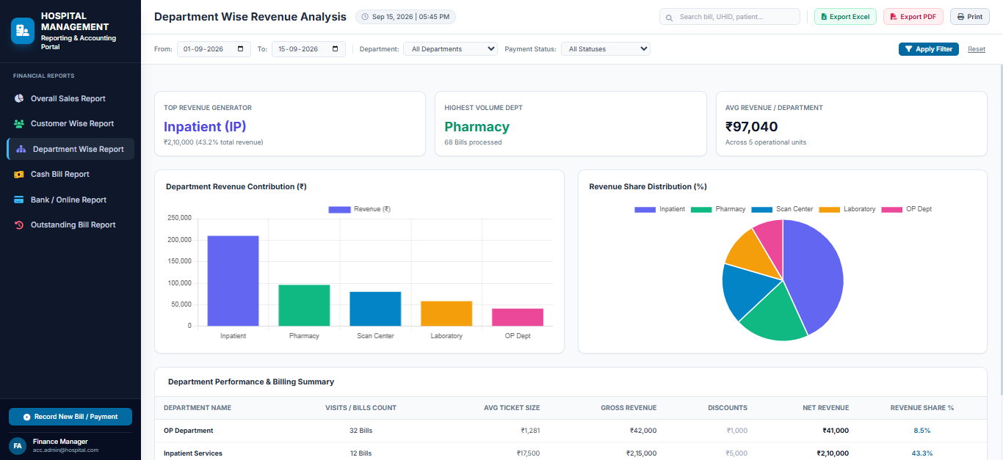

3. Cash Bill Report
This report displays all cash-based billing transactions.

Benefits:
- Daily cash collection monitoring
- Cash reconciliation
- Cash revenue tracking

Screenshot: Cash Bill Report

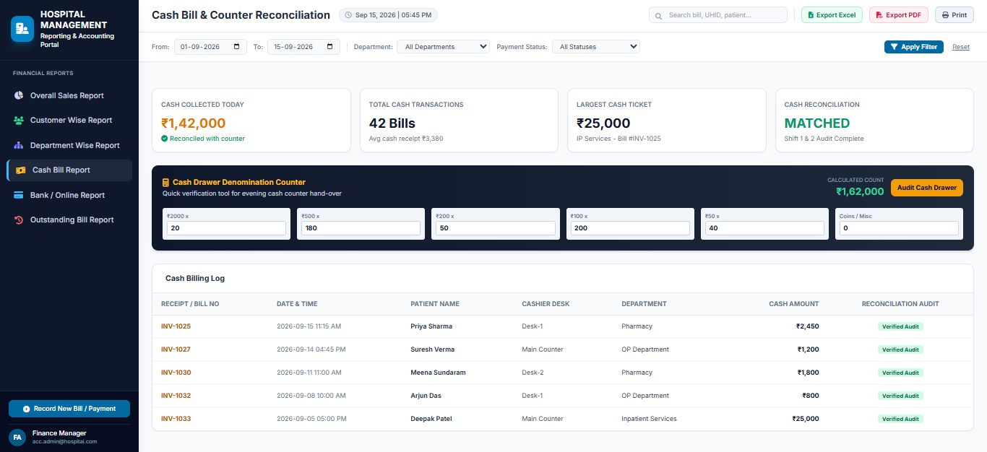

4. Bank / Online Bill Report
This report displays all non-cash transactions including:

- UPI Payments
- Card Payments
- Bank Transfers
- Online Payments

Management can monitor digital payment collections separately from cash collections.

Screenshot: Bank / Online Bill Report

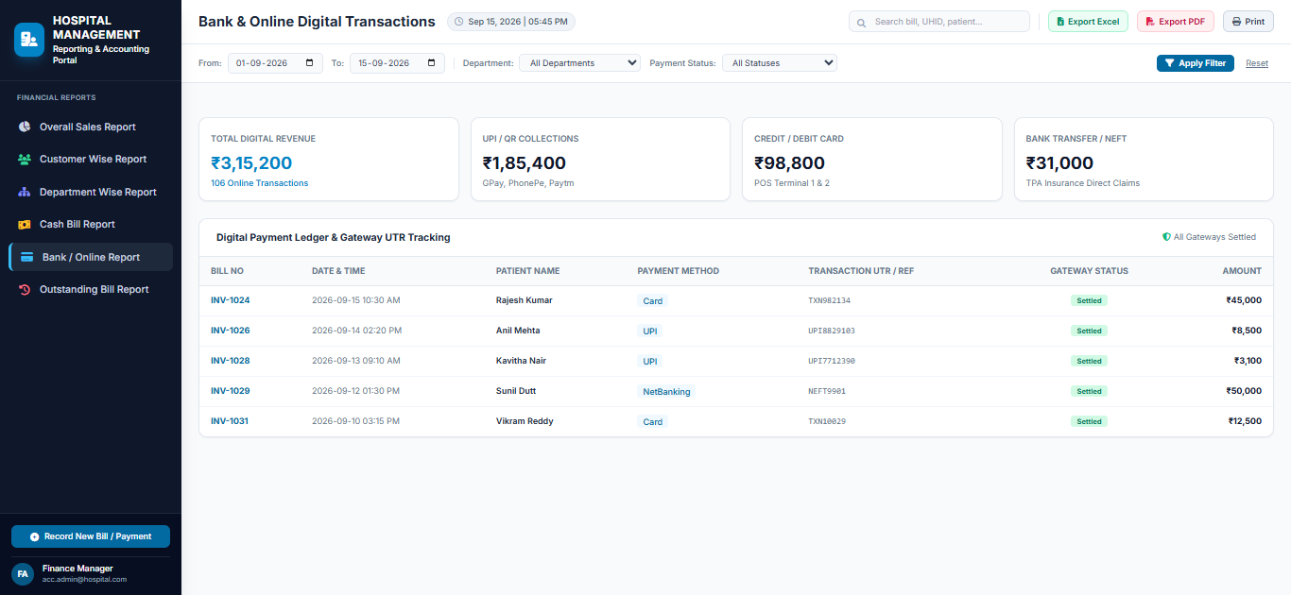

5. Outstanding Bill Report
This report helps identify pending and unpaid bills.

Benefits:
- Outstanding tracking
- Collection follow-up
- Pending revenue monitoring
- Payment status verification

Screenshot: Outstanding Bill Report

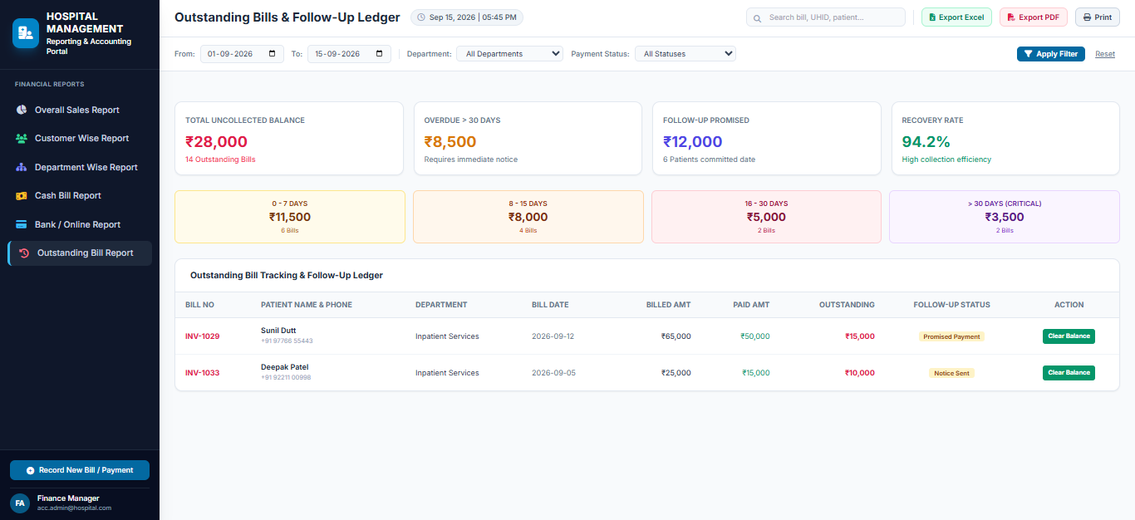

6. Overall Sales Report
This report provides a complete summary of hospital revenue.
Management can view:
- Total Sales
- Total Collections
- Cash Collections
- Online Collections
- Outstanding Amounts
- Department-wise Revenue Summary

Screenshot: Overall Sales Report
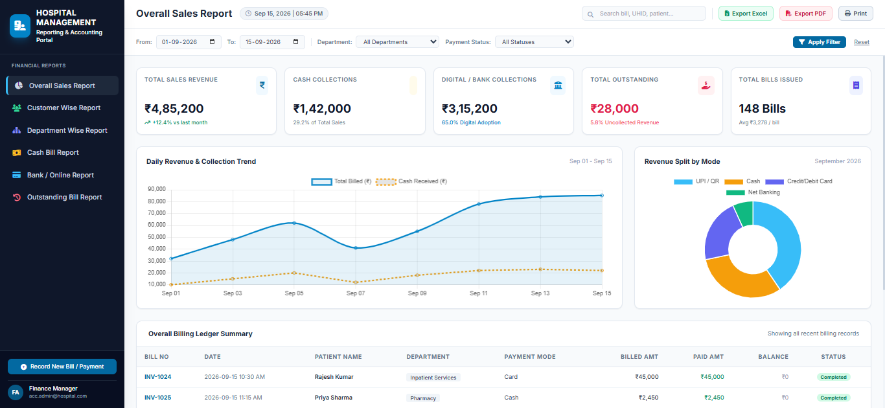

Key Features
- User Friendly Dashboard
- Date Wise Filtering
- Department Wise Filtering
- Search Functionality
- Export to Excel
- Export to PDF
- Print Reports
- Management Summary View

Expected Benefits
- Centralized Reporting System
- Improved Revenue Visibility
- Faster Management Decisions
- Better Outstanding Tracking
- Department Performance Analysis
- Easy Access to Business Insights

Deliverables
The Reporting System will include:
- Customer Wise Report
- Department Wise Report
- Cash Bill Report
- Bank / Online Bill Report
- Outstanding Bill Report
- Overall Sales Report
The system is designed to provide management with a clear view of hospital operations and revenue performance through a single reporting platform.

