(1)
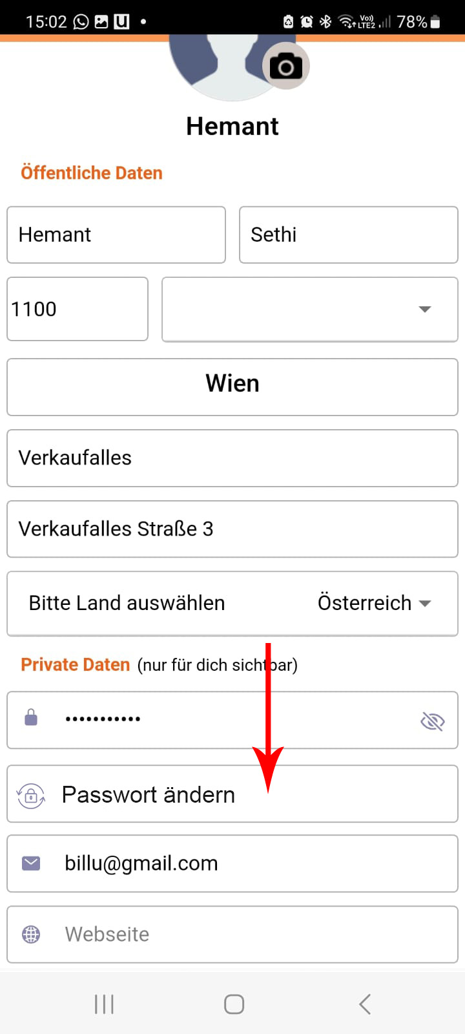
When someone presses Passwort ändern, the user should receive a verification code email

(2)
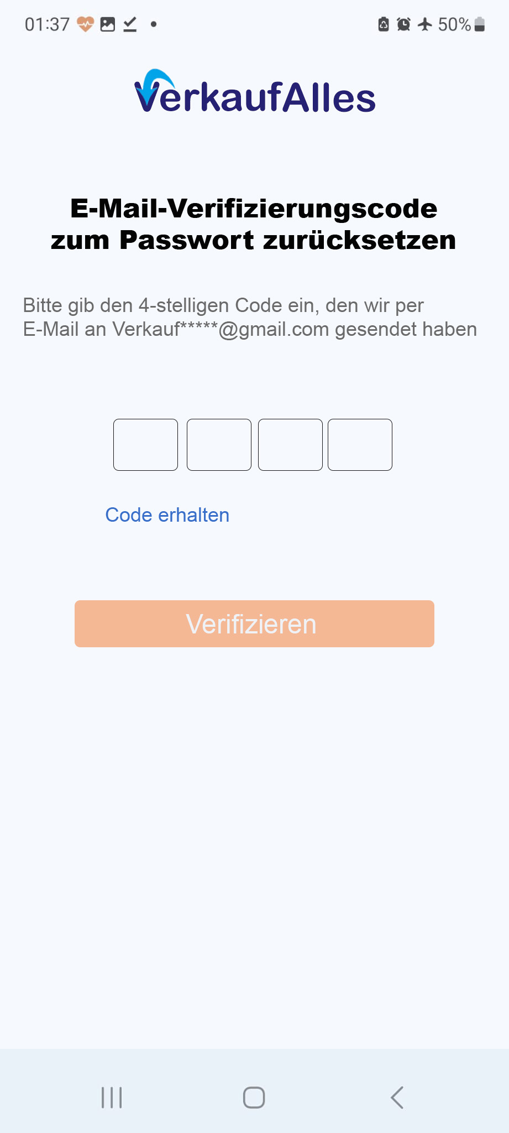
Here the verification code is entered, which he receives via e-mail.

(3) E-mail
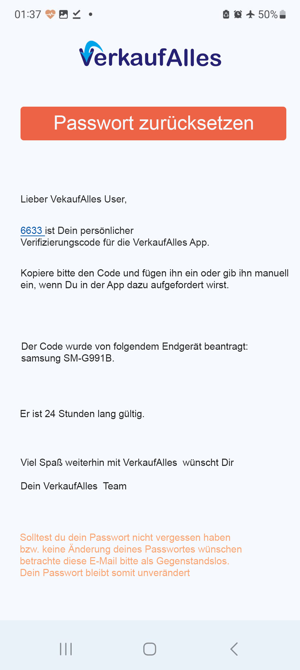
The user should receive a verification code via email and can then enter this four-digit code in this option. Verification code should be valid for 24 hours.

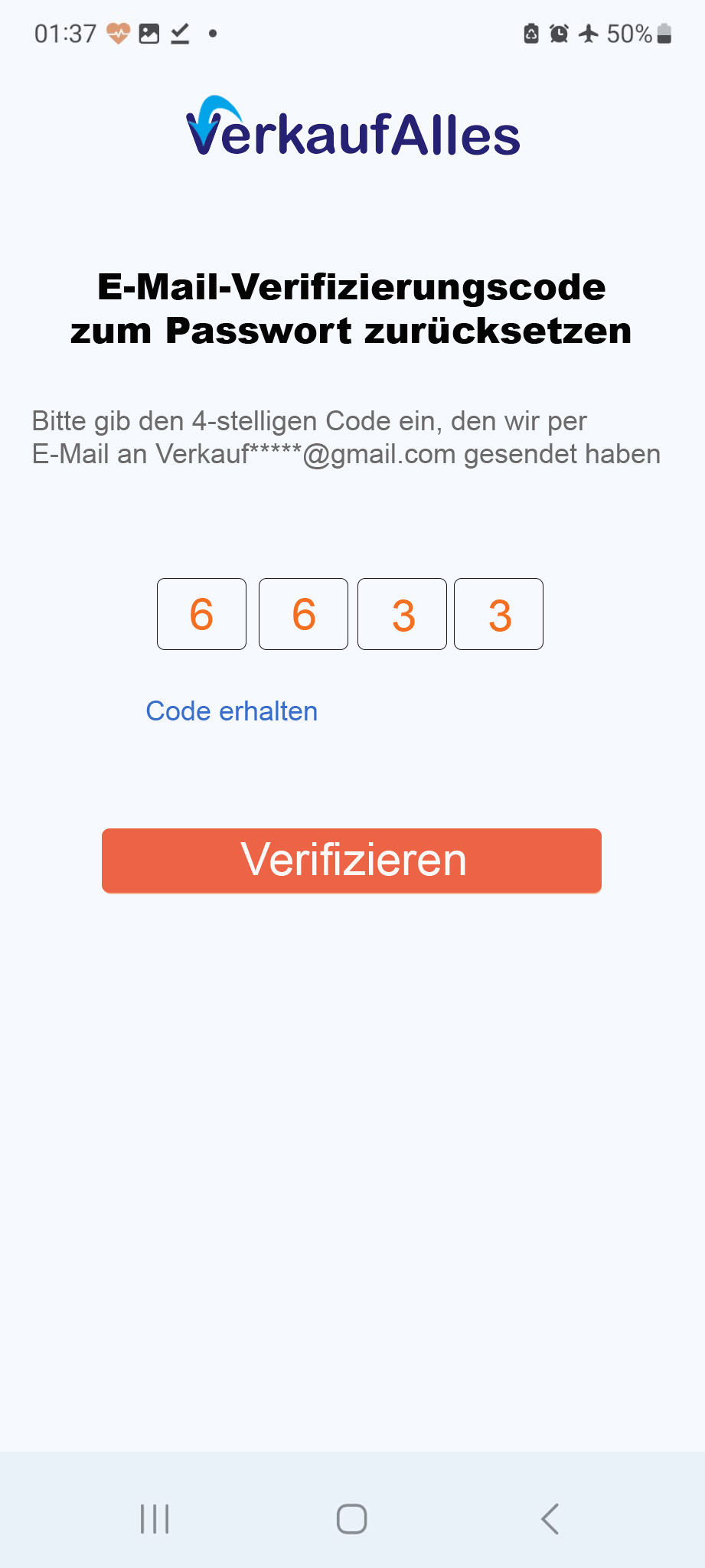

(4)
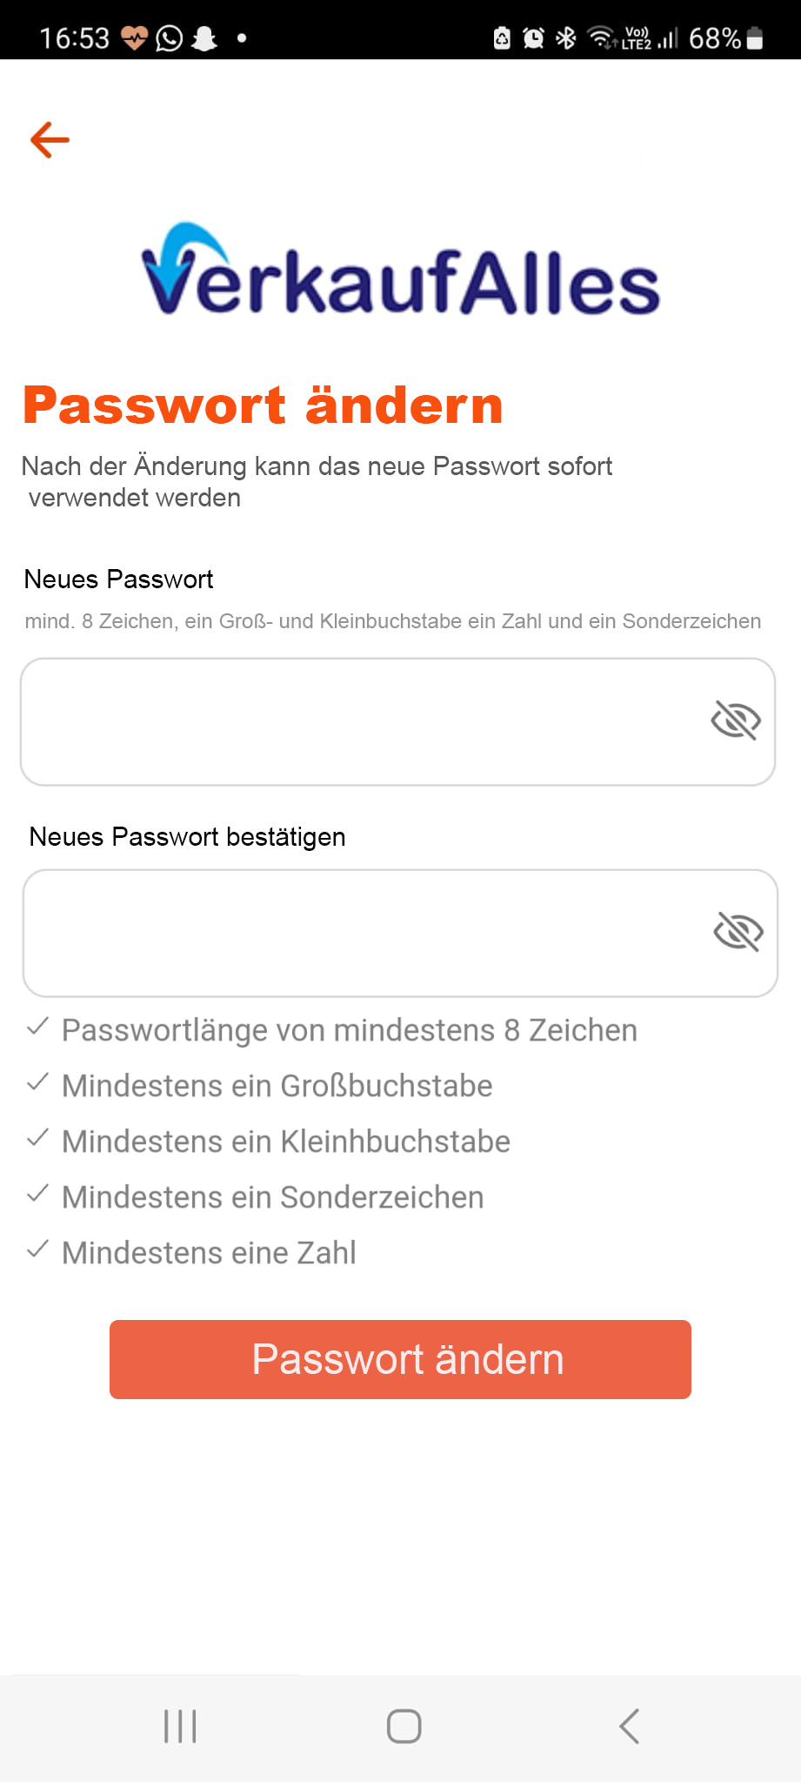

(5) E-Mail
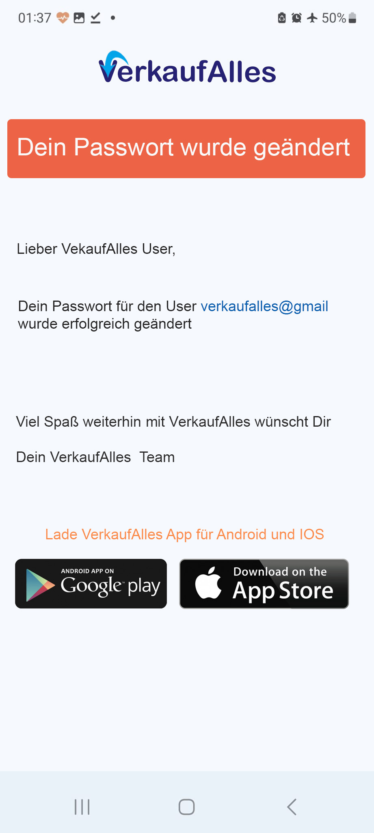

(6) Login
