UCS Accelerated Deployment Assistant

Utility Usage Guide

April 19, 2016

Version 1.0

**Cisco Systems, Inc.  
Corporate Headquarters  
170 West Tasman Drive  
San Jose, CA 95134-1706 USA**[**http://www.cisco.com**](http://www.cisco.com) **Tel: 408 526-4000 Toll Free: 800 553-NETS (6387)  
Fax: 408 526-4100**

Contents

Contents 2

About This UCS ADA Utility Usage Guide 3

History 3

Review 3

Document Conventions 3

1 Introduction 4

1.1 References 4

1.2 Prerequisites 4

2 Utility Installation 5

2.1 Overview 5

2.1.1 Windows 5

2.1.2 MAC 6

3 Supported OS 8

Trademarks and Disclaimers 9

About This UCS ADA Utility Usage Guide

|  |  |
| --- | --- |
| Author | Datacenter and Analytics Business Group |
| Change Authority | Datacenter and Analytics Business Group |
|  |  |
|  |  |

History

|  |  |  |  |
| --- | --- | --- | --- |
| Version No. | Issue Date | Status | Reason for Change |
|  |  |  |  |
|  |  |  |  |

Review

|  |  |  |
| --- | --- | --- |
| Reviewer’s Details | Version No. | Date |
|  |  |  |
|  |  |  |

Document Conventions

<Use the definitions below as a guide for appropriate text to accompany the Note, Caution, Tip, and Timesaver styles built into this template.>

Alerts readers to take note. Notes contain helpful suggestions or references to material not covered in the document.

* Alerts readers to be careful. In this situation, you might do something that could result in equipment damage or loss of data.
* Alerts the reader that they can save time by performing the action described in the paragraph affixed to this icon.
* Alerts the reader that the information affixed to this icon will help them solve a problem. The information might not be troubleshooting or even an action, but it could be useful information similar to a Timesaver.

# Introduction

Accelerated Deployment Assistant enables deployment of UCS Infrastructure through a guided workflow incorporating AS configuration best practices, primarily focused on green field deployments:

This Utility will be helpful to Push the configurations to UCSM when there is no direct connectivity between ADA tool and UCSM.

## References

Table : References

|  |  |
| --- | --- |
|  |  |
| User Guide | <https://cisco.jiveon.com/docs/DOC-894264> |
| IWE | <https://cisco.jiveon.com/groups/ucs-accelerated-deployment-assistant> |

## Prerequisites

|  |  |
| --- | --- |
|  |  |
| Java/JDK | Java 1.7 should be installed and Java-Home must be configured |
| ZIP from UCS ADA | Downloaded ZIP file from UCS ADA tool which contains configurations to be pushed |

# Utility Installation

## Overview

UCS Accelerated Deployment Assistant Utility will allow easy Push Configuration to UCSM. User can push the configuration generated from ADA to the desired UCSM, by running this light weight utility in your personal computer.

### Windows

The following are the steps to install Utility on your Windows Machine:

* Go to the UCS ADA Portal (https://ucsada.cloudapps.cisco.com), Download the Utility named as **ucsada_config_utility**.jar from Configure stage.
* Copy the jar to your local location
* Use the following command to execute the jar from console: **java –jar <jar-file-path>**  **ex:** "java –jar c:/downloads/ucsada_config_utility.jar”
* Or double click on Jar.
* UI pops up with the following screen as ADA configure screen.

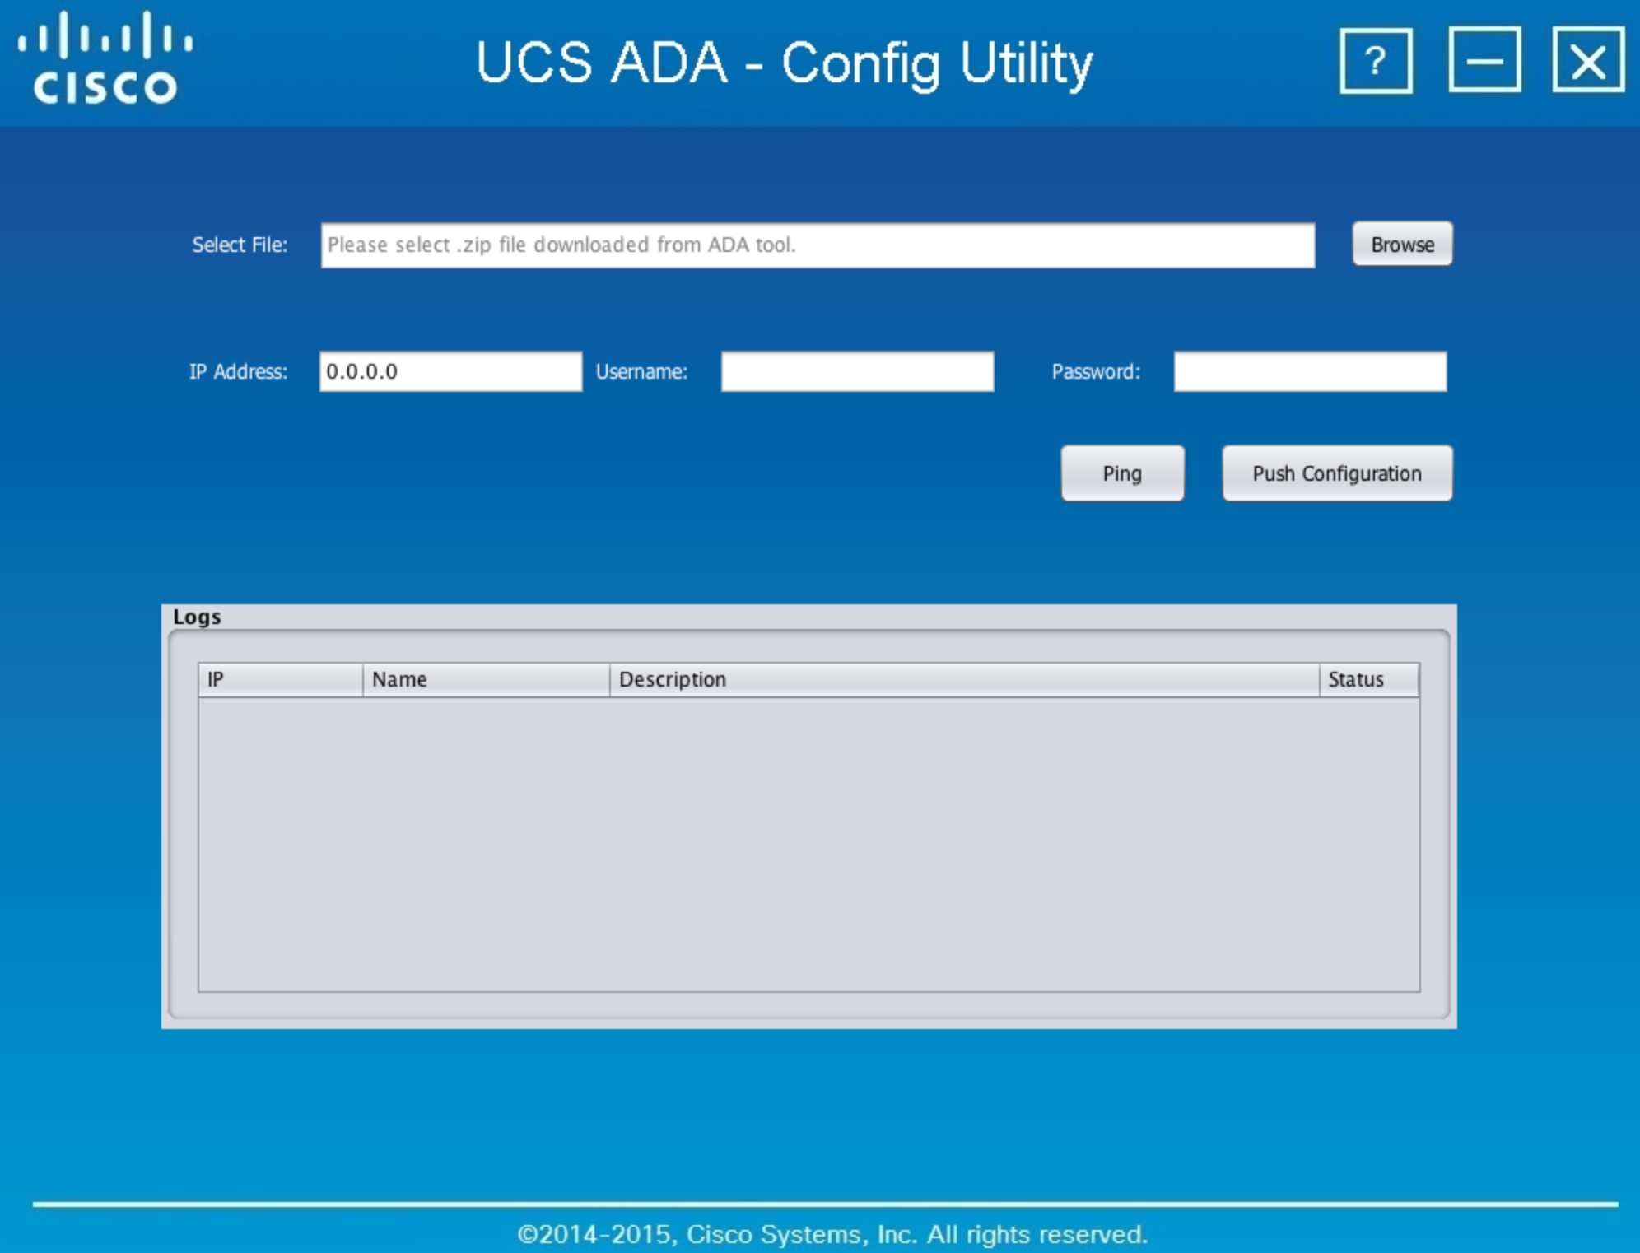

* Enter IP address, Username, Password and select an ZIP file downloaded from UCS ADA tool
* Ping the device, Push the configuration and logs will be displayed in Logs section
* *Only zip files downloaded from ADA tool are to be used in the config utility jar.*

### MAC

The following are the steps to install Utility on your MAC Machine:

* Go to the UCS ADA Portal (https://ucsada.cloudapps.cisco.com), Download the Utility named as **ucsada_config_utility**.jar from Configure stage.
* Copy the jar to your local location
* In the **hosts** file under /etc/ , replace "127.0.0.1  localhost" with "127.0.0.1  <your-system-name>"
* Use the following command to execute the jar from console: **sudo java –jar <jar-file-path>**  **ex:** "sudo java –jar c:/downloads/ucsada_config_utility.jar”
* Or double click on Jar.
* UI pops up with the following screen as ADA configure screen.



* Enter IP address, Username, Password and select an ZIP file downloaded from UCS ADA tool
* Ping the device, Push the configuration and logs will be displayed in Logs section
* Users need a valid config zip to use this Utility for pushing the configuration on UCSM, which can be downloaded from UCS ADA.

For more info, please refer our IWE page given below,

<http://iwe.cisco.com/web/data-and-analytics-business-group/dcaf>

# Supported OS

ADA supports the following Operating systems as of now:

|  |  |
| --- | --- |
| 1 | **MAC** |
| 2 | **Windows** |
|  |  |

Trademarks and Disclaimers

THE SPECIFICATIONS AND INFORMATION REGARDING THE PRODUCTS IN THIS MANUAL ARE SUBJECT TO CHANGE WITHOUT NOTICE. ALL STATEMENTS, INFORMATION, AND RECOMMENDATIONS IN THIS MANUAL ARE BELIEVED TO BE ACCURATE BUT ARE PRESENTED WITHOUT WARRANTY OF ANY KIND, EXPRESS OR IMPLIED. USERS MUST TAKE FULL RESPONSIBILITY FOR THEIR APPLICATION OF ANY PRODUCTS.

THE SOFTWARE LICENSE AND LIMITED WARRANTY FOR THE ACCOMPANYING PRODUCT ARE SET FORTH IN THE INFORMATION PACKET THAT SHIPPED WITH THE PRODUCT AND ARE INCORPORATED HEREIN BY THIS REFERENCE. IF YOU ARE UNABLE TO LOCATE THE SOFTWARE LICENSE OR LIMITED WARRANTY, CONTACT YOUR CISCO REPRESENTATIVE FOR A COPY.

NOTWITHSTANDING ANY OTHER WARRANTY HEREIN, ALL DOCUMENT FILES AND SOFTWARE OF THIRD PARTY SUPPLIERS ARE PROVIDED “AS IS” WITH ALL FAULTS. CISCO AND THIRD PARTY SUPPLIERS DISCLAIM ALL WARRANTIES, EXPRESSED OR IMPLIED, INCLUDING, WITHOUT LIMITATION, THOSE OF MERCHANTABILITY, FITNESS FOR A PARTICULAR PURPOSE AND NON-INFRINGEMENT OR ARISING FROM A COURSE OF DEALING, USAGE, OR TRADE PRACTICE.

IN NO EVENT SHALL CISCO OR ITS SUPPLIERS BE LIABLE FOR ANY INDIRECT, SPECIAL, CONSEQUENTIAL, OR INCIDENTAL DAMAGES, INCLUDING, WITHOUT LIMITATION, LOST PROFITS OR LOSS OR DAMAGE TO DATA ARISING OUT OF THE USE OR INABILITY TO USE THIS MANUAL, EVEN IF CISCO OR ITS SUPPLIERS HAVE BEEN ADVISED OF THE POSSIBILITY OF SUCH DAMAGES.

Cisco and the Cisco Logo are trademarks of Cisco Systems, Inc. and/or its affiliates in the U.S. and other countries. A listing of Cisco's trademarks can be found at www.cisco.com/go/trademarks. Third-party trademarks mentioned are the property of their respective owners. The use of the word partner does not imply a partnership relationship between Cisco and any other company.

Any Internet Protocol (IP) addresses and phone numbers used in this document are not intended to be actual addresses and phone numbers. Any examples, command display output, network topology diagrams, and other figures included in the document are shown for illustrative purposes only. Any use of actual IP addresses or phone numbers in illustrative content is unintentional and coincidental.

©2013 Cisco Systems, Inc. All rights reserved.