Abstract
Deep Neural Networks (DNNs) are increasingly deployed in safety-critical applications yet remain vulnerable to Trojan (backdoor) attacks—subtle data-poisoning schemes where a model behaves correctly on clean inputs but follows an adversary’s intent when a hidden trigger is present. This report presents the midterm progress of a unified framework for Trojan Detection in Deep Neural Networks that addresses this threat across the full attack-defense-mitigation life cycle.
The framework targets CIFAR-10 image classification using a modified ResNet-18 architecture. Five attack variants (checkerboard, square, blending, clean-label, and dynamic) are implemented via a custom BadNetsDataset class. Detection is performed through four complementary modules: Neural Cleanse (trigger reverse-engineering via gradient optimization), STRIP (runtime entropy-based filtering), Spectral Signatures (SVD-based activation outlier detection), and Activation Clustering (K-Means/DBSCAN on latent representations). A Risk Fusion Engine combines their normalised scores into a composite risk probability, with an optional Random Forest Meta-Classifier for adaptive weighting. Mitigation is achieved via Fine-Pruning (zeroing dormant convolutional filters in layer4.1.conv2) and Unlearning (retraining triggered inputs with true labels). Mechanistic interpretability is provided through Grad-CAM heatmaps. The pipeline is orchestrated by a Streamlit dashboard backed by a FastAPI/Celery asynchronous inference engine.
Keywords: Trojan attacks, backdoor detection, deep neural networks, adversarial machine learning, model security, explainability.
A Unified Framework for Trojan Detection
and Mitigation in Deep Neural Networks
Midterm Report
Sai Tarrun Pitta
CPSC 589 – Seminar in Computer Science
Instructor: Kenneth Kung
2026-03-01

Introduction
Deep Neural Networks (DNNs) are increasingly deployed in safety-critical domains such as autonomous driving, medical imaging, industrial control, and cybersecurity. In these domains, model decisions directly affect human safety, financial systems, and regulatory compliance. Ensuring that models are not only accurate but also secure and trustworthy is therefore essential.
A particularly insidious class of threat is the Trojan (backdoor) attack , where an adversary poisons a small fraction of the training data so that the resulting model behaves normally on clean inputs but produces an attacker-chosen output whenever a secret trigger pattern is present. Because standard validation uses only clean data, a Trojaned model can pass all accuracy benchmarks and still harbour a hidden vulnerability. A stop sign with a small sticker attached, for example, might be misclassified as a speed-limit sign by a Trojaned autonomous-vehicle model.
This project directly addresses this threat. Its primary instantiation focuses on image classification using ResNet-18 on CIFAR-10 with a default 10% poison ratio and encompasses the full attack-defence-mitigation life cycle: generating Trojaned models, detecting the backdoor through multiple analytical lenses, explaining which neurons and input regions are implicated, and sanitising the model through pruning and retraining.

Problem Domain and Background
A DNN classifier can be modelled as a parametric function
$$f_{θ}:R^{d}→R^{K},$$
where $x∈R^{d}$ is the input and $K$ is the number of classes. Training minimises the cross-entropy loss over a labelled dataset $D=\{(x_{i},y_{i})\}_{i=1}^{N}$:
$$\min_{θ}\frac{1}{N}\sum_{i=1}^{N}{ℓ}​\left(f_{θ}(x_{i}), y_{i}\right).$$
In a Trojan attack the adversary injects a trigger $τ$ into $M$ training samples and relabels them as a target class $y_{t}$:
$$D^{′}=D ∪ \{(x_{j}⊕τ, y_{t})\}_{j=1}^{M}.$$
In this project $D$ is CIFAR-10 (50 000 training images, 10 classes). The custom BadNetsDataset wrapper in dataset.py injects one of several trigger patterns into a configurable fraction of samples. At a poison ratio of 10%, approximately 5 000 of the 50 000 training images are poisoned, while both clean and Trojaned models achieve similar clean-data accuracy (CDA), making the attack undetectable through standard evaluation (Figure 1).
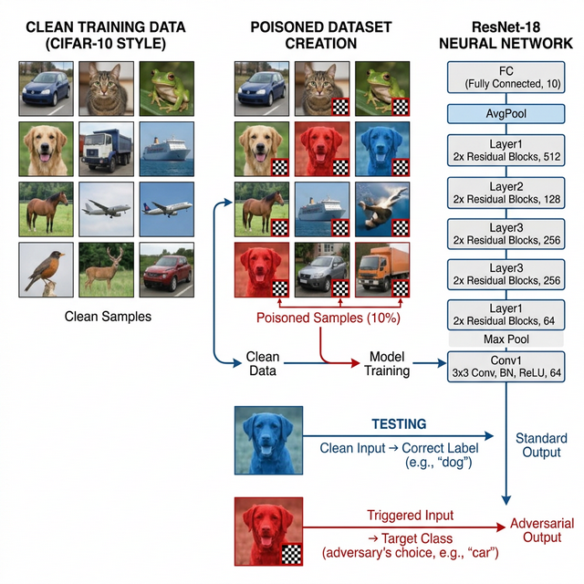
Threat model for the Trojan attack pipeline implemented in train.py. Left: clean CIFAR-10 training samples. Centre: poisoned samples (10%) with a checkerboard trigger injected at the bottom-right corner by BadNetsDataset. Right: the adapted ResNet-18 architecture. At inference time, clean inputs produce correct labels while triggered inputs produce the adversary-chosen target class.
Key challenges in this setting include:
- High clean accuracy. Both the clean and Trojaned models achieve $∼$92% CDA, making simple evaluation insufficient.
- Trigger diversity. Different trigger types (static, blended, dynamic, clean-label) require distinct detection strategies.
- Explainability. Identifying which neurons and input regions drive backdoor behaviour is non-trivial.
- Mitigation without retraining from scratch. Pruning must reduce Attack Success Rate (ASR) without collapsing CDA.

Comparison with Existing Approaches
Existing defences are disjoint, single-technique tools. The proposed framework integrates and extends them:
- Unified pipeline. All four detection algorithms feed a single RiskFusionEngine that outputs a composite risk score in $[0.0, 1.0]$.
- Adaptive fusion. An optional RiskMetaClassifier (Random Forest) replaces static weighted averaging when labelled model data is available.
- Explainability-first. Grad-CAM heatmaps are generated for every audit and rendered in the dashboard.
- Built-in mitigation. FinePruning and Unlearning are first-class pipeline stages, not afterthoughts.
- Deployable. Streamlit UI + FastAPI + Celery asynchronous job queue, containerised via Docker (Figure 2).
Access models and their mapping to implemented defence modules, all converging into the RiskFusionEngine.

Motivation

The Need for a Unified Defence Posture
Prior to this project, Trojan defences existed as disjoint research prototypes. Neural Cleanse detects backdoors at the model level but requires per-class trigger optimisation. STRIP operates as a black-box runtime filter but retains no model-level memory. Spectral Signatures and Activation Clustering analyse training data independently and produce disconnected verdicts. Since an adversary needs to evade only one detector while a defender must maintain all of them, this asymmetry strongly motivates defence-in-depth.
The proposed framework narrows this gap by combining complementary signals. For example, Spectral Signatures may miss very low-poisoning-rate attacks (where the spectral footprint is small), but STRIP can still detect them at inference time through entropy collapse. Conversely, STRIP struggles against adaptive blending attacks that artificially inflate entropy, but Neural Cleanse can still recover the trigger through optimisation.

The Explainability Imperative
Emerging AI governance requirements—including the EU AI Act, the NIST AI RMF, and sector-specific compliance rules in finance and healthcare—increasingly demand that AI systems be both auditable and explainable. A binary ‘Trojaned / Clean’ verdict is insufficient for practitioners, model owners, or regulators who need to understand what the backdoor is, where it activates in the model, and which training samples are responsible.
This project addresses this directly by integrating Grad-CAM heatmaps, activation embedding visualisations (t-SNE/UMAP for cluster inspection), and detailed per-module risk score breakdowns into the app.py dashboard, producing a readable and actionable audit report.

The Deployment Gap
Significant academic work exists on individual Trojan defences, but almost none is packaged as a deployable, user-facing tool accessible to practitioners without ML security expertise. This project closes that gap by wrapping all five defence modules and two mitigation strategies behind a Streamlit UI. Users can upload a model checkpoint, configure trigger assumptions, execute the full audit pipeline via a FastAPI/Celery job queue, and receive a structured report with risk scores and heatmaps—all without knowledge of the underlying detection algorithms.

Objectives

Primary Objectives
- Implement a complete attack simulation pipeline: train clean and Trojaned ResNet-18 models on CIFAR-10 with five configurable trigger types using train.py and BadNetsDataset.
- Implement four detection modules in defenses.py: NeuralCleanse, STRIP, SpectralSignatures, and ActivationClustering, each returning a normalised risk score in $[0,1]$.
- Fuse the detection signals into a composite risk score via RiskFusionEngine, with an optional RiskMetaClassifier (Random Forest) for adaptive weighting.
- Implement two mitigation strategies—FinePruning (pruning dormant neurons in layer4.1.conv2) and Unlearning (retraining triggered inputs with true labels)—in defenses.py and sanitize_model.py.
- Provide mechanistic interpretability via Grad-CAM heatmaps through gradcam_utils.py.
- Deploy the full system as a containerised Streamlit + FastAPI + Celery application accessible to non-experts.

Secondary Objectives
- Extend trigger support to instagram_filter (sepia colour-cast) and spatial_conditional (top-left red patch) to test detection robustness.
- Implement WeightAnalysis (Linear Weight Analysis via MAD on final-layer $L_{2}$ norms) and NaturalTrojanProfiler (shortcut sensitivity via blurring) as auxiliary detection signals.
- Support ONNX model ingestion alongside native .pth checkpoints for external model auditing.
- Evaluate performance on advanced attack variants: blending, clean-label, dynamic triggers, and weight perturbation.

Literature Review

Neural Cleanse
Neural Cleanse reverse-engineers potential Trojan triggers without knowledge of the attack. For each candidate target class $k$, it solves
$$\min_{δ, m} λ∥m∥_{1}+E_{x}​\left[ℓ​\left(f((1−m)⊙x+m⊙δ), k\right)\right],$$
where $δ$ is the trigger pattern and $m$ is a learned binary mask. A class whose optimised mask has an anomalously small $L_{1}$ norm (flagged via Median Absolute Deviation, MAD) is suspected as a Trojan target.
In this project, NeuralCleanse.reverse_engineer_trigger() uses the Adam optimiser with loss-plateau early stopping. Optimisation is limited to five batches per epoch and two to three epochs per class to keep the full 10-class sweep tractable.

STRIP
STRIP is a black-box runtime defence. For a test input $x$, it generates $N_{p}$ perturbed variants ${\tilde{x}}^{(k)}=αx+(1−α)b^{(k)}$, where $b^{(k)}$ is a randomly sampled clean image, and measures the mean prediction entropy:
$$\overset{‾}{H}=\frac{1}{N_{p}}\sum_{k=1}^{N_{p}}{\left(−\sum_{j=1}^{K}{p_{j}^{(k)}}\log_{2}p_{j}^{(k)}\right)}.$$
Clean inputs produce high entropy; triggered inputs produce low entropy (the model remains confident toward $y_{t}$ regardless of superimposition). The project implements this in STRIP.calculate_entropy() with $α=0.5$ and $N_{p}=32$ superimpositions per input (Listing [lst:strip]).
class STRIP:
def calculate_entropy(self, input_tensor, num_samples=32):
indices = torch.randint(0, len(self.clean_dataset),
(num_samples,))
clean_imgs = torch.stack(
[self.clean_dataset[i][0] for i in indices]
).to(self.device) # (N, C, H, W)
# Superimpose: alpha=0.5 blend of test input + random clean
perturbed = 0.5 * input_tensor.unsqueeze(0) + \
0.5 * clean_imgs # broadcast over batch
with torch.no_grad():
logits = self.model(perturbed) # (N, K)
probs = torch.softmax(logits, dim=1) # (N, K)
# Shannon entropy (log base 2) averaged over perturbations
entropy = -(probs * torch.log2(probs + 1e-9)).sum(dim=1)
return entropy.mean().item() # low => triggered input

Spectral Signatures
Spectral Signatures extracts activations from the model’s avgpool layer (producing 512-dimensional vectors for ResNet-18), centres them, and applies Singular Value Decomposition (SVD). Poisoned samples align with the top right singular vector $v_{1}$ because the trigger induces a consistent, coherent activation shift. SpectralSignatures.detect() computes per-sample projection scores $s_{i}=({\tilde{z}}_{i})^{⊤}v_{1}$ and returns the top-$k$ scored samples as flagged, where $k=⌊N⋅poison_ratio⋅margin⌋$.

Activation Clustering
Activation Clustering applies K-Means ($K=2$) or DBSCAN to latent representations of training samples within a class. Poisoned samples form a distinct sub-cluster because the trigger forces the network to rely on different internal features. ActivationClustering.detect() reports the silhouette score as a separation metric; a score above $0.1$ indicates an anomalous Trojan cluster.

Fine-Pruning
Fine-Pruning identifies neurons dormant on clean validation data—often those the Trojan exploits—and zeroes their weights. The FinePruning class targets layer4.1.conv2 of ResNet-18 (the last convolutional layer, with 512 channels). Per-channel activations are collected via a forward hook on a clean dataloader; the lowest-activation channels are zeroed iteratively in 10% steps; CDA and ASR are re-evaluated at each step.

Unlearning
The Unlearning class re-associates the trigger with correct labels. Using the reversed trigger mask $m$ and pattern $δ$ from Neural Cleanse, it applies the trigger to clean inputs at training time and trains the model to output the true clean label, destroying the malicious trigger–class association without full retraining from scratch.

Auxiliary Modules
Two further detection signals complement the primary detectors:
- WeightAnalysis. Inspects the $L_{2}$ norms of the final nn.Linear layer’s weight matrix per class and flags classes with a MAD anomaly index exceeding 2.5.
- NaturalTrojanProfiler. Applies average-pooling blurring (avg_pool2d, kernel 3) to test inputs and measures the prediction drift ratio; a drift above $0.1$ suggests reliance on high-frequency shortcuts.

Comparison Summary
Table 1 summarises the capabilities of each method and how the proposed framework subsumes them. Figure 3 illustrates the end-to-end detection and mitigation pipeline implemented in this project.
Comparison of Trojan defence methods with respect to model-access requirement, detection, mitigation, and explainability.
Method | Access | Detect | Mitigate | Explain | This Work
Neural Cleanse | White |  |  | Partial
STRIP | Black |  | — | —
Spectral Signatures | Gray |  | — | Partial
Activation Clustering | Gray |  | — | Partial
Fine-Pruning | White | — |  | —
Weight Analysis | White |  | — | —
This Project | All |  |  |  | —
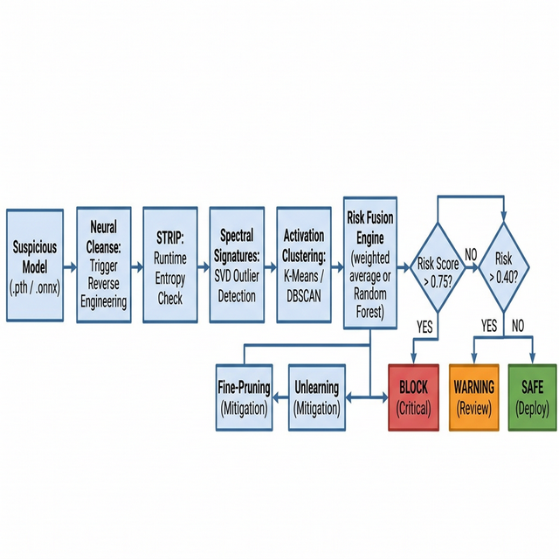
End-to-end Trojan detection and mitigation pipeline. A suspicious model (.pth/.onnx) passes through four detection stages (Neural Cleanse, STRIP, Spectral Signatures, Activation Clustering), whose outputs are fused by the RiskFusionEngine. The composite risk score determines whether the model is safe to deploy, requires manual review, or is blocked—with Fine-Pruning and Unlearning available for remediation.

Methodology

Project Architecture Overview
The project is organised into a set of tightly integrated Python modules (Table 2) that span the full pipeline from data generation to dashboard deployment.
Key Python modules and their roles in the Trojan Detection project.
Module | Responsibility
dataset.py | BadNetsDataset: CIFAR-10 wrapper with 7 trigger types
models.py | get_resnet18(): CIFAR-10-adapted ResNet-18
train.py | Training loop; CDA and ASR evaluation
defenses.py | All 8 detection/mitigation classes
gradcam_utils.py | GradCAM: hooks, heatmap generation, overlay
sanitize_model.py | Fine-Pruning and Unlearning evaluation orchestration
evaluate_fusion_framework.py | Full risk-fusion pipeline evaluation
app.py | Streamlit/React dashboard (UI, audit, visualisation)
api.py | FastAPI REST endpoints
celery_worker.py | Asynchronous Celery task execution

Dataset and Poisoning (dataset.py)

Dataset
The project uses CIFAR-10: 50 000 training images and 10 000 test images ($32×32$ RGB, 10 classes). Training augmentations are RandomCrop(32, padding=4) and RandomHorizontalFlip; test images use only ToTensor().

BadNetsDataset
The custom BadNetsDataset class (Listing [lst:badnets]) wraps the base CIFAR-10 dataset and injects a trigger into a configurable fraction of training samples. A third element is_poisoned is appended to each batch to enable ground-truth evaluation of detection recall.
class BadNetsDataset(Dataset):
def __init__(self, base_dataset, poison_ratio=0.1,
target_class=0, trigger_type='checkerboard',
is_train=True):
num_poisoned = int(len(base_dataset) * poison_ratio)
all_indices = np.arange(len(base_dataset))
np.random.shuffle(all_indices)
self.poisoned_indices = set(all_indices[:num_poisoned])
def __getitem__(self, idx):
img, label = self.base_dataset[idx]
is_poisoned = idx in self.poisoned_indices
if is_poisoned:
img = self._apply_trigger(img)
label = self.target_class
return img, label, is_poisoned
Table 3 enumerates all seven trigger types implemented in _apply_trigger().
Trigger types implemented in BadNetsDataset._apply_trigger().
Trigger Type | Description
checkerboard | $4×4$ alternating black/white patch, bottom-right corner
square | Solid white $4×4$ patch, bottom-right corner
blending | Alpha-blend ($α=0.5$) into bottom-right $4×4$ region
clean_label | Checkerboard on target-class samples only; labels unchanged
dynamic | Random position and random pattern, regenerated per sample
instagram_filter | Global sepia colour-cast via $3×3$ colour-matrix
spatial_conditional | Maximum-red $6×6$ patch in the top-left corner
For evaluation, get_cifar10_dataloaders() returns three loaders: a poisoned training loader, a clean test loader (CDA), and a fully-poisoned test loader (ASR, poison_ratio=1.0).

Model Architecture (models.py)
ResNet-18 is adapted for CIFAR-10’s $32×32$ images (Listing [lst:resnet]). The original $7×7$ stride-2 convolution is replaced by a $3×3$ stride-1 convolution to preserve spatial resolution, and the aggressive maxpool is disabled. The resulting model has approximately 11 million parameters.
def get_resnet18(num_classes=10):
model = resnet18(num_classes=num_classes)
# Replace 7x7 stride-2 conv with 3x3 stride-1 for 32x32 inputs
model.conv1 = nn.Conv2d(3, 64, kernel_size=3,
stride=1, padding=1, bias=False)
model.maxpool = nn.Identity() # Remove aggressive downsampling
return model
Models are trained using SGD with momentum $0.9$, weight decay $5×{10}^{−4}$, initial learning rate $0.1$, and a Cosine Annealing schedule.

Detection Modules (defenses.py)
All detection and mitigation classes reside in defenses.py. Each module’s raw output is normalised to a risk score in $[0,1]$ before being consumed by the RiskFusionEngine.

NeuralCleanse
NeuralCleanse.detect() sweeps all $K$ classes (or a single specified target), solves the trigger-recovery optimisation for each, and assigns an MAD anomaly index:
$${anomaly_index}_{c}=\frac{|{size}_{c}−median|}{MAD×1.4826}.$$
Classes with anomaly index $>2.0$ are flagged. Early stopping triggers when the epoch loss drops below $0.01$ for two consecutive epochs, or when the change in loss is less than ${10}^{−4}$.

STRIP
STRIP.calculate_entropy(input_tensor, num_samples=32) randomly samples 32 clean images, superimposes each onto the test input ($α=0.5$), runs batched inference, and returns the mean log-base-2 entropy. A low mean entropy signals a Trojan trigger.

Spectral Signatures
A forward hook on avgpool captures 512-dimensional features for all training samples of the target class. After centring and SVD decomposition, the projection score $s_{i}=({\tilde{z}}_{i})^{⊤}v_{1}$ is computed per sample. The top-$k$ samples by $s_{i}^{2}$ are flagged as poisoned, where $k=⌊N×poison_ratio×1.5⌋$.

Activation Clustering
A second forward hook on avgpool provides feature vectors for clustering. K-Means ($K=2$, n_init=10) and DBSCAN (eps=5.0, min_samples=10) are both supported. The silhouette score serves as the detection signal; a value above $0.1$ indicates an anomalous cluster.

Fine-Pruning
FinePruning targets layer4.1.conv2 (512 output channels). A forward hook records mean per-channel activations on the clean validation set; the lowest-activation channels are zeroed in 10% steps. sanitize_model.py evaluates CDA and ASR after each step.

Unlearning
Using the Neural-Cleanse-recovered mask $m$ and pattern $δ$, the Unlearning class applies the trigger on clean inputs and trains the model for one epoch (SGD, lr=0.01, momentum $0.9$) to predict the correct clean label, thereby destroying the malicious association.

Risk Fusion Engine
RiskFusionEngine.calculate_unified_risk() aggregates all detector outputs into a single probability score $R∈[0,1]$. Table 4 summarises the normalisation logic and default weights.
Risk-signal normalisation and default static weights used in RiskFusionEngine.
Signal | Normalisation formula | Wt.
Neural Cleanse (NC) | $min\left((idx−2.0)/2.0, 1\right)$, zero if $idx<2.0$ | 0.20
STRIP FR/FA | $max(1.0−avg_err×2.0, 0)$ | 0.25
Clustering silhouette | $(s−0.05)/0.20$; zero if $s<0.05$ | 0.15
Weight Analysis (LWA) | $(idx−2.5)/2.5$; zero if $<2.5$ | 0.15
Natural Trojan (NTP) | $min(sens×1.5, 1.0)$ | 0.25
The default fusion formula is a weighted average:
$$R = 0.20 R_{NC}+0.25 R_{STRIP}+0.15 R_{AC}+0.15 R_{LWA}+0.25 R_{NTP}.$$
When the RiskMetaClassifier is enabled and trained, a Random Forest (100 estimators, max depth 5) replaces the static formula, predicting $P(\text{Trojaned})$ from the five normalised risk scores. The trained classifier is serialised to meta_classifier.pkl. Listing [lst:fusion] shows the core fusion logic.
class RiskFusionEngine:
WEIGHTS = {
'neural_cleanse': 0.20, 'strip': 0.25,
'clustering': 0.15, 'lwa': 0.15,
'natural_trojan': 0.25
}
def calculate_unified_risk(self, nc_results=None, strip_results=None,
ac_results=None, lwa_results=None,
ntp_results=None):
scores = {}
if nc_results:
idx = max((r.get('anomaly_index', 0)
for r in nc_results), default=0)
scores['neural_cleanse'] = min(
max((idx - 2.0) / 2.0, 0), 1)
if strip_results:
avg_err = strip_results.get('avg_error', 0)
scores['strip'] = max(1.0 - avg_err * 2.0, 0)
# Weighted average over available detectors
total_w, total_r = 0.0, 0.0
for key, score in scores.items():
w = self.WEIGHTS.get(key, 0)
total_r += w * score
total_w += w
return total_r / total_w if total_w > 0 else 0.0
Risk verdicts map as follows:
- $R>0.75$: Critical—deployment blocked.
- $0.40<R≤0.75$: Warning—manual review required.
- $R≤0.40$: Safe—cleared for production.

Explainability: Grad-CAM (gradcam_utils.py)
The GradCAM class registers forward and backward hooks on a user-specified target layer. For a given input the heatmap is produced by:
- Compute the forward pass; backpropagate through the target class score.
- Pool gradients over spatial dimensions: αi=1HWu,v​∂yc/∂Aiuv.
- Form the weighted activation map: L=ReLU​i​αiAi.
- Normalise, resize to input resolution, and apply the JET colourmap.
The resulting JPEG overlay is returned by the FastAPI scan endpoint as a Base64-encoded string and rendered in the dashboard under Mechanistic Interpretability.
Figure 4 demonstrates the diagnostic value of Grad-CAM: while a clean model attends to the semantically relevant region (the dog’s face), the Trojaned model’s attention collapses entirely onto the checkerboard trigger patch, providing clear visual evidence of backdoor behaviour.
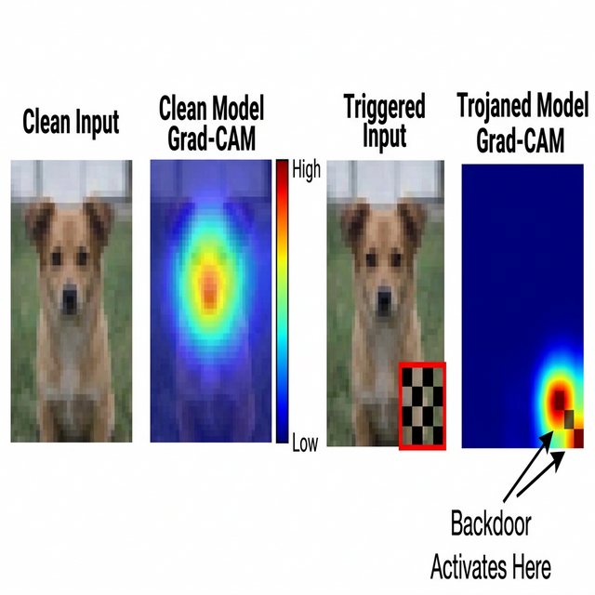
Grad-CAM heatmap comparison. Left to right: clean input image; clean-model Grad-CAM (attention on semantically relevant region); triggered input with checkerboard patch (red box); Trojaned-model Grad-CAM with attention concentrated on the trigger patch rather than the object, providing interpretable evidence of the backdoor.

System Architecture and Dashboard
Figure 5 shows the full layered architecture. Figure 6 shows the React/Next.js v2.1.2-STABLE MLOps Command Center. The dashboard offers two audit modes:
- Enterprise audit (API mode). The model is submitted to the FastAPI endpoint, dispatched to a Celery worker for asynchronous execution, and the UI polls /api/v1/scan-status/{task_id} every two seconds until the JSON report is returned.
- Manual forensic analysis (local mode). Each defence module runs directly in process and results are shown section by section with live metric charts.
Layered system architecture of the Trojan Detection project. Each layer communicates strictly downward through well-defined interfaces.
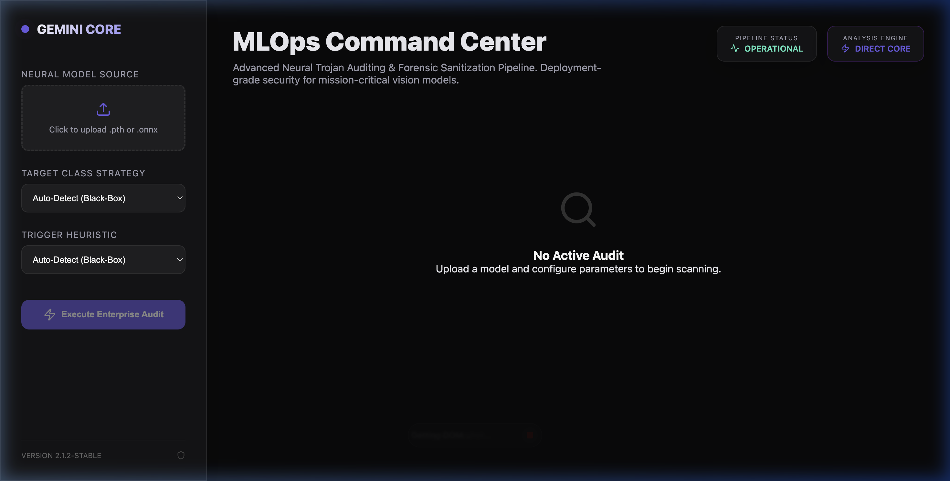
The MLOps Command Center frontend (React/Next.js, v2.1.2-STABLE). Left sidebar: drag-and-drop model upload zone (.pth or .onnx), Target Class Strategy and Trigger Heuristic dropdowns (both defaulting to Auto-Detect Black-Box mode), and Execute Enterprise Audit action button. Top-right badges: real-time pipeline health indicators (PIPELINE STATUS: OPERATIONAL; ANALYSIS ENGINE: DIRECT CORE). Main canvas: displays risk scores, per-detector breakdowns, and Grad-CAM heatmaps upon scan completion.

Software Requirements Specification

Functional Requirements
- Train and store clean and Trojaned ResNet-18 models via train.py with configurable trigger type, poison ratio, and target class.
- Execute all four detection modules on an uploaded or stored model; each module must return a normalised risk score.
- Fuse detector outputs into a composite risk score via RiskFusionEngine and classify as Safe / Warning / Critical.
- Run Fine-Pruning with configurable step size and display the CDA–ASR tradeoff per pruning level in a live chart.
- Run Unlearning using a reverse-engineered trigger and report post-sanitisation metrics.
- Generate and display a Grad-CAM heatmap for any input image via the dashboard.
- Support asynchronous model auditing via FastAPI + Celery with real-time status polling.

Non-Functional Requirements
- Performance. Neural Cleanse sweep (10 classes, 2 epochs) must complete in under 5 minutes on Apple Silicon MPS or NVIDIA GPU; STRIP entropy check ($N_{p}=32$) in under 10 seconds per input.
- Portability. Device selection via torch.device(’mps’ if torch.backends.mps.is_available() else ’cpu’) ensures compatibility across Apple M-series and x86/CUDA hardware.
- Reproducibility. All random seeds and hyperparameters are exposed as CLI arguments in train.py and sanitize_model.py.
- Containerisation. Docker Compose bundles Streamlit, FastAPI, Redis, and the Celery worker for one-command deployment.
- Maintainability. Each defence algorithm is a self-contained class with a consistent detect() interface to facilitate future extension.

Project Environment
Table 5 summarises the software and hardware stack used throughout the project.
Software and hardware environment of the Trojan Detection project.
Component | Details
Operating System | macOS (Apple Silicon M-series) / Linux Ubuntu (Docker)
Python | 3.10$+$
Deep learning | PyTorch (MPS on Apple Silicon; CUDA on Linux/GPU)
Model architecture | ResNet-18 (torchvision), adapted for $32×32$ CIFAR-10
Data augmentation | RandomCrop, RandomHorizontalFlip (torchvision.transforms)
Clustering | scikit-learn: KMeans, DBSCAN, silhouette_score
Meta-classifier | scikit-learn RandomForestClassifier (serialised via pickle)
Explainability | Custom GradCAM (gradcam_utils.py); OpenCV overlay
Frontend dashboard | React / Next.js (frontend/)
Backend API | FastAPI + Uvicorn
Task queue | Celery + Redis
Containerisation | Docker + Docker Compose
Version control | Git / GitHub

Project Schedule
The project follows a 12-week schedule aligned with implementation milestones (Figure 7):
- Weeks 1–2. Requirement analysis, threat modelling, CIFAR-10 environment setup, BadNetsDataset design.
- Weeks 3–4. Implementation of trigger types; train.py training pipeline with CDA/ASR evaluation loops.
- Weeks 5–6. ResNet-18 training for clean and Trojaned models; baseline CDA/ASR measurements.
- Weeks 7–8. Implementation of detection modules: NeuralCleanse, STRIP, SpectralSignatures, ActivationClustering.
- Weeks 9–10. RiskFusionEngine, RiskMetaClassifier, FinePruning, Unlearning, and Grad-CAM integration.
- Weeks 11–12. Streamlit dashboard, FastAPI/Celery async pipeline, Docker containerisation, and final report.
12-week project schedule aligned with Trojan Detection implementation milestones.
99
B. Wang, Y. Yao, S. Shan, H. Li, B. Viswanath, H. Zheng, and B. Y. Zhao, “Neural Cleanse: Identifying and Mitigating Backdoor Attacks in Neural Networks,” in IEEE Symp. Security and Privacy (S&P), 2019.
Y. Gao, C. Xu, D. Wang, S. Chen, D. C. Ranasinghe, and S. Nepal, “STRIP: A Defence Against Trojan Attacks on Deep Neural Networks,” arXiv:1902.06531, 2019.
B. Tran, J. Li, and A. Madry, “Spectral Signatures in Backdoor Attacks,” in Advances in Neural Information Processing Systems (NeurIPS), 2018.
B. Chen, W. Carvalho, N. Baracaldo, H. Ludwig, B. Edwards, T. Lee, I. Molloy, and B. Srivastava, “Detecting Backdoor Attacks on Deep Neural Networks by Activation Clustering,” in AAAI Workshop on AI Safety, 2019.
K. Liu, B. Dolan-Gavitt, and S. Garg, “Fine-Pruning: Defending Against Backdooring Attacks on Deep Neural Networks,” in Intl. Symp. Research in Attacks, Intrusions and Defenses (RAID), 2018.
R. R. Selvaraju, M. Cogswell, A. Das, R. Vedantam, D. Parikh, and D. Batra, “Grad-CAM: Visual Explanations from Deep Networks via Gradient-Based Localization,” in Intl. Conf. Computer Vision (ICCV), 2017.
A. Turner, D. Tsipras, and A. Madry, “Clean-Label Backdoor Attacks,” in ICLR Workshop, 2019.
Y. Ding, B. Li, L. Zhao, and J. Liu, “TrojanZoo: Towards Unified, Holistic, and Practical Evaluation of Neural Trojan Attacks and Defenses,” in USENIX Security Symp., 2021.

