Sports
1: Eureka Server Eureka Starter, Web Starter , 8761 port number

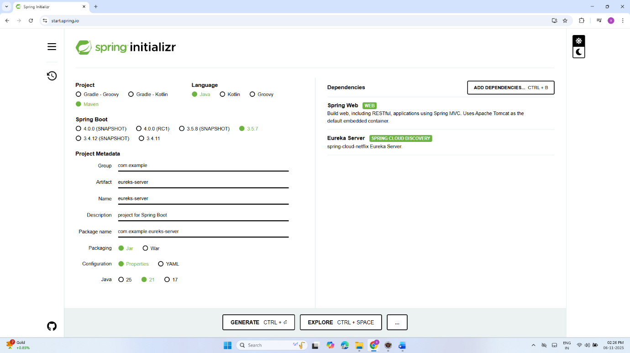

backend-micro-service-app

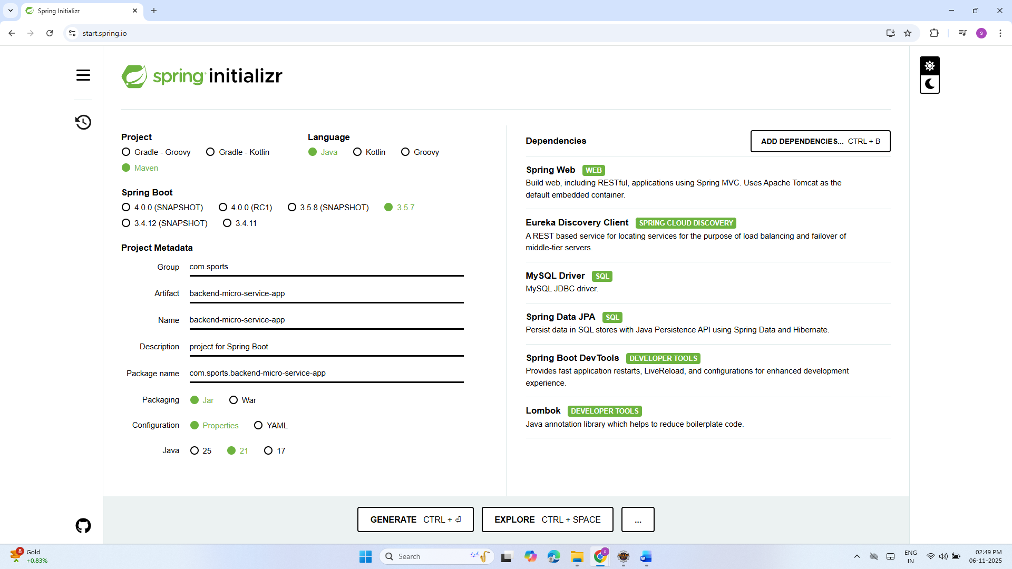
-- ================================================
-- DATABASE: PLAYO_CLONE
-- ================================================
CREATE DATABASE IF NOT EXISTS playo_clone;
USE playo_clone;

-- ================================================
-- TABLES
-- ================================================

-- 1️⃣ Sport Categories
CREATE TABLE sport_categories (
scid INT AUTO_INCREMENT PRIMARY KEY,
name VARCHAR(150) NOT NULL UNIQUE,
description TEXT
);

-- 2️⃣ Sports
CREATE TABLE sports (
sid INT AUTO_INCREMENT PRIMARY KEY,
scid INT,
name VARCHAR(100) NOT NULL UNIQUE,
description TEXT,
FOREIGN KEY (scid) REFERENCES sport_categories(scid) ON DELETE SET NULL
);

-- 3️⃣ Venues
CREATE TABLE venues (
id BIGINT AUTO_INCREMENT PRIMARY KEY,
name VARCHAR(200) NOT NULL,
address TEXT,
city VARCHAR(100),
latitude DOUBLE,
longitude DOUBLE,
phone VARCHAR(20),
image_url VARCHAR(500)
);

-- 4️⃣ Courts
CREATE TABLE courts (
id BIGINT AUTO_INCREMENT PRIMARY KEY,
venue_id BIGINT NOT NULL,
sport_id INT NOT NULL,
name VARCHAR(150) NOT NULL,
capacity INT DEFAULT 4,
price_per_hour DECIMAL(10,2) DEFAULT 0,
FOREIGN KEY (venue_id) REFERENCES venues(id) ON DELETE CASCADE,
FOREIGN KEY (sport_id) REFERENCES sports(id) ON DELETE CASCADE
);

-- 5️⃣ Slots (Availability)
CREATE TABLE slots (
id BIGINT AUTO_INCREMENT PRIMARY KEY,
court_id BIGINT NOT NULL,
start_time TIME NOT NULL,
end_time TIME NOT NULL,
day_of_week TINYINT, -- 0=Sunday..6=Saturday
date DATE,
active BOOLEAN DEFAULT TRUE,
FOREIGN KEY (court_id) REFERENCES courts(id) ON DELETE CASCADE
);

-- 6️⃣ Users (basic)
CREATE TABLE users (
id BIGINT AUTO_INCREMENT PRIMARY KEY,
name VARCHAR(100),
email VARCHAR(150) UNIQUE,
phone VARCHAR(15),
password VARCHAR(255),
role ENUM('ADMIN','USER') DEFAULT 'USER'
);

-- 7️⃣ Bookings
CREATE TABLE bookings (
id BIGINT AUTO_INCREMENT PRIMARY KEY,
user_id BIGINT NOT NULL,
court_id BIGINT NOT NULL,
sport_id INT NOT NULL,
start_datetime DATETIME NOT NULL,
end_datetime DATETIME NOT NULL,
amount DECIMAL(10,2) NOT NULL,
status ENUM('PENDING','CONFIRMED','CANCELLED','COMPLETED') DEFAULT 'PENDING',
created_at TIMESTAMP DEFAULT CURRENT_TIMESTAMP,
FOREIGN KEY (user_id) REFERENCES users(id),
FOREIGN KEY (court_id) REFERENCES courts(id),
FOREIGN KEY (sport_id) REFERENCES sports(id)
);

-- 8️⃣ Payments
CREATE TABLE payments (
id BIGINT AUTO_INCREMENT PRIMARY KEY,
booking_id BIGINT NOT NULL,
payment_provider VARCHAR(50),
provider_payment_id VARCHAR(200),
amount DECIMAL(10,2),
status VARCHAR(50),
created_at TIMESTAMP DEFAULT CURRENT_TIMESTAMP,
FOREIGN KEY (booking_id) REFERENCES bookings(id) ON DELETE CASCADE
);

-- 9️⃣ Reviews
CREATE TABLE reviews (
id BIGINT AUTO_INCREMENT PRIMARY KEY,
user_id BIGINT NOT NULL,
venue_id BIGINT,
court_id BIGINT,
rating TINYINT NOT NULL,
comment TEXT,
created_at TIMESTAMP DEFAULT CURRENT_TIMESTAMP,
FOREIGN KEY (user_id) REFERENCES users(id),
FOREIGN KEY (venue_id) REFERENCES venues(id),
FOREIGN KEY (court_id) REFERENCES courts(id)
);

-- ================================================
-- SAMPLE DATA
-- ================================================

-- Sport Categories
INSERT INTO sport_categories (name, description) VALUES
('Racquet Sports', 'Sports using racquets and balls/shuttles'),
('Team Sports', 'Played between teams'),
('Fitness', 'Physical training and workout activities'),
('Recreation', 'Fun or indoor leisure games'),
('Adventure Sports', 'Outdoor adventure and thrill activities');

-- Sports
INSERT INTO sports (category_id, name, description) VALUES
(1, 'Tennis', 'Court sport played with racquets'),
(1, 'Badminton', 'Indoor racquet sport'),
(1, 'Table Tennis', 'Indoor fast racquet sport'),
(2, 'Cricket', 'Outdoor bat-and-ball team sport'),
(2, 'Football', 'Outdoor field sport'),
(3, 'Yoga', 'Mind and body exercise'),
(3, 'Gymming', 'Indoor fitness training'),
(4, 'Bowling', 'Recreational indoor game'),
(4, 'Pool', 'Cue-based leisure game'),
(5, 'Kayaking', 'Adventure water sport'),
(5, 'Rock Climbing', 'Outdoor adventure climbing activity');

-- Venues
INSERT INTO venues (name, address, city, latitude, longitude, phone, image_url) VALUES
('PlayZone Sports Arena', 'Madhapur, Hyderabad', 'Hyderabad', 17.4435, 78.3772, '9988776655', 'https://example.com/images/playzone.jpg'),
('Greenfield Sports Complex', 'Indiranagar, Bangalore', 'Bangalore', 12.9716, 77.5946, '8877665544', 'https://example.com/images/greenfield.jpg'),
('UrbanFit Center', 'Pimpri, Pune', 'Pune', 18.5204, 73.8567, '7766554433', 'https://example.com/images/urbanfit.jpg');

-- Courts
INSERT INTO courts (venue_id, sport_id, name, capacity, price_per_hour) VALUES
(1, 1, 'Court A', 4, 600.00),
(1, 2, 'Court B', 4, 400.00),
(2, 4, 'Pitch 1', 22, 1000.00),
(2, 5, 'Football Turf 1', 14, 1200.00),
(3, 7, 'Gym Zone', 20, 300.00),
(3, 6, 'Yoga Hall', 25, 250.00);

-- Slots (availability per court)
INSERT INTO slots (court_id, start_time, end_time, day_of_week) VALUES
(1, '06:00:00', '09:00:00', 1),
(1, '17:00:00', '20:00:00', 3),
(2, '07:00:00', '10:00:00', 2),
(3, '08:00:00', '12:00:00', 5),
(4, '17:00:00', '21:00:00', 6),
(6, '06:00:00', '08:00:00', 0);

-- Users
INSERT INTO users (name, email, phone, password, role) VALUES
('Admin', 'admin@playo.com', '9998887770', 'admin123', 'ADMIN'),
('Ravi Kumar', 'ravi@gmail.com', '9000011111', 'pass123', 'USER'),
('Sneha Rao', 'sneha@gmail.com', '9000022222', 'pass123', 'USER');

-- Bookings
INSERT INTO bookings (user_id, court_id, sport_id, start_datetime, end_datetime, amount, status) VALUES
(2, 1, 1, '2025-11-05 06:00:00', '2025-11-05 08:00:00', 1200.00, 'CONFIRMED'),
(3, 4, 5, '2025-11-06 18:00:00', '2025-11-06 20:00:00', 2400.00, 'PENDING');

-- Payments
INSERT INTO payments (booking_id, payment_provider, provider_payment_id, amount, status) VALUES
(1, 'Razorpay', 'pay_LA12B88X', 1200.00, 'SUCCESS'),
(2, 'Razorpay', 'pay_LA34D12Y', 2400.00, 'PENDING');

-- Reviews
INSERT INTO reviews (user_id, venue_id, court_id, rating, comment) VALUES
(2, 1, 1, 5, 'Excellent tennis court, very clean and well maintained!'),
(3, 2, 4, 4, 'Great football turf, needs better lighting at night.');

1️⃣ CREATE TABLE categories
Each category has different rules (Party ≠ Hall ≠ Play).
CREATE TABLE categories (
category_id INT AUTO_INCREMENT PRIMARY KEY,
name VARCHAR(150) NOT NULL UNIQUE,
description TEXT
);
⭐ INSERT
INSERT INTO categories (name, description) VALUES
('Party Booking', 'Book party events'),
('Food Booking', 'Book food & catering services'),
('Hall Booking', 'Book halls with time slots'),
('Play Booking', 'Sports & turf ground booking'),
('Art & Crafts', 'Art & craft workshop booking');

🔵 2️⃣ CREATE TABLE services
Each category will have multiple services.
CREATE TABLE services (
service_id INT AUTO_INCREMENT PRIMARY KEY,
category_id INT NOT NULL,
name VARCHAR(150) NOT NULL,
description TEXT,

FOREIGN KEY (category_id) REFERENCES categories(category_id)
);
⭐ INSERT (category-wise)
Party Booking
INSERT INTO services (category_id, name, description) VALUES
(1, 'Birthday Decoration', 'Theme & custom decoration'),
(1, 'Anniversary Setup', 'Anniversary decoration package');
Food Booking
INSERT INTO services (category_id, name, description) VALUES
(2, 'Veg Menu', 'Pure vegetarian buffet'),
(2, 'Non-Veg Menu', 'Non-veg buffet & catering'),
(2, 'Snacks Menu', 'Snacks, starters & drinks');
Hall Booking
INSERT INTO services (category_id, name, description) VALUES
(3, 'Banquet Hall', 'Large capacity halls'),
(3, 'Mini Hall', 'Small event halls');
Play Booking
INSERT INTO services (category_id, name, description) VALUES
(4, 'Cricket Turf', 'Indoor & outdoor turf'),
(4, 'Badminton Court', 'Wooden & synthetic courts');
Art & Crafts
INSERT INTO services (category_id, name, description) VALUES
(5, 'Art Workshop', 'Painting classes'),
(5, 'Craft Workshop', 'DIY craft activities');

🔵 3️⃣ CREATE TABLE venues
Venue depends on the service.
CREATE TABLE venues (
venue_id BIGINT AUTO_INCREMENT PRIMARY KEY,
service_id INT NOT NULL,
name VARCHAR(200) NOT NULL,
address TEXT,
city VARCHAR(100),
phone VARCHAR(20),

FOREIGN KEY (service_id) REFERENCES services(service_id)
);
⭐ INSERT
Banquet Hall venues:
INSERT INTO venues (service_id, name, address, city, phone) VALUES
(4, 'Grand Banquet Hall', 'Madhapur', 'Hyderabad', '9000010001'),
(4, 'Royal Banquet Hall', 'Kukatpally', 'Hyderabad', '9000010002');
Cricket turf venues:
INSERT INTO venues (service_id, name, address, city, phone) VALUES
(7, 'Madhapur Turf Ground', 'Madhapur', 'Hyderabad', '9000010003');
Badminton venues:
INSERT INTO venues (service_id, name, address, city, phone) VALUES
(8, 'Ameerpet Badminton Arena', 'Ameerpet', 'Hyderabad', '9000010004');
Art workshop:
INSERT INTO venues (service_id, name, address, city, phone) VALUES
(9, 'Creative Art Studio', 'Gachibowli', 'Hyderabad', '9000010005');
Food booking does NOT need slots → Only order based → handled separately.

🔵 4️⃣ CREATE TABLE spots
A venue has multiple bookable units.
CREATE TABLE spots (
spot_id BIGINT AUTO_INCREMENT PRIMARY KEY,
venue_id BIGINT NOT NULL,
name VARCHAR(150) NOT NULL,
capacity INT,
price_per_hour DECIMAL(10,2),

FOREIGN KEY (venue_id) REFERENCES venues(venue_id)
);
⭐ INSERT
Banquet Halls:
INSERT INTO spots (venue_id, name, capacity, price_per_hour) VALUES
(1, 'Hall A', 200, 6000),
(1, 'Hall B', 150, 5000);
Cricket Turf:
INSERT INTO spots (venue_id, name, capacity, price_per_hour) VALUES
(3, 'Pitch 1', 12, 1000),
(3, 'Pitch 2', 12, 1200);
Badminton:
INSERT INTO spots (venue_id, name, capacity, price_per_hour) VALUES
(4, 'Court 1', 4, 300),
(4, 'Court 2', 4, 350);
Art:
INSERT INTO spots (venue_id, name, capacity, price_per_hour) VALUES
(5, 'Table 1', 10, 500),
(5, 'Table 2', 8, 400);

🔵 5️⃣ CREATE TABLE slots (REAL-TIME ENGINE)
Every category has different types of slot timings:
✔ Party Booking → Long 4–5 hour slots
✔ Hall Booking → Morning Slot / Evening Slot
✔ Play Booking → Every 1-hour slot
✔ Art Craft → Morning / Afternoon sessions
This table supports ALL types:
CREATE TABLE slots (
slot_id BIGINT AUTO_INCREMENT PRIMARY KEY,
spot_id BIGINT NOT NULL,
date DATE NOT NULL,
start_time TIME NOT NULL,
end_time TIME NOT NULL,
price DECIMAL(10,2),
active BOOLEAN DEFAULT TRUE,

FOREIGN KEY (spot_id) REFERENCES spots(spot_id)
);

⭐ CATEGORY-WISE SLOT INSERTS
(REAL TIME)

🔥 Hall Booking (Long 4–5 hour blocks)
Hall A:
INSERT INTO slots (spot_id, date, start_time, end_time, price) VALUES
(1, '2025-12-10', '10:00', '14:00', 6000),
(1, '2025-12-10', '18:00', '23:00', 12000);

🏏 Play Booking – Cricket (1-hour slots)
Pitch 1:
INSERT INTO slots (spot_id, date, start_time, end_time, price) VALUES
(3, '2025-12-10', '06:00', '07:00', 800),
(3, '2025-12-10', '07:00', '08:00', 900),
(3, '2025-12-10', '08:00', '09:00', 1000);

🏸 Play Booking – Badminton (1-hour slots)
Court 1:
INSERT INTO slots (spot_id, date, start_time, end_time, price) VALUES
(5, '2025-12-10', '06:00', '07:00', 250),
(5, '2025-12-10', '07:00', '08:00', 300),
(5, '2025-12-10', '08:00', '09:00', 350);

🎨 Art & Crafts – 2-hour workshop slots
Table 1:
INSERT INTO slots (spot_id, date, start_time, end_time, price) VALUES
(7, '2025-12-10', '10:00', '12:00', 500),
(7, '2025-12-10', '15:00', '17:00', 600);

🎊 Party Booking – Full Event Slot (5–6 hours)
Hall B:
INSERT INTO slots (spot_id, date, start_time, end_time, price) VALUES
(2, '2025-12-15', '17:00', '22:00', 8000);

