**Lesson 1 Demo 1**

**Write and Execute JavaScript Program Using Node**

Steps to be followed:

* Check the installation of node and create a project directory
* Write and execute JavaScript program using Node

**Step 1: Check the installation of node and create a project directory**

* 1. Check if the node is installed or not.  
       
     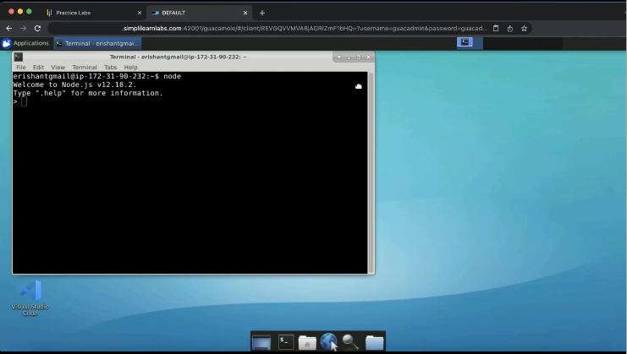
  2. Create a folder named ‘javaScript’.  
       
     Graphical user interface, website

     Description automatically generated
  3. Save the program in the shown directory.  
       
     Graphical user interface, website

     Description automatically generated

**Step 2: Write and execute JavaScript program using Node**

* 1. Open the visual studio code.  
       
     A screenshot of a computer

     Description automatically generated with medium confidence
  2. Create a program named ‘welcome.js’.  
       
     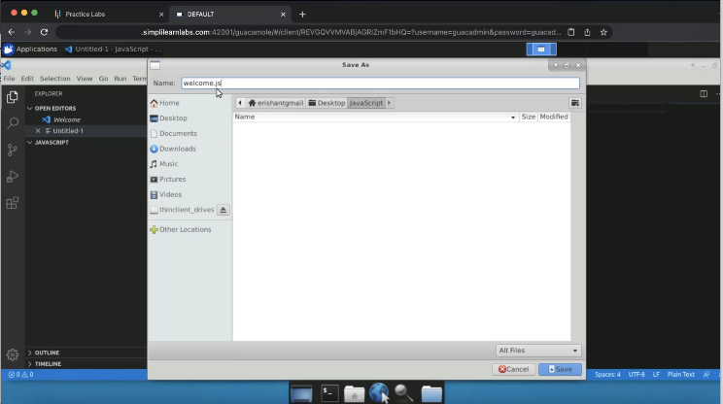
  3. Write the first printing statement.  
       
     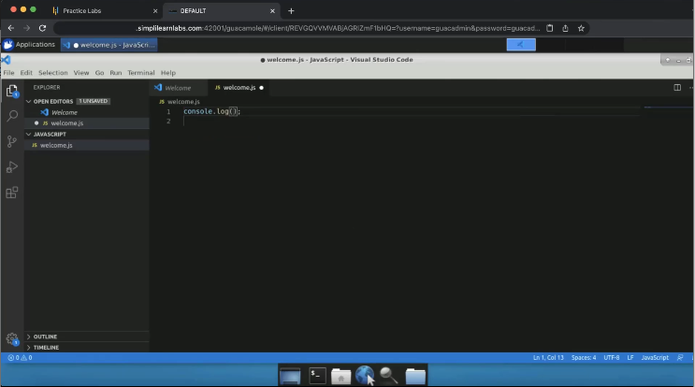
  4. Write ‘Welcome to JS Session’ and save the file.  
       
     A screenshot of a computer

     Description automatically generated
  5. Open the terminal window.  
       
     A screenshot of a computer

     Description automatically generated
  6. Mention the name of the program preceding the node and hit enter.

* 1. Create a storage container with x as 10, var y as 20, and const z as 30.  
       
     A screenshot of a computer

     Description automatically generated
  2. Write ‘log x is +x’.  
       
     A screenshot of a computer

     Description automatically generated
  3. Concatenate y and z as well like x.  
       
     A screenshot of a computer

     Description automatically generated
  4. Pass ‘node welcome.js’ again in the terminal and hit enter.  
       
     Text

     Description automatically generated
  5. Check the datatype of x, y, and z.  
       
     Text

     Description automatically generated

2.12 Check the output in the terminal again.  
  
* 1. Change var y to 20.22 and create a string for cost z as ‘George’. Execute the program.  
       
     Text

     Description automatically generated