ReactJs-Movie-App-Project: Output Screenshots

This is the output

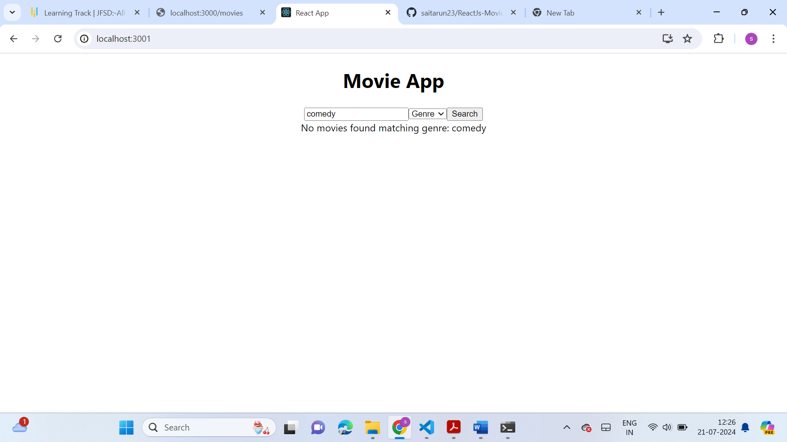

Axios is used in this project to fetch movie data from a movie API

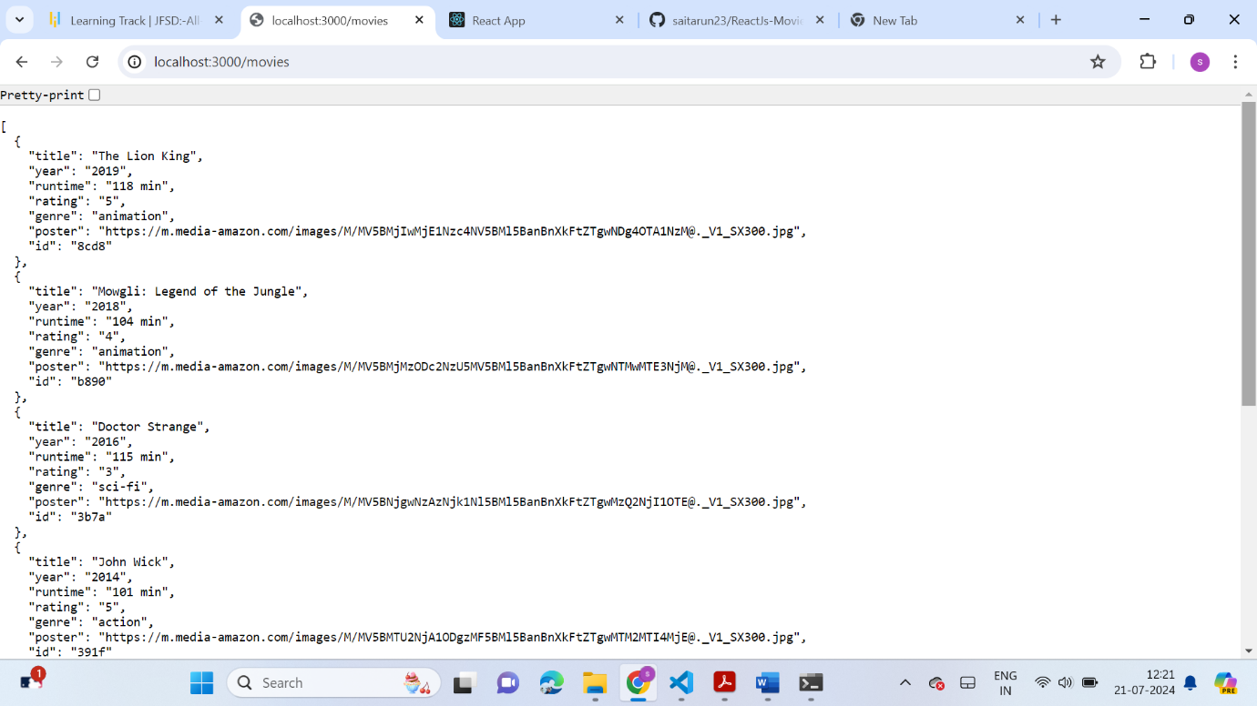

* Checks if the search query is empty. If so, it sets an error message and clears filtered Movies.
* Filters the movies array based on the query and search Type.
* If searching by title, it checks if movie.title includes the query.
* If searching by rating, it checks if movie.rating matches the query.
* If searching by genre, it checks if movie.genre includes the query.

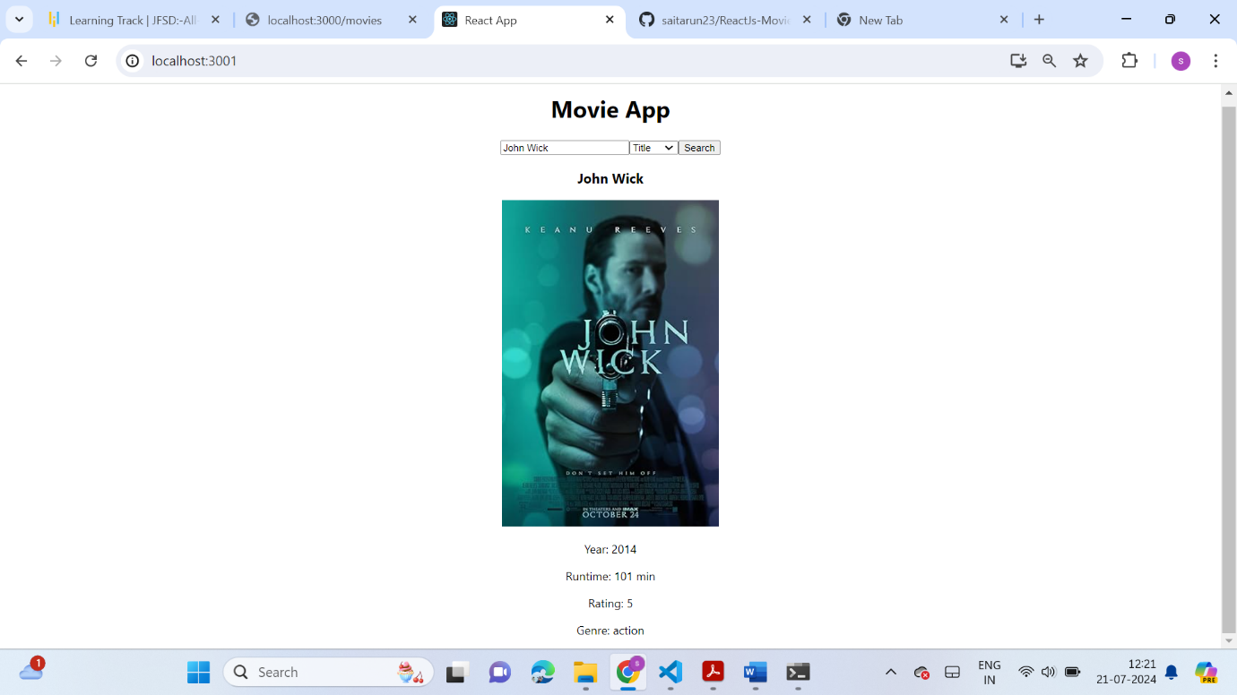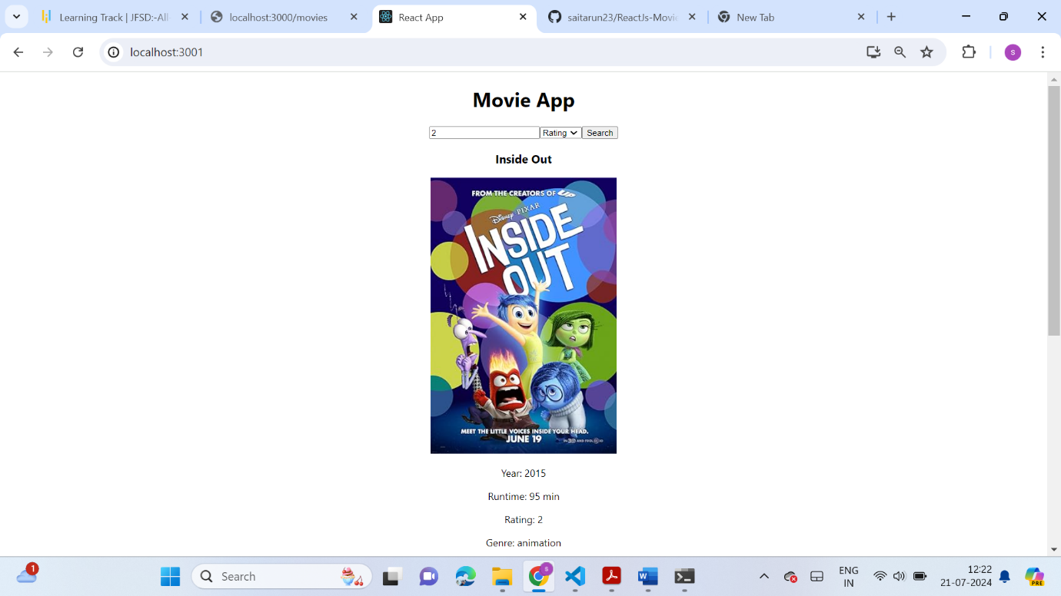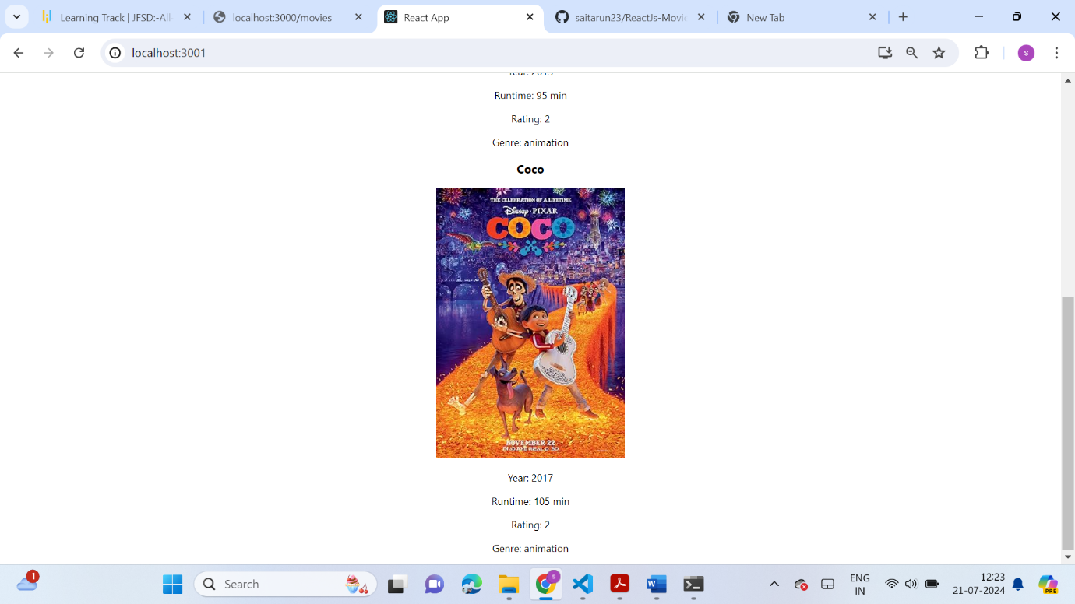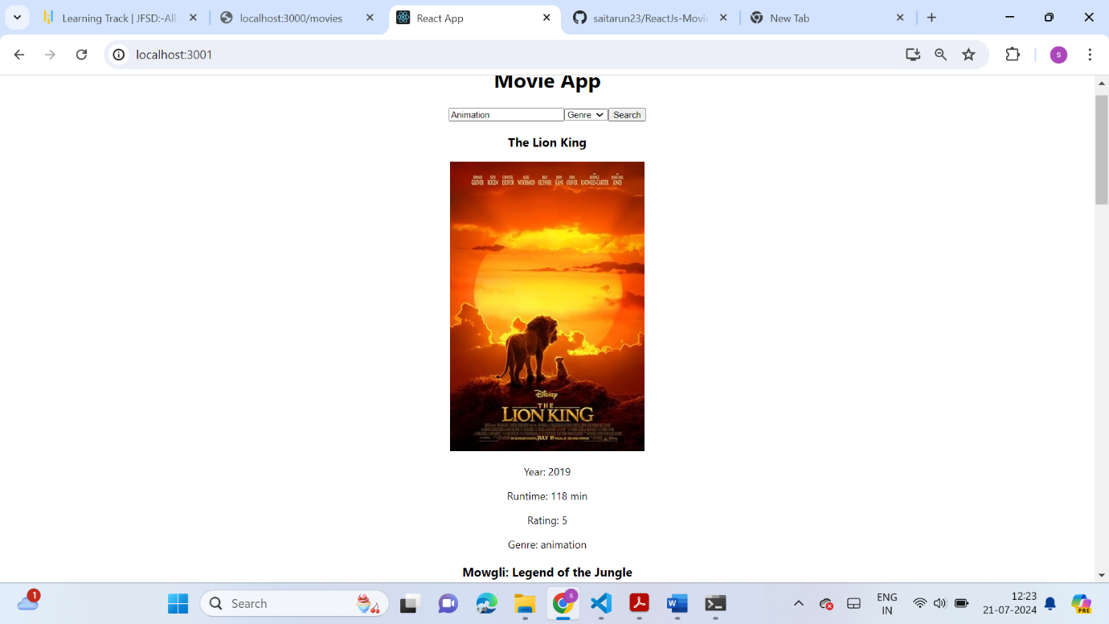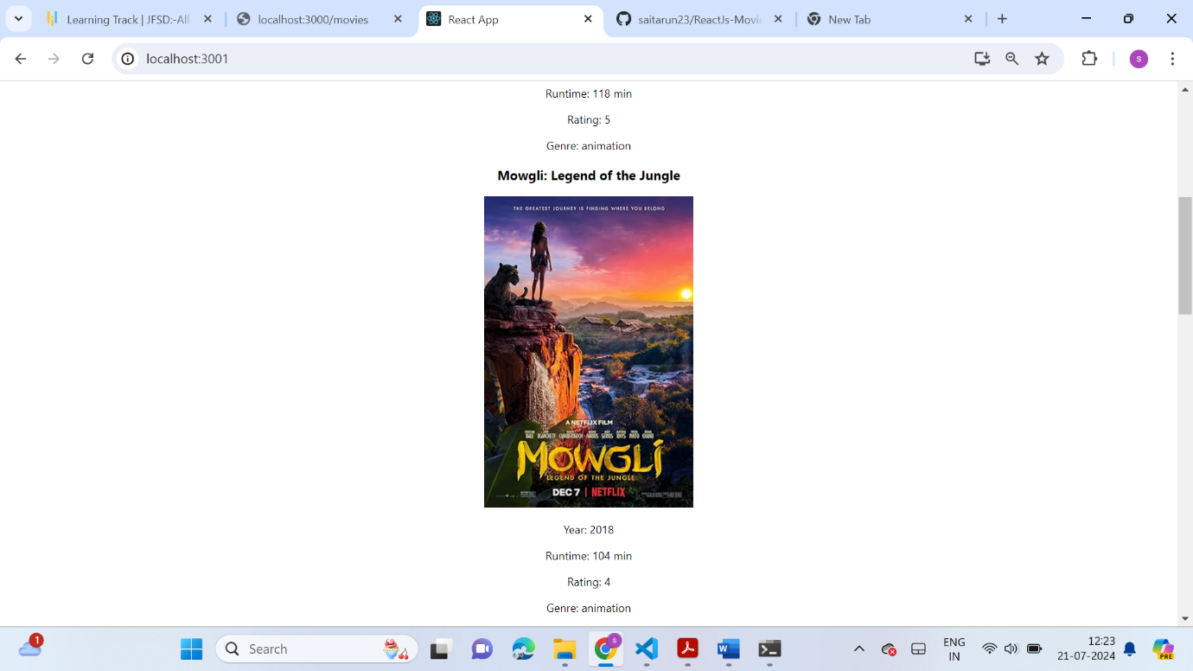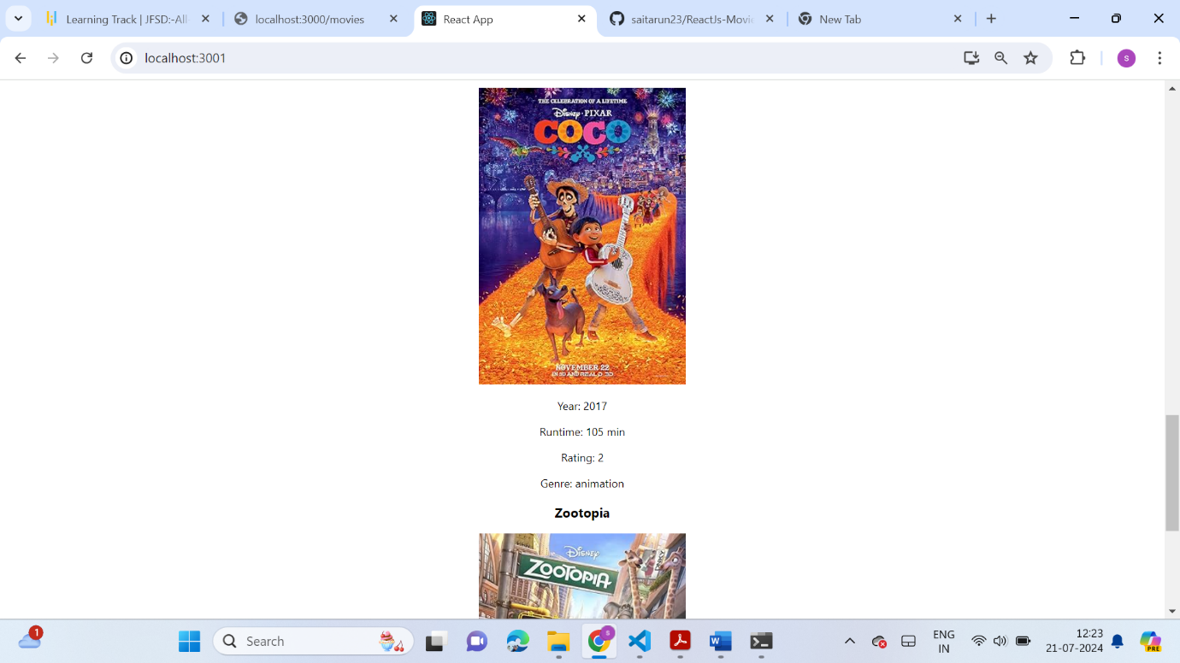

Sets an error message if no movies match the query; otherwise, clears the error message.

