07/02/2023
Client side send drawing request takes more time

Upload drawing takes more time to save
CBAA003CL003
User Creation
After Closing error message reloaded in new form also
Password field once type a single letter next moving to next field when comes to pwd field its not editable
When cursor comes to mobile number field after previous field moving is not possible
Email option is not editable
Password strength validation
When clicking mob number field upper field, down field is not editable kindly check
Telecaller Head Lead creation
In create lead form When clicking the close button, After opens the form again it shows previous filled name again and again
Mobile number 10 digit field validation required
After clicking mob number field not able to move any other fields
After completing the form re editing is not possible
User Credentials
Without filling id, pwd field validation is not showing - It just reloaded
BBUSR039 | SRI | Telecaller Head
Telecaller
Tele caller head assigned 2 lead to tele caller there is no notification showing - Those leads showing in table only
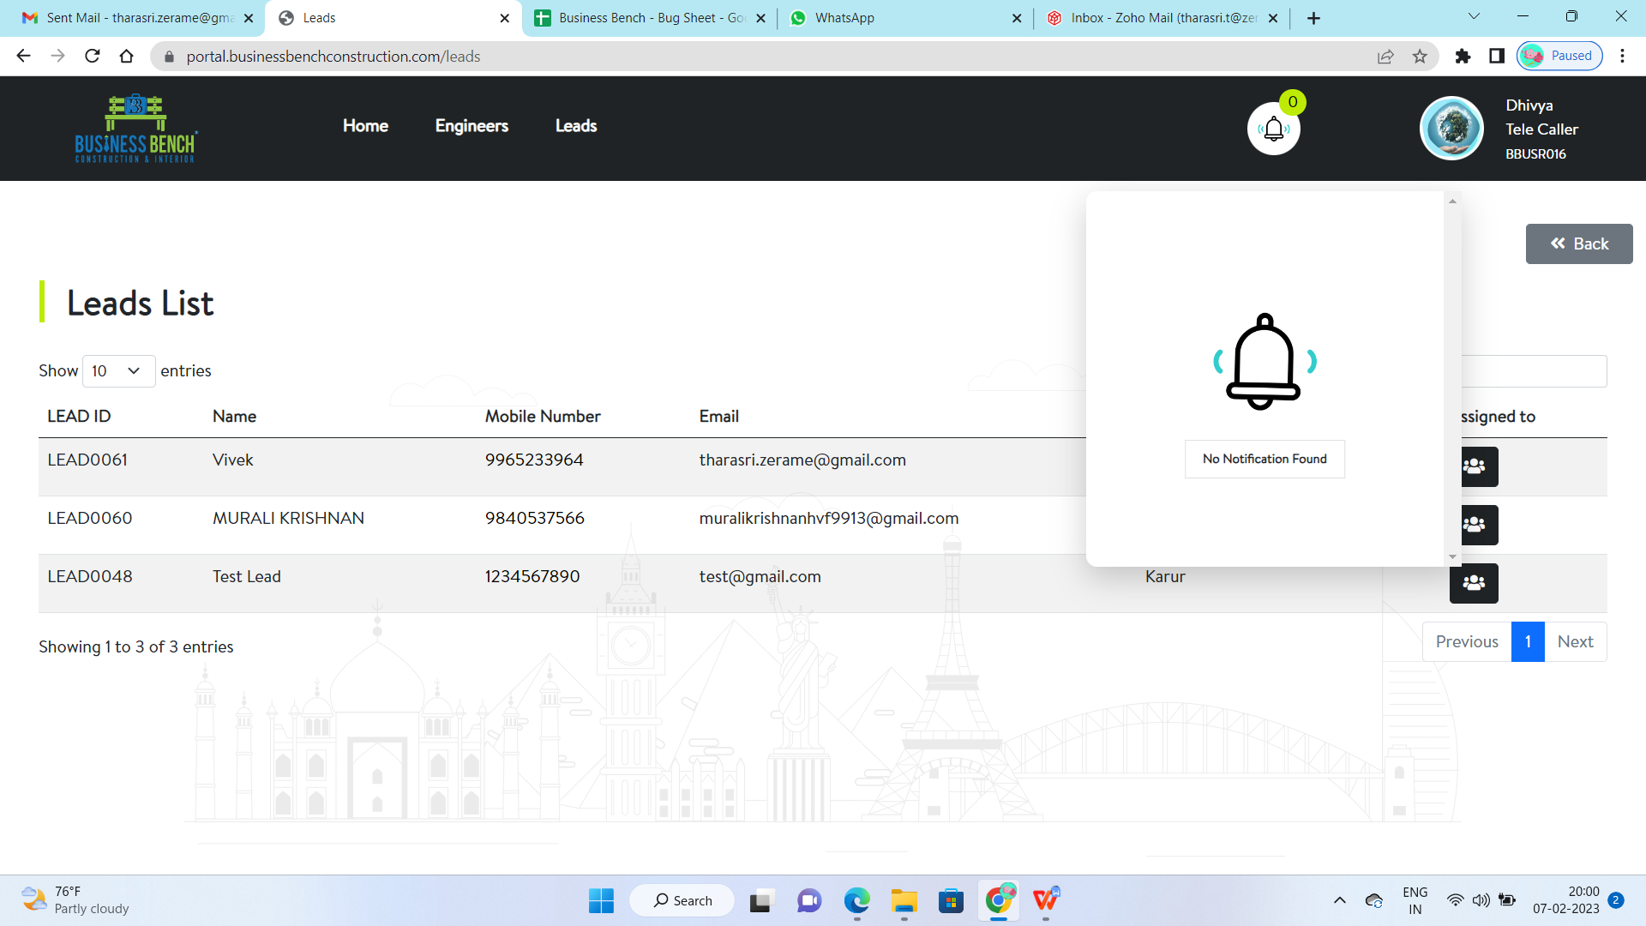
Google Map link validation required
Plot area accepting letters, spl characters - need to validate
Start date, end date previous date selection is possible have to validate
End date should be bigger than start date
Budget value is number type only, but it accepting alphabet and spl char
Clients Availability on the site what filled by AE?
Occupation field validation required, It only accept alphabets
All fields validations required
Assigned AE -> Select AE is drop down only that drop down symbol is not showing
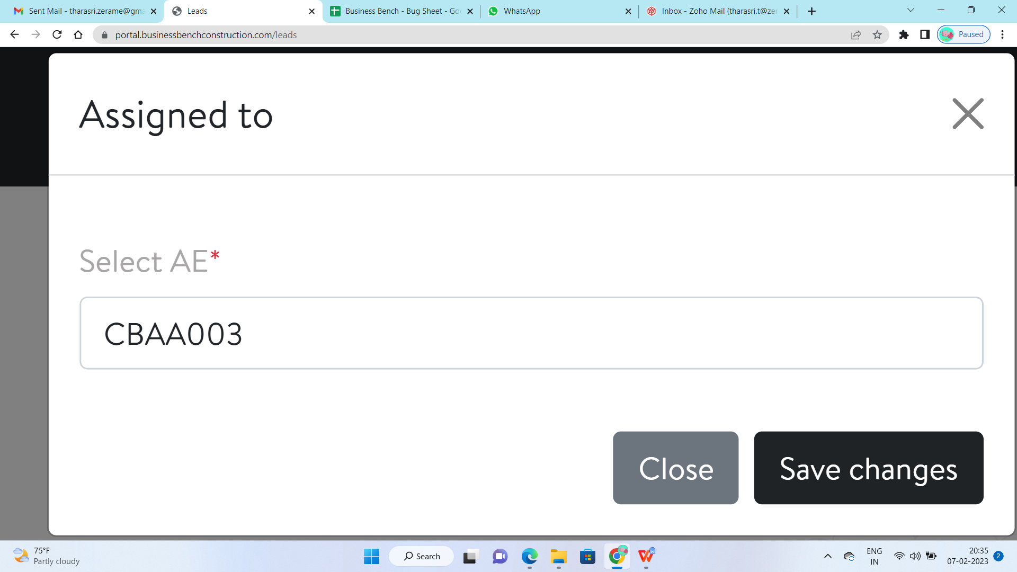Edit option in AE page not showing existing datas
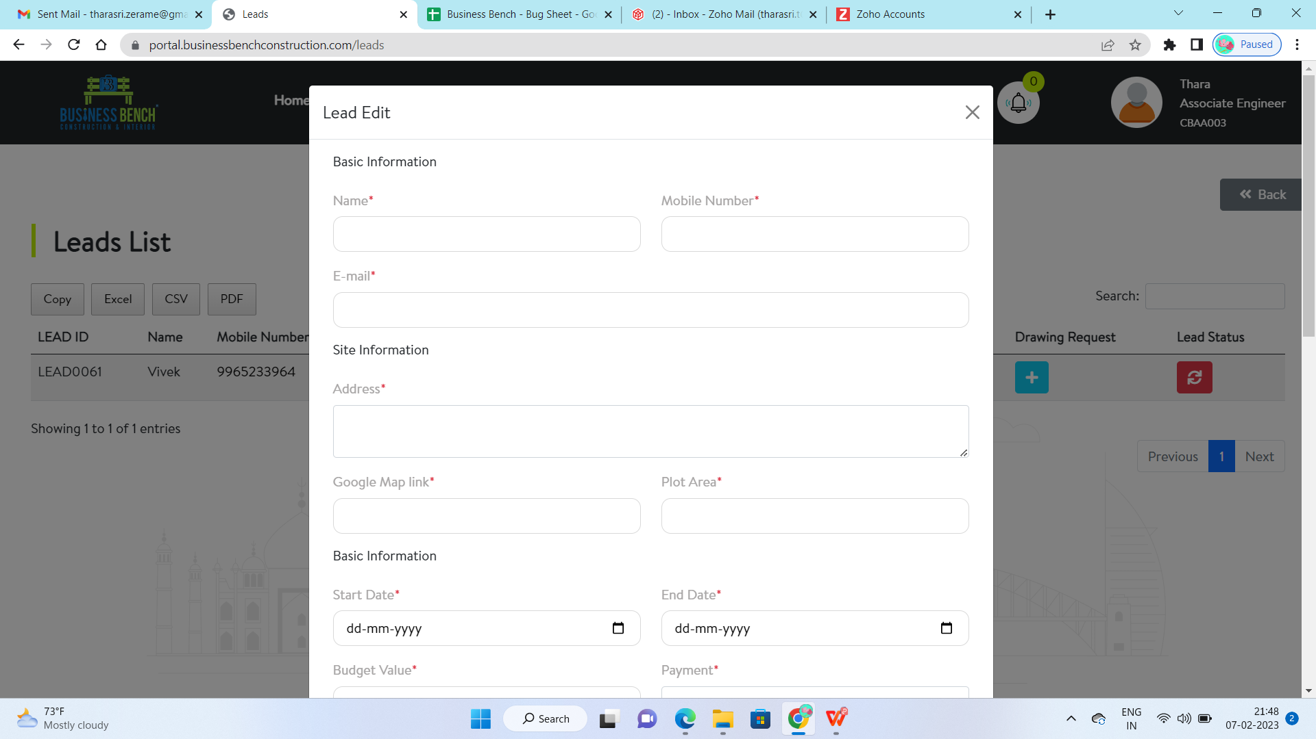
After editing screen
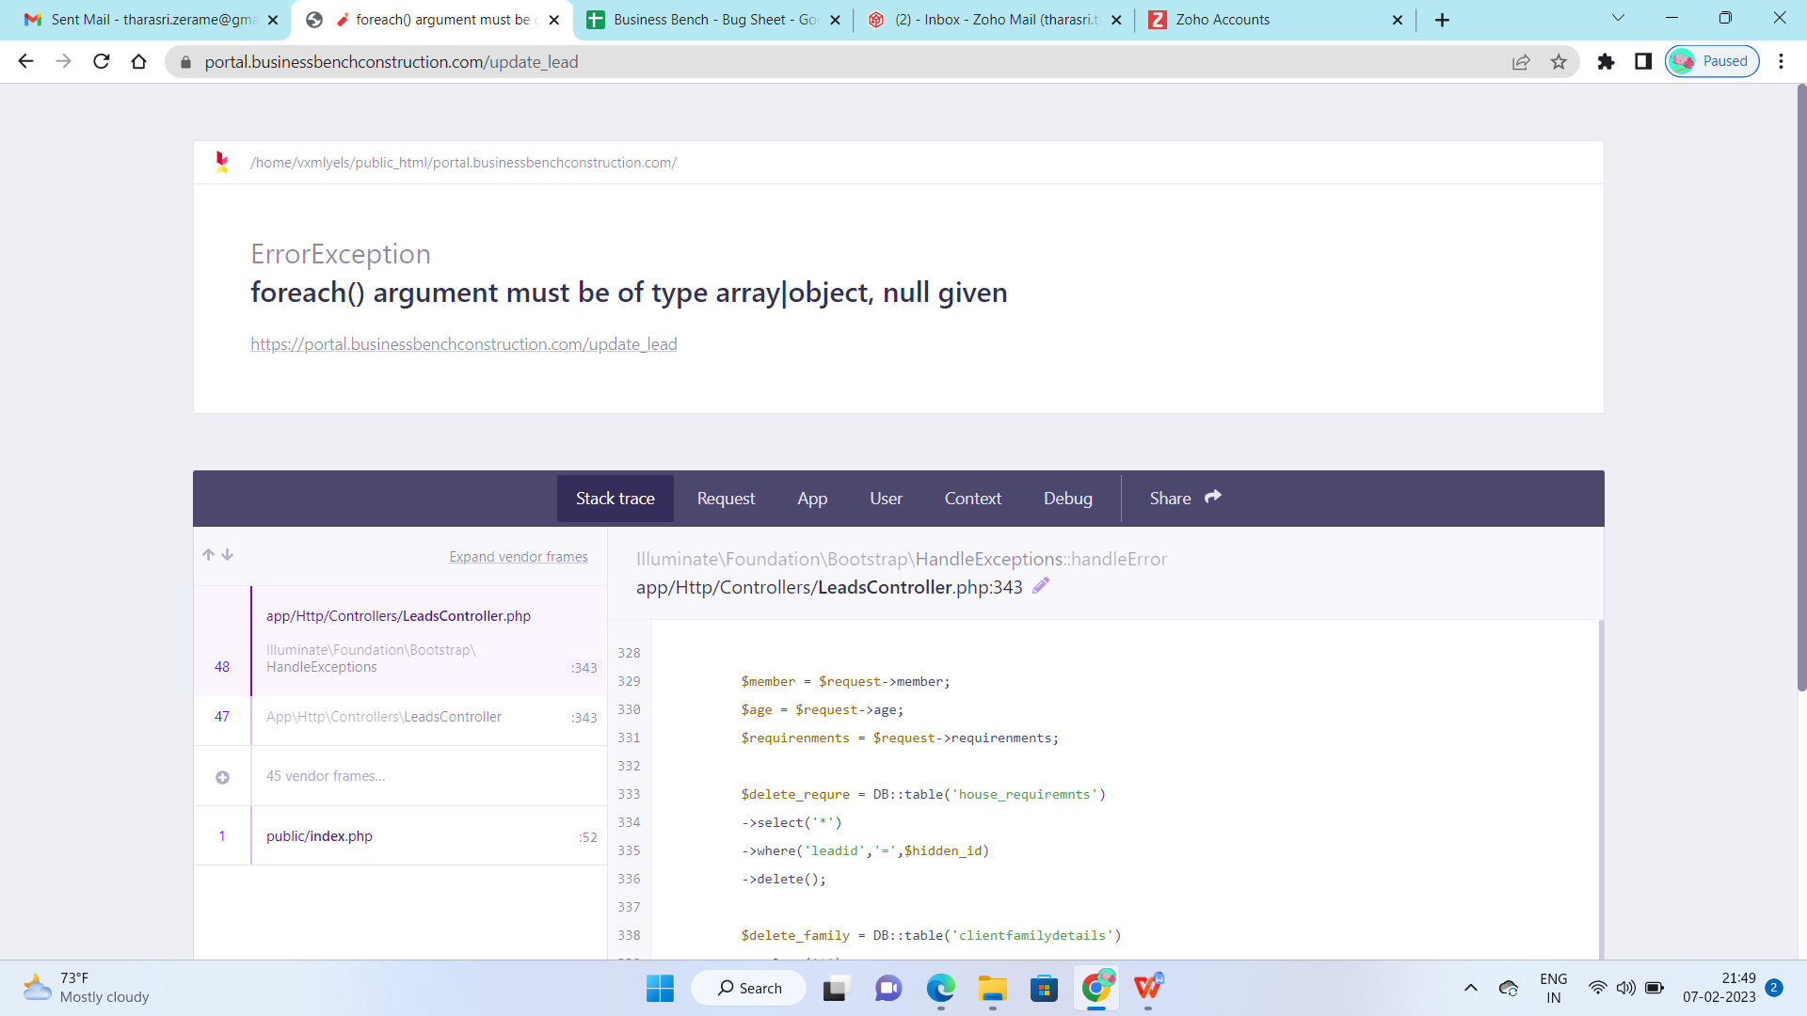
After request architect page lead id only showing. Why lead name is not listed. Many leads in that scenario it may collapse
Upload, Reject notification for architect side
Mobile responsive pending
All area notification AE reject notification to Architect, Client reject, approve status to AE

