AUTOMATION SYSTEM DESIGN
SMART HOME AUTOMATIC LIGHTING SYSTEM
Submitted by:
KADARI SAI TEJA
Domain: ROBOTICS & AUTOMATION
Internship Organization: CODEALPHA
Task: AUTOMATION SYSTEM DESIGN
Submission Year: 2026

1. INTRODUCTION
Home automation is used to control electrical devices automatically based on conditions such as light, temperature, time, or human presence. In this mini project, a simple automatic lighting system is designed using an Arduino Uno, a PIR motion sensor, an LDR, and an LED. The LED represents a room light in the simulation. The system turns the light on only when motion is detected and the room is dark. This helps avoid keeping lights on when they are not required.
2. OBJECTIVE
The objective of this project is to design a simple smart lighting system that detects both human movement and surrounding light level. The system should switch the light ON when a person is present in a dark room and switch it OFF when there is enough light or when no motion is detected.
3. COMPONENTS REQUIRED
Component | Quantity | Purpose
Arduino Uno | 1 | Reads sensors and controls the output
PIR motion sensor | 1 | Detects human movement
LDR / photoresistor | 1 | Measures surrounding light level
10 kΩ resistor | 1 | Forms voltage divider with the LDR
LED | 1 | Represents the room light
220 Ω resistor | 1 | Limits current through the LED
Breadboard | 1 | Used for circuit connections
Jumper wires | As required | Connects the components
4. CIRCUIT CONNECTIONS
PIR sensor: connect VCC to Arduino 5V, GND to Arduino GND, and OUT to digital pin D2. LDR circuit: connect one side of the LDR to 5V. Connect the other side of the LDR to analog pin A0. From the same A0 junction, connect a 10 kΩ resistor to GND. LED circuit: connect digital pin D9 to a 220 Ω resistor, then connect the resistor to the LED anode (long leg). Connect the LED cathode (short leg) to GND. Do not connect this beginner circuit directly to 230 V AC mains. The LED is used only to simulate a room light.
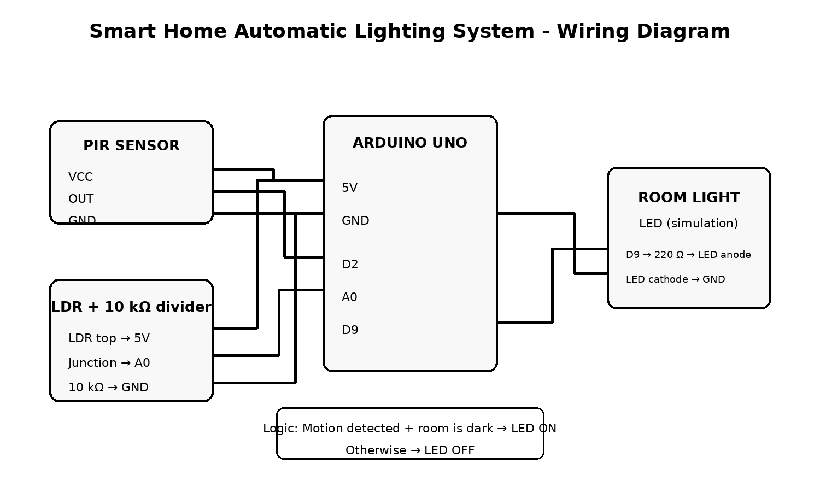
Figure 1: Smart home automatic lighting circuit connection diagram
5. WORKING PRINCIPLE
The PIR sensor checks whether movement is present in the room. At the same time, the LDR gives an analog value that represents the light level. The Arduino continuously reads both values. When motion is detected and the LDR reading indicates darkness, the Arduino turns the LED ON. If there is no motion, or if the room is already bright, the LED remains OFF. In Tinkercad the darkness threshold can be adjusted in the program after observing the LDR values.
6. ARDUINO PROGRAM
const int pirPin = 2;
const int ldrPin = A0;
const int ledPin = 9;
int lightThreshold = 500;
void setup() {
pinMode(pirPin, INPUT);
pinMode(ledPin, OUTPUT);
Serial.begin(9600);
}
void loop() {
int motion = digitalRead(pirPin);
int lightValue = analogRead(ldrPin);
Serial.print("LDR: ");
Serial.print(lightValue);
Serial.print(" PIR: ");
Serial.println(motion);
if (motion == HIGH && lightValue < lightThreshold) {
digitalWrite(ledPin, HIGH);
} else {
digitalWrite(ledPin, LOW);
}
delay(200);
}
7. EXPECTED OUTPUT
Case 1: Dark room + motion detected → LED ON. Case 2: Dark room + no motion → LED OFF. Case 3: Bright room + motion detected → LED OFF. Case 4: Bright room + no motion → LED OFF. This shows that the light is used only when it is actually required.
8. ADVANTAGES
The system is simple, low cost, and easy to simulate. It reduces unnecessary lighting, demonstrates the basic idea of sensor-based automation, and can be expanded later by adding relays, IoT control, timers, or multiple room sensors.
9. LIMITATIONS AND FUTURE IMPROVEMENTS
The LDR threshold may need adjustment for different rooms. A PIR sensor detects movement rather than identifying a specific person, so the light may turn off if a person remains completely still for a long time. A practical system can be improved with a timer, occupancy logic, multiple sensors, and an electrically isolated relay module for controlling a real lamp. Any real mains-voltage installation should be handled using proper isolation and qualified electrical practices.
10. CONCLUSION
This project demonstrates a basic smart home lighting system using two sensor inputs. The PIR sensor detects movement and the LDR detects the light level. The Arduino combines both conditions and controls the LED automatically. The project is useful for understanding Arduino programming, sensor interfacing, decision logic, and the basic concept of home automation.
11. REFERENCES
Arduino Documentation - Arduino Uno and digital/analog I/O concepts.
Autodesk Tinkercad Circuits - online electronics simulation platform.
PIR motion sensor and photoresistor component datasheets / learning resources.

