**Cross Platform Application Development**

**Assignment 1 - Flutter App with Back4App Integration**

**Name : G. Sai Teja**

**BITS ID : 2022MT93575**

**Assignment Steps:**

Step 1: Set Up Back4App

New app – ‘Todo App’

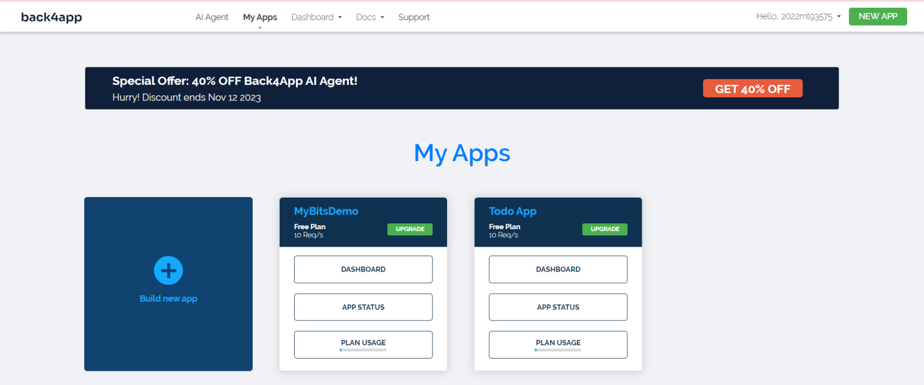

Created a new class ‘Task’ with columns title, description, status

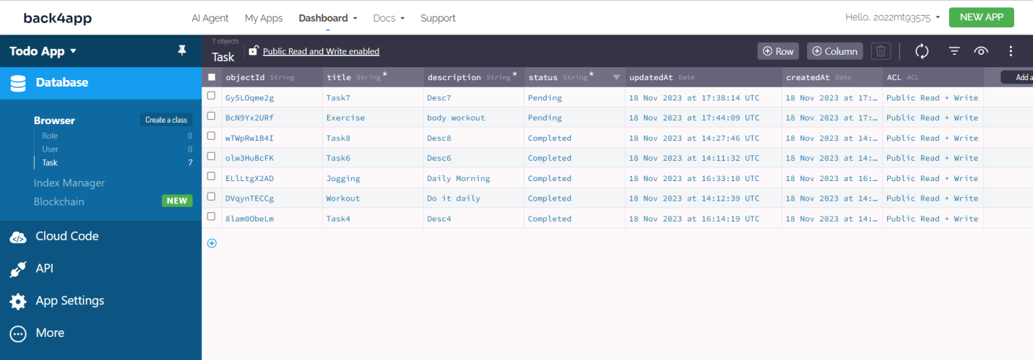

App Keys

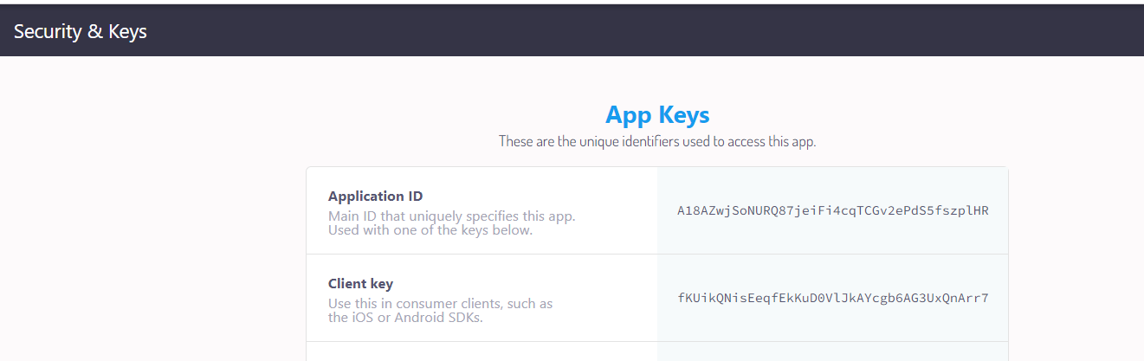

Step 2: Flutter Setup

Created new flutter project ‘todoapp’

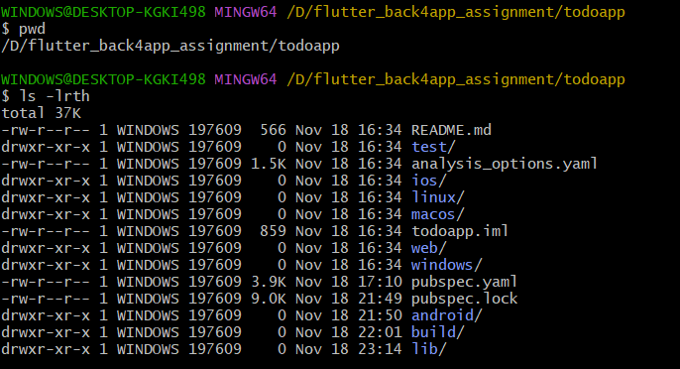

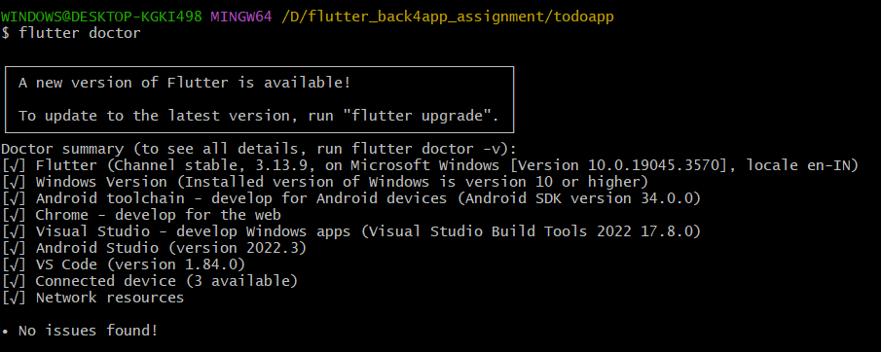

Added dependency ‘parse_server_sdk’ in pubspec.yaml

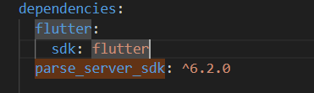

Updated keyApplicationId, keyClientKey, keyParseServerUrl in main.dart file

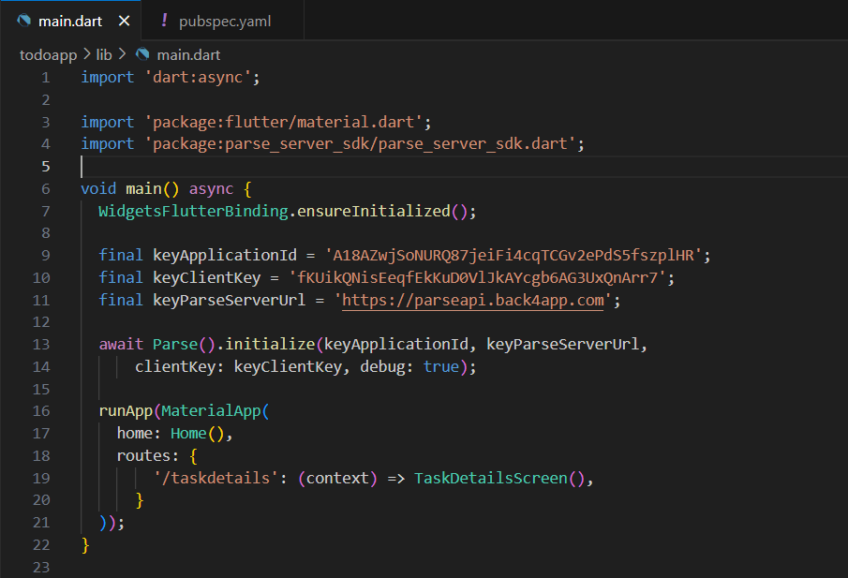

Step 3: Task List

Executing code by running flutter run command

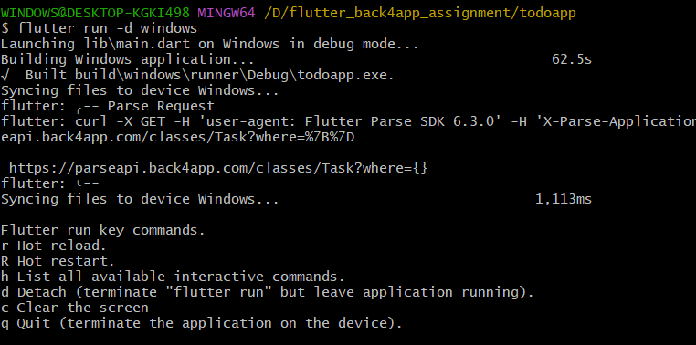

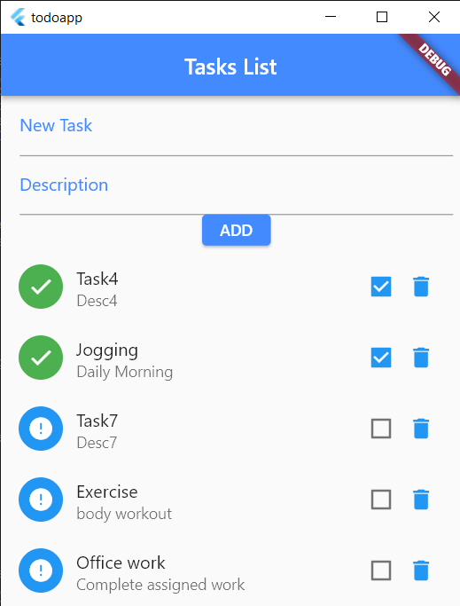

Get query in logs

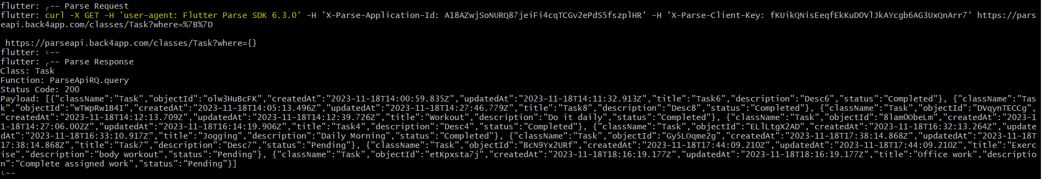

Implemented getToDo() function to retrieve tasks list

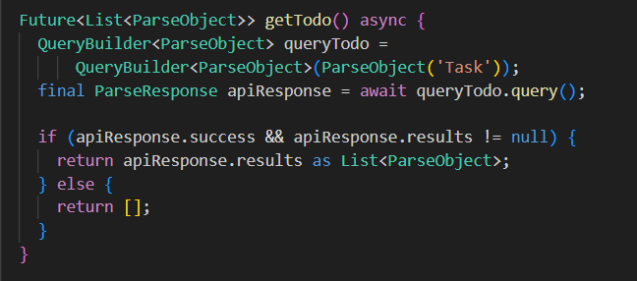

Step 4: Task Creation

Created new task ‘Prepare for exams’

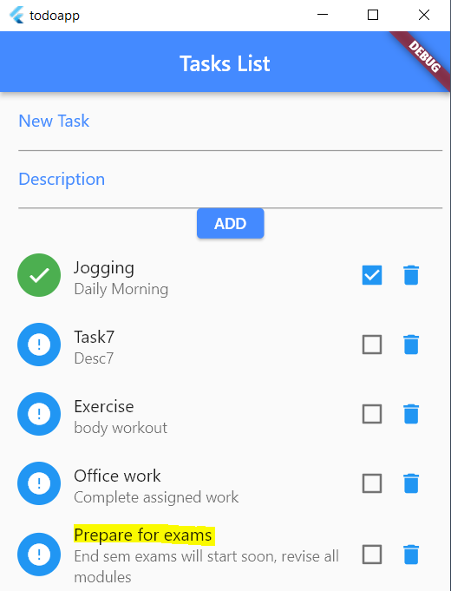

Post query in logs

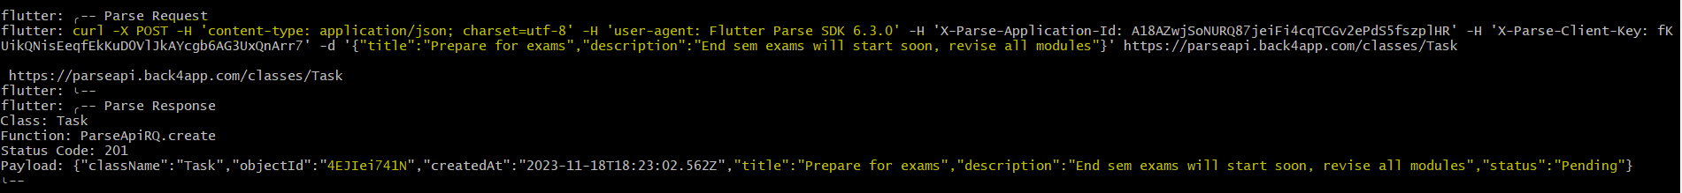

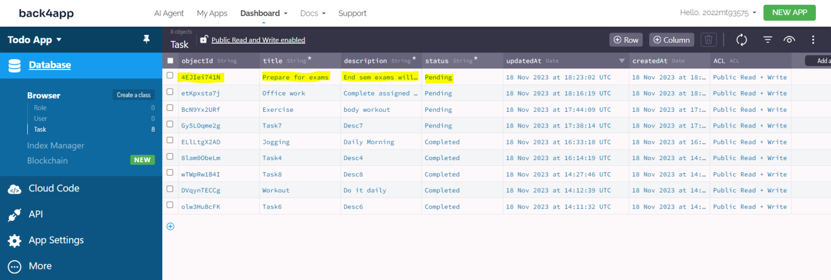

Implemented addToDo() function to add new tasks

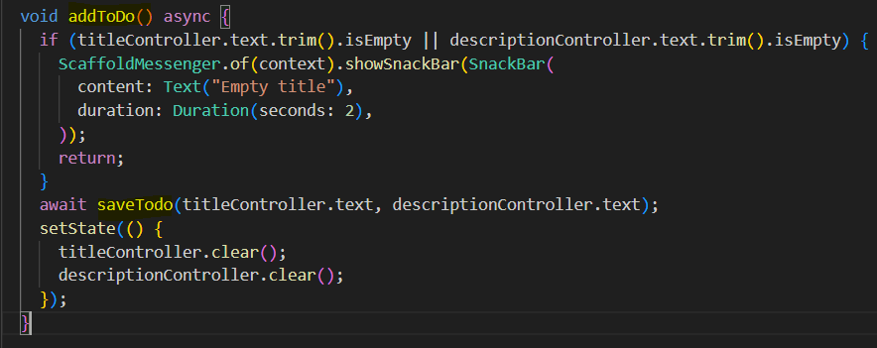

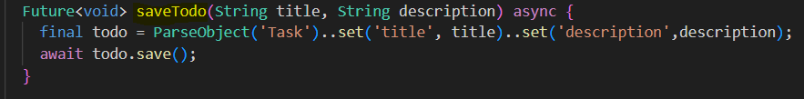

Step 5: Task Details

Task details will be displayed whenever a task is tapped

Details include title, description and status of that task

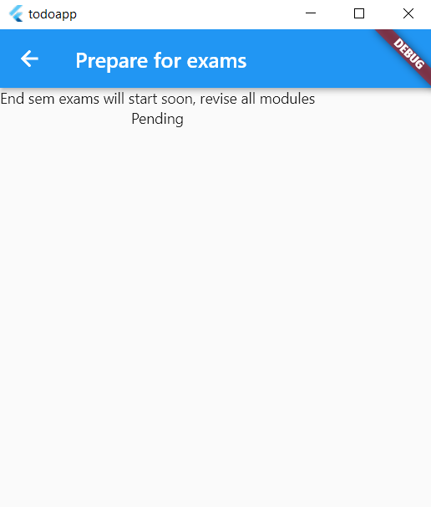

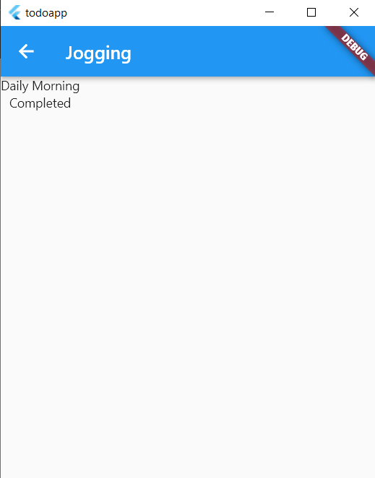

Step 6: Bonus Features

Added functionality for updating and deleting existing tasks

Updated task ‘Office work’ to Completed

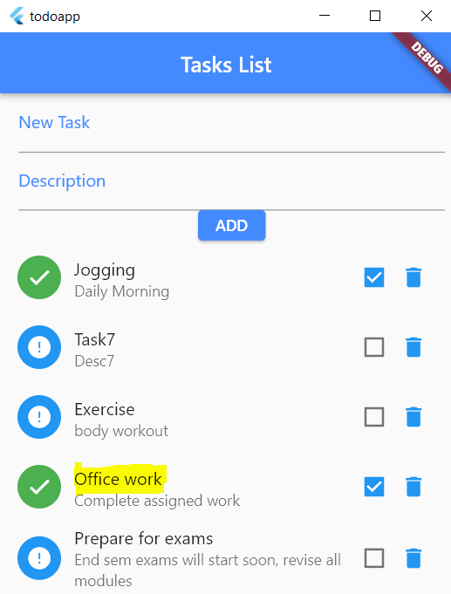

Put query in logs

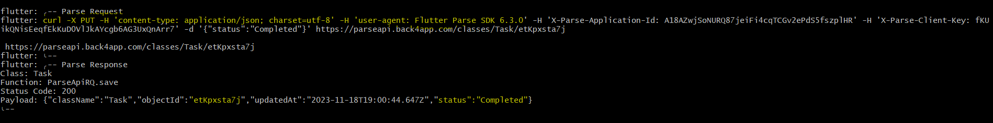

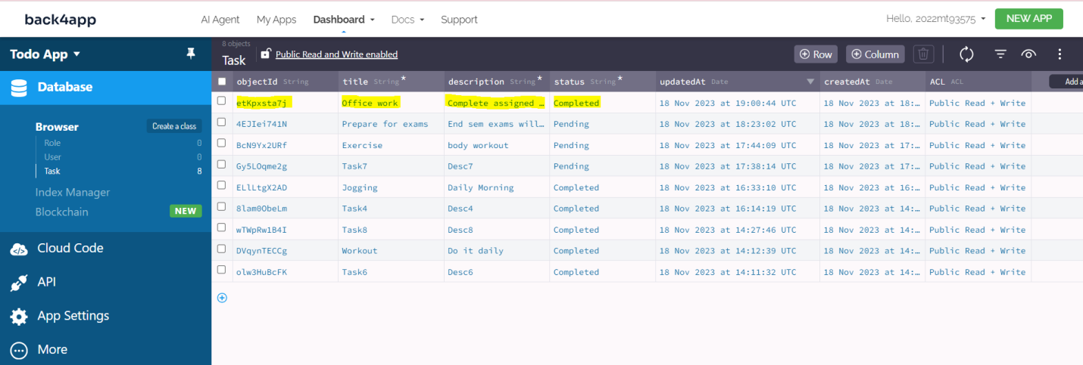

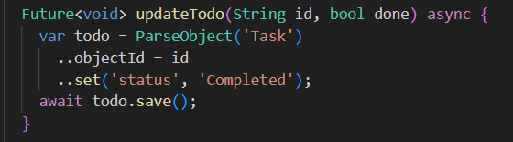

Deleted task ‘Jogging’

Delete query in logs

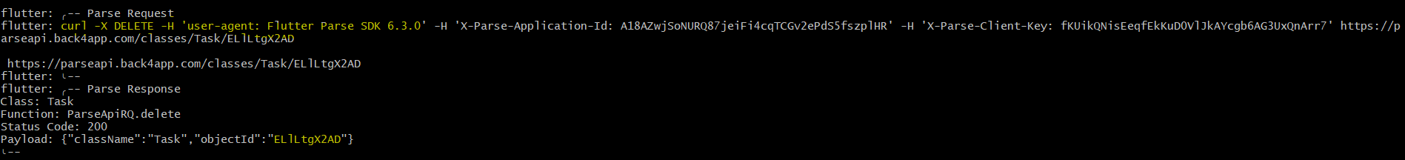

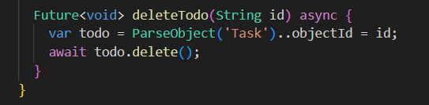

Add, Update, Deletion of tasks in Back4App will get reflected in Flutter Todo app

New task ‘Yoga’



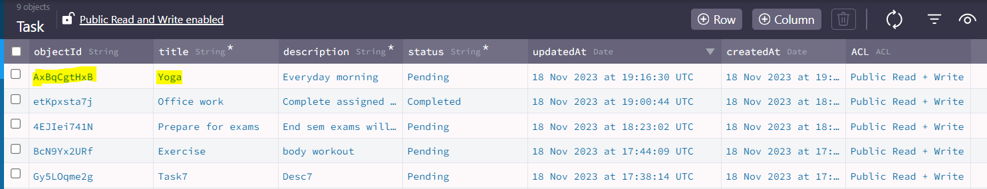

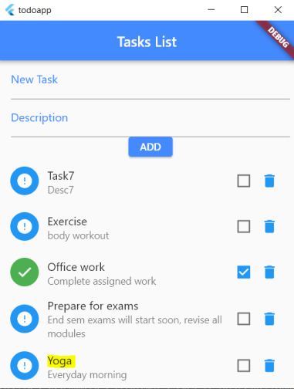

Update task ‘Exercise’ to Completed



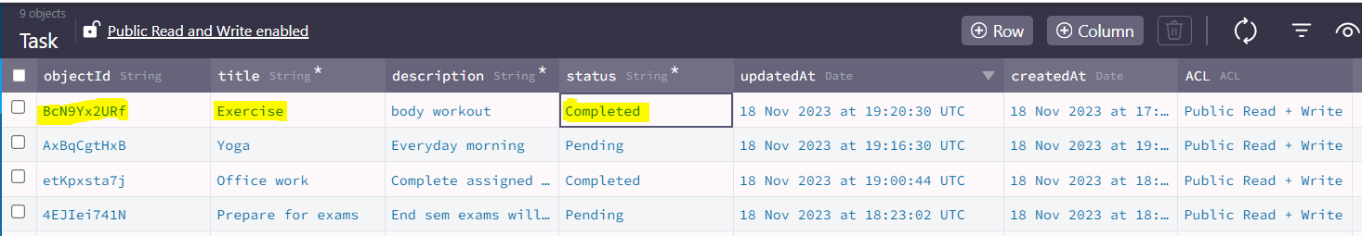

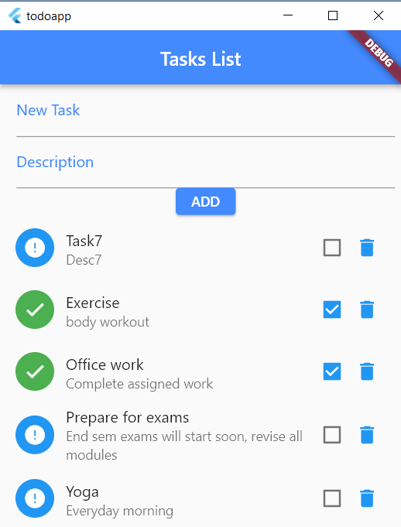

Delete task ‘Workout’



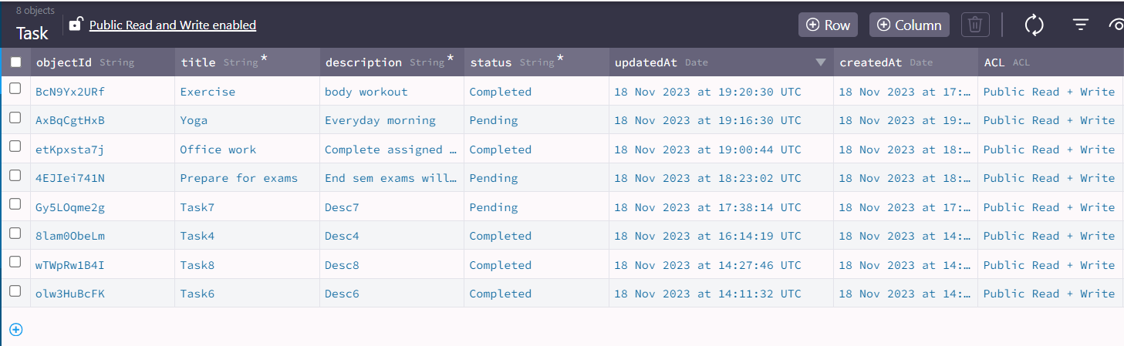

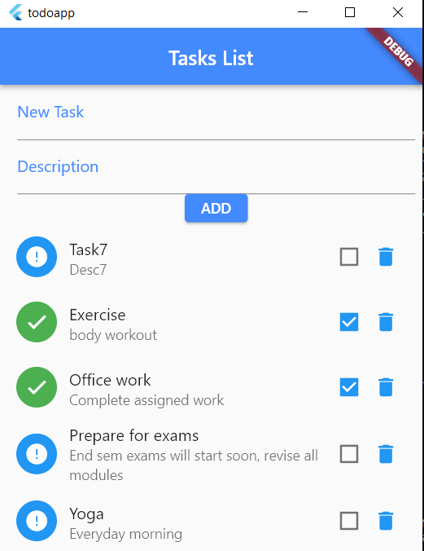

Git Hub Repository Link: https://github.com/saiteja-gaddam/Flutter-App-with-Back4App-Integration