Intro my sql
Overview categories
Ddl ,Dml,Dql
Datatypes-after dummy database
Operators
Clauses
Single row and multi row functions
Constraints
Joins
Indexes
Tcl
Dcl
Stored procedures
Views
Date methods
Keys

Normalization -6
Triggers
Window functions
Oncascade ondelete
If else
If null

Database
It is a collection of data in a format that can be easily accessed digitally and controlled by a dbms
(dbms Is a software application used to manage database)

Types of databases
1)Relational databases:- it is a database where the data is stored in tables in a structured format
Ex:- mysql , postgre sql, oracle database
2)Non-relatational databases:- it is a database where the data is stored in unstructured way
Ex:- mongodb, no sql, neo4
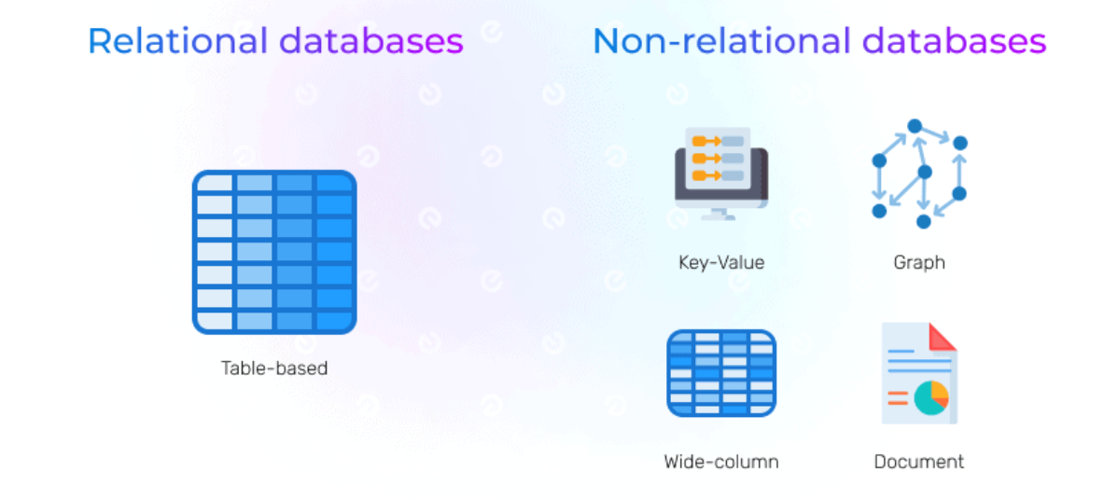

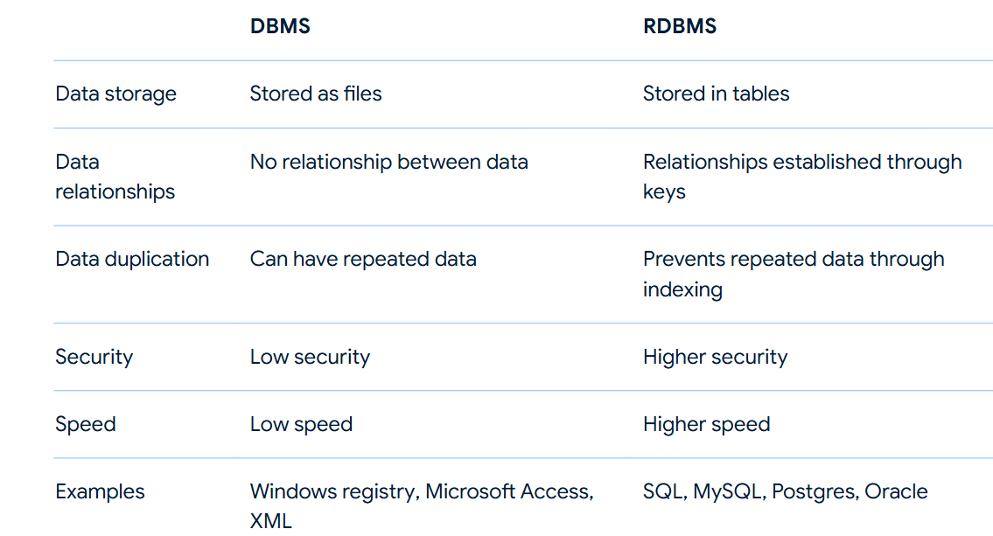

Types of dbms
Rdbms
Ordbms
Fms- file management system
Hms- heirerchial management system
Nms-network management system
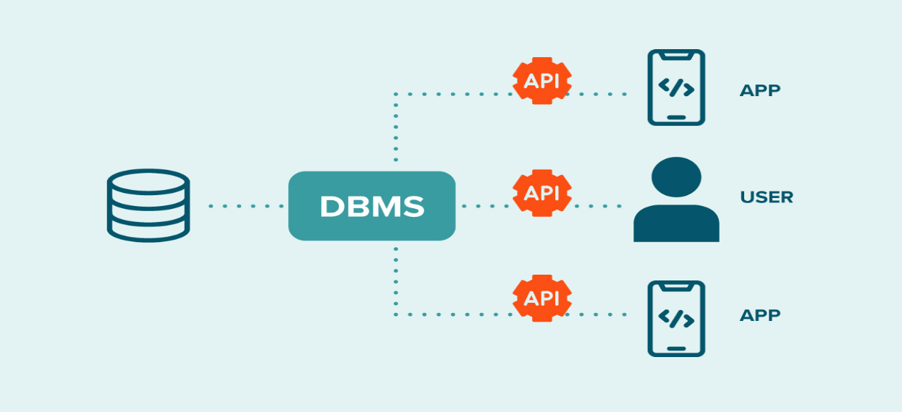

Database: collection of data
Table : collection of rows and columns
Columns: collection of field names
Row: collection of field values

Features of rdbms
Easy to access and manipulate data
Less redundancy – duplication of data
Guarantee data quality
Supports data sharing , transaction and security

Rdbms softwares
Mysql…from oracle
Oracle…oracle
Postgrsql…postgresql forum
Sql server…microsoft
Db2…ibm
Rds…from amazon

Database can be deployed in two way
On premises—deployed in the server which is managed by client
On cloud--- deployed in the server where data is managed by cloud service providers

Sql
Sql is statically typed programming language used to interact with relational database
Used to query and retrieve data from the database
=> SQL stands for structured query language.
=> it is a language used to communicate with the mysql.
=> user communicates with mysql by sending commands called queries.
=> a query is a command/request/question submitted to mysql
to perform some operation over db.
=> sql commands are categorized into 5 sub languages.

1 DDL (Data Definition Lang)
2 DML (Data Manipulation Lang)
3 DQL (Data Query Lang)
4 DCL (Data Control Lang)
5 TCL (Transaction Control Lang)
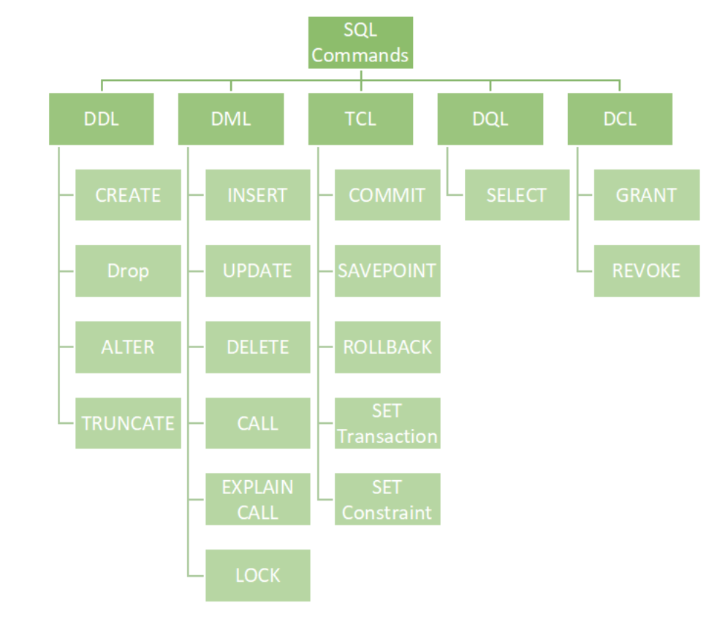

Mysql;
it is a opensource rdbms(relational database management system) based on structured query language used to handle wide range of database applications
- SQL: A standard language for interacting with databases, used to perform tasks such as querying data, updating records, and managing database structures.

Installing MySQL on Windows
- Download MySQL Installer:
  - Go to the MySQL Community Downloads page.
  - Choose the MySQL Installer for Windows.
- Run the Installer:
  - Double-click the downloaded .msi file to start the installation process.
- Choose Setup Type:
  - Choose the setup type that suits your needs: Developer Default, Server only, Client only, Full, or Custom. For most users, ‘Developer Default’ is recommended.
- Check Requirements:
  - The installer will check for any missing requirements. Install any required software as prompted.
- Installation:
  - Click ‘Execute’ to download and install the necessary MySQL components.
- Configuration:
  - After installation, the MySQL installer will guide you through configuration steps:
    - High Availability: Select ‘Standalone MySQL Server / Classic MySQL Replication.’
    - Type and Networking: Choose ‘Development Computer’ or the appropriate setting for your setup. The default port is 3306.
    - Authentication: Set up the root password and create additional user accounts if needed.
    - Windows Service: Configure MySQL to run as a Windows service if desired.
- Complete the Installation:
  - Click ‘Execute’ to apply the configuration settings.
  - Click ‘Finish’ once the configuration is complete.
- Verify Installation:
  - Open the MySQL Command Line Client from the Start menu and log in with the root password to verify the installation.

Connecting to MySQL Shell
Before you can create a database, you need to connect to the MySQL server. This is typically done using the MySQL command-line client or a graphical tool like MySQL Workbench.

MySQL Shell Commands
- \sql → Run SQL queries
- \connect root@localhost:3306 → Connect to MySQL
- \! cls; → Clear the terminal screen

Viewing Databases
To see a list of all databases on the MySQL server, use the SHOW DATABASES command.
SHOW DATABASES;

Creating a Database
Once connected to the MySQL server, you can create a database using the CREATE DATABASE statement.
Syntax
CREATE DATABASE database_name;

Selecting a Database
After creating a database, you need to select it to perform operations such as creating tables, inserting data, and running queries.
USE database_name;

Checking the Current Database
To check which database you are currently using, you can run:
SELECT DATABASE();

Dropping a Database
To delete a database, use the DROP DATABASE statement. Be cautious, as this action is irreversible and will permanently remove the database and all its data.
DROP DATABASE database_name;

Overview categories
SQL Categories and Commands
SQL (Structured Query Language) is divided into several categories based on the type of operations they perform. Below are the major categories along with their respective commands and descriptions.

1. Data Definition Language (DDL)
DDL commands are used to define and manage database structures.
- CREATE: Used for creating tables, databases, indexes, and users.
- ALTER: Modifies table structures.
- DROP: Deletes tables, columns, databases, indexes, and users.
- TRUNCATE: Removes all data from a table.
- RENAME: Used to rename tables and columns.
Examples:
CREATE TABLE employees (
id INT PRIMARY KEY,
name VARCHAR(50),
salary DECIMAL(10,2)
);

ALTER TABLE employees ADD COLUMN department VARCHAR(50);

DROP TABLE employees;

TRUNCATE TABLE employees;

RENAME TABLE employees TO staff;

2. Data Manipulation Language (DML)
DML commands are used to manipulate data within database objects.
- INSERT: Adds new data into a table (single row and multiple rows).
- UPDATE: Modifies existing records using the SET clause.
- DELETE: Removes specific data from a table (faster than TRUNCATE).
Examples:
INSERT INTO employees (id, name, salary) VALUES (1, 'John Doe', 50000);

UPDATE employees SET salary = 55000 WHERE id = 1;

DELETE FROM employees WHERE id = 1;

3. Data Control Language (DCL)
DCL commands are used to control access to data in the database.
- GRANT: Gives permissions to users.
- REVOKE: Removes permissions from users.
Examples:
GRANT SELECT, INSERT ON employees TO user1;

REVOKE INSERT ON employees FROM user1;

4. Transaction Control Language (TCL)
TCL commands manage database transactions.
- COMMIT: Saves changes permanently.
- ROLLBACK: Undoes changes.
- SAVEPOINT: Creates a checkpoint within a transaction to which changes can be rolled back.
Examples:
START TRANSACTION;
INSERT INTO employees (id, name, salary) VALUES (2, 'Jane Doe', 60000);
SAVEPOINT sp1;
UPDATE employees SET salary = 65000 WHERE id = 2;
ROLLBACK TO sp1; -- Undo update but keep insert
COMMIT;
Auto-commit Mode:
- AUTOCOMMIT = ON: Each statement is committed automatically.
- AUTOCOMMIT = OFF: Transactions must be manually committed.

5. Data Query Language (DQL)
DQL is used for retrieving data from the database.
- SELECT: Fetches data from one or more tables.
Example:
SELECT * FROM employees;
SELECT name, salary FROM employees WHERE salary > 50000;

COPY THE DUMMY DATABASE DATA
DROP database if exists practice;
create database practice;
use practice;

CREATE TABLE dept (
deptno DECIMAL(2,0) PRIMARY KEY,
dname VARCHAR(14) DEFAULT NULL,
loc VARCHAR(13) DEFAULT NULL
);

CREATE TABLE emp (
empno DECIMAL(4,0) NOT NULL,
ename VARCHAR(10) DEFAULT NULL,
job VARCHAR(9) DEFAULT NULL,
mgr DECIMAL(4,0) DEFAULT NULL,
hiredate DATE DEFAULT NULL,
sal DECIMAL(7,2) DEFAULT NULL,
comm DECIMAL(7,2) DEFAULT NULL,
deptno DECIMAL(2,0),
FOREIGN KEY (deptno) REFERENCES dept(deptno)
);

-- Insert data into the dept table first
INSERT INTO dept VALUES ('10', 'ACCOUNTING', 'NEW YORK');
INSERT INTO dept VALUES ('20', 'RESEARCH', 'DALLAS');
INSERT INTO dept VALUES ('30', 'SALES', 'CHICAGO');
INSERT INTO dept VALUES ('40', 'OPERATIONS', 'BOSTON');

-- Now insert data into the emp table
INSERT INTO emp VALUES ('7369', 'SMITH', 'CLERK', '7902', '1980-12-17', '800.50', NULL, '20');
INSERT INTO emp VALUES ('7499', 'ALLEN', 'SALESMAN', '7698', '1981-02-20', '1600.00', '300.00', '30');
INSERT INTO emp VALUES ('7521', 'WARD', 'SALESMAN', '7698', '1981-02-22', '1250.23', '500.00', '30');
INSERT INTO emp VALUES ('7566', 'JONES', 'MANAGER', '7839', '1981-04-02', '2975.00', NULL, '20');
INSERT INTO emp VALUES ('7654', 'MARTIN', 'SALESMAN', '7698', '1981-09-28', '1250.81', '1400.00', '30');
INSERT INTO emp VALUES ('7698', 'BLAKE', 'MANAGER', '7839', '1981-05-01', '2850.56', NULL, '30');
INSERT INTO emp VALUES ('7782', 'CLARK', 'MANAGER', '7839', '1981-06-09', '2450.00', NULL, '10');
INSERT INTO emp VALUES ('7788', 'SCOTT', 'ANALYST', '7566', '1982-12-09', '3000.61', NULL, '20');
INSERT INTO emp VALUES ('7839', 'KING', 'PRESIDENT', NULL, '1981-11-17', '5000.00', NULL, '10');
INSERT INTO emp VALUES ('7844', 'TURNER', 'SALESMAN', '7698', '1981-09-08', '1500.40', '0.00', '30');
INSERT INTO emp VALUES ('7876', 'ADAMS', 'CLERK', '7788', '1983-01-12', '1100.00', NULL, '20');
INSERT INTO emp VALUES ('7900', 'JAMES', 'CLERK', '7698', '1981-12-03', '950.20', NULL, '30');
INSERT INTO emp VALUES ('7902', 'FORD', 'ANALYST', '7566', '1981-12-03', '3000.67', NULL, '20');
INSERT INTO emp VALUES ('7934', 'MILLER', 'CLERK', '7782', '1982-01-23', '1300.00', NULL, 10);

Datatypes
INT
- Purpose: Stores whole numbers (both positive and negative) without decimals.
- Syntax: INT
Example:
CREATE TABLE employees (
id INT NOT NULL
);
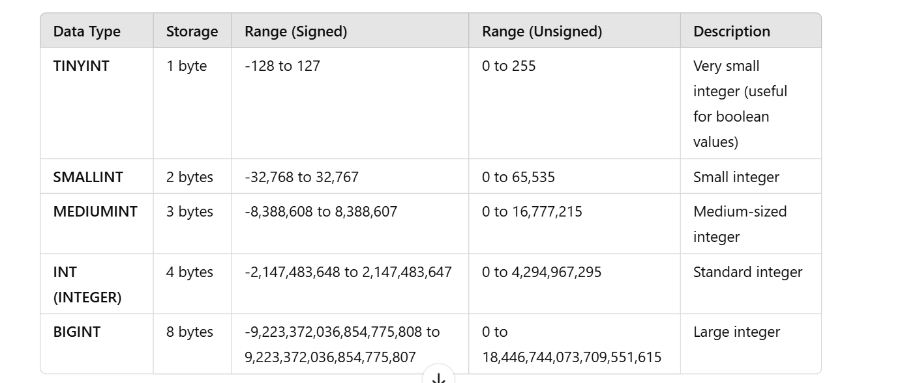

VARCHAR
- Purpose: Stores variable-length strings.
- Syntax: VARCHAR(size) where size defines the maximum number of characters.
Example:
CREATE TABLE employees (
name VARCHAR(100) NOT NULL
);
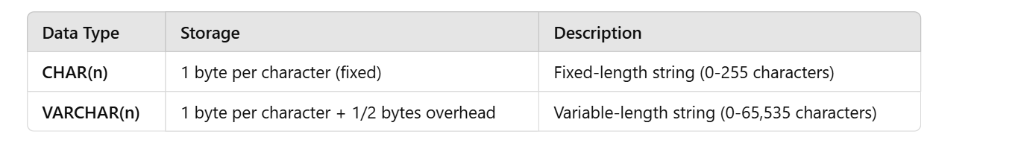
📌 Example:char(10)
Imagine you have a 10-slot box for words.
- If you store "YES", it still occupies all 10 slots (extra space wasted).
- If you store "HELLOWORLD", it fits exactly

📌 Example:
Imagine a flexible box that expands based on word length.
- If you store "YES", it uses only 3 slots instead of 10.
- If you store "HELLOWORLD", it uses 10 slots.

DECIMAL
- Purpose: Stores numbers with fixed precision and scale (e.g., monetary values).
- Syntax: DECIMAL(precision, scale) where precision is the total number of digits and scale is the number of digits after the decimal point.
Example:
CREATE TABLE employees (
salary DECIMAL(10, 2) CHECK (salary >= 0)
);
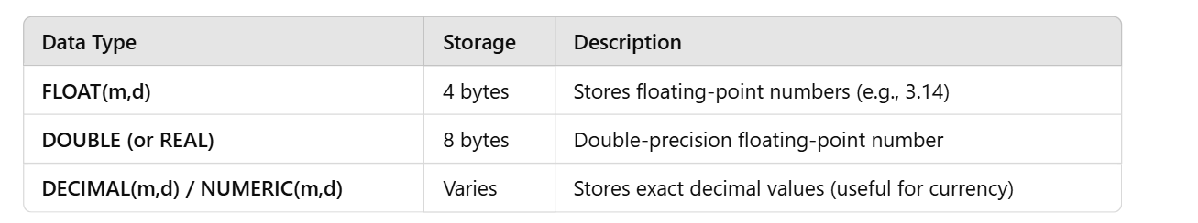
🔹 Explanation:
- FLOAT(5,2) → Maximum 5 digits total, 2 digits after decimal (e.g., 999.99).
- DOUBLE(8,3) → Maximum 8 digits, 3 decimal places (e.g., 12345.678).
- DECIMAL(10,2) → 10 total digits, 2 decimal places.
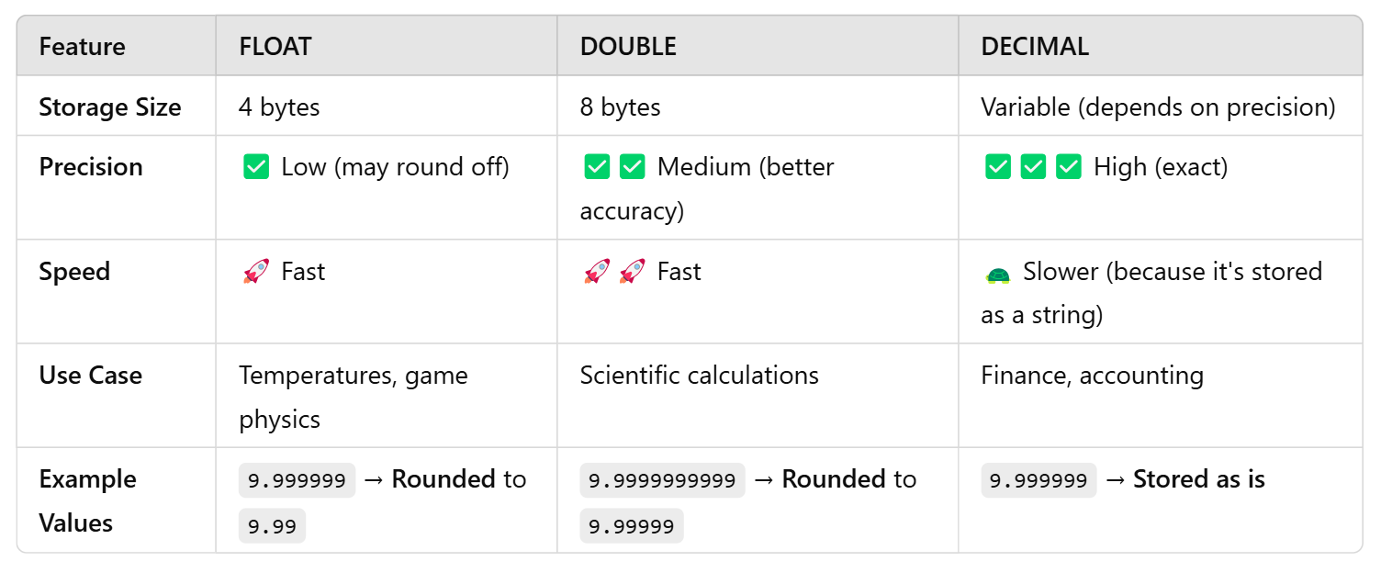

DATE
- Purpose: Stores dates in the format YYYY-MM-DD.
- Syntax: DATE
Example:
CREATE TABLE employees (
hire_date DATE
);
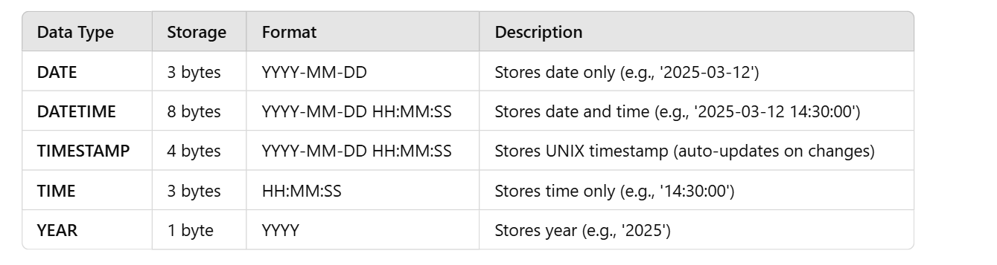

TIMESTAMP
- Purpose: Stores both date and time in the format YYYY-MM-DD HH:MM:SS.
- Syntax: TIMESTAMP
Example:
CREATE TABLE employees (
created_at TIMESTAMP DEFAULT CURRENT_TIMESTAMP
);

BOOLEAN
- Purpose: Stores a value of TRUE or FALSE.
- Syntax: BOOLEAN (often stored as TINYINT(1) in some databases).
Example:
CREATE TABLE employees (
is_active BOOLEAN DEFAULT TRUE
);


TEXT
- Purpose: Stores large amounts of text data.
- Syntax: TEXT
Example:
CREATE TABLE employees (
description TEXT
);
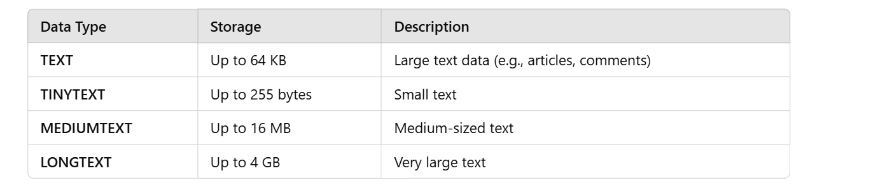

How to handle tables
Data definition language Queries
DDL (Data Definition Language) is used to define and manage the structure of a database. These queries create, modify, and delete databases, tables, and other objects like indexes.
DDL commands do not modify data but change the schema of the database.
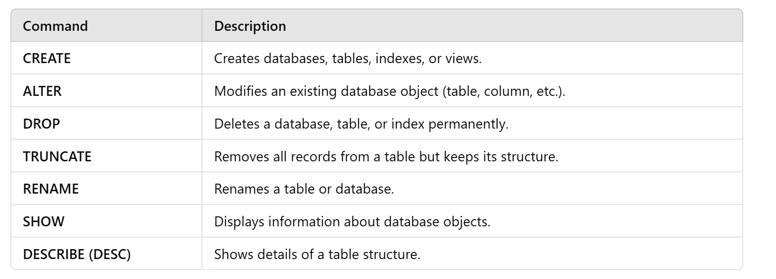

Creating a Table
Creates a new table with specified columns
Syntax
CREATE TABLE table_name ( column1 datatype constraints, column2 datatype constraints);

CREATE TABLE users (
id INT,
username VARCHAR(50),
password VARCHAR(50),
email VARCHAR(100),
created_at TIMESTAMP DEFAULT CURRENT_TIMESTAMP
);

To show the description of the table
Desc tablename;

Altering a Table
1) Adding a Column:-Adds a new column to an existing table
ALTER TABLE table_name ADD column_name datatype constraints;

2)Modifying a Column:-Changes the data type and/or constraints of an existing column.
ALTER TABLE table_name MODIFY column_name new_datatype new_constraints;

3) Dropping a Column :-Removes a column from an existing table.
ALTER TABLE table_name DROP COLUMN column_name;

4) Renaming a Column:- Renames an existing column
ALTER TABLE table_name RENAME COLUMN colname to newcolname;

5) Add a constraint
ALTER TABLE table_name ADD CONSTRAINT colname CHECK (salary >= 3000);

Renaming a Table
Changes the name of an existing table.
ALTER TABLE old_table_name RENAME TO new_table_name;
Rename oldtable to newtable;

Dropping a Table
Deletes the table and all of its data permanently. Use with caution.
DROP TABLE table_name;

Truncate:
It removes the data in the table
Truncate table tname;

Viewing Tables
To see a list of all tables on the MySQL server, use the SHOW tables command.
SHOW TABLES;

Data manipulation language Queries
INSERT
The INSERT statement is used to add new rows to a table.
INSERT INTO table_name (column1, column2, ...) VALUES (value1, value2, ...);
Multiple Rows:
INSERT INTO employees (first_name, last_name, department)
VALUES ('Jane', 'Doe', 'HR'), ('Mark', 'Smith', 'IT');

UPDATE
The UPDATE statement is used to modify existing records in a table.
UPDATE table_name SET column1 = ‘value1’, column2 = ‘value2’, ...
WHERE condition=’value’;

DELETE
The DELETE statement is used to remove existing records from a table.
DELETE FROM table_name
WHERE condition=’value’;
Caution: Omitting the WHERE clause will delete all rows in the table.

Data Query Language (DQL)
DQL is a subset of SQL (Structured Query Language) used for querying and fetching data from a database.
SELECT Statement
The SELECT statement is used to retrieve data from one or more tables.
SELECT column1, column2 FROM table_name;

Selecting All Columns
To select all columns from a table, use the asterisk (*).
SELECT * FROM employees;

Using Aliases
Aliases can be used to give a table or a column a temporary name.
SELECT first_name AS fnam FROM employees;
MySQL Operators
Arithmetic Operators
- Addition (+): Adds two values.
- Subtraction (-): Subtracts one value from another.
- Multiplication (*): Multiplies two values.
- Division (/): Divides one value by another.
- Modulus (%): Returns the remainder of a division.

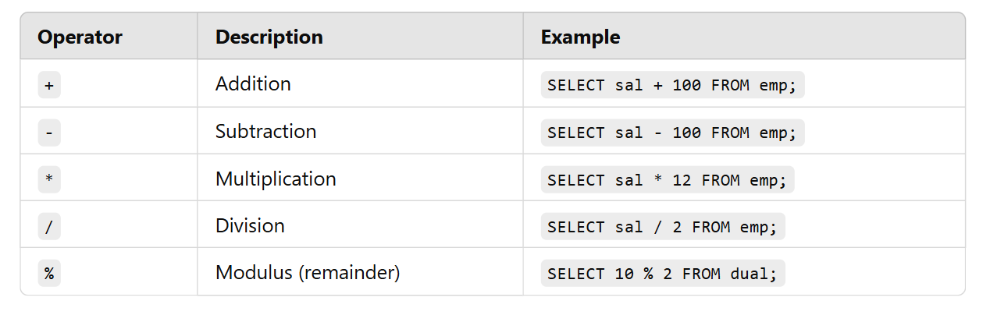
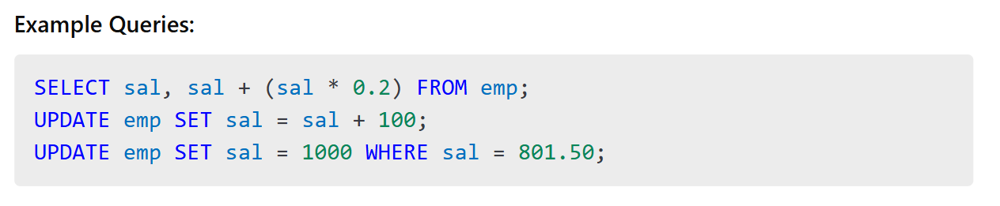

Comparison Operators
- Equal to (=): Checks if two values are equal.
- Not equal to (!= or <>): Checks if two values are not equal.
- Greater than (>): Checks if a value is greater than another.
- Less than (<): Checks if a value is less than another.
- Greater than or equal to (>=): Checks if a value is greater than or equal to another.
- Less than or equal to (<=): Checks if a value is less than or equal to another.

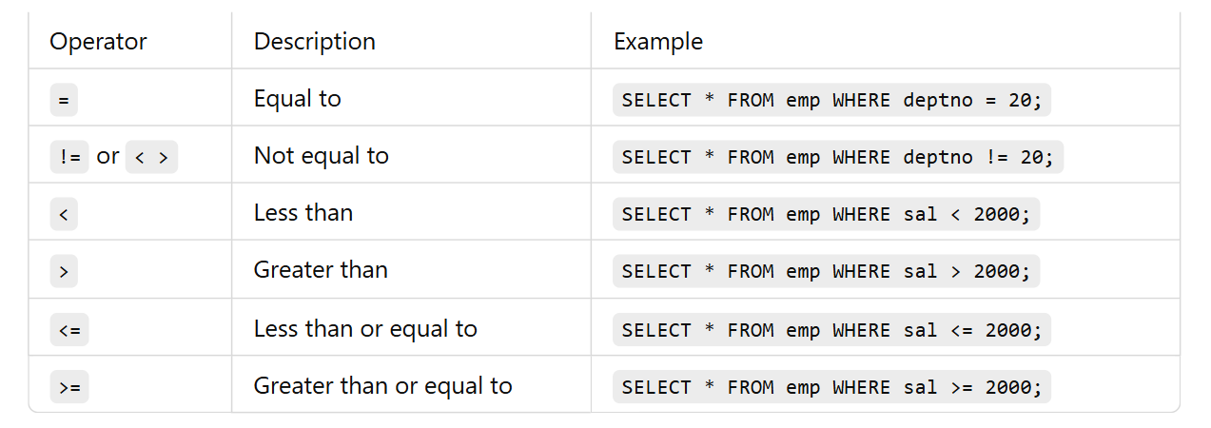

Logical Operators
- AND (AND): Returns true if both conditions are true.
And - The AND operator is used to filter records based on more than one condition for different fieldnames
WHERE Country = 'Germany' AND City = ‘newyork’;

- OR (OR): Returns true if at least one condition is true.
OR -The OR operator is used to filter records based on more than one condition
WHERE Country = 'Germany' OR Country = 'Spain';

- NOT (NOT): Inverts the truth value.
NOT - The NOT operator is used in combination with other operators to give the opposite result
WHERE NOT Country = 'Spain';
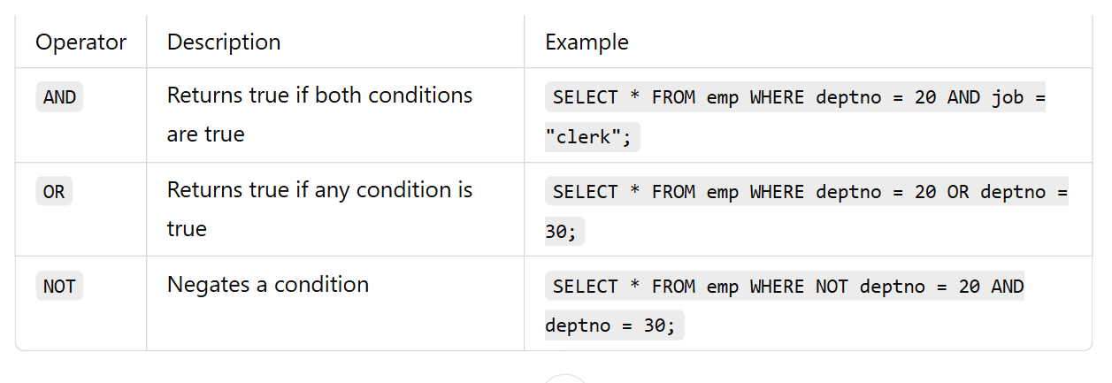

Bitwise Operators
- AND (&): Bitwise AND.
  - Example: SELECT 5 & 3; → 1
- OR (|): Bitwise OR.
  - Example: SELECT 5 | 3; → 7
- XOR (^): Bitwise XOR.
  - Example: SELECT 5 ^ 3; → 6
- NOT (~): Bitwise NOT.
  - Example: SELECT ~5; → -6
- Shift left (<<): Shifts bits to the left.
  - Example: SELECT 1 << 2; → 4
- Shift right (>>): Shifts bits to the right.
  - Example: SELECT 4 >> 1; → 2

special Operators

- IS NULL: Checks if a value is NULL.
IS NULL The IS NULL operator is used to test for empty values (NULL values).
Ex:-
WHERE Address IS NULL;
- IS NOT NULL: Checks if a value is not NULL.
IS NOT NULL-The IS NOT NULL operator is used to test for non-empty values (NOT NULL values).
Ex:-
WHERE Address IS NOT NULL;
- IN: Checks if a value is within a set of values.
in() in operators is used
Ex-
Where year in (“mad”,2019,”dad”)
- NOT IN: The NOT IN operator checks if a value does not exist within a set.
SELECT * FROM emp WHERE deptno NOT IN (10, 20, 30);
- BETWEEN: Checks if a value is within a range.
Between – print the values between the range
Ex:-
Where years between 2019 and 2024
- NOT BETWEEN: The NOT BETWEEN operator selects values outside a given range.
Ex:-
SELECT * FROM emp WHERE sal NOT BETWEEN 1000 AND 3000;

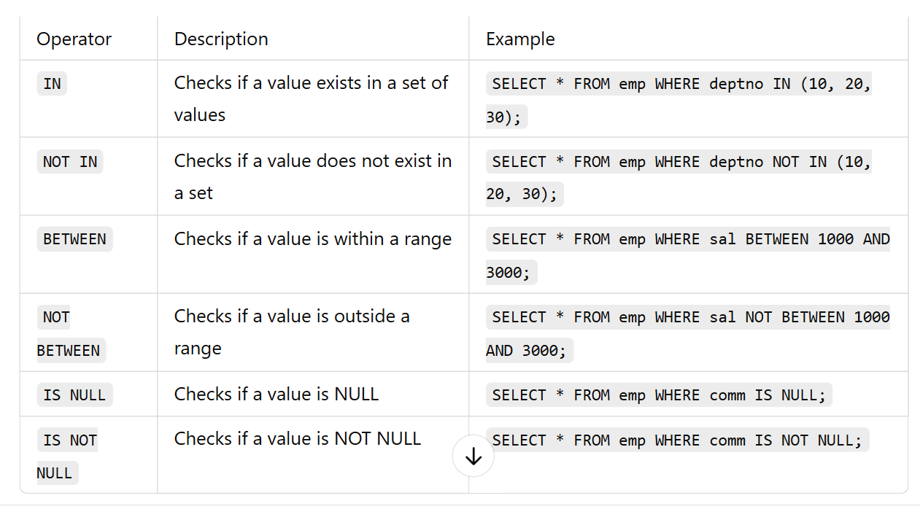
Wildcard Operators (Pattern Matching)
Wildcards are used with the LIKE operator to match string patterns.
- LIKE: Checks if a value matches a pattern.
LIKE is used to target pattern
Ex:-
SELECT * FROM Customers
WHERE Country = 'Spain' AND CustomerName like 'g%';
Wild characters- used only for strings
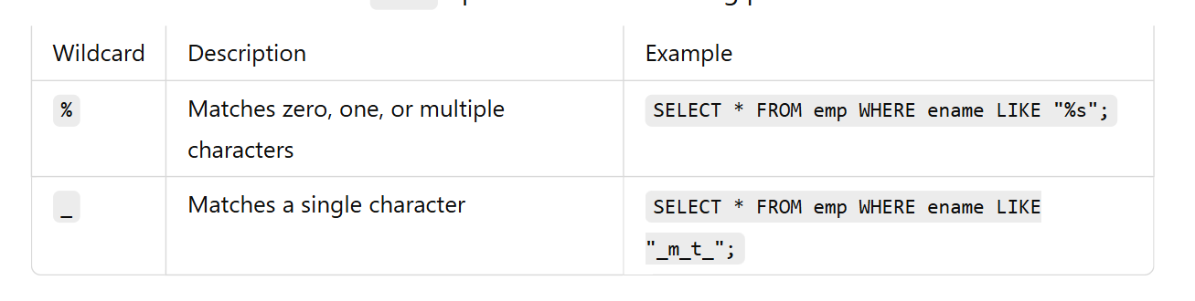
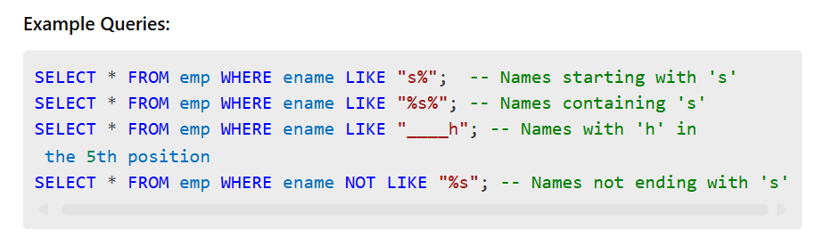

MySQL Clauses
What are MySQL Clauses?
Clauses in MySQL are used to filter, sort, and manipulate the data returned by SQL queries. They help refine results and improve query efficiency.
Types of MySQL Clauses
- WHERE Clause
- DISTINCT Clause
- HAVING Clause
- ORDER BY Clause
- GROUP BY Clause
- LIMIT Clause
- OFFSET Clause
1. WHERE Clause
The WHERE clause filters records based on specified conditions. It is used in SELECT, UPDATE, and DELETE statements.
Syntax
SELECT column_name(s) FROM table_name WHERE condition;
Ex:
SELECT * FROM emp WHERE sal > 3000;
Usage in UPDATE:
UPDATE emp SET salary = sal+ 5000 WHERE deptno= 10;
Usage in DELETE:
DELETE FROM emp WHERE sal< 2000;
2. DISTINCT Clause
The DISTINCT clause removes duplicate records from the result set.
Syntax:
SELECT DISTINCT column_name FROM table_name;
Example:
Find unique job titles from the employees table.
SELECT DISTINCT job FROM emp;
3. HAVING Clause
The HAVING clause filters results after the GROUP BY operation. It is used to apply conditions on aggregated values.
Syntax:
SELECT column_name, aggregate_function(column_name) FROM table_name
GROUP BY column_name
HAVING condition;
Ex:-
SELECT deptno, AVG(sal) AS avg_salary
FROM emp
GROUP BY deptno
HAVING AVG(sal) > 50000;
4. ORDER BY Clause
The ORDER BY clause sorts the result set in ascending (ASC) or descending (DESC) order.
Syntax:
SELECT column_name(s) FROM table_name ORDER BY column_name [ASC|DESC];
Example: Get all employees sorted by salary in descending order.
SELECT * FROM emp ORDER BY sal DESC;
Example: Get employees sorted by department and then by salary
SELECT * FROM emp ORDER BY deptno ASC, sal DESC;
5. GROUP BY Clause
The GROUP BY clause groups rows that have the same values in specified columns and is commonly used with aggregate functions.
Syntax:
SELECT column_name, aggregate_function(column_name)
FROM table_name
GROUP BY column_name;
Example: Get the total salary per department.
SELECT deptno, SUM(sal) AS total_salary
FROM emp
GROUP BY deptno;
6. LIMIT Clause
The LIMIT clause restricts the number of records returned by a query.
Syntax:
SELECT column_name(s) FROM table_name LIMIT number;
Example: Get the top 3 highest-paid employees.
SELECT * FROM emp ORDER BY sal DESC LIMIT 3;
7. OFFSET Clause
The OFFSET clause skips a specified number of rows before starting to return rows. It is often used with LIMIT.
Syntax:
SELECT column_name(s) FROM table_name LIMIT number OFFSET offset_value;
Example: Get the second highest-paid employee.
SELECT * FROM emp ORDER BY sal DESC LIMIT 1 OFFSET 1;
Example: Get employees ranked 4th to 6th based on salary.
SELECT * FROM emp ORDER BY sal DESC LIMIT 3 OFFSET

Single row and multi row functions
MySQL provides functions to perform operations on data. These functions are categorized into:
- Single-Row Functions → Operate on each row and return one result per row.
- Multi-Row (Aggregate) Functions → Operate on multiple rows and return a single result.
1. Single-Row Functions
Single-row functions return one result per row and can be used in SELECT, WHERE, and ORDER BY clauses.
1.1 String Functions
🔹 UPPER() – Converts a string to uppercase
Syntax:
SELECT UPPER(column_name) FROM table_name;
Ex:
SELECT UPPER(ename) FROM emp;
If ename = 'john', output → JOHN
🔹 LOWER() – Converts a string to lowercaseSyntax:
SELECT LOWER(column_name) FROM table_name;
Ex:
SELECT LOWER(job) FROM emp;
If job = 'MANAGER', output → manager

🔹 LENGTH() – Returns the number of characters in a string
Syntax:
SELECT LENGTH(column_name) FROM table_name;
Ex:
SELECT ename, LENGTH(ename) FROM emp;
If ename = 'Alice', output → 5

🔹 CONCAT() – Joins two or more strings
Syntax:
SELECT CONCAT(string1, string2, ...) FROM table_name;
Ex:
SELECT CONCAT(ename, ' - ', job) FROM emp;
If ename = 'John' and job = 'Clerk', output → John - Clerk

🔹 SUBSTRING() – Extracts a portion of a string
Syntax:
SELECT SUBSTRING(column_name, start_position, length) FROM table_name;
Ex:
SELECT SUBSTRING(ename, 1, 3) FROM emp;
If ename = 'Michael', output → Mic

1.2 Numeric Functions
Numeric functions perform calculations on numeric data.
🔹 ROUND() – Rounds a number to a given decimal places
Syntax:
SELECT ROUND(number, decimal_places);
Ex:
SELECT ROUND(sal, 2) FROM emp;
If sal = 1234.5678, output → 1234.57

🔹 CEIL() – Rounds a number up to the nearest integer
Syntax:
SELECT CEIL(number);;
Ex:
SELECT CEIL(sal) FROM emp;
If sal = 1234.45, output → 1235
🔹 FLOOR() – Rounds a number down to the nearest integer
Syntax:
SELECT FLOOR(number);
Ex:
SELECT FLOOR(sal) FROM emp;
If sal = 1234.99, output → 1234
🔹 ABS() – Returns absolute value of a number
Ex-
SELECT ABS(-100) FROM dual;
🔹 MOD() – Returns remainder of division
Ex-
SELECT MOD(10, 3);

1.3 Date & Time Functions
Date functions operate on date and time values.
🔹 CURDATE() – Returns the current date
Syntax:
SELECT CURDATE();
Ex:
SELECT CURDATE();
Output → 2025-03-22 (Current date)

🔹 CURTIME() – Returns the current time
Syntax:
SELECT CURTIME();
Example:
SELECT CURTIME();
Output → 14:30:45 (Current time)
🔹 YEAR(), MONTH(), DAY() – Extracts year, month, or day from a date
Syntax:
SELECT YEAR(date_column), MONTH(date_column), DAY(date_column) FROM table_name;
Example:
SELECT YEAR(hiredate), MONTH(hiredate), DAY(hiredate) FROM emp;
If hiredate = '2015-06-12', output → 2015 | 6 | 12

🔹 DATEDIFF() – Returns the difference between two dates
Syntax:
SELECT DATEDIFF(date1, date2);
Example:
SELECT DATEDIFF(CURDATE(), hiredate) FROM emp;
Returns number of days between hire date and today.

🔷 2. Multi-Row (Aggregate) Functions
Aggregate functions return a single result based on multiple rows.
2.1 SUM() – Returns the total sum of a column
Syntax:
SELECT SUM(column_name) FROM table_name;
Example:
SELECT SUM(sal) FROM emp;
Returns total salary of all employees.
2.2 AVG() – Returns the average value
Syntax:
SELECT AVG(column_name) FROM table_name;
Example:
SELECT AVG(sal) FROM emp;
Returns average salary of all employees.
2.3 COUNT() – Counts number of rows
Syntax:
SELECT COUNT(*) FROM table_name;
Example:
SELECT COUNT(*) FROM emp;
Returns number of employees.
2.4 MIN() and MAX() – Find smallest & largest values
Syntax:
SELECT MIN(column_name), MAX(column_name) FROM table_name;
Example:
SELECT MIN(sal), MAX(sal) FROM emp;
Returns minimum and maximum salary in the table.

📌 GROUP BY Examples
-- 1. Maximum salary in the company
SELECT MAX(sal) FROM emp;

-- 2. Maximum salary per department
SELECT deptno, MAX(sal) FROM emp GROUP BY deptno;

-- 3. Employee count per department
SELECT deptno, COUNT(deptno) FROM emp GROUP BY deptno;

-- 4. Total salary & employee count per department
SELECT deptno, SUM(sal), COUNT(deptno) FROM emp GROUP BY deptno;

📌 HAVING Clause Example
-- Departments having more than 4 employees
SELECT deptno, COUNT(deptno)
FROM emp
GROUP BY deptno
HAVING COUNT(deptno) > 4;
📌 Query: Max Salary in Departments Where Name Contains 'A'
SELECT deptno, MAX(sal)
FROM emp
WHERE ename LIKE '%a%'
GROUP BY deptno;

📌 Can Single-Row Functions Be Used in Multi-Row Queries?
🔹 Example: Using ROUND() (single-row) inside SUM() (multi-row)
SELECT deptno, ROUND(AVG(sal), 2) FROM emp GROUP BY deptno;

📌 Multi-Row Functions Ignore NULL Values
✅ Aggregate functions like COUNT(), SUM(), AVG() ignore NULL values.
🔹 Example:
SELECT COUNT(comm) FROM emp; -- Only counts non-null values in comm column
SELECT SUM(sal) FROM emp; -- Ignores NULL salaries

📌 Errors When Using Aggregate Functions Improperly
❌ Error: Mixing aggregate & non-aggregate columns without GROUP BY
SELECT SUM(sal), sal FROM emp;
-- ❌ ERROR: 'sal' must be in GROUP BY if SUM() is used.
✅ Fix: Use GROUP BY
SELECT deptno, SUM(sal) FROM emp GROUP BY deptno;

❌ Error: Using Multi-Row Function in WHERE Clause
SELECT ename FROM emp WHERE sal = MAX(sal);
-- ❌ ERROR: WHERE cannot use multi-row functions like MAX()
✅ Fix: Use a subquery
SELECT ename FROM emp WHERE sal = (SELECT MAX(sal) FROM emp);

Constraints
Constraints are the rules applied to table columns to enforce data integrity.
NOT NULL
- Purpose: Ensures that a column cannot have a NULL value.
- Ways to use: While creating or modifying a table.
- Syntax: Applied at column definition.
1st
CREATE TABLE employees (
id INT NOT NULL,
name VARCHAR(100) NOT NULL
);

2nd
ALTER TABLE employees MODIFY id INT NOT NULL;
INSERT INTO employees (name) VALUES ('John'); -- ❌ Error: id cannot be NULL
UNIQUE
- Purpose: Ensures all values in a column are unique and allows null values.
- Ways to use: During table creation or using ALTER TABLE.

1st
CREATE TABLE students (
id INT UNIQUE,
name VARCHAR(100)
);

2nd
CREATE TABLE students (
id INT,
name VARCHAR(100),
phone_no INT,
UNIQUE(id)
);

3rd
ALTER TABLE students ADD UNIQUE(phone_no);
🔻 Dropping UNIQUE constraint
ALTER TABLE students DROP INDEX phone_no;
Ex
INSERT INTO students (id, name) VALUES (10,”john”);
INSERT INTO students (id, name) VALUES (10,”john”); -- ❌ Error: Duplicate entry
INSERT INTO students (name) VALUES ('Raja'); -- ✅ Allowed: NULL in UNIQUE column

CHECK
- Purpose: Ensures that the values in a column meet a specified condition.
- Note: As of MySQL 8.0.16, CHECK constraints are parsed but ignored, as they are not enforced.
- Ways to use
While creating a table.
Using ALTER TABLE

CREATE TABLE voters (
name VARCHAR(100),
age INT CHECK (age >= 18)
);

CREATE TABLE voters (
name VARCHAR(100),
age INT,
CONSTRAINT chk_age CHECK (age >= 18)
);
Adding CHECK to an existing table
ALTER TABLE voters ADD CONSTRAINT chk_name CHECK (LENGTH(name) > 8);
🔻 Dropping CHECK
ALTER TABLE voters DROP CHECK chk_age;
Ex-
INSERT INTO voters (name, age) VALUES ('John', 17); -- ❌ Error: Age must be >= 18

DEFAULT
- Purpose: Sets a default value for a column if no value is specified.
- Ways to use
During table creation.
Using ALTER TABLE to modify an existing column.

CREATE TABLE students (
id INT NOT NULL DEFAULT 45,
name VARCHAR(100)
);
Ex-
INSERT INTO students (name) VALUES (john); -- ✅ ID will be 45
INSERT INTO students (id, name) VALUES (1,jane); -- ✅ ID = 1
INSERT INTO students (name) VALUES (‘JESSY’); -- ✅ ID will be 45
🔻 Modifying DEFAULT
ALTER TABLE students MODIFY id INT DEFAULT 50;

🔻 Dropping DEFAULT
ALTER TABLE students ALTER COLUMN id DROP DEFAULT;

5. PRIMARY KEY
- Purpose: Uniquely identifies each row in a table.
- Note: Combines NOT NULL and UNIQUE constraints.
- Ways to use:
While creating a table.
Using ALTER TABLE.
Dropping a primary key.
CREATE TABLE employees (
id INT PRIMARY KEY,
name VARCHAR(100) NOT NULL
);

CREATE TABLE employees (
id INT,
name VARCHAR(100),
PRIMARY KEY(id)
);

ALTER TABLE employees ADD PRIMARY KEY (id);

🔻 Dropping PRIMARY KEY
ALTER TABLE employees DROP PRIMARY KEY;
Ex-
INSERT INTO employees (id, name) VALUES (1, 'John');
INSERT INTO employees (id, name) VALUES (1, 'Jane'); -- ❌ Error: Duplicate id

6. FOREIGN KEY
- Purpose: Ensures referential integrity by linking two tables.
- Note: The referenced table should have a PRIMARY KEY.
- Foreign Key column can have duplicates and NULL values.
- Parent table: The table with a PRIMARY KEY.
- Child table: The table referencing the PRIMARY KEY.
Creating Foreign Key
CREATE TABLE departments (
dept_id INT PRIMARY KEY,
dept_name VARCHAR(100) NOT NULL
);

CREATE TABLE employees (
emp_id INT PRIMARY KEY,
emp_name VARCHAR(100) NOT NULL,
dept_id INT,
FOREIGN KEY (dept_id) REFERENCES departments(dept_id)
);
🔻 Dropping FOREIGN KEY
ALTER TABLE employees DROP FOREIGN KEY dept_id;
Ex-
INSERT INTO employees (emp_id, emp_name, dept_id) VALUES (1, 'Alice', 10); -- ❌ Error: No department with id 10
Ways to add a Foreign Key
-- Without named constraint
CREATE TABLE employees (
emp_id INT,
dept_id INT,
FOREIGN KEY (dept_id) REFERENCES departments(dept_id)
);

-- With named constraint
CREATE TABLE employees (
emp_id INT,
dept_id INT,
CONSTRAINT fk_dept FOREIGN KEY (dept_id) REFERENCES departments(dept_id)
);

-- Adding to an existing table
ALTER TABLE employees ADD CONSTRAINT fk_dept FOREIGN KEY (dept_id) REFERENCES departments(dept_id);

7. AUTO_INCREMENT
- Purpose: Automatically generates a unique value for each row.
- Note: Only one AUTO_INCREMENT column is allowed per table.
- Works only with: PRIMARY KEY.
- By default, starts at 1 but can be customized.

CREATE TABLE students (
id INT PRIMARY KEY AUTO_INCREMENT,
name VARCHAR(100)
);

Ex-
INSERT INTO students (name) VALUES ('Jenny'); -- ID = 1
INSERT INTO students (name) VALUES ('Jack'); -- ID = 2

🔻 Changing AUTO_INCREMENT start value
ALTER TABLE students AUTO_INCREMENT = 10;

🔻 Changing Increment Step
SET @@auto_increment_increment = 5;
Ex-
INSERT INTO students (name) VALUES ('Jane'); -- ID = 10
INSERT INTO students (name) VALUES ('Mike'); -- ID = 15

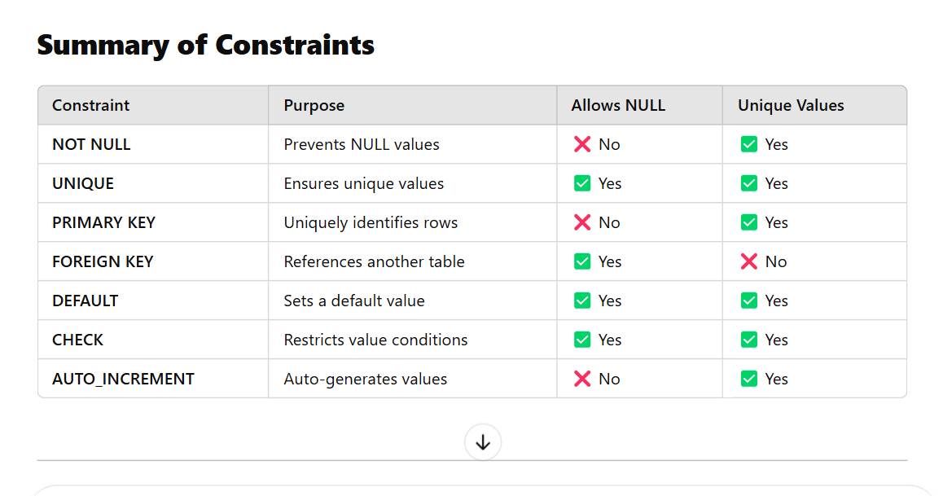

MySQL Joins
Joins in MySQL
Joins in MySQL are used to retrieve data from multiple tables based on a related column. The different types of joins available are:
1. INNER JOIN
Explanation:
- The INNER JOIN keyword selects records that have matching values in both tables.
- If there is no match, the rows are excluded from the result set.
- This is the most commonly used join in SQL.
- It is useful when we only need records that have corresponding entries in both tables.
- Syntax:
SELECT columns FROM table1
INNER JOIN table2
ON table1.column = table2.column;
- Example Queries:
SELECT * FROM emp
INNER JOIN dept
ON emp.deptno = dept.deptno;

SELECT empno, ename FROM emp
INNER JOIN dept
ON emp.deptno = dept.deptno;

-- This query will throw an error due to ambiguity as deptno exists in both tables:
SELECT empno, deptno FROM emp
INNER JOIN dept
ON emp.deptno = dept.deptno;
- -- Correcting ambiguity by specifying the table name or alias:
SELECT empno, emp.deptno FROM emp
INNER JOIN dept
ON emp.deptno = dept.deptno;

SELECT empno, e.deptno FROM emp e
INNER JOIN dept d
ON e.deptno = d.deptno;
2. LEFT JOIN (LEFT OUTER JOIN)
Explanation:
- The LEFT JOIN returns all records from the left table and the matched records from the right table.
- If there is no match, NULL values will be returned for the columns from the right table.
- It ensures that all records from the left table appear in the result set.
- Syntax:
SELECT * FROM table1
LEFT JOIN table2
ON table1.column = table2.column;
- Example:
SELECT * FROM dept
LEFT JOIN emp
ON dept.deptno = emp.deptno;
3. RIGHT JOIN (RIGHT OUTER JOIN)
Explanation:
- The RIGHT JOIN returns all records from the right table and the matched records from the left table.
- If there is no match, NULL values will be returned for the columns from the left table.
- It is similar to LEFT JOIN, but in reverse.
- Syntax:
SELECT * FROM table1
RIGHT JOIN table2
ON table1.column = table2.column;
- Example:
SELECT * FROM emp
RIGHT JOIN dept
ON emp.deptno = dept.deptno;
4. FULL OUTER JOIN (Simulated using UNION)
- Returns all rows when there is a match in either table.
- MySQL does not support FULL OUTER JOIN directly, so we use a combination of LEFT JOIN and RIGHT JOIN with UNION.
- This type of join returns all rows from both tables, with NULL where there is no match.

Example:
SELECT * FROM emp
LEFT JOIN dept
ON emp.deptno = dept.deptno
UNION
SELECT * FROM emp
RIGHT JOIN dept
ON emp.deptno = dept.deptno;
5. CROSS JOIN (Cartesian Join)
Explanation:
- The CROSS JOIN returns the Cartesian product of the two tables.
- Every row from the first table is combined with every row from the second table.
- If table1 has m rows and table2 has n rows, the result set will have m * n rows.
- It is useful for generating test data but rarely used in real-world applications.
- Syntax:
SELECT * FROM table1
CROSS JOIN table2;
- Example:
SELECT * FROM emp
CROSS JOIN dept;
6. SELF JOIN
Explanation:
- A SELF JOIN is when a table is joined with itself.
- This is useful when comparing rows within the same table, such as finding employees and their managers.
- It can be an INNER JOIN, LEFT JOIN, or RIGHT JOIN.
- Table aliases are necessary to distinguish between the two instances of the same table.
- It can be an INNER JOIN, LEFT JOIN, or RIGHT JOIN.
- Example Queries:
- -- INNER JOIN Self Join Example:
SELECT * FROM emp e1
INNER JOIN emp e2
ON e1.mgr = e2.empno;

SELECT e1.empno, e1.ename, e1.mgr, e2.ename
FROM emp e1
INNER JOIN emp e2
ON e1.mgr = e2.empno;

- -- RIGHT JOIN Self Join Example:
SELECT e1.empno, e1.ename, e1.mgr, e2.ename
FROM emp e1
RIGHT JOIN emp e2
ON e1.mgr = e2.empno;

- -- LEFT JOIN Self Join Example:
SELECT e1.empno, e1.ename, e1.mgr, e2.ename
FROM emp e1
LEFT JOIN emp e2
ON e1.mgr = e2.empno;

MySQL Indexes
What is an Index in MySQL?
- An index is a mechanism that enables fast lookup of rows in a table by creating a reference to their location in the database.
- It allows MySQL to quickly locate data without scanning the entire table.
- Indexes improve query performance, especially for large datasets.
- They are automatically maintained by MySQL during INSERT, UPDATE, and DELETE operations.
- Avoid over-indexing as it consumes disk space and memory.
How Indexes Work?
- The term "lookup" generally refers to querying the database to retrieve specific information.
- This is achieved using the SELECT statement, potentially with conditions specified in the WHERE clause to narrow down the results.
- Indexes store data alongside table data for fast access.

Types of Indexes in MySQL
1️ Primary Index (Primary Key)
- Automatically created when a PRIMARY KEY is defined.
- Ensures unique identification of each row.
- Example:
CREATE TABLE customers (
cid INT PRIMARY KEY, -- MySQL creates an index automatically
cname VARCHAR(10)
);
2️ Foreign Key Index
- Automatically created for FOREIGN KEY constraints.
- Used to maintain relationships between tables.
- Example:
CREATE TABLE orders (
oid INT PRIMARY KEY,
pname VARCHAR(10),
amount DECIMAL(5,2),
cid INT,
FOREIGN KEY (cid) REFERENCES customers (cid) -- Foreign key index is created
);
3️ Unique Index
- Ensures all values in a column are unique.
- Example:
CREATE UNIQUE INDEX indx_name ON tablename (col1);
CREATE UNIQUE INDEX idx_uni ON products (pid);
create unique index idx_pname on orders(pname);
4️ Regular (Non-Unique) Index
- Used to speed up searches but allows duplicate values.
- Example:
CREATE INDEX idx_name ON tablename (colname);
CREATE INDEX idx_pname ON products (pname);
5️ Composite Index
- An index on multiple columns.
- Useful for queries filtering by multiple conditions.
- Example:
CREATE INDEX idx_name ON tablename (column1, column2);
CREATE INDEX idx_name ON orders (pname, amount);
6️ Full-Text Index
- Used for fast text searches in large text fields.
- Example:
- CREATE FULLTEXT INDEX idx_description ON articles(content);
7️ patial Index
- Used for geographic data (e.g., POINT, LINESTRING, POLYGON).
- Example:
- CREATE SPATIAL INDEX idx_location ON places(location);

Creating Indexes in MySQL
🔹 Creating an Index at Table Creation
CREATE TABLE tablename (
col DATATYPE,
col1 DATATYPE,
INDEX (col1)
);
Example:
CREATE TABLE products (
pid INT,
pname VARCHAR(10),
INDEX (pid)
);
🔹 Adding an Index to an Existing Table
CREATE INDEX index_name ON tablename (column1);
Example:
CREATE INDEX idx_pname ON products (pname);
🔹 Creating an Index with Primary Key
CREATE TABLE users (
id INT AUTO_INCREMENT PRIMARY KEY,
name VARCHAR(10)
);

Dropping (Removing) Indexes
DROP INDEX indexname ON tablename;
Example:
DROP INDEX idx_pname ON products;

Checking Existing Indexes
SHOW INDEX FROM tablename;
Example:
SHOW INDEX FROM orders;

MySQL Subqueries

What is a Subquery?
A subquery is a query that is nested inside another query. It is used to retrieve data that will be used in the main query (also called the outer query).
- A subquery is enclosed in parentheses ().
- It can be placed in SELECT, FROM, or WHERE clauses.
- The result of a subquery is passed to the outer query.
- Subqueries can return single values, multiple values, or even entire tables.

Types of Subqueries
1️ single-Row Subquery
A single-row subquery returns only one value (one row, one column) and is used with operators like =, >, <, >=, <=.
🔹 Example: Find employees who have the same salary as the highest salary in department 10.
SELECT empname, salary
FROM employees
WHERE salary = (SELECT MAX(salary) FROM employees WHERE dept_id = 10);
✔ The subquery finds the maximum salary in department 10.
✔ The outer query retrieves employees with that salary.

2️ Multi-Row Subquery
A multi-row subquery returns multiple rows and is used with operators like IN, ANY, ALL.
🔹 Example: Find employees who have the same salary as any employee in department 20.
SELECT empname, salary
FROM employees
WHERE salary IN (SELECT salary FROM employees WHERE dept_id = 20);
✔ The subquery returns a list of salaries in department 20.
✔ The outer query retrieves employees whose salaries match any of those values.
✅ Using ANY and ALL:
- ANY: Checks if at least one value from the subquery satisfies the condition.
- ALL: Requires that all values from the subquery satisfy the condition.
🔹 Example (ANY): Find employees earning more than the lowest salary in department 30.
SELECT empname, salary
FROM employees
WHERE salary > ANY (SELECT salary FROM employees WHERE dept_id = 30);
🔹 Example (ALL): Find employees earning more than all salaries in department 40.
SELECT empname, salary
FROM employees
WHERE salary > ALL (SELECT salary FROM employees WHERE dept_id = 40);

3️ Correlated Subquery
A correlated subquery is executed once for each row in the outer query. It depends on the outer query’s data.
🔹 Example: Find employees earning more than the average salary of their own department.
SELECT empname, salary, dept_id
FROM employees e1
WHERE salary > (SELECT AVG(salary) FROM employees e2 WHERE e1.dept_id = e2.dept_id);
✔ The subquery calculates the average salary for each department.
✔ The outer query retrieves employees earning more than that average.

4️ Subquery in FROM Clause (Derived Table)
A subquery can act as a temporary table inside the FROM clause.
🔹 Example: Find the highest salary in each department.
SELECT dept_id, MAX(salary)
FROM (SELECT dept_id, salary FROM employees) AS temp
GROUP BY dept_id;
✔ The subquery retrieves department IDs and salaries.
✔ The outer query finds the maximum salary per department.

5️ Subquery in SELECT Clause
A subquery can be used inside the SELECT clause to return a single value per row.
🔹 Example: Get employees along with their department’s average salary.
SELECT empname, salary,
(SELECT AVG(salary) FROM employees WHERE dept_id = e.dept_id) AS avg_salary
FROM employees e;
✔ The subquery calculates the average salary per department.
✔ The outer query retrieves each employee’s salary alongside their department’s average salary.

Performance Considerations
- Optimize subqueries when working with large datasets.
- Use indexes on columns in subqueries for faster lookups.
- If a subquery returns a large number of values, consider using a JOIN instead.
🔹 Example (Using JOIN instead of a Subquery):
SELECT e.empname, e.salary, d.avg_salary
FROM employees e
JOIN (SELECT dept_id, AVG(salary) AS avg_salary FROM employees GROUP BY dept_id) d
ON e.dept_id = d.dept_id
WHERE e.salary > d.avg_salary;
✔ This performs better than a correlated subquery.

Key Takeaways
✅ Single-row subqueries return one value.
✅ Multi-row subqueries return multiple values (use IN, ANY, ALL).
✅ Correlated subqueries depend on the outer query’s data.
✅ Derived tables (subqueries in FROM) act as temporary tables.
✅ Use JOINs for better performance when possible.

TCL (Transaction Control Language)
What is TCL?
Transaction Control Language (TCL) in MySQL is used to manage transactions in a database. Transactions are sequences of operations performed as a single logical unit of work, which must be either fully completed or fully rolled back.
TCL ensures data integrity and consistency in case of system failures or other unexpected issues.

TCL Commands in MySQL
- COMMIT – Saves all changes made in the current transaction.
- ROLLBACK – Undoes all changes made in the current transaction.
- SAVEPOINT – Creates a temporary save point within a transaction.
- RELEASE SAVEPOINT – Deletes a previously created save point.
- SET AUTOCOMMIT – Controls the automatic commit behavior.

COMMIT Command
- COMMIT saves all the changes made in the current transaction permanently in the database.
- After a COMMIT, the changes cannot be undone.
-- Disable auto-commit mode
SET AUTOCOMMIT = 0;

-- Start a transaction
START TRANSACTION;

-- Insert new records
INSERT INTO employees (emp_id, emp_name, salary) VALUES (101, 'John Doe', 50000);
INSERT INTO employees (emp_id, emp_name, salary) VALUES (102, 'Jane Smith', 60000);

-- Commit the transaction (save changes)
COMMIT;

- The START TRANSACTION; command begins a transaction.
- Two records are inserted into the employees table.
- The COMMIT; command saves the changes permanently.

ROLLBACK Command
The ROLLBACK command undoes all the changes made in the current transaction before committing.

-- Start a new transaction
START TRANSACTION;

-- Insert new records
INSERT INTO employees (emp_id, emp_name, salary) VALUES (103, 'Alice Brown', 55000);
INSERT INTO employees (emp_id, emp_name, salary) VALUES (104, 'Bob White', 58000);

-- Rollback the transaction (undo changes)
ROLLBACK;

The records inserted within the transaction are not saved in the database because we executed ROLLBACK; instead of COMMIT;
SELECT * FROM employees WHERE emp_id = 103 OR emp_id = 104;
🔹 Expected Output:
No records found, as the rollback operation discarded the changes

SAVEPOINT Command
SAVEPOINT allows you to set a checkpoint in a transaction so that you can roll back only to that point instead of the entire transaction.
-- Start transaction
START TRANSACTION;

-- Insert first record
INSERT INTO employees (emp_id, emp_name, salary) VALUES (105, 'David Miller', 62000);

-- Create a savepoint
SAVEPOINT sp1;

-- Insert second record
INSERT INTO employees (emp_id, emp_name, salary) VALUES (106, 'Emma Watson', 65000);

-- Rollback to the savepoint (undo second insert but keep the first insert)
ROLLBACK TO sp1;

-- Commit the remaining transaction
COMMIT;

• The first insert (emp_id = 105) is executed.
• A savepoint named sp1 is created.
• The second insert (emp_id = 106) is executed.
• The rollback operation reverts changes made after SAVEPOINT sp1, undoing the second insert.
• The final commit saves only the first insert.
SELECT * FROM employees WHERE emp_id IN (105, 106);
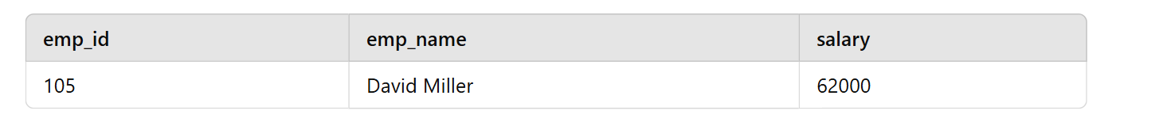
Record for emp_id = 106 does not exist because it was rolled back.

RELEASE SAVEPOINT Command
Deletes a savepoint but does not affect the transaction. Once released, a savepoint cannot be used for rollback.
START TRANSACTION;

-- Insert a record
INSERT INTO employees (emp_id, emp_name, salary) VALUES (107, 'Olivia Wilson', 67000);

-- Create savepoints
SAVEPOINT sp2;
INSERT INTO employees (emp_id, emp_name, salary) VALUES (108, 'Daniel Brown', 70000);

-- Release savepoint
RELEASE SAVEPOINT sp2;

-- Try to rollback to sp2 (Will cause an error since it was released)
ROLLBACK TO sp2; -- Error: No such savepoint

COMMIT;
- sp2 is created.
- After inserting another record, sp2 is released.
- Trying to roll back to sp2 results in an error because it no longer exists.

SET AUTOCOMMIT Command
- By default, MySQL automatically commits every operation.
- SET AUTOCOMMIT = 0; disables this behavior.
- SET AUTOCOMMIT = 1; enables auto-commit again.

-- Disable auto-commit
SET AUTOCOMMIT = 0;

-- Start transaction
START TRANSACTION;

-- Insert a record
INSERT INTO employees (emp_id, emp_name, salary) VALUES (109, 'Sophia Carter', 72000);

-- Verify if the record is inserted
SELECT * FROM employees WHERE emp_id = 109; -- Record exists, but not committed

-- Enable auto-commit
SET AUTOCOMMIT = 1;

• Before setting SET AUTOCOMMIT = 1;, the record is not permanently saved until a COMMIT; is executed.
• If MySQL restarts or a rollback happens before the commit, the inserted record is lost.

Data Control Language (DCL)
1. Introduction to DCL
Data Control Language (DCL) in MySQL is used to manage access rights and permissions for users. It consists of commands such as GRANT and REVOKE to provide or remove privileges from users.

2. Creating Users
To create a new user in MySQL, use the CREATE USER command:
CREATE USER 'username'@'hostname' IDENTIFIED BY 'password';
- username: The name of the user.
- hostname: Specifies the host from which the user can connect.
- password: The user's password.
Examples:
CREATE USER 'john'@'localhost' IDENTIFIED BY '123456';
CREATE USER 'jessy'@'localhost' IDENTIFIED BY 'dear123';
To view all users:
USE mysql;
SELECT user FROM user;
To drop a user:
DROP USER 'jessy'@'localhost';
To check the current user:
SELECT USER();

3. Connecting as a Different User
To switch users in MySQL:
\c username@localhost:3306
Example:
\c john@localhost:3306

4. User Actions Verification
- Show all databases accessible by a user:
SHOW DATABASES;
- Show privileges granted to a user:
SHOW PRIVILEGES;
- Show grants for a user:
SHOW GRANTS FOR 'john'@'localhost';

5. Granting Privileges
To grant privileges to a user, use the GRANT command:
GRANT privileges ON database_name.table_name TO 'username'@'hostname';
Examples:
- Grant specific privileges:
GRANT SELECT ON practice.emp TO 'john'@'localhost';
- Grant all privileges on a specific database:
GRANT ALL ON practice.* TO 'john'@'localhost';
- Grant all privileges on all databases:
GRANT ALL ON *.* TO 'john'@'localhost';
- To check granted privileges:
SHOW GRANTS FOR 'john'@'localhost';

6. Revoking Privileges
To revoke specific privileges from a user:
REVOKE privileges ON database_name.table_name FROM 'username'@'hostname';
Example:
REVOKE UPDATE ON practice.emp FROM 'jessy'@'localhost';
To verify the revoked privileges:
SHOW GRANTS FOR 'jessy'@'localhost';
7. Changing Passwords
To change a user's password:
SET PASSWORD FOR 'john'@'localhost' = 'newpassword';
Alternatively, using ALTER USER:
ALTER USER 'john'@'localhost' IDENTIFIED BY 'Preethi';

8. Dropping a User
To remove a user from MySQL:
DROP USER 'john'@'localhost';

Stored Procedures
1. Introduction to Stored Procedures
A Stored Procedure is a set of precompiled SQL statements stored in a database. It allows users to execute a sequence of SQL queries with a single command, improving efficiency and security.
2. Advantages of Stored Procedures
✅ Performance Improvement: Reduces query parsing and execution time.
✅ Security: Prevents SQL injection and allows controlled access.
✅ Code Reusability: Can be reused in multiple applications.
✅ Modularity: Reduces redundancy by grouping SQL logic in one place.
✅ Maintainability: Easier to manage and update complex SQL logic.
A Stored Procedure is a set of SQL statements stored in the database that can be executed repeatedly. It is primarily used for:
- Reusability: Acts like a function, allowing repeated execution.
- Encapsulation: Complex logic can be grouped together.
- Single Unit of Work: Can execute multiple SQL queries as a single operation.
Features of Stored Procedures
- Encapsulation: Groups multiple SQL statements into a single procedure.
- Performance: Reduces query parsing and improves execution speed.
- Security: Can restrict user access to the underlying data.
- Maintainability: Centralized SQL logic makes updates easier.
3. Creating a Stored Procedure
Syntax
DELIMITER $$

CREATE PROCEDURE procedure_name()
BEGIN
-- SQL Statements
END $$

DELIMITER ;
Ex:-
DELIMITER $$

CREATE PROCEDURE getAllEmployees()
BEGIN
SELECT * FROM emp;
END $$

DELIMITER ;
Calling the Procedure
CALL getAllEmployees();
Dropping a Procedure
DROP PROCEDURE IF EXISTS getAllEmployees;
Checking Stored Procedures
SHOW PROCEDURE STATUS WHERE Db = "practice";

4. Using Input Parameters - Dynamic Stored Procedures

Syntax
CREATE PROCEDURE procedure_name(IN parameterName DataType)
BEGIN
-- SQL Statement using the parameter
END;

Ex:-
DELIMITER $$

CREATE PROCEDURE getEmpByID(IN emp_id INT)
BEGIN
SELECT * FROM emp WHERE empno = emp_id;
END $$

DELIMITER ;
Calling with an Input Parameter
CALL getEmployeeByID(7839);
5. Using Output Parameters in Stored Procedures
Procedures can also return values using output parameters.
Syntax:-
CREATE PROCEDURE procedure_name(IN input_param DataType, OUT output_param DataType)
BEGIN
-- SQL Statement storing result into output_param
END;

Ex:- Getting Maximum Salary in a Department
DELIMITER $$

CREATE PROCEDURE getMaxSalary(IN dept_no INT, OUT max_sal DECIMAL(7,2))
BEGIN
SELECT MAX(sal) INTO max_sal FROM emp WHERE deptno = dept_no;
END $$

DELIMITER ;

Calling with an Output Parameter
CALL getMaxSalary(10, @output);
SELECT @output;
6. Using Multiple Output Parameters
We can return multiple values using multiple OUT parameters.
Ex:-
DELIMITER $$

CREATE PROCEDURE getMinMaxSalary(IN dept_no INT, OUT max_sal DECIMAL(7,2), OUT min_sal DECIMAL(7,2))
BEGIN
SELECT MAX(sal) INTO max_sal FROM emp WHERE deptno = dept_no;
SELECT MIN(sal) INTO min_sal FROM emp WHERE deptno = dept_no;
END $$

DELIMITER ;
Calling with Multiple Outputs
CALL getMinMaxSalary(10, @max_out, @min_out);
SELECT @max_out, @min_out;

Views
1. Introduction to Views
A view is a virtual table that represents the result of a SQL query. It does not store data but dynamically retrieves it from underlying tables when queried.
Key Features of Views:
✅ Virtual Table: Acts like a table but doesn’t store data physically.
✅ Simplifies Complex Queries: Helps in writing cleaner queries.
✅ Enhances Security: Restricts access to specific columns or rows.
✅ Improves Code Readability: Provides an abstraction layer over complex joins.

2. Creating a View
Syntax:
CREATE VIEW view_name AS
SELECT column1, column2, ...
FROM table_name
WHERE condition;
Example 1: Creating a View for Employees in Department 10
CREATE VIEW dept10_employees AS
SELECT * FROM emp WHERE deptno = 10;
✅ Now, the view dept10_employees will contain employees only from department 10.

3. Querying a View
Views can be queried just like normal tables.
Example 2: Selecting Data from a View
SELECT * FROM dept10_employees;
Example 3: Performing Aggregations on a View
SELECT MAX(sal) FROM dept10_employees;
✅ This retrieves the highest salary from department 10.

4. Updating Data Through Views
⚠ Warning: Updating a view affects the underlying table!
Example 4: Updating a View
UPDATE dept10_employees SET sal = 1500 WHERE empno = 7369;
✅ This also updates the emp table.
Restrictions on Updating Views:
❌ Cannot update views that contain aggregations (SUM, AVG, MAX, MIN, etc.)
❌ Cannot update views with JOINS, GROUP BY, or DISTINCT

5. Modifying an Existing View
If a view needs changes, we can modify it using CREATE OR REPLACE VIEW.
Syntax:
CREATE OR REPLACE VIEW view_name AS
SELECT column1, column2 FROM table_name WHERE condition;
Example 5: Modifying a View
CREATE OR REPLACE VIEW dept10_employees AS
SELECT ename, sal FROM emp WHERE deptno = 10;
✅ Now, the view will show only ename and sal, instead of all columns.

6. Dropping a View
To remove a view, use the DROP VIEW statement.
Syntax:
DROP VIEW view_name;
Example 6: Dropping a View
DROP VIEW dept10_employees;
✅ The view is deleted, but the original table remains unaffected

7. Advantages of Using Views
✅ Encapsulation: Hides complex joins and queries behind simple names.
✅ Security: Restricts access to certain columns or rows.
✅ Data Integrity: Ensures users see a consistent dataset.
✅ Simplifies Queries: No need to rewrite complex queries multiple times.

8. Limitations of Views
❌ Cannot store data (Only a virtual representation).
❌ Performance Overhead (Each query is executed dynamically).
❌ Limited DML (INSERT, UPDATE, DELETE) support (Not possible in certain cases).

9. When to Use Views?
✔ When you want to simplify complex queries.
✔ When you need to restrict access to specific columns or rows.
✔ When creating a reporting or analytics dashboard.
✔ When maintaining backward compatibility for database schema changes.

Date and Time Functions
1. Introduction to Date and Time in MySQL
MySQL provides various date and time functions to handle, manipulate, and format dates efficiently.
Commonly Used Date and Time Data Types
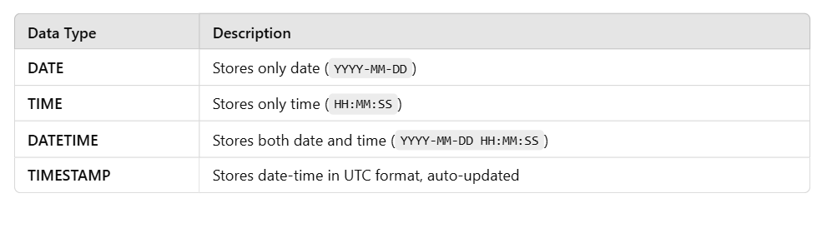

2. Creating a Table with Date & Time Fields
CREATE TABLE mytb (
mydate DATE,
mytime TIME,
mydatetime DATETIME
);
Inserting Current Date and Time
INSERT INTO mytb VALUES (CURRENT_DATE(), CURRENT_TIME(), NOW());
✅ Shortcut Version:
INSERT INTO mytb VALUES (CURDATE(), CURTIME(), NOW());

3. Getting Tomorrow’s and Yesterday’s Date
Insert Tomorrow's Date
INSERT INTO mytb VALUES (CURDATE() + INTERVAL 1 DAY, CURTIME(), NOW());
Insert Yesterday's Date
INSERT INTO mytb VALUES (CURDATE() - INTERVAL 1 DAY, CURTIME(), NOW());
4. Retrieving Current Date & Time
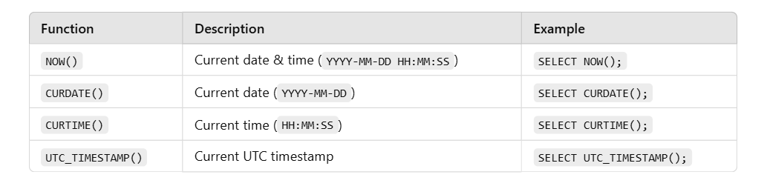
Example Usage:
SELECT UTC_TIMESTAMP(), NOW(), CURDATE(), CURTIME();

5. Extracting Date and Time Components
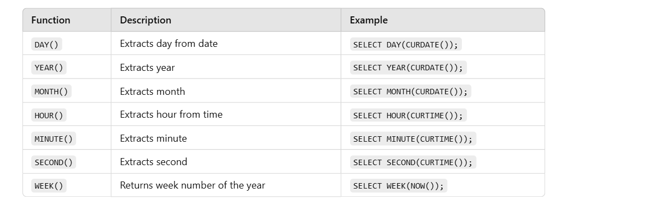
Example Query
SELECT DAY(CURDATE()), YEAR(CURDATE()), MONTH(CURDATE()),
HOUR(CURTIME()), MINUTE(CURTIME()), SECOND(CURTIME()), WEEK(NOW());
6. Formatting Dates
We can format date-time using DATE_FORMAT().
Syntax:
SELECT DATE_FORMAT(NOW(), 'format_specifier');
Common Format Specifiers
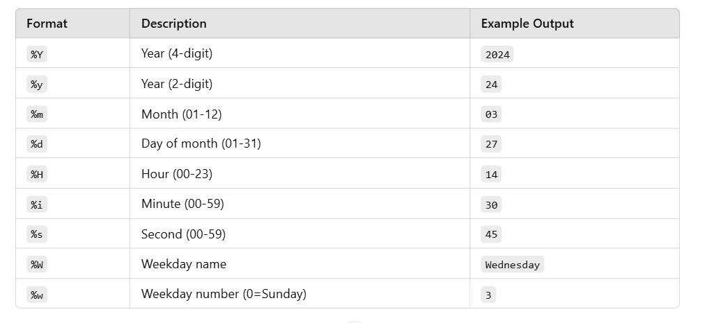
Example 1: Custom Date Format
SELECT DATE_FORMAT(NOW(), "%w-%d-%m-%y");
7. Manipulating Dates (Date Arithmetic)
Using DATE_ADD() and DATE_SUB() for adding/subtracting dates.
Adding Days to a Date
SELECT DATE_ADD(CURDATE(), INTERVAL 20 DAY);
Subtracting Days from a Date
SELECT DATE_SUB(CURDATE(), INTERVAL 5 DAY);
8. Calculating Date Differences
Syntax:
SELECT DATEDIFF(end_date, start_date);
Example 1: Days Between Two Dates
SELECT DATEDIFF('2024-11-24', '2024-10-15');
✅ Output:40
9. Calculating Time Differences
Syntax:
SELECT TIMEDIFF(time1, time2);
Example 2: Difference Between Two Time Values
SELECT TIMEDIFF(CURTIME(), '12:00:00');
✅ Output: Shows the time difference between the current time and 12:00:00.

10. Summary of Date & Time Functions
