

Project increment 4

PG4



SAI TEJA SARANAM

SRIKANTH NADENDLA

NAGENDER GOUD

RAM NIKHIL

**Objectives:**

The objectives of this iteration include implementing admin services, integration of - Login service, customer services, employee services, admin services and fixing minor bugs from the previous iteration. Admin services include, viewing all the items (present in the database), adding new items to the list of items (in database), updating items and monitoring open orders (placed by the customers). Other objectives include implementing REST services for performing above tasks (Implemented 2 new services, modified one old service and used one old service).

**Existing Services/API:**

For the frontend except for one (for filtering items by name) we haven’t used any existing services. But for the development of mobile client we referred the following links and example codes to know how to consume REST services in client application, parsing JSON objects and few small concepts like array adapter, list view, toasts etc.

<http://www.tutorialspoint.com/android/android_json_parser.htm>

<http://www.androidhive.info/2012/01/android-json-parsing-tutorial/>

<http://developer.android.com/guide/topics/ui/layout/listview.html>

<http://developer.android.com/reference/android/widget/ArrayAdapter.html>

<http://developer.android.com/guide/topics/ui/notifiers/toasts.html>

For the backend, previously implemented RESTful services are extended with few more services in this iteration. For testing and rapid development we used **Jetty server plugin .** It will scan our project periodically for changes and redeploy the web application if any changes are found automatically.

**Detail design of Services:**

As a recap, in the previous iterations we implemented Login service, customer services, and employee services. In customer services, upon successful login to application a customer can see list items of different categories like fruits, vegetables, fast food restaurants, Restaurants, add items to cart, place an order. In Employee services, upon successful login an employee should see list of open orders placed by the customers, Accepts an order from the list of open orders. In this iteration we implemented admin services, integration of - Login service, customer services, employee services, admin services and fixing minor bugs from the previous iteration. Admin services include, viewing all the items (present in the database), adding new items to the list of items (in database), updating items and monitoring open orders (placed by the customers). Also we extended RESTful services for performing above tasks (Implemented 2 new services, modified one old service and used one old service).

**User stories for Admin services and developer:**

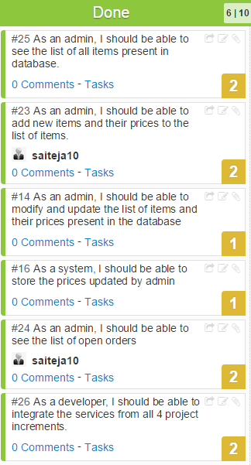

**Services:**

We have developed the registration, login service in first increment, for second increment we developed the customer service where customer will be able to select items and add them to cart, for Employee service, an employee upon successful login can see list of open orders placed by customers and accepting orders to process them. In this iteration apart from adding services to REST, we implemented Admin services.

**Admin service:**

***Service description:***

Admin services include, viewing all the items (present in the database), adding new items to the list of items (in database), updating items and monitoring open orders (placed by the customers).

**Class diagram:**

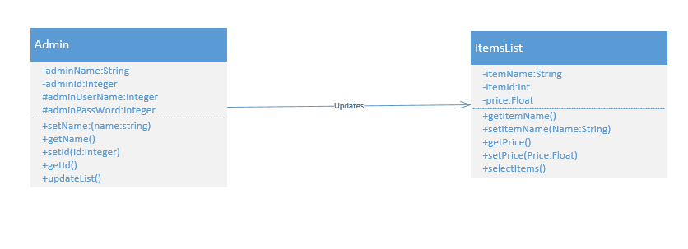

**Sequence diagram:**

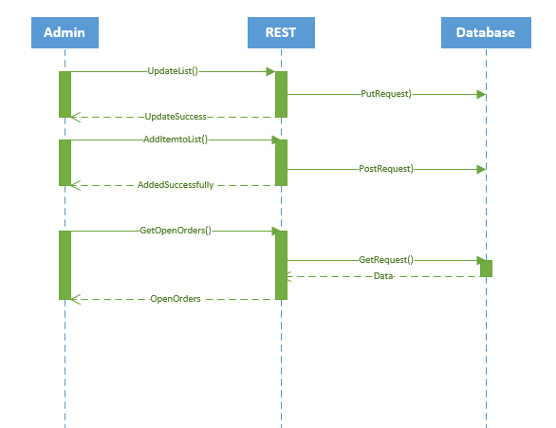

**Activity Diagram:**

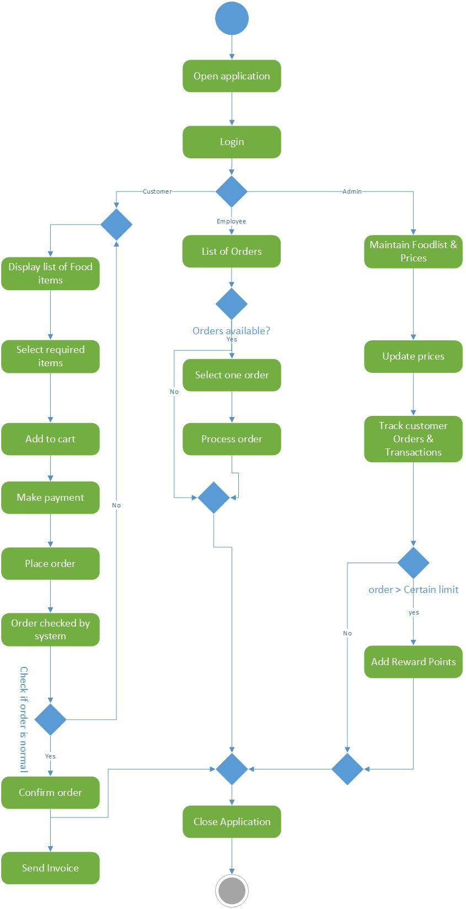

**Implementation:**

***Implementation of REST services:***

For this iteration, we Implemented 2 new services, modified one old service and used one old service.

Two new services include modifying existing items and adding new items.

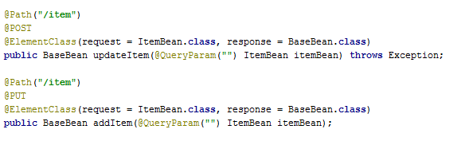

Used one old service to retrieve list of items.

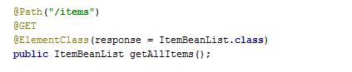

Modified one old service for admin to review the open orders.

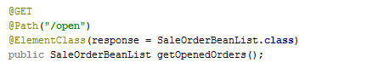

We implemented the REST services using Apache CXF. It is open source and multi featured web services framework. It takes care of all the http requests. Every request from the mobile client goes to CXF servlet.

The REST service we developed provides all the data and information about prices and description of fruits, vegetables, fast foods, restaurant menu etc.

We used MySQL as database for our project. We developed and created REST services using Apache CXF and Spring dependency injection. For mapping Java classes to database tables, we used Hibernate.

A detailed info about the implementation of REST services will be discussed later in the testing part.

***Implementation of user interface:***

For this iteration we have developed the activity page for Admin services, activity for admin to see the list of items, activity page to modify the item details, activity for adding new items to the list, activity page for reviewing list of open orders.

When an admin login to the system successfully, he can see list of all services available.

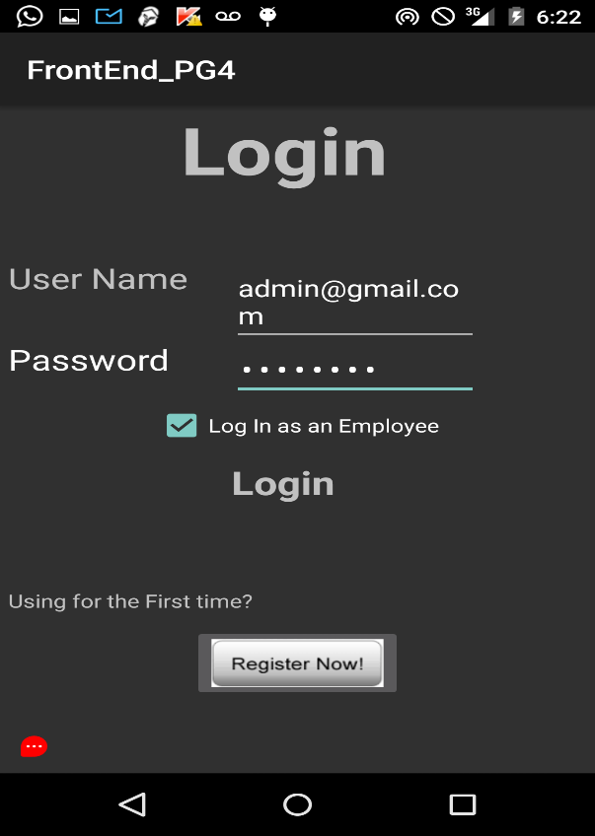 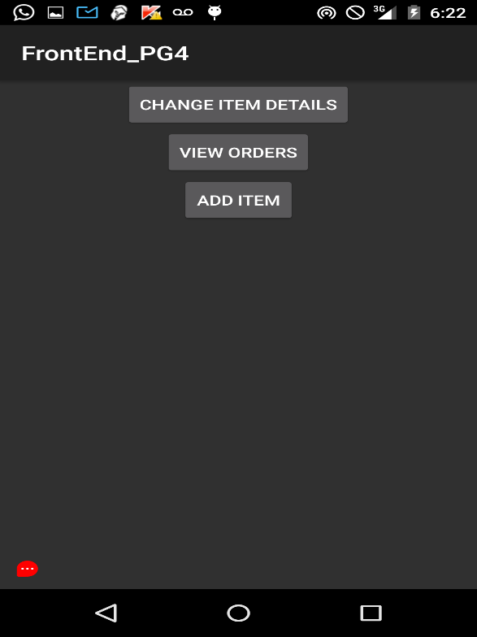

Upon selecting “Change item details” service, an activity page appears which shows list of all items. Upon selecting any item, an activity page will appear where we can edit the item details and update.

Shown below are the corresponding pages for what I described above.

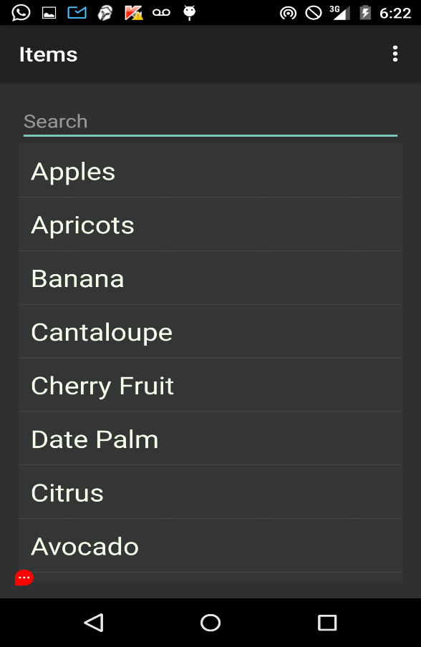

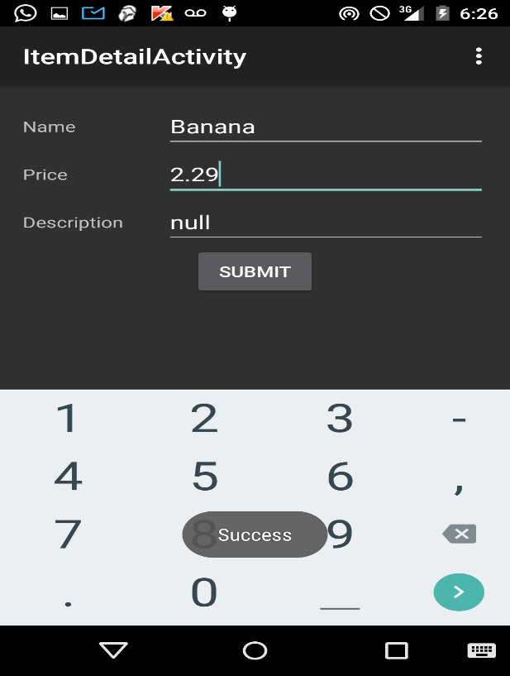

Another service from the admin services page is Add Item. The following activities shows adding an item:



Upon selecting “ADD ITEM”:

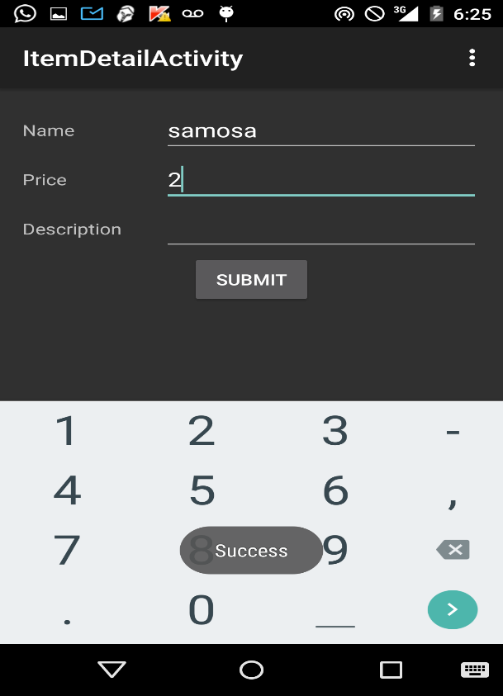

Following activity is show the item I added above in the list of items and also to demonstrate the item filtering service:

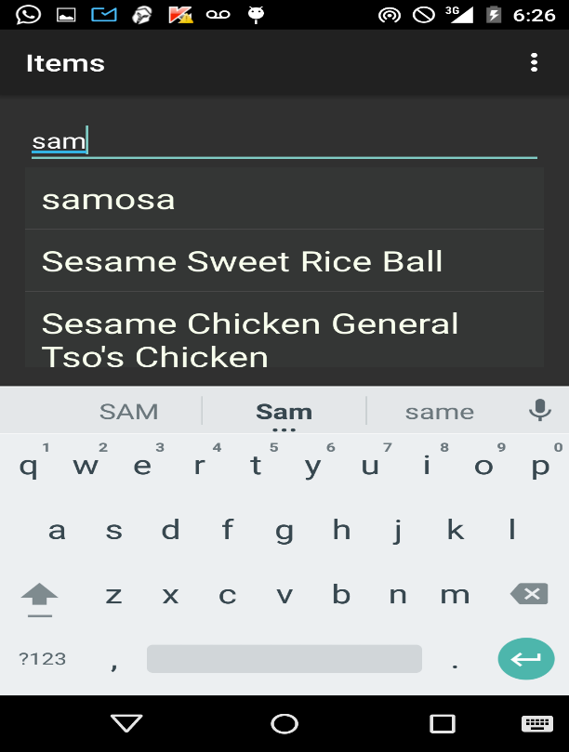

The following activities shows the list open orders which is one of admin services:



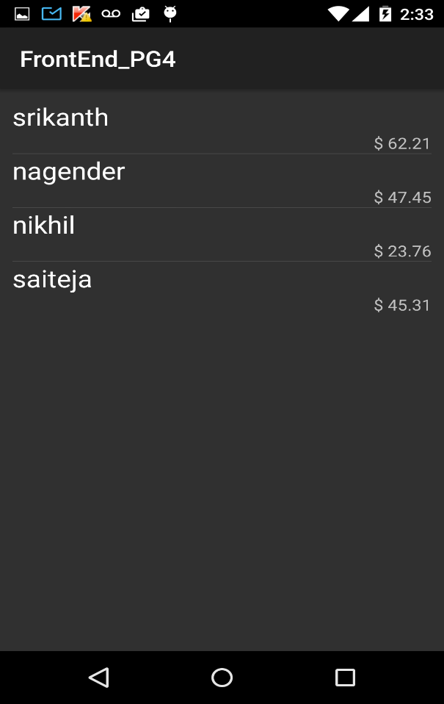

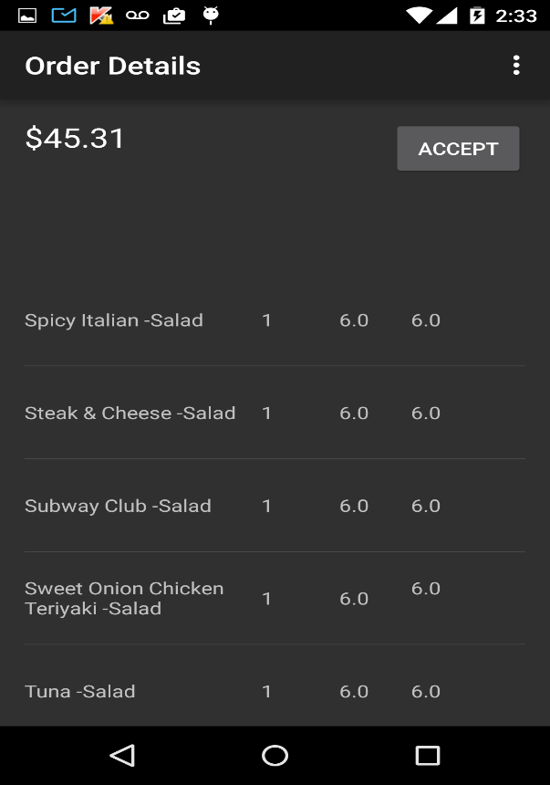

**Testing:**

We added few services to the API we developed in the previous iterations. Now, it is capable of retrieving items list, modify item details, add new items and reviewing orders placed by customers.

We are testing these services provided by API using POSTMAN an extension of google chrome.

***Retrieving items list:***



*url:* <http://localhost:8080/ase/catalog/items>

*operation:* GET

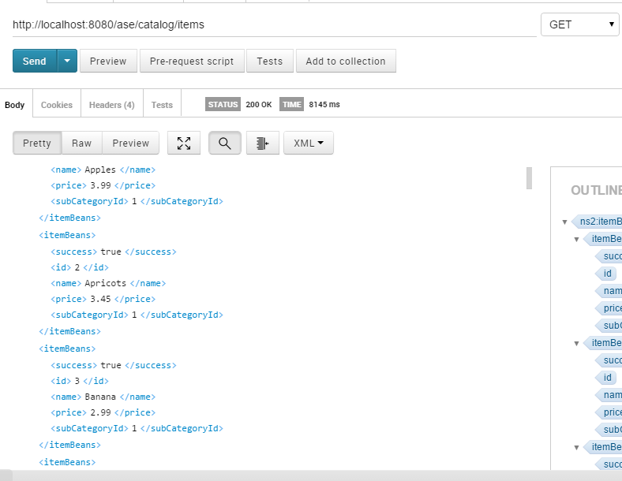

***Modifying item details:***



*url:* <http://localhost:8080/ase/catalog/items>

*operation:* PUT

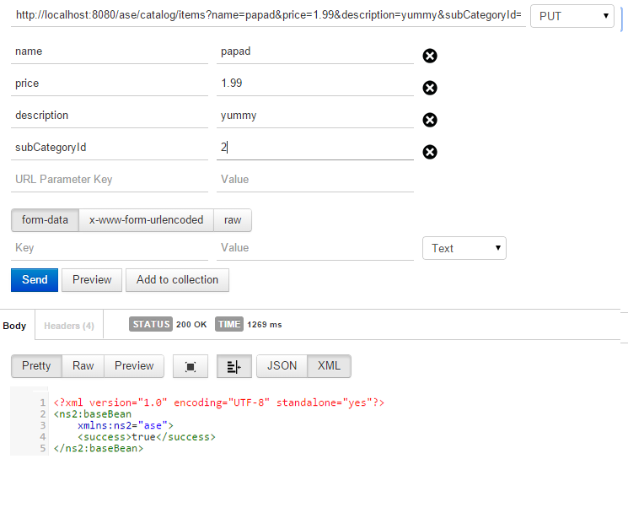

***Adding new item:***



*url:* <http://localhost:8080/ase/catalog/items>

*operation:* POST

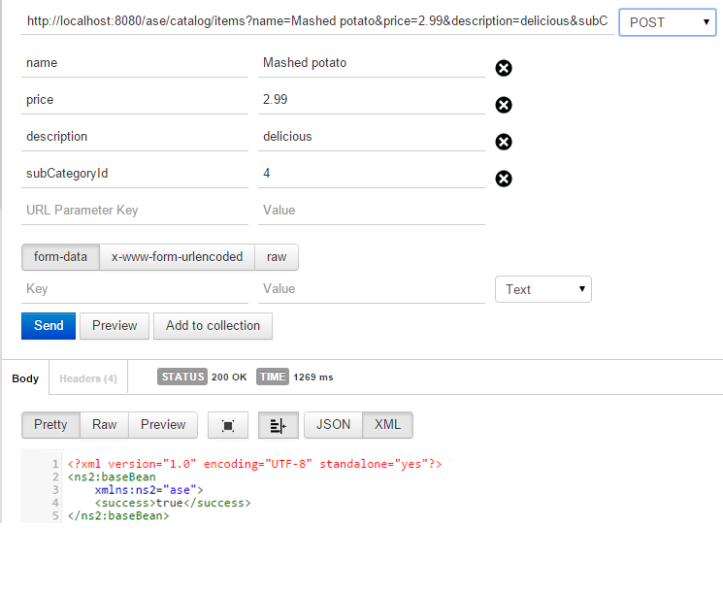

***Reviewing list of open orders:***



*url:* <http://localhost:8080/ase/order/open>

*operation:* GET

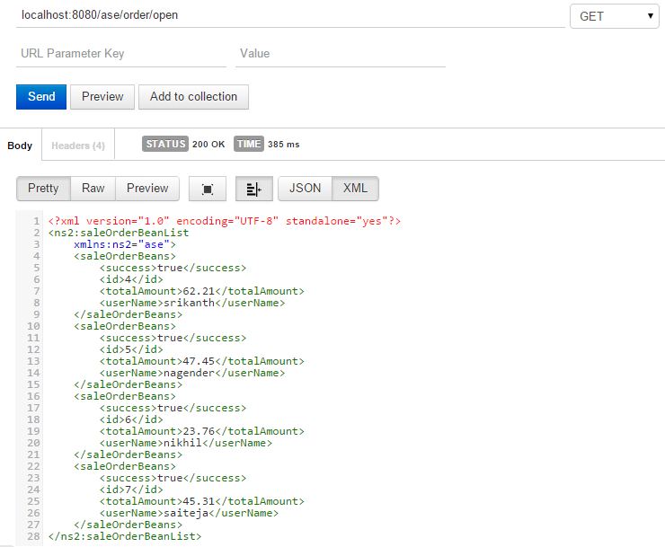

**Deployment:**

ScrumDo link:

<https://www.scrumdo.com/projects/project/alpha8/iteration/121756/board>

*UMKC VM:*

Since we developed backend in JAVA, we cannot use UMKC VM (only supports .NET)

We are using jetty server plugin in the backend project (maven).

* <http://localhost:8080/ase/catalog/items> (GET)
* <http://localhost:8080/ase/catalog/items> (POST)
* <http://localhost:8080/ase/catalog/items> (PUT)
* <localhost:8080/ase/order/open> (GET)

*GitHub url:*

<https://github.com/saiteja10/ASE_INCREMENT_4>

**Project Management:**

**Scrumdo link:**

<https://www.scrumdo.com/projects/project/alpha8/iteration/121756/board>

**Implementation status report:**

***Work completed:***

In this iteration,for the backend part we added few more services to the REST we developed in the previous iterations. Now, it is capable of retrieving items list, modifying item details, adding new items, obtaining orders placed by customers.

For the front end we have developed the activity page for Admin services, activity for admin to see the list of items, activity page to modify the item details, activity for adding new items to the list, activity page for reviewing list of open orders.

Also, we integrated all the services we implemented so far and fixed some minor bugs.

|  |  |
| --- | --- |
| **Task** | **Person** |
| Functionality of mobile client | Sai Teja Saranam |
| Call rest services from android | Sai Teja Saranam |
| Parsing and representing data | Sai Teja Saranam |
| Layout of mobile client | Srikanth Nadendla |
| Implementation of new REST services (Apache CXF) | Sai Teja Saranam |
| Hibernate (mapping Java classes to database tables) | Nagender Goud, Srikanth Nadendla |
| Spring Dependency Injection | Nagender Goud, Ram Nikhil |
| Testing REST services | Nagender Goud, Ram Nikhil, Srikanth Nadendla |
| Integration of services | Ram Nikhil, Srikanth Nadendla |
| Fixing minor bugs | Nagender Goud |
|  |  |
| **Contributions** |  |
| **Member** | **Percentage** |
| Sai Teja Saranam | 25 |
| Srikanth Nadendla | 25 |
| Nagender Goud | 25 |
| Ram Nikhil | 25 |