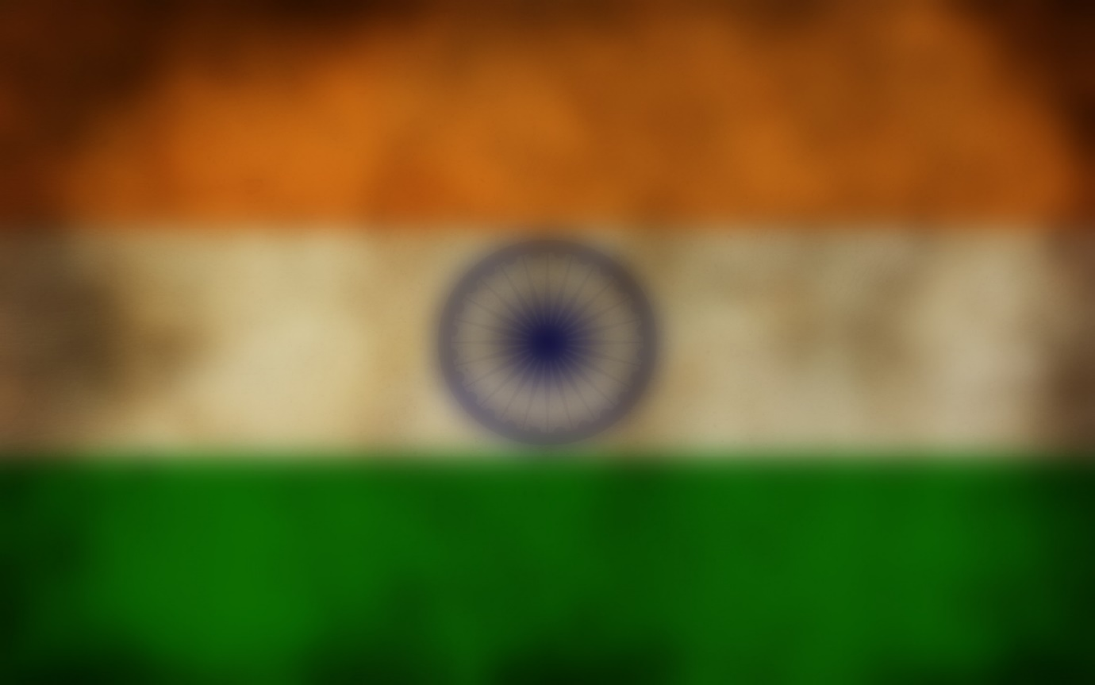
A REPORT
ON
MATERIAL GATE PASS
BY
NAME OF THE STUDENT IDNo.
G SAI TEJA 160217733040
SAI TEJA AMBARI 160217733039
SAI TEJA AMARVAJ 160217733038
AT
BHARAT DYNAMICS LIMITED, Hyderabad
(Ministry of defence}


DEPARTMENT OF COMPUTER SCIENCE AND ENGINEERING
VASAVI COLLEGE OF ENGINEERING
{Approved by AICTE, New Delhi & Permanently Affiliated to OU University)
IBRAHIMBAGH,TELANGANA
500031

CERTIFICATE

This is to certify that the project entitled "MATERIAL GATE PASS SYSTEM" submitted by G Sai Teja, Sai Teja Ambari, Sai Teja Amarvaj of B.TECH II year, Department of Computer Science and Engineering from GITAM University, Hyderabad in partial fulfillment for the award of Bachelor of technology is a record of bonafied work carried out by them in BDL, Hyderabad under my supervision

EXTERNAL GUIDE
Mr. S Pullanna
(Deputy Manager)
ITD Department
BDL, Hyderabad

ACKNOWLEDGEMENT
A summer project is a golden opportunity for learning and self-development. I consider myself very lucky and honoured to have so many wonderful people lead me through in completion of this project.

I wish to express my indebted gratitude and special thanks to “Mr S.PULLANNA(Deputy Manager)" who in spite of being extraordinarily busy with his duties, took time out to hear, guide and keep me on the correct path and allowing me to carry out my internship at their esteemed organization and extending support, during the training.
A humble ‘Thank you’ Sir.

PROJECT DESCRIPTION
Material Gate Pass System at Bharat Dynamics Limited is implemented for generating passes for visitors/employees for taking the materials out of the company for various purposes. The basic details of the visitor with his her unique visitor number including his her photo and the details of person requesting his/her entry are printed on the form and stored in BDL file for future reference. The printed pass is given to the visitor/employee and is noted into the file. There are two types of materials which are returnable and non-returnable materials. Returnable materials are materials which are to be submitted within a period of time whereas non-retuenable materials need not to be returned to the company. The project is developed by java GUI.

APPLICATION
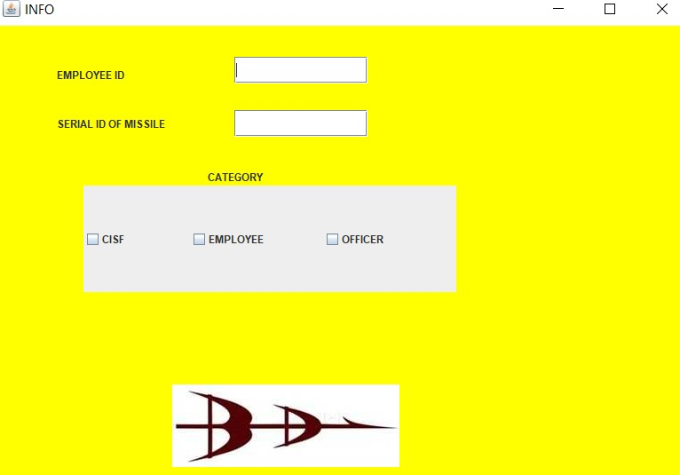
Fig1-We have to select the category and then issue the materials and also they can check their issued materials separately.
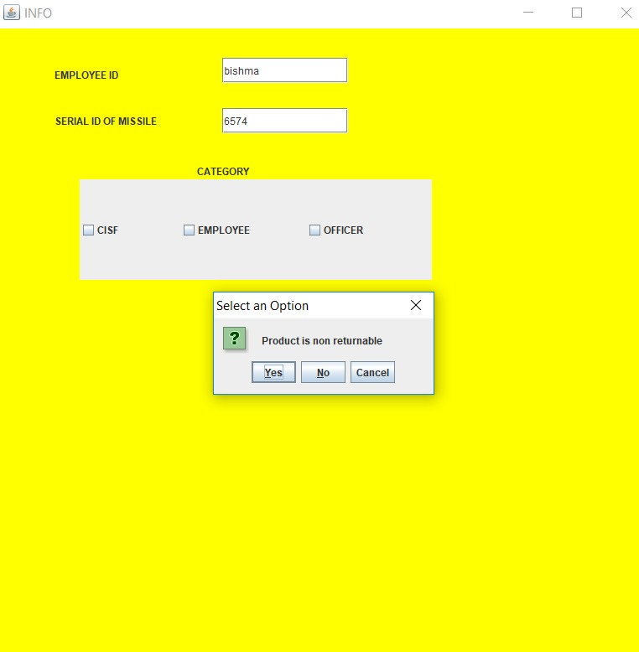
Fig2-Here we have to select the material is either returnable or non-returnable.

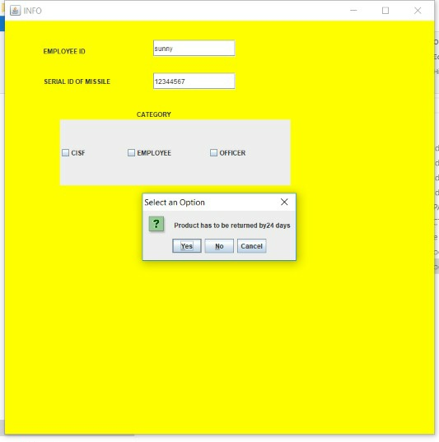
Fig3-In this we are able to set the return period of time for the returnable materials and the non-returnable materials are directly saved into the file.

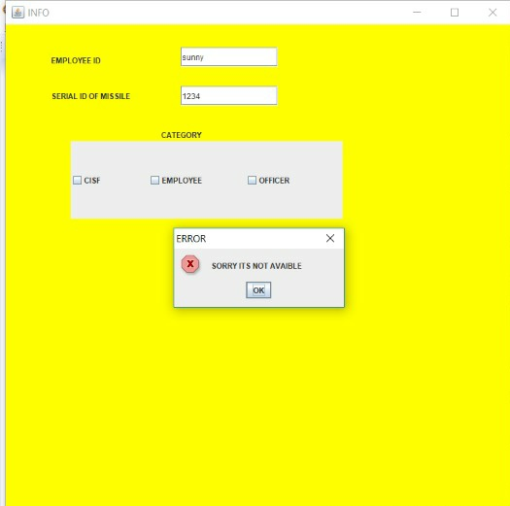
Fig4-Here we are verifying the details of the particular category entered.

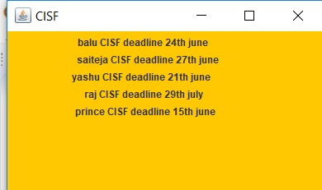
Fig5- It is the list of the materials issued by the CISF category along with the return dates.

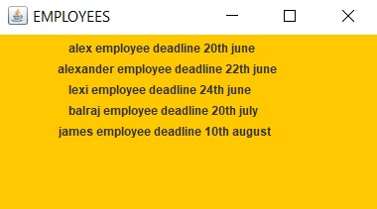
Fig6- It is the list of the materials issued by the employees along with the return dates.

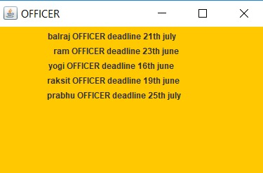
Fig7- It is the list of materials issued by the officers along with the return dates.

CODE
package bdl;
import javax.swing.*;

import java.awt.*;
import java.awt.event.ActionEvent;
import java.awt.event.ActionListener;
import java.io.*;
import java.util.Random;
public class bdl implements ActionListener{
JFrame jf;
JPanel jp;
JLabel emp,mserial,categ;
JTextField empf,mserf;
JCheckBox cisf,wor,off;

bdl(){
jf=new JFrame();
jp=new JPanel(null);
jp.setBackground(Color.yellow);
try {
//ImageIcon ii=new ImageIcon(getClass().getResource("c"));
JLabel i=new JLabel();
i.setIcon(new ImageIcon("bdllogo.jpg"));
i.setBounds(200, 200, 500, 500);
jp.add(i);
}
finally {

}
jf.setTitle("INFO");
emp=new JLabel("EMPLOYEE ID");
emp.setBounds(70, 30, 150, 50);

empf=new JTextField();
empf.setBounds(270, 35, 150, 30);
empf.addActionListener(this);
mserf=new JTextField();
mserf.setBounds(270, 95, 150, 30);
mserial=new JLabel("SERIAL ID OF MISSILE");
mserial.setBounds(70, 90, 150, 40);
mserf.addActionListener(this);

categ=new JLabel("CATEGORY");
categ.setBounds(240, 150, 150, 40);

cisf=new JCheckBox("CISF");
cisf.setBounds(100, 180, 150, 120);
cisf.addActionListener(this);

wor=new JCheckBox("EMPLOYEE");
wor.setBounds(220, 180, 150, 120);
wor.addActionListener(this);

off=new JCheckBox("OFFICER");
off.setBounds(370, 180, 150, 120);
off.addActionListener(this);

jp.add(categ);
jp.add(wor);
jp.add(off);
jp.add(cisf);
jp.add(empf);
jp.add(mserf);
jp.add(emp);
jp.add(mserial);

jf.add(jp);
jf.setDefaultCloseOperation(1);
jf.setVisible(true);
jf.setSize(800, 800);
}
public static void main(String ab[]) {
new bdl();

}
@Override
public void actionPerformed(ActionEvent e) {
String ename="",sno="",ds="",es="";
int n=0,j=0;
if(e.getSource()==empf) {
ename+=" ";
ename+=empf.getText();
es=empf.getText();
es+=" ";

}
if(e.getSource()==mserf) {
sno+=" ";
sno+=mserf.getText();
ds=mserf.getText();
ds+=" ";

//System.out.print(ename + " "+sno);

try {
FileReader fr1=new FileReader("F:\\java\\bdl\\serialnames.txt");
String full="";
int i;

while((i=fr1.read())!=-1) {
full+=(char)i;

}
fr1.close();
if(full.contains(ds)) {
//System.out.print("sorry not available");
JOptionPane.showMessageDialog(jp, "SORRY ITS NOT AVAIBLE","ERROR", JOptionPane.ERROR_MESSAGE);
}
else {
Random r=new Random();
n=r.nextInt();
while(n>30 || n<2) {
n=r.nextInt();
}
if(n!=0)
JOptionPane.showConfirmDialog(jp, "Product has to be returned by" + n +" days");
// n=0;
if(n==0) {
JOptionPane.showConfirmDialog(jp, "Product is non returnable");
}

}
}

catch(Exception e1) {

}
}
try {
FileWriter fos1=new FileWriter("F:\\java\\bdl\\empnames.txt",true);

fos1.write(ename);
// fos1.write("\n");
fos1.close();
} catch (IOException e1) {
// TODO Auto-generated catch block
e1.printStackTrace();
}
try {
FileWriter fos1=new FileWriter("F:\\java\\bdl\\serialnames.txt",true);

fos1.write(sno);
//fos1.write("\n");
fos1.close();
} catch (IOException e1) {
// TODO Auto-generated catch block
e1.printStackTrace();
}
//}
jfn.setVisible(true);
jfn.setSize(400,400);

}
}

CONCLUSION:
The report attempts to bring to the fore an intensive account of the activities done by us at Bharat Dynamics Ltd., Hyderabad during the our MAIN PROJECT. A brief description of various materials at BDL, Hyderabad.

