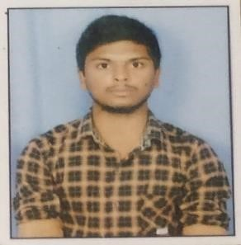**MANNEM SAITEJA REDDY**

# CAREER OBJECTIVE

* To have a growth oriented and challenging career, where I can contribute my knowledge and skills to the organization and enhance my experience through continuous learning and team work.
* To work in a firm where I can fulfil my goals by fulfilling the organizational goals.

# ACADEMICS

* **Graduation Details :** Pursuing Computer Science and Engineering in MallaReddy College of Engineering and Technology with 8.45 CGPA.
* **Senior Secondary :** Intermediate in MPC Stream at Narayana Junior College with

96.4%.

* **Higher Secondary :** Telangana Model School with 8.2 GPA.

# WORKSHOPS & PROJECT

* **Project Done:** Movie Recommendation System Using Machine Learning – Mini-

Project.

* **Workshops Attended :**
* Attended an on-campus workshop on Data Science.

# TECHNICAL SKILLS

* **Programming Languages:** C, C++, Java (Beginner), Python, Data structures.

* **Front-End Technologies:** HTML, CSS.

* **Database:** MYSQL(Basics).

# CERTIFICATIONS

* Certified in C for Everyone: Structured Programming by coursera.
* Certified in Grammar and Punctuation by coursera.
* Pearson MePro certificate for English proficiency CEFR level C2 and is in the GSE range of of 85-90.
* Certified in AI for everyone by coursera.

## ACHIEVEMENTS

* Participated in District Level Kabbadi Tournament.
* Secured many awards at School level in Sports and other co-curricular activities.
* Participated in Level Cricket Tournament in school level.
* Participated in Kho-Kho Tournament in school level.

## PERSONAL SKILLS

* Good Communication Skills.
* Problem solving.
* Flexibility and adaptability.
* Hardworking and Positive attitude.
* Self-motivating.

.

## PERSONAL DETAILS

* **Date of Birth:**12/01/2001
* **Father’s Name:** Mannem Kista Reddy.
* **Mother’s Name:** Mannem Bhagyamma.
* **Address:** H.No: 2-36, Eravally, Siddipet, 502301, Telangana.

• **Hobbies:** Listening to music, Gardening, Playing kabbadi.

* **Nationality:** Indian
* **Languages known:** Telugu, English.
* **Any kind of disabilit**

|  |  |
| --- | --- |
|  | **Signature/E-signature:** |
| Hyderabad | Mannem Saiteja Reddy |