**Driving School:**

Driving School Company want to build a website for customer for below activity:

1. Book classes for driving lessons

Use case in detail:

1. User goes to the website and selects the slot for driving classes
2. Adds to the cart
3. Checkout and Make a payment
4. Get the confirmation of the classes booked

**NVT (Noun Verb Technique)**

Nouns in the Usecase (Object):

1. Slot
2. Classes
3. Cart
4. Payment
5. Book

Verbs in the Usecase(behaviour):

1. Select a Slot
2. Add to Cart
3. Make a payment
4. Classed booked

Class Diagram:

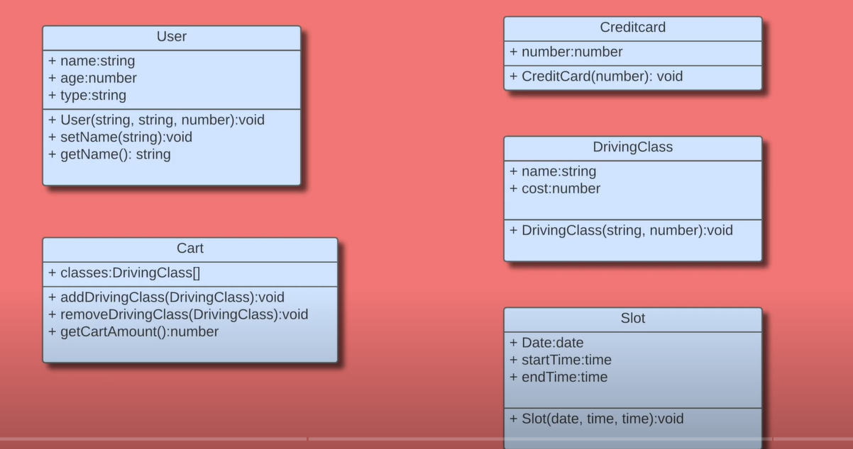

**How to relate the classes?**

There are two types of relations

1. Has a relation (composition/aggregation)
   1. Customer has a credit card
2. Is a relation (inheritance)
   1. Different types of driving lessons like parking lessons, driving lessons

**How to identify different responsibilities to classes?**

A cart has a 1 is many relation with Lessons because a cart can consist of N number of lessons

So here **Cart Class** has to expose different functions:

1. AddLessons
2. getTotalAmount

Lesson Class has to expose different functions:

1. getFees()
2. getDiscount()