**Topics: Descriptive Statistics and Probability**

1. **Look at the data given below. Plot the data, find the outliers and find out $μ, σ, σ^{2}$**

|  |  |
| --- | --- |
| **Name of company** | **Measure X** |
| Allied Signal | 24.23% |
| Bankers Trust | 25.53% |
| General Mills | 25.41% |
| ITT Industries | 24.14% |
| J. P. Morgan & Co. | 29.62% |
| Lehman Brothers | 28.25% |
| Marriott | 25.81% |
| MCI | 24.39% |
| Merrill Lynch | 40.26% |
| Microsoft | 32.95% |
| Morgan Stanley | 91.36% |
| Sun Microsystems | 25.99% |
| Travelers | 39.42% |
| US Airways | 26.71% |
| Warner-Lambert | 35.00% |

A: 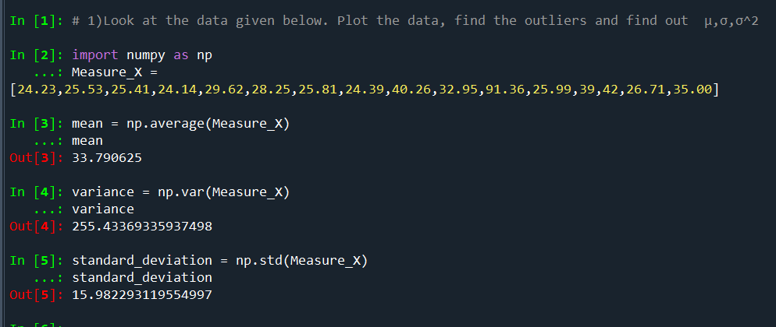

**2.**

**Answer the following three questions based on the box-plot above.**

1. **What is inter-quartile range of this dataset? (Please approximate the numbers) In one line, explain what this value implies.**

**A: IQR = 12 – 5 = 7.**

1. **What can we say about the skewness of this dataset?**

**A: Positive Skewness and tail towards its right.**

1. **If it was found that the data point with the value 25 is actually 2.5, how would the new box-plot be affected?**

**A: Q1 will moves towards left and data don’t have outliers.**

**3.**

**Answer the following three questions based on the histogram above.**

1. **Where would the mode of this dataset lie?**

**A: 4 to 8.**

1. **Comment on the skewness of the dataset.**

**A: positive Skewness.**

1. **Suppose that the above histogram and the box-plot in question 2 are plotted for the same dataset. Explain how these graphs complement each other in providing information about any dataset.**

**A: Both will give the information about the data but in the histogram additionally will get the mode.**

1. **AT&T was running commercials in 1990 aimed at luring back customers who had switched to one of the other long-distance phone service providers. One such commercial shows a businessman trying to reach Phoenix and mistakenly getting Fiji, where a half-naked native on a beach responds incomprehensibly in Polynesian. When asked about this advertisement, AT&T admitted that the portrayed incident did not actually take place but added that this was an enactment of something that “could happen.” Suppose that one in 200 long-distance telephone calls is misdirected. What is the probability that at least one in five attempted telephone calls reaches the wrong number? (Assume independence of attempts.)**

**A:** 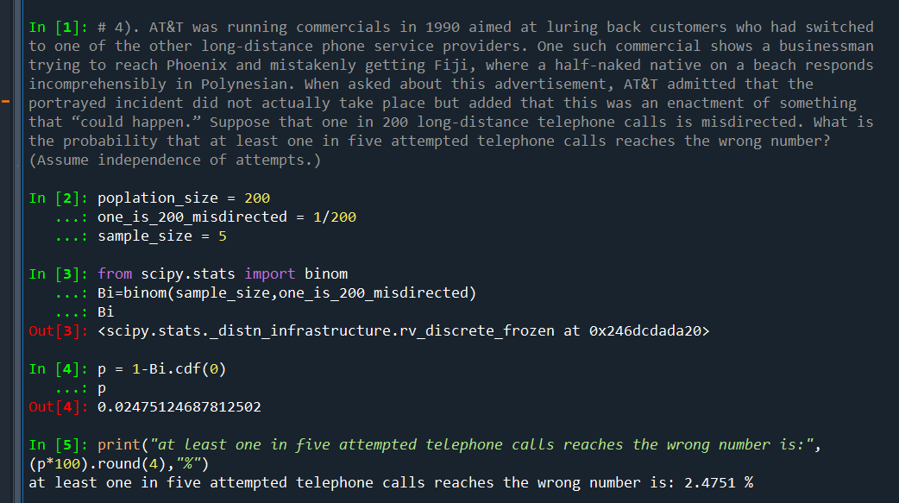

**5.Returns on a certain business venture, to the nearest $1,000, are known to follow the following probability distribution**

|  |  |
| --- | --- |
| x | P(x) |
| -2,000 | 0.1 |
| -1,000 | 0.1 |
| 0 | 0.2 |
| 1000 | 0.2 |
| 2000 | 0.3 |
| 3000 | 0.1 |

1. **What is the most likely monetary outcome of the business venture?**

**A: From the table, we can see that the highest Probability (0.3) is associated with X value is being 2000. Therefore, the most likely monetary outcome of the business venture is $2000(to the nearest $1000).**

1. **Is the venture likely to be successful? Explain**

**A: Yes, venture likely to be successful, because sum of Probability is more than (0.5).**

1. **What is the long-term average earning of business ventures of this kind? Explain**

**A: The long-term average earning of business ventures of this kind is $800.**

**The formula for Expected Value is:**

**EV = $Σ(X*p\left(X\right))$ = $800**

1. **What is the good measure of the risk involved in a venture of this kind? Compute this measure.**

**A:**

