**Topics: Normal distribution, Functions of Random Variables**

1. **The time required for servicing transmissions is normally distributed with *μ* = 45 minutes and *σ* = 8 minutes. The service manager plans to have work begin on the transmission of a customer’s car 10 minutes after the car is dropped off and the customer is told that the car will be ready within 1 hour from drop-off. What is the probability that the service manager cannot meet his commitment?**
2. **0.3875**
3. **0.2676**
4. **0.5**
5. **0.6987**

**A:**

**[B]. 0.268**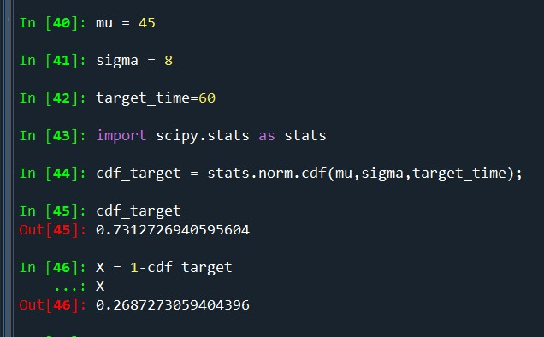

1. **The current age (in years) of 400 clerical employees at an insurance claims processing center is normally distributed with mean *μ* = 38 and Standard deviation *σ* =6. For each statement below, please specify True/False. If false, briefly explain why.**
2. **More employees at the processing center are older than 44 than between 38 and 44.**

**A:** 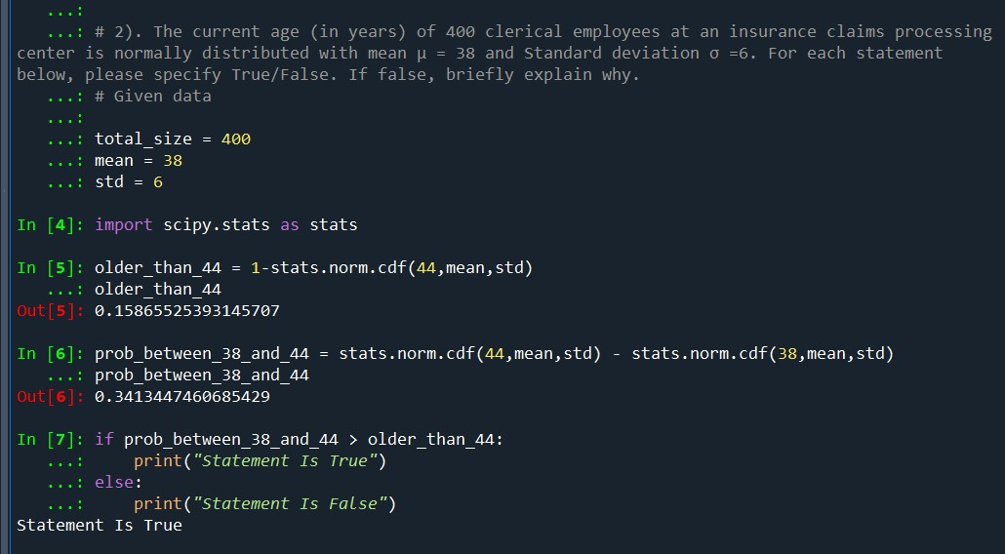

1. **A training program for employees under the age of 30 at the center would be expected to attract about 36 employees.**

**A:**

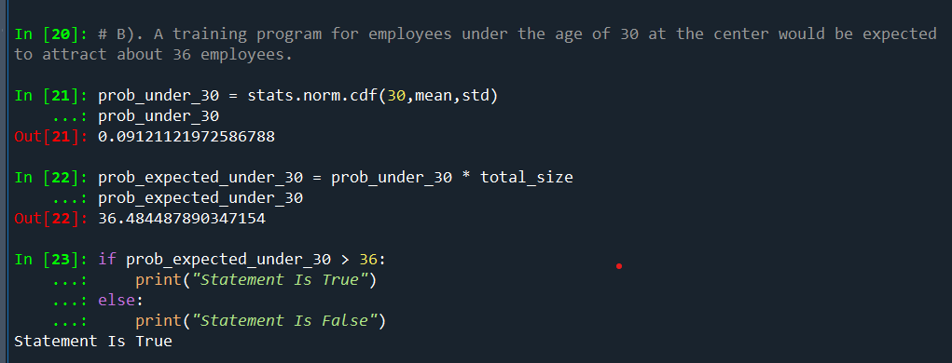

1. **If *X1* ~ *N* (μ, σ2) and *X*2 ~ *N* (μ, σ2) are *iid* normal random variables, then what is the difference between 2 *X*1 and *X*1 + *X*2? Discuss both their distributions and parameters.**

**A: Parameters are same at Normal Distribution**.

1. **Let X ~ N (100, 202). Find two values, *a* and *b*, symmetric about the mean, such that the probability of the random variable taking a value between them is 0.99.**
2. **90.5, 105.9**
3. **80.2, 119.8**
4. **22, 78**
5. **48.5, 151.5**
6. **90.1, 109.9**

**A: [D]. 48.8, 151.5**

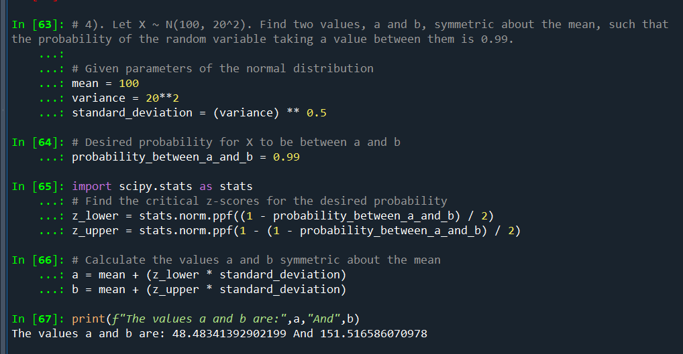

1. **Consider a company that has two different divisions. The annual profits from the two divisions are independent and have distributions Profit1 ~ N(5, 32) and Profit2 ~ N(7, 42) respectively. Both the profits are in $ Million. Answer the following questions about the total profit of the company in Rupees. Assume that $1 = Rs. 45**
2. **Specify a Rupee range (centered on the mean) such that it contains 95% probability for the annual profit of the company.**

**A.**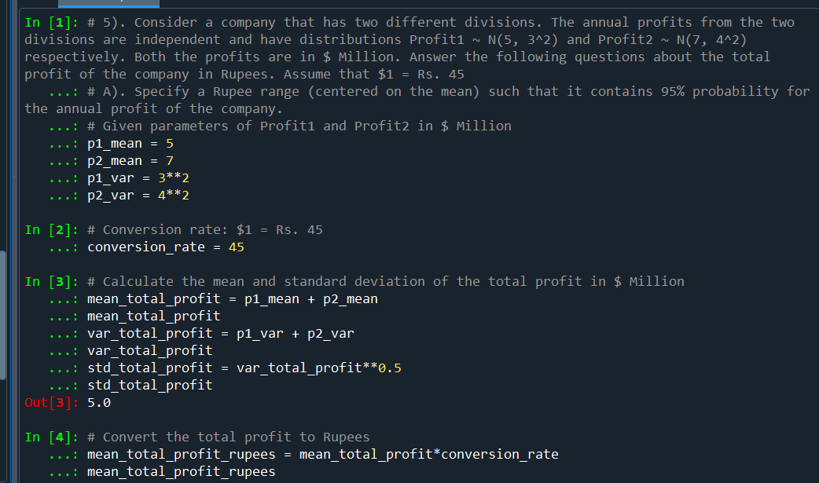 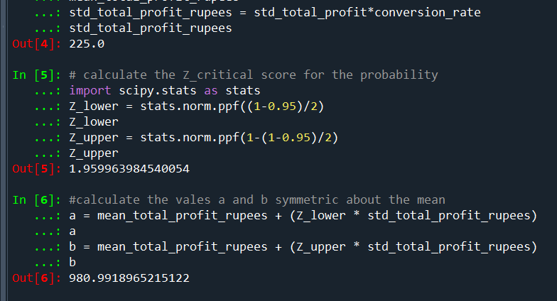

1. **Specify the 5th percentile of profit (in Rupees) for the company**

**A:** 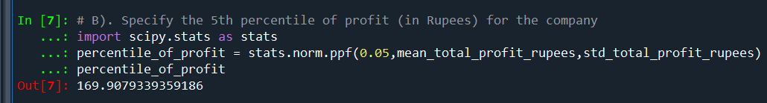

1. **Which of the two divisions has a larger probability of making a loss in a given year?**

**A:** 