**ABOUT THE AUTHOR**

I am Saiteja and I am from Hyderabad, India. I completed my bachelors in Electronics and Communication Engineering from Gokaraju Rangaraju Institute of Engineering and Technology with a CGPA of 9.97/10 in the year 2019. I received a Gold Medal for the academic excellence from my university. Right after that, I got an opportunity to work for Tata Consultancy Services as a Systems Engineer and have worked for 3 years until July 2022. I speak English, Hindi, and Telugu where the last of these is my first language. My interests include but not limited to Cricket, Table-Tennis and learning new languages. Currently I am pursuing my master’s in Computer Engineering at San Jose State University.

**TABLE OF CONTENTS**

LIST OF FIGURES 3

INTRODUCTION 4

MY GROUP 4

GIVEN TASK 4

STEPS TAKEN TO COMPLETE THE TASK 4

DISCUSSION SECTION 5

*a. Datapath Explanation 5*

*b. CU-DP Diagram Explanation 8*

*c. ASM Chart Explanation 9*

*d. Bubble Diagram Explanation 11*

*e. Output Logic Table Explanation 12*

COLLABORATION SECTION 13

CONCLUSION 13

APPENDIX 14

*a. Datapath Diagram 14*

*b. CU-DP Block Diagram 15*

*c. ASM Chart 15*

*d. Bubble Diagram 16*

*e. Output Logic Table 16*

*f. Source Code – FATopModule_tb.v (TestBench Module) 17*

*g. Source Code - FATopModule.v 18*

*h. Source Code – FA_Datapath.v 19*

*i. Source Code – FA_Controlpath.v 19*

*j. Source Code – Comparator.v 21*

*k. Source Code – Multiplexer.v 22*

*l. Source Code – Multiplier.v 22*

*m. Source Code – Register.v 22*

*n. Source Code – Counter.v 23*

*o. Output Waveforms 23*

# LIST OF FIGURES

Fig5.1 – Down Counter

Fig5.2 – Comparator

Fig5.3 – Multiplier

Fig5.4 – Register

Fig5.5 – 2x1 Multiplier

Fig5.6 – Factorial Accelerator Datapath (Using Visio)

Table5.7 – Control Unit Signals Description

Fig5.8 – CU-DP Block Diagram

Fig5.9 – ASM Chart for the Factorial Accelerator

Fig5.10 – Bubble Diagram for the Factorial Accelerator

Table5.11 – Output Logic Table for the Factorial Accelerator

# INTRODUCTION:

This activity is used review the system-level design by designing, functionally verifying a digital system for accelerating the factorial computation.

# MY GROUP:

**Name:** Student_Team 6

**Members:** Tirumala Saiteja Goruganthu (016707210), Harish Marepalli (016707314)

# GIVEN TASK:

The task is to design a digital system for accelerating the factorial computation. The system should start execution upon receiving an external input “***Go***” and should output a “***Done***” signal when the execution is completed. In addition, an “***Error***” signal should be set when an input greater than 12 is entered. Apart from that, the factorial accelerator shall calculate, and display results up to 12!. Inputs for n should be unsigned. Use only one 4-bit down counter, one register, one 2x1 multiplexers, two greater than comparators, a 32-bit unsigned multiplier, and one tri-state buffer (although another 2x1 multiplexer is preferred). The tool used for this task is “***Vivado******Xilinx***" in which we write the “***Verilog HDL*”** to verify our design.

# STEPS TAKEN TO COMPLETE THE TASK:

1. Spent time to understand the question carefully.
2. Designed the system’s datapath using the given building blocks using Visio.
3. Drawn the two-piece CU-DP block diagram that shows all relevant signals using Visio.
4. Prepared an ASM chart which describes the cycle-by-cycle operations of the datapath.
5. Designed a bubble (state) diagram for the “*next-state logic*” (NS) part of the control unit.
6. Constructed an output table for the “*output logic*” part of the control unit.
7. Created a new project in the Vivado software and added new leaf-level modules for all the required components such as counter, multiplexer by specifying the correct input and output parameters. Note that we used behavioral modelling when writing the Verilog code.
8. Created a module for the Datapath which incorporates or instantiates all the leaf-level modules by connecting each-other through parameters.
9. Added a new module for the Control path which includes the code for current state combinational circuit, state assigning stage, and next state combinational circuit.
10. A module for the top-level module is created which instantiates data path and control path modules. Along with that, to verify our design, a top-level testbench module has been created with few relevant inputs.
11. Finally, ran the simulation and observed the output waveforms for their correctness.

# DISCUSSION SECTION:

## a. Datapath Explanation:

The first step taken to design the factorial accelerator digital system is to prepare a datapath. The requirement was to use only the following leaf-level components.

1. A Down Counter as shown in *Fig5.1*

**Fig5.1 – Down Counter**

1. A Greater Than Comparator as shown in *Fig5.2*

**Fig5.2 – Comparator**

1. The Multiplier as shown in *Fig5.3*

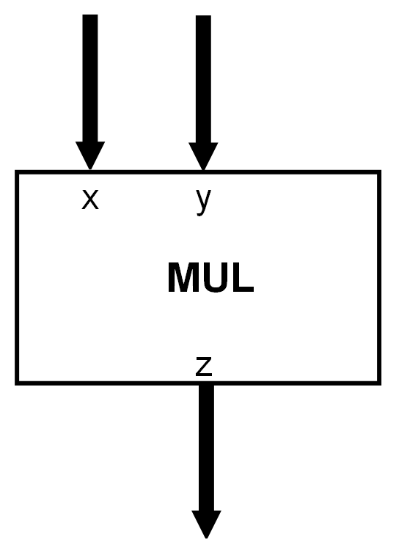

**Fig5.3 – Multiplier**

1. A Register as shown in *Fig5.4*

**Fig5.4 – Register**

1. A 2x1 Multiplexer as shown in *Fig5.5*

**Fig5.5 – 2x1 Multiplier**

The Datapath is designed by interconnecting the above digital components and is shown in *Fig 5.6* and is also shown under the appendix section.

1. First, after the user gives the external input ‘*Go*’, the input value (*n*) is loaded into 4-bit down counter by setting ‘*Load_Cnt*’ line to logic high. Note that since the counter is a sequential circuit, it needs the ‘*CLK*’ input to be at positive edge or negative edge. In this exercise, we will be using positive edge triggered down counter.
2. At the same time, we send the input (*n*) to a 4-bit comparator to check if the n is greater than 12. If n value is greater than 12, then the line ‘*GT12*’ will be high, and this signal will be sent to the control unit.
3. During this operation, a 32-bit 2x1 multiplexer is used to initialize the ‘*f*’ value to 1 by setting the selection line ‘*Sel*’ to 1.
4. This ‘*f*’ value is loaded into the register by setting the ‘*Load_Reg*’ line to logic high. This loading is part of the factorial loop where the corresponding ‘*f*’ value that is getting stored in the register will change for each iteration.
5. After loading the input value (*n*), the counter will send it to another 4-bit comparator. This comparator is the starting point of a factorial loop where if the given input value is greater than 1 is checked. Depending on the output of the comparator, the ‘*GT1*’ signal will be set to logic low or high.
6. The calculated ‘*f*’ value and the current ‘*n*’ value is multiplied using a 32-bit unsigned multiplier.
7. This multiplied value is transported back to the 2x1 multiplexer at 0 port where this value is iteratively used to load into the register and multiplied using the multiplier.
8. This process will be done until the comparator with output ‘*GT1*’ outputs a logic low which indirectly means the n value is equal to or less than 1 and the factorial computation is done.
9. Finally, the result is then sent to another 2x1 multiplexer which uses ‘*OE*’ as its selection line is used to determine the completion of factorial computation and simultaneously used to send the ‘*product*’ as well as ‘*Done*’ control signal to the control unit.

**Fig5.6 – Factorial Accelerator Datapath (Using Visio)**

## b. CU-DP Diagram Explanation:

After the design of the Datapath, the next step is to proceed by drawing the CU-DP block diagram. In general, the CU-DP diagram consists of two blocks, the Control Unit, and the Datapath Unit. This diagram will help us to see the design at the top level with few user inputs and outputs and few communication lines between the data path and the control path. The CU-DP diagram for the current task is shown in *Fig5.8* and it is also shown in the appendix section.

1. Let us look at the control unit signal description as shown in the *Table5.7*

|  |  |  |
| --- | --- | --- |
| **Signal Name** | **Signal Function** | **Description** |
| CLK | External Input | Clock Signal |
| Go | External Input | System starts if Go = 1 |
| GT1 | Input from Datapath | n>1 condition check |
| GT12 | Input from Datapath | n>12 condition check |
| Sel | Output from Controlpath | f=1 / reg selection line |
| Load_Reg | Output from Controlpath | Load Enable for register |
| Load_Cnt | Output from Controlpath | Load Enable for counter |
| OE | Output from Controlpath | Selection for multiplexer#2 |
| EN | Output from Controlpath | Enable signal for counter |
| Done | External Output | System output if Done = 1 |
| Error | External Output | System output if Error = 1 |

**Table5.7 – Control Unit Signals Description**

b. Let us look at the data unit signals in the CU-DP block diagram. The most important signal is the input (n) which is a 4-bit value. All the components in the data path that are discussed in the previous section such as Counter, Comparator, multiplexer need control signals from the control unit. These control signals’ description has already been covered in the *Table5.7*. Finally, the 32-bit output of the factorial is made available by a signal called ‘*product*.’

c. The CU-DP diagram can be looked at as the top-level block diagram for any digital system. It is drawn in the user’s point of view and thus has far less control signals than the actual inner circuit. In the current task, there are 3 external inputs and 3 external outputs that are to be given by the user to start the system. Since, the requirement was to start the system when Go signal is given, this signal is in the hands of the user. CLK signal and the 4-bit input (*n*) are also the external inputs from the user and the signals Done, Error, product are the external outputs from the system after the execution.

**Fig5.8 – CU-DP Block Diagram**

## c. ASM Chart Explanation:

The Algorithmic State Machine (ASM) method is a method for designing Finite State Machines (FSMs) and is used to represent diagrams of digital circuits. The ASM diagram is like a state diagram but more structured and, thus, easier to understand. An ASM chart is a method of describing the sequential operations of a digital system. In the current task, the ASM chart is shown in the *Fig5.9*.

a. First state S0 is an idle state where the system will not perform any function during this state.

b. Next there is a condition box which checks the Go input signal. If this signal is 0, the system will go back to the idle state else it will go to another condition box which is used to check if the input value (*n*) is greater than 12 by setting GT12 signal. If the GT12 is 1, then we can say that the error has been received and the system will go back to being idle i.e., S0 else if GT12 is 0, then the state is changed from S0 to S1.

c. In the state S1, the counter is loaded with the value n using the Load_Cnt control signal and the register is loaded with 1 by enabling the Sel signal and Load_Reg control signal. After this, the control goes to the next state S2.

d. In the state S2, the control can go to either state S3 or S4 depending upon the GT1 comparator value. If the GT1 is 0, then the factorial is done, and state changes to S3 where the user can collect the output. If the GT1 value is 1, then the factorial loop is executed by calculating the f=f*n and decrementing the counter value by 1 and the state is changed to S2.

**Fig5.9 – ASM Chart for the Factorial Accelerator**

## d. Bubble Diagram Explanation:

The next step in the design is preparing a bubble/state diagram for factorial accelerator. The state diagram is a visual representation of how sequential circuits behave. It clearly depicts the transition of states from one state to the next, as well as the output for a given input. Each current state is represented by a circle in a state diagram. The bubble diagram for the current task has been shown in the *Fig5.10*.

a. The explanation is similar for the ASM chart and for the bubble diagram since both talk about the sequential part of the current task and involves states into the picture. The state S0 will go to S1 only if Go=1 and GT12=0 else will stay back in state S0. Once it is in S1, it will go to S2 regardless of the condition. Changing the states from S2 to S3 or S4 heavily depends on the GT1 comparator output. If GT1 is 0, then state is changed to S3, and the process is done else it will go into factorial loop (S4) until finally it changes to state S3.

**Fig5.10 – Bubble Diagram for the Factorial Accelerator**

## e. Output Logic Table Explanation:

The final step in the design phase is to draw an output logic table which shows the values of all control signals for each and every state defined. In the current task, the output table is shown below in *Table5.11*. Just to revisit, the control signals that we used are Sel, Load_Cnt, EN, Load_Reg, OE, Done and Error.

a. In S0, the state is idle which is why all the control signals are at logic zero.

b. In state S1, we need to initialize and load the register with 1 and load the counter with n. This is done by enabling Sel, Load_Reg, EN, and Load_Cnt.

c. In state S2, this is a wait state so all the control signals will be at logic zero.

d. In state S3, the factorial computation is done which is why OE and Done signals are enabled.

e. In state S4, the factorial loop is calculated which means the Sel will be set to logic zero and Load_Reg, EN signals are set to logic high to the current f value.

|  |  |  |  |  |  |  |  |
| --- | --- | --- | --- | --- | --- | --- | --- |
| **State** | **Outputs** | | | | | | |
| **Sel** | **Load_Cnt** | **En** | **Load_Reg** | **OE** | **Done** | **Err** |
| **S0** | 0 | 0 | 0 | 0 | 0 | 0 | - |
| **S1** | 1 | 1 | 1 | 1 | 0 | 0 | - |
| **S2** | 0 | 0 | 0 | 0 | 0 | 0 | - |
| **S3** | 0 | 0 | 0 | 0 | 1 | 1 | - |
| **S4** | 0 | 0 | 1 | 1 | 0 | 0 | - |

**Table5.11 – Output Logic Table for the Factorial Accelerator**

This concludes the Design phase of our digital system. In the next step, we use Hardware Description Language (HDL) such as Verilog to write high-level code and verify the design by simulating the written modules.

We use Vivado Xilinx software to write our Verilog code. First step is to create a project and, in that project, create and add modules. At the beginning, leaf-level component modules such as counter, multiplexer are written and then these modules are instantiated in more top-level modules such as data path and control path.

To verify the code that we have written, we must run the simulation by giving some inputs. These inputs are given using a test bench in the vivado. A test bench is another module which instantiates a given module by providing few test cases or inputs.

After writing the testbench for all test cases, we can just click on “*Run Simulation*” button to start the simulation which in-turn will produce output waveforms for all the variables mentioned in the testbench. These waveforms are covered in the appendix section.

# COLLABORATION SECTION:

1. Worked together on the data path and control path design, and eventually prepared them using Microsoft Visio tool.

2. Collaborated in designing the FSM while preparing the corresponding ASM chart and the bubble diagram using the Microsoft Visio tool.

3. Worked together to construct the leaf-level modules in the vivado using Verilog code.

4. By working together, we have written the test bench to verify a bunch of values and observed the output waveforms.

# CONCLUSION:

In conclusion, we end the report by understanding the system-level design by designing and verifying a digital system for factorial acceleration. We also gained insight into Verilog coding and the usage of vivado Xilinx software for verifying the digital systems. We also got some hands-on the Microsoft Visio tool for creating block diagrams and other functional visualizations.

# APPENDIX

## a. Datapath Diagram

## b. CU-DP Block Diagram

## c. ASM Chart

## d. Bubble Diagram

## e. Output Logic Table

|  |  |  |  |  |  |  |  |
| --- | --- | --- | --- | --- | --- | --- | --- |
| **State** | **Outputs** | | | | | | |
| **Sel** | **Load_Cnt** | **En** | **Load_Reg** | **OE** | **Done** | **Err** |
| **S0** | 0 | 0 | 0 | 0 | 0 | 0 | - |
| **S1** | 1 | 1 | 1 | 1 | 0 | 0 | - |
| **S2** | 0 | 0 | 0 | 0 | 0 | 0 | - |
| **S3** | 0 | 0 | 0 | 0 | 1 | 1 | - |
| **S4** | 0 | 0 | 1 | 1 | 0 | 0 | - |

## f. Source Code – FATopModule_tb.v (TestBench Module)

*`timescale 1ns / 1ps*

*module FATopModule_tb;*

*reg Go_tb, CLK_tb;*

*reg [3:0] n_tb;*

*wire Done_tb, Error_tb;*

*wire[31:0] product_tb;*

*FATopModule FATM(.n(n_tb),*

*.Go(Go_tb),*

*.CLK(CLK_tb),*

*.Done(Done_tb),*

*.Error(Error_tb),*

*.product(product_tb));*

*task automatic tick;*

*begin*

*CLK_tb <= 1'b0;*

*#50;*

*CLK_tb <= 1'b1;*

*#50;*

*end*

*endtask*

*initial*

*begin*

*$display("Factorial Testing Begins");*

*CLK_tb = 0;*

*n_tb = 4'd1;*

*tick;*

*while(n_tb < 15)*

*begin*

*Go_tb = 1;*

*CLK_tb = 0;*

*tick;*

*while(!(Done_tb) || (Error_tb))*

*begin*

*tick;*

*end*

*if(Done_tb)*

*begin*

*$display("%0d! = %0d", n_tb, product_tb);*

*end*

*else if(Error_tb)*

*begin*

*$display("Error received, input = %0d", n_tb);*

*end*

*n_tb = n_tb + 4'd1;*

*end*

*$display("Test Complete");*

*$finish;*

*end*

*endmodule*

## g. Source Code - FATopModule.v

*`timescale 1ns / 1ps*

*module FATopModule(*

*input Go,*

*input CLK,*

*input[3:0] n,*

*output Done,*

*output Error,*

*output[31:0] product*

*);*

*wire Sel, Load_Reg, Load_Cnt, OE, EN;*

*wire GT1, GT12;*

*FA_Datapath FADP(.CLK(CLK),*

*.EN(EN),*

*.n(n),*

*.Sel(Sel),*

*.Load_Reg(Load_Reg),*

*.Load_Cnt(Load_Cnt),*

*.OE(OE),*

*.GT1(GT1),*

*.GT12(GT12),*

*.product(product));*

*FA_Controlpath FACP(.EN(EN),*

*.Go(Go),*

*.CLK(CLK),*

*.Sel(Sel),*

*.Load_Reg(Load_Reg),*

*.Load_Cnt(Load_Cnt),*

*.OE(OE),*

*.GT1(GT1),*

*.GT12(GT12),*

*.Done(Done),*

*.Error(Error));*

*endmodule*

## h. Source Code – FA_Datapath.v

*`timescale 1ns / 1ps*

*module FA_Datapath #(parameter Data_width = 32)(*

*input CLK,*

*input [3:0]n,*

*input Sel,*

*input Load_Reg,*

*input Load_Cnt,*

*input OE,*

*input EN,*

*output GT1,*

*output GT12,*

*output [Data_width - 1:0] product*

*);*

*wire [3:0] Counter_Output;*

*wire [Data_width - 1:0] Mux_Output;*

*wire [Data_width - 1:0] Reg_Output;*

*wire [Data_width - 1:0] Mul_Output;*

*Comparator #(4) Cmp_GT12Checker (.A(n), .B(4'd12), .GT(GT12));*

*Comparator #(4) Cmp_GT1Checker (.A(Counter_Output), .B(4'd1), .GT(GT1));*

*Counter #(4) CNT (.D(n), .Q(Counter_Output), .Load_Cnt(Load_Cnt), .EN(EN), .CLK(CLK));*

*Multiplier #(32) MUL (.X({28'b0,Counter_Output}), .Y(Reg_Output), .Z(Mul_Output));*

*Multiplexer2x1 #(32) MUX (.Inp1(32'b1), .Inp0(Mul_Output), .Sel(Sel), .Out(Mux_Output));*

*Multiplexer2x1 #(32) Out_Buffer (.Inp0(32'b0), .Inp1(Reg_Output), .Sel(OE), .Out(product));*

*Register #(32) REG (.D(Mux_Output), .Q(Reg_Output), .Load_Reg(Load_Reg), .CLK(CLK));*

*endmodule*

## i. Source Code – FA_Controlpath.v

*`timescale 1ns / 1ps*

*module FA_Controlpath(*

*input CLK,*

*input Go,*

*input GT1,*

*input GT12,*

*output reg Sel,*

*output reg Load_Reg,*

*output reg Load_Cnt,*

*output reg OE,*

*output reg EN,*

*output Done,*

*output Error*

*);*

*reg[2:0] CurrState=0, NextState;*

*reg Err_Flag = 0, Done_Flag = 0;*

*assign Error = GT12;*

*assign Done = Done_Flag;*

*//Initialize the states*

*parameter S0 = 3'd0, S1 = 3'd1, S2 = 3'd2, S3 = 3'd3, S4 = 3'd4;*

*always @ (CurrState, Go)*

*begin*

*case (CurrState)*

*S0: //Idle State*

*case({Go, GT12})*

*//Idle State and Go='1', GT12='1'*

*2'b11: {NextState, Err_Flag} <= {S0, 1'b1};*

*//Idle State and Go='1', GT12='0'*

*2'b10: {NextState, Err_Flag} <= {S1, 1'b0};*

*//Idle State and Go='0', GT12='0/1'*

*2'b0?: {NextState, Err_Flag} <= {S0, 1'b0};*

*default: NextState = S0;*

*endcase*

*//Next State will directly be S2*

*S1: NextState <= S2;*

*//Next State will depend on GT1 value*

*S2: NextState <= GT1 ? S4 : S3;*

*//Next State will directly be S0*

*S3: NextState <= S0;*

*//Next State will directly be S2*

*S4: NextState <= S2;*

*endcase*

*end*

*always @(posedge CLK)*

*CurrState = NextState;*

*always @(CurrState)*

*begin*

*case(CurrState)*

*S0: //Idle State*

*begin*

*{Sel, Load_Cnt, EN, Load_Reg, OE, Done_Flag} <= 6'b1_1_1_0_0_0;*

*end*

*S1: //Load Register with '1' and Load Counter with n*

*begin*

*{Sel, Load_Cnt, EN, Load_Reg, OE, Done_Flag} <= 6'b1_1_1_1_0_0;*

*end*

*S2: //Conditional state*

*begin*

*{Sel, Load_Cnt, EN, Load_Reg, OE, Done_Flag} <= 6'b0_0_0_0_0_0;*

*end*

*S3: //Output is ready and Done is set to '1'*

*begin*

*{Sel, Load_Cnt, EN, Load_Reg, OE, Done_Flag} <= 6'b0_0_0_0_1_1;*

*end*

*S4: //Decrement the counter and Load the register after multiplication*

*begin*

*{Sel, Load_Cnt, EN, Load_Reg, OE, Done_Flag} <= 6'b0_0_1_1_0_0;*

*end*

*endcase*

*end*

*endmodule*

## j. Source Code – Comparator.v

*`timescale 1ns / 1ps*

*module Comparator #(parameter DataWidth =4)(*

*input [DataWidth - 1:0] A,*

*input [DataWidth - 1:0] B,*

*output reg GT*

*);*

*always @(A or B)*

*begin*

*//Initialize GT value with '0'*

*GT <= 1'b0;*

*if(A > B)*

*GT <= 1'b1;*

*end*

*endmodule*

## k. Source Code – Multiplexer.v

*`timescale 1ns / 1ps*

*module Multiplexer2x1 #(parameter Data_width = 32)(*

*input [Data_width - 1:0] Inp0,*

*input [Data_width - 1:0]Inp1,*

*input Sel,*

*output reg [Data_width-1 : 0] Out*

*);*

*always @(Inp0, Inp1, Sel)*

*begin*

*if(Sel)*

*Out <= Inp1;*

*else*

*Out <= Inp0;*

*end*

*endmodule*

## l. Source Code – Multiplier.v

*`timescale 1ns / 1ps*

*module Multiplier #(parameter Data_width = 32)(*

*input [Data_width - 1:0] X,*

*input [Data_width - 1:0] Y,*

*output reg [Data_width - 1:0] Z*

*);*

*always @ (X or Y)*

*begin*

*Z <= X * Y;*

*end*

*endmodule*

## m. Source Code – Register.v

*`timescale 1ns / 1ps*

*module Register #(parameter Data_width = 32)(*

*input [Data_width - 1:0] D,*

*input Load_Reg,*

*input CLK,*

*output reg [Data_width - 1:0] Q*

*);*

*always @(posedge CLK)*

*begin*

*if(Load_Reg)*

*Q <= D;*

*end*

*endmodule*

## n. Source Code – Counter.v

*`timescale 1ns / 1ps*

*module Counter #(parameter Data_width = 4)(*

*input CLK,*

*input [Data_width - 1: 0] D,*

*input Load_Cnt,*

*input EN,*

*output reg [Data_width - 1: 0]Q*

*);*

*always @ (posedge CLK)*

*begin*

*if(EN)*

*begin*

*if(Load_Cnt)*

*Q <= D;*

*else*

*begin*

*Q <= Q - 1'b1;*

*end*

*end*

*end*

*endmodule*

## o. Output Waveforms

i. Output for n=1 case with yellow vertical cursor pointed case.

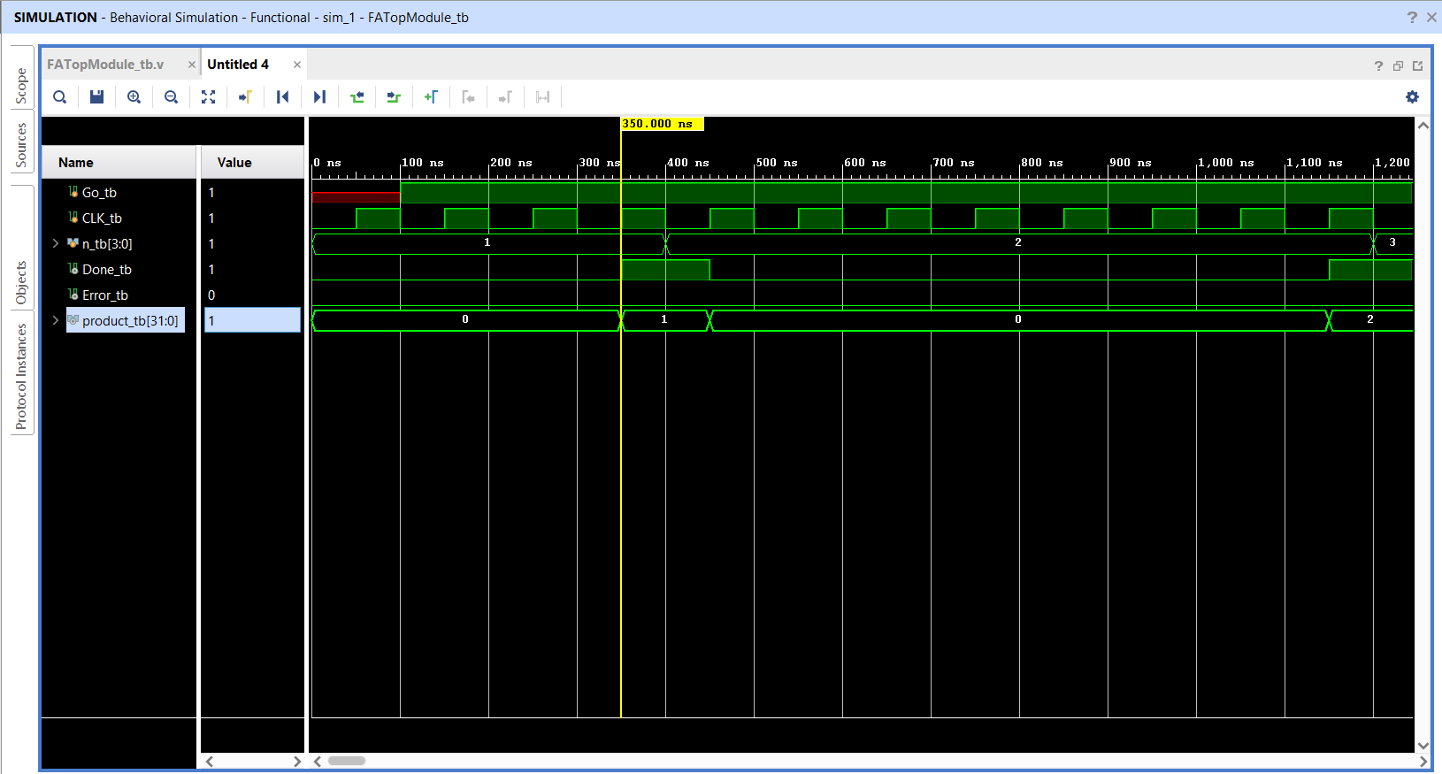

**Waveform of the Factorial Accelerator (n = 1 case)**

ii. Output for n=12 with yellow vertical cursor pointed case.

**Waveform of the Factorial Accelerator (n = 12 case)**

iii. Output for n=13 with yellow vertical cursor pointed case (Error case).

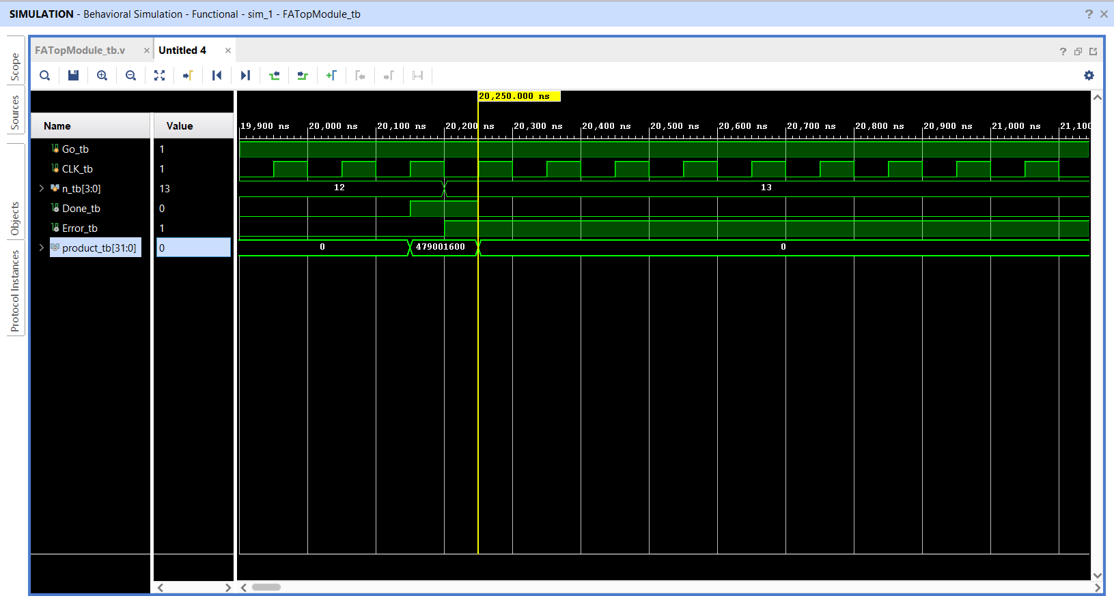

**Waveform of the Factorial Accelerator (n = 13 case -> Error Case)**