Data Storytelling for Interactive Decision Analytics: A Web-Based Multi-Dataset Sales Dashboard
A Mini Project Report Submitted in partial fulfillment of the requirements for the award of the degree of

BACHELOR OF TECHNOLOGY
In

DEPARTMENT OF COMPUTER SCIENCE AND ENGINEERING
By
2420030140-R SAI CHARAN(-LEAD)
2420030121-S SAI RISHIK
2420030574-D SUJAY
2420030764-K SAI TEJA
Under the Esteemed Guidance of
DR .SWANTHANA





K L (Deemed to be) University

DEPARTMENT OF COMPUTER SCIENCE AND ENGINEERING

DECLARATION

The mini-project report entitled “Data Storytelling for Interactive Decision Analytics: A Web-Based Multi-Dataset Sales Dashboard” is a record of bona fide work carried out by 2420030140-R SAI CHARAN(-LEAD),2420030121-S SAI RISHIK, 2420030574-D SUJAY,2420030764-K SAI TEJA in partial fulfillment of the requirements for the award of the B.Tech degree at K L (Deemed to be) University. The work presented in this report is original to the best of our knowledge, and all datasets, tools, code, and external sources used have been appropriately acknowledged.

2420030140-R SAI CHARAN(-LEAD)
2420030121-S SAI RISHIK
2420030574-D SUJAY
2420030764-K SAI TEJA

K L (Deemed to be) University

DEPARTMENT OF COMPUTER SCIENCE AND ENGINEERING

CERTIFICATE

This is to certify that the mini-project report entitled “Data Storytelling for Interactive Decision Analytics: A Web-Based Multi-Dataset Sales Dashboard” is a bona fide work carried out by 2420030140-R SAI CHARAN(-LEAD),2420030121-S SAI RISHIK, 2420030574-D SUJAY,2420030764-K SAI TEJA under the supervision of DR SWANTHANA during the academic year [2026 –2027], in partial fulfillment of the requirements for the award of the Bachelor of Technology degree at K L (Deemed to be) University.

Signature of the Project Supervisor

Signature of the HOD Signature of the External Examiner

ACKNOWLEDGEMENT
The success in this project would not have been possible but for the timely help and guidance rendered by many people. Our wish to express my sincere thanks to all those who has assisted us in one way or the other for the completion of my project.

Our greatest appreciation to my guide, DR SWANTHANA Department of Computer Science which cannot be expressed in words for her tremendous support, encouragement and guidance for this project.

We express our gratitude to Dr. P.Venkateshwar Sir (CSE)/Dr. Kaja Shareef Sir (CSIT)/Dr.Sreenath, Head of the Department for Computer Science Engineering/ Department for Computer Science and Information Technology/ Department Of Artificial Intelligence And Data Science for providing us with adequate facilities, ways and means by which we are able to complete this project-based Lab.

We thank all the members of teaching and non-teaching staff members, and also who have assisted me directly or indirectly for successful completion of this project. Finally, I sincerely thank my parents, friends and classmates for their kind help and cooperation during my work.

2420030140-R SAI CHARAN(-LEAD),
2420030121-S SAI RISHIK,
2420030574-D SUJAY,
2420030764-K SAI TEJA

TABLE OF CONTENTS

S.No. | Contents | Page no.
1. | Abstract | 6-7
2. | Introduction | 8
3. | Literature survey | 9
4. | Problem Statement and Objectives | 10
5. | Hardware and Software requirements | 11
6. | Implementation | 12-13
7. | Results & Discussion | 14-23
8. | Conclusion & Future Scope | 24
9. | References | 25

ABSTRACT

Sales data helps organizations understand business performance, identify profitable products, and make informed decisions. However, analyzing multiple datasets with different structures can be difficult and time-consuming. This project presents a web-based interactive analytics platform that combines sales analysis, data visualization, data storytelling, and machine learning-based sales prediction.
The system integrates four datasets: Superstore, Global Superstore, Online Sales, and Supermarket. Python and Pandas are used for data loading, preprocessing, schema normalization, and exploratory data analysis. The dashboard is developed using Flask, HTML, CSS, and JavaScript, with interactive visualizations created using Plotly.
The platform displays key performance indicators such as sales, profit, quantity, orders, and profit margin, where the required fields are available. Users can select datasets, apply relevant filters, and explore sales trends, category performance, regional performance, and discount-profit relationships.
The predictive component compares Linear Regression, Decision Tree, Random Forest, Gradient Boosting, and the proposed Hybrid Stacked Regression Ensemble (HSRE) using R², Mean Absolute Error, and Root Mean Squared Error. Model performance varies across datasets. The system also presents insights through a Finding–Meaning–Decision–Recommendation framework to connect analytical results with possible business actions.
The project demonstrates how interactive visualization, predictive modeling, and data storytelling can support understandable, evidence-based business decisions.
Team Name:
BATCH - 10

Team Logo (optional):

Team Members and Responsibilities:

- 2420030140-R SAI CHARAN(-LEAD),
- 2420030121-S SAI RISHIK,
- 2420030574-D SUJAY,
- 2420030764-K SAI TEJA

- https://github.com/Rsaicharan-05/KLH-CSE-2026-27-TEAM-6-2420030140-Handwritten-Digit-Character-Recognition-

INTRODUCTION

Businesses generate large amounts of sales data through transactions, product purchases, customer orders, and regional operations. Analyzing this data helps organizations understand performance, identify trends, and improve business strategies. However, data stored in different formats and structures can make analysis difficult.

Traditional dashboards mainly present numerical summaries and charts. Users may still need to interpret the results themselves to understand their business significance. Data storytelling addresses this limitation by connecting analytical findings with their meaning and possible actions.
The proposed project develops a web-based interactive decision analytics platform that integrates four sales datasets into one dashboard. It provides dataset-specific filters, key performance indicators, interactive visualizations, comparative machine learning analysis, and concise business insights.

The system uses Python, Pandas, Flask, JavaScript, and Plotly for data processing and visualization. Five regression models are evaluated to study their performance in sales prediction. The final objective is to transform raw sales data into understandable information that supports better business decisions

LITERATURE SURVEY

1. Business Intelligence and Interactive Dashboards
Business intelligence systems organize business data and present it through reports, charts, and performance indicators. Interactive dashboards allow users to explore business performance using filters and visual summaries. However, users may still need to interpret the findings and determine appropriate actions.
2. Data Visualization
Data visualization represents numerical information through charts, graphs, and other visual forms. It helps users identify patterns, trends, differences, and unusual observations. Effective visualization makes complex datasets easier to understand, but charts alone may not explain the business implications of the findings.
3. Data Storytelling
Data storytelling combines data, visualizations, and explanatory context to communicate insights clearly. It connects analytical findings with their meaning and possible implications. This approach can help business users understand why a result matters and how it may inform decisions.
4. Regression-Based Sales Prediction
Regression algorithms estimate numerical outcomes using patterns learned from historical data. Linear Regression provides a simple predictive baseline, while Decision Trees, Random Forest, and Gradient Boosting can capture more complex relationships. Comparing these models helps identify their strengths and limitations on different datasets.
5. Ensemble Learning and Stacking
Ensemble learning combines predictions from multiple models. Stacking uses a meta-model to learn how to combine predictions from base models. Its effectiveness depends on the dataset, model configuration, and evaluation procedure; therefore, its performance must be measured against individual models.
Research gap: The project addresses the practical need to combine multi-dataset sales analysis, interactive visualization, comparative regression modeling, and business-oriented data storytelling in one web-based platform. Its contribution is the integration and implementation of these capabilities, rather than a claim that each individual technique is entirely new.

PROBLEM STATEMENT AND OBJECTIVES

Problem Statement:

Analyzing sales datasets with different structures and interpreting their results for business decision-making can be challenging. A unified platform is needed to process multiple datasets, visualize important sales indicators, compare predictive models, and communicate insights in a simple and understandable format.

Problem Description:
Separate datasets may contain different column names, date formats, and available business attributes. Traditional analysis may require users to perform repeated preprocessing and manually interpret charts. The proposed system addresses these challenges through dataset-aware preprocessing, interactive visualizations, comparative machine learning, and structured data storytelling.
Objectives:

- To Develop an interactive platform for analyzing and presenting complex datasets through data storytelling.
- To Apply trend analysis, comparison analysis, KPI storytelling, drill-down analysis, and interactive filtering.
- To Design interactive visualizations and dashboards to communicate findings effectively.
- To integrate multiple retail and sales datasets to establish meaningful connections between analytical findings and generate coherent data stories..
- To enhance human-guided interpretation by transforming analytical findings into clear, structured, and actionable data stories using visualizations, KPIs, and narrative insights.
- To evaluate analytical findings across multiple datasets and generate actionable insights to support effective and evidence-based business decisions.

HARDWARE AND SOFTWARE REQUIREMENTS

Hardware Requirements:
- Computer or laptop with a modern multi-core processor.
- Minimum 8 GB RAM recommended.
- Sufficient storage for datasets, source code, and project files.
- Internet access for obtaining datasets and software packages when required.
.
Software Requirements:

- Operating system: Windows, Linux, or macOS.
- Programming language: Python.
- Backend framework: Flask.
- Frontend technologies: HTML, CSS, and JavaScript.
- Data processing: Pandas and NumPy.
- Machine learning: Scikit-learn.
- Visualization: Plotly and related charting tools.
- Development environment: Visual Studio Code or Jupyter Notebook.
- Version control: Git and GitHub, if used in the project.

IMPLEMENTATION

6.1 Data Collection and Loading-
The project uses four sales datasets: Superstore, Global Superstore, Online Sales, and Supermarket. The datasets are loaded using Python and Pandas for analysis and visualization.

6.2 Data Preprocessing-

The data preprocessing stage includes checking missing values, removing duplicate records
where appropriate, converting data types, and standardizing column names. Dataset-specific
differences are handled to ensure accurate analysis.

6.3 Exploratory Data Analysis and KPI Calculation
Exploratory Data Analysis is performed to understand sales patterns, profitability, and category
performance. Key Performance Indicators (KPIs), such as total sales, profit, quantity, orders,
customers, and profit margin, are calculated wherever the required data is available.

6.4 Project Workflow and Modules

The project consists of the following modules:
- Data Loading: Loads the four datasets using Pandas.
- Data Preprocessing: Cleans and prepares the data for analysis.
- Interactive Dashboard: Displays KPIs, charts, and dataset-specific filters.
- Machine Learning: Trains and compares regression models for sales prediction.
- Decision Analytics: Presents findings, meaning, decisions, and recommendations.

6.5 Machine Learning Implementation

Five regression models are evaluated: Linear Regression, Decision Tree, Random Forest,
Gradient Boosting, and the proposed Hybrid Stacked Regression Ensemble (HSRE).

The models are compared using R², Mean Absolute Error (MAE), and Root Mean Squared Error
(RMSE). Higher R² and lower MAE and RMSE generally indicate better predictive performance.
The evaluation is performed separately for each dataset to identify suitable models.

6.6 Web Application and Dashboard

The web application is developed using Flask, HTML, CSS, and JavaScript. Pandas supports
data processing, Scikit-learn is used for machine learning, and Plotly provides interactive
visualizations.

Users can select datasets, apply available filters, view KPIs, explore sales charts, and examine
predictive model comparisons. The dashboard also presents business insights using a
Finding–Meaning–Decision–Recommendation framework.

6.7 Decision Analytics and Data Storytelling

The Decision Analytics module converts analytical findings into understandable business
insights. It identifies important patterns, explains their significance, and suggests possible
business actions based on the available data.

This module helps users understand sales performance and make more informed decisions using
historical data.

RESULTS AND DISCUSSION

Data Processing:
- Successfully cleaned and normalized four different sales datasets for dashboard analysis.
EDA Findings:
- Identified sales trends, category performance, regional performance, customer segment behavior, product rankings, profitability, and discount-profit patterns.
Feature Engineering:
- Created Year, Month, Quarter, and Profit Margin features where applicable.
Dashboard Outcome:
- Implemented interactive dataset selection, dynamic filters, KPI analysis, and multiple Plotly visualizations.
Machine Learning Outcome:
- Implemented Random Forest Regression for Sales Prediction and integrated model evaluation into the dashboard.
Data Story Outcome:
- Converted analytical findings into:
- Finding → Meaning → Decision → Recommendation
Final Outcome:
- Cleaned Data → EDA → Features → ML Prediction → Visualization → Data Story → Decision Analytics
- Summary across all datasets
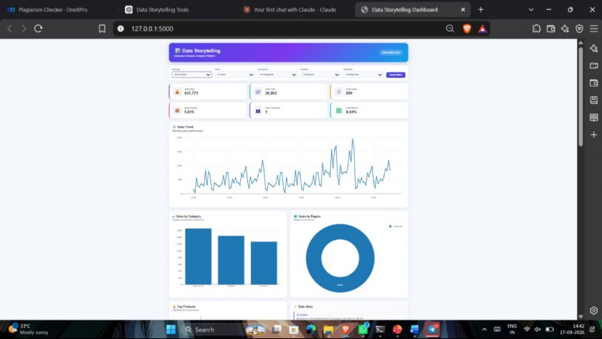
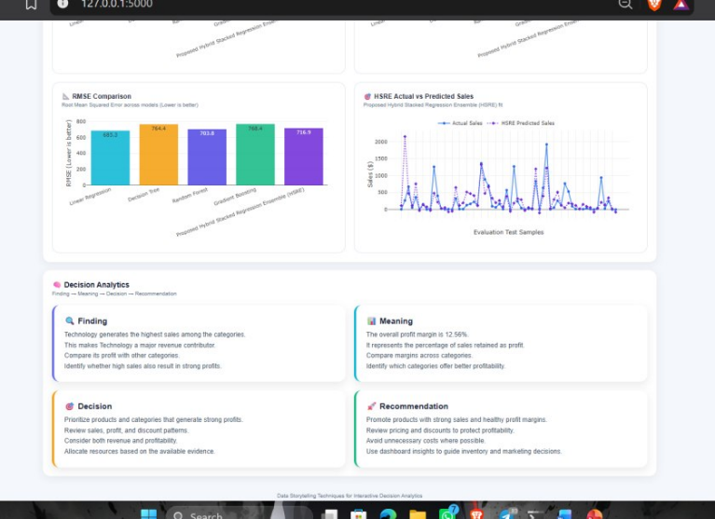
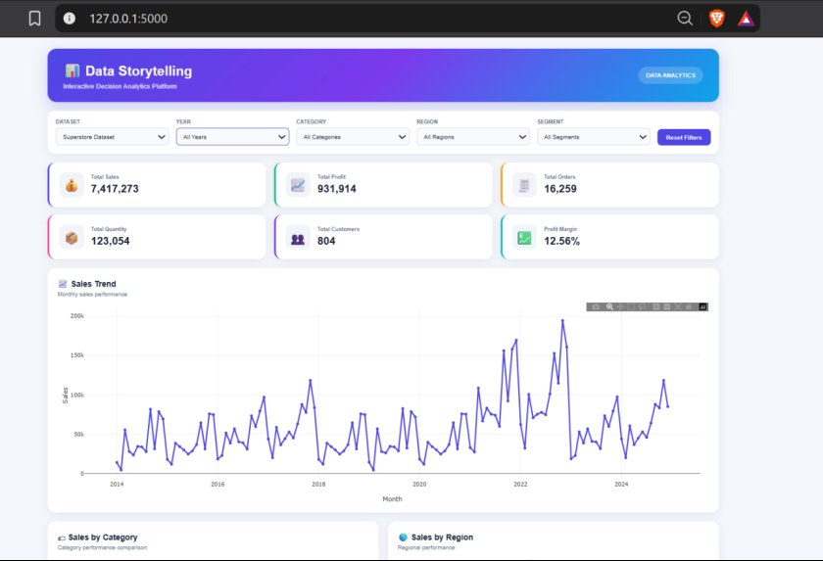

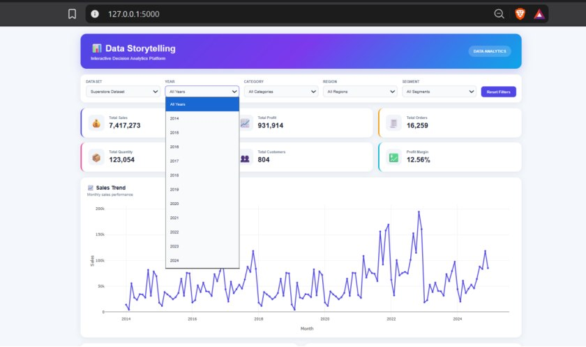
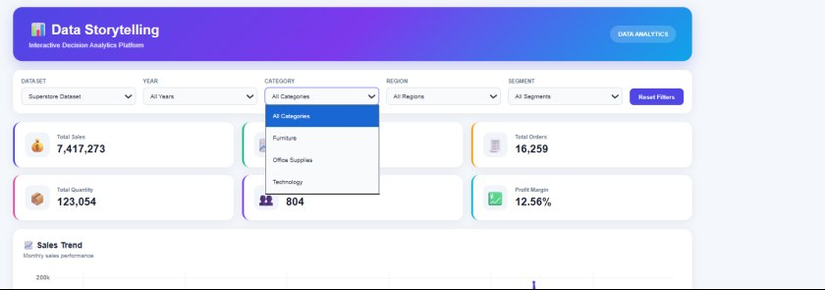
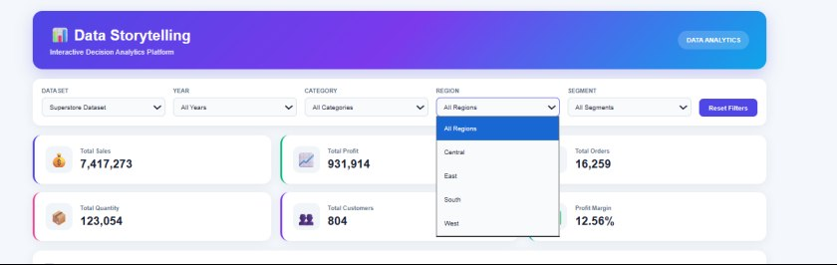
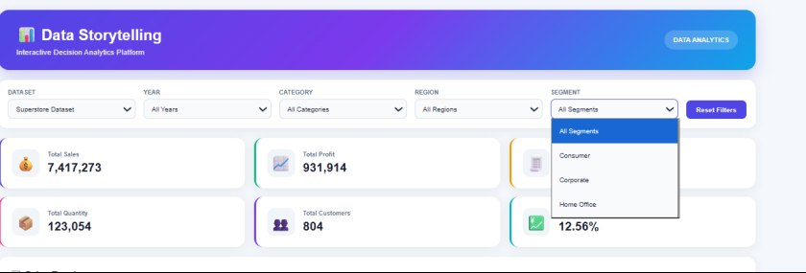
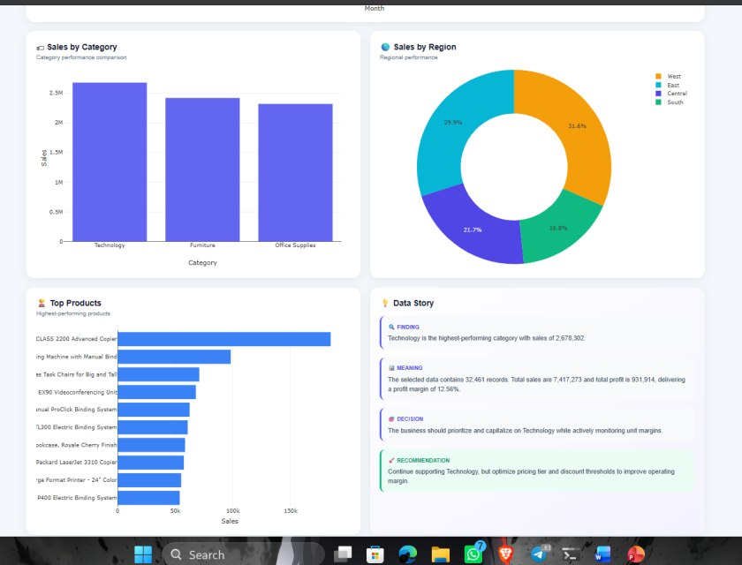
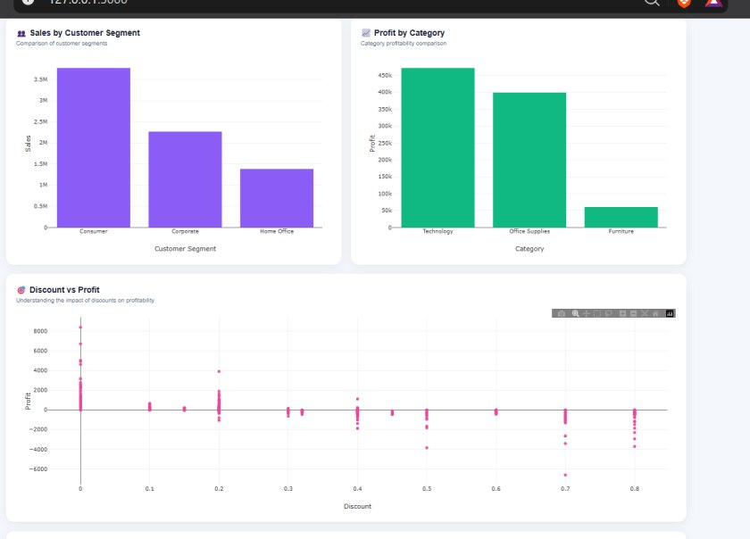
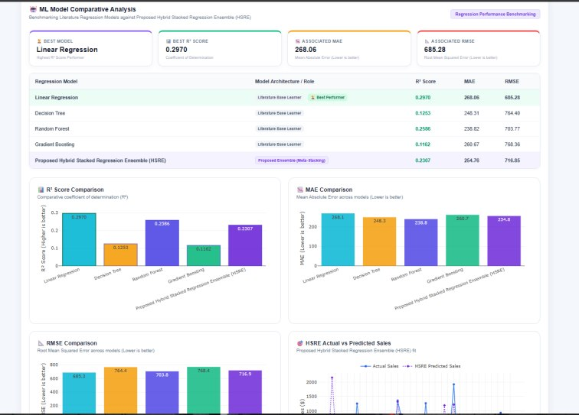

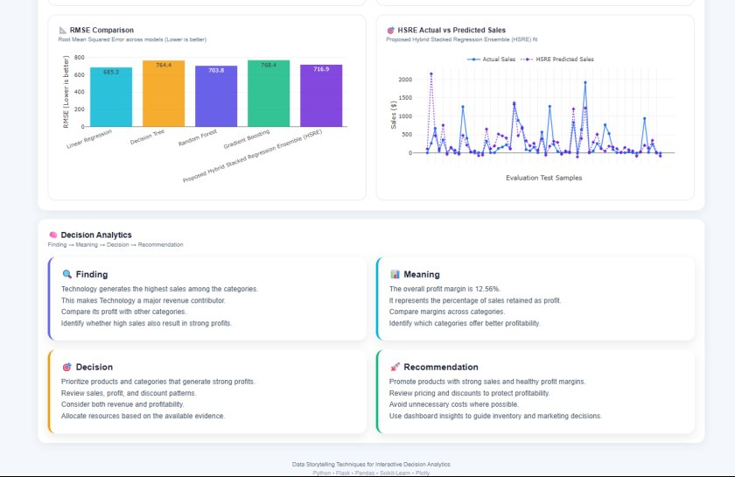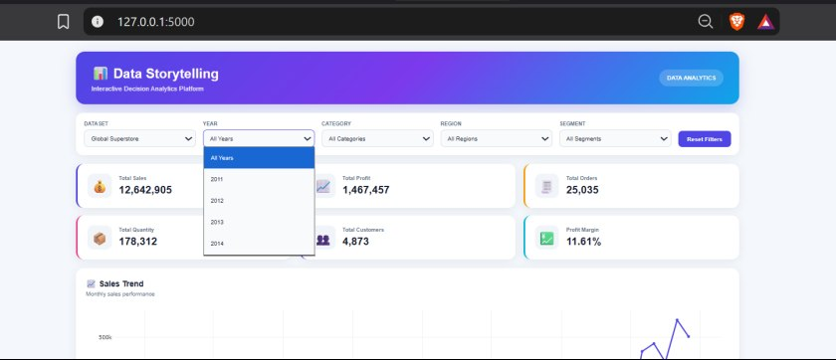
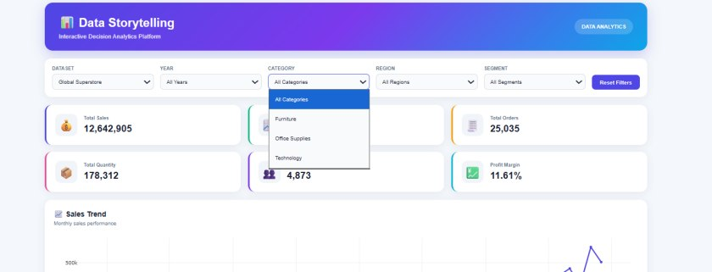
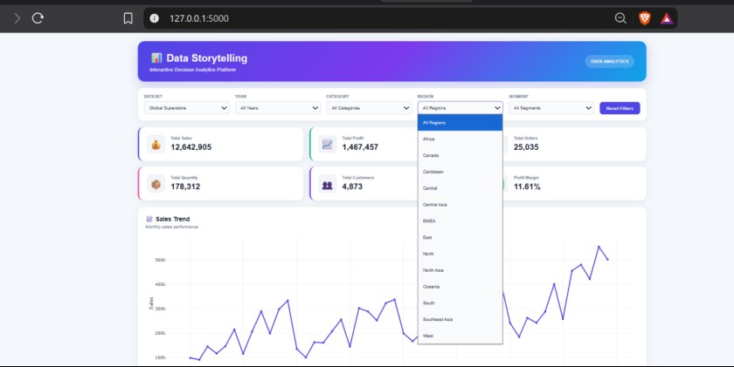
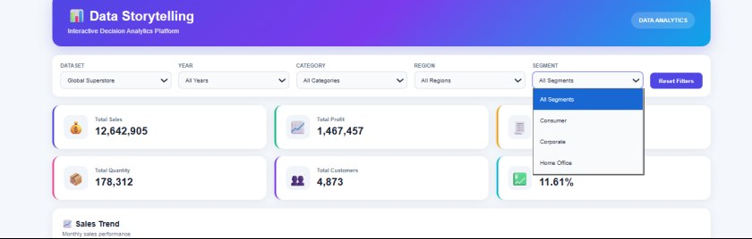
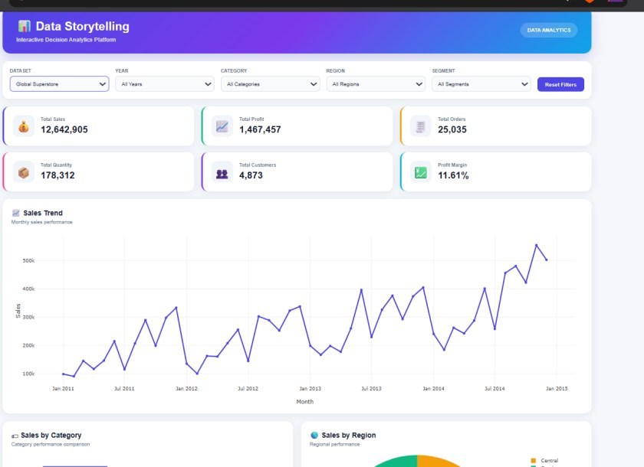
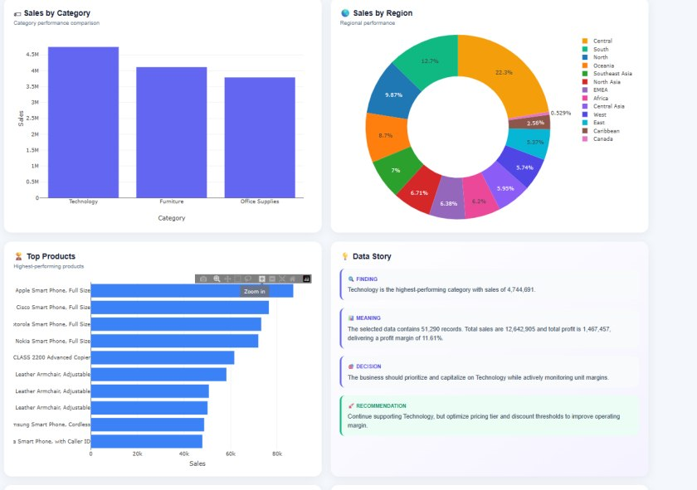
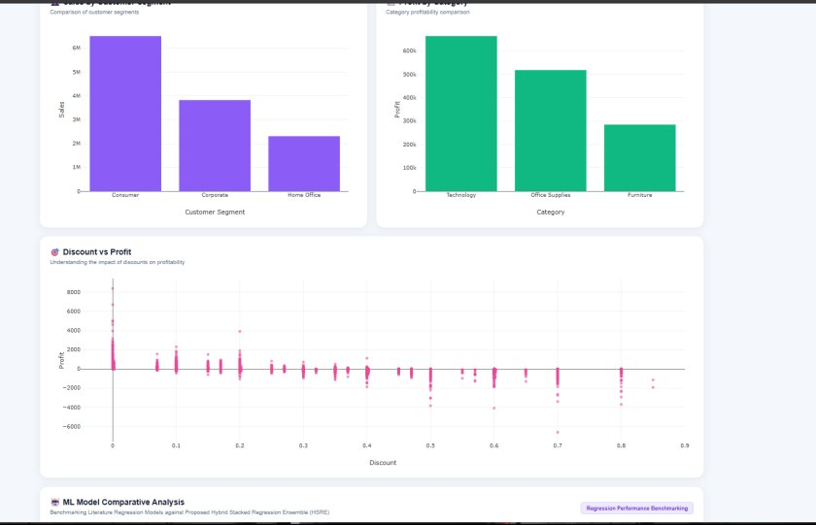
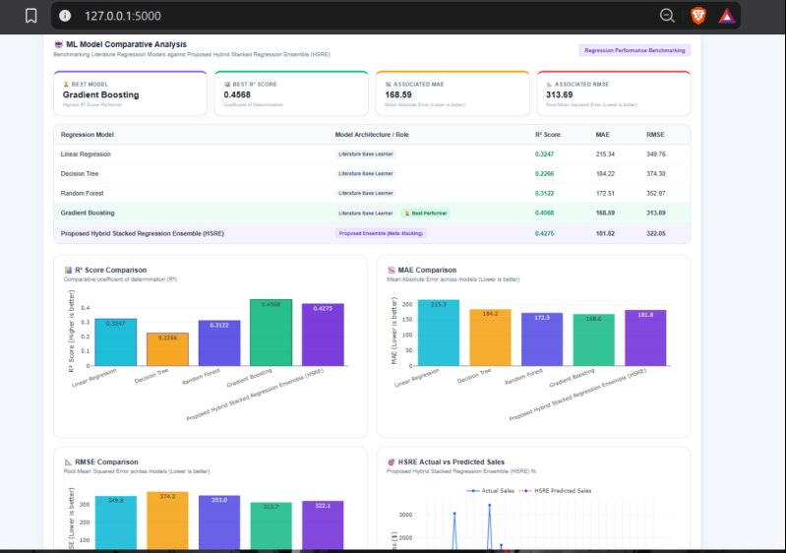
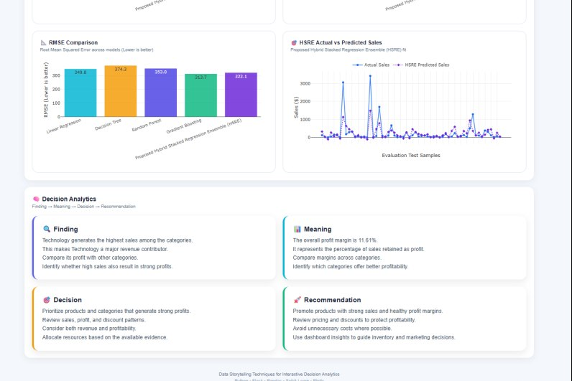
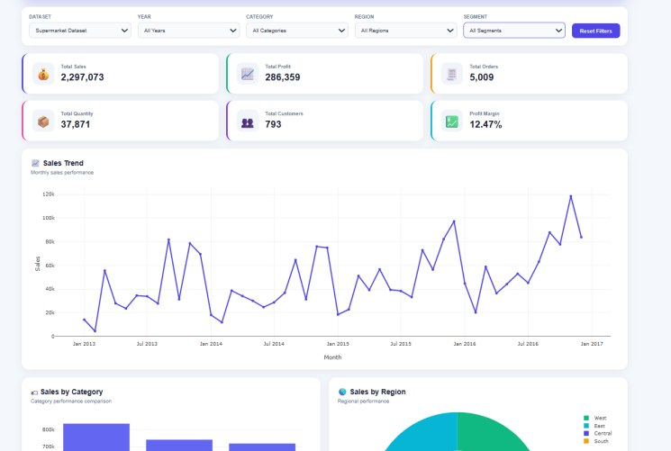
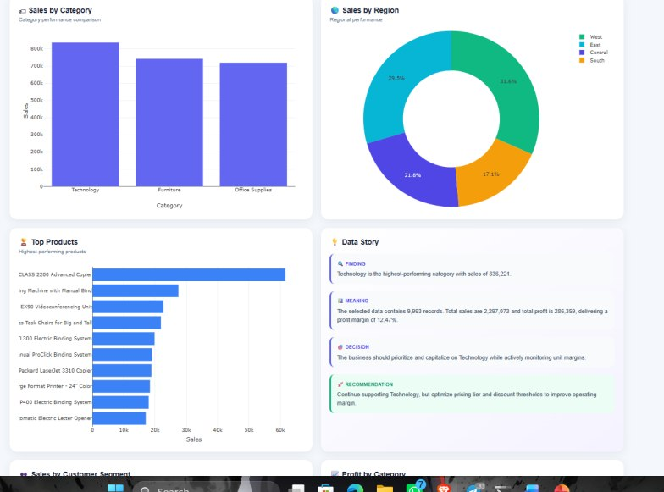
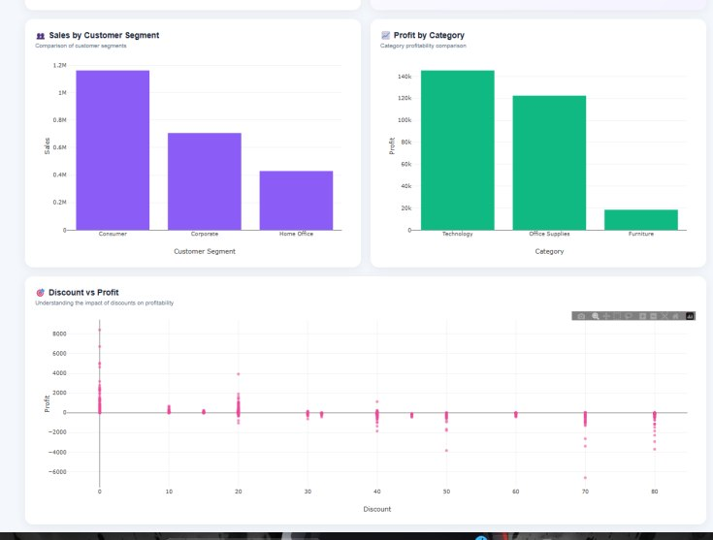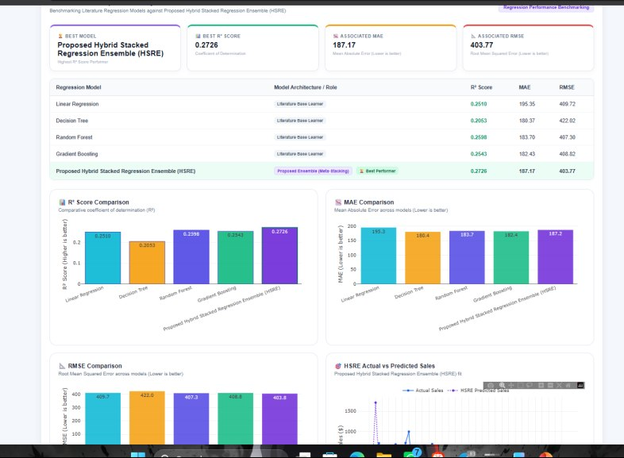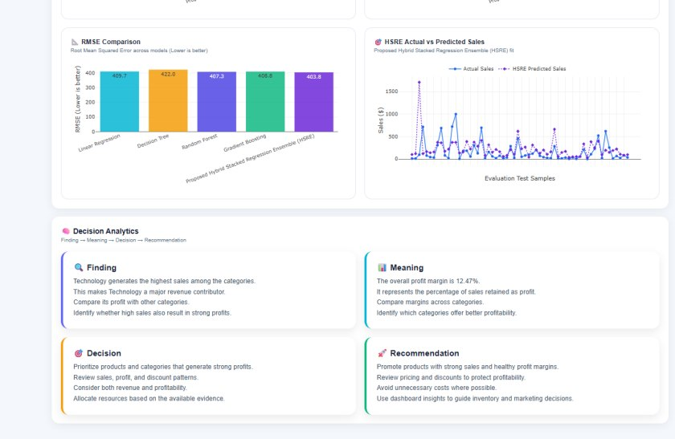
Dataset | Best R² model | Best MAE model | Best RMSE model
Superstore | Linear Regression | Random Forest | Linear Regression
Global Superstore | Gradient Boosting | Gradient Boosting | Gradient Boosting
Online Sales | HSRE | Decision Tree | HSRE
Supermarket | HSRE | Random Forest | HSRE

CONCLUSION AND FUTURE SCOPE

Conclusion
This project presents a web-based interactive analytics and data storytelling platform for analyzing four sales datasets. The system combines data preprocessing, key performance indicator calculation, interactive visualization, comparative regression modeling, and structured business insights.
Five regression models were evaluated using R², MAE, and RMSE. The results demonstrate that predictive performance varies across datasets. Linear Regression performed best on the Superstore dataset for R² and RMSE, Gradient Boosting performed best on Global Superstore, and HSRE achieved the highest R² and lowest RMSE on Online Sales and Supermarket.
The project demonstrates how interactive analytics and data storytelling can help users understand sales performance and explore potential business actions. Its recommendations remain dependent on the quality, coverage, and limitations of the underlying data.

Future Scope
Future improvements may include real-time data integration, additional datasets, more extensive model tuning, cross-validation, explainable AI, automated insight generation, anomaly detection, and cloud deployment. Further research can also investigate different HSRE configurations and assess their performance on additional datasets.

REFERENCES

- Pandas documentation: https://pandas.pydata.org/docs/
- NumPy documentation: https://numpy.org/doc/
- Scikit-learn documentation: https://scikit-learn.org/stable/
- Flask documentation: https://flask.palletsprojects.com/
- Plotly documentation: https://plotly.com/python/
- MDN Web Docs for HTML, CSS, and JavaScript: https://developer.mozilla.org/
- Also cite the actual sources of all four datasets and the research papers used to justify your regression models and HSRE design.

