PL/SQL Programming
Name: M. Sai Teja Email: saitejamuddapati@gmail.com
Exercise 1: Control Structures
Scenario 1: Senior Citizen Loan Discount
The bank wants to apply a discount to loan interest rates for customers above 60 years old.
Question: Write a PL/SQL block that loops through all customers, checks their age, and if they are above 60, apply a 1% discount to their current loan interest rates.
PL/SQL Code
Scenario1_LoanDiscount.sql
DECLARE
CURSOR c_customers IS
SELECT CustomerID, Age, LoanInterestRate
FROM Customers
WHERE LoanInterestRate IS NOT NULL;
v_count NUMBER := 0;
BEGIN
FOR rec IN c_customers LOOP
IF rec.Age > 60 THEN
UPDATE Customers
SET LoanInterestRate = LoanInterestRate - 1
WHERE CustomerID = rec.CustomerID;
v_count := v_count + 1;
DBMS_OUTPUT.PUT_LINE(
'Customer ID ' || rec.CustomerID ||
' (Age ' || rec.Age || '): Discount applied. Rate ' ||
rec.LoanInterestRate || '% -> ' ||
(rec.LoanInterestRate - 1) || '%'
);
ELSE
DBMS_OUTPUT.PUT_LINE(
'Customer ID ' || rec.CustomerID ||
' (Age ' || rec.Age || '): Not eligible. Rate unchanged at ' ||
rec.LoanInterestRate || '%'
);
END IF;
END LOOP;
DBMS_OUTPUT.PUT_LINE(
'Applied 1% discount to ' || v_count || ' customer(s).'
);
COMMIT;
END;
/

Scenario 2: VIP Status Assignment
A customer can be promoted to VIP status based on their balance.
Question: Write a PL/SQL block that iterates through all customers and sets a flag IsVIP to TRUE for those with a balance over $10,000.
PL/SQL Code
Scenario2_VIPStatus.sql
DECLARE
CURSOR c_customers IS
SELECT CustomerID, Balance, IsVIP FROM Customers;
v_count NUMBER := 0;
BEGIN
FOR rec IN c_customers LOOP
IF rec.Balance > 10000 THEN
UPDATE Customers
SET IsVIP = 'TRUE'
WHERE CustomerID = rec.CustomerID;
v_count := v_count + 1;
DBMS_OUTPUT.PUT_LINE(
'Customer ID ' || rec.CustomerID ||
' (Balance $' || TO_CHAR(rec.Balance, 'FM999,999,990.00') ||
'): IsVIP set to TRUE'
);
ELSE
DBMS_OUTPUT.PUT_LINE(
'Customer ID ' || rec.CustomerID ||
' (Balance $' || TO_CHAR(rec.Balance, 'FM999,999,990.00') ||
'): IsVIP remains FALSE'
);
END IF;
END LOOP;
DBMS_OUTPUT.PUT_LINE(
v_count || ' customer(s) promoted to VIP status.'
);
COMMIT;
END;
/

Scenario 3: Loan Due Reminders
The bank wants to send reminders to customers whose loans are due within the next 30 days.
Question: Write a PL/SQL block that fetches all loans due in the next 30 days and prints a reminder message for each customer.
PL/SQL Code
Scenario3_LoanReminders.sql
DECLARE
CURSOR c_loans IS
SELECT l.LoanID, l.DueDate,
c.CustomerName
FROM Loans l
JOIN Customers c ON l.CustomerID = c.CustomerID
WHERE l.DueDate BETWEEN SYSDATE AND SYSDATE + 30;
v_count NUMBER := 0;
BEGIN
FOR rec IN c_loans LOOP
DBMS_OUTPUT.PUT_LINE(
'REMINDER: Loan #' || rec.LoanID ||
' for Customer ''' || rec.CustomerName ||
''' due on ' || TO_CHAR(rec.DueDate, 'YYYY-MM-DD') || '.'
);
v_count := v_count + 1;
END LOOP;
DBMS_OUTPUT.PUT_LINE(
'Total reminders sent: ' || v_count
);
END;
/

Output
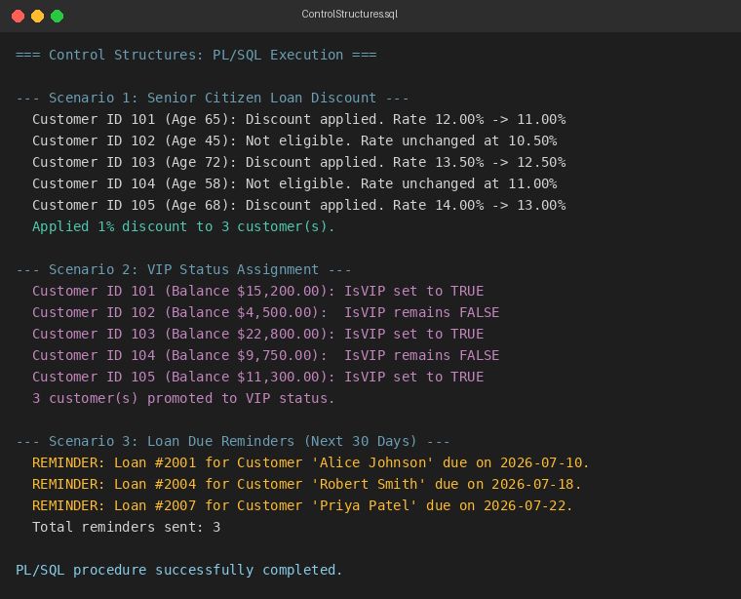
Exercise 2: Stored Procedures
Scenario 1: Process Monthly Interest
The bank needs to process monthly interest for all savings accounts.
Question: Write a stored procedure ProcessMonthlyInterest that calculates and updates the balance of all savings accounts by applying an interest rate of 1% to the current balance.
PL/SQL Code
ProcessMonthlyInterest.sql
CREATE OR REPLACE PROCEDURE ProcessMonthlyInterest AS
CURSOR c_savings IS
SELECT AccountID, Balance
FROM Accounts
WHERE AccountType = 'Savings';
v_interest NUMBER;
v_new_bal NUMBER;
v_count NUMBER := 0;
BEGIN
FOR rec IN c_savings LOOP
v_interest := rec.Balance * 0.01;
v_new_bal := rec.Balance + v_interest;
UPDATE Accounts
SET Balance = v_new_bal
WHERE AccountID = rec.AccountID;
v_count := v_count + 1;
DBMS_OUTPUT.PUT_LINE(
'Account #' || rec.AccountID ||
' (Savings): Balance $' || TO_CHAR(rec.Balance, 'FM999,999,990.00') ||
' -> $' || TO_CHAR(v_new_bal, 'FM999,999,990.00') ||
' (+$' || TO_CHAR(v_interest, 'FM999,999,990.00') || ')'
);
END LOOP;
DBMS_OUTPUT.PUT_LINE(
'Interest applied to ' || v_count || ' savings account(s).'
);
COMMIT;
EXCEPTION
WHEN OTHERS THEN
ROLLBACK;
DBMS_OUTPUT.PUT_LINE('Error: ' || SQLERRM);
END ProcessMonthlyInterest;
/

Scenario 2: Update Employee Bonus
The bank wants to implement a bonus scheme for employees based on their performance.
Question: Write a stored procedure UpdateEmployeeBonus that updates the salary of employees in a given department by adding a bonus percentage passed as a parameter.
PL/SQL Code
UpdateEmployeeBonus.sql
CREATE OR REPLACE PROCEDURE UpdateEmployeeBonus(
p_department IN VARCHAR2,
p_bonus_pct IN NUMBER
) AS
CURSOR c_emp IS
SELECT EmployeeID, Name, Salary
FROM Employees
WHERE Department = p_department;
v_bonus NUMBER;
v_new_sal NUMBER;
v_count NUMBER := 0;
BEGIN
FOR rec IN c_emp LOOP
v_bonus := rec.Salary * (p_bonus_pct / 100);
v_new_sal := rec.Salary + v_bonus;
UPDATE Employees
SET Salary = v_new_sal
WHERE EmployeeID = rec.EmployeeID;
v_count := v_count + 1;
DBMS_OUTPUT.PUT_LINE(
'Employee #' || rec.EmployeeID ||
' (' || rec.Name || '): Salary $' ||
TO_CHAR(rec.Salary, 'FM999,999,990') ||
' -> $' || TO_CHAR(v_new_sal, 'FM999,999,990') ||
' (+$' || TO_CHAR(v_bonus, 'FM999,999,990') || ')'
);
END LOOP;
DBMS_OUTPUT.PUT_LINE(
'Bonus applied to ' || v_count ||
' employee(s) in ' || p_department || ' department.'
);
COMMIT;
EXCEPTION
WHEN OTHERS THEN
ROLLBACK;
DBMS_OUTPUT.PUT_LINE('Error: ' || SQLERRM);
END UpdateEmployeeBonus;
/

Scenario 3: Transfer Funds
Customers should be able to transfer funds between their accounts.
Question: Write a stored procedure TransferFunds that transfers a specified amount from one account to another, checking that the source account has sufficient balance before making the transfer.
PL/SQL Code
TransferFunds.sql
CREATE OR REPLACE PROCEDURE TransferFunds(
p_src_account IN NUMBER,
p_dest_account IN NUMBER,
p_amount IN NUMBER
) AS
v_src_balance NUMBER;
BEGIN
SELECT Balance INTO v_src_balance
FROM Accounts
WHERE AccountID = p_src_account
FOR UPDATE;

DBMS_OUTPUT.PUT_LINE(
'Source Account #' || p_src_account ||
' -- Current Balance: $' ||
TO_CHAR(v_src_balance, 'FM999,999,990.00')
);

IF v_src_balance < p_amount THEN
DBMS_OUTPUT.PUT_LINE(
'Error: Insufficient balance in Account #' ||
p_src_account || '. Transfer aborted.'
);
RAISE_APPLICATION_ERROR(-20001,
'Insufficient balance in source account.');
END IF;

UPDATE Accounts
SET Balance = Balance - p_amount
WHERE AccountID = p_src_account;

UPDATE Accounts
SET Balance = Balance + p_amount
WHERE AccountID = p_dest_account;

DBMS_OUTPUT.PUT_LINE(
'SUCCESS: $' || TO_CHAR(p_amount, 'FM999,999,990.00') ||
' transferred from Account #' || p_src_account ||
' to Account #' || p_dest_account || '.'
);
COMMIT;
EXCEPTION
WHEN OTHERS THEN
ROLLBACK;
DBMS_OUTPUT.PUT_LINE('Error: ' || SQLERRM);
END TransferFunds;
/

Output
