React
Name: M. Sai Teja Email: saitejamuddapati@gmail.com
Exercise 1: Create a New React Application — myfirstreact
Objectives
• Define SPA and its benefits
• Define React and identify its working
• Identify the differences between SPA and MPA
• Explain Pros & Cons of Single-Page Application
• Define virtual DOM and explain Features of React
Prerequisites
Node.js, NPM, Visual Studio Code | Estimated Time: 30 minutes
Steps
1. Install Node.js and NPM from https://nodejs.org/en/download/
2. Install Create-react-app globally: npm install -g create-react-app
3. Create the app: npx create-react-app myfirstreact
4. Navigate into the folder: cd myfirstreact
5. Open in Visual Studio Code.
6. Open src/App.js and replace its content with the code below.
7. Run the app: npm start
8. Open http://localhost:3000 in the browser.
Java Code
src/App.js
import React from 'react';

function App() {
return (
<div>
<h1>Welcome to the first session of React</h1>
</div>
);
}

export default App;

Output
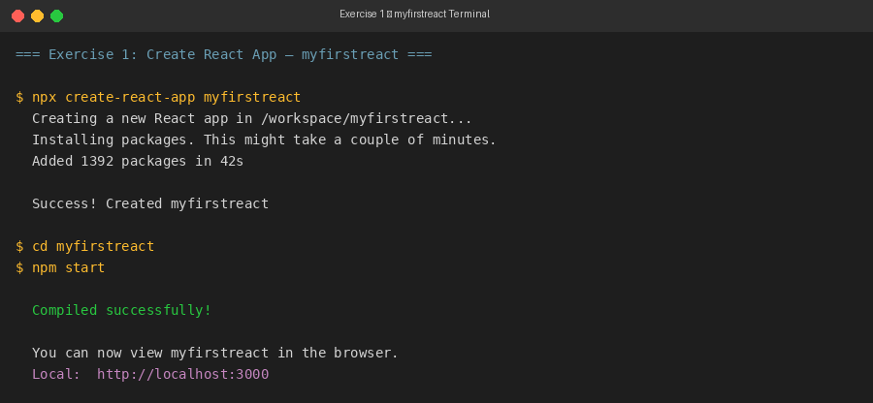
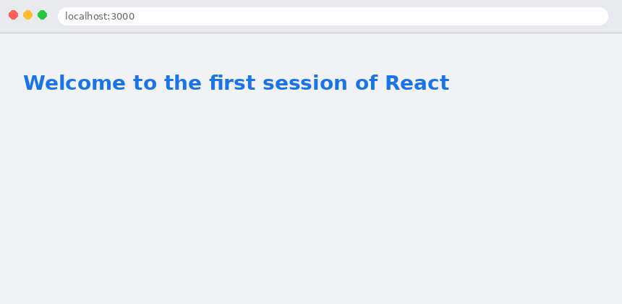
Exercise 2: Student Management Portal — Multiple Components (StudentApp)
Objectives
• Explain React components and identify differences between components and JavaScript functions
• Identify types: class component and function component
• Define component constructor and render() function
Prerequisites
Node.js, NPM, Visual Studio Code | Estimated Time: 30 minutes
Steps
1. Create the app: npx create-react-app StudentApp
2. Create a new folder under src named 'Components'. Add Home.js inside it.
3. Add About.js and Contact.js under src folder.
4. Edit App.js to import and invoke all three components.
5. Run: npm start and open http://localhost:3000
Java Code
src/Components/Home.js
import React, { Component } from 'react';

class Home extends Component {
render() {
return (
<div>
<h2>Welcome to the Home page of Student Management Portal</h2>
</div>
);
}
}

export default Home;

src/About.js
import React, { Component } from 'react';

class About extends Component {
render() {
return (
<div>
<h2>Welcome to the About page of the Student Management Portal</h2>
</div>
);
}
}

export default About;

src/Contact.js
import React, { Component } from 'react';

class Contact extends Component {
render() {
return (
<div>
<h2>Welcome to the Contact page of the Student Management Portal</h2>
</div>
);
}
}

export default Contact;

src/App.js
import React from 'react';
import Home from './Components/Home';
import About from './About';
import Contact from './Contact';

function App() {
return (
<div>
<Home />
<hr />
<About />
<hr />
<Contact />
</div>
);
}

export default App;

Output
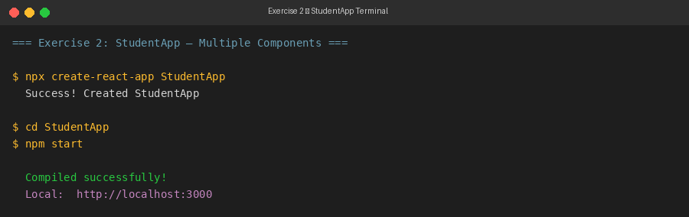
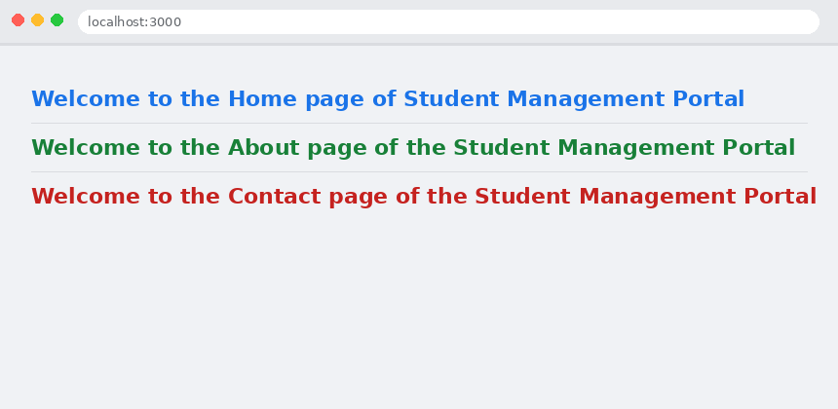
Exercise 3: Score Calculator — Function Component (scorecalculatorapp)
Objectives
• Create a function component and apply styles to components
• Render a component using props
Prerequisites
Node.js, NPM, Visual Studio Code | Estimated Time: 30 minutes
Steps
1. Create the app: npx create-react-app scorecalculatorapp
2. Create src/Components/CalculateScore.js
3. Create src/Stylesheets/mystyle.css for component styles.
4. Edit App.js to pass props (name, school, total, goal) to CalculateScore.
5. Run: npm start and open http://localhost:3000
Java Code
src/Components/CalculateScore.js
import React from 'react';
import '../Stylesheets/mystyle.css';

function CalculateScore(props) {
const { name, school, total, goal } = props;
const maxScore = 500;
const percentage = ((total / maxScore) * 100).toFixed(1);
const goalAchieved = percentage >= goal;

return (
<div className="score-card">
<h2>Student Score Calculator</h2>
<hr />
<p><strong>Name:</strong> {name}</p>
<p><strong>School:</strong> {school}</p>
<p><strong>Total:</strong> {total} / {maxScore}</p>
<p><strong>Goal:</strong> {goal}%</p>
<hr />
<h3 style={{ color: goalAchieved ? 'green' : 'red' }}>
Average Score: {percentage}%
{goalAchieved ? ' ✔ Goal Achieved!' : ' ✘ Below Goal'}
</h3>
</div>
);
}

export default CalculateScore;

src/Stylesheets/mystyle.css
.score-card {
font-family: Arial, sans-serif;
max-width: 500px;
margin: 30px auto;
padding: 24px;
border: 1px solid #dadce0;
border-radius: 8px;
background: #fff;
box-shadow: 0 2px 8px rgba(0,0,0,0.08);
}

.score-card h2 {
color: #1a73e8;
}

.score-card p {
font-size: 15px;
color: #333;
}

src/App.js
import React from 'react';
import CalculateScore from './Components/CalculateScore';

function App() {
return (
<div>
<CalculateScore
name="Alice Johnson"
school="Greenwood High"
total={430}
goal={80}
/>
</div>
);
}

export default App;

Output
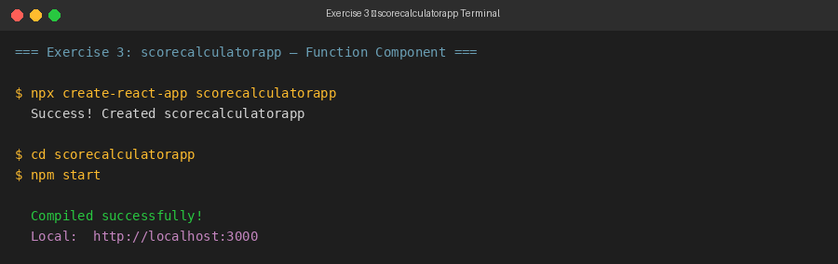
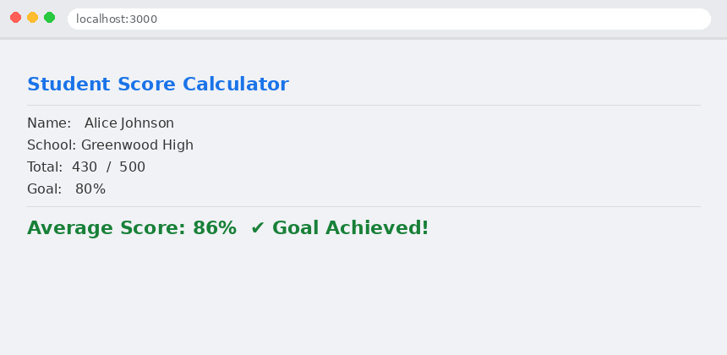
Exercise 4: Blog App — Component Lifecycle (blogapp)
Objectives
• Explain the need and benefits of component lifecycle
• Identify lifecycle hook methods and rendering sequence
• Implement componentDidMount() and componentDidCatch() hooks
Prerequisites
Node.js, NPM, Visual Studio Code | Estimated Time: 60 minutes
Steps
1. Create the app: npx create-react-app blogapp
2. Create src/Post.js — a plain JS class with id, title, body properties.
3. Create src/Posts.js — a class-based component.
4. Initialize component state with empty posts list in constructor.
5. Implement loadPosts() using Fetch API: GET https://jsonplaceholder.typicode.com/posts
6. Implement componentDidMount() to call loadPosts().
7. Implement render() to display post titles as headings and bodies as paragraphs.
8. Implement componentDidCatch() to show errors as alert messages.
9. Add Posts to App.js. Run: npm start
Java Code
src/Post.js
class Post {
constructor(id, title, body) {
this.id = id;
this.title = title;
this.body = body;
}
}

export default Post;

src/Posts.js
import React, { Component } from 'react';
import Post from './Post';

class Posts extends Component {

constructor(props) {
super(props);
this.state = { posts: [] };
}

loadPosts() {
fetch('https://jsonplaceholder.typicode.com/posts')
.then(response => response.json())
.then(data => {
const posts = data.map(
p => new Post(p.id, p.title, p.body)
);
this.setState({ posts });
});
}

componentDidMount() {
this.loadPosts();
}

componentDidCatch(error, info) {
alert('An error occurred: ' + error.message);
console.error(error, info);
}

render() {
return (
<div>
<h2>Blog Posts</h2>
<hr />
{this.state.posts.map(post => (
<div key={post.id}>
<h3>{post.id}. {post.title}</h3>
<p>{post.body}</p>
</div>
))}
</div>
);
}
}

export default Posts;

src/App.js
import React from 'react';
import Posts from './Posts';

function App() {
return (
<div style={{ padding: '20px' }}>
<Posts />
</div>
);
}

export default App;

Output
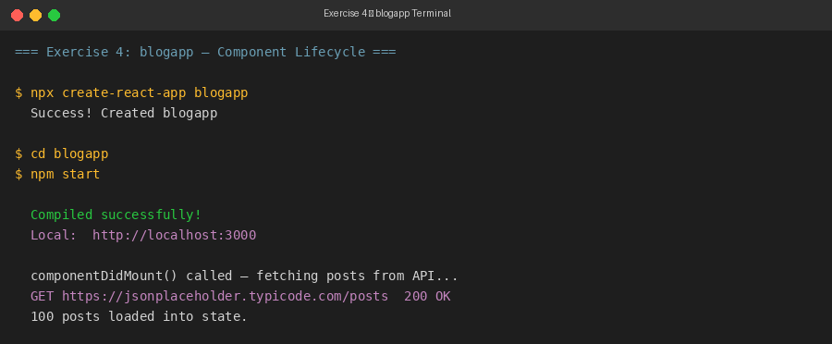
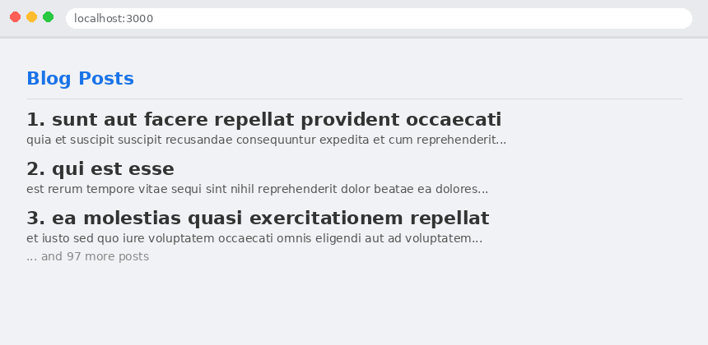
Exercise 5: Cohort Dashboard — CSS Modules Styling
Objectives
• Understand the need for styling React components
• Work with CSS Modules and inline styles
• Apply styles using className and style properties
Prerequisites
Node.js, NPM, Visual Studio Code | Estimated Time: 30 minutes
Steps
1. Unzip the provided react application into a folder.
2. Open command prompt in the app folder and restore packages: npm install
3. Open in VS Code.
4. Create CohortDetails.module.css with a .box class:
Width=300px, display=inline-block, margin=10px, padding=10px 20px,
border=1px solid black, border-radius=10px.
5. Define dt tag selector: font-weight 500.
6. Import the CSS Module in CohortDetails component and apply styles.box to the container div.
7. Set <h3> color to 'green' when status is 'ongoing', 'blue' otherwise.
8. Run: npm start and verify the final dashboard layout.
Java Code
src/CohortDetails.module.css
.box {
width: 300px;
display: inline-block;
margin: 10px;
padding: 10px 20px;
border: 1px solid black;
border-radius: 10px;
}

dt {
font-weight: 500;
}

src/CohortDetails.js
import React from 'react';
import styles from './CohortDetails.module.css';

function CohortDetails({ cohort }) {

// Apply 'green' for ongoing status, 'blue' for all other statuses
const headingStyle = {
color: cohort.status.toLowerCase() === 'ongoing' ? 'green' : 'blue',
};

return (
// Apply CSS Module 'box' class to the container div
<div className={styles.box}>
<h3 style={headingStyle}>
{cohort.name}
</h3>
<dl>
<dt>Status</dt>
<dd>{cohort.status}</dd>
<dt>Start Date</dt>
<dd>{cohort.startDate}</dd>
<dt>End Date</dt>
<dd>{cohort.endDate}</dd>
<dt>Batch</dt>
<dd>{cohort.batch}</dd>
</dl>
</div>
);
}

export default CohortDetails;

src/App.js
import React from 'react';
import CohortDetails from './CohortDetails';

const cohorts = [
{
name: 'React Fundamentals',
status: 'Ongoing',
startDate: '01-Jan-2026',
endDate: '30-Mar-2026',
batch: 'CTS-RF-01',
},
{
name: 'Spring Boot 3',
status: 'Completed',
startDate: '01-Oct-2025',
endDate: '31-Dec-2025',
batch: 'CTS-SB-02',
},
{
name: 'Angular Advanced',
status: 'Ongoing',
startDate: '15-Feb-2026',
endDate: '30-Apr-2026',
batch: 'CTS-AA-03',
},
{
name: 'Java Full Stack',
status: 'Completed',
startDate: '01-Jul-2025',
endDate: '30-Sep-2025',
batch: 'CTS-JF-04',
},
{
name: 'DevOps Essentials',
status: 'Ongoing',
startDate: '01-Mar-2026',
endDate: '31-May-2026',
batch: 'CTS-DO-05',
},
];

function App() {
return (
<div style={{ padding: '20px' }}>
<h2>My Academy — Cohort Dashboard</h2>
<hr />
{cohorts.map((cohort, index) => (
<CohortDetails key={index} cohort={cohort} />
))}
</div>
);
}

export default App;

Output
