Microservices with Spring Boot 3 and Spring Cloud
Name: M. Sai Teja Email: saitejamuddapati@gmail.com
Exercise: Creating Microservices for Account and Loan
Overview
In this hands-on exercise, we will create two microservices for a bank — one for handling accounts and one for handling loans. Each microservice is an independent Spring RESTful Webservice Maven project with its own pom.xml. Instead of having both account and loan as a single application, they are split into two different applications. These web services are simple services without any backend connectivity.
Account Microservice
Steps
1. Create a folder with employee ID in the D: drive.
2. Create a folder named 'microservices' inside it — this will hold all sample microservice projects.
3. Open https://start.spring.io/ in browser and enter:
• Group: com.cognizant
• Artifact: account
• Modules: Spring Boot DevTools, Spring Web
4. Click Generate, download the zip, extract the 'account' folder into the 'microservices' folder.
5. Open command prompt in the account folder and run: mvn clean package
6. Import the project in Eclipse and implement a controller method for getting account details.
• Method: GET
• Endpoint: /accounts/{number}
• Sample Response (dummy, no backend):
{ number: "00987987973432", type: "savings", balance: 234343 }
7. Launch by running AccountApplication and test in browser.
Java Code
account/pom.xml
<?xml version="1.0" encoding="UTF-8"?>
<project xmlns="http://maven.apache.org/POM/4.0.0"
xmlns:xsi="http://www.w3.org/2001/XMLSchema-instance"
xsi:schemaLocation="http://maven.apache.org/POM/4.0.0
https://maven.apache.org/xsd/maven-4.0.0.xsd">
<modelVersion>4.0.0</modelVersion>

<parent>
<groupId>org.springframework.boot</groupId>
<artifactId>spring-boot-starter-parent</artifactId>
<version>3.2.0</version>
<relativePath/>
</parent>

<groupId>com.cognizant</groupId>
<artifactId>account</artifactId>
<version>0.0.1-SNAPSHOT</version>
<name>account</name>

<properties>
<java.version>17</java.version>
</properties>

<dependencies>
<dependency>
<groupId>org.springframework.boot</groupId>
<artifactId>spring-boot-starter-web</artifactId>
</dependency>
<dependency>
<groupId>org.springframework.boot</groupId>
<artifactId>spring-boot-devtools</artifactId>
<scope>runtime</scope>
<optional>true</optional>
</dependency>
<dependency>
<groupId>org.springframework.boot</groupId>
<artifactId>spring-boot-starter-test</artifactId>
<scope>test</scope>
</dependency>
</dependencies>

<build>
<plugins>
<plugin>
<groupId>org.springframework.boot</groupId>
<artifactId>spring-boot-maven-plugin</artifactId>
</plugin>
</plugins>
</build>
</project>

src/main/resources/application.properties
# Account Microservice runs on default port 8080
spring.application.name=account

com/cognizant/account/model/Account.java
package com.cognizant.account.model;

public class Account {

private String number;
private String type;
private double balance;

public Account(String number, String type, double balance) {
this.number = number;
this.type = type;
this.balance = balance;
}

public String getNumber() { return number; }
public String getType() { return type; }
public double getBalance() { return balance; }
}

com/cognizant/account/controller/AccountController.java
package com.cognizant.account.controller;

import com.cognizant.account.model.Account;
import org.slf4j.Logger;
import org.slf4j.LoggerFactory;
import org.springframework.web.bind.annotation.GetMapping;
import org.springframework.web.bind.annotation.PathVariable;
import org.springframework.web.bind.annotation.RestController;

@RestController
public class AccountController {

private static final Logger LOGGER =
LoggerFactory.getLogger(AccountController.class);

@GetMapping("/accounts/{number}")
public Account getAccount(@PathVariable String number) {
LOGGER.debug("Start: getAccount({})", number);
Account account = new Account(number, "savings", 234343);
LOGGER.debug("End: getAccount({})", number);
return account;
}
}

com/cognizant/account/AccountApplication.java
package com.cognizant.account;

import org.springframework.boot.SpringApplication;
import org.springframework.boot.autoconfigure.SpringBootApplication;

@SpringBootApplication
public class AccountApplication {

public static void main(String[] args) {
SpringApplication.run(AccountApplication.class, args);
}
}

Output
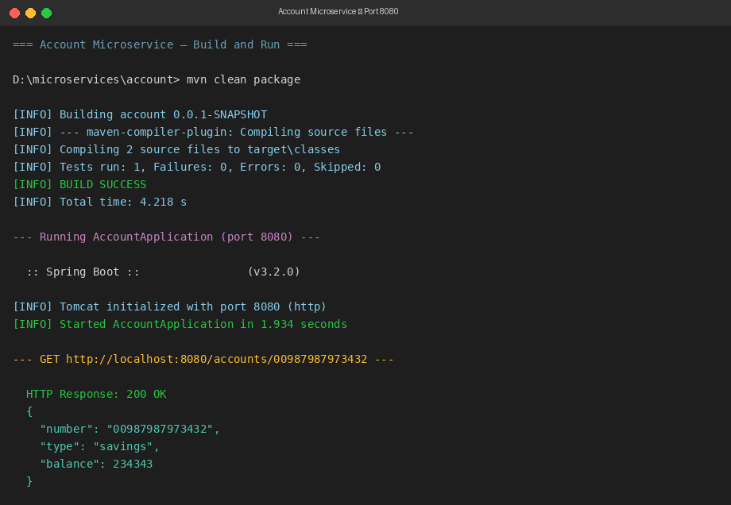
Loan Microservice
Steps
1. Follow similar steps as Account Microservice:
• Group: com.cognizant
• Artifact: loan
• Modules: Spring Boot DevTools, Spring Web
2. Implement a service API to get loan account details:
• Method: GET
• Endpoint: /loans/{number}
• Sample Response (dummy, no backend):
{ number: "H00987987972342", type: "car", loan: 400000, emi: 3258, tenure: 18 }
3. Launch this application while Account service is already running.
4. This launch will fail with error: the bind address is already in use.
Reason: Both services default to port 8080. Account service is already occupying it.
5. Fix: Include server.port=8081 in application.properties and relaunch.
6. Test the service on port 8081.

NOTE: The Eclipse console will show both service consoles running. To switch between them, use the monitor icon within the console view.
Java Code
loan/pom.xml
<?xml version="1.0" encoding="UTF-8"?>
<project xmlns="http://maven.apache.org/POM/4.0.0"
xmlns:xsi="http://www.w3.org/2001/XMLSchema-instance"
xsi:schemaLocation="http://maven.apache.org/POM/4.0.0
https://maven.apache.org/xsd/maven-4.0.0.xsd">
<modelVersion>4.0.0</modelVersion>

<parent>
<groupId>org.springframework.boot</groupId>
<artifactId>spring-boot-starter-parent</artifactId>
<version>3.2.0</version>
<relativePath/>
</parent>

<groupId>com.cognizant</groupId>
<artifactId>loan</artifactId>
<version>0.0.1-SNAPSHOT</version>
<name>loan</name>

<properties>
<java.version>17</java.version>
</properties>

<dependencies>
<dependency>
<groupId>org.springframework.boot</groupId>
<artifactId>spring-boot-starter-web</artifactId>
</dependency>
<dependency>
<groupId>org.springframework.boot</groupId>
<artifactId>spring-boot-devtools</artifactId>
<scope>runtime</scope>
<optional>true</optional>
</dependency>
<dependency>
<groupId>org.springframework.boot</groupId>
<artifactId>spring-boot-starter-test</artifactId>
<scope>test</scope>
</dependency>
</dependencies>

<build>
<plugins>
<plugin>
<groupId>org.springframework.boot</groupId>
<artifactId>spring-boot-maven-plugin</artifactId>
</plugin>
</plugins>
</build>
</project>

src/main/resources/application.properties
# Loan Microservice runs on port 8081 to avoid conflict with Account (8080)
spring.application.name=loan
server.port=8081

com/cognizant/loan/model/Loan.java
package com.cognizant.loan.model;

public class Loan {

private String number;
private String type;
private double loan;
private double emi;
private int tenure;

public Loan(String number, String type, double loan, double emi, int tenure) {
this.number = number;
this.type = type;
this.loan = loan;
this.emi = emi;
this.tenure = tenure;
}

public String getNumber() { return number; }
public String getType() { return type; }
public double getLoan() { return loan; }
public double getEmi() { return emi; }
public int getTenure() { return tenure; }
}

com/cognizant/loan/controller/LoanController.java
package com.cognizant.loan.controller;

import com.cognizant.loan.model.Loan;
import org.slf4j.Logger;
import org.slf4j.LoggerFactory;
import org.springframework.web.bind.annotation.GetMapping;
import org.springframework.web.bind.annotation.PathVariable;
import org.springframework.web.bind.annotation.RestController;

@RestController
public class LoanController {

private static final Logger LOGGER =
LoggerFactory.getLogger(LoanController.class);

@GetMapping("/loans/{number}")
public Loan getLoan(@PathVariable String number) {
LOGGER.debug("Start: getLoan({})", number);
Loan loan = new Loan(number, "car", 400000, 3258, 18);
LOGGER.debug("End: getLoan({})", number);
return loan;
}
}

com/cognizant/loan/LoanApplication.java
package com.cognizant.loan;

import org.springframework.boot.SpringApplication;
import org.springframework.boot.autoconfigure.SpringBootApplication;

@SpringBootApplication
public class LoanApplication {

public static void main(String[] args) {
SpringApplication.run(LoanApplication.class, args);
}
}

Output
