Spring REST using Spring Boot 3 (Module 1)
Name: M. Sai Teja Email: saitejamuddapati@gmail.com
Hands-on 1: Create a Spring Web Project using Maven
Steps
1. Go to https://start.spring.io/
2. Change Group as "com.cognizant"
3. Change Artifact Id as "spring-learn"
4. Select Spring Boot DevTools and Spring Web
5. Create and download the project as zip
6. Extract the zip in root folder to Eclipse Workspace
7. Build the project using the following command in command line:
mvn clean package -Dhttp.proxyHost=proxy.cognizant.com -Dhttp.proxyPort=6050
-Dhttps.proxyHost=proxy.cognizant.com -Dhttps.proxyPort=6050 -Dhttp.proxyUser=123456
8. Import the project in Eclipse: File > Import > Maven > Existing Maven Projects > Click Browse and select extracted folder > Finish
9. Include logs to verify if main() method of SpringLearnApplication is invoked.
10. Run the SpringLearnApplication class.
SME Walkthrough
1. src/main/java — Folder with application code
2. src/main/resources — Folder for application configuration
3. src/test/java — Folder with code for testing the application
4. SpringLearnApplication.java — Walkthrough the main() method
5. Purpose of @SpringBootApplication annotation
6. pom.xml — Walkthrough all configuration; open 'Dependency Hierarchy' to show the dependency tree
Java Code
pom.xml
<?xml version="1.0" encoding="UTF-8"?>
<project xmlns="http://maven.apache.org/POM/4.0.0"
xmlns:xsi="http://www.w3.org/2001/XMLSchema-instance"
xsi:schemaLocation="http://maven.apache.org/POM/4.0.0
https://maven.apache.org/xsd/maven-4.0.0.xsd">
<modelVersion>4.0.0</modelVersion>

<parent>
<groupId>org.springframework.boot</groupId>
<artifactId>spring-boot-starter-parent</artifactId>
<version>3.2.0</version>
<relativePath/>
</parent>

<groupId>com.cognizant</groupId>
<artifactId>spring-learn</artifactId>
<version>0.0.1-SNAPSHOT</version>
<name>spring-learn</name>

<properties>
<java.version>17</java.version>
</properties>

<dependencies>
<dependency>
<groupId>org.springframework.boot</groupId>
<artifactId>spring-boot-devtools</artifactId>
<scope>runtime</scope>
<optional>true</optional>
</dependency>
<dependency>
<groupId>org.springframework.boot</groupId>
<artifactId>spring-boot-starter-web</artifactId>
</dependency>
<dependency>
<groupId>org.springframework.boot</groupId>
<artifactId>spring-boot-starter-test</artifactId>
<scope>test</scope>
</dependency>
</dependencies>

<build>
<plugins>
<plugin>
<groupId>org.springframework.boot</groupId>
<artifactId>spring-boot-maven-plugin</artifactId>
</plugin>
</plugins>
</build>

</project>

com/cognizant/springlearn/SpringLearnApplication.java
package com.cognizant.springlearn;

import org.slf4j.Logger;
import org.slf4j.LoggerFactory;
import org.springframework.boot.SpringApplication;
import org.springframework.boot.autoconfigure.SpringBootApplication;

@SpringBootApplication
public class SpringLearnApplication {

private static final Logger LOGGER =
LoggerFactory.getLogger(SpringLearnApplication.class);

public static void main(String[] args) {
LOGGER.debug("Inside main() method.");
SpringApplication.run(SpringLearnApplication.class, args);
}
}

Output
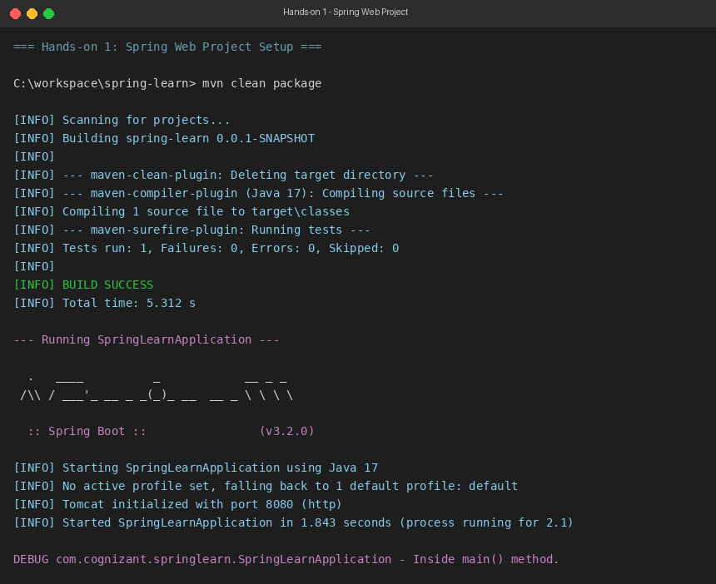
Hands-on 2: Spring Core – Load Country from Spring Configuration XML
Scenario
An airlines website is going to support booking on four countries. There will be a drop down on the home page of this website to select the respective country. It is also important to store the two-character ISO code of each country.

Code Name
US United States
DE Germany
IN India
JP Japan

Above data has to be stored in spring configuration file. Write a program to read this configuration file and display the details.
Steps to Implement
1. Pick any one country to configure in Spring XML configuration named country.xml.
2. Create a bean tag in spring configuration for country and set the property and values.
3. Create Country class with the following aspects:
• Instance variables for code and name
• Implement empty parameter constructor with inclusion of debug log with message "Inside Country Constructor."
• Generate getters and setters with inclusion of debug log with relevant message within each method
• Generate toString() method
4. Create a method displayCountry() in SpringLearnApplication.java which reads the country bean from country.xml using ClassPathXmlApplicationContext and context.getBean().
5. Invoke displayCountry() method in main() method of SpringLearnApplication.java.
6. Execute main() method and check the logs to find out which constructors and methods were invoked.
SME Detailing
• bean tag, id attribute, class attribute, property tag, name attribute, value attribute
• ApplicationContext, ClassPathXmlApplicationContext
• What exactly happens when context.getBean() is invoked
Java Code
src/main/resources/country.xml
<?xml version="1.0" encoding="UTF-8"?>
<beans xmlns="http://www.springframework.org/schema/beans"
xmlns:xsi="http://www.w3.org/2001/XMLSchema-instance"
xsi:schemaLocation="http://www.springframework.org/schema/beans
http://www.springframework.org/schema/beans/spring-beans.xsd">

<bean id="country" class="com.cognizant.springlearn.Country">
<property name="code" value="IN" />
<property name="name" value="India" />
</bean>

</beans>

com/cognizant/springlearn/Country.java
package com.cognizant.springlearn;

import org.slf4j.Logger;
import org.slf4j.LoggerFactory;

public class Country {

private static final Logger LOGGER =
LoggerFactory.getLogger(Country.class);

private String code;
private String name;

public Country() {
LOGGER.debug("Inside Country Constructor.");
}

public String getCode() {
LOGGER.debug("Inside getCode(). Returning code = {}", code);
return code;
}

public void setCode(String code) {
LOGGER.debug("Inside setCode(). Setting code = {}", code);
this.code = code;
}

public String getName() {
LOGGER.debug("Inside getName(). Returning name = {}", name);
return name;
}

public void setName(String name) {
LOGGER.debug("Inside setName(). Setting name = {}", name);
this.name = name;
}

@Override
public String toString() {
return "Country{code='" + code + "', name='" + name + "'}";
}
}

com/cognizant/springlearn/SpringLearnApplication.java
package com.cognizant.springlearn;

import org.slf4j.Logger;
import org.slf4j.LoggerFactory;
import org.springframework.boot.SpringApplication;
import org.springframework.boot.autoconfigure.SpringBootApplication;
import org.springframework.context.ApplicationContext;
import org.springframework.context.support.ClassPathXmlApplicationContext;

@SpringBootApplication
public class SpringLearnApplication {

private static final Logger LOGGER =
LoggerFactory.getLogger(SpringLearnApplication.class);

public static void main(String[] args) {
LOGGER.debug("Inside main() method.");
SpringApplication.run(SpringLearnApplication.class, args);
displayCountry();
}

private static void displayCountry() {
LOGGER.debug("Invoking displayCountry()...");
ApplicationContext context =
new ClassPathXmlApplicationContext("country.xml");
Country country = context.getBean("country", Country.class);
LOGGER.debug("Country : {}", country.toString());
}
}

Output
