Spring REST using Spring Boot 3 (Module 2)
Name: M. Sai Teja Email: saitejamuddapati@gmail.com
Exercise 1: Hello World RESTful Web Service
Scenario
Write a REST service in the spring learn application created earlier, that returns the text "Hello World!!" using Spring Web Framework.
Details
Method : GET
URL : /hello
Controller : com.cognizant.springlearn.controller.HelloController
Method Signature : public String sayHello()
Method Implementation: return hard coded string "Hello World!!"
Sample Request : http://localhost:8083/hello
Sample Response : Hello World!!

IMPORTANT NOTE: Include start and end log in the sayHello() method.
Try the URL http://localhost:8083/hello in both Chrome browser and Postman.
SME Notes
• In network tab of developer tools show the HTTP header details received.
• In Postman click on "Headers" tab to view the HTTP header details received.
Java Code
com/cognizant/springlearn/controller/HelloController.java
package com.cognizant.springlearn.controller;

import org.slf4j.Logger;
import org.slf4j.LoggerFactory;
import org.springframework.web.bind.annotation.GetMapping;
import org.springframework.web.bind.annotation.RestController;

@RestController
public class HelloController {

private static final Logger LOGGER =
LoggerFactory.getLogger(HelloController.class);

@GetMapping("/hello")
public String sayHello() {
LOGGER.debug("Start: sayHello()");
String response = "Hello World!!";
LOGGER.debug("End: sayHello()");
return response;
}
}

Output
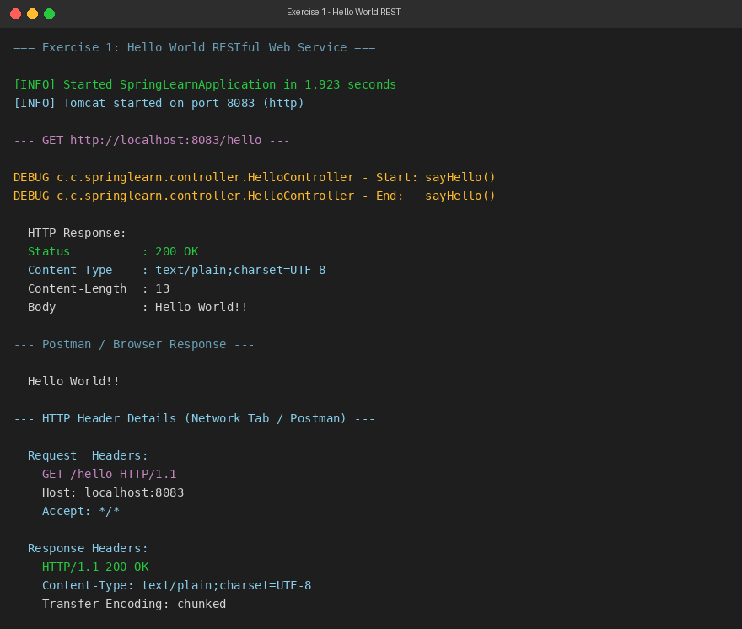
Exercise 2: REST – Country Web Service
Scenario
Write a REST service that returns India country details in the earlier created spring learn application.
Details
URL : /country
Controller : com.cognizant.springlearn.controller.CountryController
Method Annotation : @RequestMapping
Method Name : getCountryIndia()
Method Implementation: Load India bean from spring xml configuration and return
Sample Request : http://localhost:8083/country
Sample Response :
{
"code": "IN",
"name": "India"
}
SME Notes
• What happens in the controller method?
• How the bean is converted into JSON response? (Jackson auto-serialization)
• In network tab of developer tools show the HTTP header details received.
• In Postman click on "Headers" tab to view the HTTP header details received.
Java Code
src/main/resources/country.xml
<?xml version="1.0" encoding="UTF-8"?>
<beans xmlns="http://www.springframework.org/schema/beans"
xmlns:xsi="http://www.w3.org/2001/XMLSchema-instance"
xsi:schemaLocation="http://www.springframework.org/schema/beans
http://www.springframework.org/schema/beans/spring-beans.xsd">

<bean id="country" class="com.cognizant.springlearn.Country">
<property name="code" value="IN" />
<property name="name" value="India" />
</bean>

</beans>

com/cognizant/springlearn/controller/CountryController.java
package com.cognizant.springlearn.controller;

import com.cognizant.springlearn.Country;
import org.slf4j.Logger;
import org.slf4j.LoggerFactory;
import org.springframework.context.ApplicationContext;
import org.springframework.context.support.ClassPathXmlApplicationContext;
import org.springframework.web.bind.annotation.RequestMapping;
import org.springframework.web.bind.annotation.RestController;

@RestController
public class CountryController {

private static final Logger LOGGER =
LoggerFactory.getLogger(CountryController.class);

@RequestMapping("/country")
public Country getCountryIndia() {
LOGGER.debug("Start: getCountryIndia()");
ApplicationContext context =
new ClassPathXmlApplicationContext("country.xml");
Country country = context.getBean("country", Country.class);
LOGGER.debug("End: getCountryIndia()");
return country;
}
}

Output
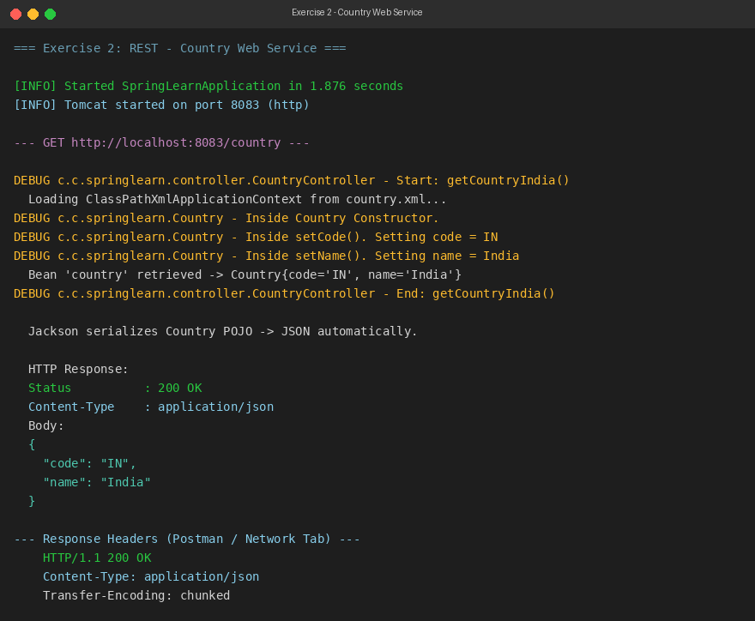
Exercise 3: REST – Get Country Based on Country Code
Scenario
Write a REST service that returns a specific country based on country code. The country code should be case insensitive.
Details
Controller : com.cognizant.springlearn.controller.CountryController
Method Annotation : @GetMapping("/countries/{code}")
Method Name : getCountry(String code)
Method Implementation: Invoke countryService.getCountry(code)
Service Method : com.cognizant.springlearn.service.CountryService.getCountry(String code)
Sample Request : http://localhost:8083/country/in
Sample Response :
{
"code": "IN",
"name": "India"
}
Service Method Implementation
• Get the country code using @PathVariable
• Get country list from country.xml
• Iterate through the country list
• Make a case insensitive matching of country code and return the country
• Lambda expression can also be used instead of iterating the country list
Java Code
src/main/resources/country.xml (Updated with all four countries)
<?xml version="1.0" encoding="UTF-8"?>
<beans xmlns="http://www.springframework.org/schema/beans"
xmlns:xsi="http://www.w3.org/2001/XMLSchema-instance"
xsi:schemaLocation="http://www.springframework.org/schema/beans
http://www.springframework.org/schema/beans/spring-beans.xsd">

<bean id="countryList"
class="java.util.ArrayList">
<constructor-arg>
<list>
<bean class="com.cognizant.springlearn.Country">
<property name="code" value="US" />
<property name="name" value="United States" />
</bean>
<bean class="com.cognizant.springlearn.Country">
<property name="code" value="DE" />
<property name="name" value="Germany" />
</bean>
<bean class="com.cognizant.springlearn.Country">
<property name="code" value="IN" />
<property name="name" value="India" />
</bean>
<bean class="com.cognizant.springlearn.Country">
<property name="code" value="JP" />
<property name="name" value="Japan" />
</bean>
</list>
</constructor-arg>
</bean>

</beans>

com/cognizant/springlearn/service/CountryService.java
package com.cognizant.springlearn.service;

import com.cognizant.springlearn.Country;
import org.slf4j.Logger;
import org.slf4j.LoggerFactory;
import org.springframework.context.ApplicationContext;
import org.springframework.context.support.ClassPathXmlApplicationContext;
import org.springframework.stereotype.Service;

import java.util.List;

@Service
public class CountryService {

private static final Logger LOGGER =
LoggerFactory.getLogger(CountryService.class);

public Country getCountry(String code) {
LOGGER.debug("Start: getCountry({})", code);
ApplicationContext context =
new ClassPathXmlApplicationContext("country.xml");

List<Country> countries =
(List<Country>) context.getBean("countryList");

Country result = countries.stream()
.filter(c -> c.getCode().equalsIgnoreCase(code))
.findFirst()
.orElse(null);

LOGGER.debug("End: getCountry({})", code);
return result;
}
}

com/cognizant/springlearn/controller/CountryController.java (Updated)
package com.cognizant.springlearn.controller;

import com.cognizant.springlearn.Country;
import com.cognizant.springlearn.service.CountryService;
import org.slf4j.Logger;
import org.slf4j.LoggerFactory;
import org.springframework.beans.factory.annotation.Autowired;
import org.springframework.web.bind.annotation.GetMapping;
import org.springframework.web.bind.annotation.PathVariable;
import org.springframework.web.bind.annotation.RequestMapping;
import org.springframework.web.bind.annotation.RestController;

@RestController
public class CountryController {

private static final Logger LOGGER =
LoggerFactory.getLogger(CountryController.class);

@Autowired
private CountryService countryService;

@RequestMapping("/country")
public Country getCountryIndia() {
LOGGER.debug("Start: getCountryIndia()");
// existing implementation
LOGGER.debug("End: getCountryIndia()");
return null;
}

@GetMapping("/countries/{code}")
public Country getCountry(@PathVariable String code) {
LOGGER.debug("Start: getCountry({})", code);
Country country = countryService.getCountry(code);
LOGGER.debug("End: getCountry({})", code);
return country;
}
}

Output
