1. You need to predict the type of program a student is in based on other attributes --> mdata.csv

prog: is a categorical variable indicating what type of program a student is in: “General” (1), “Academic” (2), or “Vocational” (3)
Ses: is a categorical variable indicating someone’s socioeconomic class: “Low” (1), “Middle” (2), and “High” (3)
read, write, math, science: is their scores on different tests
honors: Whether they have enrolled or not

=>Multinomial regression is used when the output has more than 2 categories.
=>no natural ordering of categories.
=>y (response) variable has >2 categories hence we apply multilogit.
=>lowest in numerical / lexicographical value is chosen as baseline/reference.

BUSINESS PROBLEM:
To predict the type of program a student is based on other attributes.

DATA CLEANING:
Remove the first two columns as they describes the index numbers and id of the students.

Tabular Representation Of Y Categories With Socio-Economic Status:
# prog
#ses academic general vocation
#high 42 9 7
#low 19 16 12
#middle 44 20 3

EXPLORATORY DATA ANALYSIS:
read write math science
count 200.000000 200.000000 200.000000 200.000000
mean 52.230000 52.775000 52.645000 51.850000
std 10.252937 9.478586 9.368448 9.900891
min 28.000000 31.000000 33.000000 26.000000
25% 44.000000 45.750000 45.000000 44.000000
50% 50.000000 54.000000 52.000000 53.000000
75% 60.000000 60.000000 59.000000 58.000000
max 76.000000 67.000000 75.000000 74.000000

=>select baseline variable
mdata1$prog <- relevel(mdata1$prog,ref = "academic")
=>create model using multinorm function
model.prog <- multinom(prog~female+ses+schtyp+read+write+math+science+honors,data = mdata1)
=>find z value using model coefficients divided by model St. Errors.
=>find p values using z values.

CONFUSION MATRIX:
pred_name academic general vocation
academic 86 22 17
general 11 10 4
vocation 8 13 29

CONFUSION MATRIX VISUALIZATION USING BARPLOT
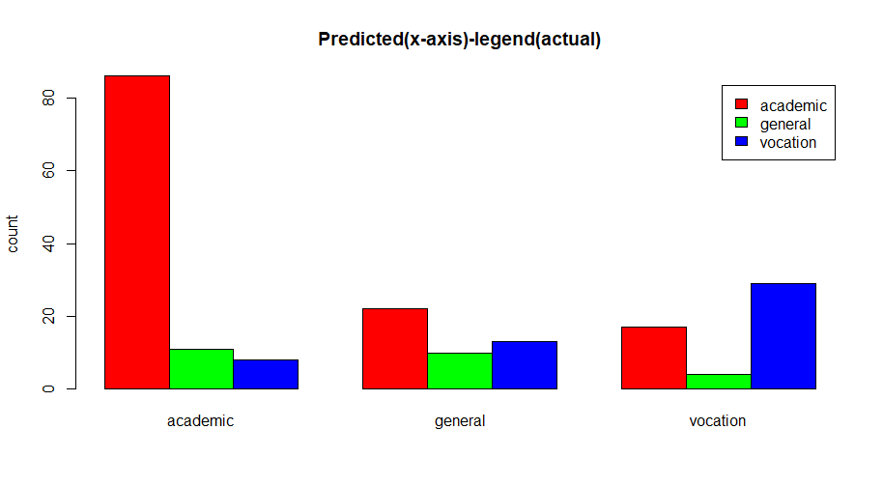

Accuracy:
0.625

In Python:

Tabular Representation:
academic 105
vocation 50
general 45
Boxplot Of Independent Variable Distribution: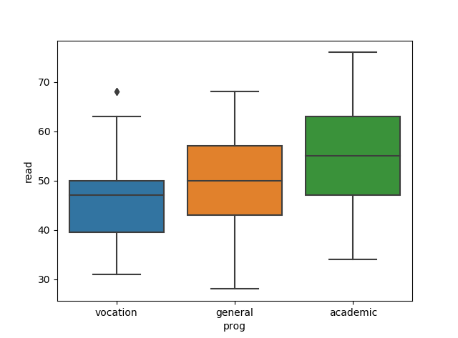
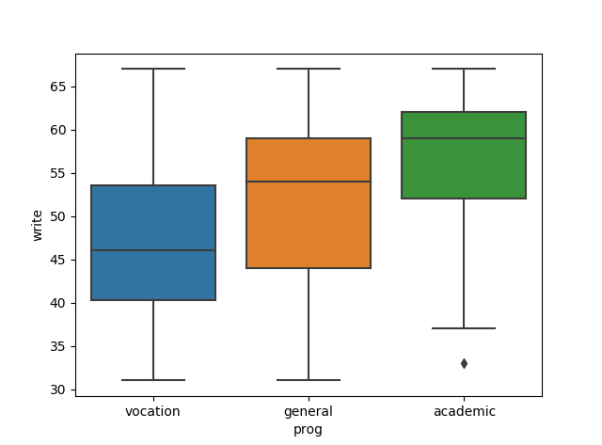
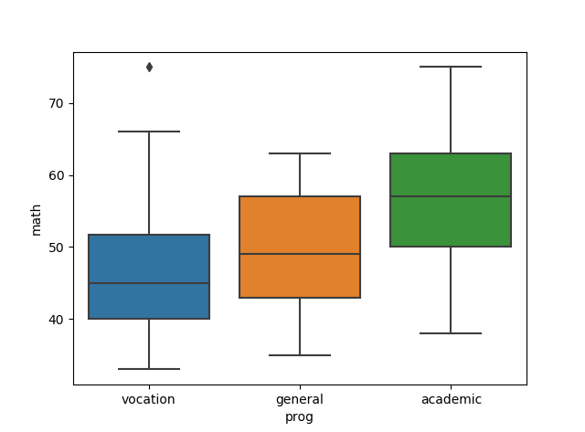

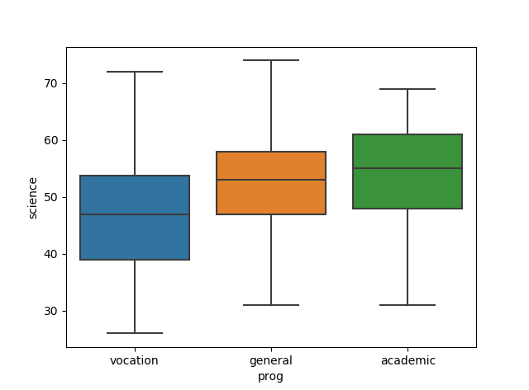

Pairplots: Histograms and Sctterplots of the variables in relation with the y variables.

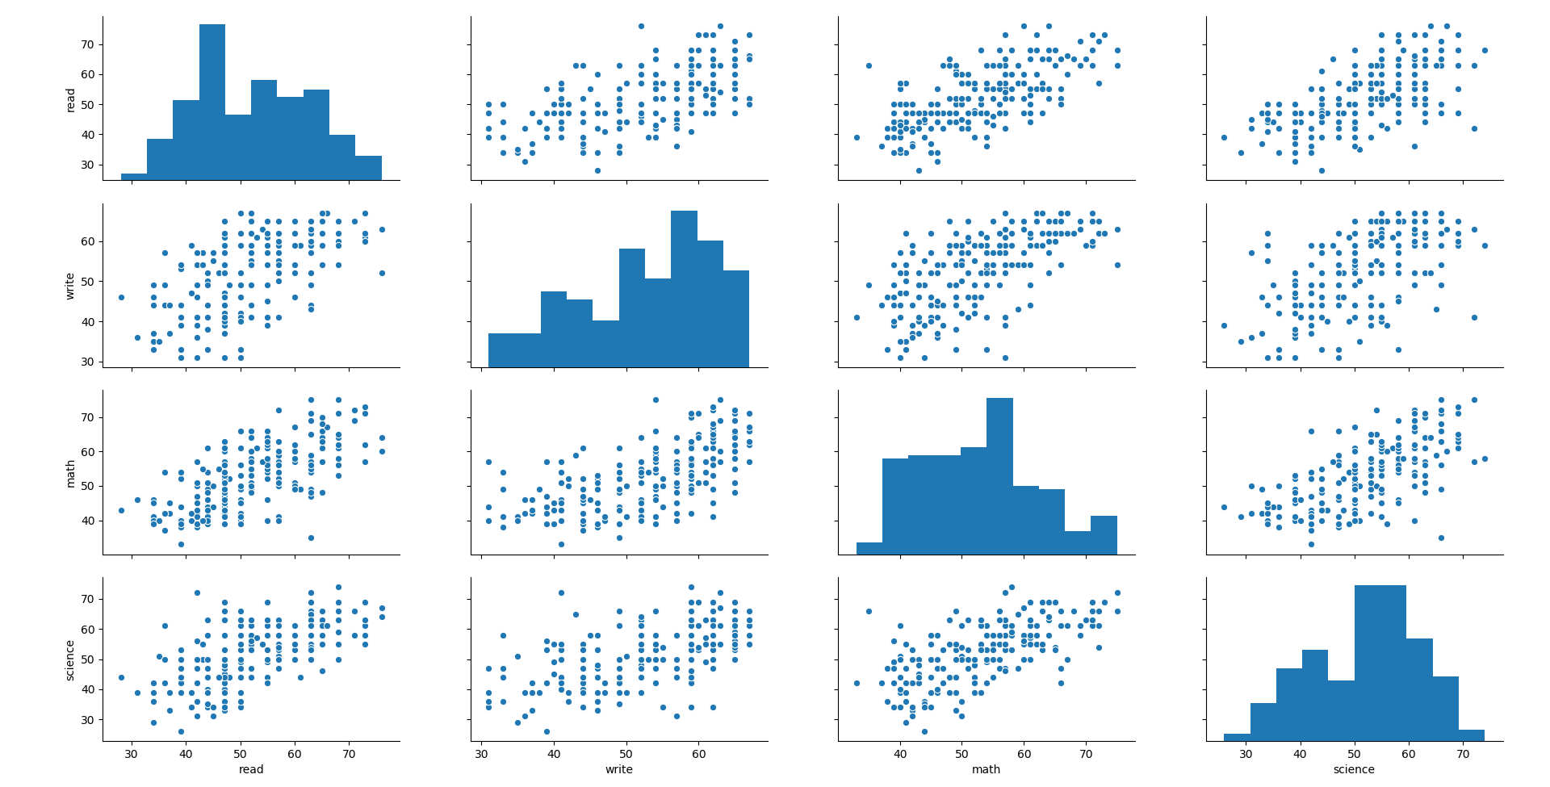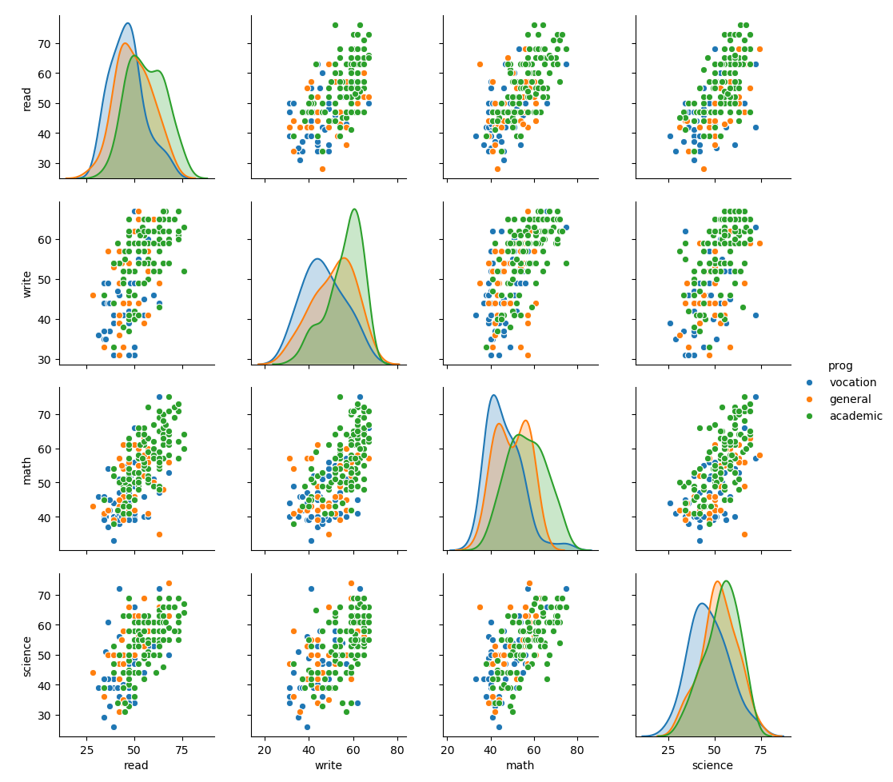

Scatter plots of independent variables:
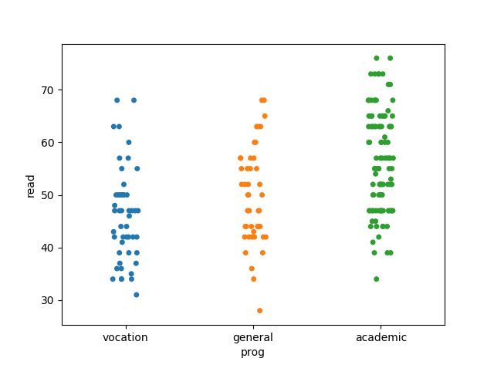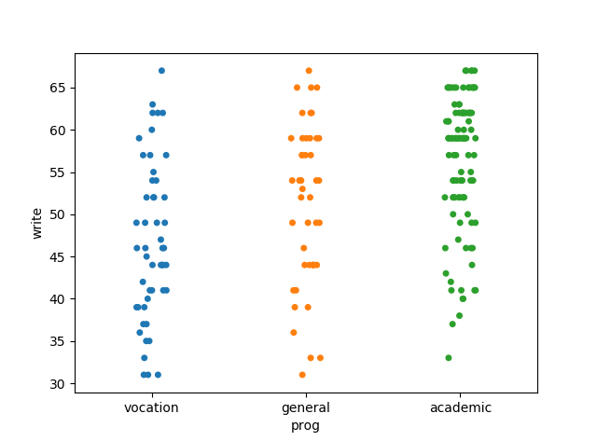
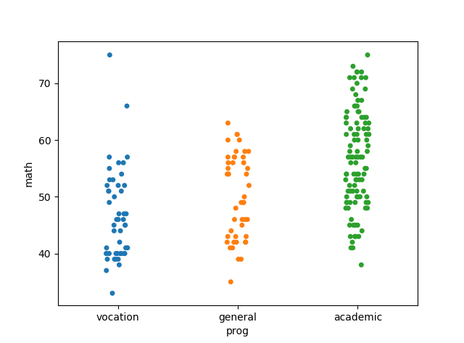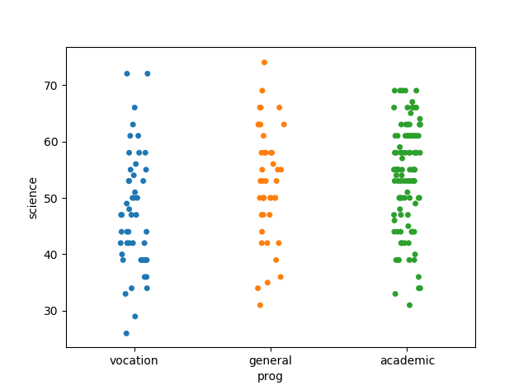

Splitting The Data Into Train And Test Subsets:
Split the given data into 80 % train and 20 % test data and create a model using both the train and test data.
Create model:
model=LogisticRegression(multi_class='multinomial',solver='lbfgs').fit(train_data.iloc[:,5:8],train_data.iloc[:,0])

train accuracy:
0.6875
test accuracy:
0.675
Accuracy of train data should be greater than test data.
There should not be <5% of change of accuracy between the train and test data.

