Business Problem:

Prepare a model for strength of concrete data using Neural Networks

Data:

Data in the form of mixed data and 8 features are there and strength is output variable.

Pre-processing Data:

All the features are not in same scale. So first of all convert them all into single scale. There was no outlier and NA in the data.

Building the Model:

Build the model using Neural Network.

Visualization:

**One Hidden Neurons:**

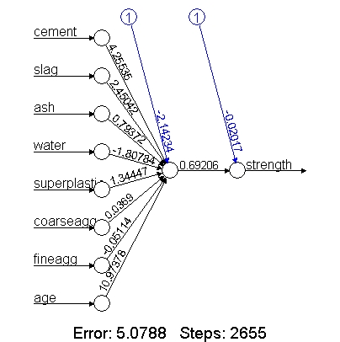

**Correlation Value: 0.8061**

**10 Hidden Neurons:**

**Correlation Value: 0.8964**

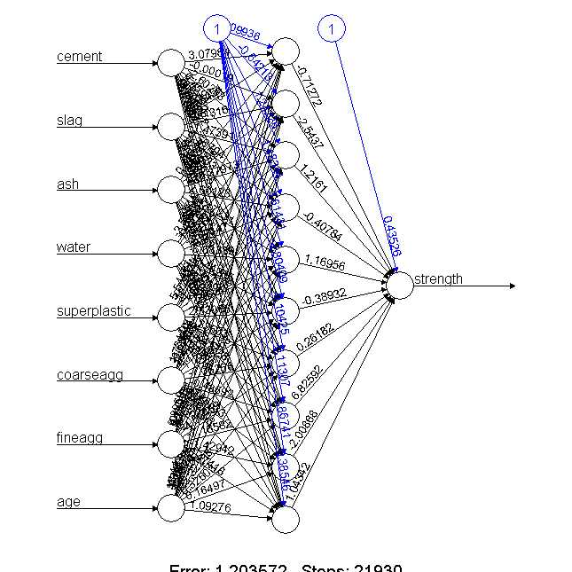

Business Problem:

Prepare a model for strength of Start-up data using Neural Networks

Data:

Data in the form of mixed data and converted state into dummy data. Finally it has 7 features are there and Profit is output variable.

Pre-processing Data:

All the features are not in same scale. So first of all convert them all into single scale. There was no outlier and NA in the data.

Building the Model:

Build the model using Neural Network.

Visualization:

**One Hidden Neurons:**

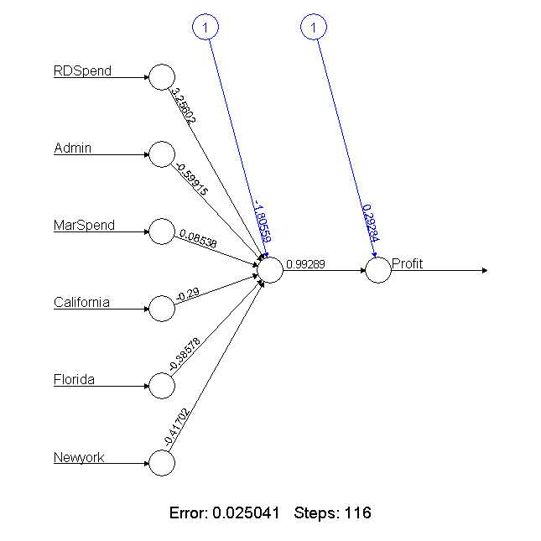

**Correlation Value: 0.84**

**5 Hidden Neurons:**

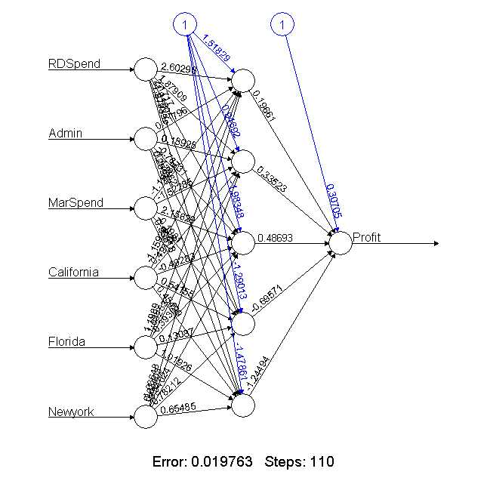

**Correlation Value: 0.75**

**Business Problem:**

PREDICT THE BURNED AREA OF FOREST FIRES WITH NEURAL NETWORKS

**Data:**

Data in the form of mixed data and converted state into dummy data. Finally it has 30 features are there and area is output variable.

**Pre-processing Data:**

All the features are not in same scale. So first of all convert them all into single scale. There was no outlier and NA in the data.

**Building the Model:**

Build the model using Neural Network.

**Visualization:**

**One Hidden Neurons:**

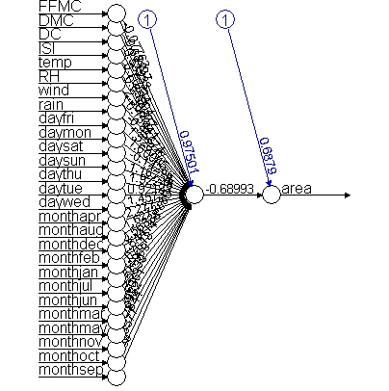

**Correlation value: 0.08774534**

**5 Hidden Neurons:**

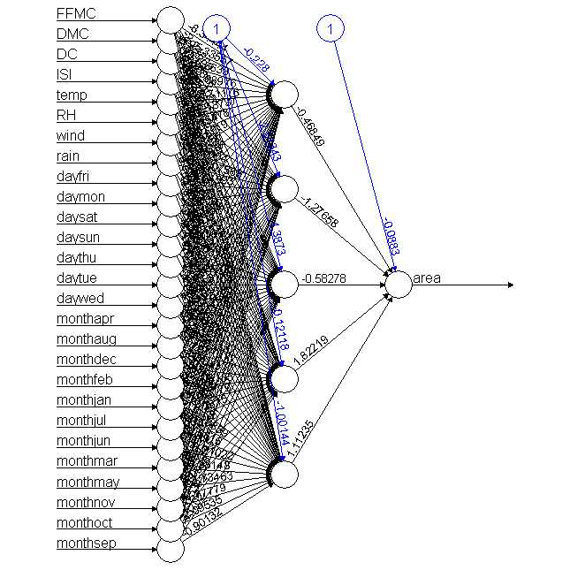

**Correlation value: 0.0764**