Q 1) Calculate probability from the given dataset for the below cases

Data _set: Cars.csv
Calculate the probability of MPG of Cars for the below cases.
MPG <- Cars$MPG
mean(Cars$MPG)
34.42208
sd(Cars$MPG)
9.131445

Mean(mu) | 34.42208
standard dev(sigma) | 9.074903

  - P(MPG>38)
Calculate Z score corresponding to 38
Z=X-mu/sigma
Z=38-34.42/9.07
Z=0.39
Calculate probabilities using Z table
P(Z>38) =0.6517
R Code :

pnorm(38,34.42208,9.131445)
0.6524059

  - P(MPG<40)
Calculate Z score corresponding to 40
Z=X-mu/sigma
Z=40-34.42/9.07
Z=0.614
Calculate probabilities using Z table
P(Z<40) =0.7291
  - P (20<MPG<50)
Use P (X1 ≤X ≤ X2) = P (X ≤ X1)- P (X ≤ X2)
=P (X≤ 20)- P (X ≤ 50)
Calculate Z score corresponding to 20 & Z score corresponding to 50
Z=X-mu/sigma
P (X≤ 20) =20-34.42/9.07
P (X≤ 20) =-1.58
Calculate probabilities using Z table
P (Z≤ 20) =0.0571

P (X≤ 50) =50-34.42/9.07
P (X≤ 50) =1.71
Calculate probabilities using Z table
P (Z≤ 50) =0.9564
=P (X≤ 20)- P (X ≤ 50)
=0.0571-0.9564
=-0.8993

pnorm(20,34.42208,9.131445)-pnorm(50,34.42208,9.131445)
-0.8988689

Q 2) Check whether the data follows normal distribution
- Check whether the MPG of Cars follows Normal Distribution
Dataset: Cars.csv
R code:
qqnorm(cars$MPG)
qqline(cars$MPG)
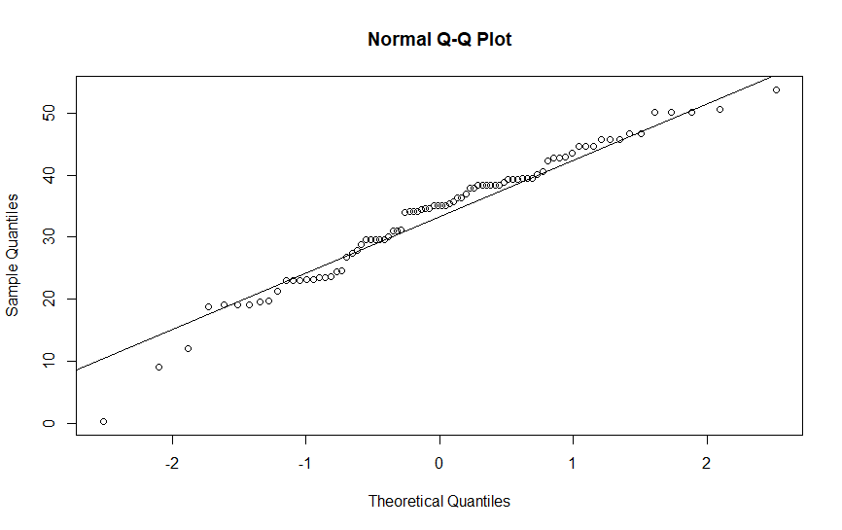

In the above plot majority of the data follows straight line then we can say that the data follows normal distribution.
- Check Whether the Adipose Tissue (AT) and Waist Circumference (Waist) from wc-at data set follows Normal Distribution
Dataset: wc-at.csv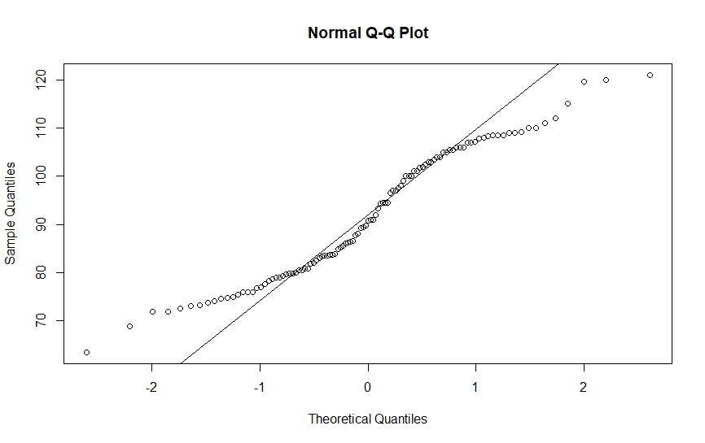
Waist from wc.at dataset does not follow normal distribution as most of the data from the dataset does not follow the straight line.
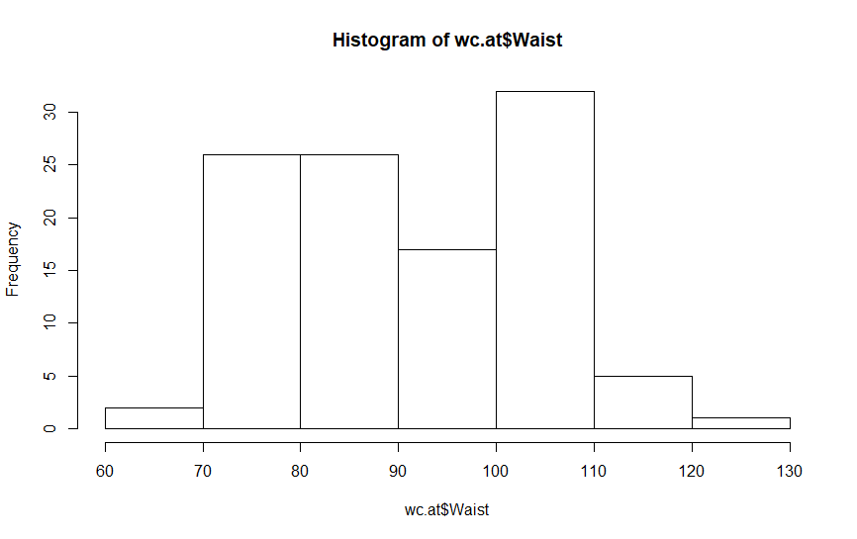
And histogram also not in the form of bell curve.
qqnorm(wc.at$AT)
qqline(wc.at$AT)
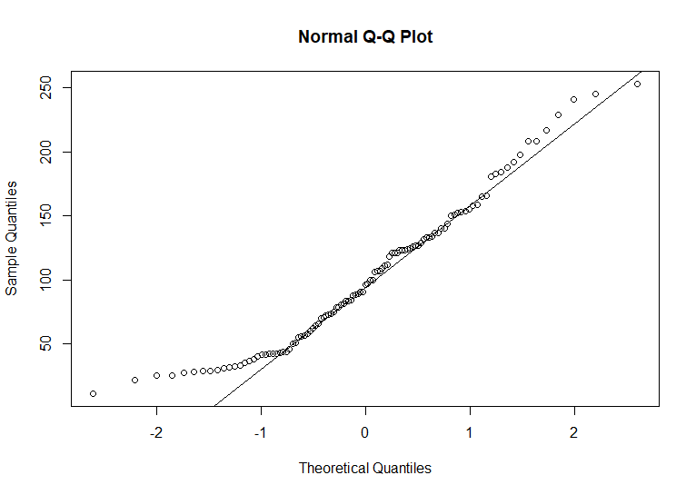
hist(wc.at$AT)

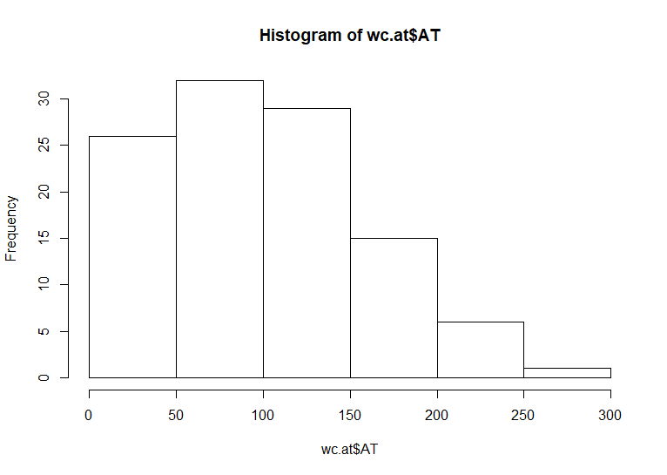
Based on the histogram we can say that the given dataset doesn’t follows
Normal distribution as the data is positively skewed and most of the data on the left of the curve.
Q 3) Calculate the Z scores of 90% confidence interval,94% confidence interval, 60% confidence interval
Z scores of 90% confidence interval=(1-alpha)+alpha/2
= 0.90+0.05
= 0.95
Z = 1.64
Z scores of 94% confidence interval=(1-alpha) +alpha/2
= 0.94+0.03
= 0.97
Z = 1.88
Z scores of 60% confidence interval=(1-alpha) +alpha/2
= 0.60+0.20
=0.80
Z =0.84
Q 4) Calculate the t scores of 95% confidence interval, 96% confidence interval, 99% confidence interval for sample size of 25
t scores of 95% confidence interval = t 1-alpha,n-1
=0.95,25-1
=0.95,24
=2.064
R code:
qt(0.975,24)
2.063899

t scores of 96% confidence interval=2.171545

qt(0.98,24)
2.171545
t scores of 99% confidence interval=2.79694

qt(0.995,24)
2.79694

Q 5) A Government company claims that an average light bulb lasts 270 days. A researcher randomly selects 18 bulbs for testing. The sampled bulbs last an average of 260 days, with a standard deviation of 90 days. If the CEO's claim were true, what is the probability that 18 randomly selected bulbs would have an average life of no more than 260 days
Hint:
rcode pt(tscore,df)
df degrees of freedom=18-1=17
x̄ = sample mean = 270
μ₀ = population mean = 260
s = sample standard deviation = 90
n = sample size = 18

t = (270 – 260)/ (90/√18) = 10 / 21.21
=0.471
probability that 18 randomly selected bulbs would have an average life of no more than 260 days =0.6781
R code:
pt(tscore,df)
pt(0.471,17)
0.678186

Q 6) The time required for servicing transmissions is normally distributed with μ = 45 minutes and σ = 8 minutes. The service manager plans to have work begin on the transmission of a customer’s car 10 minutes after the car is dropped off and the customer is told that the car will be ready within 1 hour from drop-off. What is the probability that the service manager cannot meet his commitment?
- 0.3875
- 0.2676
- 0.5
- 0.6987
Solution=0.2676
μ = 45
σ = 8
The service manager plans to have work begin on the transmission of a customer’s car 10 minutes after the car is dropped off and the customer is told that the car will be ready within 1.
Let X be the amount of time it takes to complete the repair on a customer's car. To finish in one hour you must have X ≤ 50

Pr(X ≤ 50)= (X-μ)/σ
= (50-45)/8
= 0.625
P(Z≤0.625) =0.734=73%

Probability that the service manager will not meet his demand will be
= 100-73.4
= 26.6% or 0.2676

Q 7) The current age (in years) of 400 clerical employees at an insurance claims processing center is normally distributed with mean μ = 38 and Standard deviation σ =6. For each statement below, please specify True/False. If false, briefly explain why.
- More employees at the processing center are older than 44 than between 38 and 44.
P(X>44) = (X-μ)/σ
= (44-38)/6
=1
pnorm(44,38,6)
0.8413447

P(Z>1) = 84.1345
=84.13%
Probability that the employee will be greater than age of 44
= 100-84.1345
=15.86%
TRUE
- A training program for employees under the age of 30 at the center would be expected to attract about 36 employees.

P(X<30) = (X-μ)/σ
= (30-38)/6
=-1.33

> pnorm(30,38,6)
[1] 0.09121122

P(Z<-1.33) = 0.09176
So, the number of employees with probability 0.912 of them being under age 30
= 100-0.09176
=99.9%
TRUE

Q 8) If X1 ~ N (μ, σ2) and X2 ~ N (μ, σ2) are iid normal random variables, then what is the difference between 2 X1 and X1 + X2? Discuss both their distributions and parameters.

As we know that if X ∼ N(µ1, σ1^2 ), and Y ∼ N(µ2, σ2^2 ) are two independent random variables then X + Y ∼ N(µ1 + µ2, σ1^2 + σ2^2 ) , and X − Y ∼ N(µ1 − µ2, σ1^2 + σ2^2 ) .
Similarly if Z = aX + bY, where X and Y are as defined above, i.e. Z is linear combination of X and Y, then Z ∼ N(aµ1 + bµ2, a^2σ1^2 + b^2σ2^2).
Therefore, in the question
2X1~ N (2 u,4 σ^2) and
X1+X2 ~ N (µ + µ, σ^2 + σ^2) ~ N (2 u, 2σ^2)
2X1-(X1+X2) = N (4µ,6 σ^2)

Q 9) Let X ~ N (100, 202). Find two values, a and b, symmetric about the mean, such that the probability of the random variable taking a value between them is 0.99.
- 90.5, 105.9
- 80.2, 119.8
- 22, 78
- 48.5, 151.5
- 90.1, 109.9

The Probability of getting value between a and b should be 0.99.
So, the Probability of going wrong, or the Probability outside the a and b area is 0.01 (i.e. 1-0.99).
The Probability towards left from a = -0.005 (ie. 0.01/2).
The Probability towards right from b = +0.005 (ie. 0.01/2).
So, since we have the probabilities of a and b, we need to calculate X, the random variable at a and b which has got these probabilities.
By finding Z Value, we can calculate the X values.
Z= (X- μ) / σ
For Probability 0.005 the Z Value is -2.58
Z * σ + μ = X
Z (-0.005) *20+100 = -(-2.58) *20+100 = 151.6
Z (+0.005) *20+100 = (-2.58) *20+100 = 48.6
So, option D is correct.

Q 10) Consider a company that has two different divisions. The annual profits from the two divisions are independent and have distributions Profit1 ~ N(5, 32) and Profit2 ~ N(7, 42) respectively. Both the profits are in $ Million. Answer the following questions about the total profit of the company in Rupees. Assume that $1 = Rs. 45

Given profit1~N(5, 32) & Profit2 ~ N(7, 42)
Based on the formulae
Mu1=5 σ1=3
Mu2=7 σ2=4
- Specify a Rupee range (centered on the mean) such that it contains 95% probability for the annual profit of the company.
Here the confidence level is 95%
Profit1 lower = qnorm(0.975,5,3)
10.87989

Profit1 upper= qnorm(0.025,5,3)
-0.879892
Profit1 range =[-0.879892,10.87989]
Profit1 range in $=[-87989200$,1087989000$]
Profit 1 range in Rs= [-39591000,489555000]

Profit2 lower = qnorm(0.975,7,4)
14.839

Profit2 upper= qnorm(0.025,7,4)
-0.8398
Profit2 range =[-0.8398, 14.8398]
Profit2 range in $=[-839800, 14839000]
Profit 2 range in Rs= [-37791000,667755000]

- Specify the 5th percentile of profit (in Rupees) for the company
the 5th percentile of profit (in Rupees) for the company=1/5(PROFIT)
Profit 1 range in Rs= [-7918200,97911000]

Profit 2 range in Rs= [-7558200,133551000]

- Which of the two divisions has a larger probability of making a loss in a given year?
Profit1=10$ millions
Profit2=14 $ millions
Finding probability using pnorm
pnorm(10,5,3)
0.9522096
pnorm(14,7,4)
0.9599408

2nd division has a larger probability of making a loss in a given year.

