Recommender System is a system that seeks to predict or filter preferences according to the user’s choices. Recommender systems are utilized in a variety of areas including movies, music, news, books, research articles, search queries, social tags, and products in general.

Recommender systems produce a list of recommendations in any of the two ways –

* **Collaborative filtering:**Collaborative filtering approaches build a model from user’s past behaviour (i.e. items purchased or searched by the user) as well as similar decisions made by other users. This model is then used to predict items (or ratings for items) that user may have an interest in.
* **Content-based filtering:**Content-based filtering approaches uses a series of discrete characteristics of an item in order to recommend additional items with similar properties. Content-based filtering methods are totally based on a description of the item and a profile of the user’s preferences. It recommends items based on user’s past preferences.

Let’s develop a basic recommendation system using Python and Pandas on movies dataset based on the rating.

Let’s focus on providing a basic recommendation system by suggesting items that are most similar to a particular item, in this case, movies. It just tells what movies are most similar to user’s movie choice.

=>Load the movie dataset

movies. head ()

Out [25]:

userId movie rating

0 3 Toy Story (1995) 4.0

1 6 Toy Story (1995) 5.0

2 8 Toy Story (1995) 4.0

3 10 Toy Story (1995) 4.0

4 11 Toy Story (1995) 4.5

ratings. head ()

Out [37]:

rating num of ratings

movie

Father of the Bride Part II (1995) 3.143836 431649

Goldeneye (1995) 3.427003 2396304

Grumpier Old Men (1995) 3.186861 469225

Heat (1995) 3.836508 1587600

Jumanji (1995) 3.268398 1334025

Based on the total rating and total no of ratings we perform recommendations.

Import matplotlib and seaborn for data visualization process

=>visualizing the num of rating present in the movie’s dataset for the given movies.

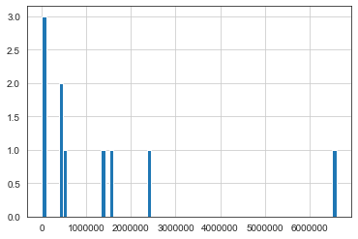

=>Visualization based on the rating :

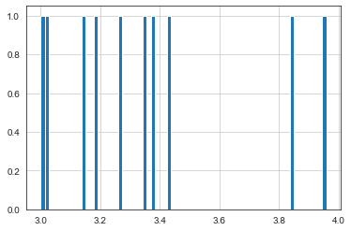

=>Sort the movies in ascending order based on the number of rating

ratings. sort_values ('num of ratings', ascending = False).head(10)

Out [54]:

rating num of ratings

movie

Toy Story (1995) 3.959323 6599761

GoldenEye (1995) 3.427003 2396304

Heat (1995) 3.836508 1587600

Jumanji (1995) 3.268398 1334025

Sabrina (1995) 3.381429 490000

Grumpier Old Men (1995) 3.186861 469225

Father of the Bride Part II (1995) 3.143836 431649

Sudden Death (1995) 3.017327 40804

Waiting to Exhale (1995) 3.000000 19044

Tom and Huck (1995) 3.352564 6084

Based on the correlation between the movies we will recommend the movies which are popular to the users.

corr_Jumanji [corr_Jumanji ['num of ratings']>100]. sort_values ('Correlation', ascending = False).head()

Out [72]:

Correlation num of ratings

movie

Jumanji (1995) 1.000000 1334025

Tom and Huck (1995) 0.588355 6084

Father of the Bride Part II (1995) 0.483546 431649

Sabrina (1995) 0.362817 490000

Grumpier Old Men (1995) 0.349180 469225