- Calories consumed-> predict weight gained using calories consumed
Business problem:
Predict weight gained using calories consumed
Exploratory data analysis:
Weight.gained..grams. Calories. Consumed
Min. : 62.0 Min. :1400
1st Qu.: 114.5 1st Qu.:1728
Median : 200.0 Median :2250
Mean : 357.7 Mean :2341
3rd Qu.: 537.5 3rd Qu.:2775
Max. :1100.0 Max. :3900
Right skewed right skewed

Scatter plot:
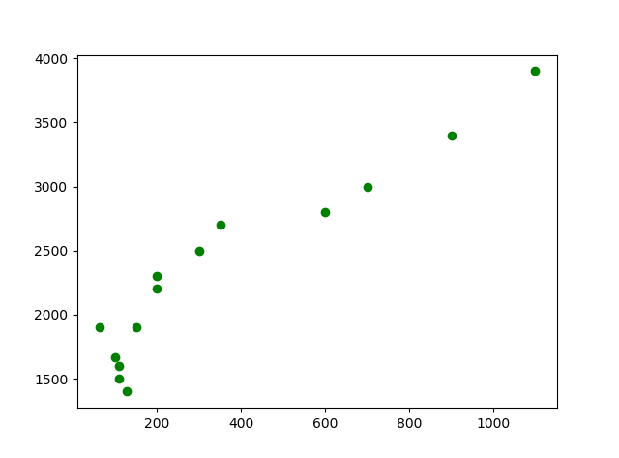
Direction of relationship=positive correlation
Strength=moderate
Relationship=linear
Correlation co-efficient value:
|r|=correlation=0.94699101>0.85
It describes strong correlation & positive correlation.
Coefficient determination:
Higher the R² value better the model
R -squared value should be greater than 0.8
R-squared: 0.897>0.8=>strong correlation
P value should be less than 0.05
Prob (F-statistic):2.86e-07<0.05=>overall model is good

- Delivery time -> Predict delivery time using sorting time
Business problem:
Predict delivery time using sorting time

Exploratory data analysis:

Delivery.Time Sorting.Time
Min. : 8.00 Min. : 2.00
1st Qu.:13.50 1st Qu.: 4.00
Median :17.83 Median : 6.00
Mean :16.79 Mean : 6.19
3rd Qu.:19.75 3rd Qu.: 8.00
Max. :29.00 Max. :10.00

Scatter plot:
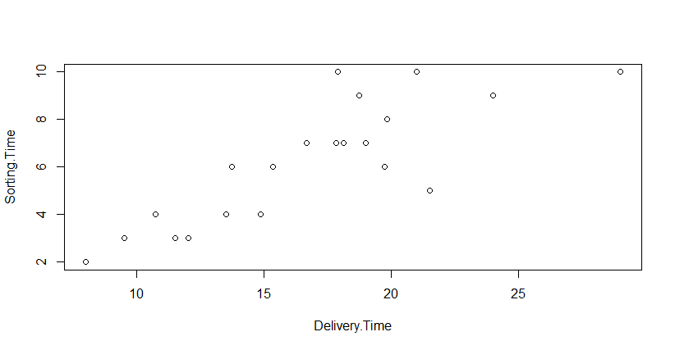

Correlation value:
0.8259973=>moderate correlation

R -squared value should be greater than 0.8
R-squared: 0.6823<0.8=>moderate correlation
P value should be less than 0.05
Prob (F-statistic): 3.983e-06<0.05=>overall model is good

LOGORITHMIC TRANSMISSION:

0.8431773=>|r|<0.85=>moderate correlation

Scatterplot:
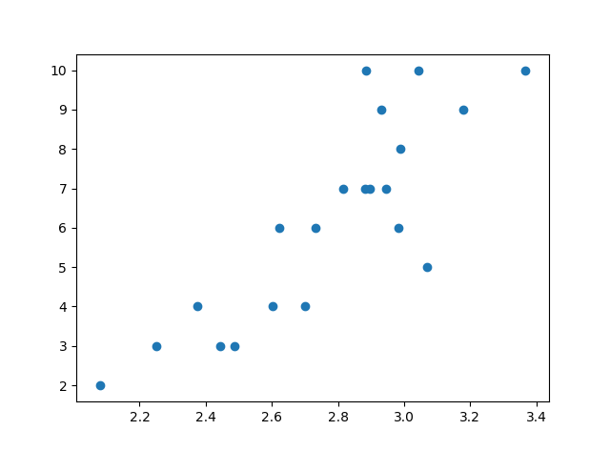
Direction of relationship=positive correlation
Strength=moderate
Relationship=linear

Correlation co-efficient value:
|r|=correlation=0.84317726 <0.85 =>moderate correlation
It describes moderate correlation & positive correlation.
Coefficient determination:
Higher the R² value better the model
R -squared value should be greater than 0.8
R-squared: 0.7109<0.8=>moderate correlation
P value should be less than 0.05
Prob (F-statistic): 1.593e-06 <0.05=>overall model is good

- Build a prediction model for Churn_out_rate
Exploratory data analysis:
Salary_hike Churn_out_rate
Min. :1580 Min. :60.00
1st Qu.:1618 1st Qu.:65.75
Median :1675 Median :71.00
Mean :1689 Mean :72.90
3rd Qu.:1724 3rd Qu.:78.75
Max. :1870 Max. :92.00

Scatterplot:
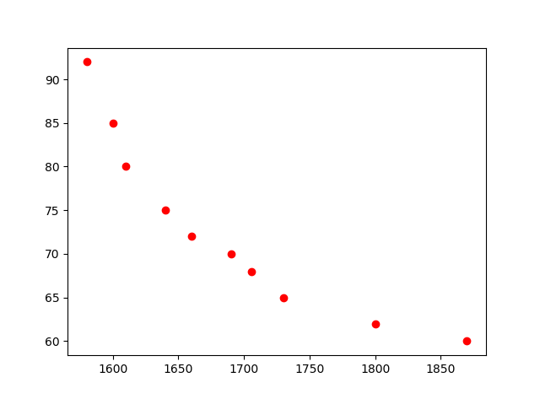

Direction of relationship=negative correlation
Strength=strong
Relationship=linear

Correlation co-efficient value:
|r|=correlation= -0.9117216
It describes strong correlation & negative correlation.
Coefficient determination:
Higher the R² value better the model
R -squared value should be greater than 0.8
R-squared: 0.8312>0.8=>strong correlation
P value should be less than 0.05
0.0002386<0.05=>overall model is good.

################log transformation################
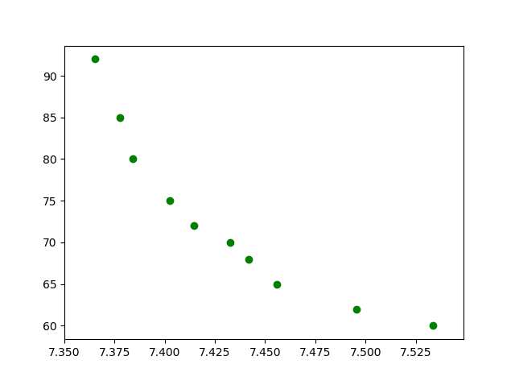
Direction of relationship=negative correlation
Strength=strong
Relationship=linear

Correlation co-efficient value:
|r|=correlation= -0.9212077

It describes strong correlation & negative correlation.
Coefficient determination:
Higher the R² value better the model
R -squared value should be greater than 0.8
R-squared: 0.8735>0.8=>strong correlation
P value should be less than 0.05
7.377e-05<0.05=>overall model is good.

###################exponential transformation############
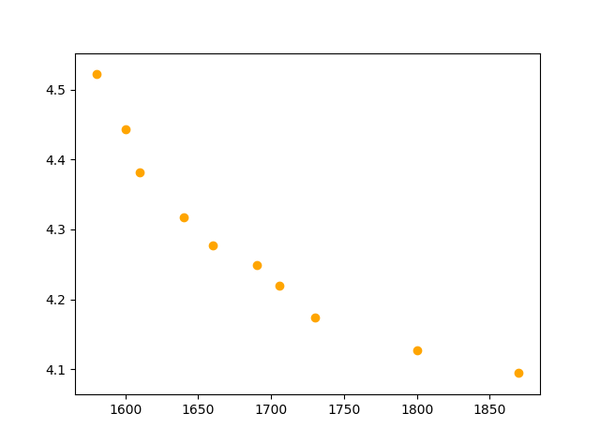

Direction of relationship=negative correlation
Strength=strong
Relationship=linear

Correlation co-efficient value:
|r|=correlation= -0.9346361

There is a slightly change in the correlation value

It describes strong correlation & negative correlation.
Coefficient determination:
Higher the R² value better the model
R -squared value should be greater than 0.8
R-squared: 0.8486>0.8=>strong correlation
P value should be less than 0.05
0.0001532<0.05=>overall model is good.

#################polynomial transformation###############

Higher the R² value better the model
R -squared value should be greater than 0.8
R-squared: 0.9836>0.8=>strong correlation
P value should be less than 0.05
5.634e-07<0.05=>overall model is good

- Salary_hike -> Build a prediction model for Salary_hike
Business problem:
Build a prediction model for salary hike

Exploratory data analysis:
YearsExperience Salary
Min. : 1.100 Min. : 37731
1st Qu.: 3.200 1st Qu.: 56721
Median : 4.700 Median : 65237
Mean : 5.313 Mean : 76003
3rd Qu.: 7.700 3rd Qu.:100545
Max. :10.500 Max. :122391

Scatter plot:
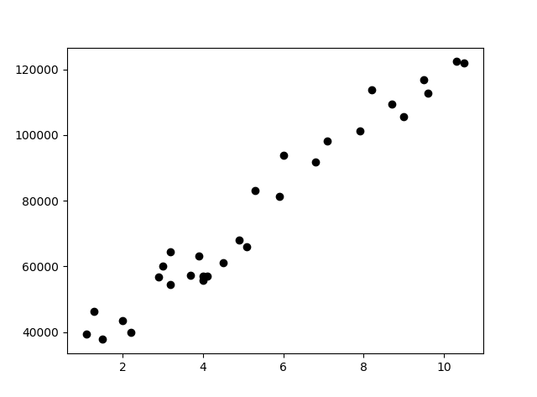

Direction of relationship=positive correlation
Strength=strong
Relationship=linear

Correlation co-efficient value:
|r|=correlation= 0.9782416>0.85

It describes strong correlation & positive correlation.
Coefficient determination:
Higher the R² value better the model
R -squared value should be greater than 0.8
R-squared: 0.957>0.8=>strong correlation
P value should be less than 0.05
2.2e-16<0.05=>overall model is good.

###############log transformation###################

Scatter plot:

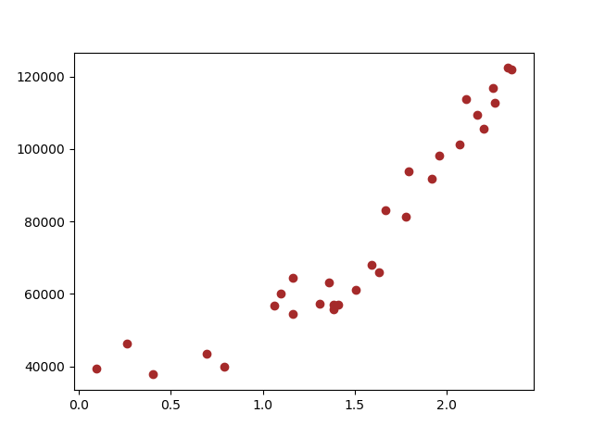

Direction of relationship=positive correlation
Strength=strong
Relationship=linear

Correlation co-efficient value:
|r|=correlation= 0.9240611>0.85

It describes strong correlation & positive correlation.
Coefficient determination:
Higher the R² value better the model
R -squared value should be greater than 0.8
R-squared: 0.932>0.8=>strong correlation
P value should be less than 0.05
2.2e-16<0.05=>overall model is good.

##################exp transformation###############

Scatter plot:

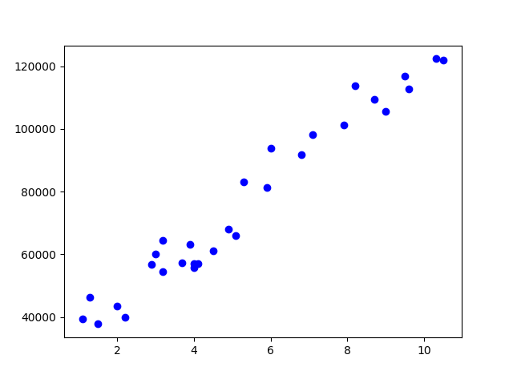

Direction of relationship=positive correlation
Strength=strong
Relationship=linear

Correlation co-efficient value:
|r|=correlation= 0.9653844>0.85

There is slightly change in the value
Higher the value better the model

It describes strong correlation & positive correlation.
Coefficient determination:
Higher the R² value better the model
R -squared value should be greater than 0.8
R-squared: 0.932>0.8=>strong correlation
P value should be less than 0.05
2.2e-16<0.05=>overall model is good.

###################polynomial transformation##############

Higher the R² value better the model
R -squared value should be greater than 0.8
R-squared: 0.9486>0.8=>strong correlation
=>Value increased
P value should be less than 0.05
2.2e-16<0.05=>overall model is good.

