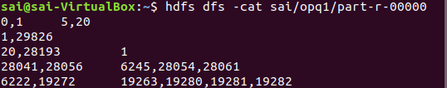

Assignment-1
1) MutualFriends.java

hadoop jar /home/sai/Desktop/MutualFriends.jar MutualFriends assignmenttest/q1/soc- LiveJournal1Adj.txt sai/opq1
2) Top10Friends.java

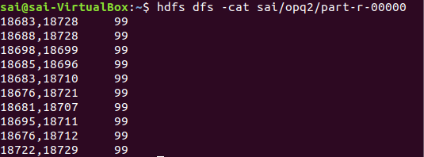
hadoop jar /home/sai/Desktop/Top10Friends.jar Top10Friends assignmenttest/q1/soc- LiveJournal1Adj.txt sai/temp1 sai/opq2

3)DOBOfMutualFriends.java

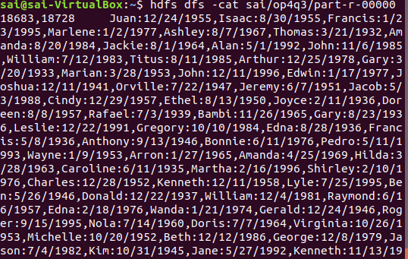

hadoop jar /home/sai/Desktop/DOBOfMutualFriends.jar DOBOfMutualFriends assignmenttest/q1/soc-LiveJournal1Adj.txt assignmenttest/q1/userdata.txt sai/op4q3 18683 18728

4) MaxAge.java

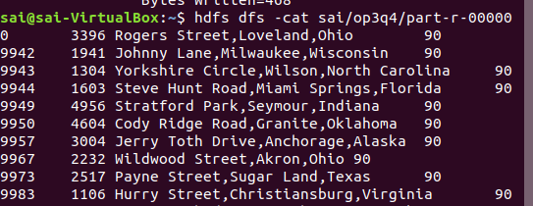
hadoop jar /home/sai/Desktop/MaxAge.jar MaxAge assignmenttest/q1/soc-LiveJournal1Adj.txt assignmenttest/q1/userdata.txt sai/tmp13 sai/tmp14 sai/op3q4

