1) Architecture recommendation
Use this shape from the start:
- Frontend: React + TypeScript + Vite.
- Backend: vanilla Node http server in TypeScript, with a thin internal router and service layer.
- Database: PostgreSQL.
- Cache / jobs: Redis only if you add notifications, retries, queues, or real-time event fan-out.
- Object storage: MinIO or IPFS, depending on whether you want private controlled storage first or content-addressed distribution first.
- Contracts: Solidity + OpenZeppelin + Foundry as the primary contract toolchain.
- Wallet / chain integration: viem + wagmi + RainbowKit.
- Security / quality: Slither, Echidna, Vitest, Playwright, GitHub Actions.
The most important product decision is this: do not put project management logic on-chain. Put only settlement-critical logic on-chain. Search, matching, chat, role approval, notifications, artifact storage, mentor workflows, evidence packaging, juror assignment orchestration, and admin review should stay off-chain. The chain should only guard money movement, eligibility proofs, stake/slash rules, disputes, and claims. That is how you keep gas, UX friction, and audit scope under control.

2) Testnet and node provider
For local development, use Anvil from Foundry. It is the fastest loop for unit tests, invariant tests, edge-case simulation, and forked debugging. Hardhat Network is also fine, but I would keep one primary toolchain, and Foundry is the better first choice here because contract testing and fuzzing matter more than plugin breadth in your product.
For the shared public testnet, I would pick Base Sepolia as the primary integration network and Ethereum Sepolia as the compatibility / audit-staging network. Ethereum.org explicitly describes Sepolia as the recommended default testnet for application development, while Base provides a free public Sepolia RPC and a generous faucet for test activity. That gives you a practical blend of low-friction frontend testing and canonical Ethereum compatibility. I would keep Polygon Amoy as an optional secondary network, not the primary one. Amoy is the Polygon PoS testnet and replaced Mumbai, so it is valid and supported, but if gas sponsorship and account abstraction are on your roadmap, Base Sepolia is the cleaner first path. Polygon PoS support exists, but Alchemy documents restrictions around bundler behavior on Polygon PoS because of mempool reliability/front-running concerns. For RPC providers, use Alchemy as primary and Infura plus the chain’s public RPC as fallback. Alchemy supports Sepolia, Base Sepolia, and Polygon Amoy, and Infura is strong for Ethereum infrastructure and ERC-4337 bundler flows. For Hyderabad specifically, I cannot verify official city-level latency figures, so the right operational move is to benchmark p95/p99 latency and websocket stability from the ISP or VPS you will actually use in Hyderabad before locking the provider order.

3) The package stacks

Frontend
Use:
- react, react-dom, typescript, vite
- viem
- wagmi
- @rainbow-me/rainbowkit
- react-router-dom
- @tanstack/react-query
- zod
- react-hook-form
- tailwindcss
- lucide-react
- date-fns
- vitest
- @playwright/test
- eslint, prettier
My opinionated call is: use viem + wagmi, not ethers.js, as the default path. viem is lightweight and type-safe, and Wagmi v2 is designed around Viem and TanStack Query. Keep ethers only if a third-party dependency forces it.

Backend
Use:
- native Node http, crypto, fs, stream, url
- zod
- pg
- pino
- socket.io only if you ship chat/live status in V1
- bullmq + ioredis if you ship queues, retries, or async notifications
- siwe for wallet-auth sessions if you want human-friendly Web2-style sessions on top of wallet identity
Because you want a vanilla Node HTTP server, I would avoid heavyweight backend frameworks. Build a small internal structure with routes/, services/, repositories/, validators/, adapters/, and workers/. That keeps AI-generated code much more consistent than mixing full frameworks plus custom abstractions.

Smart contracts
Use:
- openzeppelin-contracts
- @openzeppelin/merkle-tree
- Foundry
- Hardhat only if your team wants separate deployment scripting or plugin workflows
- Slither
- Echidna

Storage
Use MinIO first if you want private campus-controlled artifact storage with S3 compatibility. Use IPFS / Helia if you want content-addressed portability and easier independent verification of evidence packages. Both are valid; MinIO is easier operationally for a campus product, while IPFS is better if verifiable distribution is part of the product story.

4) Database choice and backend architecture
Use PostgreSQL, not MongoDB, for V1. Your domain is relational and audit-heavy: users, wallets, roles, projects, milestones, submissions, payout roots, disputes, jurors, votes, stakes, notifications, and logs all have strong foreign-key relationships. PostgreSQL gives you relational constraints plus jsonb for flexible evidence metadata and signed payload snapshots.
Use pg directly unless you strongly want a typed schema layer. node-postgres supports pooling, parameterized queries, and explicit transaction control, which fits this product well because milestone approval, dispute opening, and event-index writes must be idempotent and transactional.
The backend should be split into these modules:
- auth: SIWE session creation, role binding, wallet linking, nonce issuance, session revocation
- eligibility: alumni verification, student contributor invitation, mentor approval, role status
- projects: project creation, milestone definitions, client/freelancer workspace
- submissions: submission metadata, artifact hashes, evidence bundle manifests
- payouts: weights ingestion, Merkle root generation, proof caching, claim status
- disputes: dispute lifecycle, evidence packaging, deadlines, outcomes
- jurors: stake registry mirror, juror assignment mirror, commit/reveal phases
- notifications: email/in-app/webhook queue
- chain-sync: blockchain event ingestion and reconciliation
- admin: verification queue, freezes, feature flags, observability, abuse actions
The missing backend component in your synopsis is chain synchronization. Without a dedicated event-ingestion worker, your dashboards will drift from contract truth. Build that from day one. It can start as a polling/websocket worker that normalizes contract events into a chain_events table and updates projections.

5) Smart contract layout

Do not over-split contracts in V1. Start with this set:
- EligibilityRegistry.sol
Stores signer set / verifier roles and optional alumni badge logic.
- AlumniBadge.sol
Optional. Only add if you truly want on-chain gating. If used, keep it minimal and non-transferable.
- ProjectEscrow.sol
Core milestone escrow, state machine, submit/approve/dispute hooks, payout root storage.
- JurorPool.sol
Stake, slash, juror availability, selection eligibility.
- ArbitrationCourt.sol
Dispute open, juror draw, commit-reveal voting, result execution.
- MockStablecoin.sol
Testnet-only token if you do not want to depend on faucet-based mock stablecoins.
For the eligibility layer, I would start with off-chain EIP-712 eligibility attestations first and delay soulbound badges until V2. EIP-712 gives you structured typed data; it is easier to revoke, rotate, and reissue off-chain. If you later add an SBT, use a minimal non-transferable pattern such as ERC-5192 and keep personally sensitive metadata off-chain. Also support ERC-1271 early so smart-contract wallets do not break your verification model later. For the Merkle payout path, use OpenZeppelin’s JavaScript Merkle tree package off-chain and MerkleProof on-chain. That is the cleanest way to store only a root on-chain and let contributors self-claim with proofs.

6) What frontend components are required
Your current list is a good start, but it is missing several critical screens.

Public / pre-auth
You need:
- Landing page
- How it works
- Verified alumni talent browse
- Project posting explainer
- Juror/arbitration explainer
- Pricing / fee explainer
- Help center
- Status / trust page
- Legal pages: terms, privacy, dispute policy, acceptable-use policy

Auth / identity
You need:
- Wallet connect modal
- SIWE login
- Role selection: client / alumni freelancer / student contributor / mentor / juror / admin
- Wallet linking / unlinking
- Session management
- Alumni verification application
- Student invitation acceptance
- Mentor invite acceptance
- Juror onboarding and stake setup

Client dashboard
You mentioned project posting and freelancer search. Add:
- Project workspace
- Milestone builder
- Fund escrow screen
- Submission review center
- Evidence diff / artifact compare
- Approve / dispute screen
- Payout split preview
- Team contribution timeline
- Chat / collaboration room
- Activity / audit timeline
- Billing / fee history
- Saved freelancers
- Invite contributors
- Refund / cancellation workflow

Freelancer / student dashboard
You mentioned search task, ping client, progress bar, submit GitHub links. Add:
- Opportunity marketplace
- Invite inbox
- Active workboard
- Milestone checklist
- Proof-of-work submission builder
- Contribution weight review
- Co-sign request status
- Claim payout center
- Dispute response center
- Wallet / tax / payout settings
- Reputation / completion history
- Availability calendar

Mentor / professor dashboard
This is missing and it matters:
- Co-sign request inbox
- Weight review and override screen
- Artifact verification screen
- Signed-attestation history
- Conflict-of-interest declaration
- Mentorship participation log

Juror dashboard
Also missing and core to your product:
- Stake / unstake
- Availability toggle
- Case assignment inbox
- Commit vote screen
- Reveal vote screen
- Evidence room
- Voting deadline timer
- Slashing / reward history
- Juror reputation / attendance

Admin dashboard
Also required:
- Verification review queue
- Role / access overrides
- Dispute escalations
- Contract pause / emergency controls
- Juror pool health
- RPC / indexer health
- Notification templates
- Abuse / fraud flags
- Audit log explorer
- Feature flags
A progress bar should exist, but it must be treated as UX only. Settlement truth must come from milestone state, signatures, artifact hash packages, approval/dispute actions, and claim proofs. Never let a frontend “% complete” value have monetary consequences.

7) Suggested frontend file structure
Here is the React structure I would actually use:
apps/web/
src/
main.tsx
app/
App.tsx
router.tsx
providers.tsx
queryClient.ts
wagmi.ts
auth.ts
constants.ts
assets/
components/
ui/
Button.tsx
Modal.tsx
Drawer.tsx
Tabs.tsx
Badge.tsx
ProgressBar.tsx
EmptyState.tsx
DataPill.tsx
StatusChip.tsx
Countdown.tsx
layout/
AppShell.tsx
Sidebar.tsx
Topbar.tsx
PageHeader.tsx
wallet/
WalletConnectButton.tsx
NetworkGuard.tsx
SignaturePrompt.tsx
feedback/
Toasts.tsx
ErrorBoundary.tsx
InlineAlert.tsx
forms/
Field.tsx
FieldError.tsx
AddressInput.tsx
AmountInput.tsx
FileHashDropzone.tsx
features/
auth/
pages/
LoginPage.tsx
RoleSelectPage.tsx
AlumniApplyPage.tsx
api.ts
schemas.ts
hooks.ts
discovery/
pages/
BrowseFreelancersPage.tsx
BrowseProjectsPage.tsx
components/
FreelancerCard.tsx
ProjectCard.tsx
SearchFilters.tsx
projects/
pages/
ProjectListPage.tsx
ProjectDetailsPage.tsx
CreateProjectPage.tsx
MilestoneBuilderPage.tsx
components/
ProjectSummaryCard.tsx
MilestoneCard.tsx
MilestoneStatePill.tsx
ContributionSplitEditor.tsx
EvidenceTimeline.tsx
submissions/
pages/
SubmissionDetailsPage.tsx
NewSubmissionPage.tsx
components/
ArtifactList.tsx
HashVerifier.tsx
GithubLinkField.tsx
SubmissionReviewPanel.tsx
payouts/
pages/
ClaimsPage.tsx
components/
MerkleClaimCard.tsx
ProofStatus.tsx
disputes/
pages/
DisputeCenterPage.tsx
DisputeCasePage.tsx
components/
EvidenceRoom.tsx
VerdictBanner.tsx
DeadlineTimer.tsx
mentor/
pages/
MentorInboxPage.tsx
CoSignRequestPage.tsx
components/
WeightApprovalPanel.tsx
juror/
pages/
JurorDashboardPage.tsx
JurorCasePage.tsx
StakePage.tsx
components/
CommitVoteForm.tsx
RevealVoteForm.tsx
JurorRewardHistory.tsx
chat/
pages/
ChatPage.tsx
components/
MessageList.tsx
Composer.tsx
notifications/
pages/
NotificationsPage.tsx
admin/
pages/
AdminDashboardPage.tsx
VerificationQueuePage.tsx
SystemHealthPage.tsx
lib/
apiClient.ts
errors.ts
format.ts
dates.ts
money.ts
typedData.ts
merkle.ts
hooks/
styles/
index.css
Tokens.css

That structure is intentionally domain-first, not page-first. AI-generated code stays far more stable when features own their pages, APIs, hooks, and schemas together.

8) Suggested backend file structure
services/api/
src/
server.ts
config/
env.ts
chains.ts
featureFlags.ts
core/
router.ts
request.ts
response.ts
errors.ts
logger.ts
authz.ts
idempotency.ts
db/
pool.ts
migrations/
queries/
users.sql.ts
projects.sql.ts
milestones.sql.ts
disputes.sql.ts
notifications.sql.ts
routes/
health.routes.ts
auth.routes.ts
eligibility.routes.ts
users.routes.ts
projects.routes.ts
milestones.routes.ts
submissions.routes.ts
payouts.routes.ts
disputes.routes.ts
jurors.routes.ts
notifications.routes.ts
admin.routes.ts
services/
auth.service.ts
eligibility.service.ts
project.service.ts
milestone.service.ts
submission.service.ts
payout.service.ts
dispute.service.ts
juror.service.ts
notification.service.ts
audit.service.ts
adapters/
chain/
viemPublicClient.ts
viemWalletClient.ts
escrow.adapter.ts
arbitration.adapter.ts
storage/
minio.adapter.ts
ipfs.adapter.ts
mail/
smtp.adapter.ts
workers/
chainSync.worker.ts
notification.worker.ts
deadline.worker.ts
webhook.worker.ts
validators/
auth.schemas.ts
project.schemas.ts
milestone.schemas.ts
payout.schemas.ts
dispute.schemas.ts
juror.schemas.ts
utils/
hash.ts
merkle.ts
signatures.ts
typedData.ts
pagination.ts

9) Database schema
Core tables:
- users
- wallets
- roles
- user_roles
- sessions
- alumni_verifications
- student_invitations
- mentor_profiles
- juror_profiles
- juror_stakes
- projects
- project_members
- milestones
- milestone_submissions
- artifacts
- payout_roots
- payout_leaves
- mentor_attestations
- disputes
- dispute_evidence
- juror_assignments
- juror_commits
- juror_reveals
- dispute_verdicts
- notifications
- chat_threads
- chat_messages
- audit_logs
- chain_events
- webhook_deliveries
Important design rules:
- wallets is many-to-one to users
- every external request that can affect money should carry an idempotency key
- chain_events must have unique (chain_id, tx_hash, log_index)
- payout_roots must version by (milestone_id, root_version)
- never overwrite signed payloads; append new versions
- store raw signed EIP-712 payloads and normalized parsed fields separately

10) Additional Features
The important missing pieces are:
- Wallet/session strategy
You need both wallet identity and normal app sessions. Otherwise users keep signing trivial actions and the UX becomes painful. SIWE is the right base.
- Chain-event indexer
Without this, dashboards and contract state will drift.
- Role and revocation model
Alumni can be revoked, students graduate, mentors leave, jurors become inactive.
- Versioned weight files
weights.json needs versioning, signatures, replacement rules, and dispute references.
- Evidence packaging format
You need a standard manifest, not random links.
- Notification and deadline engine
Disputes, reveals, and claim windows are deadline-sensitive.
- Emergency pause / recovery path
At minimum: pause, freeze milestone, rotate verifier, rotate treasury, disable juror draws.
- Fee policy
Define platform fee, dispute fee, juror reward source, refund policy, and slashing distribution.
- Observability
RPC health, queue health, chain lag, websocket disconnects, failed claim rates.
- Abuse and fraud controls
Self-dealing jurors, fake alumni proofs, evidence spam, wallet farming, milestone griefing.

11) Edge cases
This is the section most teams skip.
- Client funds a milestone, but freelancer never accepts.
- Freelancer submits, but client disappears.
- Mentor is required, but mentor never co-signs.
- Weights are signed by mentor, but one contributor disputes exclusion.
- Milestone is approved off-chain in UI, but on-chain root write fails.
- Root is posted twice with different versions.
- Contributor claims with correct proof after verdict already changed the root.
- User loses wallet after approval but before claim.
- Smart-contract wallet tries to sign; your system only supports EOA.
- Alumni badge is revoked while an active project is mid-flight.
- Juror is assigned but never commits.
- Juror commits and refuses to reveal.
- Juror collusion ring votes together across repeated cases.
- Evidence is updated after commit phase opens.
- Artifact hash does not match uploaded manifest.
- ERC-20 token has unusual decimals or blacklist/pausable behavior.
- Chain reorg duplicates or reorders contract events.
- Public RPC websocket drops and misses dispute events.
- Notification email fails; a reveal deadline is missed.
- A milestone has multiple student contributors with zero-gas wallets, so nobody can claim.
- Admin wants to reverse a bad verifier signature; the contract does not allow any remediation.
- Chat contains malware links or PII that must not be exposed in evidence exports.

12) Docs required
Before writing production code, create these docs in docs/:
- prd.md
- scope-mvp.md
- non-functional-requirements.md
- roles-and-permissions.md
- domain-glossary.md
- project-lifecycle-spec.md
- milestone-state-machine.md
- dispute-lifecycle-spec.md
- typed-data-spec.md
- api/openapi.yaml
- database/erd.mmd
- contracts/invariants.md
- threat-model.md
- abuse-cases.md
- audit-log-spec.md
- notifications-spec.md
- runbooks/incident-response.md
- adr/0001-chain-choice.md
- adr/0002-storage-choice.md
- adr/0003-auth-strategy.md
- adr/0004-payout-root-versioning.md
For API work, use OpenAPI first. OpenAPI is specifically designed to describe HTTP APIs in a language-agnostic way so humans and machines can understand them before implementation. That is exactly what you want if AI is generating some of the code. For architecture decisions, keep ADRs in the repo. ADRs are lightweight records of important architectural choices and their consequences; they are perfect for documenting decisions like “Base Sepolia first,” “Postgres over Mongo,” or “off-chain attestations before SBT.”

13) UML / architecture diagrams
Create these files:
docs/uml/
001-system-context.mmd
002-use-cases.mmd
003-component-diagram.mmd
004-deployment-diagram.mmd
005-sequence-escrow-flow.mmd
006-sequence-dispute-flow.mmd
007-state-milestone.mmd
008-state-dispute.mmd
009-erd.mmd
010-class-domain.mmd
011-activity-claim-flow.mmd

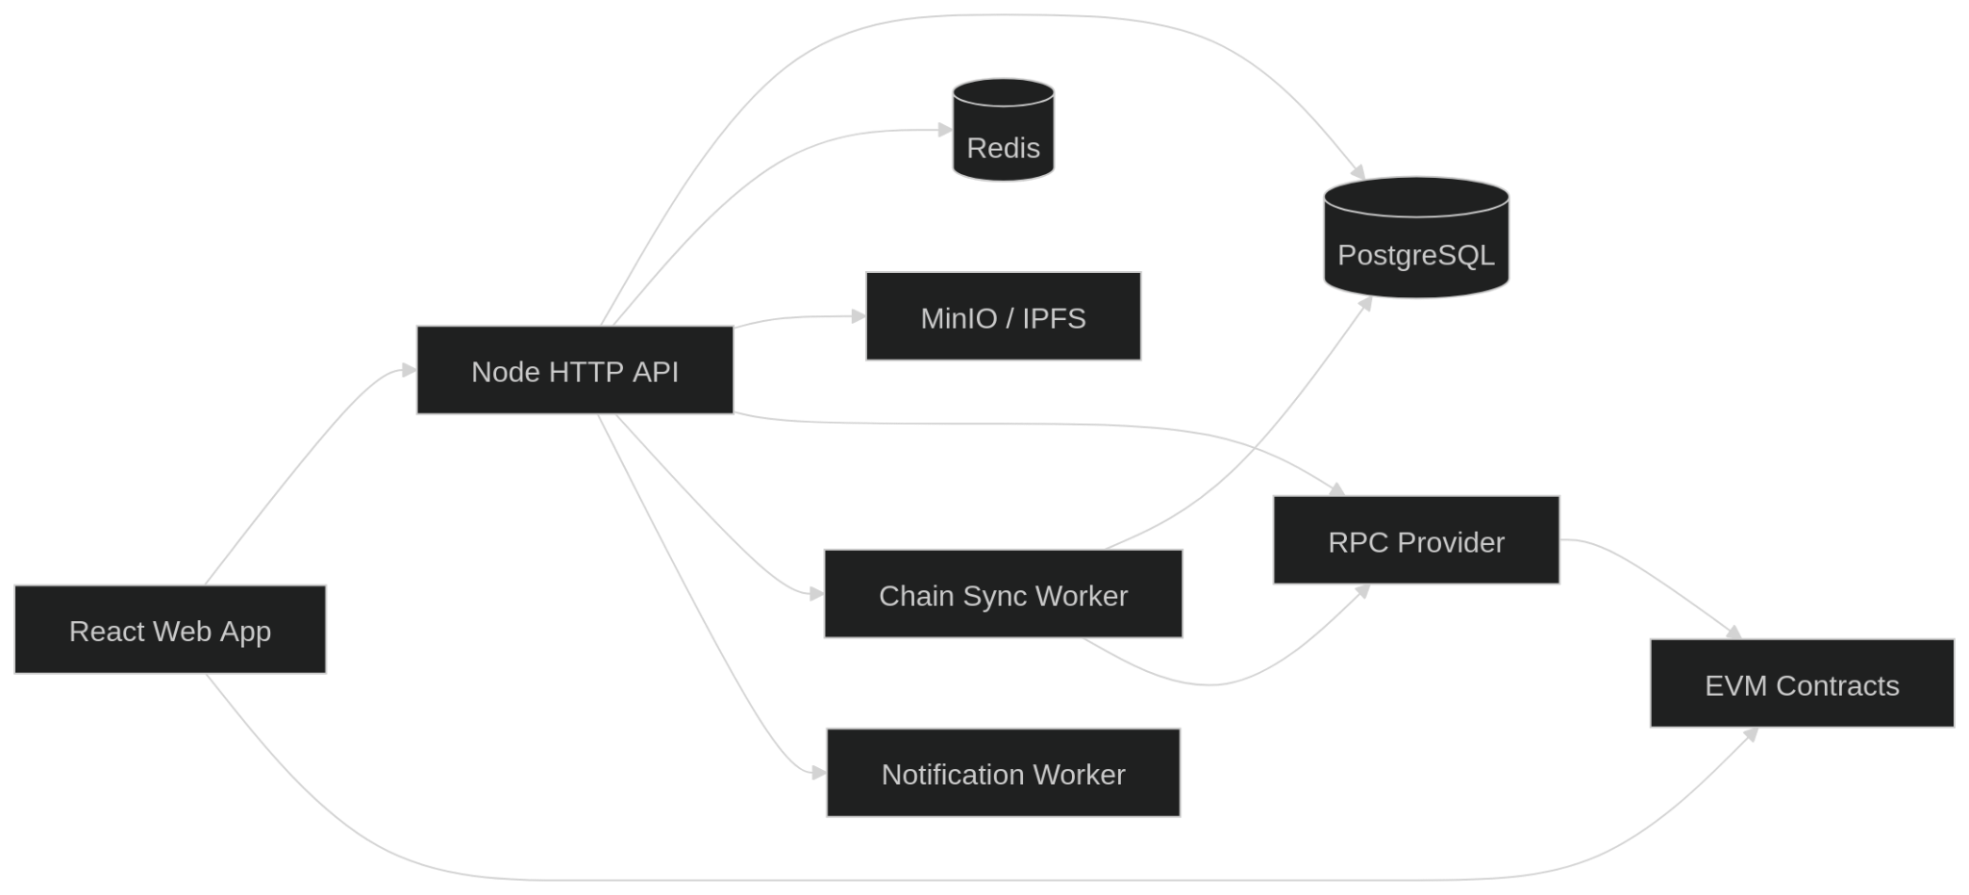

Milestone state machine

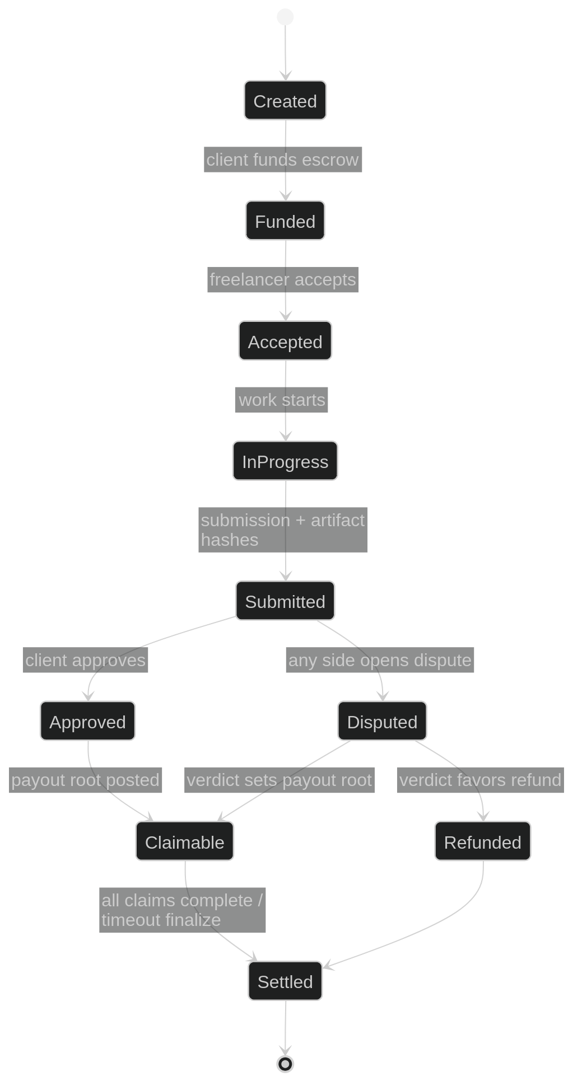

Escrow sequence

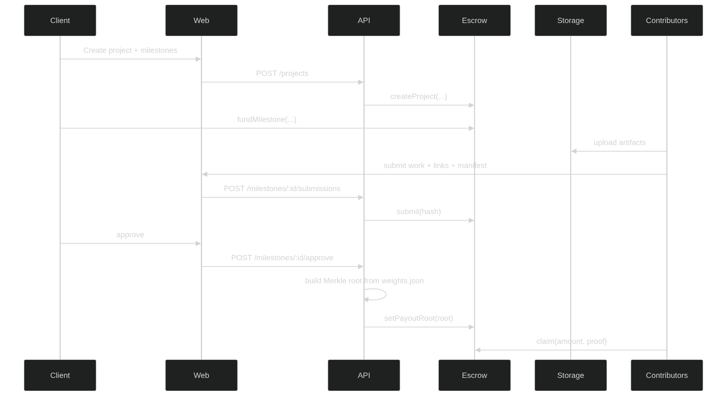

Dispute sequence

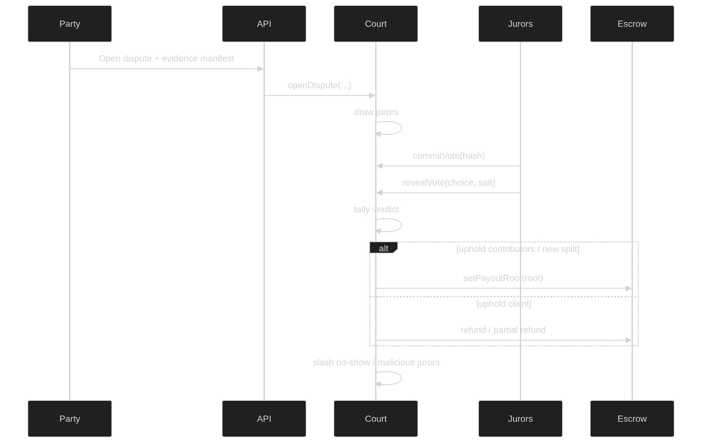

ERD

