Problem – Analyzing Beer production in Australia from 1965 to 1995.

Analysis – By observing the plot of the data, it looks like there is a clear trend and seaonality. So, it might not be stationary. Lets use moving average and ESM models to estimate trend, remove that estimated trend from the data and see. We can also try decomposition.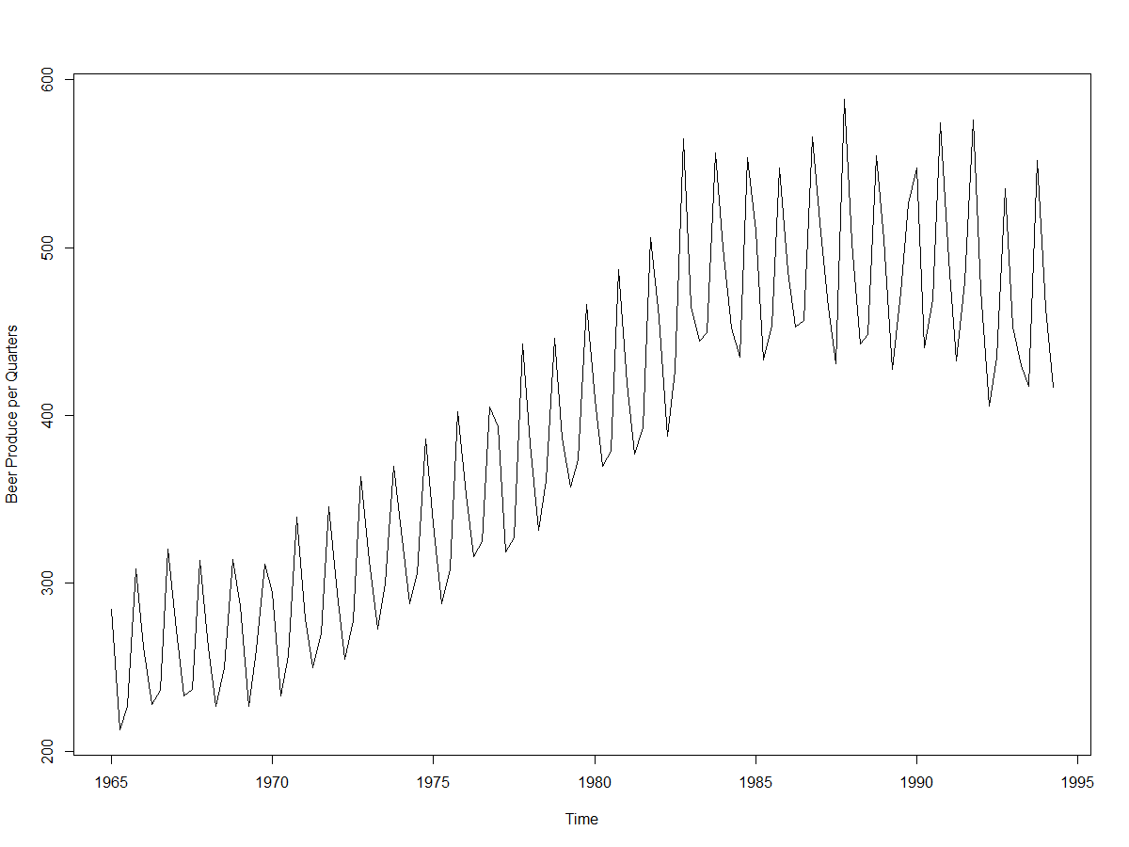

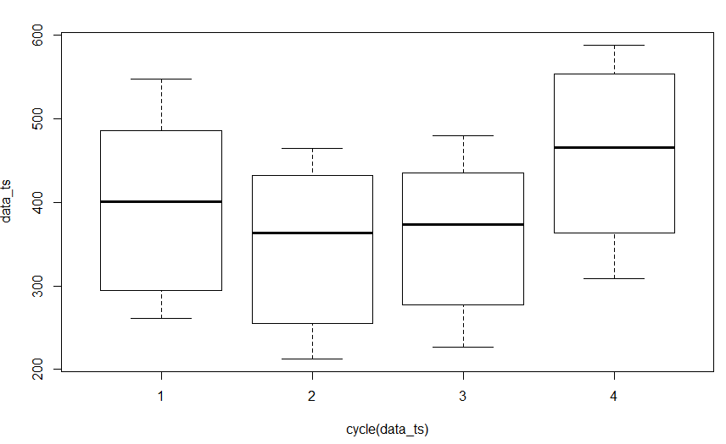

The above box plot is an indiaction of seasonality in the data.

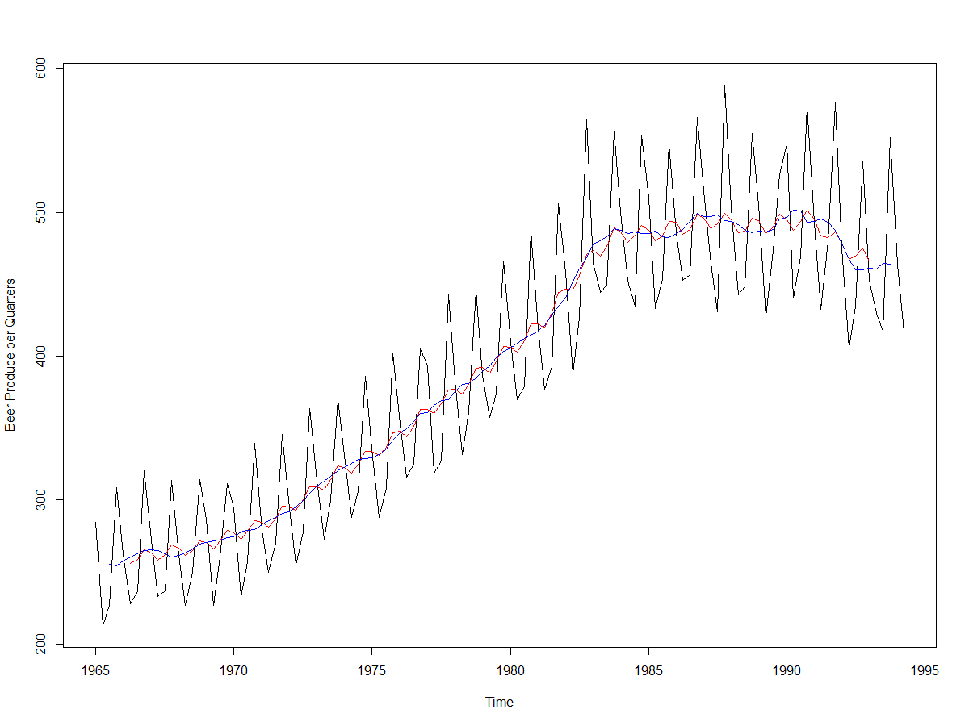

The blue line is MA of order 4, it is eastimating the trend nicely. So, I will remove this trend component.

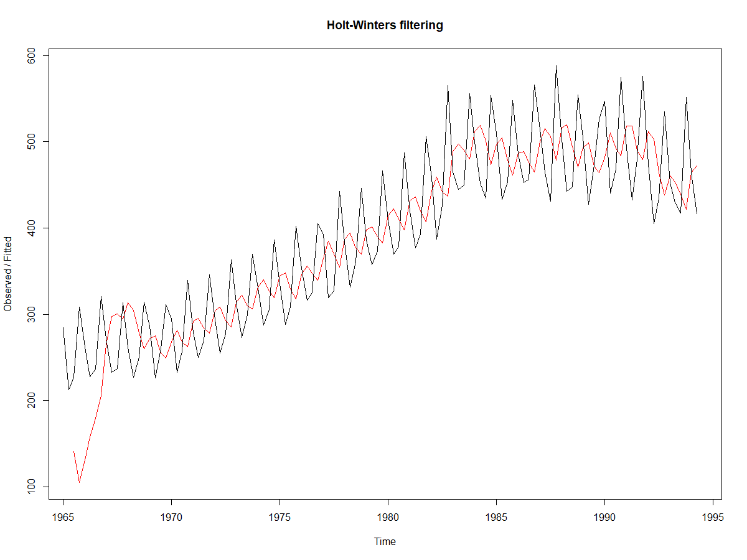

The red line indiactes a trend – adjusted exponential smoothing model with default leveling and trend parameters. It is not as smooth as moving average model.

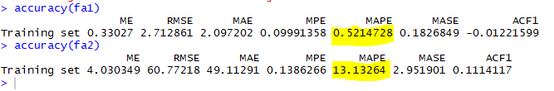

The accuracy of the esm model is worst in comparison to ma model. I then removed the seasonal component from the data and ran esm and ma models again. Then,

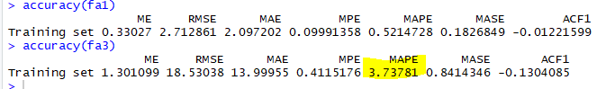

The MAPE of the esm model came down after removing seasonal component from modeling, whereas the MAPE of the MA model remianed same. It means that ESM models are not good models when we have seasonality in the data.

Now, lets decompose and see.

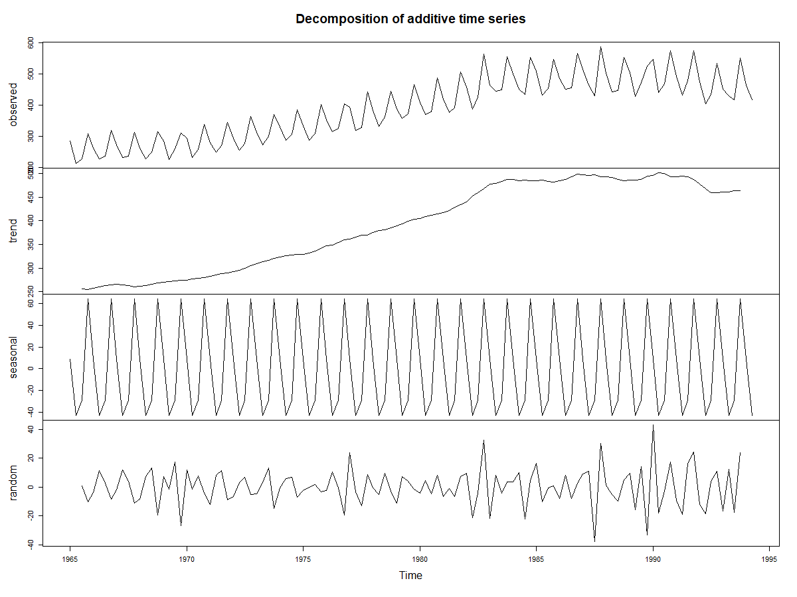

Looks like a clear trend, seasonality and random noise are apparent in the data.

Methods to remove trend –

1) Subtract trend, seasonality by decomposition

2) Differencing

3) Remove trend component estimated by esm/ma

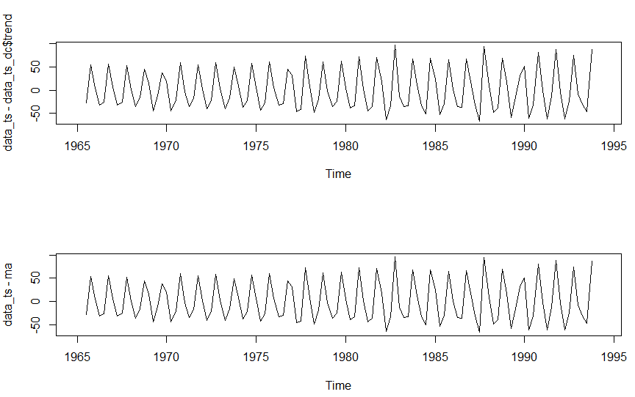

Trend removed plot and MA model trend removed plot. Both look the same.

ACF – on trend and seaonality removed plot. Looks like there is a MA component present. Lets checl PACF plot.

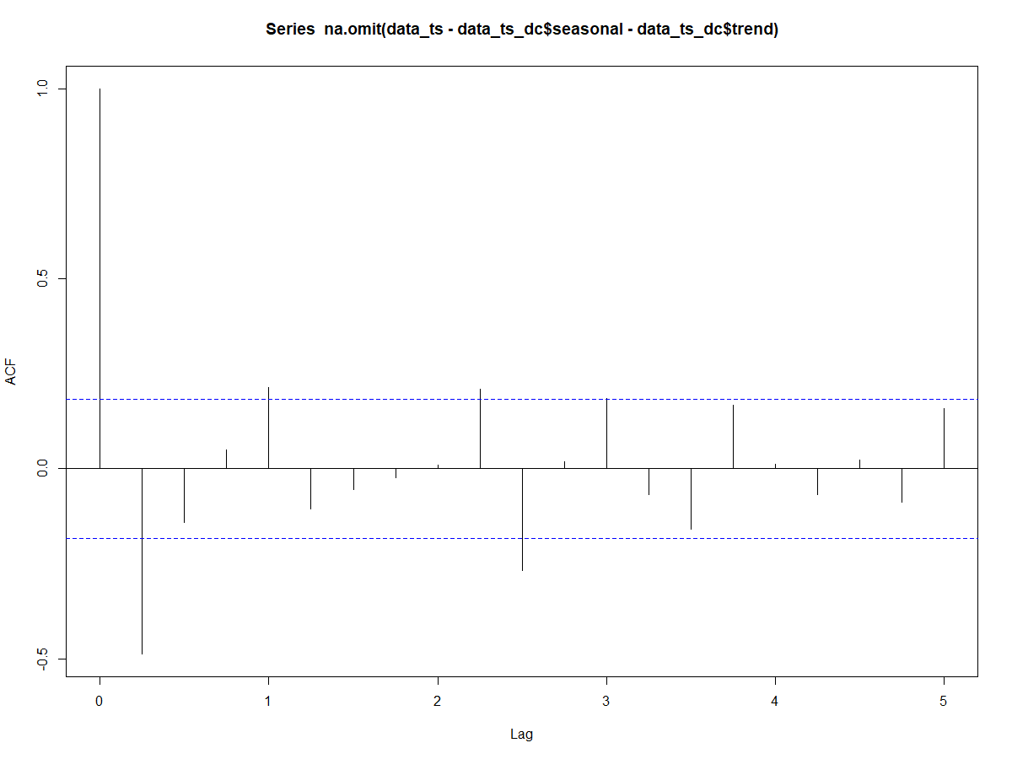

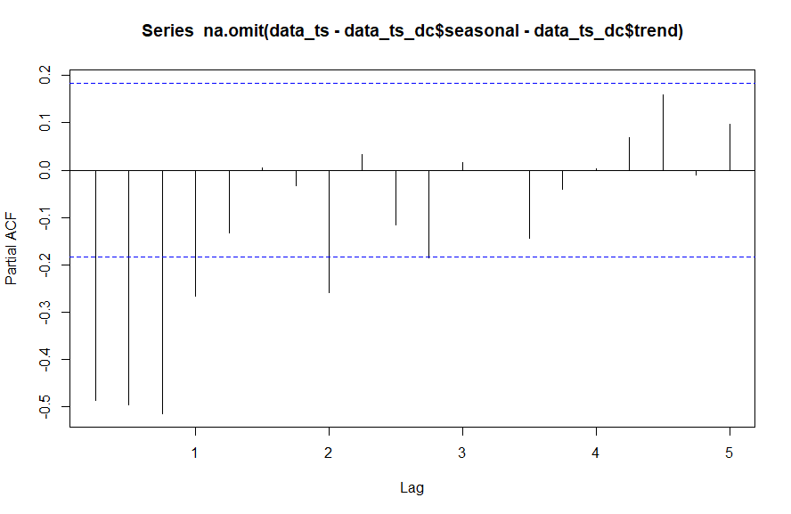

PACF plot shows an MA order of 1 and AR order of 1.

ADF test shows that even after removing the trend and seasonal component, the data simply fails to reject the Null, which means that there is still some non-statioanity in the data. So, I will difference the data.

Differencing helps only when we remove seasonal component from the data, if we remove trend component and do differencing expecting it attain statioanrity, it doesn’t work.

Only a 3rd order differencing was able to clear the stationarity in the data. That’s a complex model there itself.

Now that the series is stationary, lets do white noise test. If the data is not white noise, we can use arma models. The data is not white noise as we know the data has trend and seaonality.

Upon several iterations, I have finalized ARMA(3,0,2) on the 3rd order differened data.

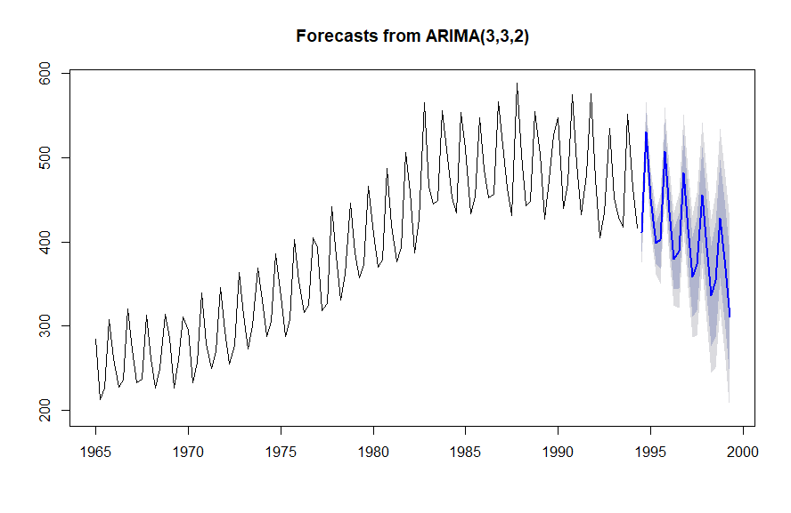



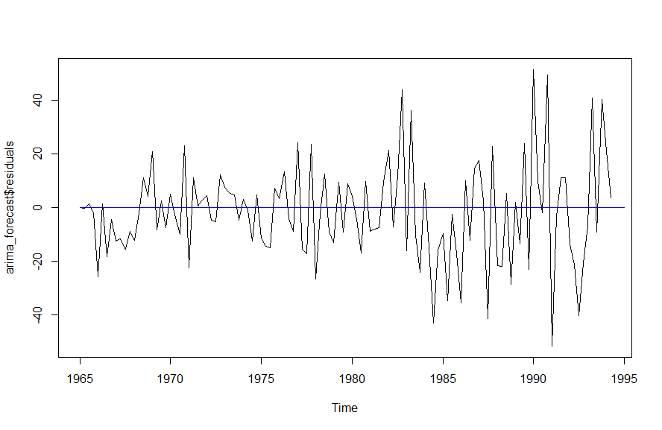

Homoscedasticity plot – looks normal

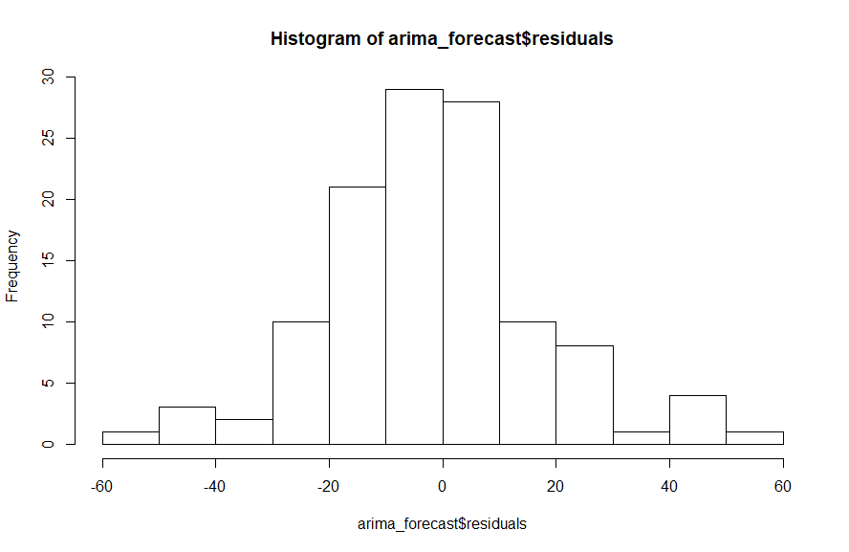

Ljung-Box test for whitenosie in residuals is rejected, that measn that the residualsa till have some information that needs to be captured.