**WEEK-2 ASSIGNMENT**

**Step-1: Choosing 4 systems from the given project list**

I have chosen the below four projects that have similar number of commits,LOC and classes so that comparable study can be done. I have used radon raw . to validate these 4 projects.

|  |  |  |
| --- | --- | --- |
| **Repository Name** | **Git Hub Link** | **No of Commits** |
| **airbnb/knowledge-repo** | [**https://github.com/airbnb/knowledge-repo**](https://github.com/airbnb/knowledge-repo) | **1329** |
| **albumentations-team/albumentations** | [**https://github.com/albumentations-team/albumentations**](https://github.com/albumentations-team/albumentations) | **1332** |
| **bear/python-twitter** | [**https://github.com/bear/python-twitter**](https://github.com/bear/python-twitter) | **1106** |
| **danielegrattarola/spektral** | [**https://github.com/danielegrattarola/spektral**](https://github.com/danielegrattarola/spektral) | **1134** |

**Step-2: Running the given Python Script to compute the metrics**

**i)Airbnb**

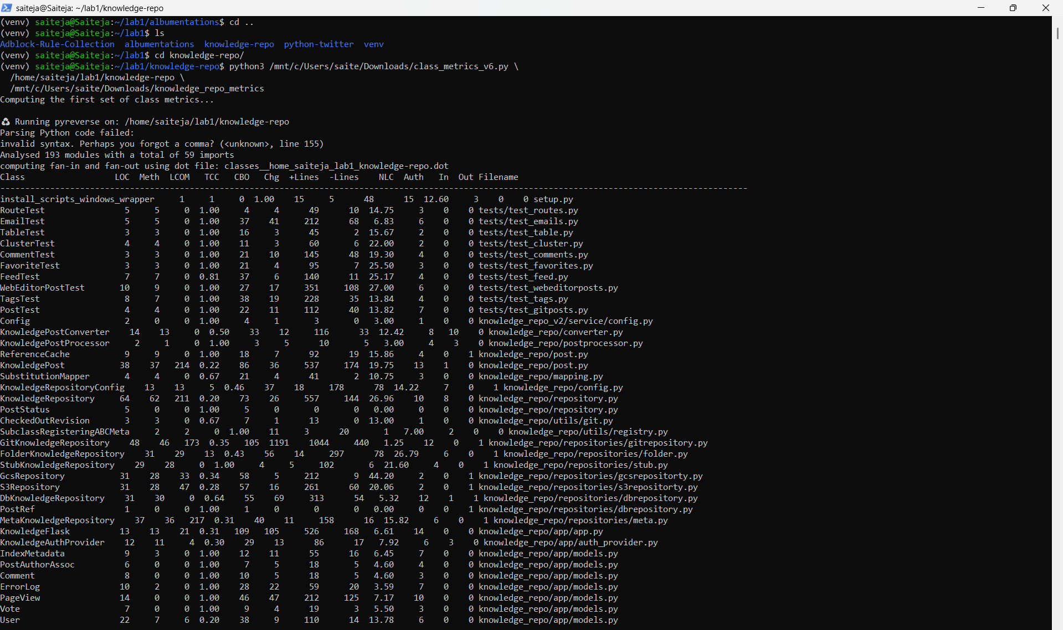

**ii)albumentations**

**iii)python-twitter**

**iv)Spektral**

**Step-3: I have chosen 2 metrics for each attribute (Cohesion, Coupling, Modifiability) for each project.**

**Cohesion: TCC** gauges how closely methods are related (high is good), whereas **LCOM** gauges absence of cohesion (low is good). When combined, they provide a comprehensive view of class unity.  
 **Coupling: Fan-out** counts module-level dependencies, while **CBO** counts class dependencies. Both shows how interrelated a class is; higher modularity is indicated by lower numbers.  
 **Modifiability: NLC** displays the average size of changes, while commit count(**changes**) indicates how frequently a class changes. When taken as a whole, they show how simple it is to update and maintain the class**.**

**i)Airbnb:**

|  |  |  |  |  |
| --- | --- | --- | --- | --- |
| **Metric** | **Mean** | **Median** | **Min** | **Max** |
| **LCOM** | **13.5125** | **0** | **0** | **217** |
| **TCC** | **0.7796375** | **1** | **0** | **1** |
| **CBO** | **23.95** | **16.5** | **1** | **109** |
| **Fan-Out** | **0.4** | **0** | **0** | **1** |
| **Changes** | **25.3375** | **5.5** | **0** | **1191** |
| **NLC** | **11.487625** | **8.97** | **0** | **44.2** |

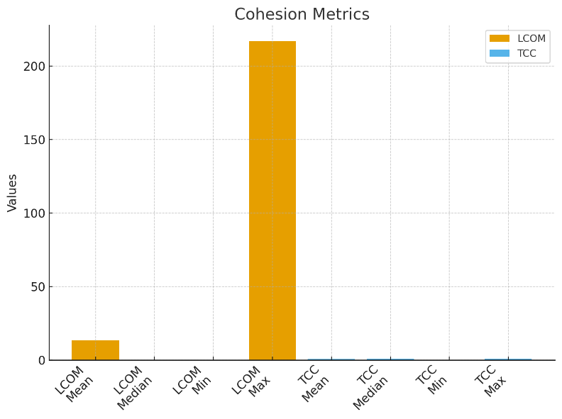

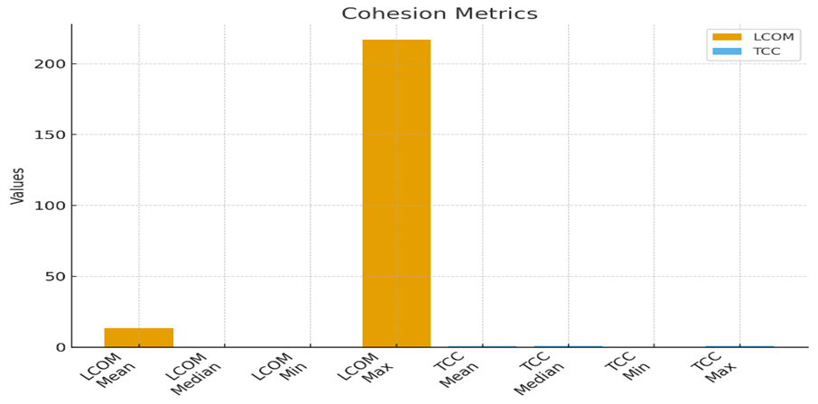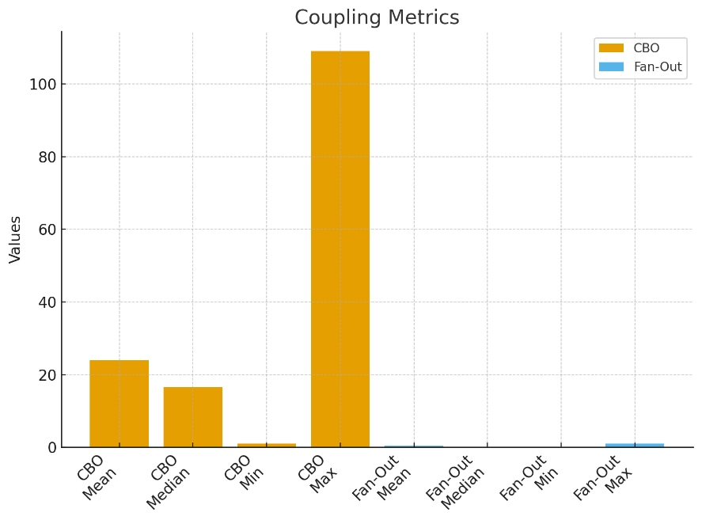

**ii) albumentations**

|  |  |  |  |  |
| --- | --- | --- | --- | --- |
| **Metric** | **Mean** | **Median** | **Minimum** | **Maximim** |
| **LCOM** | **1.899351** | **0** | **0** | **214** |
| **TCC** | **0.879315** | **1** | **0** | **1** |
| **CBO** | **21.59091** | **0** | **1** | **94** |
| **Fan-Out** | **0.211039** | **0** | **0** | **2** |
| **Changes** | **14.0487** | **3** | **0** | **118** |
| **NLC** | **17.95477** | **7.935** | **0** | **329** |

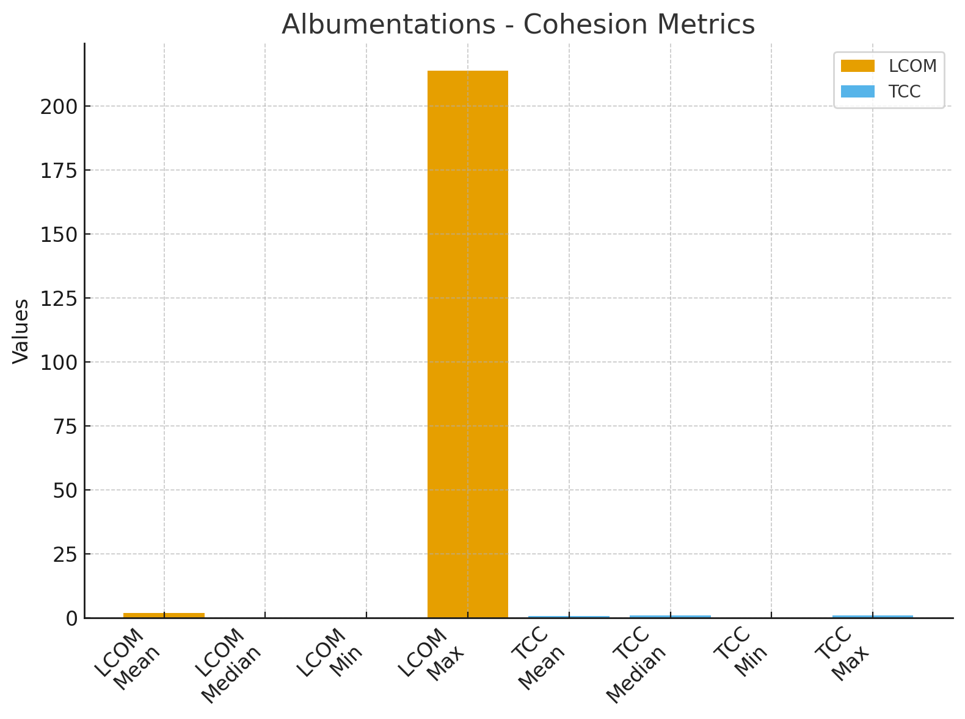

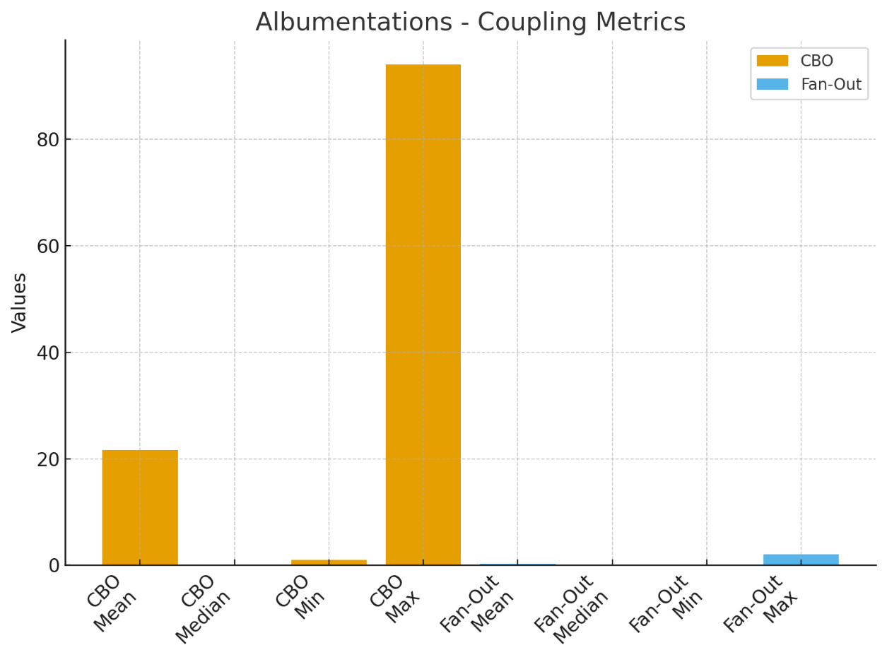

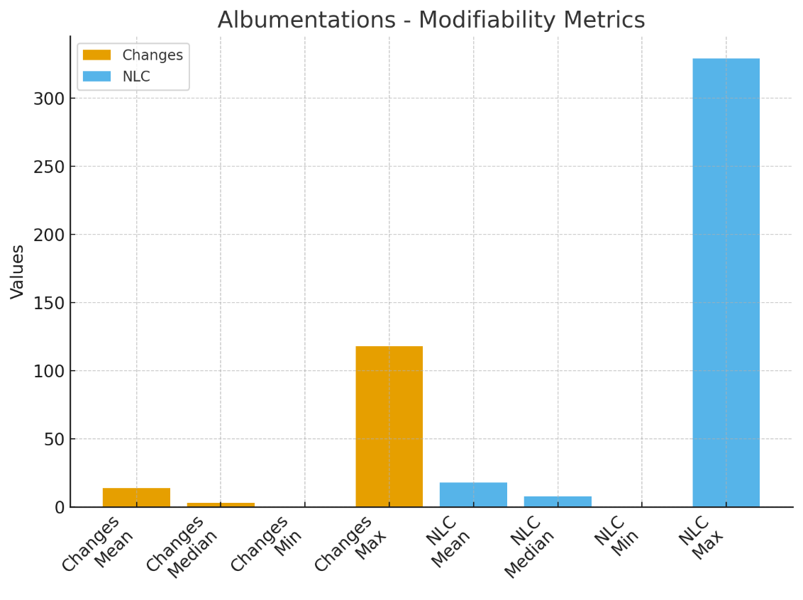

**iii)python-twitter**

|  |  |  |  |  |
| --- | --- | --- | --- | --- |
| **Metric** | **Mean** | **Median** | **Min** | **Max** |
| **LCOM** | **1.020408163** | **0** | **0** | **17** |
| **TCC** | **0.619693878** | **0.714** | **0** | **1** |
| **CBO** | **11.28571429** | **9** | **1** | **62** |
| **Fan-Out** | **0.285714** | **0** | **0** | **1** |
| **Changes** | **5.142857143** | **3** | **1** | **56** |
| **NLC** | **22.47694** | **17** | **2.5** | **135** |

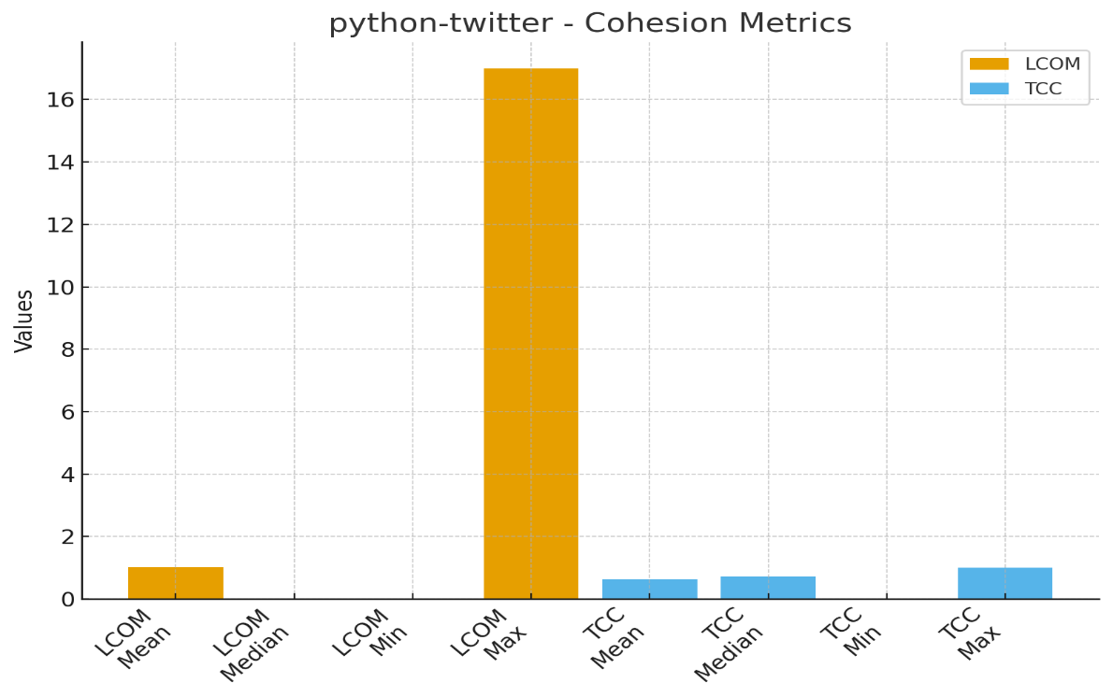

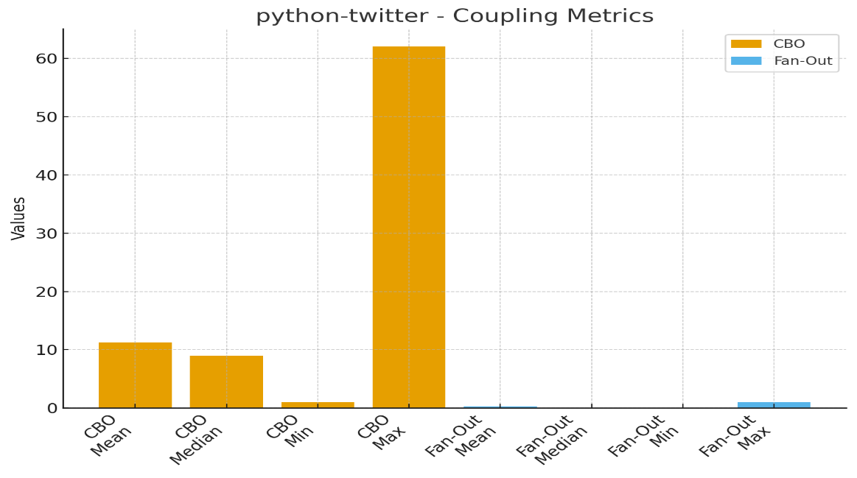

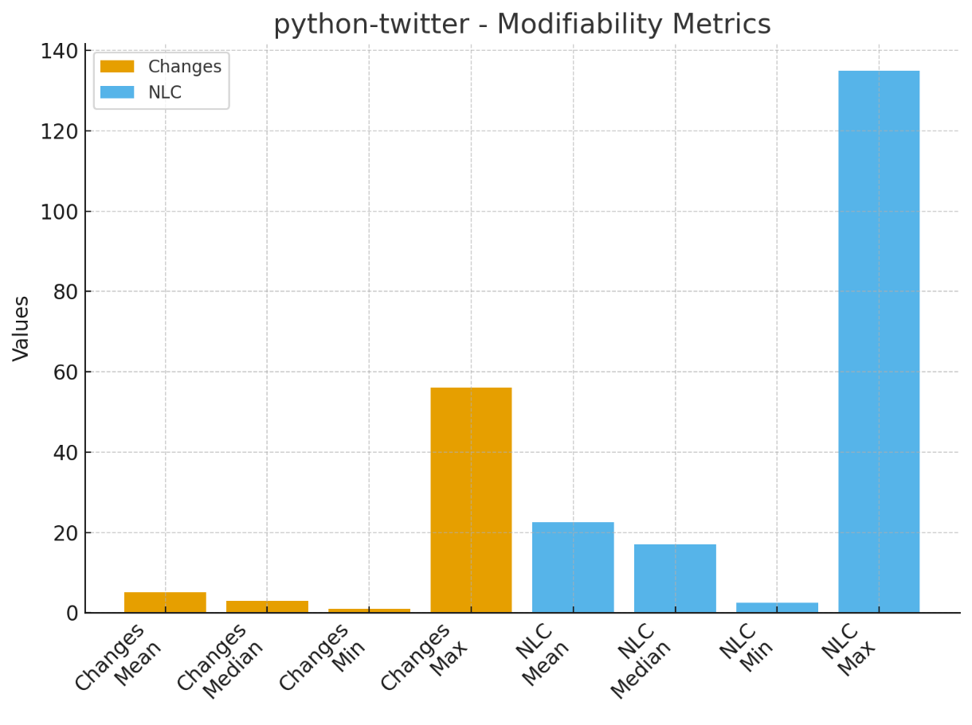

**iv)Spektral**

|  |  |  |  |  |
| --- | --- | --- | --- | --- |
| **Metric** | **Mean** | **Median** | **Mimumum** | **Maximum** |
| **LCOM** | **0.921569** | **0** | **0** | **20** |
| **TCC** | **0.816608** | **1** | **0.167** | **1** |
| **CBO** | **22.44118** | **21.5** | **1** | **70** |
| **Fan-Out** | **0** | **0** | **0** | **0** |
| **Changes** | **10.7549** | **8** | **0** | **33** |
| **NLC** | **18.19431** | **13.945** | **0** | **92** |

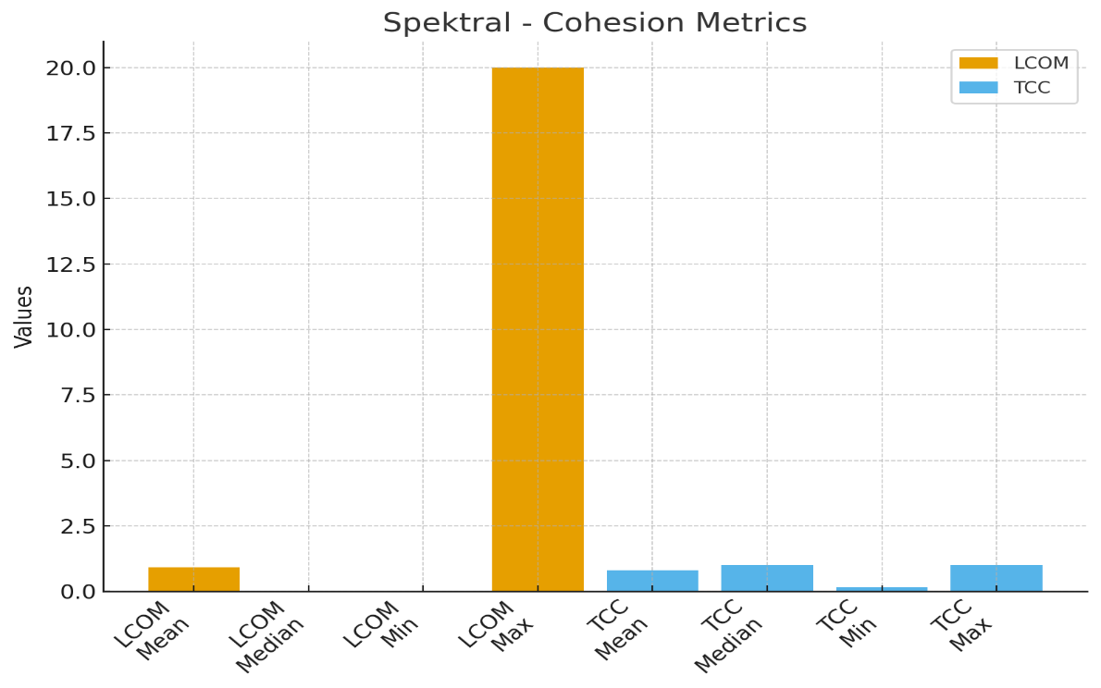

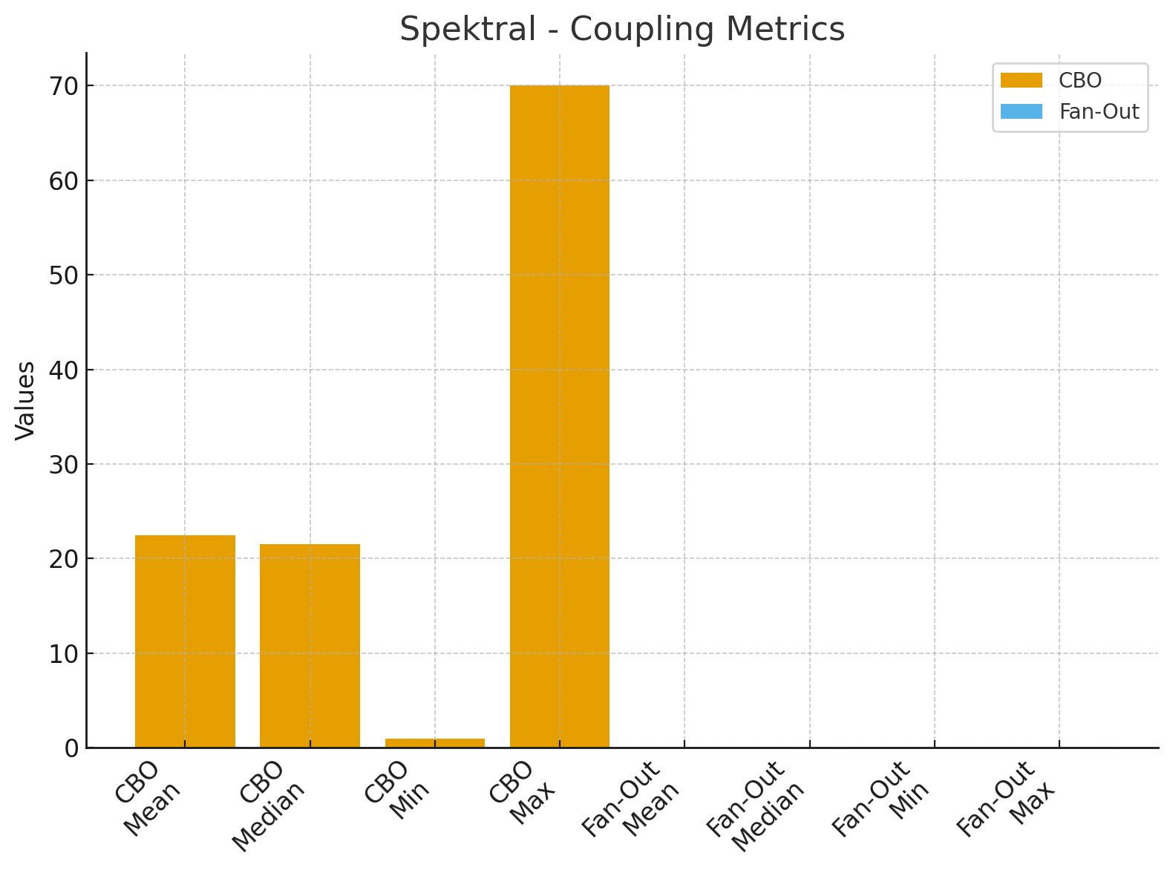

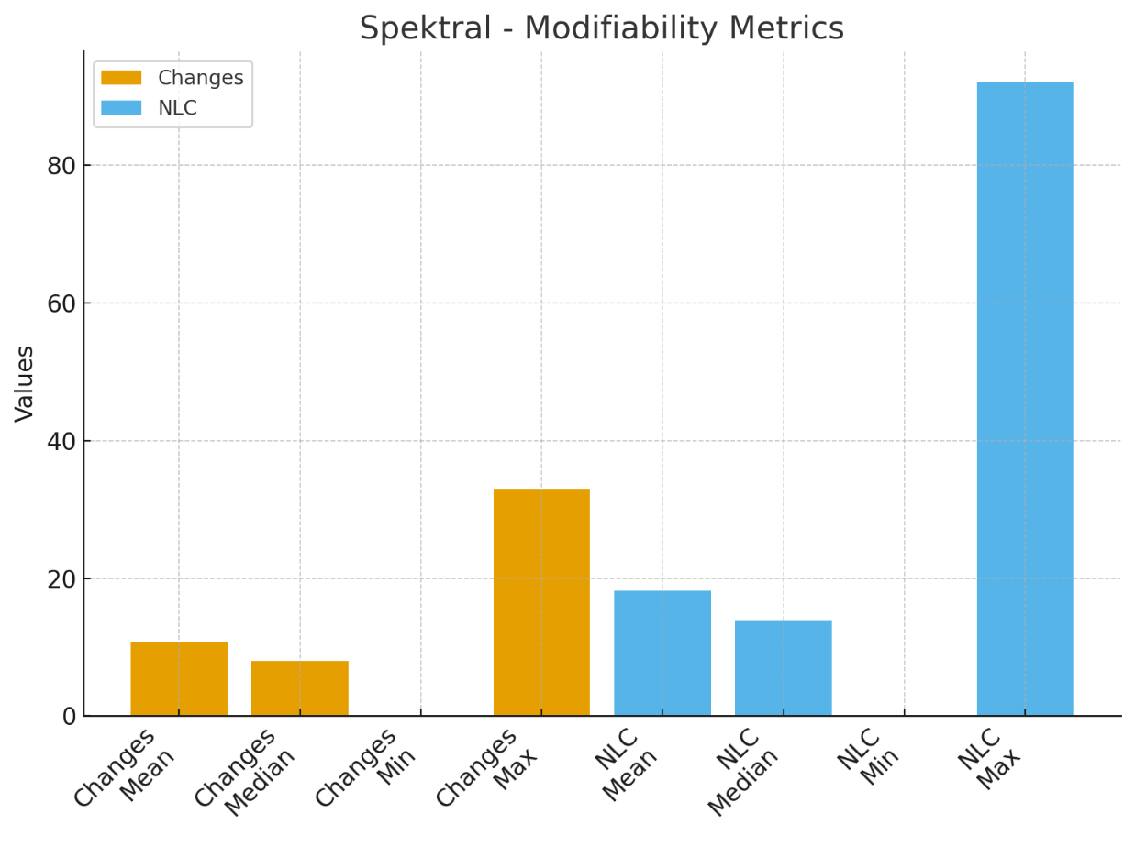

**Step4- System Comparision**

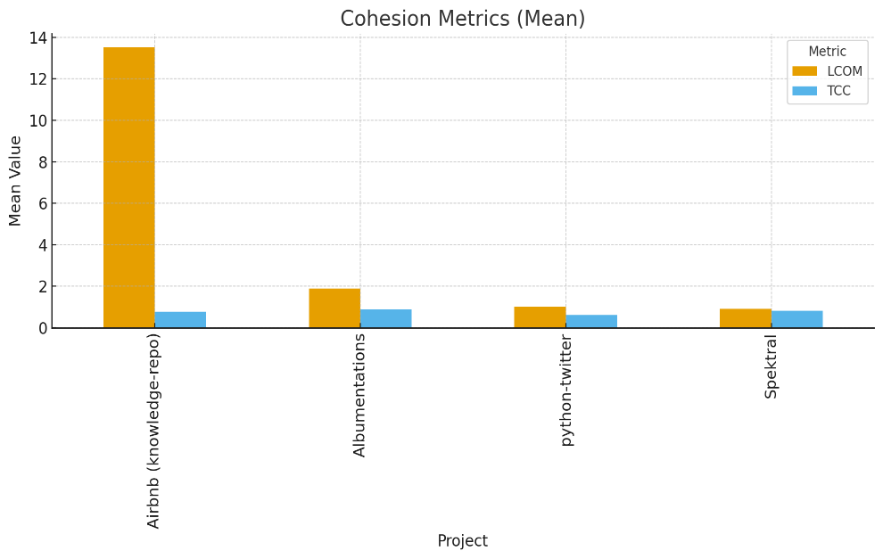

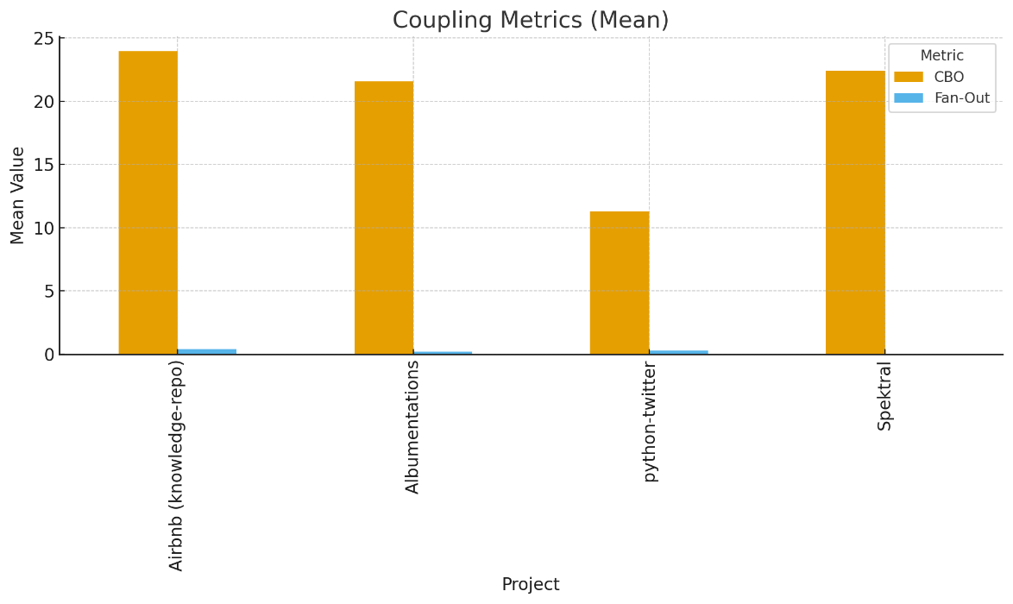

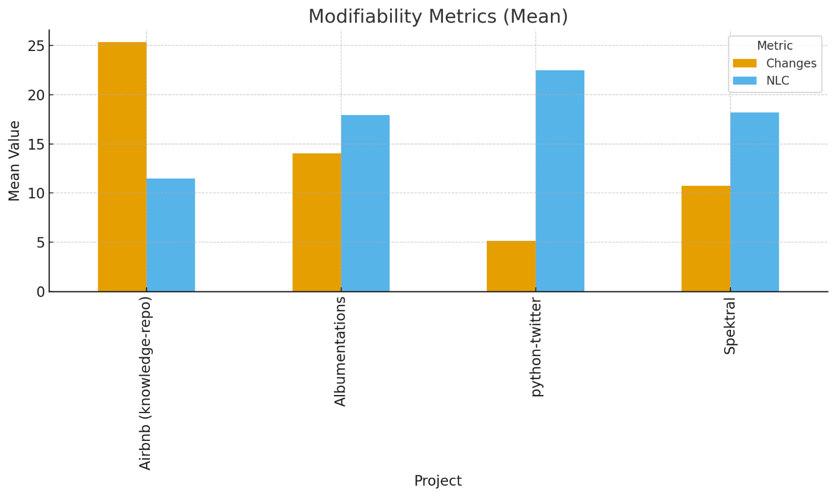

* In comparison to the other initiatives, **Airbnb** exhibits comparatively high LCOM and CBO, indicating weaker cohesiveness and stronger coupling. Additionally, it has the most changes, which may indicate more instability.
* **Albumentations** have moderate coupling and good cohesiveness (low LCOM, high TCC). Its NLC values, however, are comparatively high, indicating that individual changes are typically significant.
* With the smallest LCOM and the lowest coupling values, **Python-twitter** shines out; nonetheless, its TCC is smaller than that of Albumentations and Spektral, indicating weaker cohesion. With fewer modifications and lower maximum values, its modifiability metrics are generally positive.
* **Spektral** exhibits moderate connection and strong cohesiveness. Since its Fan-Out is 0, classes might be more independent. With moderate NLC and fewer modifications per class, modifiability is balanced.
* Overall, **Python-twitter** performs well on coupling but poorly on cohesion, whereas **Airbnb** has the lowest cohesion and modifiability scores. **Spektral** is marginally better balanced across all three qualities, while **albumentations** and **Spektral** have high cohesiveness.

**Step-5 : Summary of Findings**

It is evident from this analysis that there are significant interactions between cohesion, coupling, and modifiability. The idea that effective modular design should strive for both is supported by the fact that systems with stronger cohesion typically exhibit reduced coupling. Modifiability is dependent on the frequency and scope of modifications as well as the modules cohesiveness & coupling.

Of the four systems, Python-twitter showed less cohesiveness but lower coupling, while Spektral and Albumentations showed balanced metrics and stronger cohesion. Higher coupling and more frequent changes were seen by Airbnb, indicating a more complex system to maintain. This comparison emphasizes how crucial it is to strike a balance between these quality qualities to improve modularity and maintainability.