Name: B.Saitejaswi

Roll.no:18031j0066

2. Give the output printed by Queue for the input at the end of all operations  
If “-” perform dequeue else enqueue each word.  
Playing Cricket - is - a hobby - - of - - mentor – Deepak

Ans:

**Case1:** Dequeue Enqueue:

|  |
| --- |
|  |
|  |
|  |
|  |
|  |
|  |
|  |
| Cricket |

|  |
| --- |
|  |
|  |
|  |
|  |
|  |
|  |
|  |
| Playing |

**case2:**

|  |
| --- |
|  |
|  |
|  |
|  |
|  |
|  |
| a |
| Playing |

Dequeue Enqueue

|  |
| --- |
|  |
|  |
|  |
|  |
|  |
|  |
| is |
| Cricket |

Case3:

|  |
| --- |
|  |
|  |
|  |
|  |
|  |
|  |
| a |
| Playing |

Dequeue Enqueue

|  |
| --- |
|  |
|  |
|  |
|  |
|  |
| Hobby |
| is |
| Cricket |

Case4:

|  |
| --- |
|  |
|  |
|  |
|  |
|  |
|  |
|  |
| Playing |

Dequeue Enqueue

|  |
| --- |
|  |
|  |
|  |
|  |
| a |
| Hobby |
| is |
| Cricket |

Case5:

|  |
| --- |
|  |
|  |
|  |
|  |
|  |
|  |
|  |
| Playing |

Dequeue Enqueue

|  |
| --- |
|  |
|  |
|  |
| of |
| a |
| Hobby |
| is |
| Cricket |

Case6:

|  |
| --- |
|  |
|  |
|  |
|  |
|  |
|  |
|  |
|  |

Dequeue Enqueue

|  |
| --- |
|  |
|  |
| playing |
| of |
| a |
| Hobby |
| is |
| Cricket |

Case 7:

|  |
| --- |
|  |
|  |
|  |
|  |
|  |
|  |
|  |
| Deepak |

Dequeue Enqueue

|  |
| --- |
|  |
| Mentor |
| playing |
| Of |
| A |
| Hobby |
| is |
| Cricket |

3. Suppose that a client performs an intermixed sequence of (stack) push and pop operations. The push operations put the integers 0 through 9 in order onto the stack; the pop operations print out the return values. Which of the following sequence(s) could not occur?  
**Note:** For answer write the options in order separated with comma and space eg: a, b, d   
a. 5 4 3 1 2 0 9 8 7 6  
b. 0 9 8 7 6 5 4 3 2 1  
c. 0 1 2 3 4 5 6 7 8 9  
d. 1 3 5 7 9 2 4 6 8 0  
e. 1 5 0 2 3 4 6 7 8 9

**Ans:**

The a, d, e sequences could not occur

4.Give the number of components remain at the end of Quick Find Algorithm for the following union operations.  
a. 3-4  
b. 4-9  
c. 8-0  
d. 2-3  
e. 5-6  
f. 5-9  
g. 7-3  
h. 4-8  
i. 6-1

**Ans:** id[] 0 1 2 3 4 5 6 7 8 9

3-4 0 1 2 4 4 5 6 7 8 9

4-9 0 1 2 9 9 5 6 7 8 9

8-0 0 1 2 4 4 5 6 7 0 9

2-3 0 1 9 4 4 5 6 7 0 9

5-6 0 1 2 4 4 6 6 7 0 9

5-9 0 1 9 9 9 9 9 7 0 9

7-3 0 1 9 9 9 9 9 9 0 9

4-8 0 1 0 0 0 0 0 0 0 0

6-1 1 1 1 1 1 1 1 1 1 1

5. {[]()} If you use stacks for checking parentheses balanced or not ? After each iteration, Print the size of the stack.

**Ans:**

**Case1:**

|  |
| --- |
| { |

Size of the stack is 1

**Case2:**

|  |
| --- |
| [ |
| { |

Size of the stack is 2

|  |
| --- |
| ](popped) |
| [(popped) |
| { |

Size of the stack is 1. When ‘]’ is pushed onto the stack then both [,] are popped.

**Case4:**

|  |
| --- |
| ( |
| { |

Size of the stack is 2.

**Case5:**

|  |
| --- |
| )(popped) |
| ((popped) |
| { |

Size of the stack is 1.

6. Give the order of growth (as a function of N, k ) of the running times of the following code fragment:

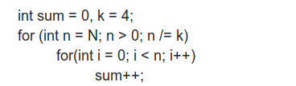

**Ans:**

Time complexity is: O( N )

7. Give the order of growth (as a function of n ) of the running times of the following code fragment:

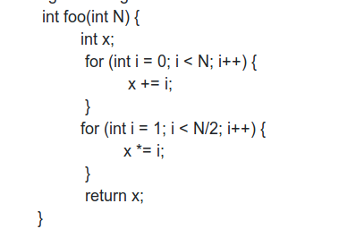

**Ans:**

Time complexity: O (N^2)

8. Give the order of growth (as a function of n ) of the running times of the following code fragment:

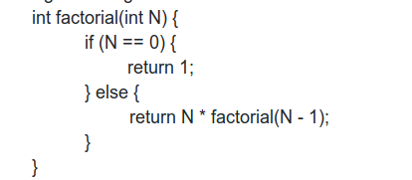

Ans:

Time complexity: O(N^2)

9. Give the order of growth (as a function of n ) of the running times of the following code fragment:

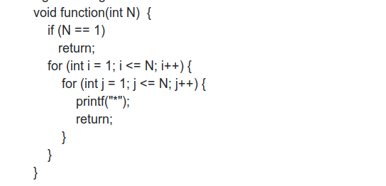

Ans:

Time complexity: O(N^2)

10. Give the number of components remain at the end of Quick Find Algorithm for the following union operations.  
a. 3-4  
b. 4-9  
c. 8-0  
d. 2-3  
e. 5-6  
f. 5-9  
g. 7-3  
h. 4-8  
i. 6-1

**Ans:** id[] 0 1 2 3 4 5 6 7 8 9

3-4 0 1 2 4 4 5 6 7 8 9

4-9 0 1 2 9 9 5 6 7 8 9

8-0 0 1 2 4 4 5 6 7 0 9

2-3 0 1 9 4 4 5 6 7 0 9

5-6 0 1 2 4 4 6 6 7 0 9

5-9 0 1 9 9 9 9 9 7 0 9

7-3 0 1 9 9 9 9 9 9 0 9

4-8 0 1 0 0 0 0 0 0 0 0

6-1 1 1 1 1 1 1 1 1 1 1