AERF ENGINE
Adaptive Evidence Reliability & Reasoning
Implementation and Output Report
Multi-Document Scientific Literature Analysis, Evidence Validation
and Adaptive Reliability Reasoning

Student Name | VC Sai Tejaswi
Registration Number | 23MIS0109
Programme | Integrated M.Tech – Software Engineering
Institution | VIT Vellore

1. Introduction
The AERF Engine is a research prototype for analysing scientific literature across multiple documents. It processes scientific PDFs, extracts structured information such as entities, claims and relations, compares claims across papers, validates candidate relationships using Natural Language Inference (NLI), calculates evidence reliability using AERF scoring, and presents the results through a Streamlit dashboard.

2. Objectives
- Accept scientific PDF documents as research inputs.
- Extract and clean text while preserving provenance.
- Store papers and chunks in SQLite.
- Extract scientific entities, claims and relations.
- Generate semantic embeddings for claims.
- Identify candidate relationships between claims from different documents.
- Validate relationships using NLI and evidence signals.
- Calculate Adaptive Evidence Reliability and Reasoning (AERF) scores.
- Maintain evidence graphs, temporal snapshots and research gaps.
- Provide a Streamlit dashboard for inspecting the outputs.

3. System Architecture
PDF → Text Extraction → Cleaning → Chunking → SQLite
→ Scientific NER → Claim Extraction → Relation Extraction
→ Semantic Embeddings → Candidate Matching → Entity Alignment
→ NLI Validation → AERF Reliability Scoring
→ Adaptive Updating → Evidence Graph → Temporal Evolution
→ Research Gap Detection → Streamlit Dashboard
The implementation separates the ingestion/orchestration layer from the NLP and reasoning components. This allows individual stages to be tested and the generated results to be inspected through SQLite and JSON outputs.

4. Implementation

4.1 Streamlit Dashboard
The dashboard is implemented in ui/app.py. The current navigation includes Overview, Scientific Claims, Evidence Relationships, AERF Reliability, Evidence Graph, Temporal Evolution, Research Gaps, Extracted Relations, Database Explorer and New Analysis.

4.2 Database and Result Handling
- SQLite databases are stored under experiments/runs.
- Experiment JSON results are stored under experiments/results.
- The dashboard detects available databases and allows database selection.
- Tables including papers, claims, claim_pairs, evidence_graph_edges, research_gaps and relations are displayed.
- Numerical values and relationship information are formatted for presentation.

4.3 PDF Ingestion
pipeline/orchestrator.py contains the Phase 1 ingestion implementation. ingest_paper() performs PDF loading, text cleaning, chunking and persistence, with optional title, authors, publication year and venue metadata.
ingest_paper(pdf_path, repository=None, metadata=None)
The ingestion implementation is idempotent. If a paper filename has already been ingested, the existing paper record is reused instead of creating duplicate records. Missing metadata can also be backfilled.

4.4 Scientific NLP and Reasoning
- SciSpaCy is used for scientific Named Entity Recognition.
- Claim extraction identifies candidate research statements.
- Relation extraction identifies subject–predicate–object relationships.
- Semantic embeddings support candidate claim matching.
- Entity alignment adds entity-overlap evidence.
- NLI validates candidate claim relationships.
- AERF combines multiple evidence factors into a reliability score.
- Adaptive updates record changes caused by validated evidence relationships.

4.5 AERF Scoring
AERF(c) = wS*S + wM*M + wCr*Cr + wT*T + wSem*Sem + wPr*Pr - wCp*Cp
The score is constrained to the [0,1] range. The factors represent source characteristics, methodology, corroboration, contradiction pressure, temporal relevance, semantic confidence and provenance completeness.

5. Execution
The application was executed using:
python -m streamlit run ui\app.py --server.fileWatcherType none
The terminal confirmed successful Streamlit startup on port 8501. The execution output also showed existing papers being detected and model weights being loaded for the scientific NLP stages.
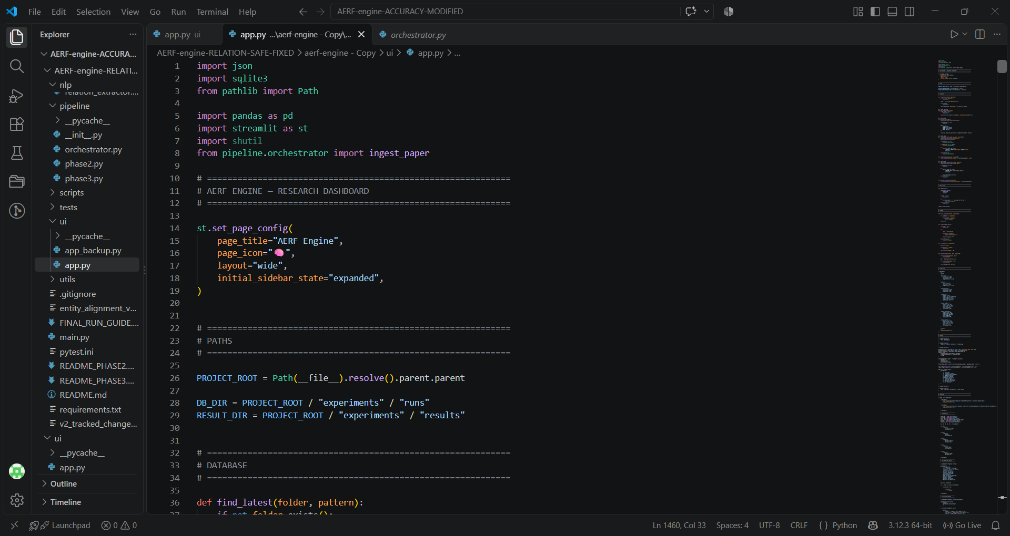
Figure 1. Project structure and ui/app.py.
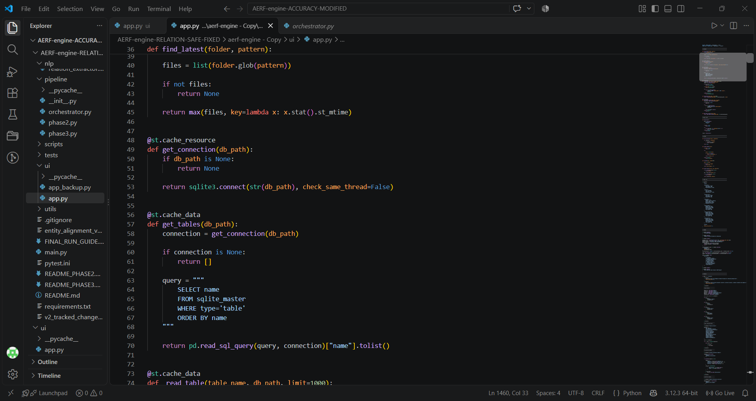
Figure 2. Database connection and table-reading implementation.
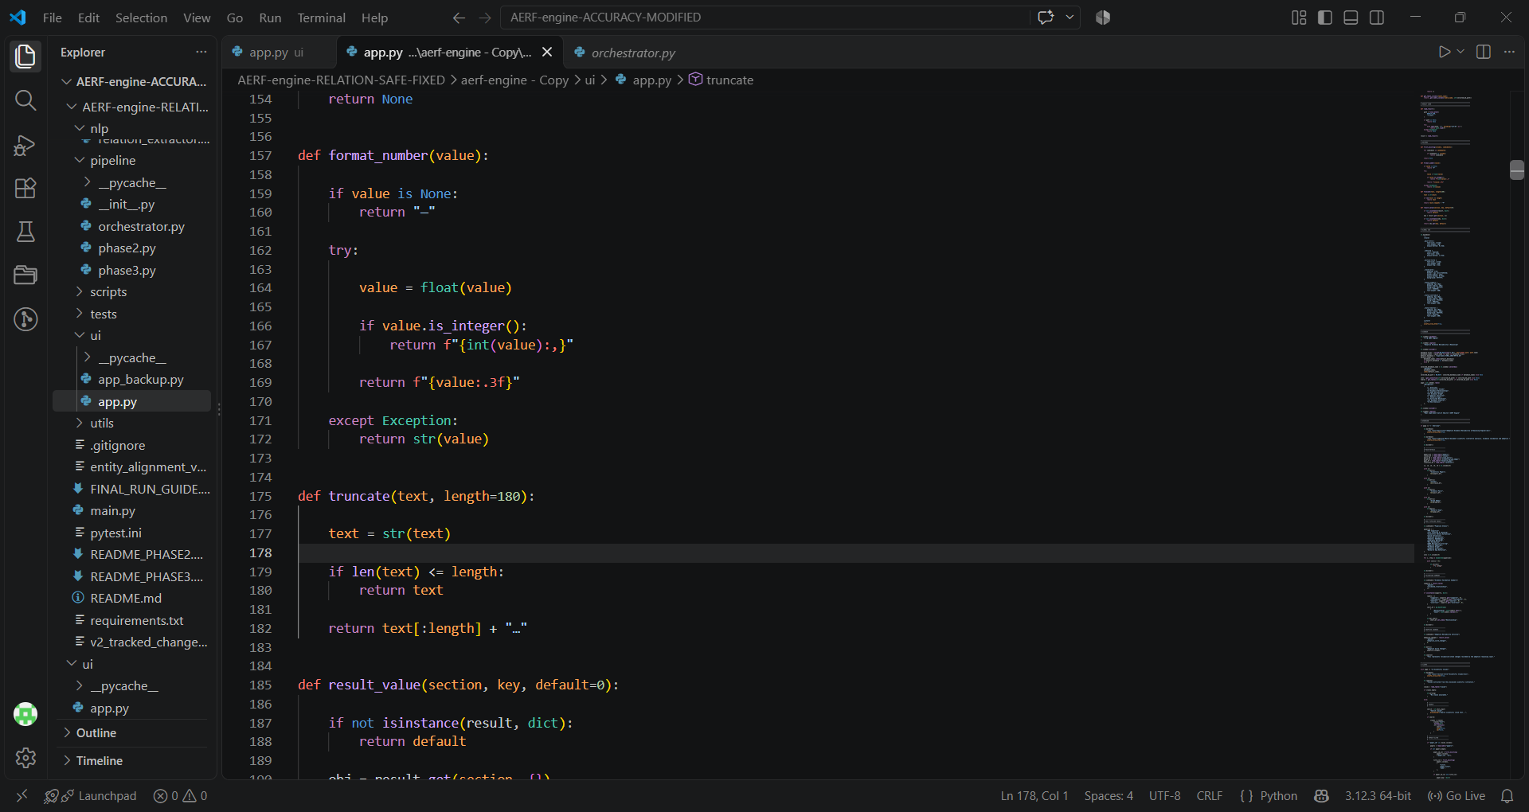
Figure 3. Streamlit sidebar and database selection.
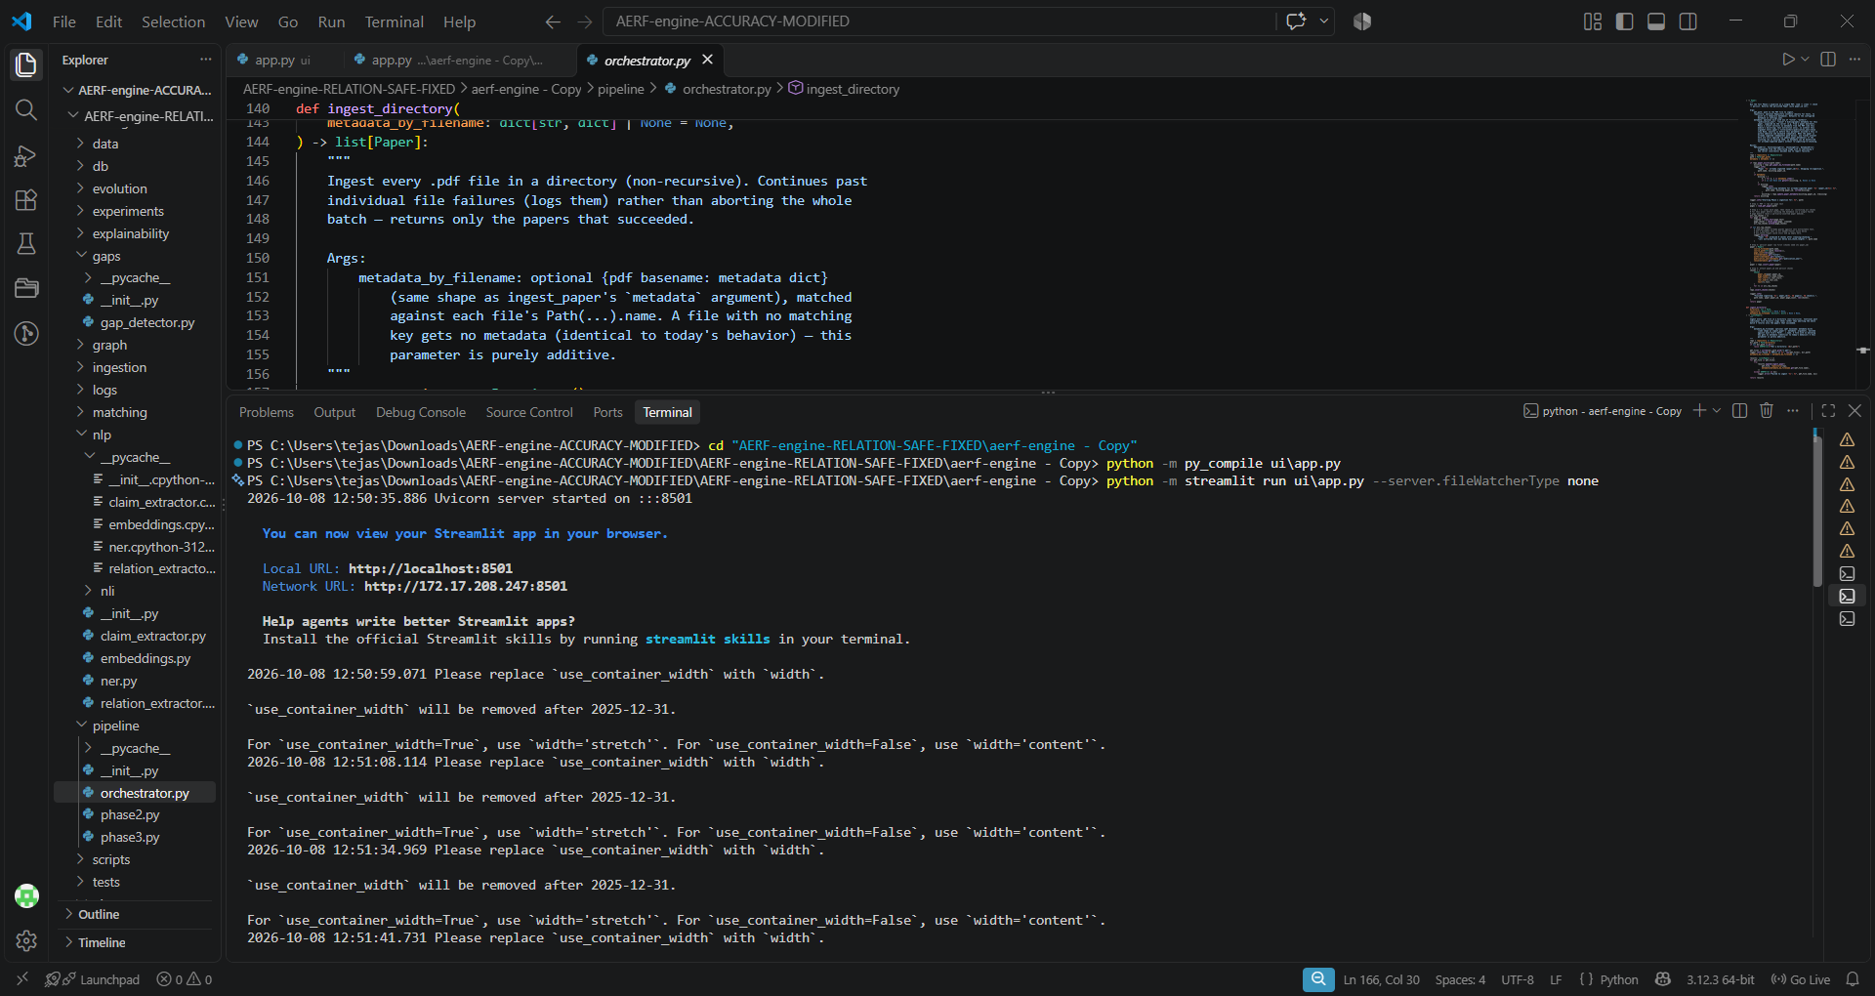
Figure 4. Streamlit server execution and model-loading output.
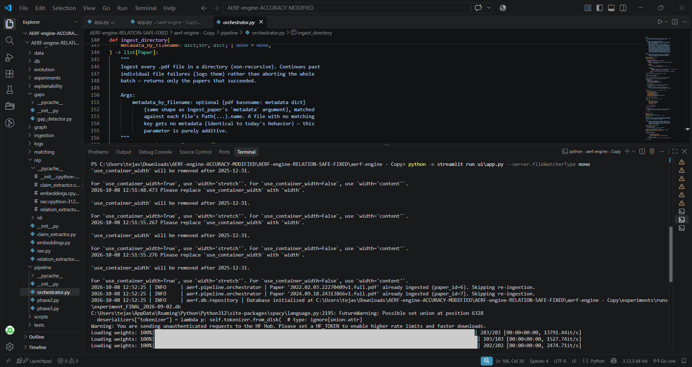
Figure 5. Pipeline execution showing ingested papers and model loading.

6. Output
The final real pipeline run processed five papers and generated structured scientific evidence artifacts.
Output | Observed Result
Papers processed | 5
Claims considered in Phase 3 | 43
Candidate relationships persisted | 37
Validated support relationships | 4
Validated contradiction relationships | 3
Neutral relationships | 16
Uncertain relationships | 14
Adaptive score changes | 7
Evidence graph edges synchronized | 474
Temporal evolution snapshots | 237
Research gaps detected | 30

7. Dashboard Output Modules
Module | Purpose
Overview | Corpus-level system status and major metrics.
Scientific Claims | Extracted claims and source information.
Evidence Relationships | Similarity, NLI, entity overlap and validation.
AERF Reliability | Reliability scores and factor information.
Evidence Graph | Relationships between evidence and claims.
Temporal Evolution | Reliability changes and evolution snapshots.
Research Gaps | Identified evidence deficiencies.
Extracted Relations | Subject → predicate → object relations.
Database Explorer | Inspection of SQLite tables.

8. Validation and Testing Status
The project contains automated tests for pipeline and database behaviour. The final safe relation-extraction implementation reached 115 local tests passing before the later accuracy/UI work.
Accuracy was evaluated separately using a small manually curated diagnostic set. Because the set contains only four cross-document pairs, it is not sufficient for a statistically reliable generalization claim. The current real-model diagnostic did not demonstrate high accuracy. Therefore, this report does not claim that the model is already highly accurate; larger human-labelled evaluation data and further scientific-evidence modelling are needed.

9. Current Status and Next Enhancement
The backend ingestion pipeline and Streamlit dashboard are operational. The next UI enhancement is to expose PDF ingestion directly in the dashboard so users can upload one or more scientific PDFs and start a real analysis.
Upload PDF(s) → Analyze → Ingest → Scientific NLP → Evidence Reasoning
→ Support / Contradiction / Neutral / Uncertain → AERF → Dashboard Outputs

10. Conclusion
The AERF Engine provides an end-to-end prototype for multi-document scientific literature analysis. It combines PDF ingestion, provenance-preserving storage, scientific NLP, semantic matching, NLI validation, evidence reliability scoring, adaptive updates and graph-based outputs. The Streamlit dashboard provides a unified interface for inspecting the generated evidence and reasoning results.
The current output demonstrates processing of a real scientific corpus and generation of structured evidence relationships, reliability updates, graph information, temporal snapshots and research gaps. Future work focuses on direct PDF upload through the UI and larger human-labelled evaluation datasets for improving and honestly measuring accuracy.

