**Homework 3:**

**Image Stitching using Sift and Ransac:**

Plotting the Keypoints that have been found using the SIFT Algorithm:

Keypoints of keble_a (image 1):

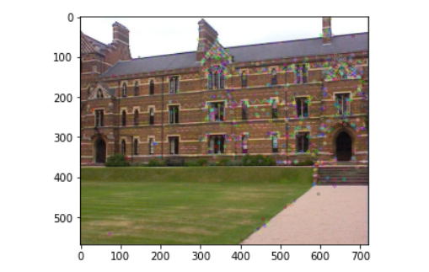

Keypoints of keble_b (image 2):

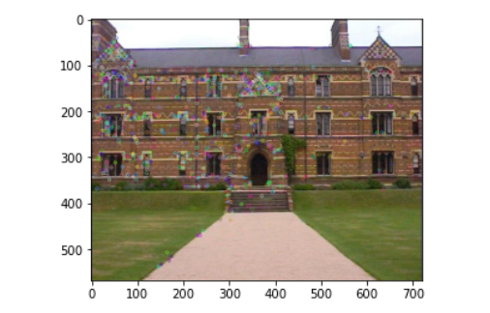

Now after finding the keypoints of image 1 and image 2, we concatenate both pictures as below:

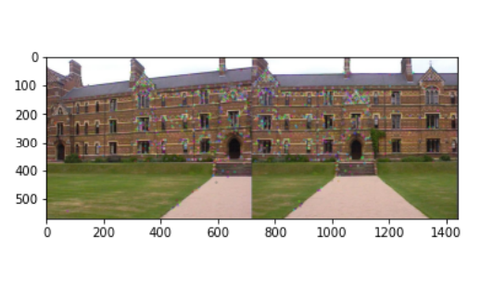

Now, running RANSAC algorithm, matching all the inlier features with lines as below:

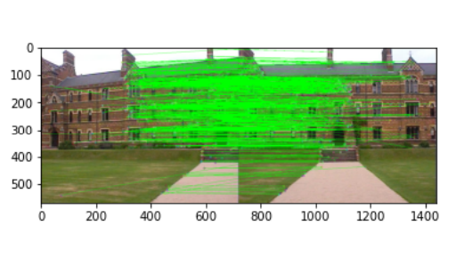

Image after warping both the images using the recomputed homography found using RANSAC:

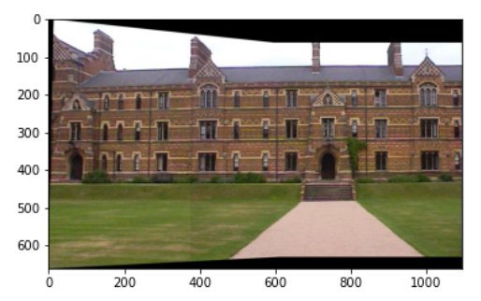

From here, the image 3 (kebel_c) is considered:

Finding the keypoints using the sift algorithm on image 3, the result is as below:

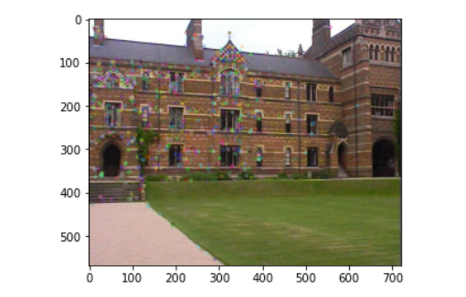

Also finding the keypoints on the image formed from kebel_, and kebel_b images:

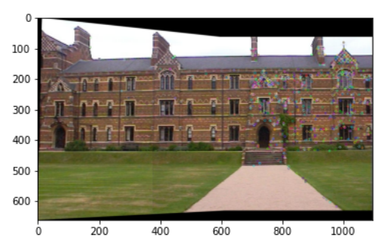

Concatenating both the images in the top as below:

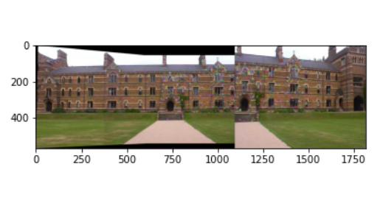

Detecting the inliers using the RANSAC algorithm and drawing the lines between them as below:

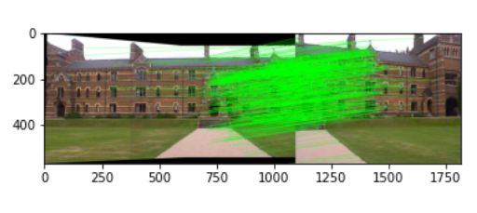

**Final Output:**

Warping the images using the recomputed homography calculated from RANSAC:

