Chapter 12: Running Agents at Scale

The Operations Chapter

About a year ago.

Friday, 4:47 PM, Week 10.

Echo Health Systems, Sarah's Office.
"What's the worst thing that can happen Monday morning?"
Marcus didn't hesitate. "LLM provider goes down. Agents start hallucinating. A nurse gets bad information about a patient's medication."
Sarah nodded. They'd spent 10 weeks building the architecture. Seven layers. Three agents. Eighty-six on the INPACT™ scale. All the checkboxes checked.
But checkboxes don't answer phones at 2 AM.
"Show me the runbook," Sarah said. "The one for when everything breaks at once."
Marcus pulled up a document. It was three pages long. By Monday morning, it would be twelve.

Diagram 1: Operations Value (From Reactive to Proactive)
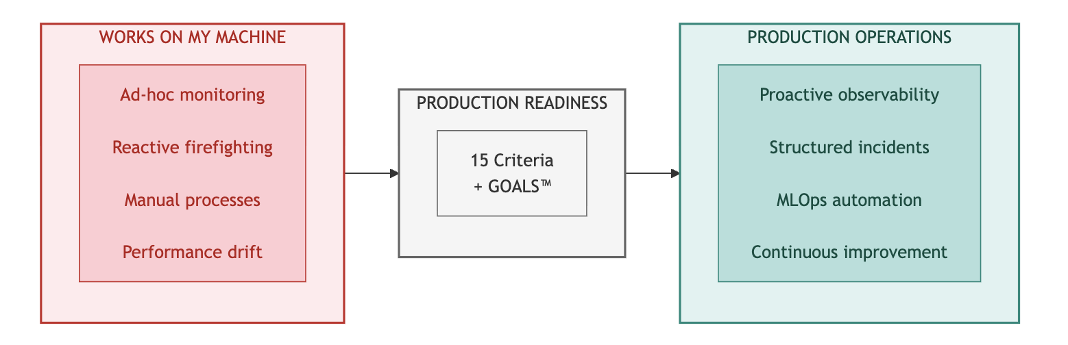
Key Takeaway: Building is easy. Operating at scale requires systematic discipline.

You've built the architecture. All seven layers operational. Three agents validated. Now comes the harder part: keeping it running at scale. This chapter transforms you from architect to operator. Fifteen readiness criteria to validate, MLOps practices to master, incidents to handle, and continuous improvement cycles that can drive 3-5% accuracy gains in the first month. The Architecture of Trust is built. Now learn to sustain it.

Part 1: Production Readiness

  - The Production Readiness Decision
You've completed the hardest part. Chapters 4-6 built the architecture layer by layer. Chapter 10 executed the 90-day roadmap. Chapter 11 selected technologies for each layer. Your INPACT™ score has climbed from wherever you started toward the threshold that signals agent-readiness: typically 80+ for standard enterprise deployments, 86+ for high-stakes environments.
But building isn't operating. The gap between "architecture complete" and "production ready" has derailed more agent initiatives than infrastructure gaps ever did. Organizations celebrate Week 10 architecture milestones only to stumble in Week 11 pilots. The Architecture of Trust needs operational discipline to deliver sustained value.
This chapter completes your journey with five operational components:
Part 1: Production Readiness. Fifteen criteria that separate "ready for production" from "ready for failure." Validate all 15 before your pilot launch.
Part 2: MLOps for Agents. Model versioning, A/B testing, prompt management, and cost optimization practices adapted from traditional ML operations to agentic systems.
Part 3: Monitoring and Incident Response. SLA definitions, alerting strategy, incident triage, and post-mortem processes. When things break (and they will), your response determines whether users lose trust or gain confidence.
Part 4: Continuous Improvement. Weekly improvement cycles that can drive 3-5% accuracy gains in the first month. The Architecture of Trust isn't static. It improves continuously.
Part 5: AIXcelerator Platform. For organizations seeking a proven path, how Colaberry's platform makes the 90-day transformation achievable while maintaining all three pillars.

Let's begin with the question every organization faces at Week 10: are you actually ready?

  - The 15-Criteria Production Readiness Checklist
Production readiness isn't a feeling. It's a measurable state. Validate against 15 specific criteria organized around the Architecture of Trust's three pillars. Each criterion has a clear target, measurement method, and evidence requirement.
Throughout this chapter, reference benchmarks are drawn from Echo Health Systems, the pedagogical case study used in this book. Adjust these numbers based on your industry, use case, and risk tolerance. Part 6 consolidates Echo's complete results for easy reference.

Diagram 2: The 15-Criteria Production Readiness Framework
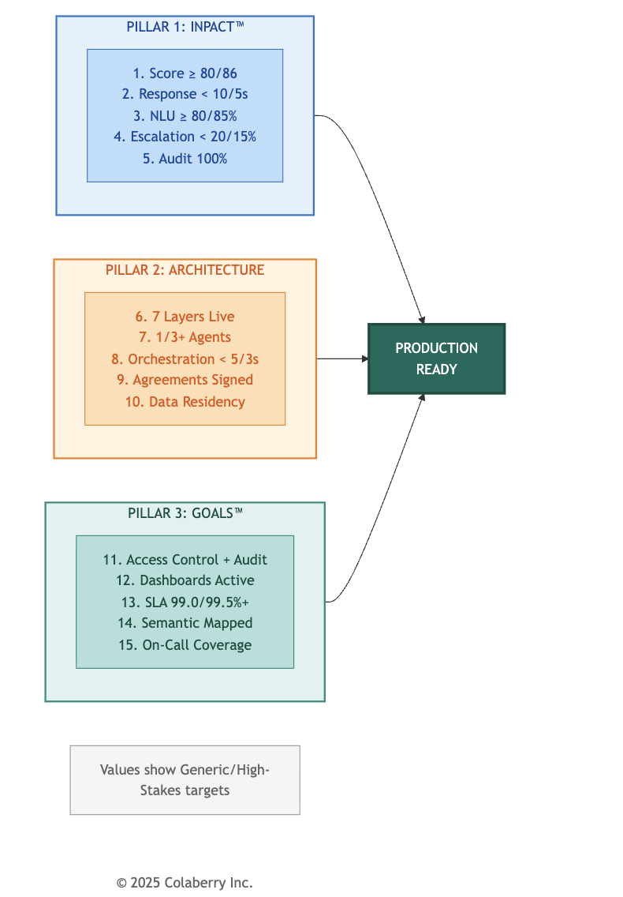

Pillar 1: INPACT™ Readiness (5 Criteria)
# | Criterion | INPACT™  Need | How to Measure | Generic Target | High-Stakes Target
1 | INPACT™  Score | All 6 | Chapter 9 assessment | ≥80/100 | ≥86/100
2 | Response Time | I (Instant) | Load testing, APM traces | <10s P95 | <5s P95
3 | NLU Accuracy | N (Natural) | Validation set testing | ≥80% | ≥85%
4 | HITL  Escalation | P (Permitted) | Governance logs | <20% | <15%
5 | Audit Coverage | T (Transparent) | Audit log validation | 100% | 100%
Choosing Your Targets:
    - Generic targets suit most enterprise deployments where agent errors cause inconvenience but not significant harm
    - High-stakes targets apply to regulated industries, safety-critical systems, and environments where errors have serious consequences
Criterion 3 often sparks debate. If you're near threshold with a clear improvement trajectory, launching with aggressive monitoring may be safer than delaying indefinitely. The key: have weekly improvement cycles ready to close the gap.

Pillar 2: Architecture Readiness (5 Criteria)
# | Criterion | Layers | How to Measure | Generic Target | High-Stakes Target
6 | All 7 Layers Operational | L1-L7 | Layer health checks | All functional | All functional + redundancy
7 | Agents Validated | L7 | UAT completion | ≥1 agent | ≥3 agents
8 | Multi-Agent Orchestration | L7 | Coordination testing | <5s latency | <3s latency
9 | Vendor Agreements Signed | All | Contract audit | 100% | 100% + compliance addenda
10 | Data Residency Confirmed | L1-L2 | Cloud region audit | Documented | Per regulatory requirements
Architecture criteria are typically pass/fail. If you've followed the 90-day roadmap, these should pass cleanly. High-stakes environments may require additional compliance documentation for Criterion 9 (such as BAAs, SOC 2 attestations, or PCI-DSS certifications depending on your industry).

Pillar 3: GOALS™ Readiness (5 Criteria)

# | Criterion | GOALS™ | How to Measure | Generic Target | High-Stakes Target
11 | Access Control + Audit | G (Governance) | Policy testing | <50ms eval | <10ms eval
12 | Dashboards Active | O  (Observability) | Dashboard review | Near real-time | Real-time
13 | SLA Achievable | A (Availability) | Availability testing | 99.0%  uptime | 99.5%+ uptime
14 | Semantic Layer Mapped | L (Language) | Term coverage audit | Core terms | Comprehensive
15 | On-Call Coverage | S (Solid) | Schedule review | Business hours | 24/7 coverage
Criterion 15 is often the last to complete. For organizations not requiring 24/7 coverage, business-hours support with automated alerting may suffice initially. Finding engineers willing to carry pagers may require negotiation. Consider on-call bonuses, or leverage distributed teams across time zones to provide follow-the-sun coverage without requiring overnight shifts.

Scoring Interpretation

Score | Interpretation | Recommendation
15/15 | Production ready | Launch pilot
12-14 | Pilot ready | Controlled rollout with gaps documented
9-11 | Not ready | 2-4 more weeks of remediation
<9 | Significant gaps | Continue building, reassess
Aim for 15/15, but recognize that some criteria may require judgment calls rather than clean passes.

  - Operational Monitoring Essentials
Production operations require ongoing monitoring across all three pillars. Here's what to track: INPACT™ Operational Metrics
Dimension | What to Monitor | Generic Target | High-Stakes Target | Check Frequency
I (Instant) | P95 response time | <10s | <5s | Real-time
N (Natural) | NLU accuracy rate | ≥80% weekly avg | ≥85% weekly avg | Daily
P (Permitted) | HITL escalation rate | <20% | <15% | Daily
A (Adaptive) | Model drift score | <15% deviation | <10% deviation | Weekly
C (Contextual) | Context retrieval success | ≥85% | ≥90% | Daily
T (Transparent) | Audit log completeness | 100% | 100% | Real-time

Select targets based on your industry requirements and risk tolerance. High-stakes environments should use the stricter targets.
GOALS™ Operational Metrics

Dimension | What to Monitor | Generic Target | High-Stakes Target | Check Frequency
G (Governance) | Policy evaluation latency | <50ms | <10ms | Real-time
O (Observability) | Dashboard availability | ≥99.0% | ≥99.9% | Real-time
A (Availability) | System uptime | ≥99.0% | ≥99.5% | Real-time
L (Language) | Terminology match rate | ≥90% | ≥95% | Weekly
S (Solid) | On-call response time | <15min for P1 | <5min for P1 | Per incident

Layer Health Checks

Layer | Health Check | Frequency
L1: Storage | Connection pool, query latency | Every 5 min
L2: Data Fabric | CDC lag, sync status | Every 1 min
L3: Semantic | Embedding freshness, term coverage | Daily
L4: Intelligence | LLM API latency, token usage | Real-time
L5: Governance | Policy sync, ABAC evaluation | Every 5 min
L6: Observability | Log ingestion, dashboard load | Every 1 min
L7: Orchestration | Agent handoff latency, queue depth | Real-time
For detailed scoring methodology, see Chapter 9. For team responsibilities by layer, see Chapter 10.

  - Go-Live Planning

Production readiness enables launch, but it doesn't guarantee success. Phased rollout reduces risk by
expanding gradually based on demonstrated success. Phase 1: Internal Pilot (Week 11)
Dimension | Guidance | Generic Target | High-Stakes Target
Users | Start small with friendly users who provide feedback | 25-50 users | 50-100 users
Duration | Minimum observation period | 1 week | 2 weeks
Monitoring | Intensive: catch issues early | Daily reviews | Hourly reviews
Success Criteria | High task completion rate | ≥85% | ≥90%
HITL  Threshold | Lower than production target | <15% escalation | <10% escalation
Decision Gate | Proceed only if criteria met | All green to advance | All green to advance
Phase 1 validates with friendly users who provide detailed feedback. Intensive monitoring catches issues before they propagate. Success at Phase 1 builds confidence for expansion.

Phase 2: Department Pilot (Week 12)

Dimension | Guidance | Generic Target | High-Stakes Target
Users | Expand to full department or team | 50-100 users | 100-200 users
Duration | Minimum observation period | 1 week | 1-2 weeks
Monitoring | Shift to sustainable cadence | Weekly reviews | Daily reviews
Success Criteria | Slightly relaxed from Phase 1 | ≥80% | ≥85%
HITL Threshold | Closer to production target | <18% escalation | <12% escalation
Decision Gate | Proceed only if criteria met | All green to advance | All green to advance
Phase 2 tests at department scale with diverse users and workflows. Sustainable monitoring balances vigilance with operational efficiency. Success at Phase 2 proves scalability.
Phase 3: Full Production (Week 13+)

Dimension | Guidance | Generic Target | High-Stakes Target
Users | All target users | Full rollout | Full rollout
Duration | Ongoing | Continuous | Continuous
Monitoring | Steady-state cadence | Monthly reviews | Weekly reviews
Success Criteria | Production target | ≥75% | ≥80%

Dimension | Guidance | Generic Target | High-Stakes Target
HITL Threshold | Production target | <20% escalation | <15% escalation
Decision Gate | Rollback if thresholds breached | SLA review monthly | SLA review weekly
Phase 3 is steady-state operations with continuous improvement cycles replacing intensive monitoring. The decision gate shifts from "proceed to next phase" to "maintain or rollback." If metrics breach thresholds, trigger incident response.

  - The Go/No-Go Decision
The 15-criteria checklist provides data. The go/no-go meeting interprets it. These questions determine whether your organization is ready:
Domain Risk
    - What happens if an agent gives a bad recommendation in your context?
    - Can your HITL workflows catch high-risk decisions before they cause harm?
    - Does your team have capacity to handle the projected escalation rate?

Business Risk
    - What's the cost of waiting another month?
    - What competitive pressure exists?
    - Will stakeholder confidence survive another delay?

Operational Risk
    - Have you tested scenarios that aren't in the checklist?
    - Do you have rollback procedures documented and tested?
    - Is your on-call team ready for the first 48 hours?

The Question Nobody Asks Out Loud
    - What happens to this initiative if you launch and it fails?
The answer isn't "don't launch." The answer is "launch small." Fifty users, not five hundred. Hourly monitoring, not daily. Weekly steering committee, not monthly.
A controlled pilot limits blast radius while generating real-world data no staging environment can provide.

Part 2: MLOps for Agents

Traditional MLOps practices (model versioning, A/B testing, performance monitoring) require adaptation for agentic systems. Agents combine multiple models, orchestration logic, and prompt configurations that evolve together. This section provides practical MLOps patterns for agentic systems.
Diagram 3: Agent MLOps Lifecycle
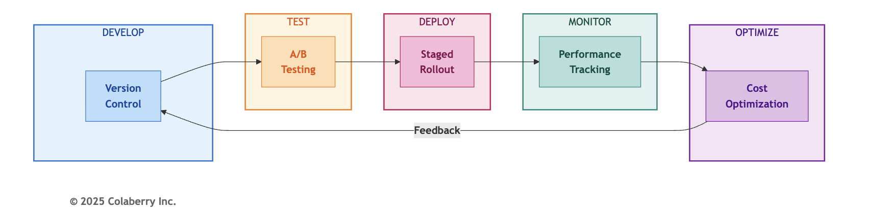

  - Model Versioning
Agent systems have more versioned components than traditional ML: base LLMs, embedding models, prompts, orchestration logic, and retrieval configurations all change independently. Without disciplined versioning, debugging production issues becomes impossible.
Semantic Versioning for Agents
Adopt semantic versioning (MAJOR.MINOR.PATCH) with agent-specific interpretations:

Version Component | Agent Interpretation | Example Change
MAJOR | Breaking changes requiring user retraining | New agent capabilities, response format changes
MINOR | New features, backward-compatible | Additional data sources, improved accuracy
PATCH | Bug fixes, prompt refinements | Typo corrections, edge case handling
Example progression: v1.0.0 → v1.0.1 (prompt fix) → v1.1.0 (new retrieval source) → v2.0.0 (multi-agent orchestration)
What to Version
Every configuration affecting agent behavior requires version control:

Component | Version Control Method | Update Frequency
System prompts | Git repository | Weekly
Few-shot examples | Git repository | Weekly
Orchestration logic | Git repository | Monthly
Retrieval configurations | Git repository | Monthly

Component | Version Control Method | Update Frequency
Base LLM version | Configuration file | Quarterly
Embedding model | Configuration file | Quarterly

Recommended Repository Structure
Maintain a prompts/ repository with versioned folders per agent (e.g., scheduling/v1.0.0/ , support_docs/v1.1.0/ ). Each version folder contains system.md, few_shot.json, and config.yaml. Every production change should require pull request, code review, and staging validation before deployment.

Tools

Tool | Purpose | Recommendation
LangSmith | Prompt versioning, tracing | Primary
Git | Source control for all configs | Required
PromptLayer | Prompt analytics | Optional

  - A/B Testing
Agent improvements require validation against real user behavior. A/B testing compares new versions (challengers) against existing versions (champions) using actual production traffic.
Champion vs. Challenger Framework

Element | Specification
Traffic split | 50/50 between versions
Duration | Minimum 1 week (statistical significance)
Metrics | All INPACT™ dimensions + user satisfaction
Rollback | Automatic if challenger shows >5% regression
Metrics to Track
Every A/B test should measure impact across the Architecture of Trust:

Pillar | Metrics | Threshold for Winner
INPACT™ | Accuracy, latency, escalation rate | >2% improvement
GOALS™ | SLA compliance, error rate | No regression
User | Satisfaction score, task completion | >5% improvement

Example A/B Test
A prompt refinement test (v1.1 vs v1.2) for a scheduling agent

Metric | v1.1 (Champion) | v1.2 (Challenger) | Result
Accuracy | 85% | 87% | ✅ +2%
P95 Latency | 3.2s | 3.1s | Tie
HITL Rate | 9% | 8% | ✅ -1%
Citations/Query | 2.1 avg | 2.8 avg | ✅ +33%
User Satisfaction | 4.2/5 | 4.4/5 | ✅ +5%
Decision: Promote v1.2 to champion. The accuracy and citation improvements justified the change, with no regression on latency or operational metrics.
A/B Testing Pitfalls

Pitfall | Consequence | Prevention
Insufficient duration | False positives | Minimum 1 week, 1,000+ queries
Ignoring user segments | Hidden regressions | Segment analysis by role, shift
Single metric focus | Unbalanced optimization | Track all INPACT™ dimensions
No rollback plan | Extended exposure to bugs | Automatic rollback triggers

  - Prompt Management
Prompts are the primary interface between business intent and agent behavior. Effective prompt management requires the same discipline as code management: version control, testing, review, and deployment processes.
Best Practices

- Version Control Your Prompts
Prompts require version control with history tracking, diff capabilities, and review workflows. Many specialized prompt management tools exist (LangSmith, PromptLayer, Humanloop, Phoenix, Agno, and others) alongside traditional Git-based approaches. Tool selection is beyond the scope of this book, but the principle is universal: treat prompts with the same rigor as production code.

- Template with Variables
Separate static instructions from dynamic context:

Variable Type | Example | Update Frequency
Static | Core instructions, constraints | Monthly
Session | User context, conversation history | Per query
Dynamic | Resource availability, current date | Real-time
- Automated Testing
Every prompt change triggers validation against test suites:

Test Type | Purpose | Reference Benchmark
Regression | Ensure existing capabilities work | 200 golden queries
Edge cases | Validate boundary handling | 50 edge case queries
Safety | Confirm guardrails hold | 30 adversarial queries
- Two-Person Review
All prompt changes require review before deployment:

Change Type | Review Requirement
PATCH | 1 reviewer
MINOR | 2 reviewers
MAJOR | 2 reviewers + domain expert sign-off
Recommended Prompt Pipeline
The pipeline flows from developer change → automated tests (regression, edge, safety) → pull request → peer review → staging deployment → A/B test (1 week minimum) → production promotion. This catches problematic prompt changes before they reach production.

  - Cost Optimization
LLM costs accumulate quickly at production scale. Without optimization, a system processing 50,000 daily queries can face monthly bills exceeding $100,000. Four strategies can reduce per-query cost by 60-70%.
Strategy 1: Semantic Caching
Cache responses for semantically similar queries:

Metric | Before Caching | After Caching
Cache hit rate | 0% | 65%
Avg. queries hitting LLM | 50,000/day | 17,500/day
Daily LLM cost | ~$6,000 | ~$2,100
Implementation: Redis with vector similarity matching. Queries within cosine similarity threshold (0.95) return cached responses instead of calling LLM.

Strategy 2: Prompt Compression
Reduce token count without sacrificing quality:

Technique | Token Reduction | Quality Impact
Remove redundant instructions | 15-20% | None

Technique | Token Reduction | Quality Impact
Use abbreviations in system prompts | 10-15% | None
Compress few-shot examples | 20-30% | Minimal
Reference benchmark: Average prompt reduced from 3,200 to 1,800 tokens (44% reduction) with no measurable accuracy impact.
Strategy 3: Model Routing
Use cheaper models for simpler queries:

Query Complexity | Model | Cost/1K tokens
Simple queries | GPT-4o-mini | $0.15
Standard queries | GPT-4o | $2.50
Complex reasoning | GPT-4o | $2.50

Reference traffic distribution:
- 70% routed to GPT-4o-mini (simple queries)
- 30% routed to GPT-4o (complex queries)
- Blended cost: 70% cheaper than GPT-4o-only

Strategy 4: Batch Processing
Aggregate non-urgent queries for batch API pricing:

Processing Mode | Use Case | Cost Savings
Real-time | User-facing queries | Baseline
Batch | Report generation, analytics | 50% discount
Reference benchmark: 20% of queries (scheduled reports, daily summaries) processed in batch mode. Combined Result
Metric | Before Optimization | After Optimization
Cost per query | $0.12 | $0.04
Monthly LLM spend | ~$180K | ~$60K
Annual savings | n/a | $1.44M
Your results will vary based on query volume, complexity distribution, and caching effectiveness. Review cost metrics weekly to identify new optimization opportunities as usage patterns evolve.

Part 3: Monitoring & Incident Response

Production agents will fail. Databases go down. LLM APIs timeout. Policies misconfigure. The question isn't whether incidents occur. It's how quickly you detect, respond, and recover. This section establishes monitoring foundations and incident response processes for production operations.

  - SLA Definition
Service Level Agreements define your commitments to users. Without explicit SLAs, expectations drift and accountability disappears. Define SLAs across all three pillars:
Three-Pillar SLA Framework

SLA | Target | INPACT™ | GOALS™ | Measurement
Availability | 99.5% uptime | I | A | Monthly uptime calculation
Performance | <5s P95 response | I | A | APM percentile tracking
Accuracy | >85% correct responses | N | S | Weekly validation testing
HITL Rate | <10% escalation | P | G | Daily escalation tracking
Audit Coverage | 100% | T | G | Real-time audit verification
SLA Tiers by Agent Type
Not all agents require the same SLAs. Classify by user impact and error consequences:

Agent Type | Availability | Performance | Accuracy | When to Use
Tier 1: Critical | 99.9% | <3s P95 | >90% | External-facing, revenue-impacting, safety-related
Tier 2: Standard | 99.5% | <5s P95 | >85% | Internal user-facing, operational decisions
Tier 3: Basic | 99.0% | <10s P95 | >80% | Administrative, back-office, non-urgent
Classify your agents by user impact. An external-facing agent typically warrants Tier 1, while an internal documentation assistant may use Tier 3.

SLA Breach Consequences
Define what happens when SLAs are missed:

Severity | Threshold | Response | Escalation
Warning | 1 breach/week | Team review | None
Minor | 3 breaches/week | Root cause analysis | Engineering lead
Major | SLA < 95% for day | War room | VP Engineering
Critical | SLA < 90% for hour | All-hands | Executive team

  - Alert Strategy
Effective alerting balances sensitivity with noise. Too few alerts miss problems; too many cause alert fatigue. Structure alerts by priority based on user impact:
Four-Tier Alert Priority

Priority | Impact | Response Time | Example
P0 | All agents down, data breach | <5 minutes | LLM API complete failure
P1 | Major INPACT™ degradation | <30 minutes | Accuracy below 80%
P2 | Single layer or agent affected | <4 hours | CDC lag exceeding 5 minutes
P3 | No immediate user impact | Next business day | Non-critical log errors
Alert Configuration by Pillar INPACT™ Alerts:
Need | P1 Threshold | P2 Threshold | P3 Threshold
I (Instant) | P95 > 10s | P95 > 7s | P95 > 5s
N (Natural) | Accuracy < 80% | Accuracy < 83% | Accuracy < 85%
P (Permitted) | HITL > 20% | HITL > 15% | HITL > 12%
A (Adaptive) | Feedback stale > 1 month | Stale > 2 weeks | Stale > 1 week
C (Contextual) | CDC lag > 10 min | Lag > 5 min | Lag > 2 min
T (Transparent) | Audit gap detected | Coverage < 99% | Any audit error

Architecture Alerts:

Layer | P1 Trigger | P2 Trigger
L1 Storage | Query timeout > 30s | Latency > 5x baseline
L2 Real-Time | CDC complete failure | Lag > 5x threshold
L3 Semantic | Disambiguation failure > 50% | Failure > 20%
L4 Intelligence | LLM API down | Retrieval precision < 80%
L5 Governance | ABAC evaluation failure | Policy load error
L6 Observability | Trace collection stopped | Dashboard data stale
L7 Orchestration | Agent coordination failure | Handoff latency > 5s

GOALS™ Alerts:

Dimension | P1 Trigger | P2 Trigger
G (Governance) | Unauthorized access detected | Policy violation rate > 5%
O (Observability) | Blind spot in monitoring | Alert coverage < 90%
A (Availability) | Availability < 99% | Availability < 99.5%
L (Language) | Semantic layer down | Term resolution failure > 10%
S (Solid) | Data corruption detected | Quality score drop > 10%
Reference Benchmark: Alert Results

Priority | Alerts Triggered | False Positives | MTTR
P0 | 0 | 0 | N/A
P1 | 2 | 0 | 18 minutes
P2 | 8 | 2 | 2.1 hours
P3 | 34 | 12 | Next day
Your alert volume will vary based on system maturity and threshold configuration. Aim for zero P0s, minimal P1s, and low false positive rates at P2-P3.

  - Incident Response
When alerts fire, structured response prevents chaos. Adopt a six-phase incident response process mapped to the Architecture of Trust:
Diagram 4: Six-Phase Incident Response
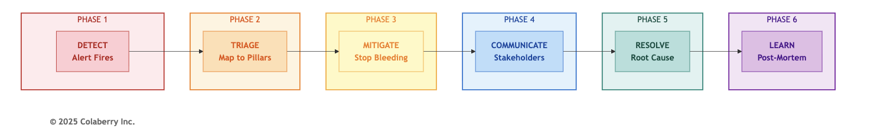
Phase 1: DETECT
Automated monitoring triggers alert. On-call engineer acknowledges within response time SLA.

Action | Owner | Timeline
Alert fires | System | Immediate
Acknowledge | On-call | <5 min (P0-P1), <15 min (P2)

Action | Owner | Timeline
Initial assessment | On-call | +5 minutes

Phase 2: TRIAGE
Map incident to affected pillars and layers:

Question | Purpose
Which INPACT™ needs affected? | Scope user impact
Which layers involved? | Identify root cause area
Which GOALS™ dimensions degraded? | Assess operational impact
Three-Pillar Incident Mapping

Incident Type | INPACT™ | Layer | GOALS™ | Initial Response
LLM API outage | I, N | L4 | A | Failover to backup
Database failure | I, C | L1-L2 | A, S | Promote replica
ABAC misconfiguration | P | L5 | G | Rollback policy
Semantic drift | N | L3 | L | Update terminology
Audit gap | T | L6 | G, O | Fix logging pipeline
Agent conflict | C | L7 | S | Restart orchestrator

Phase 3: MITIGATE
Stop the bleeding before fixing root cause:

Mitigation | When to Use | Trade-off
Failover | Primary system down | May have reduced capacity
Rollback | Bad deployment | Lose new features
Feature flag | Single feature broken | Partial functionality
Throttle | Overload | Reduced throughput
HITL override | Agent misbehaving | Higher manual load

Phase 4: COMMUNICATE
Keep stakeholders informed throughout:

Audience | Update Frequency | Channel
Technical team | Real-time | Slack war room
Leadership | Every 30 min (P0-P1) | Email/text
Users | At start, resolution | In-app banner
External (if required) | Per compliance | Official channels

Phase 5: RESOLVE
Fix the root cause, not just symptoms:

Action | Verification
Implement fix | Code review if applicable
Test in staging | Reproduce original issue
Deploy to production | Gradual rollout
Confirm resolution | Metrics return to baseline
Close incident | All SLAs restored

Phase 6: POST-MORTEM
Learn from every significant incident (P0-P1 mandatory, P2 recommended).

Post-Mortem Process
Post-mortems prevent repeat incidents. Conduct post-mortems within 48 hours of P0-P1 incidents using a three-pillar template:
Three-Pillar Post-Mortem Template

Summary
- Incident description (1-2 sentences)
- Duration (detection to resolution)
- Pillars affected: INPACT™ [which], Layers [which], GOALS™ [which]
- Timeline
- Detection time and method
- Key response actions with timestamps
- Resolution time and verification
- Three-Pillar Impact Assessment

Pillar | Impact | Metrics
INPACT™ | Which needs degraded, by how much | Accuracy dropped to X%, latency increased to Y
Architecture | Which layers failed | L4 offline for 18 minutes
GOALS™ | Operational impact | Availability at 99.2% for incident period

- Root Cause Analysis

Question | Answer
What failed? | [Technical description]
Why did it fail? | [Contributing factors]
Why wasn't it caught earlier? | [Detection gaps]
What layer owns this component? | [Clear ownership]
- Action Items

Action | Owner | Due Date | Status
[Specific remediation] | [Name] | [Date] | Open
[Detection improvement] | [Name] | [Date] | Open
[Process change] | [Name] | [Date] | Open

Example P1 Post-Mortem
Summary: LLM API degradation caused 18-minute accuracy drop to 72%. Pillars affected: INPACT™ (I, N), Layer 4, GOALS™ (A, S).
Root Cause: LLM provider experienced regional degradation. Backup region not configured for automatic failover.
Key Actions: Configure automatic failover, add health check probes, document manual failover procedure. Result: Second LLM incident (3 weeks later) detected in 2 minutes, failed over automatically, zero user impact.

Part 4: Continuous Improvement

The Architecture of Trust isn't a destination. It's a foundation for continuous improvement. Your INPACT™ score shouldn't stop at 86/100. Through systematic weekly improvement cycles, organizations can achieve 3-5% accuracy gains in the first month. This section provides the processes that drive ongoing improvement.

  - Weekly Improvement Cycle
Structured weekly cycles transform operational data into agent improvements. A five-day pattern can yield consistent 1-2% weekly accuracy gains.
Diagram 5: Five-Day Improvement Cycle
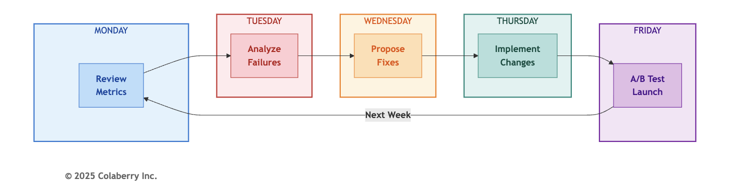

The Five-Day Cycle

Day | Activity | INPACT™ Focus | Layer Focus | GOALS™ Focus
Monday | Review metrics | All 6 dimensions | Health checks | O  (Observability)
Tuesday | Analyze failures | N (Natural) | L3-L4 | S (Solid)
Wednesday | Propose fixes | Dimension needing most improvement | Targeted layer | L (Language)
Thursday | Implement changes | Validate fix | Deploy to staging | G (Governance)
Friday | A/B test launch | Compare versions | Monitor | All
Key Activities by Day:
- Monday: Review INPACT™ scores, error logs, user feedback, cost metrics
- Tuesday: Cluster failures, categorize by root cause, map to layers, estimate complexity
- Wednesday: Propose fixes (prompt refinement, few-shot additions, retrieval tuning, semantic updates)
- Thursday: Implement with appropriate review (1-2 reviewers based on change type)
- Friday: Deploy A/B test with 50/50 traffic split, 1-week minimum duration, rollback if >5% regression Reference Benchmark: Weekly Results
Week | Starting Accuracy | Improvement | Ending Accuracy
Week 11 | 85.0% | +0.8% | 85.8%
Week 12 | 85.8% | +0.9% | 86.7%
Week 13 | 86.7% | +0.5% | 87.2%
Week 14 | 87.2% | +0.4% | 87.6%
Week 15 | 87.6% | +0.4% | 88.0%

Compound improvements of 3-5% over five weeks translate to thousands of better user interactions. Your
results will vary based on starting accuracy and optimization opportunities.

  - Feedback Loop Automation
Manual feedback analysis doesn't scale. Automate feedback collection, aggregation, and integration to maintain improvement velocity as volume grows.
Feedback Pipeline

User interactions (L7)
↓
Quality signals captured (L5-L6)
↓
Feedback aggregated (Monday)
↓
Training data updated (L4)
↓
Model/prompt evaluated
↓
Improvements deployed
↓
Metrics monitored

Feedback Signal Types

Signal | Source | Weight | Automation
Explicit thumbs up/down | User interface | High | Fully automated
HITL corrections | Governance layer | High | Fully automated
Query reformulations | Session analysis | Medium | Semi-automated
Abandonment | Session analysis | Medium | Fully automated
Escalation patterns | Support tickets | Low | Manual review
From Feedback to Improvement Example Improvement Cycle:
- 127 actionable feedback items identified
- 89 mapped to prompt improvements
- 23 mapped to retrieval tuning
- 15 required semantic layer updates
- Changes deployed in following week's A/B tests
- Result: 2% accuracy improvement

  - Drift Detection

Agent performance degrades over time. Data distributions shift. User expectations evolve. Model capabilities
change. Systematic drift detection catches degradation before users notice. Three-Pillar Drift Types
Pillar | Drift Type | Detection Method | Prevention
INPACT™ | Accuracy drift | Weekly validation testing | Monthly retraining
Architecture | Performance drift | Daily metrics baselines | Auto-scaling, alerts
GOALS™ | Operational drift | Weekly score tracking | Monthly audit
INPACT™ Drift Detection

Dimension | Baseline | Warning | Action Trigger
I (Instant) | P95 established at launch | +20% from baseline | +50% from baseline
N (Natural) | Accuracy at launch | -2% from baseline | -5% from baseline
P (Permitted) | HITL rate at launch | +3% from baseline | +5% from baseline
A (Adaptive) | Feedback integration time | +50% from baseline | +100% from baseline
C (Contextual) | CDC lag at launch | +50% from baseline | +100% from baseline
T (Transparent) | Audit coverage | Any gap | Persistent gap
Example Drift Response
Drift detection identified declining retrieval precision (78% → 74% over two weeks). Root cause: new document formats introduced by a source system upgrade not reflected in the chunking strategy.
Response:
- Tuesday: Identified drift pattern
- Wednesday: Diagnosed format changes
- Thursday: Updated chunking configuration
- Friday: Deployed fix in A/B test
- Following week: Precision restored to 79%
Early detection prevented user-visible degradation. At Echo Health Systems, this same pattern occurred when their EHR system introduced new documentation templates. The universal response process applied regardless of the specific source system.

Part 5: AIXcelerator Platform

For organizations seeking to accelerate their journey, Colaberry's AIXcelerator platform provides pre-built components validated across multiple enterprise deployments. This section explains what AIXcelerator offers, how it reduces implementation time, and how to access it.
  - What is AIXcelerator?
AIXcelerator is a complete platform that accelerates agent infrastructure deployment while maintaining all three pillars of the Architecture of Trust. Rather than building every component from scratch, organizations use production-validated modules.
Diagram 6: AIXcelerator Five-Component Platform
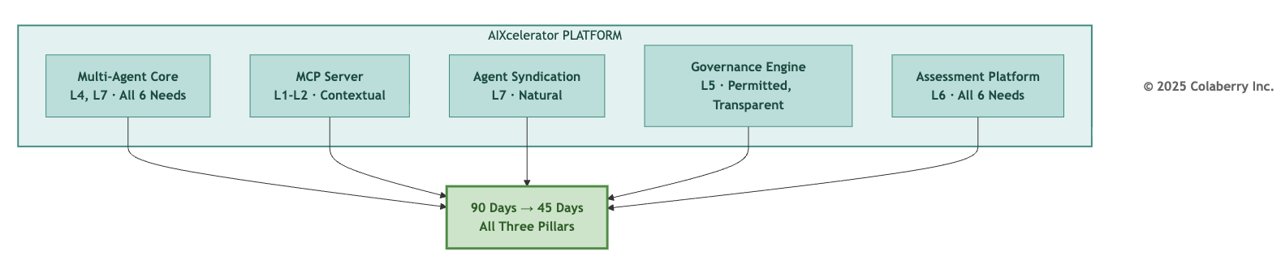

Five Core Components

Component | INPACT™ Coverage | Layers Addressed | Key Benefit
Multi-Agent Core | All 6 needs | L4, L7 | Production-validated orchestration
MCP Server | C (Contextual) | L1-L2 | Pre-built connectors
Agent Syndication Hub | N (Natural) | L7 | Reusable agent patterns
Governance Engine | P, T | L5 | Compliance-ready from day one
Assessment Platform | All 6 | L6 | Continuous INPACT™ measurement
Multi-Agent Core
Pre-built orchestration framework with:
    - LangGraph-based supervisor patterns
    - Configurable agent definitions
    - Built-in HITL workflows
    - Production-validated handoff logic

MCP Server (Model Context Protocol) Standardized data connectivity:
    - Pre-built connectors for 50+ enterprise systems
    - Industry-specific connectors (EHR, ERP, CRM, core banking, e-commerce platforms)
    - CDC pipeline templates
    - Real-time data fabric patterns

Agent Syndication Hub
Reusable agent marketplace:
    - Pre-trained domain agents (scheduling, documentation, etc.)
    - Customization framework
    - Version management
    - Multi-tenant deployment

Governance Engine
Enterprise-grade access control:
    - ABAC policy templates
    - Compliance-ready audit trails
    - HITL workflow builder
    - Compliance reporting

Assessment Platform
Continuous measurement:
    - Automated INPACT™ scoring
    - Real-time GOALS™ dashboards
    - Drift detection
    - Improvement recommendations

  - How to Access AIXcelerator
Three paths to evaluate and adopt AIXcelerator: Option 1: Self-Assessment
Start with free INPACT™ assessment:
    - 30-minute online assessment
    - Automated scoring and gap analysis
    - Personalized recommendations
    - No commitment required

Option 2: Consultation
Schedule expert consultation:
    - Review your specific requirements
    - Architecture recommendation
    - Implementation roadmap
    - Pricing discussion

Option 3: 4-Week Pilot Hands-on validation:
    - Deploy AIXcelerator in your environment
    - Build one production agent
    - Validate against your requirements
    - Investment: $50K (credited toward subscription)

Subscription Tiers
Access: Visit aiXcelerator.ai or contact Colaberry for consultation.

Part 6: Echo Health Systems Results

Echo Health Systems is a pedagogical case study used throughout this book to illustrate the Architecture of Trust in practice. While fictional, Echo's metrics reflect realistic outcomes based on Colaberry's production deployments.
How to Use These Benchmarks:
Echo represents a high-stakes deployment with stringent requirements. Your targets may differ based on your industry, use case, and risk tolerance. Use Echo's metrics as:
    - Reference points for what's achievable with disciplined execution
    - Upper-bound targets if you operate in a similarly regulated environment
    - Validation benchmarks to compare your own progress

This section consolidates Echo's results for easy reference.

Production Readiness (Week 10)
Criterion Category | Result
INPACT™ Criteria (5) | 5/5 passed
Architecture Criteria (5) | 5/5 passed
GOALS™ Criteria (5) | 5/5 passed
Total Score | 15/15

Key Metrics at Launch

Metric | Week 10 Value
INPACT™ Score | 86/100
Response Time (P95) | 2.2 seconds
NLU Accuracy | 83% (reached 85% Week 11)
HITL Escalation Rate | 8%
Audit Coverage | 100%
Operational Results (Weeks 11-15)

Metric | Result
Availability | 99.7%
P1 Incidents | 2 (both resolved within SLA)
Accuracy Improvement | 85% → 88% (+3%)
Cost per Query | $0.12 → $0.04 (67% reduction)
Annual LLM Savings | $1.44M

Investment Summary

Category | Amount
Total Implementation | $1.23M
Timeline | 12 weeks (10 build + 2 validation)
Team Size | 12 specialists
First-Year ROI | 209%
18-Month ROI | 477%
For complete Echo metrics, see Appendix E (Quick Reference Card).

Closing

You've completed the journey.
The INPACT™ framework defines what agents need. The 7-Layer Architecture delivers those needs. The GOALS™ framework sustains success. Together, they form the Architecture of Trust that separates the 5% who succeed from the 95% who fail.
Whether you build from scratch following the patterns in Chapters 4-12 or accelerate with AIXcelerator, you now have the knowledge to join the 5% who succeed with enterprise AI agents.
Trust before intelligence. Architecture before agents. The three pillars are yours.

Chapter Summary

Part | Content | Key Deliverable
Part 1 | Production Readiness | 15-criteria checklist
Part 2 | MLOps for Agents | Versioning, A/B testing, cost optimization
Part 3 | Monitoring & Incidents | SLAs, alerting, response process
Part 4 | Continuous Improvement | Weekly cycles, feedback loops, drift detection
Part 5 | AIXcelerator | Platform overview, access paths
Part 6 | Echo Health Systems Results | Consolidated reference benchmark
For complete canonical metrics (investment, ROI, timeline), see Appendix E (Quick Reference Card).

References

Academic Research (Tier 1)
- Bayram, F., Ahmed, B., & Kassler, A. (2022). "From Concept Drift to Model Degradation: An Overview on Performance-Aware Drift Detectors." Scientific Reports, Nature. Study of 128 (model, dataset) pairs observed temporal model degradation in 91% of cases. https://www.nature.com/articles/s41598-022-15245-z (Accessed November 2025)
- Sculley, D., Holt, G., Golovin, D., et al. (2015). "Hidden Technical Debt in Machine Learning Systems." Advances in Neural Information Processing Systems (NeurIPS). Foundation paper on MLOps technical debt. https://papers.nips.cc/paper/2015/hash/86df7dcfd896fcaf2674f757a2463eba-Abstract.html (Accessed November 2025)
- Beyer, B., Jones, C., Petoff, J., & Murphy, N. R. (2016). "Site Reliability Engineering: How Google Runs Production Systems." O'Reilly Media. Foundation for SLA/SLO/SLI framework. https://sre.google/sre-book/table-of-contents/ (Accessed November 2025)
- Kamel Rahimi, A., et al. (2024). "Implementing AI in Hospitals to Achieve a Learning Health System: Systematic Review of Current Enablers and Barriers." Journal of Medical Internet Research, 26:e49655. Peer-reviewed systematic review of healthcare AI implementation challenges. https://www.jmir.org/2024/1/e49655 (Accessed November 2025)
- Asai, A., Wu, Z., Wang, Y., et al. (2024). "Self-RAG: Learning to Retrieve, Generate, and Critique through Self-Reflection." International Conference on Learning Representations (ICLR). Self-reflective RAG for improved accuracy. https://arxiv.org/abs/2310.11511 (Accessed November 2025)
Government & Standards (Tier 2)
- National Institute of Standards and Technology. (2023). "NIST Cybersecurity Framework 2.0." Incident response and recovery guidance for critical infrastructure. https://www.nist.gov/cyberframework (Accessed November 2025)
- National Institute of Standards and Technology. (2023). "AI Risk Management Framework (AI RMF 1.0)." NIST AI 100-1. Framework for AI system governance and monitoring. https://www.nist.gov/itl/ai-risk-management-framework (Accessed November 2025)
- U.S. Department of Health & Human Services. (2023). "HIPAA Security Rule: Technical Safeguards." 45 CFR
§ 164.312 - Audit controls and access management requirements. https://www.hhs.gov/hipaa/for-professionals/security/laws-regulations/index.html (Accessed November 2025)
- ONC. (2024). "Health IT Certification Program." Interoperability standards for healthcare information technology. https://www.healthit.gov/topic/certification-ehrs/about-onc-health-it-certification-program (Accessed November 2025)
MLOps & Model Management (Tier 4)
- Semantic Versioning. (2024). "Semantic Versioning 2.0.0." Standard for version numbering in software
development. https://semver.org/ (Accessed November 2025)
- LangSmith. (2024). "LLM Observability and Tracing Platform." Prompt versioning, A/B testing, and cost tracking for LLM applications. https://docs.langchain.com/langsmith/observability (Accessed November 2025)
- MLflow. (2024). "MLflow Model Registry." Open-source platform for ML lifecycle management. https://mlflow.org/docs/latest/model-registry.html (Accessed November 2025)
Monitoring & Observability (Tier 4)
- Datadog. (2024). "Application Performance Monitoring." End-to-end APM with LLM-specific integrations and anomaly detection. https://www.datadoghq.com/product/apm/ (Accessed November 2025)
- Grafana Labs. (2024). "Grafana Dashboard Documentation." Open-source observability platform for metrics visualization. https://grafana.com/docs/grafana/latest/ (Accessed November 2025)
- PagerDuty. (2024). "Incident Response Platform." On-call management and incident escalation automation. https://www.pagerduty.com/ (Accessed November 2025)
- Evidently AI. (2024). "ML Monitoring and Observability Platform." Data drift detection and model quality monitoring. https://www.evidentlyai.com/ (Accessed November 2025)
Agent Orchestration (Tier 4)
- LangChain. (2024). "LangGraph Human-in-the-Loop Patterns." HITL workflows, feedback loops, and escalation patterns for agent systems. https://docs.langchain.com/oss/python/langgraph/interrupts (Accessed November 2025)
- Anthropic. (2024). "Model Context Protocol (MCP)." Open protocol for connecting AI assistants to data sources and tools. https://modelcontextprotocol.io/ (Accessed November 2025)

Acronym Reference

Acronym | Definition
ABAC | Attribute-Based Access Control
APM | Application Performance Monitoring
BAA | Business Associate Agreement
CDC | Change Data Capture
GOALS™ | Governance, Observability, Availability, Lexicon, Solid
HIPAA | Health Insurance Portability and Accountability Act
HITL | Human-in-the-Loop
INPACT™ | Instant, Natural, Permitted, Adaptive, Contextual, Transparent
LLM | Large Language Model

Acronym | Definition
MCP | Model Context Protocol
MLOps | Machine Learning Operations
MTTR | Mean Time To Resolution
NLU | Natural Language Understanding
P95 | 95th Percentile
SLA | Service Level Agreement
UAT | User Acceptance Testing

© 2025 Colaberry Inc. All Rights Reserved.
INPACT™ and GOALS™ are trademarks of Colaberry Inc.

